**LEADERSHIP AND MANAGEMENT IN INTERNATIONAL BUSINESS -PORTFOLIO REPORT**

TABLE OF CONTENTS

Part 1 3

Explanation of assessment of why they are the most suitable 3

Indication of what leadership traits /styles /experience etc 3

Explain how this would be suitable for what Intra-NOW-World now faces in the years ahead. 4

Analyse your chosen candidate’s development areas 5

Assess the development areas of Intra-NOW-World and consider any cultural issues they may face, based on the candidates and global nature 6

Recommendation 7

Part 2 8

Leadership Profile 8

Six-Month Personal Action Plan 9

Reference list 12

# Part 1

## Explanation of assessment of why they are the most suitable

The board ought to select a global chief who can steer Intra-NOW-World out of its ongoing problem and ensure that it regains its previous progress to reshape the company's fortunes. This means choosing a leader who has not only knowledge and experience but also the vision and drive to make the changes that are needed.

The ideal candidate for Intra-NOW-World's Global CEO position should have previous experience running successful multinational businesses, particularly technology-based ones. They should have the option to speak with individuals in the different business sectors that Intra-NOW-World works in and appreciate them well (Oleribe *et al.* 2019). In addition, they should be able to identify potential opportunities and threats and have a solid understanding of the current financial environment. In addition, the person chosen to be Worldwide President should be able to identify strengths in one of Intra-NOW-World's products and services and devise and implement novel strategies to keep them competitive in the global market. They should also be able to identify and capitalize on current market opportunities and have the vision to devise a long-term strategy for the company's success.

The Worldwide Chief ought to, in particular, be a change specialist. As a result, they ought to be able to inspire and move their team, as well as foster trust and cooperation. They should be able to communicate effectively with multiple partners in person and make difficult decisions when they need to (Chang *et al,* 2020). To wrap things up, the Worldwide Chief should be not set in stone to make the vital changes following guarantee the drawn-out progress of Intra-NOW-World. They should be willing to question the status quo and have the courage to take risks. In the long run, the board needs to pick an Overall Boss who has the stuff and qualities to guarantee that Intra-NOW-World will make progress later on. The chosen leader must have the right combination of experience, knowledge, vision, and determination to make the necessary adjustments to bring the company back to life and ensure its continued success.

## Indication of what leadership traits /styles /experience etc

To help Intra-NOW-World in conquering its ongoing challenges, the organization's new worldwide President will require many abilities, character types, encounters, and information. Transformational leadership, strategic vision, and operational acumen will be required of them (Merga and Haji, 2019). The new leader should be able to communicate clearly and concisely with the board, employees, and investors. They ought to be groundbreaking chiefs who can move and persuade representatives to cooperate to accomplish the organization's objectives. They ought to be able to think strategically, comprehend the present and future goals of the company, and determine the steps that must be taken to achieve them.

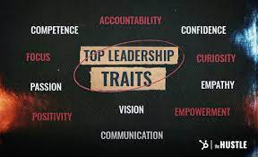

**Figure 1: Leadership Traits**

(Source: https://blog.hubspot.com,)

The new pioneer ought to be heavily involved in the growth of the business, new ideas, activities, deals, and finances. They should have experience driving development and driving change in a complex worldwide association. They ought to also be well-versed in the most recent developments in the industry and business, the landscape of competition, and the requirements of customers. The new leader should also be able to establish productive relationships with internal and external stakeholders, collaborate closely with the board of directors, and ensure that the business's interests and those of investors are aligned with its objectives. They ought to be able to completely resolve issues and swiftly adapt to shifting business conditions and requirements (Tsalis *et al.* 2020*). In* addition, the new leader ought to be an example to follow who can inspire and direct their team through difficult times. They should have the choice to drive execution, see accomplishments, and foster a positive gathering society with glorious people in the board capacities. In addition, they ought to be able to resolve disagreements and reach an agreement. The organization's new global chief should have the necessary skills and experience to guide Intra-NOW-World through its ongoing challenges and ensure its long-term progress.

## Explain how this would be suitable for what Intra-NOW-World now faces in the years ahead.

A global CEO will be chosen by the Intra-NOW-World board to lead the business for the next five years. This person will be in charge of making sure that the business continues to be successful. The picked pioneer should have the experience and data to appreciate the different business areas where Intra-NOW-World works, and the ability to develop a relationship with people in those business areas. Furthermore, they ought to have the option to recognize potential open doors and dangers and have a strong comprehension of the ongoing monetary environment (Wilson. 2020). In addition, the Global CEO should have a solid understanding of Intra-NOW-World's products and services and be able to devise and implement novel strategies to ensure the company's continued competitiveness in the global market. In addition, they should have the vision to develop a planned strategy for the organization's success.

The Global CEO should, most importantly, be a change agent. According to leadership theory, a transformational leader is one who "inspires and motivates people to achieve extraordinary outcomes" My six-month strategy is intended to assist me in moving closer to the desired leadership position. I am on the right track to attaining my objectives thanks to my study, networking, development of my leadership abilities, and job applications (Dabić *et al.* 2019). To execute the required changes that will guarantee Intra-NOW-World's long-term success, the Worldwide Chief must possess the motivation and assurance to take on difficulties and shake things up. According to Consumes, "starting change" and "imaginative critical thinking" are two components of the ground-breaking initiative. The selected pioneer should be prepared to take chances and upend the status quo to secure the organization's continued success (Aguilera and Grøgaard, 2019). Generally speaking, the board of directors of Intra-NOW-World must choose a worldwide CEO who has the expertise, knowledge, vision, and desire required to salvage the company and assure its success moving forward. The chosen leader has to possess the ideal mix of abilities and traits to guide Intra-NOW-World over the following five years and implement the reforms necessary to ensure the business's long-term success.

## Analyse your chosen candidate’s development areas

The Global CEO should focus on developing their ability to solve problems and make decisions, as well as their interpersonal and communication abilities. They should also make an effort to be more imaginative and take more chances when necessary (Yoder-Wise . and Sportsman, 2022). To succeed, the chosen leader must also put in the effort to grasp the marketplaces of Intra-NOW-World and the current state of the economy (Feng. and Savani, 2020). Last but not least, the trailblazer should focus on fostering a long-term foundation for the organization's development as well as the capability to recognise and seize possibilities in the active business sector.

In conclusion, the Intra-NOW-World board must select a global CEO with the qualities and skills necessary for the company's future success (Dumay *et al.* 2019). One of Intra-NOW-World's products or services should be a strong area of strength for the chosen pioneer, as should the ability to develop and implement novel strategies to keep them competitive in the global market. They ought to be transformative leader who is driven and determined to make the adjustments required for the long-term success of the business. The Global CEO should focus on developing their ability to solve problems and make decisions, as well as their interpersonal and communication abilities. They should also make an effort to be more imaginative and take more chances when necessary.

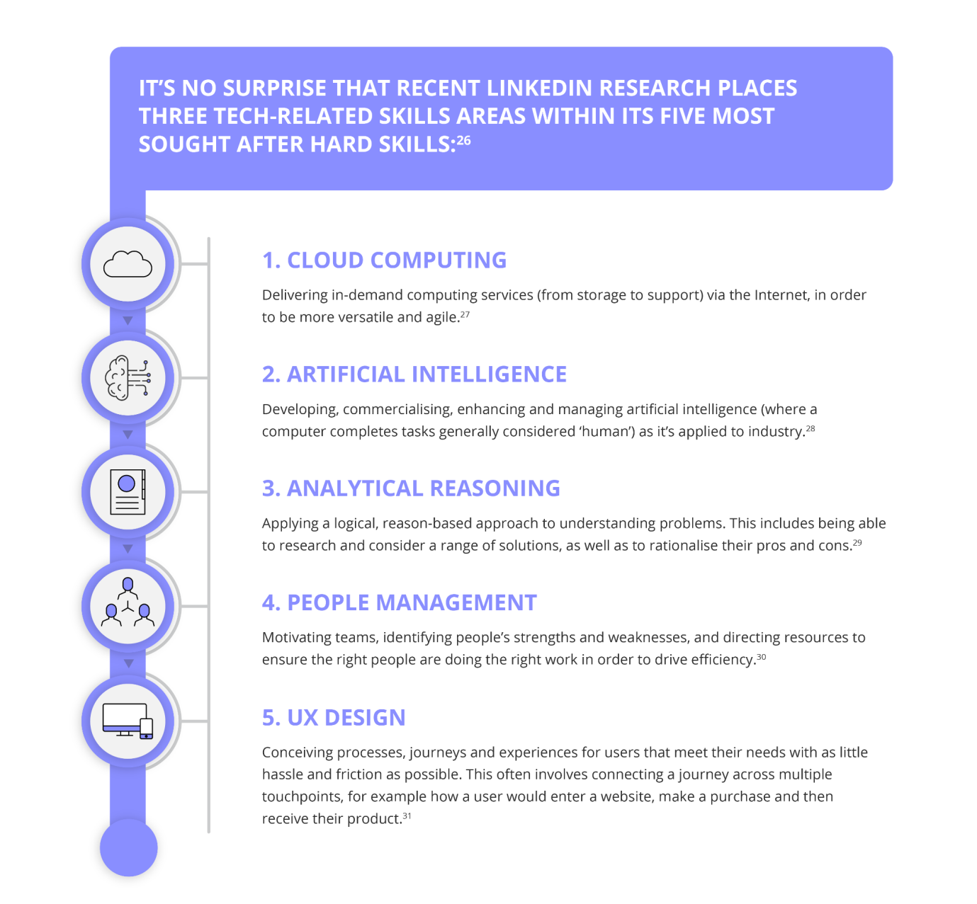

**Figure 2: Development area**

(Source: https://www.getsmarter.com,)

## Assess the development areas of Intra-NOW-World and consider any cultural issues they may face, based on the candidates and global nature

To guarantee future achievement, Intra-NOW-World should address areas of improvement, for example, successful initiative, a reasonable vision, a methodology to accomplish this vision, and a culture of trust and straightforwardness (Paul and Mas, 2020). Leadership: Intra-NOW-World needs to make sure that its new global CEO can lead the company well. This suggests that the leader must demonstrate a strong capacity for employee empowerment and motivation, collaborative relationships with stakeholders, and leading by example. The pioneer should also make sure that they can make sound decisions that are in line with Intra-NOW-World's strategy and vision.

Vision: The new Global CEO must clearly articulate the vision, strategic goals, and approaches to achieving them. A comprehensive strategy outlining the company's objectives and approaches to achieving them should be developed as part of this.

Strategy: The new Worldwide President should have the option to devise and carry out a procedure that will help Intra-NOW-World in accomplishing its objectives. This methodology needs to be adequately unique and versatile to consider changes in the outside climate.

Culture: Inside Intra-NOW-World, the new Overall Boss ought to be prepared for spreading out a culture of trust and straightforwardness. This will include developing a culture that fosters open communication, teamwork, and development (Jones and Wynn, 2019). In addition, Intra-NOW-World ought to make certain that its employees have access to the resources and instruction they require to succeed.

Social Issues: Issues can emerge because of social contrasts in social standards and values because Intra-NOW-World is a global partnership. The new Worldwide President ought to have the option of comprehending and valuing these social distinctions to ensure that Intra-NOW-World's global initiatives continue to achieve genuine success. The new Global CEO must also be able to bridge cultural divides and ensure that all employees are treated fairly and with respect.

The new Global CEO must be able to address the aforementioned growth areas for Intra-NOW-World's future success. Great initiative, an unmistakable vision, a system for accomplishing it, and a culture that is open and trusting are fundamental for Intra-NOW-World to succeed. As a result of the global concept of Intra-NOW-World, the new Worldwide President ought to be aware of and capable of resolving any social issues that may arise.

The new Worldwide President ought to be given the option to draw on the skills of Connor Dayton to make wise decisions that are in line with the strategy and vision of Intra-NOW-World. This can be done with the help of well-known theories like Transformational Leadership (Schermerhorn *et al.* 2020), which encourage leaders to inspire their employees and cultivate a strong sense of purpose and identity for the group. In circumstances like Intra-NOW-World's, it has been exhibited that this hypothesis works, and it can help the new Worldwide Chief in achieving the essential change and ensuring Intra-NOW-World's future achievement.

## Recommendation

**The following is my suggested development plan for the prospective new Global CEO:**

1. Leadership Training: The Global CEO ought to concentrate on improving their leadership abilities, and they ought to be provided with the resources and instruction necessary to do so. This should involve utilizing well-known theories like Transformational Leadership (Masdeu Yelamos *et al.* 2019) to inspire and empower employees and foster a strong sense of collective identity and purpose.

2. Planning Strategically: A comprehensive strategy outlining Intra-NOW-World's goals and methods should be created and implemented by the new Global CEO. This ought to include the improvement of a reasonable vision and technique that is dynamic and adaptable enough to consider changes in the outside climate.

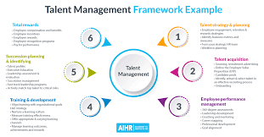

**Figure 3: talent management development plan**

(Source: https://www.aihr.com,)

3. Cultural sensitivity: The multi-national nature of Intra-NOW-World should ensure that the new Global CEO is aware of and able to address any cultural issues. This ought to include the production of a culture that empowers open correspondence, joint effort and development and guarantees that all staff are regarded and treated reasonably.

4. Making use of Connor Dayton's expertise: To make sound decisions that are in line with the strategy and vision of Intra-NOW-World, the new Global CEO ought to draw on the expertise and experience of Connor Dayton.

The new Global CEO ought to be able to guarantee Intra-NOW-World's future success by concentrating on the aforementioned growth areas.

# Part 2

## Leadership Profile

My name is X, and I recently graduated with a Bachelor's and a Master's degree in X. Throughout my education, I have had several leadership experiences, and I am eager to learn more about this field. I am aware that my traits are suitable for a position of authority and that any relationship could benefit from my presence.

Since I acknowledge that everyone has something to contribute and that a gathering collaborating will be more convincing than a single individual working, my organization style stresses facilitated exertion (Moldoveanu and Narayandas, 2019). Because I am organized and restrained, I ensure that assignments are completed to the highest possible standard. In addition, I am a good listener who can accurately interpret a team's requirements and propose solutions to any problems.

I enjoy taking on new challenges and am motivated to succeed. I can effectively lead a team to complete tasks on time and assume responsibility. I work hard to get the best results and am willing to take risks if I think they will help the team. My performance is also improved because I can constructively respond to and listen to criticism.

My greatest strength is my capacity for effective oral and written communication. I am confident in my capacity to convey concepts and ideas to a group. I also have a lot of imagination, and I like coming up with new ways to solve problems.

Personal action plan

## Six-Month Personal Action Plan

Month 1 of my six-month personal action plan: I will make certain that I am establishing a solid foundation of knowledge regarding the leadership position I am seeking. This will include investigating and perusing the subjects of authority and the board. To further my education and comprehension, I will also enrol in online courses.

**Month 1**

1. I will meet people working in the field I'm interested in and learn from their experiences. To improve my leadership abilities, I will make use of these connections as mentors and resources.
2. I will go to systems administration occasions and gatherings to acquire an understanding of the business. I will also make use of these events to meet more people.

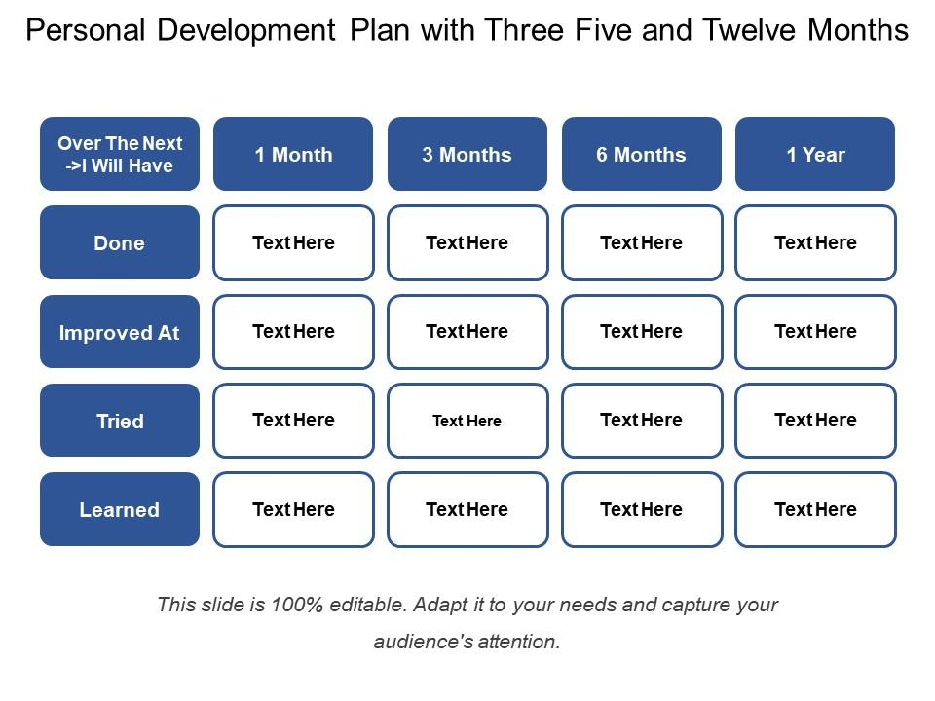

**Figure 4: Personal development plan**

(Source: https://www.slideteam.net,)

1. I'll help out with projects that have to do with the leadership position I want. This will offer me more experience and the chance to foster my abilities.

**Month 2**

1. I will start partaking in administration advancement projects and studios that are presented in my space. I will be able to improve my skills in a structured and supportive setting through these programs.
2. I will keep expanding my network and meeting new people in the business. I will make use of these connections to learn more about the job and gain valuable insight.
3. I will continue to study and read about management and leadership. I will likewise search for ways of applying the data I have learned in reasonable ways.
4. Within my current organization, I will assume additional leadership responsibilities. This will offer me the chance to rehearse and foster my initiative abilities.
5. In the third month, I will develop a personal development plan outlining the areas I want to concentrate on and my objectives. This plan will assist me with remaining focused and keep me roused.

**Month 3**

• I will begin working on improving my interpersonal and communication skills. This will entail attending networking events and classes on public speaking.

• I will keep on building my organization and connect with new individuals in the business. I will make use of these connections to learn more about the job and gain valuable insight.

• Within my current organization, I will assume additional leadership responsibilities. I will have the chance to practice and improve my leadership abilities as a result of this.

**Month 4:**

In my current position, I will begin taking on more difficult responsibilities and projects. This will allow me the opportunity to extend myself and foster my administration abilities.

• I will create a portfolio to show off my work and completed projects. I'll have a concrete way to show off my skills with this.

• I will continue to study and read about management and leadership. Additionally, I will look for practical applications of the knowledge I have acquired.

• To learn more about the position I want, I will attend conferences and events in the industry.

**Month 5**

I'll take on more leadership responsibilities at my current company. I will have the chance to practice and improve my leadership abilities as a result of this.

• I will devise a strategy for my professional growth outlining the actions I must take to advance in the position I am seeking.

• I will keep expanding my network and connecting with important industry figures.

• I will look for volunteer or internship opportunities in the industry. This will allow me the opportunity to get more active experience and gain important understanding.

**Month 6:**

I'll start applying for industry leadership positions. This will necessitate researching potential employers and customizing my cover letter and resume to the position I am seeking.

• I will keep taking on more leadership responsibilities within my current organization. I will have the chance to practice and improve my leadership abilities as a result of this.

• I will take part in industry occasions and gatherings to acquire an understanding of the job I'm chasing.

• I will look for ways to assist those around me and give back to the industry by utilizing my skills and experience.

• I'll make a blog or website to show off my work and completed projects. I will have a chance to show off my abilities and skills on this.

My six-month strategy is intended to assist me in moving closer to the desired leadership position (Shukla *et al.* 2019). I am on the right track to attaining my objectives thanks to my study, networking, development of my leadership abilities and job applications.

# Reference list

**Journal**

Aguilera, R.V. and Grøgaard, B., 2019. The dubious role of institutions in international business: A road forward. *Journal of International Business Studies*, *50*, pp.20-35.

Chang, Y., Iakovou, E. and Shi, W., 2020. Blockchain in global supply chains and cross border trade: a critical synthesis of the state-of-the-art, challenges and opportunities. *International Journal of Production Research*, *58*(7), pp.2082-2099.

Dabić, M., Stojčić, N., Simić, M., Potocan, V., Slavković, M. and Nedelko, Z., 2021. Intellectual agility and innovation in micro and small businesses: The mediating role of entrepreneurial leadership. *Journal of Business Research*, *123*, pp.683-695.

Dumay, J., La Torre, M. and Farneti, F., 2019. Developing trust through stewardship: Implications for intellectual capital, integrated reporting, and the EU Directive 2014/95/EU. *Journal of Intellectual Capital*, *20*(1), pp.11-39.

Feng, Z. and Savani, K., 2020. Covid-19 created a gender gap in perceived work productivity and job satisfaction: implications for dual-career parents working from home. *Gender in Management: An International Journal*, *35*(7/8), pp.719-736.

Jones, P. and Wynn, M.G., 2019. The circular economy, natural capital and resilience in tourism and hospitality. *International Journal of Contemporary Hospitality Management*.

Masdeu Yelamos, G., Carty, C. and Clardy, A., 2019. Sport: A driver of sustainable development, promoter of human rights, and vehicle for health and well-being for all. *Sport, Business and Management: An International Journal*, *9*(4), pp.315-327.

Merga, B. and Haji, J., 2019. Economic importance of chickpea: Production, value, and world trade. *Cogent Food & Agriculture*, *5*(1), p.1615718.

Moldoveanu, M. and Narayandas, D., 2019. The future of leadership development. *Harvard business review*, *97*(2), pp.40-48.

Oleribe, O.O., Momoh, J., Uzochukwu, B.S., Mbofana, F., Adebiyi, A., Barbera, T., Williams, R. and Taylor-Robinson, S.D., 2019. Identifying key challenges facing healthcare systems in Africa and potential solutions. *International Journal of general medicine*, pp.395-403.

Paul, J. and Mas, E., 2020. Toward a 7-P framework for international marketing. *Journal of Strategic Marketing*, *28*(8), pp.681-701.

Schermerhorn Jr, J.R., Bachrach, D.G. and Wright, B., 2020. *Management*. John Wiley & Sons.

Shukla, P.R., Skea, J., Calvo Buendia, E., Masson-Delmotte, V., Pörtner, H.O., Roberts, D.C., Zhai, P., Slade, R., Connors, S., Van Diemen, R. and Ferrat, M., 2019. IPCC, 2019: Climate Change and Land: an IPCC special report on climate change, desertification, land degradation, sustainable land management, food security, and greenhouse gas fluxes in terrestrial ecosystems.

Tsalis, T.A., Malamateniou, K.E., Koulouriotis, D. and Nikolaou, I.E., 2020. New challenges for corporate sustainability reporting: United Nations' 2030 Agenda for sustainable development and the sustainable development goals. *Corporate Social Responsibility and Environmental Management*, *27*(4), pp.1617-1629.

Wilson, S., 2020. Pandemic leadership: Lessons from New Zealand’s approach to COVID-19. *Leadership*, *16*(3), pp.279-293.

World Health Organization, 2., 2020. Universal health coverage partnership annual report 2019: in practice: bridging global commitments with country action to achieve universal health coverage.

Yoder-Wise, P.S. and Sportsman, S., 2022. *Leading and Managing in Nursing E-Book*. Elsevier Health Sciences.