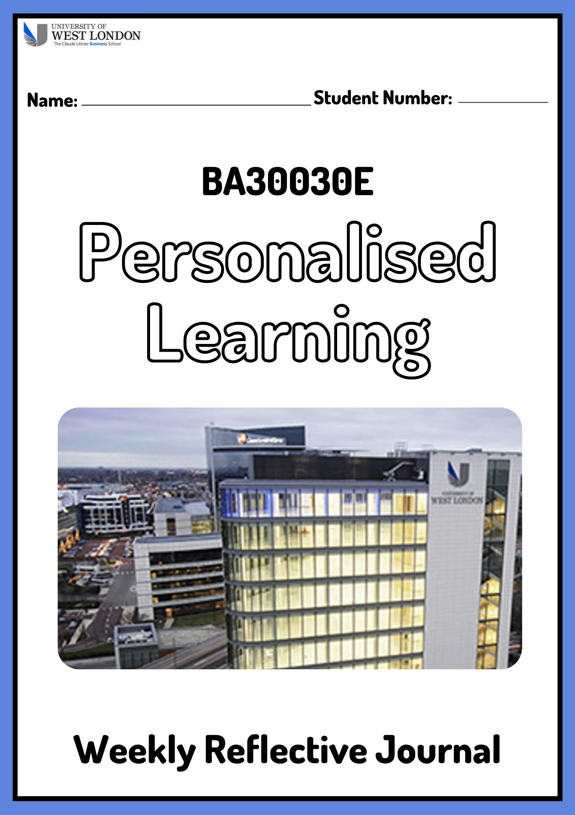

Module Leader: Dr Francisca Chiamaka Umeh

**Introduction:**

This template should be used to record your reflections on the weekly sessions. Please use the spaces provided to reflect on what was discussed in class, what you gained from the session; did you find the content useful, how can you relate it to your studies at university as a business student. You will also need to discuss how you intend to further develop the skills discussed in class. This is a continuous process and should be completed during the module and not at the end.

In week 8 you will be expected to submit what you have completed so far, via Blackboard, in order to receive feedback. You will then complete weeks 9 and 10 and summatively submit the journal in week 15.

The Weekly Reflective Journal will be used in conjunction with your Personal Learning and Development Plan and Interview to work out the final grade for this module. Submission of all parts of the assessment are required in order to receive a grade.

# Part A: Reflective Journal

## Week 1

Please describe in less than 200 words what was discussed in this session and how you plan to develop these skills.

This week I have learned that through personalized learning I can improve my strength and skills as it is a customized learning plan for the students, it is basically based on what I know and what I can learn in the best possible way. Through this personal learning, I can gain academic success in enhancing knowledge both theoretically and conceptually in the subjects. It will help me to get timely responses to the queries from the teachers and will able to learn how I will apply the subject in the business environment which will help me to learn professionalism and good communication skills and will also assist me in preparing assessments.

## Week 2

Please describe in less than 200 words what was discussed in this session and how you plan to develop these skills.

This week I have learned about the capital necessary for a business which is basically the resources that the business owner invests in their business, assets which are the original and actual resources of a business that the business owns, and liabilities of the business that it owes from a third party. This learning helped me to have a clear idea of financial accounting which provides a clear view of the financial position of an organization which will help the stakeholders and the customers to have an interest in that business. I will develop my learning skills in the financial equation so that I can perform better in accounting tasks if assigned to me in an organisation.

## Week 3

Please describe in less than 200 words what was discussed in this session and how you plan to develop these skills.

This week I have learned about the source documents where the information about the sale and purchase invoices, receipts, and paying in the slip are provided and every organization that is involved in trading uses this source document. I have also learned about the flow of the entry of the records in a business, first, the transactions are recorded in the books of original entry which includes the transactions in the cash book, journal, and many other books associated with it then it was recorded in the double entry accounts of ledger books followed by trial balance, income statement and the final statement of financial position of an organization. It also helps me to gain knowledge about sale stock and various kinds of ledger.

## Week 4

Please describe in less than 200 words what was discussed in this session and how you plan to develop these skills.

This week I have learned how the balance accounts help to have an idea of every accounting period and to summarise the financial situation of the business. It gives me the idea about the trial balance which provides the account list according to the debit and credit balances. It can be drawn at the end of the month and the organisation generally prepared the trial balance at the end of every accounting period before the statement of the profit and loss to ascertain the financial position of the organisation. I will develop knowledge about the trial balance which will help me to contribute to financial organisation.

## Week 5

Please describe in less than 200 words what was discussed in this session and how you plan to develop these skills.

This week I have learned about the journal entry in accounting which is the record of the transaction in the business that is kept in the account books of the organisation. The first step of the accounting cycle is the journal entry which keeps all the details of the financial transaction and notifies the accounts that are being affected in a business. It also helps me to learn about the procedure of the journal entry which basically impacts both the debit and the credit account. Through this, I have developed skills in journal entry which will help me to differentiate between credit and debit accounts and to understand the financial transaction of an organisation properly.

## Week 6

Please describe in less than 200 words what was discussed in this session and how you plan to develop these skills.

This week I have learned about the income statement which is basically a financial statement of the previous financial year and gives a review of the revenue, sales, income, and expenditure of the business. The income statement helps to evaluate the profit earned by the business during that period and to compare it with the other business related to the industry to know the position of the business in the market. It help me to get a clear idea about the cost of the goods sold, the goods sold and returned by the customers, the net profit earned by the business, and the gross profit.

## Week 7

Please describe in less than 200 words what was discussed in this session and how you plan to develop these skills. Use a minimum of one academic source and reference this.

This week I have learned about plagiarism which includes copying the ideas of someone else without crediting them, giving information that is incorrect about the source, and copying major parts from the source works that include the majority of the assignment. It is considered a serious academic offense (Santini, 2018). I have also learned that to avoid plagiarism in a work it is important to give credit to the author through proper referencing. Referencing generally provides insight into the literature work of the author from which the idea has been extracted on the particular subject. In my academic project, I will put references of the source in every work from which I have extracted the idea to avoid plagiarism.

References: Santini, A. 2018. The importance of referencing, Journal of critical care medicine (Universitatea de Medicina si Farmacie din Targu-Mures). U.S. National Library of Medicine. Available at: https://www.ncbi.nlm.nih.gov/pmc/articles/PMC5953266/#:~:text=Referencing%20and%20references%2C%20signify%20the,it%20is%20accepted%20for%20publication. (Accessed: April 27, 2023).

## Week 8

Please describe in less than 200 words what was discussed in this session and how you plan to develop these skills. Use a minimum of one academic source and reference this.

***This journal should be formatively submitted for feedback, via Blackboard, at the end of this week.***

This week I have learned about presentation skills which are the ability to provide information and education to engage the audience through the proper presentation. Effective presentation skills include speaking in public without fear, creative content in the presentation, and gestures (NZ Day, *et al.,* 2022). I have learned to make a presentation successful it is important to practice it repeatedly and to have an immense knowledge about the matter which will be presented. For giving a proper presentation I have to develop my confidence And need to speak passionately about the subject so that the audience gets engaged, I need to work on my weakness which is the fear of speaking in public.

References: NZ Day, I., Saab, N. and Admiraal, W., 2022. Online peer feedback on video presentations: type of feedback and improvement of presentation skills. Assessment & Evaluation in Higher Education, 47(2), pp.183-197.

## Week 9

Please describe in less than 200 words what was discussed in this session and how you plan to develop these skills. Use a minimum of one academic source and reference this.

This week I have learned that organisation culture is the shared values and beliefs that the leaders generally follow and then communicated to the employees through various ways. It helps to shape the perception of the employee and their behaviours in the organisation. Every organisation has its unique way of working that contributes to its culture, ideology, and values and the principles of that organisation generally form the culture of that organisation. I have also learned that it generally controls the behaviour of the employees among them and with the people associated with the organisation (Carvalho *et al*., 2019). It is the culture that decides the way the employees interact with their superiors in the organisation, a culture that motivates the employee are generally observed to have dedication towards the work which increase the productivity of the organisation and also help in gaining profitability.

References: Carvalho, A.M., Sampaio, P., Rebentisch, E., Carvalho, J.Á. and Saraiva, P., 2019. Operational excellence, organisational culture and agility: the missing link?. Total Quality Management & Business Excellence, 30(13-14), pp.1495-1514.

## Week 10

Please describe in less than 200 words what was discussed in this session and how you plan to develop these skills. Use a minimum of one academic source and reference this.

This week I have learned about employability which basically depends upon the knowledge and skills of an individual and how they use it to present themselves to their employers. It is generally the capability to move within the labour market which helps in the growth of sustainable employment (Smaldone *et al.*, 2022). The competencies that are required in the 21st century related to employability are the ability of critical thinking effective communication skills and resilience, which will help the individual to flourish in the workplace. I have learned that employability will help me to remain competitive in my career and helps me to achieve my goal; it will also help me to enhance my knowledge and to utilize my academic studies.

References: Smaldone, F., Ippolito, A., Lagger, J. and Pellicano, M., 2022. Employability skills: Profiling data scientists in the digital labour market. European Management Journal, 40(5), pp.671-684.

# Part B: Personal Development Plan

**Part B: Personal Development Plan**

|  |  |
| --- | --- |
| **Name:** |  |
| **Degree pathway:** |  |

## Section 1 – Personal Analysis

|  |  |
| --- | --- |
| **Strengths** | **Areas for further development** |
| The following things  I can do well are:   * Teamwork * Creativity * Integrity * Fast learning * Work ethics and beliefs | I would like to improve in these areas:   * Analytical skills * Communication skills * Fear of public speaking * Time management |
| **Opportunities** | **Threats** |
| The following things will provide me with an opportunity to grow:   * The work project that requires effective communication is an opportunity for me to develop that skill. * Online classes develop analytical skills and are an opportunity to develop my skill. | The following things are considered threats to me that will be an impediment to my career growth:   * Workload due to shortage of employees * Prevailing economic conditions that hit the marketing industry. |

**Section 2 - Setting goals**

|  |  |  |  |
| --- | --- | --- | --- |
| **What do I want to learn?** | **What do I have to do?** | **How will I measure success?** | **Target date for review?** |
| I want to learn proper analytical skills | I have to join classes to enhance my skill so that I can perform better | I will measure my skill through various analytical skill-based tests, and the result will help me to evaluate my performance. | The target date for improving my skill and getting a review, I will be set for 3 months. |
| I want to learn effective communication skills so that I can connect with the fellow employee. | I have to engage myself in various tasks of the organization that required effective communication. | I will measure the success of my communication skill by evaluating my performance which will help to increase productivity. | The target date of review will be 2 months and after that, I will see improvement in my performance. |
| I want to learn effective time management so that I can finish the work within the stipulated time. | I have to divide my work into priority segments and will try to complete it segment wise which will give an effective result. | I will measure my success by evaluating my ability to complete the work within the stipulated time. | The target date for reviewing my time management skill will be set for 2 months. |
| I want to learn how to overcome the fear of public speaking which is an important skill required for effective presentation. | I have to participate in organizational   work that requires presentation in front of the board of directors and stakeholders which will help me to overcome the fear of speaking in public. | I will measure my success when I will observe improvement in my presentation skill and will be able to speak confidently in front of the public. | The target date for reviewing my performance will be set by me for 2 months. |

## Section 3 – Personal Objectives

|  |
| --- |
| **Short-term goals (next 12 months)** |
| Short-term goal is something that an individual wants to achieve in the near future. My short-term goal is to attend online classes or offline courses that offered analytical skill development and data interpretation as I need to improve my skills for effective career development. I need to achieve my short-term goal within a period of 3 months so I can get a better employment opportunity. Another goal that I want to achieve within six months is to develop my presentation skill through effective communication and to overcome the fear of public presentation. |
| **Medium term goals (next 2-3 years)** |
| Medium-term goals are generally set between the period of short-term goals and long-term goals. My medium-term goal is to pursue another degree in the next two years that will help me in my career development and also accelerate the opportunity for achieving my long-term goals. I have also a goal to repay the educational loan that I have borrowed from a bank and to set myself free from liabilities. |
| **Longer term goals (beyond 3 years)** |
| Long-term goals are generally set to achieve in the future and it requires proper planning. After successfully achieving the short-term and medium-term goals I have developed the skill that I was lagging behind and from the experience and knowledge that I have gained through previous goals I would like to start my own business in the long run after 5 years I would like to see myself as a successful entrepreneur and I would also take care of the fact that my business should work towards maintaining sustainability. |

***This PLDP should be formatively submitted for feedback, via Blackboard, at the end of this week.***

# Part C: Interview (30%)

**Students must bring their completed reflective journal and personal learning and development plan to this interview for discussion. The reflective journal and personal learning and development plan must be submitted, via Blackboard, at the end of week 15.**