**ASSIGNMENT 1- INDIVIDUAL BUSINESS DISSERTATION PROPOSAL**

**A STUDY INTO HOW COMPANIES INFLUENCE TECHNOLOGY AND INNOVATION WITHIN SUPPLIERS: CASE OF APPLE AND SAMSUNG**

### 

**Table of Contents**

Introduction 3

Background of the research 3

The Rationale of the Research 4

Research Aims and Objectives 5

Aims 5

Objectives 5

Research Question 6

Significance of the study 6

Brief literature review 6

Research Methodology 9

Research Philosophy 9

Research approach 10

Research Design 11

Data Collection Method 11

Data Analysis 12

Ethical Consideration 12

Potential outcomes 12

References 12

# Introduction

## Background of the research

The success of Samsung and Apple has been acknowledged in the last decade. By applying innovations and technology, both companies grow their business. In order to maintain control over the production process. Apple has focused on its supply chain strategy and also ensured the quality of its product. This strategy helps Apple to reduce their product cost and increase efficiency. The below figure shows Apple's supply chain strategy.

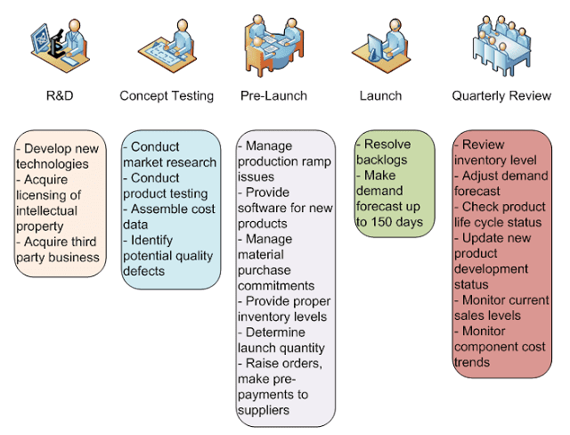

**Figure 1: Supply Chain Strategy of Apple**

(Source: Loiseau *et al.* 2020)

The below figure shows Samsung's supply chain management that has ensured its product cost, quality, technology, delivery, and human resources, to increase speed, synergy and efficiency with its suppliers and enable sustainable growth.

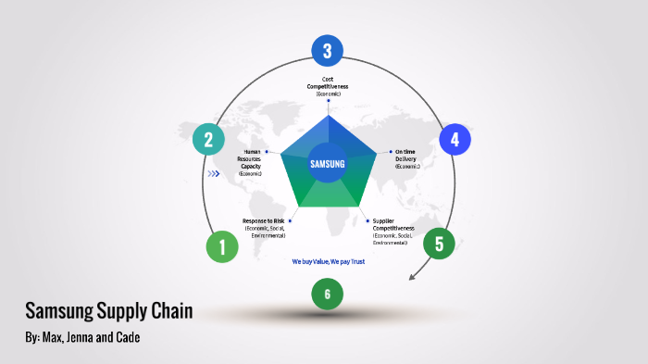

**Figure 2: Supply chain strategy of Samsung**

(Source: Haizar *et al.* 2020)

## The Rationale of the Research

Apple and Samsung both gained the highest spot respectively in the smartphone market (Kim *et al.* 2020). Continued supply push on 5G, pent-up demand, the popularity of low to mid-priced phones and aggressive promotions, all those factors create a competitive market with other electronic companies such as MI, Oppo, Huawei and many more. The below figure shows the worldwide shipments of Apple, Samsung, MI, Oppo, and Huawei in Q4 2020.

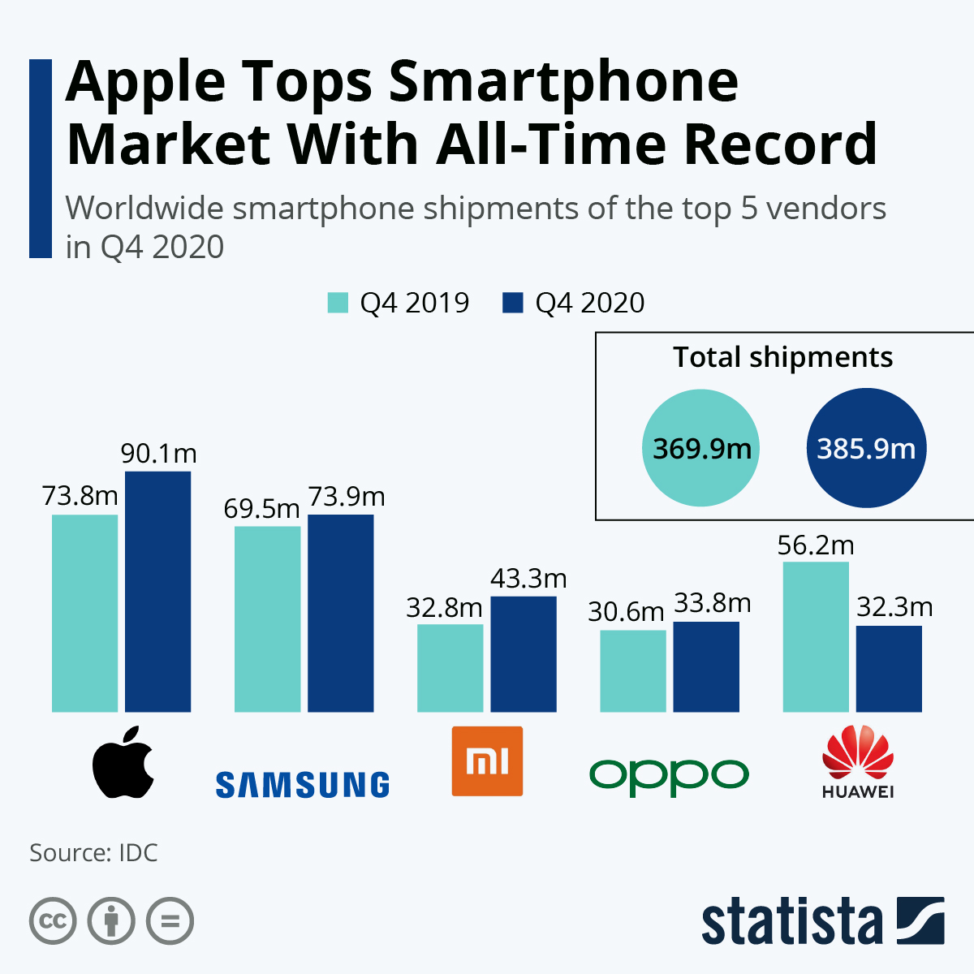

**Figure 3: the worldwide shipments of Apple, Samsung, MI, Oppo, and Huawei in Q4 2020**

(Source: Statista, 2021)

In order to maintain a competitive edge, Apple and Samsung should maintain their product quality and other variables.

## Research Aims and Objectives

### Aims

This research will aim to influence innovation and technology within suppliers of Apple and Samsung.

### Objectives

* To analyse the key importance of influencing suppliers of Apple and Samsung to foster technological innovation
* To identify the primary challenges faced by Apple and Samsung while sustaining their supplier relationships
* To provide potential recommendations to Apple and Samsung for improving their supplier relationship through adapting technological innovation

## Research Question

In order to get an effective outcome for this research, some research questions are formulated.

1. What are the key importance influencing suppliers of Apple and Samsung to foster technological innovation?
2. What are the primary challenges faced by Apple and Samsung while sustaining their supplier relationships?
3. What are the recommendations to Apple and Samsung for improving their supplier relationship through adapting technological innovation?

## Significance of the study

In order to grow the business, Samsung and Apple ought to focus on new technologies and innovation. Therefore, the current research is quite significant to influence innovation and technology within suppliers of Apple and Samsung.

# Brief literature review

According to Graef (2019), the suppliers are the backbone of the electronic products business. Because of new technology and innovation, the supply chain of electronic products is growing rapidly and improving business efficiency as well. The below figure shows the flow of Supply chain Management.

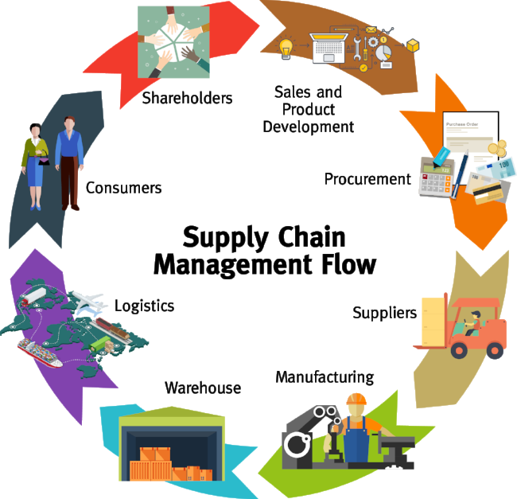

**Figure 4: Supply Chain Management Flow**

(Source:Hazen *et al.* 2021)

There are multiple ways in which technologies and innovations can be used to improve the efficiency of processes within the entire supply chain. With the help of new technology, electronic products become cost-effective and products are delivered to customers more effectively and efficiently.

Using technology and innovation for suppliers of electronic products makes significant value to the business. This also helps to optimize the cost of electronic products and increase revenue. Supply chain technology helps to enhance the agility of the electronics business and also evaluates data on customer demand, supplier lead times, and transportation restrictions (Modgil *et al.* 2021). Technology and innovation also help to improve collaboration to maintain a flow of information, choices and analysis and meet the level of satisfaction of electronic products users.

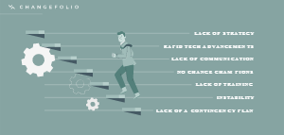

**Figure 5: Challenges to adopting new technology and innovation**

(Source: Gaur *et al.* 2020)

The above figure shows some challenges to implementing new technology and innovation. Implementing new technology and innovation makes it difficult for the suppliers of electronic products. New technology and innovation seem inherently risky. Therefore suppliers face issues while implementing those technologies. It is also time-consuming for the suppliers to adapt the technology and innovation.

In order to mitigate the risk factor of new technology and innovation, firstly the risk should be identified and evaluate the effectiveness of the risk process. Risk mitigation handling can be done by accepting, avoiding, controlling, transferring, and monitoring (Boeckl *et al.* 2019). In order to reduce the time evolving new technology, skilled suppliers are required so that it takes less time to adapt the technology and innovation to expand the market of electronic goods.

This research study will observe the theory of Diffusion of Innovation that describes the speed and pattern at which innovation and technology spread which helps to build sustainable suppliers of Apple and Samsung. The below figure shows the lifecycle of the Diffusion of Innovation.

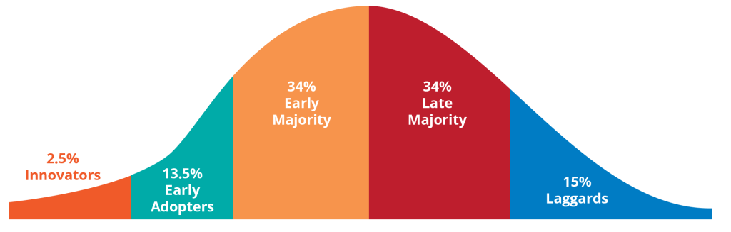

**Figure 6: Innovation Adoption Lifecycle**

(Source: Mogull, 2021)

Stakeholder Management Theory will be observed in this research study. This theory establishes a fact that interconnects the relationship between organization management and its employees, customers, suppliers, investors, stakeholders, and communities. In this research, Apple and Samsung both develop a relationship with suppliers concerning innovation and technologies.

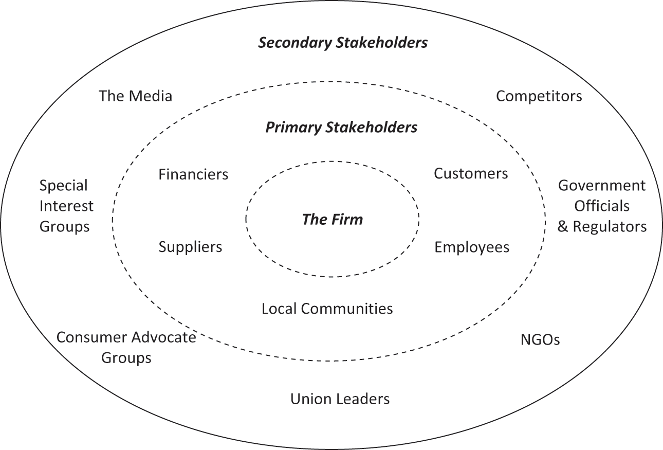

**Figure 7: Elements of Stakeholder Management Theory**

(Source: Freeman *et al.* 2021)

The researchers have established strategies to cope with the competitive market of electronic products. However, no other findings have been observed on the strategies to manage the electronic product business in future for the competitive market. Hence, the literature gap has been observed.

# Research Methodology

## Research Philosophy

In order to justify this research, interpretivism philosophy has been used. The below figure shows the types of Research Philosophy.

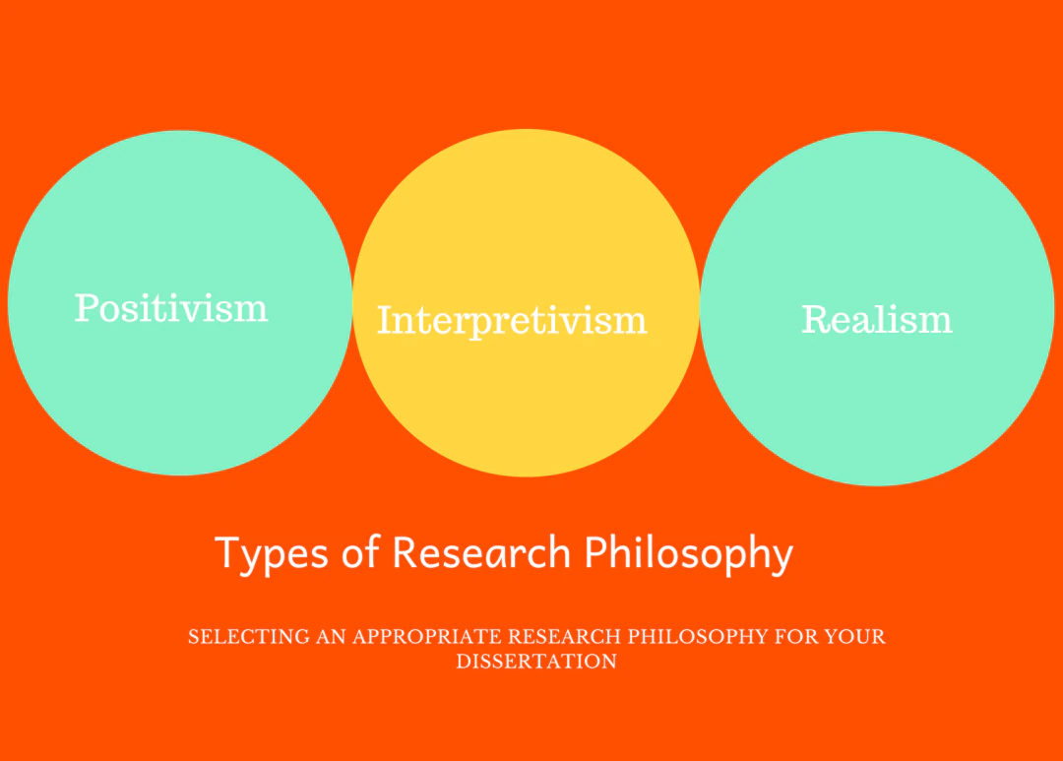

**Figure 8: Types of Research Philosophy**

(Source: Moon *et al.* 2019)

As per Van der Walt(2020), interpretivism is stated as access to reality through social constructions. Interpretivism is based on the analysis of qualitative and quantitative data together. In regards, usage of such philosophy can help the researcher to interpret the performance of the suppliers based on social construction and involvement of Apple and Samsung.

## Research approach

In this research study, the inductive approach is more suitable because this approach is beneficial to conclude the research study by analysing the progress from general ideas (Pearse, 2019). The below figure explains two different types of research approaches.

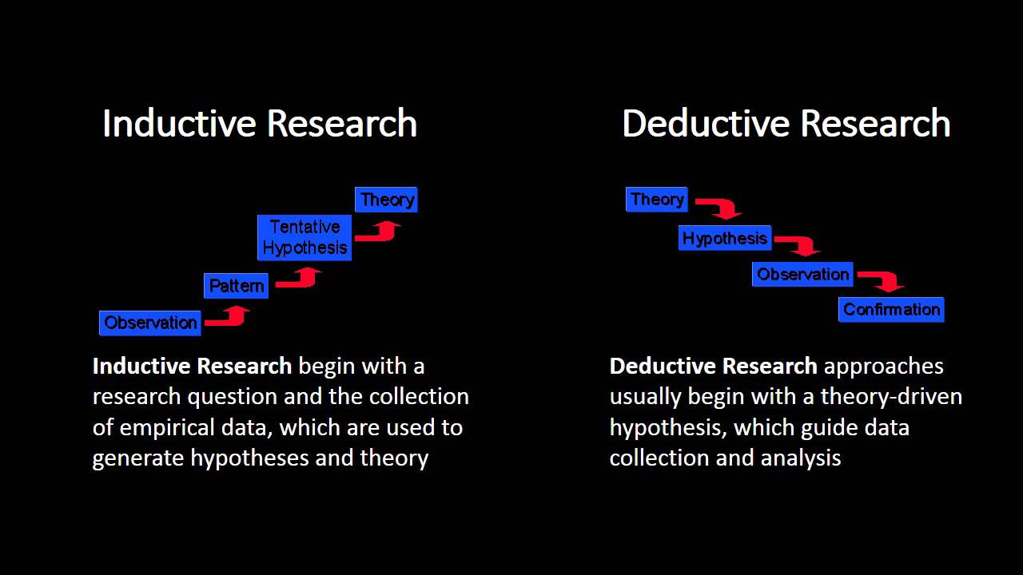

**Figure 9: Explanation of different approaches**

(Source: Mittelstadt *et al.* 2019)

Hence, using a inductive approach can help the researcher to specify the findings that make it easy to understand the influences of innovation and technology within the suppliers of Apple and Samsung.

## Research Design

Here, the descriptive research design will be used by the researcher as it helps to obtain relative information by describing the phenomenon (Doyle *et al*. 2020). With the help of this research design, the researcher will obtain supply chain information of Apple and Samsung that influences innovation and technology as well.

## Data Collection Method

The researcher would collect secondary quantitative data from online journals and news that is available on authentic websites such as Google Scholar, and the organization website of Apple and Samsung. Reports of Samsung and Apple initially will choose 50 sources out of which 15-20 data sources will be sampled using purposive sampling where inclusion and exclusion criteria will be applied. Hence, data sources which are relevant and valid in terms of supplier management of the concerned businesses will be selected (Ruggiano and Perry, 2019).

## Data Analysis

In this study, the researcher will analyse the data with the help of thematic data analysis. Thematic data analysis involves qualitative data analysis of new technology and innovation that involves a data set of supplier management data sources of Samsung and Apple.

## Ethical Consideration

In this context, the researcher will consider the ethical aspect of managing the collected data. Hence, the researcher will choose data from authentic sources and citations will be used to appraise the contribution of multiple scholars. Plagiarized data and outdated information will not be considered in this research study.

# Potential outcomes

It is expected that the research can provide findings that help to foster sustainability by using technology and innovation within the suppliers of Apple and Samsung. However, the competitive market is the major challenge faced by Apple and Samsung while sustaining their relationships with suppliers. Some potential recommendations will also be provided to Apple and Samsung for improving their supplier sustainability through adopting technological innovation

# References

Boeckl, K., Boeckl, K., Fagan, M., Fisher, W., Lefkovitz, N., Megas, K.N., Nadeau, E., O'Rourke, D.G., Piccarreta, B. and Scarfone, K., 2019. Considerations for managing Internet of Things (IoT) cybersecurity and privacy risks. Gaithersburg: US Department of Commerce, *National Institute of Standards and Technology.*

Doyle, L., McCabe, C., Keogh, B., Brady, A. and McCann, M., 2020. An overview of the qualitative descriptive design within nursing research. *Journal of Research in Nursing,* 25(5), pp.443-455.

Freeman, R.E., Dmytriyev, S.D. and Phillips, R.A., 2021. Stakeholder theory and the resource-based view of the firm. *Journal of Management*, 47(7), pp.1757-1770.

Gaur, U., Majumder, M.A.A., Sa, B., Sarkar, S., Williams, A. and Singh, K., 2020. Challenges and opportunities of preclinical medical education: COVID-19 crisis and beyond. *SN comprehensive clinical medicine*, 2(11), pp.1992-1997.

Graef, I., 2019. Rethinking the essential facilities doctrine for the EU digital economy. *RJT ns,* 53, p.33.

Haizar, N.F.B.M., Kee, D.M.H., Chong, L.M. and Chong, J.H., 2020. The impact of innovation strategy on organizational success: A study of Samsung. *Asia Pacific Journal of Management and Education (APJME)*, 3(2), pp.93-104.

Hazen, B.T., Russo, I., Confente, I. and Pellathy, D., 2021. Supply chain management for circular economy: conceptual framework and research agenda. *The International Journal of Logistics Management*, 32(2), pp.510-537.

Kim, J., Lee, H. and Lee, J., 2020. Smartphone preferences and brand loyalty: A discrete choice model reflecting the reference point and peer effect. *Journal of Retailing and Consumer Services,* 52, p.101907.

Loiseau, E., Colin, M., Alaphilippe, A., Coste, G. and Roux, P., 2020. To what extent are short food supply chains (SFSCs) environmentally friendly? Application to French apple distribution using Life Cycle Assessment. *Journal of Cleaner Production,* 276, p.124166.

Mittelstadt, B., Russell, C. and Wachter, S., 2019, January. Explaining explanations in AI. *In Proceedings of the conference on fairness, accountability, and transparency* (pp. 279-288).

Modgil, S., Gupta, S., Stekelorum, R. and Laguir, I., 2021. AI technologies and their impact on supply chain resilience during COVID-19. *International Journal of Physical Distribution & Logistics Management,* 52(2), pp.130-149.

Mogull, S.A., 2021. Technical content marketing along the technology adoption lifecycle: experience report. *Communication Design Quarterly Review, 9(2),* pp.27-35.

Moon, K., Blackman, D.A., Adams, V.M., Colvin, R.M., Davila, F., Evans, M.C., Januchowski‐Hartley, S.R., Bennett, N.J., Dickinson, H., Sandbrook, C. and Sherren, K., 2019. Expanding the role of social science in conservation through an engagement with philosophy, methodology, and methods. *Methods in Ecology and Evolution,* 10(3), pp.294-302.

Pearse, N., 2019, June. An illustration of deductive analysis in qualitative research. *In 18th European conference on research methodology for business and management studies* (p. 264).

Ruggiano, N. and Perry, T.E., 2019. Conducting secondary analysis of qualitative data: Should we, can we, and how?. *Qualitative Social Work,* 18(1), pp.81-97.

Statista, 2021. Apple Tops Smartphone Market With All-Time Record. Available at: <https://www.statista.com/chart/20803/top-5-smartphone-vendors-worldwide-based-on-shipments/> [Accessed on: 9 April 2023]

Statista, 2023. Industry revenue of “manufacture of electronic components“ in the United Kingdom from 2012 to 2025. Available at: <https://www.statista.com/forecasts/397320/manufacture-of-electronic-components-revenue-in-the-united-kingdom> [Accessed on: 9 April 2023]

Van der Walt, J.L., 2020. Interpretivism-constructivism as a research method in the humanities and social sciences-more to it than meets the eye. *International Journal of Philosophy and Theology*, 8(1), pp.59-68.