**WHAT SHOULD ENTREPRENEURS KNOW WHEN CREATING BUSINESS PLANS IN THE 21ST CENTURY?**

## 4.2 Findings

| **Question 1: What is your age?** | | |
| --- | --- | --- |
| **Responses** | **Respondents** | **Percentage** |
| **18-24** | **10** | **5** |
| **25-34** | **50** | **25** |
| **35-44** | **50** | **25** |
| **45-54** | **40** | **20** |
| **55 and above** | **50** | **25** |
| **Total** | **200** | **100** |

**Table 4.1 Responses to survey question 1**

(Source: Created by Author)

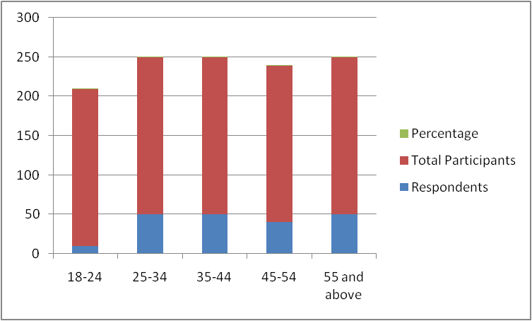

**Figure 4.1: Responses to the first survey question**

(Source: Created by the Author)

**Comments**

It has been observed that the minimum percentage of the chosen participants belong to the youngest age group of 18 to 24. On the other hand, 25% of the selected candidates belong to the oldest age group of 55 and above.

| **Question 2: What is your gender?** | | |
| --- | --- | --- |
| **Responses** | **Respondents** | **Percentage** |
| **Male** | **160** | **80** |
| **Female** | **35** | **17.5** |
| **Others** | **5** | **2.5** |
| **Total** | **200** | **100** |

**Table 4.2: Responses based on gender orientation**

(Source: Created by the Author)

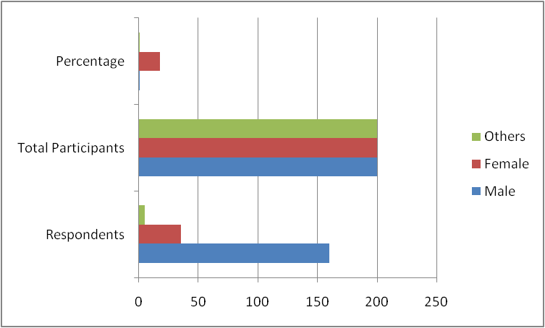

**Figure 4.2: Responses to the second survey question**

(Source: Created by the Author)

**Comments**

It has been derived from the above-framed table that the maximum percentage of the selected candidates is male. On the other hand, the minimum percentage of the chosen participants belongs to the third gender.

| **Question 3: What is your highest level of education?** | | |
| --- | --- | --- |
| **Responses** | **Respondents** | **Percentage** |
| **High School** | **10** | **5** |
| **Associate’s Degree** | **100** | **50** |
| **Bachelor’s Degree** | **30** | **15** |
| **Master’s Degree** | **40** | **20** |
| **Doctorate Degree** | **20** | **10** |
| **Total** | **200** | **100** |

**Table 4.3: Responses for educational qualifications**

(Source: Created by Author)

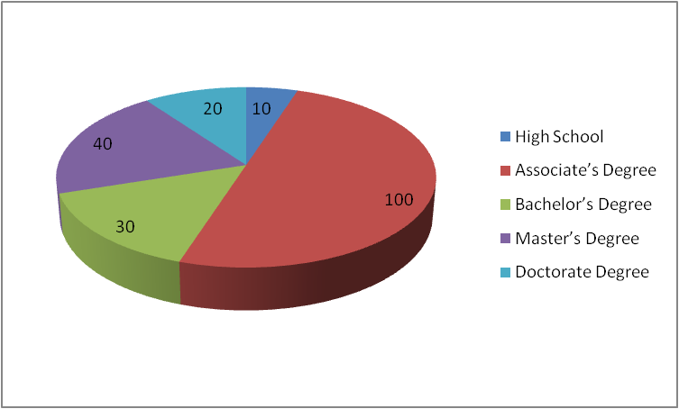

**Figure 4.3: Overview of the responses to the third survey question**

(Source: Created by Author)

**Comments**

It has been found by analysing the above-mentioned table that the maximum percentage of the chosen participants hold the “Associate’s Degree”. On the other hand, the minimum percentage of the selected candidates seems to belong to high school.

| **Question 4: What is the issue which is being addressed in your business?** | | |
| --- | --- | --- |
| **Responses** | **Respondents** | **Percentage** |
| **Financial Issues** | **120** | **60** |
| **Management Issues** | **65** | **32.5** |
| **Marketing Issues** | **15** | **7.5** |
| **Total** | **200** | **100** |

**Table 4.4: Responses for the fourth survey question**

(Source: Created by Author)

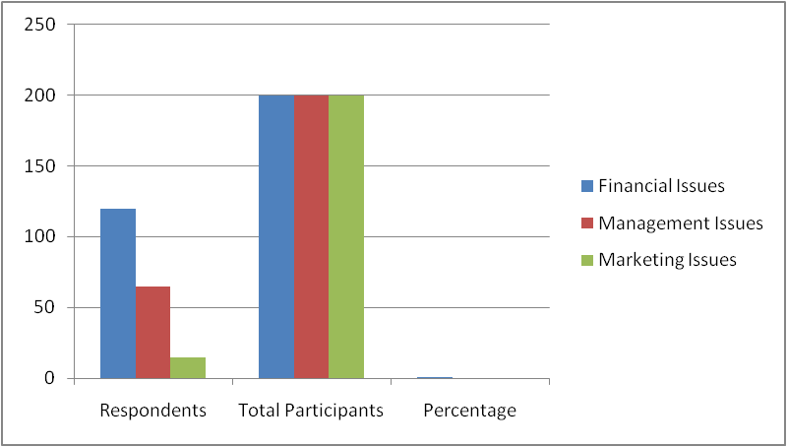

**Figure 4.4: Responses to the fourth survey question**

(Source: Created by the Author)

**Comments**

It has been observed from the above-stated table that the maximum percentage of the chosen candidates responded that financial issues have been addressed in this business. In contrast, the minimum percentage of the chosen participants has opined that this business is addressing marketing issues.

| **Q5 Do you think that you can achieve the long-term mission and vision of your business?** | | |
| --- | --- | --- |
| **Response** | **Number of Participants** | **Percentage** |
| Strongly Agree | 40 | 20 |
| Agree | 90 | 45 |
| Neutral | 20 | 10 |
| Disagree | 40 | 20 |
| Strongly Disagree | 10 | 5 |
| Total | 200 | 100 |

**Table 4.5: Achievement of long-term mission and vision of business**

(Source: Created by the Author)

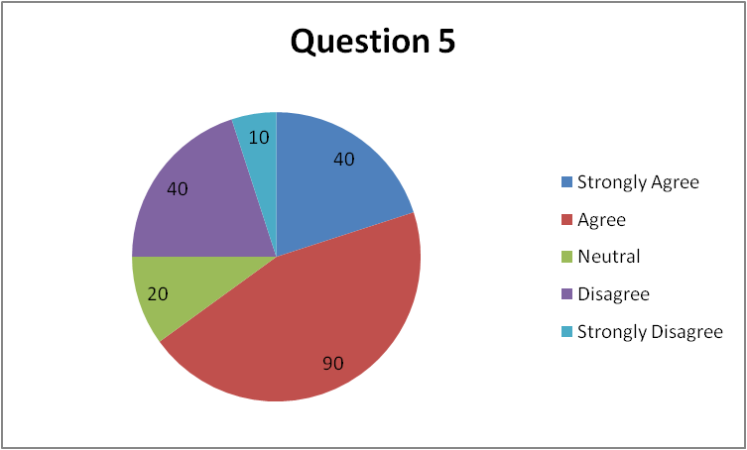

**Figure 4.5: Achievement of long-term mission and vision of business**

(Source: Created by the Author)

As per the findings of Question 5, 45% of participants have agreed that they believe that their business can achieve its long-term mission and mission. On the other hand, 20% of respondents strongly agreed with the statement. Furthermore, 10% and 20% of participants responded as being neutral and in disagreement with the statement respectively. Lastly, 5% of respondents strongly disagreed with the statement.

| **Q6 Do you think you can measure the success of your business?** | | |
| --- | --- | --- |
| **Response** | **Number of Participants** | **Percentage** |
| Strongly Agree | 10 | 5 |
| Agree | 60 | 30 |
| Neutral | 80 | 40 |
| Disagree | 40 | 20 |
| Strongly Disagree | 10 | 5 |
| Total | 200 | 100 |

**Table 4.6: Ways to measure the success of a business**

(Source: Created by the Author)

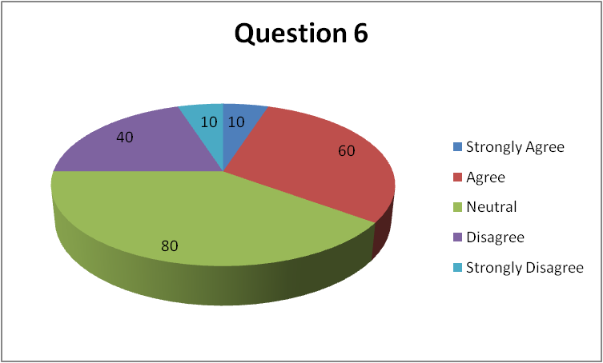

**Figure 4.6: Ways to measure the success of a business**

(Source: Created by the Author)

In response to Question 6, only 5% of participants strongly agreed that they can measure the success of their business while 30% agreed with the statement. Further, the highest proportion of participants numbering 40% have been neutral in the statement. However, 20% and 5% of respondents disagreed and strongly disagreed with the statement respectively.

| **Q7 What are the factors which you think you should know before framing a business plan in the modern era?** | | |
| --- | --- | --- |
| **Response** | **Number of Participants** | **Percentage** |
| Consumer Demands | 120 | 60 |
| Employee Demands | 20 | 10 |
| Supply chain issues | 60 | 30 |
| Total | 200 | 100 |

**Table 4.7: Important factors to frame a business plan in the modern era**

(Source: Created by the Author)

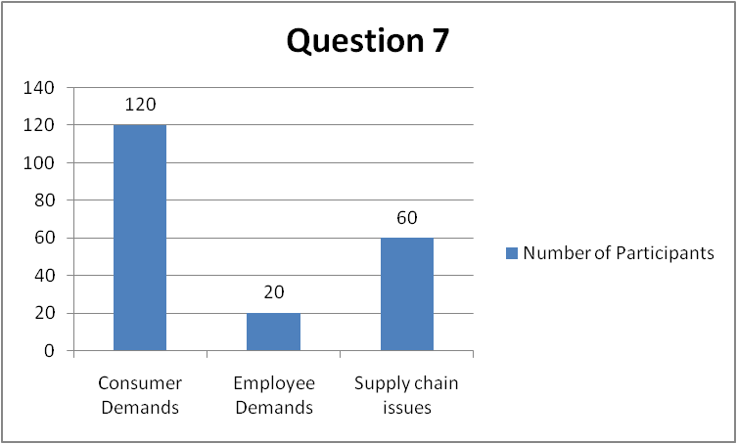

**Figure 4.7: Important factors to frame a business plan in the modern era**

(Source: Created by the Author)

Following the response to Question 7, it has been determined that 60% of the respondents believed that consumer demands form an important factor to understand before framing a business plan. Furthermore, 10% of respondents have indicated that employee demands are an important factor for framing a business plan in the modern era while 30% have responded that supply chain issues need to be considered in the process.

| **Q8 Do you agree that you will face barriers while framing a business plan in the 21st century?** | | |
| --- | --- | --- |
| **Response** | **Number of Participants** | **Percentage** |
| Strongly Agree | 90 | 45 |
| Agree | 70 | 35 |
| Neutral | 30 | 15 |
| Disagree | 10 | 5 |
| Strongly Disagree | 0 | 0 |
| Total | 200 | 100 |

**Table 4.8: Likelihood of facing barriers in framing a business plan in the 21st century**

(Source: Created by the Author)

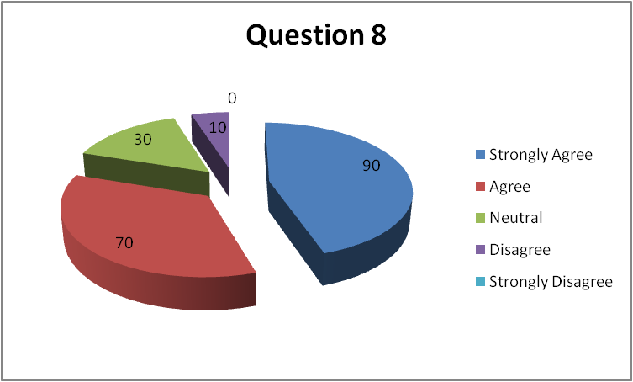

**Figure 4.8: Likelihood of facing barriers in framing a business plan in the 21st century**

(Source: Created by the Author)

In response to Question 8, 45% of participants responded that they strongly agree that they will face barriers while framing a business plan in the 21st century. Furthermore, 35% of respondents agreed with the statement while 15% responded naturally. Lastly, 5% of participants disagreed with the statement and 0% strongly disagreed with the question.

## 4.3 Analysis

The first survey table highlights that 5% of the selected participants belong to the age group of 18 to 24. Furthermore, 25% of the chosen candidates stated that they belong to the age groups of 25 to 34 and 35 to 44 respectively. However, 20% of the participants are aged from 45 to 54 and 25% of the selected respondents are from the age range of 55 and above. Thus, more candidates need to be selected from the age group of 55 and above for obtaining better responses.

80% of the engaged survey participants are male entrepreneurs. On the other hand, 17.5% of the selected candidates are female. In addition, it has been found that 2.50% of the chosen participants seem to belong to the third gender category. Thus, male participants are likely to dominate this survey.

Furthermore, 5% of the respondents hold a “High school degree” while 50% of the selected candidates possess an “Associate Degree”. It has been derived that 15% of the chosen participants have a “Bachelor’s Degree”. In addition, 20% of the engaged respondents inherit a “Master’s Degree” Finally, 10% of the participants hold a “Doctorate Degree”. Hence, the chosen candidates are likely to have a strong educational background.

It has been observed that 60% of the involved respondents opined that this business is addressing the financial issue effectively. However, 32.50% of the chosen candidates stated that this business is likely to address management issues. 7.50% of the selected participants stated that this business is focusing on eliminating marketing issues. Hence, financial issues can be mitigated successfully through this business.

It can be analysed that a majority of the participants believe that their business can achieve its long-term mission and vision. Therefore, contemporary entrepreneurs are optimistic regarding their businesses and perceive their endeavours in a positive light. Furthermore, only a small proportion of the participants responded negatively, which indicates that the ratio of business entrepreneurs having low faith in their business is less compared to optimistic leaders. The analysis also reveals that a majority of the respondents have been neutral in measuring the level of success of their business, indicating that there is confusion among entrepreneurs regarding the measurement of the success of their business. However, the second largest section of the participants agreed that they can succeed in measuring the level of success of their business endeavour. Therefore, it can be interpreted that despite some confusion regarding the issue of measuring business success, entrepreneurs can succeed in the process by researching metrics of business success like profit generation. Further, there is substantial evidence that consumer demands present the most important factor that entrepreneurs need to consider while drafting their business plans in the present times. In this context, supply chain issues have some significance but the dominance of response indicates that consumer demands are the most important consideration. The analysis also reveals that most entrepreneurs understand and acknowledge that the process of framing a business plan in modern times has barriers like a lack of market research. Therefore, it can be analysed that contemporary entrepreneurs are likely to conduct thorough research before developing a business plan to ensure that they can overcome contemporary barriers in the process through informed decision-making.

**Discussion**

It has been observed that the minimum number of the selected candidates belongs to the age group of 18 to 24. On the other hand, it has also been found that a maximum of the involved participants agreed that the long-term mission and vision of the business can be achieved successfully. However, a maximum of the participants remained neutral about the fact that the success of the business can be measured accurately.

It has been found that most of the chosen candidates agreed on the fact that the utilisation of digital channels will be appropriate in the context of communicating business plans and objectives conveniently to employees in the 21st century. Additionally, the maximum number of participants agreed that customer satisfaction can be observed in the modern era. It has been observed that the maximum percentage of the chosen participants opined that promotional campaigns will be used in terms of enhancing the brand’s visibility.

|  |  |  |
| --- | --- | --- |
| **Question 13: How are you planning to increase your brand visibility?** | | |
| **Responses** | **Respondents** | **Percentage** |
| **Using offline channels** | **50** | **25** |
| **Promotional campaigns** | **60** | **30** |
| **Online advertisements** | **50** | **25** |
| **I don't know** | **40** | **20** |
| **Total** | **200** | **100** |

**Table 4.13: Planning to increase your brand visibility**

(Source: Created by Author)

**Figure 4.13: Planning to increase your brand visibility**

(Source: Created by Author)

**Comments**

Based on the above graph, it can be stated that 25% of respondents agreed that offline channels are beneficial for developing brand visibility. On the other hand, 30% of respondents stated that a promotion campaign is more effective for the business to increase its brand visibility. Moreover, 25% of respondents stated that online advertising is good for developing brand visibility and 20% of respondents stayed neutral in this overall survey.

|  |  |  |
| --- | --- | --- |
| **Question 14: Do you think you can deliver finished goods to the market?** | | |
| **Responses** | **Respondents** | **Percentage** |
| **Agree** | **120** | **60** |
| **Disagree** | **40** | **10** |
| **Neutral** | **60** | **30** |
| **Total** | **200** | **100** |

**Table 4.14: Delivering finished goods to the market**

(Source: Created by Author)

**Figure 4.14: Delivering finished goods to the market**

(Source: Created by Author)

**Comments**

Based on the above graph, 60% of respondents have stated that finished goods are more effective instead of raw materials for delivery in the market. On the other hand, 10% of respondents disagreed with this statement and 30% of respondents stayed neutral in this discussion.

|  |  |  |
| --- | --- | --- |
| **Question 15: What are the resources required in terms of increasing your productivity?** | | |
| **Responses** | **Respondents** | **Percentage** |
| **Financial Resources** | **80** | **55** |
| **Human Resources** | **50** | **30** |
| **Technical resources** | **30** | **5** |
| **I don’t know** | **40** | **10** |
| **Total** | **200** | **100** |

**Table 4.15: Resources required in terms of increasing your productivity**

(Source: Created by Author)

**Figure 4.15: Resources required in terms of increasing your productivity**

(Source: Created by Author)

**Comments**

Based on the above discussion, it can be identified that resources are required for the companies for developing their products in the market. In this context, 55% of participants stated that financial resources are effective for developing productivity. 30% of respondents also stated that human resources are more effective for increasing productivity within the industries. Moreover, 5% of respondents agreed that technological resources have played a vital role in increasing productivity in recent years.

|  |  |  |
| --- | --- | --- |
| **Question 16: What are your strategies for strengthening your financial infrastructure?** | | |
| **Responses** | **Respondents** | **Percentage** |
| **Joint Ventures** | **70** | **35** |
| **Venture Capitalists** | **50** | **25** |
| **Bank loans** | **40** | **20** |
| **I don’t know** | **40** | **20** |
| **Total** | **200** | **100** |

**Table 4.16: Strategies for strengthening your financial infrastructure**

(Source: Created by Author)

**Figure 4.16: Strategies for strengthening your financial infrastructure**

(Source: created by author)

**Comments**

Based on the above graph, it can be stated that 35% of respondents agreed that joint ventures are important for organisations for developing their financial structure. On the other hand, 25% of respondents stated that venture capitalists are more effective in improving the financial structure. Moreover, 20% of respondents stated that a bank loan is more effective for the organisation for managing their financial structure in terms of developing their business plans.

**Analysis**

Organisations focus on developing their business planning in terms of increasing their brand visibility in the global market. In this context, 30% of respondents stated that a promotion campaign is more effective for the business to increase its brand visibility. On the other hand, 25% of respondents stated that online advertising is good for developing brand visibility. Thus, it can be stated that promotional and online advertising is more effective instead of offline channels which help to increase the visibility of organisations in the global market.

On the other hand, organisations have maintained their resources in terms of developing their brand visibility in the global market. 55% of participants stated that financial resources are effective for developing productivity. Thus it is easy to understand that financial resources are beneficial for the company because it helps to develop the HRM and technical resources which helps to increase the brand visibility in the global market.

Moreover, delivering finished products increases the brand's reputation in the global market. Based on the survey process, 60% of respondents have stated that finished goods are more effective instead of raw materials for delivery in the market. Thus, it can be stated that organisations focus on developing their reputation and market position by delivering their finished products on time to their consumers. Thus, it can be stated that organisations increase their visibility in the competitive market by providing finished products to their consumers on managing their time.

On the other hand, organisations also maintain their business strategies in terms of developing their financial structure in the market. In this context,  35% of respondents stated that joint ventures are a significant business strategic plan which helps to increase brand visibility and develop the financial structure in managing the brand values in the market. On the other hand, 20% of respondents agreed that bank loans help new entrepreneurs for managing their financial structure and increase their brand position in the competitive market. In addition, venture capitalists can play a major role in improving the financial structure of the market. It also helps to increase the decision-making ability of the organisations for handling their financial structure in the market.

Based on the findings, digital channels are effective for communicating with employees regarding business plans and objectives with the employees positively. Using digital channels such as social media helps in communicating with each other in business. Thus, companies can use social media platforms such as Facebook and Instagram to communicate with each other in terms of meeting business goals and objectives. According to the findings,  it can be suggested that observing customer satisfaction is an important factor for companies to gain positive business value. Similarly, companies can use social media platforms to gather feedback from customers regarding products or services. Accordingly, feedback collection can help companies to identify customer satisfaction levels in this modern era. Besides, the improvement in the customer satisfaction level can help companies to achieve a strong position in the international market. Hence, it can be highlighted that the observation of the customer satisfaction level is important in order to improve the business progress in this competitive era. According to the findings, it can be said that publicity plays an important role in developing the business in this target market. Publicity helps in improving the brand value of the business at the cosmopolitan level. In this context, companies promote their product effectively to gain the attention of customers. Therefore, The promotional strategy of companies needs to be effective in order to gain publicity in this modern market. Based on question 12, it can be analysed that providing offers and discounts is prominent for companies for retaining existing customers towards the business. However, the manufacturing of quality products can also help in attracting existing customers towards the brand. Therefore, it can be analysed that companies can make quality products with discounts for retaining existing customers.

| **Question 9: Do you agree that digital channels will be appropriate for communicating your business plans and objectives to the employees in the 21st century?** | | |
| --- | --- | --- |
| **Responses** | **Respondents** | **Percentage** |
| **Agree** | **150** | **75** |
| **Disagree** | **30** | **15** |
| **Neutral** | **20** | **10** |
| **Total** | **200** | **100** |

**Table 4.9: Digital channels are appropriate for communicating business plans**

**(Source: Created by author)**

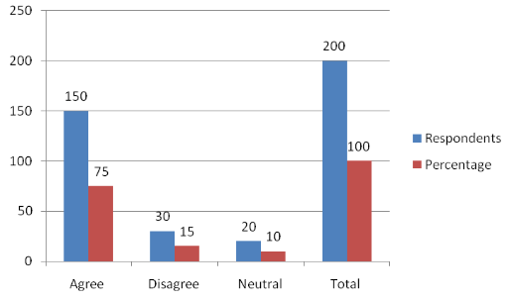

**Figure 4.9: Digital channels are appropriate for communicating business plans**

**(Source: Created by author)**

**Comment:** Based on the above graph, it can be said that 150 participants have agreed that the digital network can be easier for communicating business plans and objectives with the employees. Moreover, 15% of participants disagreed that digital communication could not be effective for business communication. However, 10% of participants stayed neutral in this discussion. Therefore, digital channels are effective for communicating in business.

| **Question 10: Do you think you can observe customer satisfaction in the modern era?** | | |
| --- | --- | --- |
| **Responses** | **Respondents** | **Percentage** |
| **Agree** | **145** | **72.5** |
| **Disagree** | **25** | **12.5** |
| **Neutral** | **30** | **15** |
| **Total** | **200** | **100** |

**Table 4.10: Observation of Customer Satisfaction in the Modern Era**

**(Source: Created by author)**

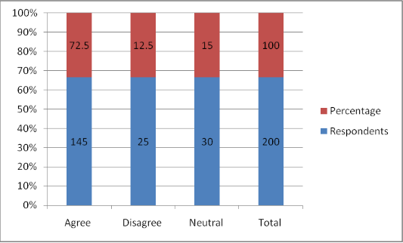

**Figure 4.10: Observation of Customer Satisfaction in the Modern Era**

**(Source: Created by author)**

**Comment:** According to the above graph, it can be identified that 145 participants among 200 agreed that the satisfaction level of customers can be observed in this modern era. On the other hand, 12.5% of participants disagreed that the satisfaction level of customers can not be observed in this competitive modern era. However, 30 participants stayed neutral in this discussion. Thus, the observation of customer satisfaction levels is important for developing the b business in this modern era.

| **Question 11: Do you think your business will gain publicity in the target market?** | | |
| --- | --- | --- |
| **Responses** | **Respondents** | **Percentage** |
| **Agree** | **135** | **67.5** |
| **Disagree** | **35** | **17.5** |
| **Neutral** | **30** | **15** |
| **Total** | **200** | **100** |

**Table 4.11: Publicity gain for business in the target market**

**(Source: Created by author)**

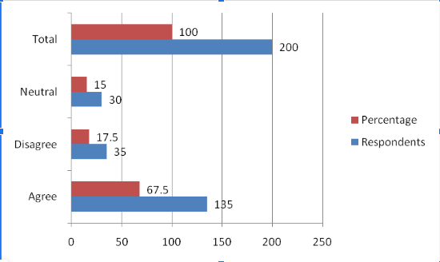

**Figure 4.11: Publicity gain for business in the target market**

**(Source: Created by author)**

**Comment:** Based on the above graph, it can be evaluated that 67.5% of participants believed that the business will gain publicity in this target business. On a contradictory note, 17..5% of participants disagreed with the fact that gaining publicity in business is a difficult factor in this modern era. However, 30 participants were neutral regarding this discussion. Hence, it can be said that publicity is an important factor for business in this target market.

| **Question 12: What are the procedures by which you will retain your existing consumers?** | | |
| --- | --- | --- |
| **Responses** | **Respondents** | **Percentage** |
| **Manufacturing unique products** | **35** | **17.5** |
| **Offer Discounts** | **95** | **47.5** |
| **Lower the selling prices of the products** | **40** | **20** |
| **I don’t know** | **30** | **15** |
| **Total** | **200** | **100** |

**Table 4.12: Procedures for retaining existing customers**

**(Source: Created by author)**

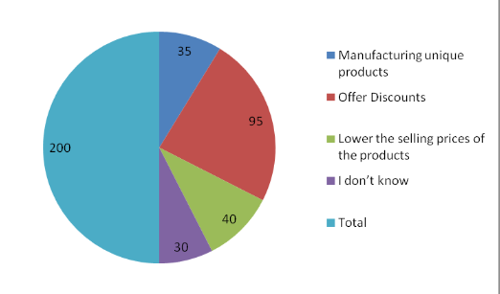

**Figure 4.12: Procedures for retaining existing customers**

**(Source: Created by author)**

**Comment:** According to the above chart, it can be said that 95%  of participants agreed on the fact that providing offers and discounts can help in retaining existing customers in business. On the other hand, 35 participants believed that manufacturing unique products can help the business retain existing customers positively. Moreover, 20% of participants agreed that the reduction in product prices can attract existing customers towards the business. However, 15% of participants said that they are unaware of the discussion. Therefore, companies can provide offers and discounts to retain customers towards the business.