| Close-up image showing the leaf-sides of two oversized books side-by-side on a bookshelf, with additional books in soft focus background |
| --- |
| Evaluation Of Charity Pop-Up events  A Group Collaborative Report |
| | Word Count – 2,500 words | Due Date – Friday 21st April | MD3055 - Stella Unsworth | | --- | --- | --- | |



| University of Central Lancashire Logo | **Lancashire School of Business and Management** | **Coursework Cover Sheet**  **Group Report** |
| --- | --- | --- |

*Students should add this coversheet, to the start of their assessment before submission through Turnitin.*

| Seminar Tutor (If appropriate): Stella Unsworth | |
| --- | --- |
| Module Title: **Managing your Business** | Programme Title: Pop Up 2 Group Report |
| Module Code: **MD3055** | Year of Study: **2022/23** |

***Academic Misconduct / Plagiarism Declaration***

By attaching this front cover sheet to my assessment I confirm and declare that I am the sole author of this work, except where otherwise acknowledged by appropriate referencing and citation, and that I have taken all reasonable skill and care to ensure that no other person has been able, or allowed, to copy this work in either paper or electronic form, and that prior to submission I have read, understood and followed the University regulations as outlined in the Academic Integrity Policy and Procedure for Academic Misconduct available at the following link: <https://www.uclan.ac.uk/study_here/assets/assessment_handbook_2122.pdf>

| **Have you checked the following in order to maximise the grade you can achieve for this assignment?** | **Please mark X to confirm** |
| --- | --- |
| Learning Outcomes have been addressed | X |
| Similarity check via Turn-it-in | X |
| Referencing accuracy according to provided guide | X |
| Grammar | X |
| Spelling | X |
| Word count (or other length limitation as described in the brief) | X |

**WELLBEING**

| We wish to support any student who is experiencing mitigating circumstances which prevents students from performing to the best of their ability when completing or submitting assignments. If you are experiencing such circumstances then you may apply for mitigating circumstances**.** Wherever possible this must be done prior to handing your assignment. | I believe **that I do not need** to apply for mitigating circumstances for this assignment at this moment in time  Please **delete** as appropriate  (You may still apply for mitigating circumstances if you subsequently feel that your performance has been adversely affected by issues that you may currently be unaware of). |
| --- | --- |

# Executive Summary

The purpose of this report is to evaluate the performance of two pop-up businesses including both the planning and running aspects of both events. An investigation into the issues that arose from the individual popup’s will be compared and contrasted and two major recommendations will be outlined to help with future forecasts.

Contents

Executive Summary 2

Introduction 2

Evaluating performance 2

Improvement Recommendations 2

Business form and advice 2

Financial Forecast 2

Conclusion 2

Appendix 2

# Introduction

As part of MD3055 Managing Your Business Model, we were instructed as a group of five to plan and host two separate charity fundraising events to raise a donation for a charity of our choice. We came to the collective decision of selecting Mind UK. It was within our best efforts to make the events successful in order to raise enough profit from the £40 start up cost we were given during semester one. This report will compare the performance of each pop-up and include the issues that occurred that helped with the second pop-up. A summary of the difficulties during pop-up 2 and an explanation on how raising money for charity helped with sales is included alongside a statement of financial accounts and evidence of donation to our chosen charity.

# Evaluating performance

Pop up 1 SWOT:

| Strengths:   * Suitable location (STFSS) | Weaknesses:   * Limited scope for additional revenue streams |
| --- | --- |
| Opportunities:   * Sponsorship possibilities * Build relationship with local community and football teams | Threats:   * Legal and safety issues |

Pop up 2 SWOT:

| Strengths:   * Attractive stall design * Freshly and locally sourced | Weaknesses:   * Timing the event * Limited product range |
| --- | --- |
| Opportunities:   * Expand product range * Explore new locations | Threats:   * Competition * Challenges with sourcing products |

To begin with, the contingency theory (Fred Fiedler, 1964), which contends that an organisation's effectiveness depends on how well its framework fits with its surrounding environment, and depending on the circumstances, it forms judgements, may be used to compare the outcomes of our two pop-up businesses. In this instance, pop-up 1, the football competition, was hosted in a suitable setting (UCLan STFSS), which drew an acceptable number of players and assisted in raising satisfactory funds for the charity. Conversely, pop-up 2, the cakes and desserts stand, was located in a befitting location (the UCLan student centre), which had a beneficial effect on sales performance. We utilised our encompassing situation of being in the university to try to locate ourselves where a large amount of students and staff proceeded. Evidence for pop up 2 successes can be seen as the net profit was greater compared to pop up 1 which can also be viewed in our financial statements.

The value of efficient advertising and marketing was one of the significant takeaways from pop-up 1 that benefited pop-up 2. The Marketing Mix theory developed by Jerome McCarthy (1960) states that successful advertising is crucial to drawing consumers to a company. By advertising the event on the student union website and disseminating information in the neighbourhood, we used this lesson in pop-up 2 to help create exposure and lure consumers to the event.

Another precept we grasped from pop-up 1 was how crucial it was to have a strongly arranged strategy. According to the contingency theory which was mentioned above, organisations must have a defined strategy established before reacting to outside environmental forces. For pop-up 2, we created a thorough plan that covered everything from product selection to pricing, enabling us to efficiently adapt to the surrounding environment.

The timing of the event may have been one of the elements that impacted pop-up 2's performance. The number of students on campus may not have been as high as it had been a few months prior because it was towards the end of March or the beginning of April. It was not the best time for a stall in this situation. To enhance sales success, we understood that it is critical to pick a time that works for the sort of business and the demographic being targeted.

The cost-of-living crisis is a factor can have a significant impact on a consumer's buying behaviours. In recent times, the cost-of-living has increased, many people's wages aren't keeping up with the rise of inflation (BBC, 2023). Due to this, customers could have fewer disposable income to use on unnecessary items. This may lead to a temporary decline in the demand for particular goods like luxuries such as ours. Customers may prioritise necessities like food and housing over additional items. To adapt to shifts in customer behaviour and preserve our competitiveness, we may need to modify our pricing or marketing techniques.

As seen below, the profit and loss statement for both pop-up events which matches the income and expenditure regarding each event with the final figure of £103.74.

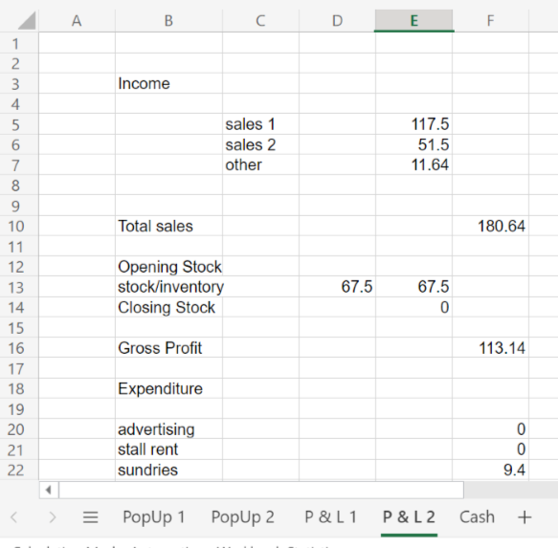

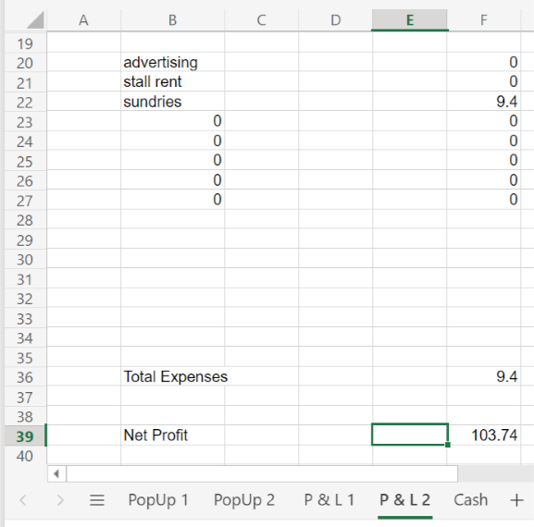

# Improvement Recommendations

If we were able to redo our charity event there would be a few things that we wish, we could have done differently. In this report we will discuss some of the things we wish we could have done differently using Ansoff’s Matrix. Ansoff’s Matrix is a table split into four sections about the new and existing markets, along with new and existing products and services.

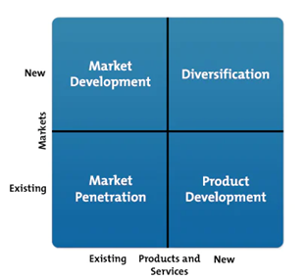

The first thing that I believe we could have done differently is to bring new products into the existing market. With the theme of our stall being Easter time, it would have been the perfect opportunity to sell Easter Eggs. We decided to sell cupcakes and boxes of sweets and chocolate. However, with easter being a few weeks away I believe a stand with large easter eggs on it may have drawn in a larger number of customers. The target audience of the easter eggs would be the same people who were already walking by our stall, which was university students, however with a newer product which no one was selling around us it would have allowed us to stand out. Although other groups prior to us had also sold easter eggs we were the last to do our event, so us selling Easter Eggs would have benefited us more I believe as it was closer to the holiday and therefore more relevant of an item to sell. This in turn could have resulted in a higher demand for our product as people would be more willing to buy an easter egg two weeks before the holiday, compared to a month prior.

A second way in which we could have improved upon out charity event and maximised our profits is by travelling around with our products instead of remaining at the stall. We did discuss toward the end of our event whether we should do this or not, however ultimately decided against it. If we had prepared for this beforehand and brough a nice basket which could hold the cupcakes and boxes, I believe we would’ve made more sales this way. Our charity event took place in the Student Centre on the ground floor. This was good for us as we were able to get the attention of anyone coming in this way, however we were missing out on custom of those coming in through the first floor and sitting upstairs. If we were to have travelled around the first floor selling our products for reduced rates, I believe we would have been able to sell off the rest of our stock.

# Business form and advice

# Financial Forecast

During year 1, there is an initial forecast of 2 events per month from January to May, increasing the number of goods sold from 96 to 152 cakes sold at a price of £2.50. This takes into account a sales return and discount rate which gradually increases, representing discounts at the end of the day as well as stock that does not sell. Expenses consist of marketing which will be in the form of posters and social media, as well as transaction fees from purchases. Estimated product sales reduce during the summer period of June-July due to the customer base reducing over the university break. This gradually increases once the new university year begins, with the advertising doubling to take advantage of the potential new customers. Parallel to this, the number of events will increase to 3 per month to increase revenue. This increases to 4 events during December to address seasonal opportunities and a likelihood of increased spending around Christmas. In both Year 2 and Year 3, January has a drop in product sales compared to December due to people spending less shortly after Christmas, though this would be lower if the variable of student finance payments wasn’t considered. This applies for April and September also, with students likely to be willing to spend more despite the cost of living due to their sudden influx of cash. The estimated net incomes for year 1 is £1,945, which increases to £5,221 in Year 2, and finally reaching £7,338 by the end of the 3rd year. An increase of advertising encourages this growth, as well as a prediction that cost of goods would go down from a £1.60 unit cost to around £1 due to economies of scale and the ability to buy in bulk from suppliers.

Charity help

**Did you get a chance to use the charity material? How did you use or advertise the fact that it was for charity in the circumstances? Do you think it helped with both popups?**

Yes, I have had the opportunity to use the charity material, the t-shirt. I put up the picture of the t-shirt on my social media accounts and also mentioned that the product was for charity. I spoke about it in my post on social media platforms that as Instagram and Twitter. I wrote about the charity organisation Mind and also spoke about their activities. Along with a few pictures of the charity organisation, I spoke about the importance of Mental Health on my social media platform.

On the day of Popup 1, we put up a hoarding beside the football match ground informing people about the product and the cause behind the charity. the digital hoarding attracted the customers to the match which lead to conversations among the customers as well as with us where we talk about the processes of the organisation as well as the people they support. We also ended up talking about mental disease and the importance of having a healthy state of mind. Before popup 2, we created a social media campaign on Twitter for 2 days before the confectionery stall was launched. On the first day, we create a hashtag with the name “beautiful MIND” and shared the story of the Charity that we were engaged in and ask others to share their own. On the second day, we collaborated with 2 social media influencers in order to promote the charity t-shirt (Hermanda et al., 2019). We provided them with videos and images of the charity organisation which they shared on their social media profile and talk about the cause of the charity. They also share pictures of them wearing the t-shirt and asking followers to support the cause. This had a positive impact on the crowd gathering around the stall which positively contributed to the collection of funds that way to be donated to the mental health support organisation during the day of the football match. Both of these advertisements caused people to get attracted to and added to the collection of funds. The funds raised from both events were donated to the charity organisation.

Both advertising strategies help the popups together huge crowd which ultimately contributed to the success of the popups. People spoke about the good cause of the Charity organisation which further created awareness as well as the conversations around the Mind acted as a word of mouth for the popup as well.

# Conclusion

Based on the discussion it can be concluded that organising popups in order to raise funds for charity can be a challenging task. The above report highlights the Trends of the popup is the location of organising them. It further discusses the opportunities in terms of possibilities of engaging with sponsors and building a local football team for the events. It even discusses the weaknesses and threats of fundraising events as well. The report pinpoint the fact that since the events were organised inside the university, an acceptable number of crowds was easily available within the university premises. In addition to that the football competition especially attracted the crowd due to the curiosity and excitement around the event. On the other hand, the confectionery stand was able to gather even more crowd than the first pop-up event. The success of the events where measured on the basis of the collection of the funds which can be seen on the financial statement of the overall collection from the event [Refer to the appendices]. It can also be concluded that due to making efforts into Advertising and Marketing the events, it was capable of gathering a much more crowd which led to a greater collection of funds in pop-up 2 than in the first one.

In addition to that, the purchasing behaviour of customers in the events also sheds light on the fact that Due to the rising inflation in the market, the purchasing power of the customers is decreasing. As a result of this, customers prefer to purchase products of necessity instead of products of luxury. Based on this understanding, the prices of the products were shifted to meet the demands and preferences of the customer. The report also makes suggestions based on the experience of the fundraiser events and discusses ways in which they could have been improved.

# Appendix

Proof of charity donation -

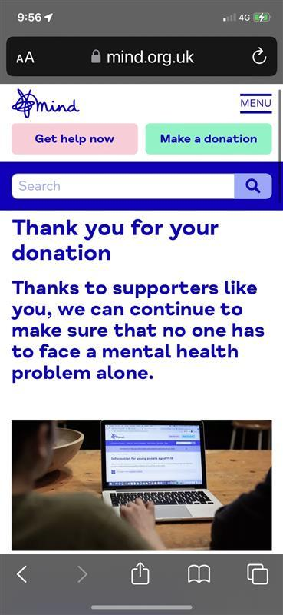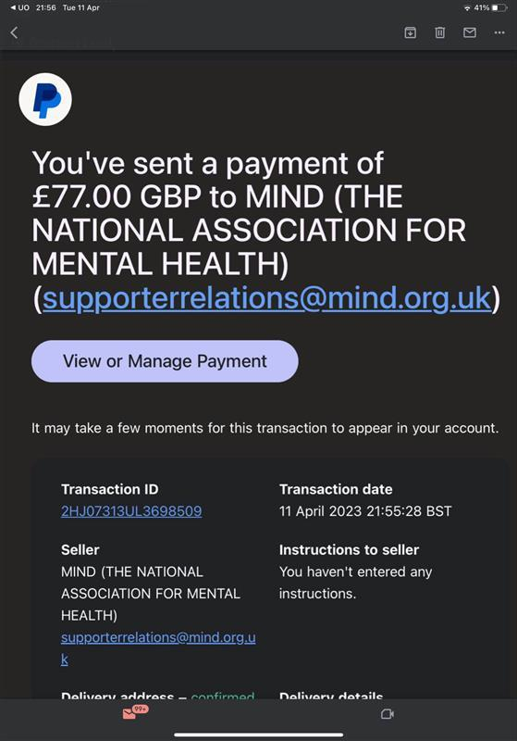

Second Pop-Up Poster -

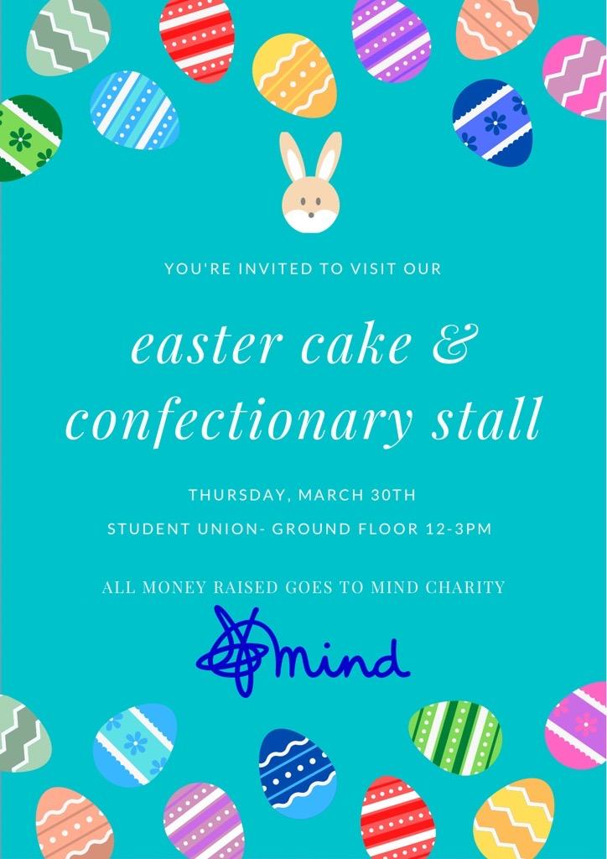

Receipts for second pop-up -

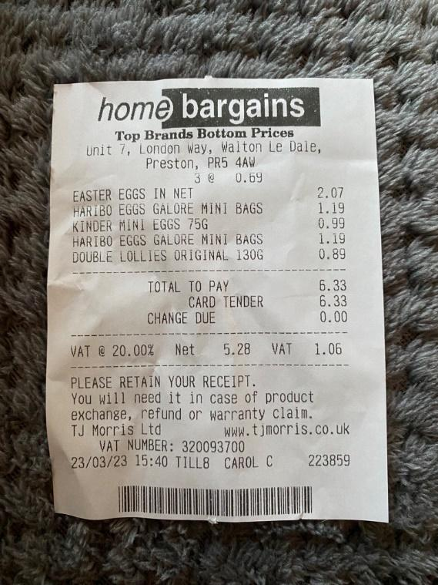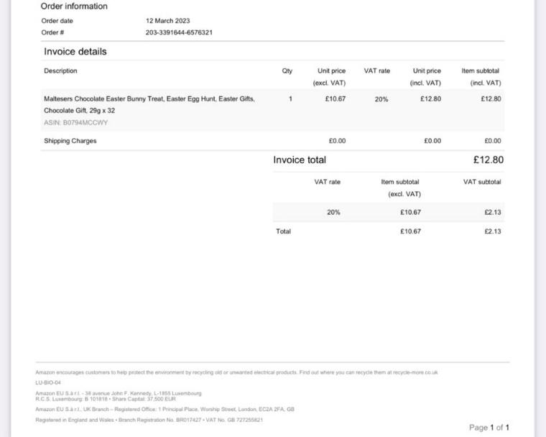

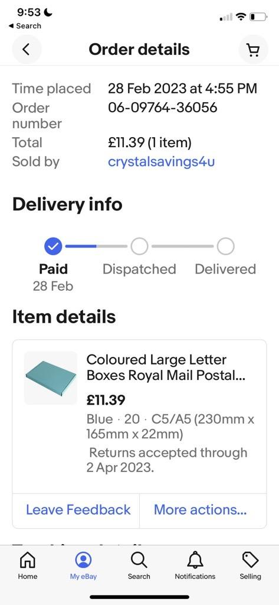

# References

Communication, in O. (2018) *Contingency theory*, *Communication Theory*. Available at: <https://www.communicationtheory.org/contingency-theory/> (Accessed: April 17, 2023).

McCarthy, J., 1964. The concept of the marketing mix. *Journal of Advertising Research, June*, pp.2-7.

Ford, D., Gadde, L.E., Håkansson, H., Snehota, I. and Waluszewski, A., 2008, September. Analysing business interaction. In *24th IMP Conference, Uppsala* (pp. 1-37).

*What is the UK inflation rate and why is the cost of living rising?* (2023) *BBC News*. BBC. Available at: <https://www.bbc.co.uk/news/business-12196322> (Accessed: April 19, 2023).

*Home* (2022) *MindTools*. Available at: <https://www.mindtools.com/amtbj63/swot-analysis> (Accessed: April 19, 2023).

Hermanda, A., Sumarwan, U. And Tinaprillia, N., 2019. The effect of social media influencers on brand image, self-concept, and purchase intention. Journal of Consumer Sciences, 4(2), pp.76-89.