**BUSINESS REPORT BASED ON CASE STUDY**

**Table of Contents**

Executive Summary 2

Motivation of the proposed investment 3

Application of the investment appraisal technique 3

Discussion of the risks and the return 7

Conclusion 8

References 9

Appendices 10

# Executive Summary

**Introduction of the company**

Frasers Group Plc is a well-known organisation that belongs to the retail segment of sports and fitness and lifestyle products. It is a British multinational organisation. The company is most famous for the brand of the products that they provide to its customers. Apart from this the company also serves customers by the means of branded shirts and jackets (*Frasers* 2023). In this context, it can be stated the company mainly formulates the business by the means of branded apparel products to the customers.

**Purpose of the report**

The main purpose of the report is to determine the efficiency of the investment that has been ascertained over here for the growth and development of the concerned organisation. It has been observed that the outbreak of the global pandemic has affected the overall productivity of the company. In this respect, the company will be undertaking a particular investment to enhance its business. For this reason, the effectiveness of the investment is to be discussed here.

**Conclusion**

The report is providing a positive response in terms of associating with the concerned investment for th company Frasers Group PLC. In this respect, it has been asccepted that the company shall involve with the concerned investment plan for the growth of the business. The major reason behind this aspect is just that the investment can deliver a better result in the upcoming years. Moreover, in addition to this, it has been ascertained that the rate of return of the company for the future course of action is also high which indicates that the company will be receiving a higher4 average rate of return in the future course of return.

**Recommendation**

In terms of the recommendation, it can be stated that the company is not required to spend such a huge amount of capital in terms of investment. It has been observed from the investment appraisal techniques that the amount of investment, as well as the expenditure, takes a huge time in terms of covering the same. In this respect, the amount of initial investment could have been lower over here. In addition to this, the organisation can also decrease their aggregate budgetary line to further increase the profit margin of the same.

# Motivation of the proposed investment

In order to decrease the effect of the Covid-19 the company has already taken various strategies to enhance business operations with the same. Further, for the development of the business in the long run it is necessary that the company get associated with a strong investment for the growth and development of the same. This indicates that the company needs to develop a better investment for the formulation of the business in the future course of action.

Moreover, the company needs to invest in new companies which are having a higher brand value. In this respect, the Frasers Group needs to first ascertain that the company is having a higher level of return in the future course of action. The main reason behind getting associated with the concerned investment is just to develop the business of both companies at a higher level. Moreover, the only problem that will be caused by the investment is the consideration of the requirements of both companies. As it has been observed that both the companies are having a higher brand value, it may create an issue in terms of covering the requirements of each of them. However, in this particular investment, it is necessary for both companies to ensure they are each and every requirement.

# Application of the investment appraisal technique

| **Calculation of NPV** | | | |
| --- | --- | --- | --- |
| **Years** | **Net cash flows**  **in $** | **Discounting**  **factor @ 6%** | **Net discounted**  **cash inflow in $** |
| 1 | 268,700 | 0.94 | $253,490.57 |
| 2 | 132,300 | 0.89 | $117,746.53 |
| 3 | 86,800 | 0.84 | $72,878.95 |
| 4 | 295,700 | 0.79 | $234,222.10 |
| 5 | 384,800 | 0.75 | $287,544.94 |
| PV of discounted cash flow |  |  | $965,883.09 |
| less-total intitial cash |  |  | $904,000.00 |
| **Net Present Value** |  |  | **$61,883.09** |

**Table No 1: Computation of the NPV**

(Source: Created by self)

The Net Present Value (NPV) mainly provides an overview of the relationship between the present and future cashflows of a particular business in order to understand the effectiveness of a particular investment (Dobrowolski, 2022). The higher the NPV is the higher will be the return from the same. With respect to this, the NPV of the investment made by the concerned organisation is about $61,883.09. This indicates that the investment will be delivering a better result in the future course of action. For this reason, the organisation shall undertake the investment to generate a standard level of return in the upcoming financial years.

| **Payback period** | | |
| --- | --- | --- |
| **Year** | **Cashflow** | **Cumulative CashFlows** |
| 0 | -$904,000.00 | -$904,000.00 |
| 1 | 268,700 | -$635,300.00 |
| 2 | 132,300 | -$503,000.00 |
| 3 | 86,800 | -$416,200.00 |
| 4 | 295,700 | -$120,500.00 |
| 5 | 384,800 | $264,300.00 |
| **Payback Period in years** | | **5.31** |

**Table No 2: Computation of the Payback Period**

(Source: Created by self)

The payback period is associated with the determination of the number of years in which a particular investment covers all the cost of expenses including the investment amount and starts generating income from the same (Fetner, 2021). From the above table, the payback period reflects the years after which a particular investment will be delivering income from the same. With respect to this, the payback period of the investment over is about 5 years and 3 months. This indicates that the investment will be able to generate a return after the end of about 5 years and 3 months.

| **Computation of the Average Rate of Return** | |
| --- | --- |
| **Year** | **Cash Flows** |
| 1 | 268,700 |
| 2 | 132,300 |
| 3 | 86,800 |
| 4 | 295,700 |
| 5 | 384,800 |
| Estimated Life | 5 |
| Initial Investment | $904,000.00 |
| Salvage Value | 180800 |
| Average Annual Net Earning | 233,660 |
| **Average Rate of Return** | **32.31** |

**Table No 3: Computation of the Average Rate of Return**

(Source: Created by self)

The average rate of return indicates the average amount that is expected from a particular business after a certain financial year (Prol, 2020). In this context, the ARR that the investment will be provided in the future course of action towards the company is observed to be about 32.31%. This indicates that the investment will be providing a standard level of return in the future course of action that is after five financial years.

In terms of analysing all three investment appraisal techniques for the concerned investment, it has been observed that it will be quite profitable for the company in terms of associating with the same. This is because the investment is delivering a standard level of return in the upcoming financial years. It has been observed that the investment is consuming a huge time in terms of covering the entire cost of expenses as well as the investment. However, the average rate of return is also higher over here which makes the investment more efficient enough over here.

**SWOT Analysis**

| **Strength**   * The company is observed to be one of the prominent retailers of sports products. * The company is having a strategic partnership with various branded companies that makes the company more valuable (Simply Wall St, 2023). * The company is observed to be using a multi-channel strategy of elevation for having a better customer offering. | **Weakness**   * The company has observed various negative publicities for which the business has got hampered. * The company is focusing on the expansion of the stores rather than the branding of the same. |
| --- | --- |
| **Opportunity**   * The company is having an opportunity in terms of expanding into new market segments. * The company is having potentiality in terms of partnering with other branded organisations. | **Threat**   * The company is having risk, in terms of the rising cost of raw materials. * Entry into the e-commerce sector is having a higher chance of cyberattacks (*Frasers Group PLC SWOT analysis*, 2023). |

**Table No 1: SWOT Analysis**

(Source: Created by self)

# Discussion of the risks and the return

The initial amount of capital that is involved within the investment is about $904,000. Whereas on the other hand, the scrap value of the investment at the end of the fifth financial year is about $1,801,800. Apparently, it has been observed that the investment is delivering a standard level if return in the upcoming financial years. In addition to this, it can be stated that the return that the investment will be delivering is relatively higher which can provide better products to the concerned organisation. However, on the other hand, it has been observed that there is a risk in terms of consuming more years for covering the entire cost of expenses. It has been observed over here that the company will require more than five years to cover the amount of investment as well as the expenses involved within the same.

# Conclusion

The assessment has covered a wide piece of information in terms of the fact that whether Frasers Group PLC shall undertake the concerned investment or not in terms of further developing their business. With respect to the various positive and negative aspects of the concerned organisation, it has been observed the company will be profitable in case it is associated with the concerned investment over here. In addition to this, it has been observed that the investment will be generating a higher level of return in the future course of action. Apart from this, the rate of return from the investment is also at a higher level which is making it more profitable over here.

# References

Dobrowolski, Z. and Drozdowski, G., 2022. Does the net present value as a financial metric fit investment in green energy security?. Energies, 15(1), p.353.

Fetner, H. and Miller, S.A., 2021. Environmental payback periods of reusable alternatives to single-use plastic kitchenware products. The International Journal of Life Cycle Assessment, 26, pp.1521-1537.

Frasers Group PLC SWOT analysis Ghent University Library. MarketLine, a Progressive Digital Media business. Available at: <https://lib.ugent.be/catalog/ejn01:4100000011642417> (Accessed: April 15, 2023).

Frasers. Available at: <https://frasers.group/> (Accessed: April 15, 2023).

Prol, J.L. and Steininger, K.W., 2020. Photovoltaic self-consumption is now profitable in Spain: Effects of the new regulation on prosumers' internal rate of return. Energy Policy, 146, p.111793.

Simply Wall St (2023) Is there an opportunity with Frasers Group plc's (Lon:fras) 31% undervaluation?, Simply Wall St News. Simply Wall St. Available at: <https://simplywall.st/stocks/gb/retail/lse-fras/frasers-group-shares/news/is-there-an-opportunity-with-frasers-group-plcs-lonfras-31-u> (Accessed: April 15, 2023).

# Appendices

Appendix No 1

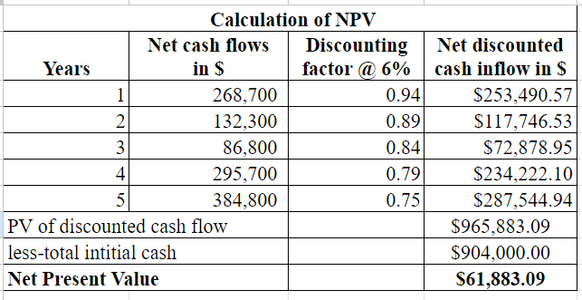

Appendix No 2

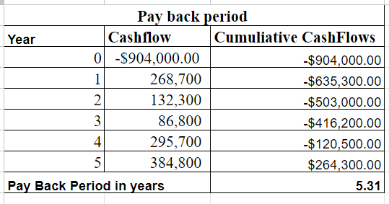

Appendix No 3

