**INDIVIDUAL PROJECT REPORT**

**Executive Summary**

The report had highlighted the importance of project management plan to improve productivity and deliver the project within stipulated time frame. In this context, here had been discussing about a hotel business, which planned to shift to the computerized administration system from the manual method. Therefore, the application of methodologies had discussed in this study. In addition to this, the effective communication plan and the risk management strategies had highlighted in this study. Moreover, the importance of project control and the cost allocation that had made positive impact on the project had also highlighted in this report in the systematic way.

Table of Contents

Introduction 3

1. Evaluating project management methodologies including waterfall and agile in the project 3

2) Discuss the project scope, project strategy, WBS, Network Diagram and Gantt chart 5

3) Analyse the communication plan of the Project 8

4) Develop a risk management plan for the Project 10

5) Analyse the resource and cost allocation of the project 13

6) Discuss the project control system for the new project 13

7) Evaluate the performance of the project 14

8) Analysing the lessons learned and recommendations for the project 15

Conclusion 16

References 17

Appendices 20

Appendix 1: Agile approach uses in project 20

Appendix 2: Utilization of technology 21

# Introduction

The project management plan has been considered as essential in a business that allows to delivery of the project within the stipulated time frame without any possibility of errors. In this context, here has discussed about the business strategy for a hotel that is planning to adopt a computerized administration scheme to understand the customer’s needs in a better way. Moreover, the network diagram, communication plan, as well as risk management plan associated with this new project, has also been illustrated in this study.

# 1. Evaluating project management methodologies including waterfall and agile in the project

Project management methodologies are the crucial part that reduces risk, and avoids duplication of efforts that ultimately resulted in increasing the durability of the projects. Based on the views of Aroral (2021), with effective methodologies, the project managers have quickly adopted the new challenges and monitored the whole task to create a solid foundation for the project. This is considered the main reason that leaders have paid attention to implementing project tools to increase the motivation of the team as well as increase productivity in a better way. There have seen different types of methodologies such as “waterfall”, “kanban”, “agile”, and “adaptive project framework” which has used by project managers to ensure success in the minimum time frame.

***Agile methodology:***

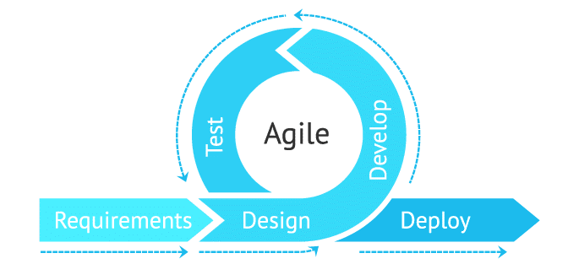

**Figure 1: “Agile methodology”**

(Source: Salza *et al.* 2019)

Agile methodology is a way to manage projects systematically by breaking them down into several phases. The best thing about this project is that it required constant collaboration from the stakeholders and thus this ***improves the process of planning***, and ***execution*** to ensure successful delivery as well (Salza *et al.* 2019). In this context, the hotel business has shifted to adopt the computerised administration system from the manual method to facilitate the experience of the customers. Therefore, by adopting agile approaches the management team of the hotel ***can successfully respond to the change*** by following a plan as well as maintaining the interactions over processes and tools. The merits of this project approach have mainly included ***increased flexibility*** and ***adapting changes*** as per the requirements of the customers. Contrarily, the main demerits of this methodology are that it often creates a ***poor decision-making strategy*** because flexibility is the core of this. Based on the views of Hayat *et al.* (2019), in the agile project, adequate commitment from the developers and clients has been required so the lack of involvement can make the project easily fall off track. The advantages of agile methodology are inherent in several principles that include providing the consumer with ***valuable software*** and ***welcoming the changing infrastructure*** to develop the work in the best possible ways. Therefore, it can be analysed that with the improvement of collaboration and reducing the risks of the new project the hotel business can successfully implement a computerised administration system to satisfy the customers in the market.

*[Referred to Appendix 1]*

***“Waterfall methodology”***

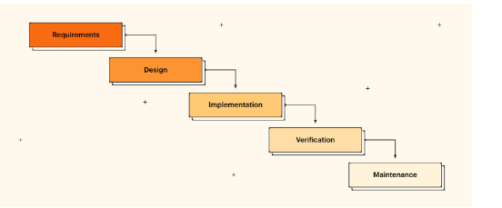

**Figure 2: “Waterfall methodology”**

(Source: Rumetna *et al.* 2022)

This methodology has relied on the ***sequence of steps*** and ensures that one step is properly completed before moving to another phase. As per the views of Rumetna *et al.* (2022), the best thing about waterfall methodology is that this can ***determine the end goal*** as well as ***transfer the information*** well with the stakeholders. The other thing is that with this approach, the leaders in the project have not to worry about overlapping each of the stages and this provides a structured approach. Contrarily, there has created several issues such as it has ***required huge costs*** and before starting any phase the managers have to ***analyse the whole project*** (Heriyanti and Ishak, 2020). In this context, consumers in today’s age have preferred online booking and reviews before visiting any hotel, thus the waterfall approach can enable leaders to respond quickly to their demands and fix issues faster by designing the goal in the proper manner.

# 2) Discuss the project scope, project strategy, WBS, Network Diagram and Gantt chart

***Project scope***

Project scope is part of the planning and execution that involves documenting project goals with the proper costs and deadlines. The main factor about this is that it helps to define the project deliverables and identify the constraints in better ways. In this context, as the hotel business has been completely shifted with a computerised administration system, thus there has required understanding the goals and assigning the right tasks to the employees. Based on the views of Fagarasan *et al.* (2021), the project elements have mainly relied on several factors such as budget and costs as well as the deadline of the projects. Hence, the managing authority by understanding the constraints in terms of adapting the new administration system can plan for innovative technologies such as IoT, and block chain to generate observable outcomes.

***Project strategy***

The project strategy has mainly dependent on the company’s mission and objectives as well as the resources that are allocated for the particular project. In this context, the hotel administrator can utilise the methodologies such as “agile”, and “waterfall” so that it establishes future projection and improve the collaboration with the stakeholders (Thummadi and Lyytinen, 2020). The main thing is that before designing the project such as shifting to a computerized administration system the leaders have to analyse the strengths of the employees and whether they have coped with the changing software within the workplace. This can create a better direction to develop the project strategy for ensuring successful accomplishment and ultimately lead in allow the customers to book their hotel through the online system.

***Work breakdown structure of the project***

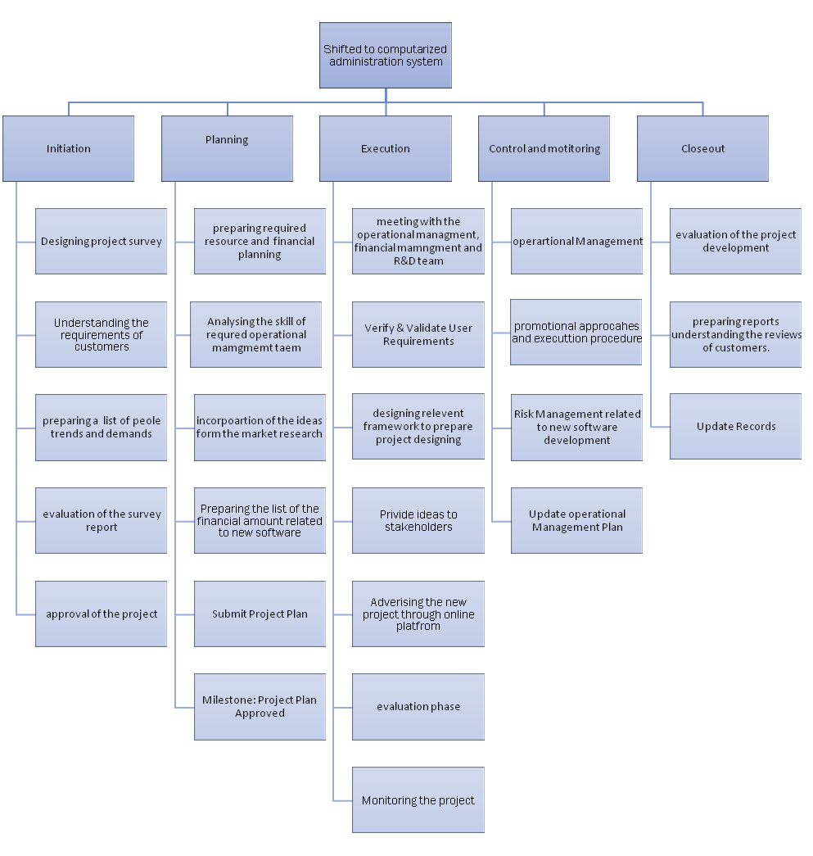

**Table 1: “Work breakdown structure”**

(Source: Self-developed)

This table has illustrated that shifting to the computerized administration system there has required proper planning, initiation, execution and control of the whole project. In this context, the leaders can divide the project into various phases in terms of identifying the risks and solving them in a better way (Hofmann *et al.* 2020). An understanding of the requirements of the customers is essential to plan the projects at the initial stage because the success of the organisation can completely rely on them. Moreover, the evaluation of the financial amount and resources can be needed to develop the projects and promote them through the online channel to improve the awareness of the people about the start of this project.

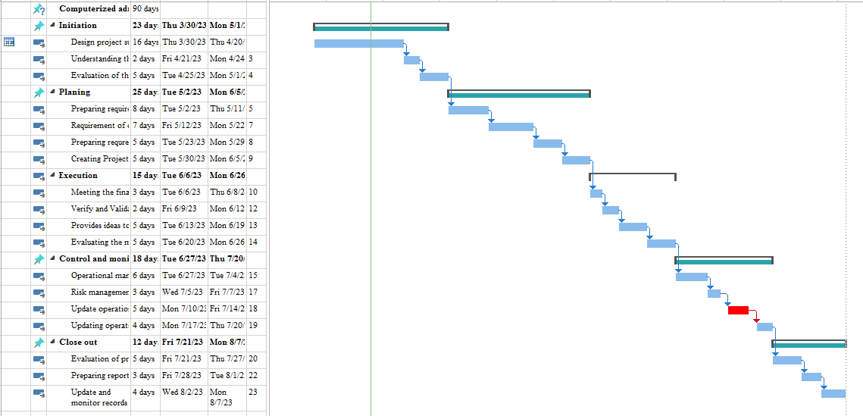

**Table 2: “Gantt chart”**

(Source: Self-developed)

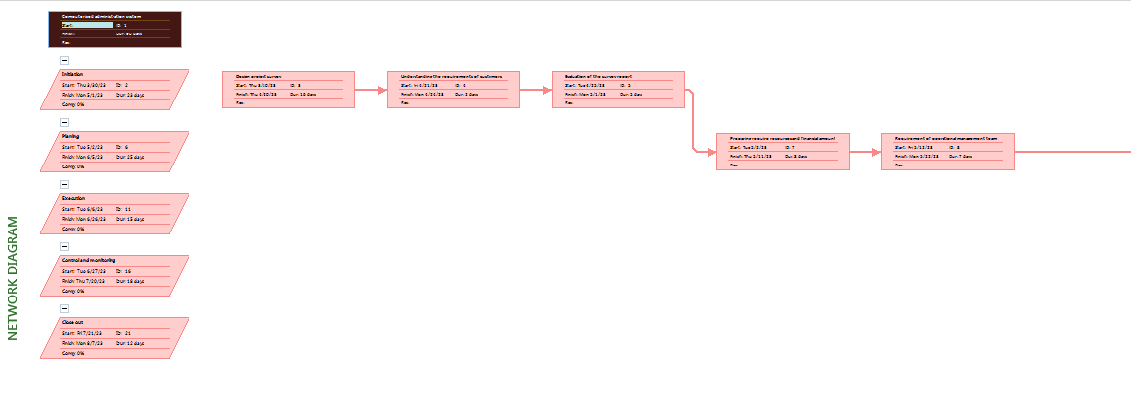

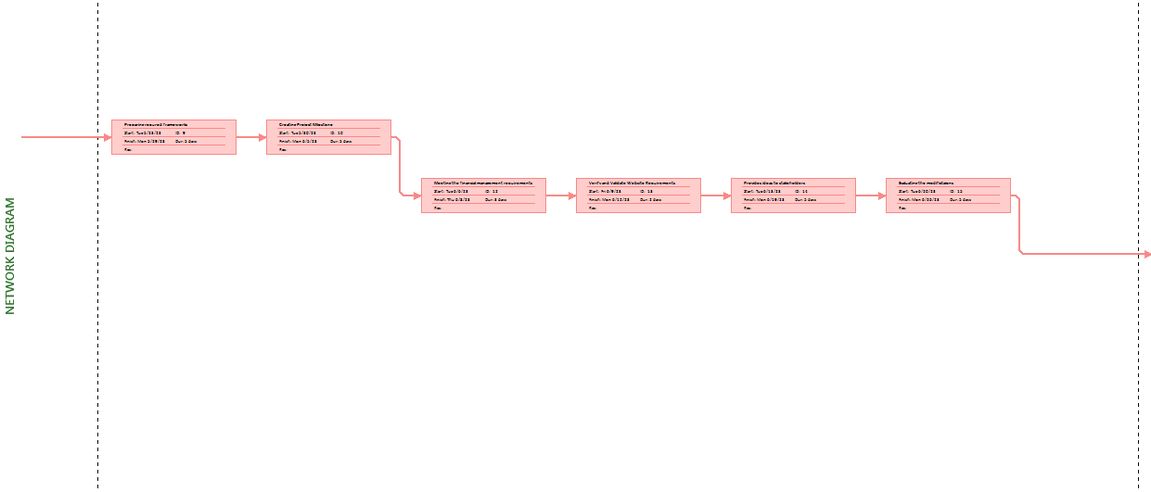

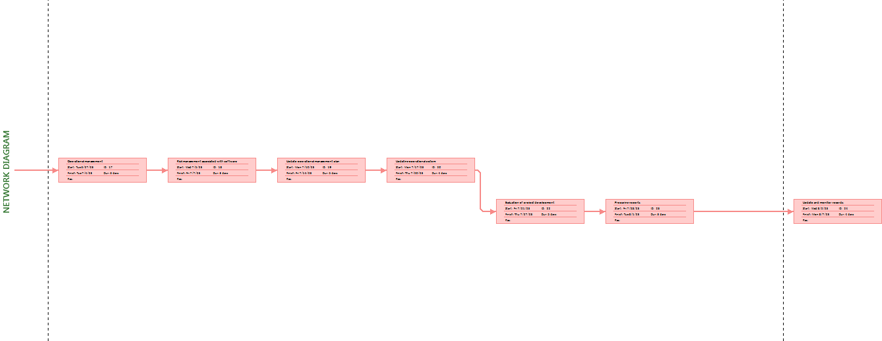

**Figure 3: “Network diagram”**

(Source: Self-created)

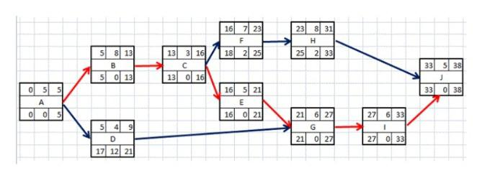

**Figure 4: “Network diagram”**

(Source: Self-developed)

# 3) Analyse the communication plan of the Project

A project communication plan is seen as the agreement between the stakeholders and collaborators to develop ideas about the task-related information and project details. In this context, to successfully accomplish projects within the stipulated time period, communication can help the stakeholders to receive ideas about the changing operations in a systematic way.

| ***Plan*** | ***Implementation Process*** | ***Timeline*** |
| --- | --- | --- |
| Determining the communication goals | * The leaders first have to understand what type of information has required for this project. * The project managers can use the online medium or a database by which they can share the necessary details. | Within 1 month |
| Select the best communication method | * The managers can choose the ***email messaging*** or design a ***website*** on which the employees can provide their queries and suggestion (Tereso *et al.* 2019). * The leaders can conduct project team meetings on a weekly basis. | Within 2 months |
| Designing the frequency of communication | * High frequency allows for quicker communication. * The project managers can choose satellite and telephone communications for developing the project. | Within 1 month |
| Identify the stakeholders | * The leaders by the use of technologies such as AI can identify the issues of stakeholders (Auth *et al.* 2019). * They can use personal massaging to solve their problems and develop a bond with them to ensure success. | Within 1 month |

**Table 3: "Communication Plan"**

(Source: Self-developed)

The above table has highlighted the project managers by choosing the best channel such as a database and designing the meeting can provide ideas to the stakeholders about the new software management that has been utilised in the computerized administrative system. Moreover, the leaders by defining the communication goals and solving the problems of stakeholders by communicating with them can improve their performance and ensure the successful accomplishment of projects.

# 4) Develop a risk management plan for the Project

The risk management plan has deal with the potential risks and allows the project managers to solve these to ensure successful outcomes. The risk management plan has relied on several steps such as "risk identification", "assessment", and "mitigation strategy" (Erwanto and Zusi, 2020). Therefore, the leaders of the business before shifting to the new software development by identifying the risks associated with this can deliver the project to improve the customer's satisfaction with the business.

| **Identified risks** | **Priority** | **Actions to be taken** | **Outcomes** | **Time** |
| --- | --- | --- | --- | --- |
| The communication gap between the stakeholders | High | * The project managers can design an online website for the employees where they can share their queries. * The leaders can utilise email messaging and telephonic communication to present the detail of the projects. | The successful accomplishment of the project has required better communication among the stakeholders. | Within 2 months |
| Managing the huge data as per the customer’s requirements | High | * The project managers can select innovative technologies such as AI, and ML in terms of understanding the customer’s requirements. * The leaders can implement professionals so that they can store huge data in technological devices. | The analysis of customer data can help this hotel business to design the websites and upgrade software management so that consumers can receive all types of information and book their hotels before visiting any place. | Within 3 months |
| Lack of financial amount to invest in technologies | Low | * The project managers can include financial experts to allocate the right amount at the required places. * The expert can help the hotel business to choose the right technology and cut down extra financial costs. | The investment into innovative technologies can be seen as beneficial to upgrade the software management system. | Within 2 months |
| Difficulty in presenting manual methods | Medium | * The project managers can provide the necessary training for the employees so that they can understand the adaptation of technologies in the workplace. * The leaders can communicate with the stakeholders to analyse what type of problems they have gone through by understanding the huge data in the workplace. | The necessary training and the development of the communication strategy can help the project managers to identify the issues of the stakeholders and thus by solving them it can ensure the successful outcomes of the projects. | Within 1 month |

**Table 4: “Risk management plan”**

(Source: Self-developed)

The above table has illustrated that in a project there have many issues associated with this such as lack of financial aid, communication gap and lack of ideas about technologies. In this context, by recruiting professionals and allocating the right financial amount the hotel business can properly implement new software in their business (Kobylkin *et al.* 2020). Moreover, by giving the value of their queries and feedback the team members can feel more motivated and help in better delivery of the projects.

# 5) Analyse the resource and cost allocation of the project

| **Resources** | **Cost allocation** |
| --- | --- |
| Designing the project | 200 GBP |
| Technology implementation | 500 GBP |
| Website design | 150 GBP |
| Conducting training session | 100 GBP |
| Recruiting experts | 100 GBP |
| Database management | 250 GBP |
| Improvised the infrastructure | 400 GBP |

**Table 5: “Budget estimation of the project”**

(Source: Self-developed)

The above table has outlined the resources and the estimated budget structure that can be required to generate the successful outcomes of the project.

*[Referred to Appendix 2]*

# 6) Discuss the project control system for the new project

Project control is the process of analysing the data and monitoring as well as controlling the costs to ensure success. In this context, changing the administrative process from the manual methods to the computerized administrative system there can be required for planning, scheduling, and managing the risks as well as cost estimating (Taghipour *et al.* 2020). The project managers for this project can use ***“cybernetic control”*** as this has focused on the output system of the projects. Based on the views of Wysocki and Orłowski (2019), in a project, if the milestones or outputs do not measure the set standards, this can hamper the whole process of the system. Moreover, the leadership management team of this business can apply ***“post-performance control”*** to analyse and monitor the issues that have been faced by their workers during the development of the project. Hence, this can help in better design of the project in the future and designing the strategies considering the risks associated with this in a more effective way.

# 7) Evaluate the performance of the project

The success of the project has dependent on some necessary factors such as analysing the risk management strategies, and improvised infrastructure by which the tasks can be completed in the best possible ways. In this context, for this hotel business, the implementation of new technologies is mainly required so that the company can turn their administration systems into computerised ones (Ford and Lyneis, 2020). Therefore, the project managers can use an “agile approach” in terms of dividing the projects into smaller phases and identifying the risks to ensure success.

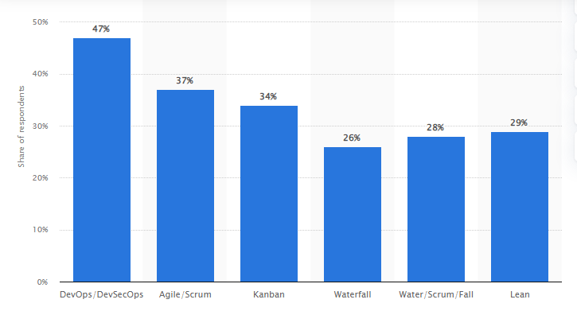

**Figure 6: “Adaptation of project methodologies”**

(Source: Statista.com, 2023)

This figure has clearly outlined that the utilisation of the project methodologies has increased day by day by the project managers. According to a report, 37% of the respondents have claimed that they have seen project development with agile approaches (Statista.com, 2023). In addition to this, the leaders of the business can also utilise artificial intelligence to understand the requirements of customers and design promotional videos and software as per their requirements.

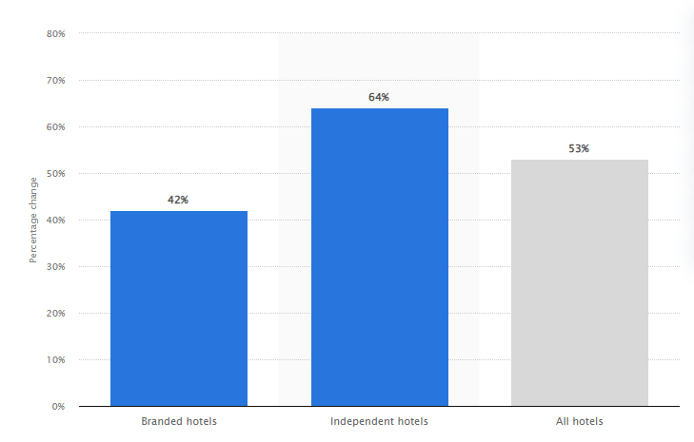

**Figure 7: “Utilisation of AI”**

(Source: Statista.com, 2023)

This figure has illustrated that the hotel industries have relied on innovative technology to increase the profit percentages of the business. According to a report, in 2022, the utilisation of AI chat-bots has expected to increase by 53% worldwide (Statista.com, 2023). Thus, it can be stated that to begin a new project the managers have to improvise the structure with the help of technologies and paid attention to adopting the project methodology to successfully complete the projects within minimum time frames.

# 8) Analysing the lessons learned and recommendations for the project

Based on the above discussion, it has been evaluated that the before starting a project, the execution of the plan as well as proper monitoring of each of the stages has required for completion successfully. In this context, the hotel business by utilising project approaches can improve the collaboration with the stakeholders and design the software management in the best possible manner to enhance their customer experience. However, there has also required ***the resource and budget planning*** to allocate the exact amount in the necessary places (Freitas *et al.* 2020). The project managers ***can recruit financial experts and professionals*** so that they can provide ideas for every detail of the projects to the employers. Moreover, the ***redesign of the infrastructure*** can help them to implement new software management in the business to enhance customer services.

# Conclusion

Based on the above discussion, it can be stated that an effective project management plan has required for the business to successfully complete the projects within the minimum time frame. In this context, as the hotel business has faced issues because of their manual method, thus by designing a new project such as shifting to a computerized system has increased the services and attracted more people in business.

# References

Aroral, H.K., (2021). Waterfall Process Operations in the Fast-paced World: Project Management Exploratory Analysis. International Journal of Applied Business and Management Studies, 6(1), pp.91-99.

Auth, G., JokischPavel, O. and Dürk, C., (2019). Revisiting automated project management in the digital age–a survey of AI approaches. Online Journal of Applied Knowledge Management (OJAKM), 7(1), pp.27-39.

Erwanto, E.D. and Zusi, H., (2020). Factors Affecting Success of ERP (Enterprise Resource Planning) System Implementation. International Humanities and Applied Science Journal, 1(1), p.12.

Fagarasan, C., Popa, O., Pisla, A. and Cristea, C., (2021), August. Agile, waterfall and iterative approach in information technology projects. In IOP Conference Series: Materials Science and Engineering (Vol. 1169, No. 1, p. 012025). IOP Publishing.

Ford, D.N. and Lyneis, J.M., (2020). System dynamics applied to project management: a survey, assessment, and directions for future research. System Dynamics: Theory and Applications, pp.285-314.

Freitas, F., Silva, F.J., Campilho, R.D.S.G., Pimentel, C. and Godina, R., (2020). Development of a suitable project management approach for projects with parallel planning and execution. Procedia Manufacturing, 51, pp.1544-1550.

Hayat, F., Rehman, A.U., Arif, K.S., Wahab, K. and Abbas, M., (2019), July. The influence of agile methodology (Scrum) on software project management. In 2019 20th IEEE/ACIS International Conference on Software Engineering, Artificial Intelligence, Networking and Parallel/Distributed Computing (SNPD) (pp. 145-149). IEEE.

Heriyanti, F. and Ishak, A., (2020), May. Design of logistics information system in the finished product warehouse with the waterfall method: review literature. In IOP Conference Series: Materials Science and Engineering (Vol. 801, No. 1, p. 012100). IOP Publishing.

Hofmann, P., Jöhnk, J., Protschky, D. and Urbach, N., (2020), March. Developing Purposeful AI Use Cases-A Structured Method and Its Application in Project Management. In Wirtschaftsinformatik (Zentrale Tracks) (pp. 33-49).

Kobylkin, D., Zachko, O., Popovych, V., Burak, N., Golovatyi, R. and Wolff, C., (2020). Models for Changes Management in Infrastructure Projects. *ITPM*, *2020*, pp.106-115.

Rumetna, M.S., Lina, T.N., Rajagukguk, I.S., Pormes, F.S. and Santoso, A.B., (2022). Payroll Information System Design Using Waterfall Method. International Journal of Advances in Data and Information Systems, 3(1), pp.1-10.

Salza, P., Musmarra, P. and Ferrucci, F., (2019). Agile methodologies in education: A review. Agile and lean concepts for teaching and learning: Bringing methodologies from industry to the classroom, pp.25-45.

Statista.com, (2023)*. Breakdown of software development methodologies practiced worldwide in 2022*.Available at: https://www.statista.com/statistics/1233917/software-development-methodologies-practiced/[Accessed: 13.04.2023]

Statista.com, (2023). *Forecast annual percentage increase in hotels using chatbots worldwide in 2022, by hotel type.* Available at: https://www.statista.com/statistics/1310836/forecast-annual-percentage-increase-hotels-using-chatbots-by-type-worldwide/ [Accessed: 13.04.2023]

Statista.com,(2023). *Size of the agile application life cycle management tools market worldwide from 2013 to 2017.* Available at: https://www.statista.com/statistics/500055/worldwide-agile-application-lifecycle-management-tools-market/ [Accessed: 13.04.2023]

Statista.com, (2023). *Leading technologies adopted in hotels worldwide as of November 2021, by period of implementation.* Available at: https://www.statista.com/statistics/1310828/top-technologies-hotels-worldwide/ [Accessed: 13.04.2023]

Taghipour, M., Shamami, N., Lotfi, A. and Parvaei, M.S., (2020). Evaluating project planning and control system in multi-project organizations under fuzzy data approach considering resource constraints (Case study: wind tunnel construction project). Management, 3(1), pp.29-46.

Tereso, A., Ribeiro, P., Fernandes, G., Loureiro, I. and Ferreira, M., (2019). Project management practices in private organizations. *Project Management Journal*, *50*(1), pp.6-22.

Thummadi, B.V. and Lyytinen, K., (2020). How much method-in-use matters? A case study of agile and waterfall software projects and their design routine variation. Journal of the Association for Information Systems, 21(4), p.7.

Wysocki, W. and Orłowski, C., (2019). A multi-agent model for planning hybrid software processes. *Procedia computer science*, *159*, pp.1688-1697.

## Appendices

## Appendix 1: Agile approach uses in project

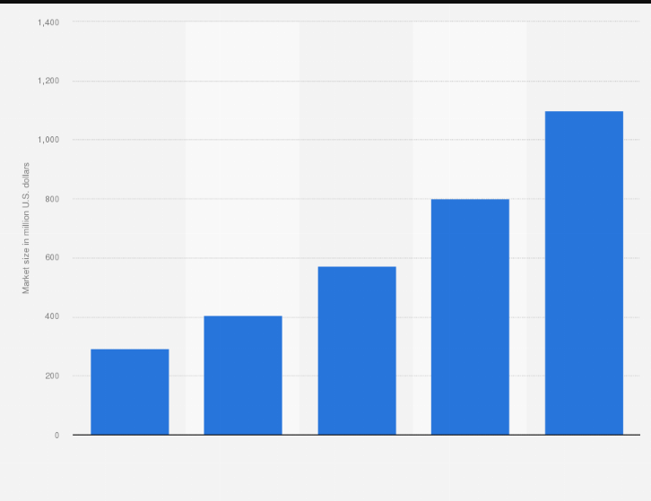

(Source: Statista.com, 2023)

## Appendix 2: Utilization of technology

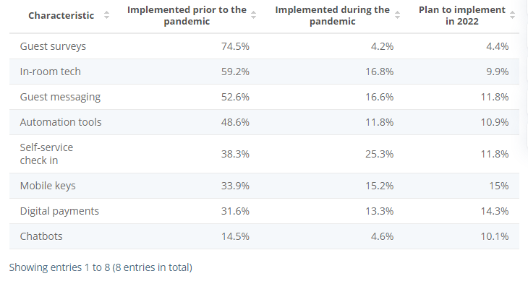

(Source: Statista.com, 2023)