**COURSEWORK 2 (CW2) - INDIVIDUAL PROJECT REPORT**

Executive Summary

The report provides a discussion on the project of creating a YouTube channel featuring videos on the development of a POS system for the business operations of Mart. The report provides a critical evaluation of the project management methodologies along with a review of the project to identify the areas that could have been improved. Further, there is a critical reflection on the report followed by recommendations to improve the management of future projects.

Table of Contents

Introduction 3

Critical evaluation of project management methodologies 3

Review of Project 4

Project Scope 4

Project Strategy 4

Work Breakdown Structure 5

Network Diagram 5

Gantt Chart 7

Critical presentation of the Communication Plan 8

Comprehensive Risk Management Plan 10

Critical presentation of Resource and Cost allocation 11

Critical discussion on the project control System 12

Evaluation and critical reflection on the Performance of Project 13

Critical Reflection on the Management of Project 15

Future Recommendations 15

Conclusion 16

Reference List 17

# Introduction

Project Management refers to the process of managing a project by utilising the expertise, skills, and knowledge of project team members to deliver value to the client of the project in the form of predetermined deliverables. This report discusses the project undertaken to develop a YouTube channel with 4 videos that explain the Point of Sale (POS) system developed for Mart to address operational issues like human error and improve efficiency. There is also a discourse on the project communication plan, risk management plan, resource and cost allocation, project control system, and the performance of the project. In addition, there is a critical reflection on the management of the project along with future recommendations for improving the project management process.

# Critical evaluation of project management methodologies

Project management methodologies represent the overarching guidelines that help in planning, managing, and executing projects. Prominent project management methodologies include the Waterfall and Agile methodologies (Thesing *et al.* 2021). According to Thesing *et al.* (2021), the Waterfall methodology emphasises rigid incremental steps to managing and executing projects that make it difficult to revisit completed phases. The waterfall methodology can provide an advantage to the project by helping complete the project within the pre-decided timeframe by discouraging reworks like remodifying work done in already completed phases of a project. However, it can lead to lowered flexibility of the YouTube project using the waterfall methodology because of the lack of modification of earlier phases to improve project outcomes, which can lead to lower client satisfaction.

Furthermore, the Agile methodology emphasises an iterative approach that uses client feedback to create continuous releases with small modifications to flexibly create an improved deliverable version with every iteration (Dursun and Goker, 2022). The YouTube project can gain benefit from the Agile methodology by continuously adapting the project to better suit client needs by flexibly making modifications to any part of the project, whether completed earlier or not. However, the Agile methodology can lead to the project going over its timeline because modifying the project deliverable based on every feedback can increase the time required for the project completion.

Based on the discussion above, it is apparent that the Agile methodology is more useful in continuous and long-term projects that can afford to have a flexible timeline to generate higher client satisfaction rates. However, the Waterfall methodology is critical for shorter projects that have a rigid timeline for completion (Akhmetshin *et al.* 2019). In this context, the Waterfall methodology has been used in the project to manage the project because it is a shorter project with only 32 days duration having a non-flexible timeline.

# Review of the project

## Project Scope

The scope of a project provides an outline of a project that defines the overall needs, outcomes, and process of the project. The scope of the project includes the development of a POS system for Mart that features the usage of Barcode scanners, Management Information System (MIS) computers, dot matrix printers, and other computing devices like laptops and smartphones. The project utilises these elements to create a comprehensive sale system for Mart in terms of improving the efficiency of the sale management process and minimising errors by using technological tools like computer calculations. Further, the project scope covers the usage of cloud database systems to improve the processing power of the POS system for Mart.

## Project Strategy

The strategy of the project has been focused on implementing a digital POS system to improve customer satisfaction, operational efficiency and accuracy, and help scale the system to the needs of the growing business Mart. However, the strategy of the project has led to some issues like a higher cost due to digital transformation and internet dependency that makes customer satisfaction dependent on network stability. Further, there is a need to train employees of Mart to properly use the new POS system. Threats like cybersecurity because of increased reliance on digital technologies can lead to competitive losses (Antunes *et al.* 2021). Opportunities like real-time reporting and remote access to manage sale processes can be helpful in improving the outcomes of the project strategy.

## Work Breakdown Structure

**Figure 1: WBS**

(Source: Created by the author)

The work breakdown structure (WBS) comprises 6 major phases named planning, analysis, design, development, testing, and deployment. The incremental approach to project management has helped to satisfactorily accomplish the requirements of individual phases and sub-activities in the YouTube project.

## Network Diagram

|  |
| --- |

**Figure 2: Network Diagram**

(Source: Created by the author)

The network diagram is important to understand the relationship between the different activities of a project.

## Gantt Chart

|  |
| --- |

**Figure 3: Gantt Chart**

(Source: Created by the author)

# Critical presentation of the Communication Plan

| **Communication Strategy** | **Activities** | **Responsible person** |
| --- | --- | --- |
| **Communication among the team** | Online and offline meetings | Project Manager |
| **Communication with viewers** | Social Media Marketing | Project Team |

**Table 1: Communication Plan**

(Source: Created by the author)

The stakeholders directly connected to the project included the project supervisor, project manager, and project team members. The communication plan emphasised communication among these stakeholders through online and offline meetings along with e-mails to ensure that the project can be completed satisfactorily. The project management process requires an extensive communication strategy for enabling collaboration among project managers and members (Fischer *et al.* 2020). In this context, the project achieves a suitable level of operational quality by utilising both online and offline meeting media such as tools for communication and collaboration among the stakeholders in the project team including members, managers, and supervisors. Thus, the communication plan helped in improving the collaborative quality within the whole project team. However, it can be analysed that the plan focused on formal communication among the team which can lower the quality of the communication outcomes due to the lack of free sharing of innovative ideas. Therefore, the project communication plan enabled the project to effectively fulfil the project goals by improving collaboration among the project team.

A communication plan focuses on networking aspects of a project that help in ensuring smooth project operations by maintaining the support of stakeholders. Furthermore, the communication with the viewers and subscribers of the YouTube channel and videos are important stakeholders as they comprise the audience of the videos developed as part of the project. The project communication plan detailed that social media marketing can help in communicating with the intended audience of the YouTube videos. Social Media Marketing is useful in reaching out to a wide audience because of the massive user base of platforms like Facebook and Instagram (Li *et al.* 2021). In this context, the communication plan helped enhance the communication with the intended audience of the project through marketing on Facebook and Instagram.

# Comprehensive Risk Management Plan

| **Risk** | **Probability** | **Impact** | **Risk Level** | **Control measures** |
| --- | --- | --- | --- | --- |
| Breach of data through POS system | Medium | High | High | Implement firewall |
| Network downtime | High | High | Very High | A regular check of the network |
| Compatibility issues among computers and the new POS system | Low | Medium | Low | Updating computers |
| Lack of user adoption of the new POS system | Medium | Medium | Medium | Provide staff training |
| Cybersecurity issues like hacking and fraud | High | High | Very High | Using antivirus software |
| Loss of data due to hardware failure in the POS system | Low | High | Low | Regular firmware updates |

**Table 2: Risk Register**

(Source: Created by the author)

The risk management plan covered a wide range of vulnerabilities of the project including cybersecurity, network issues, and compatibility issues with the older and newer systems. According to Table 1, the cybersecurity risks and network downtimes present very high risks that can severely limit the reliability of the new POS system in Mart. Cybersecurity risks have arisen due to the growing reliance on digital technologies, which have made newer organisational processes vulnerable to hackers that can attain unapproved access to digital systems (Antunes *et al.* 2021). In this context, cybersecurity risks can lead to the stoppage of the new POS system resulting in severe limitations on the project outcomes. Therefore, it can be analysed that these risks represent serious challenges for the project. For this purpose, the project adopts control measures like the adoption of firewalls and antivirus software to protect the digital system and network against malefic parties. Furthermore, firewall and antivirus software also protect the project from the risk of data breach from the new POS system that can lead to the lowered competitiveness of Mart. Thus, these measures help the project achieve favourable outcomes that can lead to the satisfaction of the project clients by mitigating the important risks that can degrade the project outcomes. Other risks include data breaches, lack of implementation of POS, and compatibility issues, for which control strategies include regular updates to systems and provision of staff training.

# Critical presentation of Resource and Cost allocation

The major resources that have been used in the project include the expertise of the team members, computers, laptops, internet connectivity, and cameras to make the YouTube videos. The expertise of the project team includes soft skills, coordination and collaboration, cross-cultural environment, and Leadership skills. An effective project team requires members to work properly with each other and have good collaborative ability to help in the satisfactory fulfilment of their responsibilities within a project (Fernandes and O'sullivan, 2022). In this context, the project team resources have been critical in achieving favourable project outcomes through extensive collaboration among the team members along with a division of work to generate positive deliverables.

| **Activity** | **Cost (in pounds)** |
| --- | --- |
| Planning | 1000 |
| Analysis | 2000 |
| Design | 4000 |
| Development | 5000 |
| Testing | 2000 |
| Deployment | 1000 |
| Making YouTube videos | 500 |
| Others | 500 |
| **Total** | **16,000** |

**Table 3: Cost Allocation**

(Source: Created by the author)

The cost allocation strategy of the project has included a division of financial resources in the different stages of the project named “planning, analysis, design, development, training, and deployment.” The overall cost of the project is 16,000 pounds with most of the cost being allocated to the design and development process for the new POS system. Further, the cost allocation has included a budget for the making of the final YouTube videos for the channel on the platform.

# Critical discussion on the project control system

The project control system represents the mechanism that helps in managing the activities included in a project to ensure the generation of suitable outcomes within the predetermined time frame and budgetary limitations. The control system adopted in the YouTube project included an emphasis on daily reporting of the progress of the tasks in the project. Regular reports helped the project manager to stay up-to-date on the progress of the overall project, and identify any emerging issues in the earlier stages. Furthermore, regular reporting of project progress has helped in minimising resource wastage by helping to accurately determine the resources required to complete unfinished tasks. The project control system also emphasised regular audits by the project supervisors to check that the project has been progressing according to the predetermined timeframe and within the decided budgetary allocations. Project management requires regular checks to identify any issues within a project and avoid cost overruns (Layton *et al.* 2020). The independent audits by the project supervisor have helped the project to accurately determine the progress of the project and avoid any emerging issues by addressing these in the earlier stages when they have a lower impact.

The implementation measures for addressing any emerging issues consist of the project supervisor making decisions for any changes that can help solve operational issues like delays in activities. However, the project control system had limited effectiveness in managing the individual progress of the employees because the system emphasised evaluating the overall project activities. Thus, the project control system can be improved by adding individual evaluation metrics to improve the analysis of the performance of each team member associated with the project.

# Evaluation and critical reflection on the performance of the project

Evaluation of the performance of a project is important to ensure the development of professional skills in individuals to help them improve the performance of their future projects. The project had the goal of generating 200 subscribers per video with a viewership of 2,000 on each video released on YouTube. However, the views on the videos range from 20 to 500 with the YouTube channel having 47 subscribers (Savatar IT Mentors, 2023). Thus, it can be analysed that the project is growing to achieve its aims. The project focused on creating a functional POS system for Mart that had good features like the ability to track inventory and notify sales to automated databases. However, the project has yet to garner the expected response from viewers on YouTube.

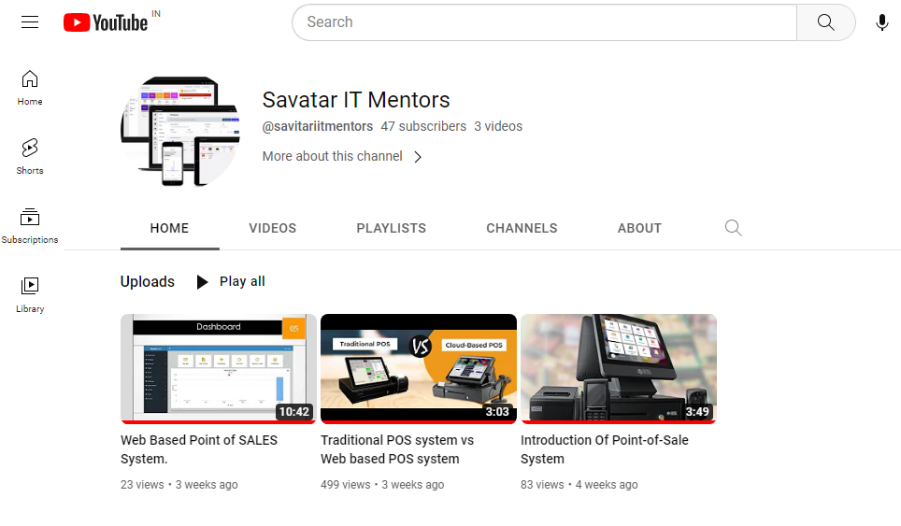**Figure 4: YouTube channel**

(Source: Savatar IT Mentors, 2023)

I believe that the usage of animations and other appealing visuals instead of a PowerPoint-based presentation can improve the performance of YouTube videos and help in achieving the required outcomes. However, it can be understood that the project performed well on other deliverables including the development of a functional POS system for Mart that can be used to improve operational efficiency and minimise human errors in the workplace. The number of POS terminals has been growing in the UK, representing their usefulness, with the value reaching almost 3 million in 2019 (Statista, 2023). Furthermore, the developed POS system features the ability to manage inventory and identify any misplacements of the stocks in the operations of Mart. In this context, it is easy to understand that the POS system has been successful in improving the operational outcomes at Mart.

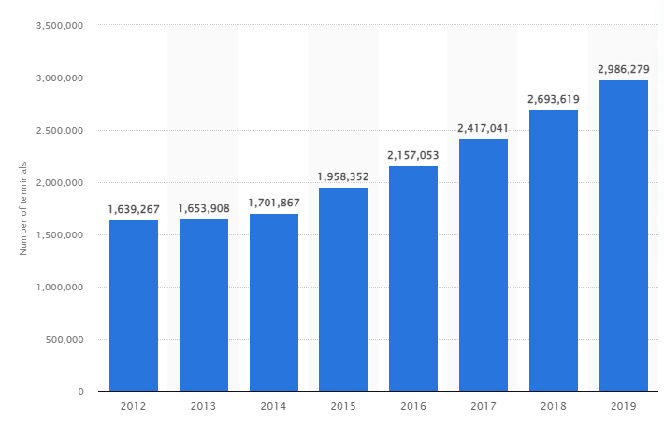

**Figure 5: Growth of POS terminals in the UK**

(Source: Statista.com, 2023)

# Critical reflection on the management of the project

In my opinion, the management of the project has been largely successful due to the implementation of a Waterfall methodology using rigid timelines and cost allocations. However, the project had limited favourable results in YouTube viewership and growth of subscribers. In this context, I believe that a lack of animations and appealing imagery has led to lower interest of the audience in the developed YouTube videos. Thus, it can be said that an emphasis on rigid PowerPoint-based presentations lowered the project outcomes.

## Future Recommendations

**Hosting informal sharing of ideas**

Future projects can be improved by using an informal communication approach to improve the idea-sharing and idea-co-development process among the team members and managers. It can help in improving the level of innovation and creativity in projects that can improve project outcomes.

**Using creative suggestions from the team**

Future projects can also gain benefit from the creative ideas of team members. Thus, collaboration to gain creative suggestions from team members can help improve project quality.

# Conclusion

In conclusion, this report provides information on the project management methodologies followed by a review of the project. The project of making YouTube videos based on the newly developed POS system for Mart has been successful in improving the organisational efficiency of Mart. However, the project has been lacking in achieving the planned viewership and subscriber growth for the YouTube channel. In conclusion, it can be said that a better presentation of the videos could have improved the project outcomes by using animations and appealing imagery. Furthermore, it is easy to understand that the project has helped in improving the operational quality of Mart. However, it can be concluded that future projects can be improved from an informal idea-sharing process to include innovation and creativity through the free-sharing of ideas among team members and managers to improve the project outcomes.

# Reference List

Akhmetshin, E.M., Romanov, P.Y., Zakieva, R.R., Zhminko, A.E., Aleshko, R.A. and Makarov, A.L., (2019). Modern approaches to innovative project management in entrepreneurship education: A review of methods and applications in education. *Journal of Entrepreneurship Education*, 22, pp.1-15.

Antunes, M., Maximiano, M., Gomes, R. and Pinto, D., (2021). Information security and cybersecurity management: A case study with SMEs in Portugal. *Journal of Cybersecurity and Privacy*, 1(2), pp.219-238.

Dursun, M. and Goker, N., (2022). Evaluation of Project Management Methodologies Success Factors Using Fuzzy Cognitive Map Method: Waterfall, Agile, And Lean Six Sigma Cases. *International Journal of Intelligent Systems and Applications in Engineering*, 10(1), pp.35-43.

Fernandes, G. and O’sullivan, D., (2022). Project management practices in major university-industry R&D collaboration programs–a case study. *The Journal of Technology Transfer*, pp.1-31.

Fischer, M., Imgrund, F., Janiesch, C. and Winkelmann, A., (2020). Strategy archetypes for digital transformation: Defining meta objectives using business process management. *Information & Management*, 57(5), p.103262.

Layton, M.C., Ostermiller, S.J. and Kynaston, D.J., (2020). *Agile project management for dummies*. John Wiley & Sons.

Li, F., Larimo, J. and Leonidou, L.C., (2021). Social media marketing strategy: definition, conceptualization, taxonomy, validation, and future agenda. *Journal of the Academy of Marketing Science*, 49, pp.51-70.

Savatar IT Mentors, (2023). *Savatar IT Mentors*. Available at: https://www.youtube.com/channel/UC7ZCKUbmApDFhJd75dV0mRQ [Accessed on: 10.4.23]

Statista.com, (2023). *The total number of POS terminals in the United Kingdom (UK) from 2012 to 2021*. Available at: https://www.statista.com/statistics/444938/number-of-pos-terminals-the-united-kingdom/ [Accessed on: 10.4.23]

Thesing, T., Feldmann, C. and Burchardt, M., (2021). Agile versus waterfall project management: decision model for selecting the appropriate approach to a project. *Procedia Computer Science*, 181, pp.746-756.