**STUDENT NAME: MADHURI**

**STUDENT ID: 22043592**

**MODUEL NAME: CW3 DISSERTATION**

**MODUEL LEADER: EWA CARLTON**

**SUPERVISOR: MDASADUZZAMAN KHAN**

**SUBMISSION DATE: 17-JAN-2023**

**WHAT SHOULD ENTREPRENEURS KNOW WHEN CREATING BUSINES PLANS IN THE 21ST CENTURY?**

**Abstract**

Entrepreneurship appears to gain significant interest in the contemporary business world as it has been able to increase economic growth and stability within the market. The first chapter in this study has therefore analysed the background of entrepreneurship and its association with successful business planning. The chapter has also set the aims, objectives and research questions for analysing the factors that help entrepreneurs’ successful business plans. In addition, the chapter has also provided an overview of the methodological choices and overall structure of the dissertation.

The literature review chapter has highlighted the role of entrepreneurs in the corporate sector. In addition, this chapter has discussed the challenges faced by entrepreneurs to improve the business operation system and increase economic growth. The second chapter has also identified the concept of entrepreneurship and its essential characteristics in respect of corporate business planning. On the other hand, the chapter has also explored the strategic measures that may help to overcome the challenges of successful business planning. This chapter includes a literature gap and conceptual framework to understand the aspects consumed in this chapter.

The methodological chapter has enlightened the applied methods in order to observe the factor which entrepreneurs need to evaluate before starting businesses in the 21st century. Additionally, this chapter has also shed light on illustrating the ethical aspects which have been strictly maintained throughout this study. Furthermore, great emphasis has also been laid on evaluating the validity and reliability of this study in a detailed manner. Lastly, the inclusion of the limitations has been effective in highlighting the gaps in this section.

The study has also presented the findings of the primary survey and analysed them in order to identify the factors that are important to reduce the challenges of making an effective business plan.

The discussion chapter has illustrated the key findings derived by analysing the results. It has also shed light on discussing the factors and barriers which need to be considered by entrepreneurs before establishing a business start-up in 21st-century marketplaces.

The conclusion chapter has summarised the main points of this study vividly. In addition, a strong focus has also been laid on providing effective recommendations to assist entrepreneurs to achieve success and business growth. The synchronisation of the objectives with this study has also been highlighted in this section in a detailed manner. Additionally, the key limitations and future benefits of this research have also been incorporated in the conclusion chapter.

**Table of contents**

Chapter 1: Introduction 7

1.0 Research Background 7

1.1 Research Rationale 8

1.2 Research Aim and Objectives 9

1.3 Research Questions 10

1.4 Research Significance 10

1.5 Structure of Dissertation 10

Chapter 2: Literature Review 12

2.0 Introduction 12

2.1 Concept of entrepreneurship within the corporate industry in the 21st century 12

2.2 Role of entrepreneurs in developing a business plan in the modern times 13

2.3 Key factors that are required to be learned by entrepreneurs in order to create a successful business plan in the 21st century 16

2.4 Challenges faced by entrepreneurs to develop entrepreneurship in terms of creating effective business plans in modern times 18

2.5 Potential Strategies to increase the effectiveness of Business Planning in Entrepreneurial activities 19

2.5.1. Improving the Strategic Level of Business Planning 19

2.5.2. Modifying the Operational level of busin*ess planning* 20

2.5.3. Rectification in the Tactical Levels of Business Planning 20

2.6 Theoretical Perspectives 21

2.6.1. Diffusion of Innovation Theory 22

2.6.2. Consumer-Behaviour Theory 23

2.6.3. Fiedler’s Contingency Model 24

2.7 Gap in Literature 24

2.8 Conceptual Framework 25

2.9 Chapter Summary 26

Chapter 3- Methodology 27

3.0 Introduction 27

3.1 Philosophy of the research 27

3.2 Research Approach 27

3.3 Design of the Research 28

3.4 Research Strategy 28

3.5 Data Collection Method 29

3.6 Data Analysis 30

3.7 Sample Size and Sampling Technique 30

3.8 Validity and Reliability 31

3.9 Ethical Considerations 31

3.10 Limitations 31

3.11 Summary 31

Chapter 4: Data Analysis and findings 33

4.2Data Analysis 33

4.3. findings 48

4.3 Summary 51

Chapter 5: Discussion 52

Chapter 6: Conclusion 55

6.1 Conclusion 55

6.2 Recommendations 55

6.3 Linking with objective 56

6.4 Limitation 57

6.5 Future scope 57

References 58

Appendix 1- Questionnaire 64

**List of Figures**

Figure 1.1: Increase in Entrepreneurial business in the UK since 2000 9

Figure 1.2: Top reasons for Failure in Entrepreneurial activities 11

Figure 1.3: Dissertation Structure 13

Figure 2.1: Seven Essential Characteristics of Entrepreneurship 15

Figure 2.2: Fundamental roles of entrepreneurs in the corporate sector 18

Figure 2.3: Role of entrepreneurs in the global industry 20

Figure 2.4: Four Stages of Risk Management 23

Figure 2.5.: Diffusion of Innovations Theory 24

Figure 2.6: Consumer Behaviour Model 25

Figure 2.7: Fiedler’s Contingency Model 26

Figure 2.8: Conceptual framework 28

Figure 4.5: Achievement of long-term mission and vision of business 36

Figure 4.6: Ways to measure the success of a business 37

Figure 4.7: Important factors to frame a business plan in the modern era 38

Figure 4.8: Likelihood of facing barriers in framing a business plan in the 21st century 39

Figure 4.9: Digital channels are appropriate for communicating business plans 40

Figure 4.10: Observation of Customer Satisfaction in the Modern Era 41

Figure 4.11: Publicity gain for business in the target market 42

Figure 4.12: Procedures for retaining existing customers 44

Figure 4.13: Planning to increase your brand visibility 45

Figure 4.14: Delivering finished goods to the market 46

Figure 4.15: Resources required in terms of increasing your productivity 47

**List of Tables**

Table 4.5: Achievement of long-term mission and vision of business 35

Table 4.6: Ways to measure the success of a business 37

Table 4.7: Important factors to frame a business plan in the modern era 38

Table 4.8: Likelihood of facing barriers in framing a business plan in the 21st century 39

Table 4.9: Digital channels are appropriate for communicating business plans 40

Table 4.10: Observation of Customer Satisfaction in the Modern Era 41

Table 4.11: Publicity gain for business in the target market 42

Table 4.12: Procedures for retaining existing customers 43

Table 4.13: Planning to increase your brand visibility 44

Table 4.14: Delivering finished goods to the market 46

Table 4.15: Resources required in terms of increasing your productivity 47

# Chapter 1: Introduction

## 1.0 Research Background

Entrepreneurial activities have gained prominence in the contemporary world as it has positively affected organisational innovation and accelerated the economic growth in business. Based on its rising importance in both organisational profit and sustainability, the share of entrepreneurs has significantly increased over the global platforms. Since 2011, the share of entrepreneurial start-ups has increased by 61% within the international platform so that B2B solutions can be offered to customers (Statista.com, 2022). In the UK, the number of fresh entrepreneurs within the industry has increased by 0.36% since 2020 with an annual turnover of almost 4.16 trillion GBP (Statista.com, 2022). Accordingly, it can be stated that entrepreneurial businesses hold a considerable opportunity for growth in the market.

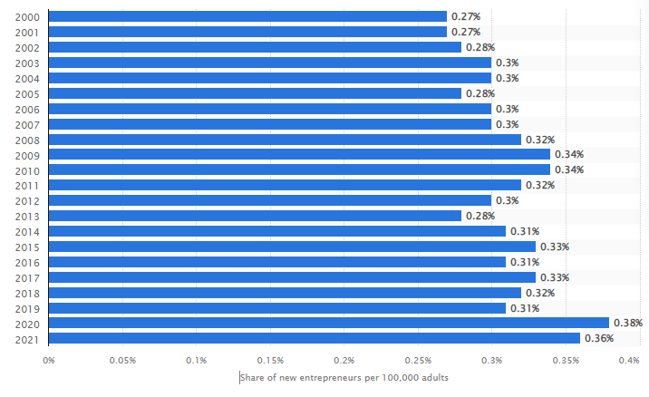

#### Figure 1.1: Increase in Entrepreneurial business in the UK since 2000

(Source: Statista.com, 2022)

Following this context, it is also to be noted that the success of entrepreneurship lies in the development of a successful business plan. As per the opinion of Byun *et al.* (2018), successful business planning in entrepreneurship helps to increase the effectiveness of organisational operations and assess the potential risks in advance. Successful entrepreneurial organisations including Tesla, Apple and Facebook manifest detailed planning of their business that has helped them to avoid potential risks and deal with sudden challenges. For example, in the last six years, one of the most famous entrepreneurs Steve Jobs has directed the business planning of Apple on a Merger and Acquisition strategy that has helped the company to gain the biggest revenue in recent times, with 111.4 billion USD in the first quarter of FY2021 (Bbc.com, 2021). On the other hand, the lack of sufficient planning in terms of the protection of health data in private groups has caused Facebook a loss of 87 million users in 2021 (Bbc.com, 2019). Thus, based on the following findings, it can be stated that it becomes essential for the entrepreneurs of modern times to know some critical factors that incorporate success into a business plan.

## 1.1 Research Rationale

Based on the above analysis, it can be stated that Entrepreneurship has become a dominant trend in recent times. Almost 27 million people within the UK have been associated with the entrepreneurial business in recent times (Statista.com, 2022). As a result, the number of private enterprises has increased to 5.51 million within the UK (Statista.com, 2022). Hence, it can be stated that Entrepreneurial business has become a major source for creating job opportunities within both national and international platforms. However, it is to be noted that with rapid globalisation, a constant shift is observed within the market trends and customer preferences.

Accordingly, it can be stated that ***the issue is*** the successful development of a business plan in entrepreneurship. Successful business plan creation has become ***an issue because*** entrepreneurial business majorly depends on implementing innovative ideas in the practical fields supported by research and development. As a result, it includes a threat of being failed from all financial, technological and competitive perspectives. Hence, a lack of successful business planning may result in missing potential opportunities for growth, failure to turn a profit and leading the business in the wrong direction.

In present times, it has ***become an issue now*** because most entrepreneurial businesses fail due to a lack of sufficient planning on marketing research or resource allocation. As seen in Figure 1.2, in recent times, 70% of tech entrepreneurs are found to fail in their attempts due to a lack of any regard for the adjacent market, improper planning of resources or development of the right team in business planning (Statista.com, 2022). In addition, lost focus on customer preferences and issues in pricing planning are also significant contributors to the failures of business start-ups.

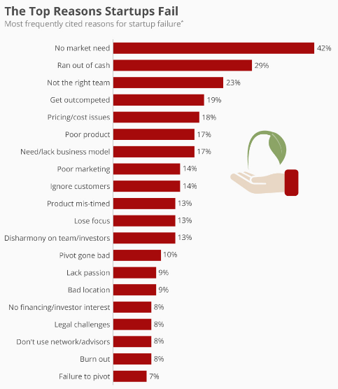

#### Figure 1.2: Top reasons for Failure in Entrepreneurial activities

(Source: Statista.com, 2022)

Consequently, the completion of the following study would therefore shed light on the challenges that create barriers to the development of a successful business plan and the factors that contribute to the feasibility and sustainability of those plans.

## 1.2 Research Aim and Objectives

***Aim***

The aim of this research is to identify the factors that are essential for entrepreneurs to know as well as adopt in terms of creating an effective business plan in the 21st century.

***Objectives***

The fundamental purpose of this research is to investigate key points that entrepreneurs need to follow while developing business plans-

1. To identify the key factors that are responsible for the successful management of a business plan creation
2. To evaluate the role of entrepreneurs in successful business planning and organisational growth
3. To analyse the potential challenges that may disrupt the development of the business plan in modern times
4. To explore the alternative strategies that may help entrepreneurs to overcome challenges and improve business plans

## 1.3 Research Questions

Based on the above research aim and objectives, the present study has attempted to derive the solution to the following questions-

Q1) What are the key factors that are responsible for the successful management of a business plan creation?

Q2) What role do entrepreneurs play in ensuring organisational goals through a successful business plan?

Q3) What potential challenges are faced by entrepreneurs in case of developing a successful business plan?

Q4) What alternative strategies can be undertaken by the entrepreneurs to overcome the challenges of developing a successful business plan and improving business performance?

## 1.4 Research Significance

Based on the above findings, it can be stated the process of business planning helps an entrepreneur identify the specific requirements of success within a business and explore the areas of improvement accordingly. The completion of the following study would help to effectively establish the intricate association between entrepreneurial activities and business plan development. In addition, the study would also help modern entrepreneurs to get a detailed overview of the factors that contribute most towards the success of a business plan. On the other hand, the sturdy would also bring forth the limitations and challenges faced in business plan development so that modern entrepreneurs can be motivated to improve their business strategies accordingly.

## 1.5 Structure of Dissertation

#### Figure 1.3: Dissertation Structure

(Source: Created by the Author)

In this present study, to analyse the factors that are significant for developing successful business planning, the study has included six chapters. The first chapter provides an introductory overview of the key research area in terms of this research's aims, objectives and rationale. The Second chapter, the Literature Review Section in this study provides a critical overview of the existing literature from a theoretical perspective on the research topic and analyses the gap in it. The third chapter has included the Methodology section. It has evaluated the methodological choices for data collection and data analysis in this study. The fourth chapter includes the Findings and analysis and the fifth chapter provides an overall discussion of the topic. The sixth and final chapter includes a conclusion on the study with the appropriate recommendations and its future scopes.

# Chapter 2: Literature Review

## 2.0 Introduction

Entrepreneurs help businesses to develop innovative and effective business plans that can help business firms in creating creative products and services. Entrepreneurs enable organisations to take risks in terms of introducing innovative technologies that reflect on increasing economic growth. This chapter has identified the concept of entrepreneurship to evaluate its role in successfully managing a business. In addition, this chapter has described the challenges faced by entrepreneurs along with effective strategies to overcome the challenges in order to effectively develop business strategy. Additionally, this chapter includes a conceptual framework and literature gap that is helpful to understand the key points identified in this chapter.

## 2.1 Concept of entrepreneurship within the corporate industry in the 21st century

The goal of entrepreneurship is to develop competitive competency within the organisation and increase innovation and creativity within the business. Hence, the very idea of entrepreneurship within the corporate industry includes the development of new approaches not only towards business ideas rather also towards organisational structure, managerial aspects, ownership of the business, and empowerment of the team members. As a result, the concept of entrepreneurship has achieved a wider dimension within the business world of the 21st Century.

In contemporary literature, multiple definitions of Entrepreneurship have been designed. As per the observations of Doren*et al.* (2021), entrepreneurship can be defined as the process of planning, organising and running a new business initiative to generate profit despite having financial risks. Accordingly, it can be stated that entrepreneurial activities have been directly associated with both leadership and managerial qualities. Following this context, Tittle and Terzidis (2020) have observed that the entrepreneurial competencies of modern business executives can be defined as inspiration for integrating the strategic skills of the leaders with that their managerial skills and knowledge management skills. Hence, it can be stated that entrepreneurship has played a crucial role in designing and launching the shape of a business and adding economic value to it.

Among the available definitions that establish the concept of Entrepreneurship within the business, ***Schumpeter’s theoretical perspective of entrepreneurship*** becomes significant. Schumpeter’s Theory of Entrepreneurship has argued that entrepreneurship can be perceived as a creative destruction that breaks the circulatory system inherent to an organisation. As per the observations of Mehmood *et al.* (2019), Schumpeter’s perception of Entrepreneurship captures its ability for setting a disruption towards market equilibrium. Hence, it can be interpreted from the above definitions that the individuals who play an active role in the case of introducing a new idea or a service or product within the market can be termed an entrepreneur.

#### Figure 2.1: Seven Essential Characteristics of Entrepreneurship

(Source: Created by the Author)

However, the implementation of entrepreneurship within the recent corporate industry manifests certain characteristics. As per the observations of Hameed and Irfan (2019), successful entrepreneurship has depended on seven essential features. These seven essential elements of building entrepreneurial ventures have included an affinity for innovation, aspiration for higher achievements and goals, locus of control, positive attitude toward risks, propensity for taking risks, providing motivation and exhibiting fortitude. Based on these essential characteristics, an individual becomes able to introduce new products within the corporate market and create substantial opportunities for job creation within the market.

## 2.2 Role of entrepreneurs in developing a business plan in the modern times

Entrepreneurs are known for their individual capability and creativity that helps them to lead a business successfully as well as increase the economic and performance growth of the organisations. As per the view of Tur-Porcaro*et al.* (2018), entrepreneurs play an important role in developing business whereas the major significance of entrepreneurs lies in driving sustainable operation systems to boost economic growth. Therefore, the most impactful role of entrepreneurs is to drive the economic performance of an organisation by adopting innovative business plans to develop a creative product range or services. This also implies that entrepreneurs enable organisations to identify the commercial needs in the current market and take risks to develop a strong market value for the products and services.

**Planning and initiating business activities**

Planning and initiating a business plan is one of the most important roles of entrepreneurs that further enable them to launch the plan in the current market. Entrepreneurs are responsible to evaluate the strategic progress that enables them to understand changing market demand. According to Ratten (2020), entrepreneurs are capable of satisfying the market need by introducing innovative ideas that result in generating effective products or services for the well-being of communities. Thus, it can be said that planning and leading business activities are major responsibilities of an entrepreneur in order to make effective decisions, create and venturing opportunities along with increasing employee engagement.

**Identifying and recruiting talents**

One of the significant roles of entrepreneurs is finding and recruiting proper talents in their projects and business in order to increase the operational efficiency of the organisation. As per the view of Malik *et al.* (2020), recruiting an appropriate and skilled workforce is one of the entrepreneurial behaviours that benefit enterprises to gain talented employees for proper responsibilities. Thus, it implies that entrepreneurs have the ability to attract as well as retain talented employees which further results in increasing competitiveness within the operational settings. Moreover, entrepreneurs' behavioural adaptation among employees supports them to enhance their productivity and capabilities which is reflected in the increasing financial growth and productivity of the organisations.

**Forecasting changes in the business environment**

Another role of entrepreneurs is forecasting the potential as well as risks in terms of creating opportunities for business firms to sustain their growth and market value in the current market. As mentioned by Bacq *et al.* (2020), the major aspect of entrepreneurs is to anticipate the potential challenges along with addressing the issues to minimise financial damage. Hence, this indicates that entrepreneurs can forecast the possible changes that help organisations to take necessary initiatives to prevent any financial and operational damage due to sudden changes.

**Identifying opportunities in business**

Entrepreneurs are also responsible to create opportunities for business firms which can result in increasing the sales and products of the services market. As per the opinion of Foss *et al.* (2019), entrepreneurs in the corporate sector are gaining popularity due to their capability to seek opportunities in deploying products according to customers’ needs. Therefore, entrepreneurs hold a significant role in identifying the market needs in order to bring necessary changes in products and services that have further benefited the organisations to improve and expand their business in the global market.

**Identify and take risks**

It is an important factor for business firms to take risks in order to learn new skills and business processes that help organisations to evolve their business system for better outcomes. As per the findings of Haugh (2021), entrepreneurs help enterprises to measure and analyse the risks in terms of reducing their impact on the business system. In this case, the entrepreneurs provide support to organisations in developing organisational competency in order to mitigate the risks by bringing significant improvements in the product or service system as well as attracting more investors to accelerate the business growth.

**Developing strategic partnership**

Developing partnerships is an effective business strategy to sustain the growth of the business along with launching new products or services in a competitive market. In the corporate sector, entrepreneurs are seeking out opportunities for creating partnerships with renowned companies that can accelerate the expansion of the business in terms of acquiring new customers in the global market. As per the knowledge of Sabirov *et al.* (2021), effective partnership development enabled business firms to make informed decisions for future improvement as well as gain more investments. Hence, it can be stated that entrepreneurs support businesses to maximise their market capability and future prospects by creating strategic partnerships in the global market. This reflects the increasing market growth and development of organisations in terms of achieving competitive advantages.

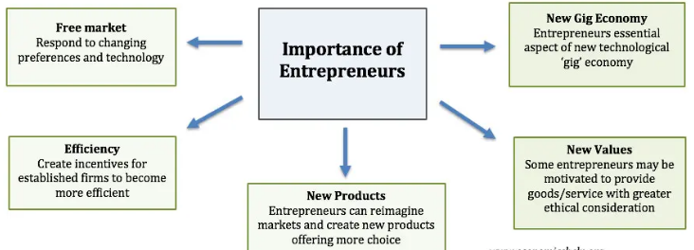

#### Figure 2.2: Fundamental roles of entrepreneurs in the corporate sector

(Source: Inspired by Tur-Porcar *et al.* 2018)

## 2.3 Key factors that are required to be learned by entrepreneurs in order to create a successful business plan in the 21st century

**Promoting creativity and accumulation of new ideas**

Entrepreneurs are required to adopt the creativity within their working system that can benefit them to accumulate their innovative ideas in an operational system. As commented by Del Giudice *et al.* (2019), entrepreneurs help business firms to improve their already existing ideas by implementing their own innovations. In addition, entrepreneurs offer their efforts in launching new ideas or bringing changes to existing products or services by integrating unique technologies. Thus, it can be said that in the current industry organisations are encouraging employees in developing entrepreneurship behaviour in order to generate innovative ideas that can be helpful to reach the customer’s demands. This can further result in increasing market share and brand value of the organisations due to increasing customer satisfaction and experiences while using the products or receiving services.

**Adopting risk tolerances**

Entrepreneurs need to possess the capabilities of risk tolerances that can help them to identify the potential risks as well as take risks for better improvement. As opined by Saeidi *et al.* (2019), risk tolerances can result in driving investment for organisations in order to expand their business portfolio and potentiality in a competitive market. Hence, it can be stated that entrepreneurs need to enhance their risk tolerance capability which can further help the business firms to attract more investors in low or high-risk business environments. It can result in increased investment in the project or products that have been beneficial for business firms to make informed decisions to achieve success in the globally competitive market.

**Being responsive to opportunities**

It is essential for entrepreneurs to be responsive towards availability as well as potential opportunities in order to develop competitive advantages in the global industry. As mentioned by Liu (2020), being responsive toward market changes along with new opportunities for business expansion can generate a sharp difference between successful entrepreneurs and business failure. Thus, it indicates that it is necessary for entrepreneurs to develop the capability to adopt and gain opportunities for future improvement. This can result in increasing the potential of entrepreneurs and also benefit organisations to expand their business portfolio among global customers. Hence, it is evident that entrepreneurs need to adopt responsiveness to opportunities that can support them in self-development and business firms to implement changes for achieving competitiveness.

**Providing motivation to workers**

A significant aspect of being an entrepreneur is to motivate employees in order to encourage them in sharing their ideas and cultivating uniqueness in their skills. As per the findings of Boldureanu *et al.* (2020), entrepreneurs result in creating a defined vision for employees that motivates them to dedicate themselves to performing a better job in terms of achieving target success. In this instance, entrepreneur leaders inspire their employees to improve their personal capabilities in terms of increasing the productivity of each employee along with the entire operating system. Therefore, entrepreneurial leaders lead organisations towards success by adopting new ideas and capitalising these ideas in initiatives to create opportunities for employees as well as firms in further improvement. This can lead to motivating and inspiring the employees to take the opportunity in sharing their thoughts which can reflect on the financial growth and operational stability within the organisations.

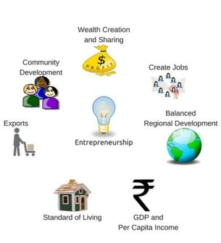

#### Figure 2.3: Role of entrepreneurs in the global industry

(Source: Influenced by Del Giudice *et al.* 2019)

## 2.4 Challenges faced by entrepreneurs to develop entrepreneurship in terms of creating effective business plans in modern times

**Poor employee management**

Entrepreneurs guide organisations and employees towards target success by instructing and communicating with each employee. As per the observation of Cletus *et al.* (2018), communication is an essential factor that enables organisations to embed the organisational goal and visions among employees. In this case, the majority of entrepreneurs face obstacles to communicating with co-workers that have resulted in creating barriers to cultivating entrepreneurship behaviour within the organisational settings. It further results in a lack of employee management that reflects in the decreasing organisational productivity due to inefficient management and leadership to achieve business goals.

**Difficulties in product or service development**

Entrepreneurs possess the skills to develop innovative products or services that can gain attention from global customers due to their uniqueness and features. In this case, organisations are struggling to develop entrepreneurship due to a lack of innovation and uniqueness in cultivating products or services among employees. As opined by Tien *et al.* (2019), product design and service planning play a significant role in acquiring customers in the global market. Therefore, it can be said that the lack of uniqueness and skills in developing new products or services has led to creating challenges for organisations in adopting entrepreneurship in terms of generating innovative products and services. It can lead to creating barriers to further development and improvement in the product manufacturing process to design innovative products as well as services.

**The poor implication of business strategy**

Creating business and sales plans can result in creating opportunities for business firms within a certain community. As mentioned by Jelonek *et al.* (2022), a lack of a defined business strategy can lead to effective and smooth expansion of business in the global market. In this case, entrepreneurs are struggling to create an effective business strategy to sell and market the product in the global market. This can affect the business in terms of reaching its organisational goals in a competitive market.

**Lack of budget maintenance and generating revenues**

In the case of adopting entrepreneurship in the organisation, it is important to provide people training to employees. In this instance, the lack of capital for training has resulted in creating issues for organisations in developing entrepreneurship. As per the view of O’Reilly and Binns (2019), proper budget maintenance drives performance growth to organisations in terms of developing market growth by acquiring new customers. Hence, the increasing issues of budget maintenance have been affecting the performance of entrepreneurs which also has reflected in the decreasing revenue generation of the organisation.

## 2.5 Potential Strategies to increase the effectiveness of Business Planning in Entrepreneurial activities

Based on the above discussion, it can be stated that for maintaining the flow of business operations and reducing the financial risks in business, it becomes important for entrepreneurs to implement some effective strategies. As per the observations of Pasha *et al.* (2020), effective business planning can be conducted from three levels including the strategic level, the tactical level and the operational level. Hence, improving the business planning techniques from these three domains can help the entrepreneurs of the 21st century to achieve organisational goals and reduce potential risk factors.

### 2.5.1. Improving the Strategic Level of Business Planning

***Developing a Market Analysis***

A thorough research of the existing markets based on various frameworks and models such as SWOT, PESTLE and VRIO helps entrepreneurs to get a detailed overview of both the external and internal environment of the organisation. In addition, strategic market research with help of Porter’s Five forces model becomes crucial for determining the position of the organisation within the respective industry (Anastasiu *et al.* 2020). Thus, a market analysis may help in bringing clarity about the advantages and challenges that the business plan may face.

***Identifying the target consumer segment within the industry***

Determining the target consumer segment increases the appropriateness of the business plan. In association with STP Analysis, the entrepreneurs can effectively analyse the requirements of the target population from both their behavioural and psychographic perspectives. As a result, they can eventually modify the idea of their new products or services accordingly.

### 2.5.2. Modifying the Operational level of busin*ess planning*

***Planning the Budgetary and Financial constraints***

The role of budgetary planning becomes a crucial aspect in dealing with financial constraints. In the views of Chugunov and Makohon (2019), based on the fiscal strategy, it becomes essential for entrepreneurs to assess their financial resources, determine their expenses and set financial goals accordingly. In addition, reviewing the budget on a regular basis may also help the entrepreneurs to optimise the cost and resources.

***Conducting Competitor Analysis***

Performing a competitor analysis in the process of business planning helps an entrepreneur to get a better insight into the industry and identify the areas of improvement. In addition, as per Bogers *et al.* (2019), a competitor analysis helps the business plan to become more dynamic in terms of analysing the marketing strategies and pricing policies for the business. Hence, it can be stated that conducting a competitor analysis may help modern entrepreneurs too to increase their competitiveness on global platforms and ensure the feasibility of their business plan.

### 2.5.3. Rectification in the Tactical Levels of Business Planning

***Conducting Frequent Risk Analysis***

Frequent risk analysis appears to play the most crucial role in improving a business. According to Shad *et al.* (2019), frequent risk analysis with corporate business planning helps to avoid unwanted situations and maintain the flow of business. In addition, it also adds to the sustainable development of economic growth. In this aspect, the risk management model with its four stages may become effective. The four stages of the ***Risk Management Model*** include Risk Acceptance, Risk Transference, Risk Avoidance and Risk Reduction. Based on these four strategies, the entrepreneurs would be able to gain a competitive advantage and reduce both financial and operational risks.

#### Figure 2.4: Four Stages of Risk Management

(Source: Created by the Author)

***Developing a contingency plan***

In business planning, Contingency planning refers to setting a course of action that helps to design effective responses towards a particular crisis or a complicated situation. Hence, based on the findings of frequent risk analysis, it becomes essential for entrepreneurs to develop a contingency plan. According to the observations of Obrenovic *et al.* (2020), the development contingency plan helps business executives to sustain their business operations and increase productivity in times of crisis. In this aspect, ***Fiedler’s Contingency Model*** becomes effective. According to Le *et al.* (2021), this model helps to analyse the characteristics of the present situation. Thus, it can be stated that it helps to determine leadership and managerial directions befitting the present situation.

## 2.6 Theoretical Perspectives

### 2.6.1. Diffusion of Innovation Theory

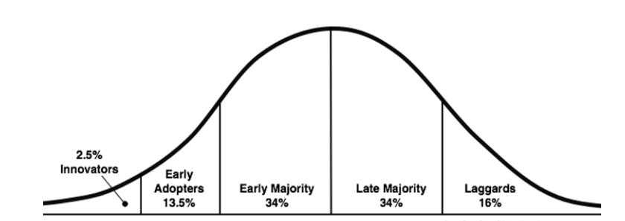

#### Figure 2.5.: Diffusion of Innovations Theory

**(Source:** García-Avilés *et al.* 2019**)**

The Diffusion of Innovations theory focuses on the identification of early influences that helps to accelerate the acceptance of consumers towards a new product or service. According to the findings of García-Avilés *et al.* (2019), the theory suggests that a new idea or service achieves its momentum within the respective market in respect of a specific population within the society and fades away over time as well. Accordingly, the key factors of this theory have included the early adopters, the laggards, the early majority and the late majority. The early adopters help to increase the acceptance of the new product within the target market and the late majority helps to sustain the demand for the specific product within the specific population of the adjacent society. Following this context, it becomes essential for entrepreneurs that they consider thorough market research and segment the target audience accordingly to increase the success and feasibility of their new business plans.

### 2.6.2. Consumer-Behaviour Theory

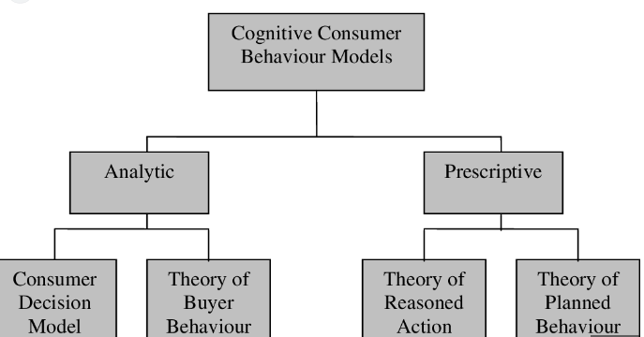

#### Figure 2.6: Consumer Behaviour Model

(Source: Giza and Wilk, 2021)

The application of the consumer-behaviour theory also becomes essential as it helps to study the pattern of buying decisions and their purchasing attitude. As per the views of Giza and Wilk (2021), the consumer behaviour theory positively influences the buying behaviour of the customers and reduces uncertainties within the acceptance of the business plan among the target consumers. The theory suggests that consumer behaviour can be categorised into four segments including habitual buying, variety-seeking buying, dissonance-reducing buying and complex buying behaviour. Hence, the theory becomes essential for entrepreneurs in case of analysing the requirements of the target consumers and adopting the strategies of marketing accordingly.

### 2.6.3. Fiedler’s Contingency Model

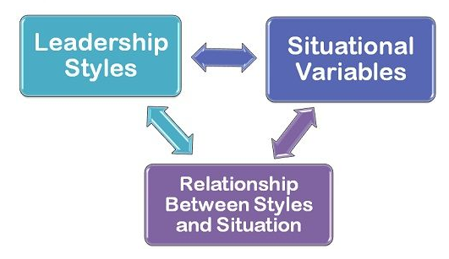

#### Figure 2.7: Fiedler’s Contingency Model

(Source: Shaikh and Shaikh, 2019)

Analysing the contingency plans plays a significant role in reducing the risk factors and increasing the feasibility of a plan. In reducing the risk factors and undertaking an alternative measure, the application of Fiedler’s Contingency Model becomes appropriate. As per the observations of Musavinejad and Nastiezaie (2018), this contingency model suggests that in order to emerge as an effective business executive or organisational leader, it becomes essential to assess the situation and determine the current direction for strategic leadership. Accordingly, the major elements of this contingency model have included leadership style exhibited by entrepreneurial leaders, situational variables, and relationship management between leadership styles and situations. As per the observations of Shaikh and Shaikh (2019), Fiedler’s contingency model in association with situational leadership theory helps entrepreneurial leaders to increase the dynamic approach within their business planning.

## 2.7 Gap in Literature

This chapter has discussed various factors of entrepreneurship in terms of assessing the key roles of entrepreneurs in creating business plans in modern times. However, there is a gap in the current literature in terms of a detailed analysation of key factors that are helpful to developing entrepreneurship in the current industry. Moreover, the lack of relevant literature regarding specific entrepreneurship in the corporate world has resulted in creating a deficiency in resources for developing an in-depth understanding of the fundamental components to adopt entrepreneurship.

## 2.8 Conceptual Framework

**Role of entrepreneurs in developing a business plan in the modern times**

Entrepreneurs are known for their individual capability and creativity that helps them to lead a business successfully as well as increase the economic and performance growth of the organisations.

**Key factors that are required to be learned by entrepreneurs in order to create a successful business plan in the 21st century**

* **Promoting creativity and accumulation of new ideas**
* **Adopting risk tolerances**
* **Being responsive to opportunities**
* **Providing motivation to workers**

**Potential Strategies to increase the effectiveness of Business Planning**

* Improving the Strategic Level of Business Planning
* Developing a Market Analysis
* Modifying the Operational level of business planning
* Planning the Budgetary and Financial constraints
* Developing a Market Analysis
* Rectification in the Tactical Levels of Business Planning
* Conducting Frequent Risk Analysis
* Developing a contingency plan

**Challenges faced by entrepreneurs to develop entrepreneurship in terms of creating effective business plans in modern times**

Entrepreneurs guide organisations and employees towards target success by instructing and communicating with each employee.

**Concept of entrepreneurship within the corporate industry in the 21st century**

* The goal of entrepreneurship is to develop competitive competency
* Entrepreneurial competencies of modern business executives can be defined as inspiration for integrating the strategic skills of the leaders with that their managerial skills

#### Figure 2.8: Conceptual framework

(Source: Created by author)

## 2.9 Chapter Summary

This chapter has highlighted that the most significant role of entrepreneurs lies in creating innovative products to generate industry revenues and boost the economic growth of an organisation. In addition, this literature review chapter has addressed the issues faced by entrepreneurs in the current corporate market in terms of product development, implicating business strategies as well as maintaining the budget. Additionally, it is evident that organisations can benefit from entrepreneur adaptation in terms of boosting their economic growth, creating opportunities as well as taking advantage of promoting their innovative products.

# Chapter 3- Methodology

## 3.0 Introduction

The methodology chapter has focused on highlighting the utilised methods in terms of collecting and interpreting real-time data based on this specific research topic. In addition, this section has incorporated the ethical dimensions and validity of this research study. This chapter has also included specific limitations which have created gaps in the methodological application.

## 3.1 Philosophy of the research

“Research philosophy” refers to the personal belief of an individual researcher based on the ways by which relevant data can be gathered and analysed in order to successfully produce accurate outcomes. In accordance with the statements of Kumatongo and Muzata (2021), “research philosophy” can be mainly classified into “positivism research philosophy” and “interpretivism research philosophy”. Accordingly, the ***“positivism research philosophy”*** has been implied in this study in order to accurately synchronise with the collection and usage of “primary data”. Based on the observations of Ayeni *et al.* (2019), the “positivism research philosophy” remarkably assists an individual researcher in setting accurate hypotheses in a research study and further testing those to generate high-quality results. Thus, applying the “positivism philosophy” seems to be effective in analysing the key factors entrepreneurs should consider before starting businesses in the 21st century.

Furthermore, the “positivism philosophy” has also been advantageous in gathering and analysing “quantitative data” accurately by integrating the chosen participants. As mentioned by Dawadi *et al.* (2021), the “positivism philosophical approach” facilitates researchers to accumulate and examine first-hand “quantitative data”. Consequently, the usage of “positivism philosophy” has been fruitful in collecting realistic data from authentic primary sources based on the factors which need to be understood by entrepreneurs for starting a business in the 21st century.

## 3.2 Research Approach

The approach of research can be defined as the overall plan and procedure which are utilised by a researcher in order to achieve the desired outcomes through valid data interpretation successfully. As per the comments of Pittman (2021), the “research approach” can be identically divided into two main groups which are the “inductive research approach” and the “deductive research approach”. Accordingly, the ***“inductive research approach”*** has been adopted and implicated in this study in order to evaluate valid data based on the dimensions which should be comprehended by entrepreneurs before establishing a business start-up in the 21st century. According to the viewpoints of Kiger and Varpio (2020), the “inductive research approach” is a powerful and flexible procedure in data collection and analysis. This advantageous feature of the “inductive research approach” has eventually proved to be highly beneficial in the context of amalgamating real-time data relevant to this specific research topic.

Additionally, the “inductive approach” has also been significant to evaluate the in-depth meaning of data. As stated by Rashid *et al.* (2019), the “inductive approach” enables researchers to carry out an in-depth exploration of sourced data. Hence, the “inductive approach” has been appropriate in accurately recognising the business factors which need to be examined by entrepreneurs before starting a business in the 21st century.

## 3.3 Design of the Research

“Research design” refers to the process by which an individual researcher attempts to create a link among the different variables of research in a logical and systematic manner. Based on the opinions of Asenahabi (2019), “research designs” can be mainly classified into three groups which are the “explanatory research design”, the “exploratory research design” and the “descriptive research design”. Consequently, the ***“descriptive research design”*** has been applied in this study in order to accumulate and interlink different variables for finding the factors which should be considered by entrepreneurs before establishing businesses in the 21st century.

In addition, the “descriptive research design” has turned out to be significant in creating a relationship among various elements and variables in this study by comprehending their respective significance. As per the comments of Hong *et al.* (2018), the ”descriptive research design” facilitates an individual researcher to describe the distribution and relationship among existing variables in research. This influential dimension of the “descriptive research design” has been fruitful in this research in terms of linking the various factors like market analysis and business plans in this study. Additionally, the aforementioned factors need to be investigated by entrepreneurs in order to achieve success in their businesses within 21st-century marketplaces. As a consequence, it can be determined that the “descriptive research design” has been effective in successfully synchronising the independent and dependent variables in this research study by identifying their actual importance.

## 3.4 Research Strategy

Selecting and applying a proper research strategy is crucial for researchers in order to produce accurate deliverables by gathering and analysing data in a coherent manner. “Research strategy” can be explained as the “step-by-step” method followed by a researcher to eventually generate error-free outcomes. In accordance with the viewpoints of Abutabenjeh and Jaradat (2018), “research strategies” can be classified into “the qualitative research strategy”, “the quantitative research strategy” and “the mixed methods research strategy”. Accordingly, the ***“quantitative research strategy”*** has been implicated in this study in order to source and obtain first-hand primary data by engaging the selected respondents.

Furthermore, the “quantitative research strategy” has been effective in order to gather important facts from numeric data which have been gathered by involving the participants through surveys. According to the findings of Basias and Pollalis (2018), it is simpler and more convenient to calculate and compare numeric data by applying the “quantitative research strategy. This beneficial dimension of “quantitative research strategies” has eventually been effective in calculating the numeric and statistical results derived from the surveys. In addition, interpreting the collected numeric data through “quantitative research strategies” has been significant in understanding real-time scenarios of the key market factors which need to be comprehended by entrepreneurs before starting their businesses in the 21st century.

## 3.5 Data Collection Method

Gathering real-time and realistic data is essential for an individual researcher in the context of generating precise research results by avoiding the collection of vague data. “Data collection” refers to the methodological way of accumulating relevant data based on a particular research topic. The article by Moises Jr (2020), states that surveys are the key methods of collecting data in “quantitative research”. Accordingly, a ***“survey”*** has been used in this study to collect first-hand primary data by engaging the chosen respondents ***[Refer to appendix]***. Furthermore, “survey” has also turned out to be advantageous in terms of gathering ample amounts of real-time primary data by interacting actively with the adjacent population. As per the statements of Banks and Xu (2020), “surveys” provide great “statistical power” to researchers to effectively collect large volumes of numeric data in “quantitative research”. In addition, using “a survey” as the key “data collection method” has also proved to be valuable in order to amalgamate a wide range of data from the relevant population.

This data collection strategy has further highlighted the factors that need to be examined before starting businesses in the 21st century by interpreting the responses of the involved participants. Based on the ideas of Duncan (2022), “surveys” are appropriate methods of gathering huge volumes of numeric and statistical data by connecting with a large population. Thus, it can be stated that the “survey” and the “survey questionnaire” have emerged as appropriate methods of recognising the factors which entrepreneurs need to understand before starting businesses in the 21st century.

## 3.6 Data Analysis

“Data analysis” indicates the ways by which researchers evaluate, examine and interpret collected data in a logical and statistical order. In accordance with the observations of Nunfam *et al.* (2018), “data analysis methods” can be divided into “the thematic data analysis method”, “the narrative data analysis method”, “the statistical data analysis method” and “descriptive data analysis method”. Accordingly, the “statistical data analysis process” has been implied through the usage of graphs, charts and tables in this study to extract precise numeric data from the involved respondents. This aspect has been advantageous in interpreting data relevant to the dimensions which entrepreneurs need to recognise before starting businesses in 21st-century markets. As commented by Islam (2020), the “statistical data analysis” process simplifies the interpretation of numeric data in “quantitative research”. Thus, the “statistical data analysis” has been effective in calculating the numeric responses of the chosen candidates.

## 3.7 Sample Size and Sampling Technique

***Sample Size***

Choosing an appropriate sample is vital for researchers in terms of amalgamating an adequate amount of valid data by interacting with the selected population conveniently. As a consequence, a sample size of ***“70 entrepreneurs who have been in the field of business for at least 3 years”*** has been chosen to collect authentic primary data. In addition, this specific sample has been involved by providing a ***“set of questionnaires”*** which contains ***“15 relevant questions”***. Furthermore, the respective responses of the chosen entrepreneurs have been fruitful in understanding the key factors which should be investigated before starting a business in the 21st century.

***Sampling Technique***

The ***“random probability sampling technique”*** has been applied to arrange the selected sample size in a systematic manner. As per the ideas of Rahman *et al.* (2022), the “random sampling method” is a probability sampling technique which allows a researcher to randomly select valid participants from a large population. As a consequence, the “random probability sampling method” has turned out to be advantageous in involving efficient participants to gather unbiased real-time data based on this specific topic in terms of increasing the opportunities for each participant to be involved in the sample size of the research. Accordingly, it can be analysed that the “random probability technique” has been precise in understanding the factors which entrepreneurs need to consider achieving success in business in the 21st century.

## 3.8 Validity and Reliability

Great emphasis has been laid on collecting and using genuine data and information which has been effective in terms of positively enhancing the validity of this study. In addition, the content of this research has not been copied from any existing source which has further influenced the reliability of this study significantly. Furthermore, the collection of vague and invalid data has been strictly prohibited while conducting this research study which has also turned out to be valuable in maximising the validation and reliability of this study. Besides these factors, a strong focus has also been laid on accumulating first-hand data through the “survey” which has eventually produced accurate results. Lastly, none of the data has been extracted from any sort of unauthorised data source which has ultimately preserved the overall validation and reliability of this research study positively.

## 3.9 Ethical Considerations

Deliberate attempts have been made on preventing the leakage of confidential data by storing the collected data in a secure database. Besides this protective measure, the guidelines of the ***“Data Protection Act of 2018 in the UK”*** have also been strictly followed to conserve the analysed data safely. The ***“Data Protection Act of 2018 in the UK”*** provides effective outlines in terms of successfully preventing the leakage of private data (Legislation.gov.uk, 2022). In addition, the prevention of data leakage has been effective in successfully preserving the identity of the data providers. Apart from these, informed consent has been taken from the involved participants before engaging them in the “survey”. On the other hand, genuine “in texting” has been done throughout this study which has also restricted the occurrence of any sort of misconduct in this study.

## 3.10 Limitations

This research study seems to have focused only on utilising “primary quantitative data” to highlight the factors which entrepreneurs need to comprehend before establishing business start-ups in 21st-century marketplaces. Contradictorily, the usage of “secondary qualitative data” has been completely neglected in this study which has eventually degraded the overall accuracy of this research study. Accordingly, the inclusion of “secondary qualitative data” might have been beneficial in terms of acquiring more volumes of genuine data based on this particular research topic. Hence, it can be determined that the exclusion of “secondary qualitative data” has been the key drawback in this research study.

## 3.11 Summary

This chapter has summarised the ways by which the “quantitative research strategy” and adjacent methodological tools have been significant in finding the factors which entrepreneurs need to consider before starting businesses in the 21st century. Additionally, this section has also provided detailed information about the validity, ethical dimensions and limitations of this research study.

# Chapter 4: Data Analysis and findings

**4.1 Introduction**

Developing a successful business plan becomes a major challenge for entrepreneurs in the age of increasing competition as there has been a constant shift in market trends and consumer requirements. Accordingly, the chapter has analysed the primary survey findings regarding factors that are essential to know in developing a successful business plan for entrepreneurs.

## Data analysis

| **Question 1: What is your age?** | | |
| --- | --- | --- |
| **Responses** | **Respondents** | **Percentage** |
| **18-24** | **10** | **5** |
| **25-34** | **50** | **25** |
| **35-44** | **50** | **25** |
| **45-54** | **40** | **20** |
| **55 and above** | **50** | **25** |
| **Total** | **200** | **100** |

**Table 4.1 Responses to survey question 1**

(Source: Created by Author)

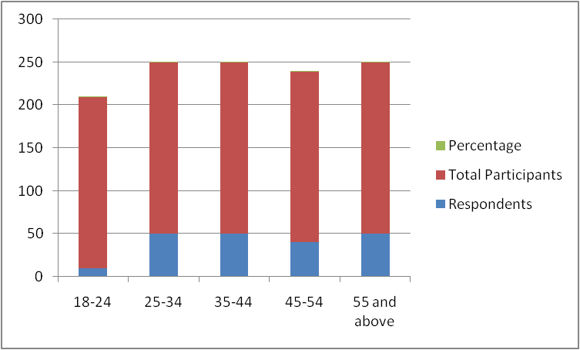

**Figure 4.1: Responses to the first survey question**

(Source: Created by the Author)

**Comments**

It has been observed that the minimum percentage of the chosen participants belong to the youngest age group of 18 to 24. On the other hand, 25% of the selected candidates belong to the oldest age group of 55 and above.

| **Question 2: What is your gender?** | | |
| --- | --- | --- |
| **Responses** | **Respondents** | **Percentage** |
| **Male** | **160** | **80** |
| **Female** | **35** | **17.5** |
| **Others** | **5** | **2.5** |
| **Total** | **200** | **100** |

**Table 4.2: Responses based on gender orientation**

(Source: Created by the Author)

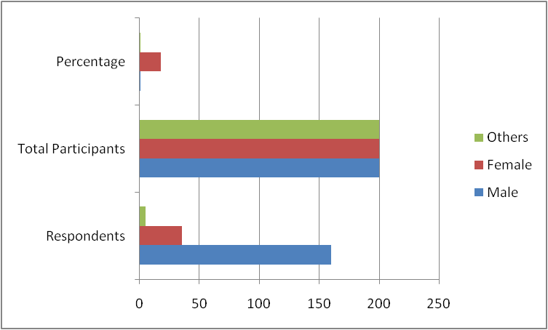

**Figure 4.2: Responses to the second survey question**

(Source: Created by the Author)

**Comments**

It has been derived from the above-framed table that the maximum percentage of the selected candidates is male. On the other hand, the minimum percentage of the chosen participants belongs to the third gender.

| **Question 3: What is your highest level of education?** | | |
| --- | --- | --- |
| **Responses** | **Respondents** | **Percentage** |
| **High School** | **10** | **5** |
| **Associate’s Degree** | **100** | **50** |
| **Bachelor’s Degree** | **30** | **15** |
| **Master’s Degree** | **40** | **20** |
| **Doctorate Degree** | **20** | **10** |
| **Total** | **200** | **100** |

**Table 4.3: Responses for educational qualifications**

(Source: Created by Author)

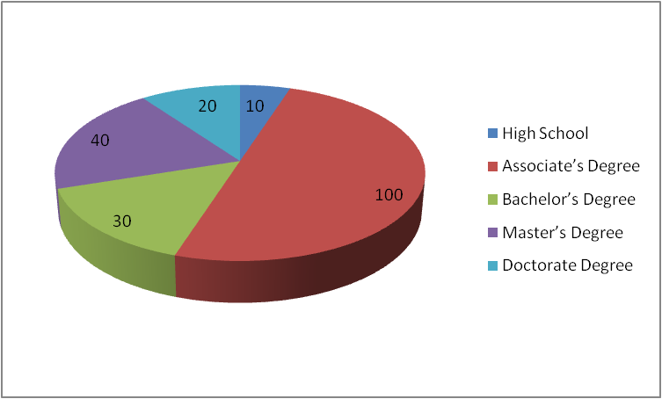

**Figure 4.3: Overview of the responses to the third survey question**

(Source: Created by Author)

**Comments**

It has been found by analysing the above-mentioned table that the maximum percentage of the chosen participants hold the “Associate’s Degree”. On the other hand, the minimum percentage of the selected candidates seems to belong to high school.

| **Question 4: What is the issue which is being addressed in your business?** | | |
| --- | --- | --- |
| **Responses** | **Respondents** | **Percentage** |
| **Financial Issues** | **120** | **60** |
| **Management Issues** | **65** | **32.5** |
| **Marketing Issues** | **15** | **7.5** |
| **Total** | **200** | **100** |

**Table 4.4: Responses for the fourth survey question**

(Source: Created by Author)

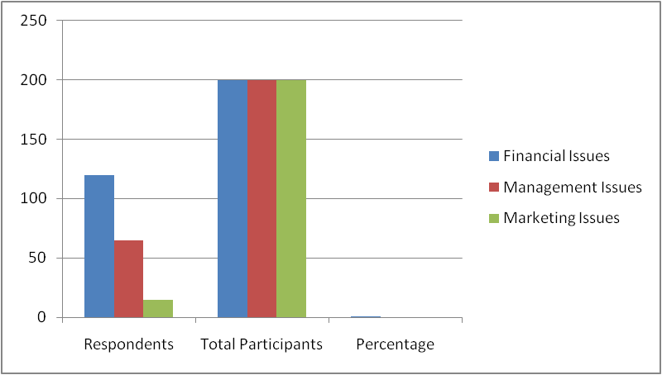

**Figure 4.4: Responses to the fourth survey question**

(Source: Created by the Author)

**Comments**

It has been observed from the above-stated table that the maximum percentage of the chosen candidates responded that financial issues have been addressed in this business. In contrast, the minimum percentage of the chosen participants have opined that this business is addressing marketing issues.

| **Q5 Do you think that you can achieve the long-term mission and vision of your business?** | | |
| --- | --- | --- |
| **Response** | **Number of Participants** | **Percentage** |
| Strongly Agree | 40 | 20 |
| Agree | 90 | 45 |
| Neutral | 20 | 10 |
| Disagree | 40 | 20 |
| Strongly Disagree | 10 | 5 |
| Total | 200 | 100 |

##### Table 4.5: Achievement of long-term mission and vision of business

(Source: Created by the Author)

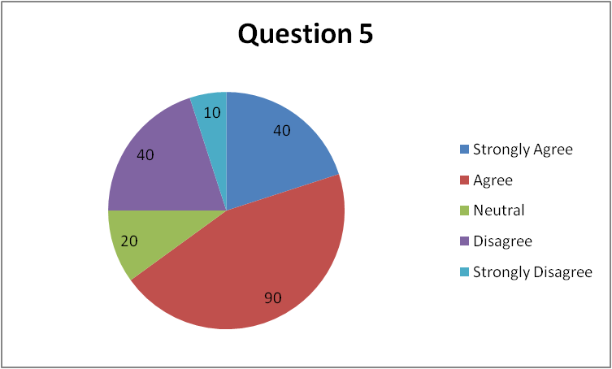

#### Figure 4.5: Achievement of long-term mission and vision of business

(Source: Created by the Author)

As per the findings of Question 5, 45% of participants have agreed that they believe that their business can achieve its long-term mission and mission. On the other hand, 20% of respondents strongly agreed with the statement. Furthermore, 10% and 20% of participants responded as being neutral and in disagreement with the statement respectively. Lastly, 5% of respondents strongly disagreed with the statement.

| **Q6 Do you think you can measure the success of your business?** | | |
| --- | --- | --- |
| **Response** | **Number of Participants** | **Percentage** |
| Strongly Agree | 10 | 5 |
| Agree | 60 | 30 |
| Neutral | 80 | 40 |
| Disagree | 40 | 20 |
| Strongly Disagree | 10 | 5 |
| Total | 200 | 100 |

##### Table 4.6: Ways to measure the success of a business

(Source: Created by the Author)

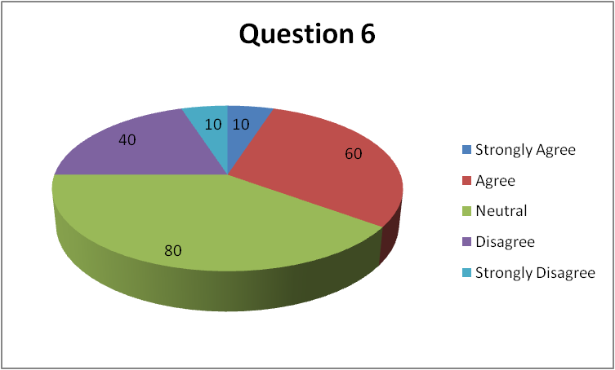

#### Figure 4.6: Ways to measure the success of a business

(Source: Created by the Author)

In response to Question 6, only 5% of participants strongly agreed that they can measure the success of their business while 30% agreed with the statement. Further, the highest proportion of participants numbering 40% have been neutral in the statement. However, 20% and 5% of respondents disagreed and strongly disagreed with the statement respectively.

| **Q7 What are the factors which you think you should know before framing a business plan in the modern era?** | | |
| --- | --- | --- |
| **Response** | **Number of Participants** | **Percentage** |
| Consumer Demands | 120 | 60 |
| Employee Demands | 20 | 10 |
| Supply chain issues | 60 | 30 |
| Total | 200 | 100 |

##### Table 4.7: Important factors to frame a business plan in the modern era

(Source: Created by the Author)

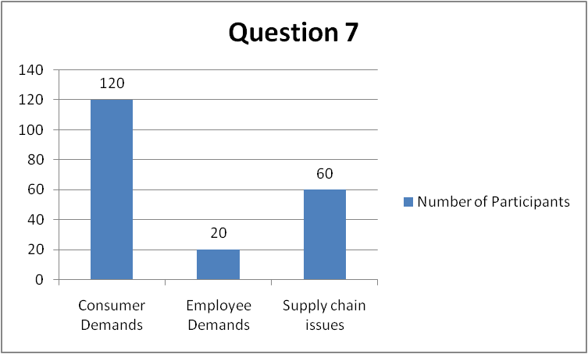

#### Figure 4.7: Important factors to frame a business plan in the modern era

(Source: Created by the Author)

Following the response to Question 7, it has been determined that 60% of the respondents believed that consumer demands form an important factor to understand before framing a business plan. Furthermore, 10% of respondents have indicated that employee demands are an important factor for framing a business plan in the modern era while 30% have responded that supply chain issues need to be considered in the process.

| **Q8 Do you agree that you will face barriers while framing a business plan in the 21st century?** | | |
| --- | --- | --- |
| **Response** | **Number of Participants** | **Percentage** |
| Strongly Agree | 90 | 45 |
| Agree | 70 | 35 |
| Neutral | 30 | 15 |
| Disagree | 10 | 5 |
| Strongly Disagree | 0 | 0 |
| Total | 200 | 100 |

##### Table 4.8: Likelihood of facing barriers in framing a business plan in the 21st century

(Source: Created by the Author)

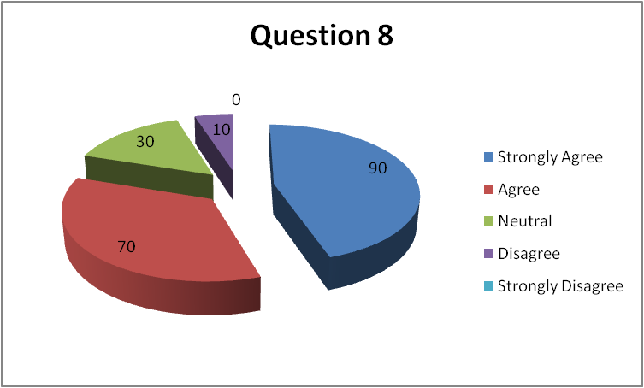

#### Figure 4.8: Likelihood of facing barriers in framing a business plan in the 21st century

(Source: Created by the Author)

In response to Question 8, 45% of participants responded that they strongly agree that they will face barriers while framing a business plan in the 21st century. Furthermore, 35% of respondents agreed with the statement while 15% responded naturally. Lastly, 5% of participants disagreed with the statement and 0% strongly disagreed with the question.

| **Question 9: Do you agree that digital channels will be appropriate for communicating your business plans and objectives to the employees in the 21st century?** | | |
| --- | --- | --- |
| **Responses** | **Respondents** | **Percentage** |
| **Agree** | **150** | **75** |
| **Disagree** | **30** | **15** |
| **Neutral** | **20** | **10** |
| **Total** | **200** | **100** |

##### Table 4.9: Digital channels are appropriate for communicating business plans

**(Source: Created by author)**

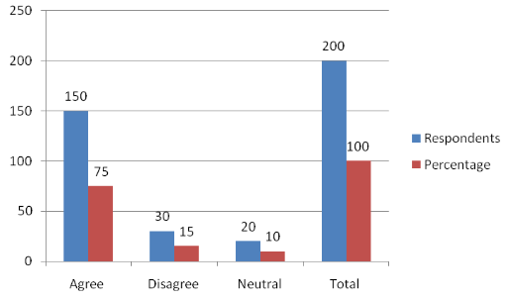

#### Figure 4.9: Digital channels are appropriate for communicating business plans

**(Source: Created by author)**

**Comment:** Based on the above graph, it can be said that 150 participants have agreed that the digital network can be easier for communicating business plans and objectives with the employees. Moreover, 15% of participants disagreed that digital communication could not be effective for business communication. However, 10% of participants stayed neutral in this discussion. Therefore, digital channels are effective for communicating in business.

| **Question 10: Do you think you can observe customer satisfaction in the modern era?** | | |
| --- | --- | --- |
| **Responses** | **Respondents** | **Percentage** |
| **Agree** | **145** | **72.5** |
| **Disagree** | **25** | **12.5** |
| **Neutral** | **30** | **15** |
| **Total** | **200** | **100** |

##### Table 4.10: Observation of Customer Satisfaction in the Modern Era

**(Source: Created by author)**

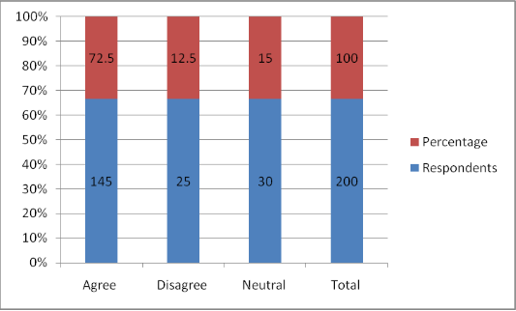

#### Figure 4.10: Observation of Customer Satisfaction in the Modern Era

**(Source: Created by author)**

**Comment:** According to the above graph, it can be identified that 145 participants among 200 agreed that the satisfaction level of customers can be observed in this modern era. On the other hand, 12.5% of participants disagreed that the satisfaction level of customers can not be observed in this competitive modern era. However, 30 participants stayed neutral in this discussion. Thus, the observation of customer satisfaction levels is important for developing the b business in this modern era.

| **Question 11: Do you think your business will gain publicity in the target market?** | | |
| --- | --- | --- |
| **Responses** | **Respondents** | **Percentage** |
| **Agree** | **135** | **67.5** |
| **Disagree** | **35** | **17.5** |
| **Neutral** | **30** | **15** |
| **Total** | **200** | **100** |

##### Table 4.11: Publicity gain for business in the target market

**(Source: Created by author)**

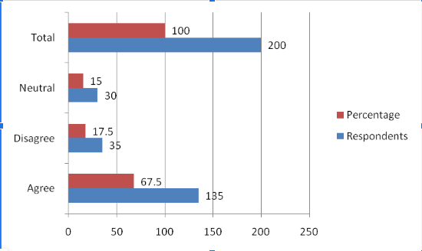

#### Figure 4.11: Publicity gain for business in the target market

**(Source: Created by author)**

**Comment:** Based on the above graph, it can be evaluated that 67.5% of participants believed that the business will gain publicity in this target business. On a contradictory note, 17..5% of participants disagreed with the fact that gaining publicity in business is a difficult factor in this modern era. However, 30 participants were neutral regarding this discussion. Hence, it can be said that publicity is an important factor for business in this target market.

| **Question 12: What are the procedures by which you will retain your existing consumers?** | | |
| --- | --- | --- |
| **Responses** | **Respondents** | **Percentage** |
| **Manufacturing unique products** | **35** | **17.5** |
| **Offer Discounts** | **95** | **47.5** |
| **Lower the selling prices of the products** | **40** | **20** |
| **I don’t know** | **30** | **15** |
| **Total** | **200** | **100** |

##### Table 4.12: Procedures for retaining existing customers

**(Source: Created by author)**

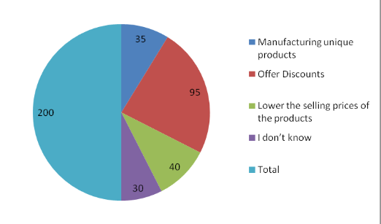

#### Figure 4.12: Procedures for retaining existing customers

**(Source: Created by author)**

**Comment:** According to the above chart, it can be said that 95%  of participants agreed on the fact that providing offers and discounts can help in retaining existing customers in business. On the other hand, 35 participants believed that manufacturing unique products can help the business retain existing customers positively. Moreover, 20% of participants agreed that the reduction in product prices can attract existing customers towards the business. However, 15% of participants said that they are unaware of the discussion. Therefore, companies can provide offers and discounts to retain customers towards the business. 

|  |  |  |
| --- | --- | --- |
| **Question 13: How are you planning to increase your brand visibility?** | | |
| **Responses** | **Respondents** | **Percentage** |
| **Using offline channels** | **50** | **25** |
| **Promotional campaigns** | **60** | **30** |
| **Online advertisements** | **50** | **25** |
| **I don't know** | **40** | **20** |
| **Total** | **200** | **100** |

##### Table 4.13: Planning to increase your brand visibility

(Source: Created by Author)

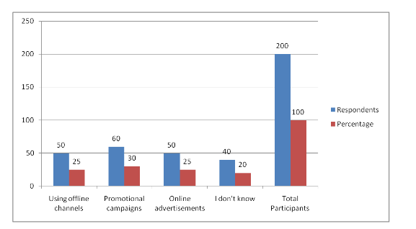

#### Figure 4.13: Planning to increase your brand visibility

(Source: Created by Author)

**Comments**

Based on the above graph, it can be stated that 25% of respondents agreed that offline channels are beneficial for developing brand visibility. On the other hand, 30% of respondents stated that a promotion campaign is more effective for the business to increase its brand visibility. Moreover, 25% of respondents stated that online advertising is good for developing brand visibility and 20% of respondents stayed neutral in this overall survey.

|  |  |  |
| --- | --- | --- |
| **Question 14: Do you think you can deliver finished goods to the market?** | | |
| **Responses** | **Respondents** | **Percentage** |
| **Agree** | **120** | **60** |
| **Disagree** | **40** | **10** |
| **Neutral** | **60** | **30** |
| **Total** | **200** | **100** |

##### Table 4.14: Delivering finished goods to the market

(Source: Created by Author)

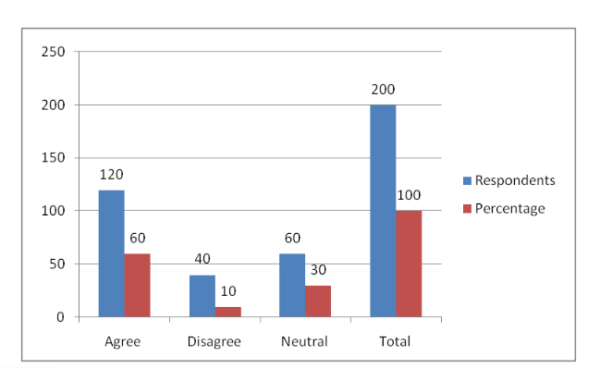

#### Figure 4.14: Delivering finished goods to the market

(Source: Created by Author)

**Comments**

Based on the above graph, 60% of respondents have stated that finished goods are more effective instead of raw materials for delivery in the market. On the other hand, 10% of respondents disagreed with this statement and 30% of respondents stayed neutral in this discussion.

|  |  |  |
| --- | --- | --- |
| **Question 15: What are the resources required in terms of increasing your productivity?** | | |
| **Responses** | **Respondents** | **Percentage** |
| **Financial Resources** | **80** | **55** |
| **Human Resources** | **50** | **30** |
| **Technical resources** | **30** | **5** |
| **I don’t know** | **40** | **10** |
| **Total** | **200** | **100** |

##### Table 4.15: Resources required in terms of increasing your productivity

(Source: Created by Author)

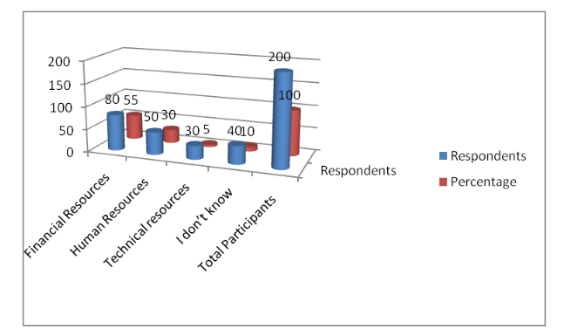

#### Figure 4.15: Resources required in terms of increasing your productivity

(Source: Created by Author)

**Comments**

Based on the above discussion, it can be identified that resources are required for the companies for developing their products in the market. In this context, 55% of participants stated that financial resources are effective for developing productivity. 30% of respondents also stated that human resources are more effective for increasing productivity within the industries. Moreover, 5% of respondents agreed that technological resources have played a vital role in increasing productivity in recent years.

|  |  |  |
| --- | --- | --- |
| **Question 16: What are your strategies for strengthening your financial infrastructure?** | | |
| **Responses** | **Respondents** | **Percentage** |
| **Joint Ventures** | **70** | **35** |
| **Venture Capitalists** | **50** | **25** |
| **Bank loans** | **40** | **20** |
| **I don’t know** | **40** | **20** |
| **Total** | **200** | **100** |

**Table 4.16: Strategies for strengthening your financial infrastructure**

(Source: Created by Author)

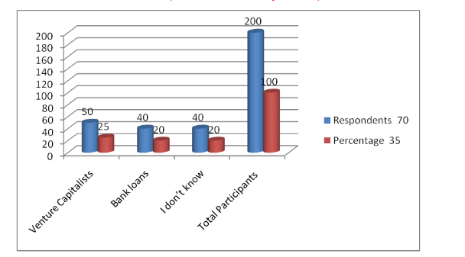

**Figure 4.16: Strategies for strengthening your financial infrastructure**

(Source: created by author)

**Comments**

Based on the above graph, it can be stated that 35% of respondents agreed that joint ventures are important for organisations for developing their financial structure. On the other hand, 25% of respondents stated that venture capitalists are more effective in improving the financial structure. Moreover, 20% of respondents stated that a bank loan is more effective for the organisation for managing their financial structure in terms of developing their business plans.

## 4.3. Analysis

The first survey table highlights that 5% of the selected participants belong to the age group of 18 to 24. Furthermore, 25% of the chosen candidates stated that they belong to the age groups of 25 to 34 and 35 to 44 respectively. However, 20% of the participants are aged from 45 to 54 and 25% of the selected respondents are from the age range of 55 and above. Thus, more candidates need to be selected from the age group of 55 and above for obtaining better responses.

80% of the engaged survey participants are male entrepreneurs. On the other hand, 17.5% of the selected candidates are female. In addition, it has been found that 2.50% of the chosen participants seem to belong to the third gender category. Thus, male participants are likely to dominate this survey.

Furthermore, 5% of the respondents hold a “High school degree” while 50% of the selected candidates possess an “Associate Degree”. It has been derived that 15% of the chosen participants have a “Bachelor’s Degree”. In addition, 20% of the engaged respondents inherit a “Master’s Degree” Finally, 10% of the participants hold a “Doctorate Degree”. Hence, the chosen candidates are likely to have a strong educational background.

It has been observed that 60% of the involved respondents opined that this business is addressing the financial issue effectively. However, 32.50% of the chosen candidates stated that this business is likely to address management issues. 7.50% of the selected participants stated that this business is focusing on eliminating marketing issues. In turn, financial issues can be mitigated successfully through this business. Hence, it can be stated that budgetary availability and sufficient resource allocation play a significant role in maintaining the flow of a business plan. Based on the findings, it can be analysed that financial constraints may leave a minor effect on developing a successful business plan

It can be analysed that a majority of the participants believe that their business can achieve its long-term mission and vision. Therefore, contemporary entrepreneurs are optimistic regarding their businesses and perceive their endeavours in a positive light. Furthermore, only a small proportion of the participants responded negatively, which indicates that the ratio of business entrepreneurs having low faith in their business is less compared to optimistic leaders. The analysis also reveals that a majority of the respondents have been neutral in measuring the level of success of their business, indicating that there is confusion among entrepreneurs regarding the measurement of the success of their business. However, the second largest section of the participants agreed that they can succeed in measuring the level of success of their business endeavour. Therefore, it can be interpreted that despite some confusion regarding the issue of measuring business success, entrepreneurs can succeed in the process by researching metrics of business success like profit generation. Further, there is substantial evidence that consumer demands present the most important factor that entrepreneurs need to consider while drafting their business plans in the present times. In this context, supply chain issues have some significance but the dominance of response indicates that consumer demands are the most important consideration. The analysis also reveals that most entrepreneurs understand and acknowledge that the process of framing a business plan in modern times has barriers like a lack of market research. Therefore, it can be analysed that contemporary entrepreneurs are likely to conduct thorough research before developing a business plan to ensure that they can overcome contemporary barriers in the process through informed decision-making.

Based on the findings, digital channels are effective for communicating with employees regarding business plans and objectives with the employees positively. Using digital channels such as social media helps in communicating with each other in business. Thus, companies can use social media platforms such as Facebook and Instagram to communicate with each other in terms of meeting business goals and objectives. According to the findings, it can be suggested that observing customer satisfaction is an important factor for companies to gain positive business value. Similarly, companies can use social media platforms to gather feedback from customers regarding products or services. Accordingly, feedback collection can help companies to identify customer satisfaction levels in this modern era. Besides, the improvement in the customer satisfaction level can help companies to achieve a strong position in the international market. Hence, it can be highlighted that the observation of the customer satisfaction level is important in order to improve the business progress in this competitive era.

According to the findings, it can be said that publicity plays an important role in developing the business in this target market. Publicity helps in improving the brand value of the business at the cosmopolitan level. In this context, companies promote their product effectively to gain the attention of customers. Therefore, The promotional strategy of companies needs to be effective in order to gain publicity in this modern market. Based on question 12, it can be analysed that providing offers and discounts is prominent for companies for retaining existing customers towards the business. However, the manufacturing of quality products can also help in attracting existing customers towards the brand. Therefore, it can be analysed that companies can make quality products with discounts for retaining existing customers.

Organisations focus on developing their business planning in terms of increasing their brand visibility in the global market. In this context, 30% of respondents stated that a promotion campaign is more effective for the business to increase its brand visibility. On the other hand, 25% of respondents stated that online advertising is good for developing brand visibility. Thus, it can be stated that promotional and online advertising is more effective instead of offline channels which help to increase the visibility of organisations in the global market.

On the other hand, organisations have maintained their resources in terms of developing their brand visibility in the global market. 55% of participants stated that financial resources are effective for developing productivity. Thus it is easy to understand that financial resources are beneficial for the company because it helps to develop the HRM and technical resources which helps to increase the brand visibility in the global market.

Moreover, delivering finished products increases the brand's reputation in the global market. Based on the survey process, 60% of respondents have stated that finished goods are more effective instead of raw materials for delivery in the market. Thus, it can be stated that organisations focus on developing their reputation and market position by delivering their finished products on time to their consumers. Thus, it can be stated that organisations increase their visibility in the competitive market by providing finished products to their consumers on managing their time.

On the other hand, organisations also maintain their business strategies in terms of developing their financial structure in the market. In this context,  35% of respondents stated that joint ventures are a significant business strategic plan which helps to increase brand visibility and develop the financial structure in managing the brand values in the market. On the other hand, 20% of respondents agreed that bank loans help new entrepreneurs for managing their financial structure and increase their brand position in the competitive market. In addition, venture capitalists can play a major role in improving the financial structure of the market. It also helps to increase the decision-making ability of the organisations for handling their financial structure in the market.

## 4.3 Summary

Based on the above primary findings of the quantitative survey, it can be stated that the gradual shift in consumer requirements and the changing trends in the business world have made it difficult for entrepreneurs to make successful business plans. In this respect, it is essential for entrepreneurs to gain knowledge about the daily operations within the business along with key trends in the market and the requirements of the customers.

# Chapter 5: Discussion

Effective leadership is essential for entrepreneurs in terms of successfully directing employees and other staff to the right path while establishing a start-up in the 21st century. In addition, leadership teams play a significant role in regulating and managing the activities of workers. As commented by Tittel and Terzidis (2020), leaders need to inherit strong managerial skills and knowledge management skills to improve the efficiency of employees. However, entrepreneurs also need to take up the responsibility to intervene and handle any tough situations in operational markets. Based on the ideas of Mehmood *et al.* (2019), Schumpeter’s perception of Entrepreneurship denotes that entrepreneurs need to be capable of managing any disputes within the market equilibrium. The capability of managing disputes can be fruitful in avoiding uncertainties and sudden economic risks during a start-up.

On the other hand, a shortage of skills and attributes prevents entrepreneurs from creating accurate business plans and eventually achieving their desired business growth. Moreover, it can be stated that entrepreneurs need to be capable of applying innovative ideas to increase productivity. As mentioned by Ratten (2020), entrepreneurs need to possess the ability to satisfy customers’ needs by introducing innovative ideas in product development. As a consequence, entrepreneurs can successfully develop creative products by applying innovative strategies and successfully meeting consumers’ demands in 21st-century marketplaces. Additionally, it has also been comprehended that introducing innovation within their production procedures is highly required for entrepreneurs in order to successfully attract and retain more customers in the 21st century. Contradictorily, entrepreneurs might face severe challenges such as low productivity and a lack of skilled employees during the establishment of business start-ups in the 21st century. Accordingly, poor management of employees can be the most severe issue which might restrict entrepreneurs from improving productivity. However, maintaining uninterrupted communication can be fruitful for entrepreneurs in effectively managing the activities of their staff members and improving their individual performance. According to the statements of Cletus *et al.* (2018), undisputed communication facilitates business leaders to convey their organisational goals and visions among employees. Thus, entrepreneurs need to use digital portals like email and video conferencing to maintain uninterrupted communication with employees.

Besides these factors, business leaders need to be prepared for any sort of uncertainty while establishing their start-ups in the 21st century and product promotion. Accordingly, entrepreneurs need to be capable of risk tolerance in terms of identifying potential risks in a target market during product promotion through digital channels such as cyber incidents and hacking. As per the viewpoints of Saeidi *et al.* (2019), risk tolerances can facilitate entrepreneurs to enhance their business portfolio and potential within competitive markets. Additionally, increasing risk tolerance can also be effective in positively driving investment in start-ups by identifying and eliminating financial risks initially. Furthermore, it can also be stated that entrepreneurs need to develop a strategic partnership in order to generate adequate amounts of investment capital before establishing a start-up in 21st-century marketplaces by obtaining economic support from partners. Moreover, it can also be analysed that business plans can be fruitful for entrepreneurs in terms of assessing sudden changes within their target markets in the 21st century by predicting the potential downfall of market prices.

Based on the opinions of Boldureanu *et al.* (2020), entrepreneurs need to create a defined vision of organisational goals for employees to motivate them and eventually improve their individual performance. Consequently, an improvement in employees’ individual performance can ultimately enhance productivity positively by boosting teamwork. As stated by Tien *et al.* (2019), high-quality service planning and product designing remarkably assist leaders and organisations to attract and retain customers in international and local markets. Accordingly, the application of the Diffusion on Innovation Theory can be significant for entrepreneurs in positively introducing innovative ideas in production processes by understanding customers’ product preferences.

It has been observed that the minimum number of the selected candidates belongs to the age group of 18 to 24. On the other hand, it has also been found that a maximum of the involved participants agreed that the long-term mission and vision of the business can be achieved successfully. However, a maximum of the participants remained neutral about the fact that the success of the business can be measured accurately.

It has been found that most of the chosen candidates agreed on the fact that the utilisation of digital channels will be appropriate in the context of communicating business plans and objectives conveniently to employees in the 21st century. Additionally, the maximum number of participants agreed that customer satisfaction can be observed in the modern era. It has been observed that the maximum percentage of the chosen participants opined that promotional campaigns will be used in terms of enhancing the brand’s visibility.

In addition, competitor analysis can also facilitate an entrepreneur to identify the areas of improvement by observing the products offered by their competitors. In accordance with the statements of Bogers *et al.* (2019), competitor analysis increases the accuracy of business plans by determining marketing policies and pricing strategies while entering a new market. Accordingly, it can be stated that competitor analysis can enable 21st-century business entrepreneurs to enhance the feasibility of their businesses by producing more unique products as compared to their competitors. On the other hand, entrepreneurs need to strongly focus on developing new products in order to successfully attract more customers in 21st-century places. In this context, it can be said that the application of the Diffusion of Innovation Theory can be effective for entrepreneurs in positively accelerating new product development. As opined by García-Avilés *et al.* (2019), the Diffusion of Innovation Theory denotes that a new product gains its visibility within a market based on its demand and availability. As a consequence, entrepreneurs can successfully produce unique products in order to maximise their demands in target markets and further gain a competitive advantage positively.

# Chapter 6: Conclusion

## 6.1 Conclusion

Based on the above discussion, it can be concluded that entrepreneurs need to lay a strong focus on improving their market research and development strategies in the 21st century. This strategy can be fruitful for entrepreneurs in order to accurately identify risks and opportunities. This factor can be fruitful for entrepreneurs to avoid any sort of financial risk while establishing their start-ups in 21st-century markets. In addition, it has also been understood that business leaders and entrepreneurs need to frame accurate business plans in order to analyse potential risks and growth scopes before entering a new marketplace. On the other hand, entrepreneurs also need to apply innovative strategies to mitigate the factors which hamper business start-ups such as employees with poor skills, shortage of investment capital and lack of marketing strategies. Apart from these aspects, key challenges such as vulnerable employee management, low product quality and poor business plans which can hamper business start-ups have also been recognised in this study. In addition, it has been comprehended that accurate market analysis and identification of customer segments can be fruitful for entrepreneurs in enhancing their sales rates in the 21 century.

Entrepreneurs can successfully manufacture creative commodities to satisfy the requirements of 21st-century customers and eventually gain a competitive advantage by applying the Diffusion Theory of Innovation and Consumer Behaviour Theory. Additionally, entrepreneurs need to avoid the risk of low product quality in order to maintain a stable customer base in the 21st century. These leadership-based theories can be beneficial for entrepreneurs to manage any sudden financial or social change in their target markets in the 21st century. On the other hand, the primary research strategy has been effective in understanding the factors which need to be considered by 21st-century entrepreneurs by analysing the responses of the chosen candidates. Thus, it can be stated that entrepreneurs need to improve their decision-making strategies and business management techniques in order to achieve success in the 21st century.

## 6.2 Recommendations

***Recommendation 1- Implicating digital marketing***

Product promotion is essential in the 21st century to inform target customers about the launch of a new product. Accordingly, entrepreneurs need to use digital channels like email and social media posts to promote their upcoming or existing products. As stated by Desai (2019), digital marketing enhances the global reach of companies by allowing them to engage with their target and existing customers. However, cyber threats in digital marketing such as hacking, and scams can be adverse for entrepreneurs to preserve confidential documents. Thus, entrepreneurs can successfully overcome the issue of poor marketing by applying this recommended strategy.

***Recommendation 2- Empowering employees to introduce innovation***

Business leaders need to empower their staff members in order to provide the flexibility to express their innovative perspectives. Based on the opinions of Bin Saeed *et al.* (2019), empowering employees by providing freedom and flexibility positively motivates them to exhibit their creative ideas. This factor can eventually facilitate entrepreneurs to increase innovation within their production processes by allowing employees to express their individual creative perspectives and successfully attract more customers in 21st-century marketplaces.

***Recommendation 3- Improving employees’ skills through training***

Creating a skilled and dependable workforce is crucial for entrepreneurs to maximise their production levels. According to the viewpoints of Guterresa *et al.* (2020), the personal skills of employees can be modified through education-training sessions. Hence, entrepreneurs need to introduce training programmes to train their staff in order to enhance their skills and successfully create a diverse workforce in the 21st century.

## 6.3 Linking with objective

***Objective 1***

This objective mainly highlights the key factors which need to be included in a business plan. Accordingly, the first, sixth and ninth question has been framed in order to meet this objective successfully. Accordingly, the individual responses of the selected participants have been fruitful in terms of understanding the factors which need to be included in 21st-century business plans by entrepreneurs.

***Objective 2***

The second objective has focused on evaluating the role of entrepreneurs in enhancing the financial and social growth of businesses. Consequently, the second, seventh, eighth and tenth question has been created in this research study to successfully synchronise with the requirements of this objective.

***Objective 3***

This objective has been framed in terms of identifying potential challenges which can restrict entrepreneurs from improving their businesses in the 21st century. As a consequence, the third, fourth, twelfth and fifteenth question has been created in order to meet the dimensions of this objective positively.

***Objective 4***

The fourth objective has aimed at finding alternate strategies which can facilitate entrepreneurs to successfully overcome the identified challenges and successfully establish their start-ups in the 21st century. Accordingly, the fifth, seventh, eleventh, thirteenth and fourteenth question has been set in order to satisfy the requirements of this objective.

## 6.4 Limitation

The research topic has a vast scope which is challenging to be explored within a limited time frame. In addition, there were certain databases which required monetary charges to provide data. However, the chargeable databases have not been explored due to a shortage of economic resources. This factor has eventually hampered the overall accuracy of the research outcomes. Additionally, this research has utilised only primary data which has also limited the accuracy and quality of the results. The primary research strategy seems to have failed to amalgamate more authentic data by analysing existing literature sources. This dimension has eventually reduced the validity and accuracy of the research outcomes. Thus, the inclusion of the secondary research strategy might have been effective in positively generating more accurate outcomes by gathering more genuine data from existing literature sources.

## 6.5 Future scope

Outcomes of this research can be fruitful for entrepreneurs to identify and understand the factors which need to be analysed before starting businesses in the 21st century. In addition, the research results can also serve as a strong source of information for future researchers in terms of conducting any further research based on this exact topic. Furthermore, this research can also enable entrepreneurs to understand and implicate innovative strategies to avoid the identified challenges like low product quality and poor employee management and eventually establish their businesses in future.

# References

Abutabenjeh, S. and Jaradat, R., (2018). Clarification of research design, research methods, and research methodology: A guide for public administration researchers and practitioners. Teaching Public Administration, 36(3), pp.237-258.

Anastasiu, L., Gavriş, O. and Maier, D., (2020). Is human capital ready for the change? A strategic approach adapting Porter's five forces to human resources. *Sustainability*, *12*(6), p.2300.

Asenahabi, B.M., (2019). Basics of research design: A guide to selecting appropriate research design. International Journal of Contemporary Applied Researches, 6(5), pp.76-89.

Ayeni, E.O., Saman, U.P. and Kasimu, S., (2019). Facts and fiction in positivism and neo positivism. Research on Humanities and Social Sciences, 9(4), pp.21-33.

Bacq, S., Geoghegan, W., Josefy, M., Stevenson, R. and Williams, T.A., (2020). The COVID-19 Virtual Idea Blitz: Marshalling social entrepreneurship to rapidly respond to urgent grand challenges. *Business Horizons*, *63*(6), pp.705-723.

Banks, J. and Xu, X., (2020). The mental health effects of the first two months of lockdown during the COVID‐19 pandemic in the UK. Fiscal Studies, 41(3), pp.685-708.

Basias, N. and Pollalis, Y., (2018). Quantitative and qualitative research in business & technology: Justifying a suitable research methodology. Review of Integrative Business and Economics Research, 7, pp.91-105.

Bbc.com (2019), Facebook 'failed to protect’ health data in private groups, Available at: https://www.bbc.com/news/technology-47308655 [Accessed on: 23 December 2022]

Bbc.com (2021), Apple buys a company every three to four weeks, Available at: https://www.bbc.com/news/business-56178792 [Accessed on: 23 December 2022]

Bin Saeed, B., Afsar, B., Shahjeha, A. and Imad Shah, S., (2019). Does transformational leadership foster innovative work behavior? The roles of psychological empowerment, intrinsic motivation, and creative process engagement. Economic research-Ekonomska istraživanja, 32(1), pp.254-281.

Bogers, M., Chesbrough, H., Heaton, S. and Teece, D.J., (2019). Strategic management of open innovation: A dynamic capabilities perspective. *California Management Review*, *62*(1), pp.77-94.

Boureanu, G., Ionescu, A.M., Bercu, A.M., Bedrule-Grigoruță, M.V. and Boldureanu, D., (2020). Entrepreneurship education through successful entrepreneurial models in higher education institutions. *Sustainability*, *12*(3), p.1267.

Byun, C.G., Sung, C.S., Park, J.Y. and Choi, D.S., (2018). A study on the effectiveness of entrepreneurship education programs in higher education institutions: A case study of Korean graduate programs. *Journal of Open Innovation: Technology, Market, and Complexity*, *4*(3), p.26.

Chugunov, I. and Makohon, V., (2019). Fiscal strategy as an instrument of economic growth. *Baltic Journal of Economic Studies*, *5*(3), pp.213-217.

Cletus, H.E., Mahmood, N.A., Umar, A. and Ibrahim, A.D., (2018). Prospects and challenges of workplace diversity in modern day organisations: A critical review. *HOLISTICA–Journal of Business and Public Administration*, *9*(2), pp.35-52.

Dawadi, S., Shrestha, S. and Giri, R.A., (2021). Mixed-methods research: A discussion on its types, challenges, and criticisms. Online Submission, 2(2), pp.25-36.

Del Giudice, M., Garcia-Perez, A., Scuotto, V. and Orlando, B., (2019). Are social enterprises technological innovative? A quantitative analysis on social entrepreneurs in emerging countries. *Technological Forecasting and Social Change*, *148*, p.119704.

Desai, V., (2019). Digital marketing: A review. International Journal of Trend in Scientific Research and Development, 5(5), pp.196-200.

Doern, R., Williams, N. and Vorley, T., (2019). Special issue on entrepreneurship and crises: business as usual? An introduction and review of the literature. *Entrepreneurship & Regional Development*, *31*(5-6), pp.400-412.

Duncan, K.J., (2022). All-purpose, all-sky photometric redshifts for the Legacy Imaging Surveys Data Release 8. Monthly Notices of the Royal Astronomical Society, 512(3), pp.3662-3683.

Foss, N.J., Klein, P.G. and Bjørnskov, C., (2019). The context of entrepreneurial judgement: organisations, markets, and institutions. *Journal of Management Studies*, *56*(6), pp.1197-1213.

García-Avilés, J.A., Carvajal-Prieto, M., Arias, F. and De Lara-González, A., (2019). How journalists innovate in the newsroom. Proposing a model of the diffusion of innovations in media outlets. *The Journal of Media Innovations*, *5*(1), pp.1-16.

Giza, W. and Wilk, B., (2021). Revolution 4.0 and its implications for consumer behaviour. *Entrepreneurial Business and Economics Review*, *9*(4), pp.195-206.

Guterresa, L.F.D.C., Armanu, A. and Rofiaty, R., (2020). The role of work motivation as a mediator on the influence of education-training and leadership style on employee performance. Management Science Letters, 10(7), pp.1497-1504.

Hameed, I. and Irfan, Z., (2019). Entrepreneurship education: a review of challenges, characteristics and opportunities. *Entrepreneurship Education*, *2*(3), pp.135-148.

Haugh, H., (2021). Call the midwife! Business incubators as entrepreneurial enablers in developing economies. In *Business, Entrepreneurship and Innovation Toward Poverty Reduction* (pp. 156-175). Routledge.

Hmieleski, K.M. and Sheppard, L.D., (2019). The Yin and Yang of entrepreneurship: Gender differences in the importance of communal and Agentic characteristics for entrepreneurs' subjective well-being and performance. *Journal of Business Venturing*, *34*(4), pp.709-730.

Hong, Q.N., Pluye, P., Fàbregues, S., Bartlett, G., Boardman, F., Cargo, M., Dagenais, P., Gagnon, M.P., Griffiths, F., Nicolau, B. and O’Cathain, A., (2018). Mixed methods appraisal tool (MMAT), version 2018. Registration of copyright, 1148552(10).

Islam, M., (2020). Data Analysis: Types, Process, Methods, Techniques and Tools. International Journal on Data Science and Technology, 6(10).

Jelonek, D., Tien, N.H., Dao, M.T.H. and Minh, D.T., (2022). Comparative analysis of business strategy of Vietnamese real estate developers: the use of Hoffer matrix. *International journal of multidisciplinary research and growth evaluation*, *3*(1), pp.197-204.

Kiger, M.E. and Varpio, L., (2020). Thematic analysis of qualitative data: AMEE Guide No. 131. Medical teacher, 42(8), pp.846-854.

Kocherbaeva, A., Samaibekova, Z. and Isabaeva, K., 2019, October. Leadership and leaders in successful small and medium enterprises. In 4th International Conference on Social, Business, and Academic Leadership (ICSBAL 2019) (pp. 89-94). Atlantis Press.

Kumatongo, B. and Muzata, K.K., (2021). Research paradigms and designs with their application in education. Journal of Lexicography and Terminology (Online ISSN 2664-0899. Print ISSN 2517-9306)., 5(1), pp.16-32.

Le Li, X.L. and Zhang, Y., ((2021)). Critical Evaluated the Contingency Theories of Leadership and Trait Theories of Leadership more Useful for Leaders in Organisation.

Legislation.gov.uk, (2022). *Data Protection Act 2018.* Available at: https://www.legislation.gov.uk/ukpga/2018/12/contents/enacted[Accessed on 29.12.2022]

Liu, Y., (2020). Contextualising risk and building resilience: Returnees versus local entrepreneurs in China. *Applied Psychology*, *69*(2), pp.415-443.

Malik, S.Y., Cao, Y., Mughal, Y.H., Kundi, G.M., Mughal, M.H. and Ramayah, T., (2020). Pathways towards sustainability in organisations: Empirical evidence on the role of green human resource management practices and green intellectual capital. *Sustainability*, *12*(8), p.3228.

Mehmood, T., Alzoubi, H.M. and Ahmed, G., (2019). Schumpeterian entrepreneurship theory: evolution and relevance. *Academy of Entrepreneurship Journal*, *25*(4).

Moises Jr, C., (2020). Online data collection as adaptation in conducting quantitative and qualitative research during the COVID-19 pandemic. European Journal of Education Studies, 7(11).

Musavinejad, S.H. and Nastiezaie, N., (2018). Predicting the effectiveness of school principals based on Fiedler’s leadership model. *The New Educational Review*, *51*, pp.184-191.

Nunfam, V.F., Adusei-Asante, K., Van Etten, E.J., Oosthuizen, J. and Frimpong, K., (2018). Social impacts of occupational heat stress and adaptation strategies of workers: A narrative synthesis of the literature. Science of the total environment, 643, pp.1542-1552.

O’Reilly, C. and Binns, A.J., (2019). The three stages of disruptive innovation: Idea generation, incubation, and scaling. *California Management Review*, *61*(3), pp.49-71.

Obrenovic, B., Du, J., Godinic, D., Tsoy, D., Khan, M.A.S. and Jakhongirov, I., (2020). Sustaining enterprise operations and productivity during the COVID-19 pandemic:“Enterprise Effectiveness and Sustainability Model”. *Sustainability*, *12*(15), p.5981.

Pasha, J., Dulebenets, M.A., Kavoosi, M., Abioye, O.F., Theophilus, O., Wang, H., Kampmann, R. and Guo, W., (2020). Holistic tactical-level planning in liner shipping: An exact optimization approach. *Journal of Shipping and Trade*, *5*(1), pp.1-35.

Pittman, I., (2021). The disconnect between textbook and research: Inductive versus deductive approaches to grammar in first-year German college textbooks. Glottodidactica. An International Journal of Applied Linguistics, 48(2), pp.61-81.

Rahman, M.M., Tabash, M.I., Salamzadeh, A., Abduli, S. and Rahaman, M.S., (2022). Sampling techniques (probability) for quantitative social science researchers: a conceptual guidelines with examples. Seeu Review, 17(1), pp.42-51.

Rashid, Y., Rashid, A., Warraich, M.A., Sabir, S.S. and Waseem, A., (2019). Case study method: A step-by-step guide for business researchers. International journal of qualitative methods, 18, p.1609406919862424.

Ratten, V., (2020). Coronavirus (Covid-19) and entrepreneurship: cultural, lifestyle and societal changes. *Journal of Entrepreneurship in Emerging Economies*.

Sabirov, O.S., Berdiyev, B.T., Yusupov, A.S., Abdusalamov, A.T. and Berdibek, A.I.U., (2021). Improving Ways to Increase the Attitude of the Investment Environment. *REVISTA GEINTEC-GESTAO INOVACAO E TECNOLOGIAS*, *11*(2), pp.1961-1975.

Saeidi, P., Saeidi, S.P., Sofian, S., Saeidi, S.P., Nilashi, M. and Mardani, A., (2019). The impact of enterprise risk management on competitive advantage by moderating the role of information technology. *Computer standards & interfaces*, *63*, pp.67-82.

Shad, M.K., Lai, F.W., Fatt, C.L., Klemeš, J.J. and Bokhari, A., (2019). Integrating sustainability reporting into enterprise risk management and its relationship with business performance: A conceptual framework. *Journal of Cleaner production*, *208*, pp.415-425.

Shaikh, S. and Shaikh, R., (2019). Modeling of dynamic/situational leadership for effective entrepreneurship development. *Journal of Model Based Research*, *1*(1), pp.1-6.

Statista.com (2022), Business enterprises in the UK - Statistics & Facts, Available at: https://www.statista.com/topics/6848/businesses-in-the-uk/#topicHeader__wrapper [Accessed on: 23 December 2022]

Statista.com (2022), Business enterprises in the UK - Statistics & Facts, Available at: https://www.statista.com/topics/6848/businesses-in-the-uk/#dossierContents__outerWrapper [Accessed on: 23 December 2022]

Statista.com (2022), Global startups - statistics & facts, Available at: https://www.statista.com/topics/4733/startups-worldwide/#topicHeader__wrapper [Accessed on: 23 December 2022]

Statista.com (2022), The Top Reasons Startups Fail, Available at: https://www.statista.com/chart/11690/the-top-reasons-startups-fail/ [Accessed on: 23 December 2022]

Tien, N.H., Phu, P.P. and Chi, D.T.P., (2019). The role of international marketing in international business strategy. *International journal of research in marketing management and sales*, *1*(2), pp.134-138.

Tittel, A. and Terzidis, O., (2020). Entrepreneurial competences revised: developing a consolidated and categorized list of entrepreneurial competences. *Entrepreneurship Education*, *3*(1), pp.1-35.

Tur-Porcar, A., Roig-Tierno, N. and Llorca Mestre, A., (2018). Factors affecting entrepreneurship and business sustainability. *Sustainability*, *10*(2), p.452.

# Appendix 1- Questionnaire

|  |
| --- |
| **1. Do you think that the leadership team is responsible for the successful management of a business plan creation?** |
| **2. Do you agree that entrepreneurs have successfully managed their role in terms of developing business planning and organisational growth?** |
| **3. Do you think that a lack of skills and attitudes are the major issues that are faced by entrepreneurs to develop a business in modern times?** |
| **4. Do you agree that entrepreneurs have faced issues to develop effective business plans in modern times?** |
| **5. Do you agree that using online platforms is helpful for entrepreneurs in terms of developing business plans in modern times?** |
| **6. Do you think that improving productivity is the best choice for entrepreneurs in terms of developing business planning?** |
| **7. Do you agree that providing training sessions to the employees is an effective plan for the entrepreneurs to increase the employee's knowledge?** |
| **8. Do you think employee job satisfaction is correlated with the aspects of developing a business plan within the organisation?** |
| **9. Do you agree that managing the operational level is effective in terms of developing the business planning of entrepreneurs?** |
| **10. Do you agree that identifying the competitor's trends helps entrepreneurs to improve business planning in modern times?** |
| **11. Do you think that recruiting experts allows entrepreneurs in order to increase the business planning concept in modern times?** |
| **12. Do you agree that day-to-day operations are helpful for entrepreneurs in developing business planning in modern times?** |
| **13. Do you agree that identifying the marketing trends is significant for entrepreneurs to establish business planning?** |
| **14. Do you think that entrepreneurs should produce innovative products or services based on the consumer’s needs in terms of developing the business plan?** |
| **15. Do you think that lack of money is a major issue that has faced by entrepreneurs while developing a business plan in modern times?** |