**Student registration number: BP0260646**

**Date submitted: 20 April 2023**

**Word count: 9892 words**

**Module name: Dissertation (MSc Healthcare Leadership)**

**Assignment name: Impact of health care leadership for ensuring effective care to elderly arthritis patients**

**Tutor’s name: Amina Adetunj**

**IMPACT OF HEALTH CARE LEADERSHIP FOR ENSURING EFFECTIVE CARE TO ELDERLY ARTHRITIS PATIENTS**

**Executive summary**

The research has developed to identify the impacts of healthcare leadership on ensuring effective care support for arthritis patients. The aim and objectives of the research are developed in this paper which helps to identify research questions. The literature review of this paper analyses quantitative existing studies which consider barriers to healthcare leadership and suggestive strategies for mitigating challenges. A secondary quantitative research strategy is followed in the whole research where descriptive design is followed. This research has identified the estimated timeline for the whole study process. The findings of the research have been conducted with the use of 8 peer-reviewed articles.

Arthritis is a major problem among individuals who are obtaining the services from different healthcare organisations. The care seekers can be supported with effective nursing facilities for their health improvement. The challenges and strategies associated with the leadership development in different healthcare sectors have been highlighted in this context. The findings have been done based on quantitative data from different secondary articles and newspapers. The secondary data from different articles on Google Scholar have been collected to understand the main contingency of leaders in providing healthcare services. Leaders have technical knowledge gaps and brand extension issues. In that case, leaders have been focused on the data activation framework and brand construction strategies in terms of supporting leadership activities for arthritis care seekers. Along with that, leaders have adopted these relevant strategies to change their poor performative structure to provide better treatment to all care seekers.

**Table of Contents**

Introduction 6

Topic introduction 6

Research position in healthcare 6

Problem statement 7

Context and background 7

Rationale 8

Aim and objectives 9

2. Literature review 11

2.0 Introduction 11

Conceptual framework 12

2.1 Overview of health service leadership 12

Concept of effective care for arthritis Patients and its barriers 13

2.2Impacts of leadership in healthcare for effective care to arthritis Patients 13

2.3Challenges present in leadership in healthcare for the care of arthritis patients and suggestive strategies 15

2.4 Strategies to mitigate the problems of leaders in ensuring effective care to the care seekers 16

2.5 Theoretical perspectives 18

2.6 Literature Gap 20

2.7Chapter Summary 20

3. Methodology 21

Research design and approach 21

Research method 22

Sampling 23

Data collection methods 23

Data analysis methods 24

Ethical Considerations 25

4: Results 27

4.0 Introduction 27

4.1 Findings 27

4.2 Analysis 33

4.3 Chapter Summary 36

5: Discussion 37

5.0 Discussion 37

5.1 Research Limitations 41

5.2 Future Research 41

6. Conclusion 42

Reference 43

**List of Figures**

Figure 1: Increased arthritis in aged people 6

Figure 2: Gender and age division in the prevalence of Arthritis in the UK 8

Figure 2.1: Conceptual framework 12

Figure 2.2: Challenges faced by Leaders in providing effective care services to the care seekers 16

Figure 2.3: Strategies to ensure effective care for individuals suffering from Arthritis 18

Figure 2.4: Transformational leadership 19

Figure 2.5: Health Promotion Model (HPM) 20

Figure 3.1: Research approaches 21

Figure 4.1: Maintenance of drug costs in providing services to care seekers suffering from Arthritis 28

Figure 4.2: The interview conducted in households 29

Figure 4.3: Sample characteristics that are based on *“adverse events”* and *“cointerventions”* at the follow up stage 31

Figure 4.4: Different kinds of Overarching Principles 32

# Introduction

## Topic introduction

Healthcare leadership is considered the ability to identify priorities, investigate strategic direction and give benefits and services to the patients. This study sheds light on effective care development with the use of healthcare service leadership for arthritis patients. In addition, the study has focused on the old arthritis patient as elderly patients require effective care support and cognitive support for health improvement. The whole research has developed as a “secondary quantitative study” which helps to analyse the relevant data from existing literature. Challenges associated with leadership development and barriers to effective care are examined in this research.

## Research position in healthcare

In the development of modern healthcare, effective leadership by healthcare professionals helps in the improvement of patient care. This research is focusing on a specific health issue (Arthritis) which is commonly identified all over the world. At present, up to “29.3%” of people “aged 45 to 64 years” are suffering from arthritis in the whole world (Cdc.gov, 2022). Therefore, this research is focusing on effective care for those patients with effective healthcare service leadership. The research linked healthcare and its improvement with the support of the leadership. In the adult populations of the UK, “18-21%” of the population above the age group of 45 years are diagnosed with arthritis and associated knee issues (Cdc.gov, 2022). Therefore, this study helps to apply healthcare service leadership for the care of old patients which helps in the improvement of healthcare.

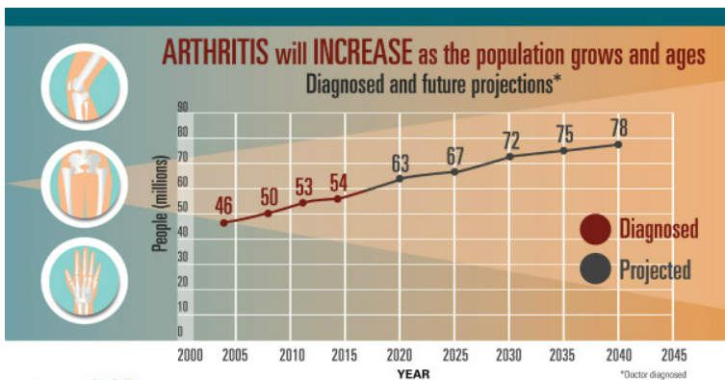

#### Figure 1: Increased arthritis in aged people

(Source: Centers for Disease Control and Prevention, 2022)

## Problem statement

The development of effective care is hampered by the present barriers to quality care development and the lack of effective leadership skills. The identification of the barriers to effective care in arthritis *“pain and fatigue”* are observed as the physical obstacle which is faced by the old patient (Walker *et al.* 2022). On the other hand, healthcare leaders also face various challenges during the development of care for arthritis patients. Understanding the needs of the patient, developing a multidimensional overview and lack of healthcare staff are some common challenges faced by healthcare service leaders. Ineffective healthcare facilities and the support of the leaders caused treatment failure as in the UK, per year *“£5.5 billion”* is estimated for management of the health inequalities (Nikiphorou *et al.* 2019). Therefore, the lack of management and efficiency of the leaders have developed issues for effective care of arthritis for the healthcare service leaders.

## Context and background

Various trends of leadership in the healthcare settings are measured such as *“bureaucratic and hierarchical cultures issues and quality care service”*. In the UK, up to *50%* of the population aged *“65 and older”* are diagnosed with arthritis which increases the need for effective care (Dostálová *et al.* 2022). At present, *“20.3 million”* people in the UK are facing complications for *“musculoskeletal (MSK) conditions”* measured as arthritis along with back pain. Therefore, several aged populations are suffering from the mentioned health issues where *32%* of the population is included (Statista.com, 2022). In addition, measurement of the present statistical information of the whole world, females are identified as more prone to arthritis than elderly male populations. The trends for the care of the population with implementation of the healthcare service leadership give opportunities for improved care practices.

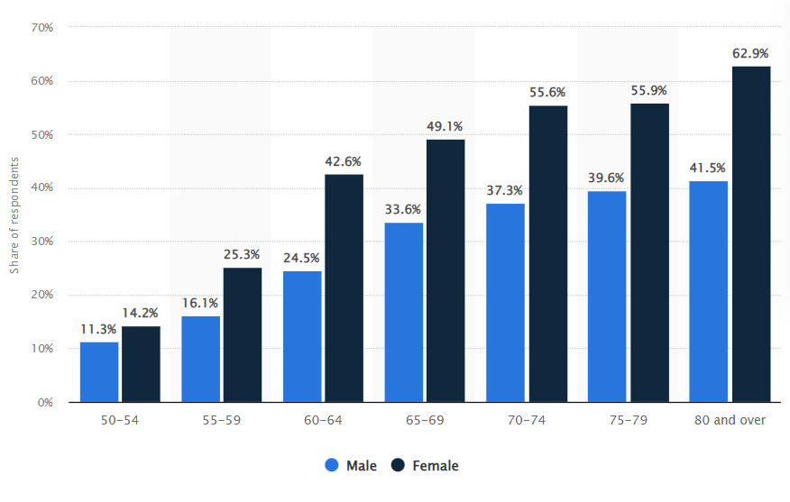

#### Figure 2: Gender and age division in the prevalence of Arthritis in the UK

(Source: Statista.com, 2022)

The measurement of the political environment of the UK as stable is seen where supportive legislation for improving effective care of the arthritis patient is seen. The *“Care Act 2014” and “Health and Care Act 2022”* are developed by the government of the UK which helps healthcare leaders to identify supportive principles for effective care of arthritis patients (Legislation.gov.uk, 2022). The economic support of the government is also required for the development of quality healthcare services which helps to improve leadership with training support.

# Rationale

This research helps to identify several consequences of effective care to old arthritis patients and the role of healthcare service leadership in the process. In addition, a present overview of care support and healthcare leadership strategy is interpreted in this research process. Challenges related to the effective care development for an elderly patient suffering from Arthritis are rising which requires management with appropriate care support. In the whole world, up to *“350 million elderly people”* have been identified who have suffered from arthritis which shows a compilation of the health issue is developed (Cdc.gov, 2022). Therefore, management of the present health issues with the healthcare leadership is needed. This study helps to identify a supportive leadership strategy for the management of the health of old arthritis patients. Additionally, challenges associated with effective care development are identified in this study which helps the healthcare centres to relate those challenges with the healthcare environment (Barber *et al.* 2020). Therefore, this study helps to improve healthcare facilities and care services for old arthritis patients with leadership.

The research helps to identify relevant principles and strategies for the development of healthcare service leadership. *“Ageing”* is identified as a common risk factor as those developed changes in the *“musculoskeletal system”* by increasing propensity to OA which raises the risk of joint injury and associated disease (Nikiphorou *et al.* 2019). Therefore, supportive care strategies adopted by healthcare leaders manage the critical situation faced by elderly people. Analysis of the impacts of healthcare service leadership gives support to the healthcare centre to implement identified strategies for improving their leadership aspect (Barber *et al.* 2020). Interpretation of the existing literature organised an authentic and information-generated study which provides supportive data for the management of quality service for healthcare services. A physical disability is developed due to arthritis which is managed by healthcare leaders. Measurement of healthcare support and leadership approach is done in this study which makes the research an important study paper for effective care of arthritis patients. This research highlighted the impacts of healthcare leadership on the management of effective care for arthritis patients and improving the care systems.

# Aim and objectives

*Aim*

The study aims to evaluate health service leadership in the development of effectiveness for old arthritis patients.

*Objectives*

* To examine the role of health service leadership in arthritis patient care.
* To identify the impacts of leadership in healthcare for effective care to old arthritis patients.
* To investigate challenges associated with healthcare leadership in the care of old arthritis patients.
* To develop recommended strategies for managing challenging factors of healthcare leadership in arthritis patient care.

*Research Questions*

* What is the role of health service leadership in arthritis patient care?
* What are the impacts of leadership in healthcare for effective care to old arthritis patients?
* What are the challenges associated with healthcare leadership in the care of old arthritis patients?
* What are the recommended strategies for managing challenging factors of healthcare leadership in arthritis patient care?

# 2. Literature review

## 2.0 Introduction

Arthritis is an impairment among adults which requires a lot of treatment and therapies. The disease leads to the tenderness and swelling of one or more joints which results in the symptoms of stiffness and joint pain. Leaders of different healthcare organisations can provide effective treatment for individuals suffering from arthritis. The pain of arthritis among individuals can be aggressively addressed by leaders through appropriate medical management in healthcare organisations. "Health Promotion Model (HPM)" and "Transformational leadership theory" have been analysed for ensuring effective patient care for individuals who are suffering from old arthritis.

## Conceptual framework

**Conceptual Framework**

***health service leadership***

***effective care for arthritis Patients and its barriers***

***Impacts of leadership in healthcare for effective care to arthritis Patients***

***Challenges in health care leadership for the care of arthritis patients and suggestive strategies***

* ***Transformational leadership***
* ***Health Promotion Model (HPM)***

#### Figure 2.1: Conceptual framework

(Source: Self-developed)

## 2.1 Overview of health service leadership

An action to lead an organisation or a group of people is known as leadership which helps to achieve the targeted goals. As per the view of Laukka *et al.* (2021), within healthcare, one skilled leader has motivated other staff to reach the highest potential for rising benefits to workers, patients and organisations. The healthcare sectors are associated with the constant reformation for the effective delivery of quality care. Consequently, the support of healthcare leaders with effective skills drove the changes in the healthcare systems. As stated by Laukka *et al.* (2021), *“transactional, charismatic, transformational and servant”* are relevant leadership styles applicable in healthcare organisations. Therefore, health service leadership in healthcare is also known as evidence-based leadership and organisational excellence which gives support to the patients along with the staff.

## Concept of effective care for arthritis Patients and its barriers

Effective care is known as the support of people to aching positive outcomes and improved quality of life support. According to the view of Barton *et al.* (2021), application of the *evidence-based practices* is appropriate for the development of supportive care for arthritis patients. The effective care of arthritis patients caregivers and nurses are focusing on the management of the disgrace and improving quality of life with medication. In arthritis, the main objectives of effective care included *“pain relief, prevention of additional joint damage, maintaining the current function, and relief of fatigue and weakness”*. As per the view of Barton *et al.* (2021), *“lack of time, training, staff, and evaluation tools”* are the main barriers to effective care delivery to arthritis patients. Therefore, the presence of those barriers increases challenges for healthcare leaders to provide supportive care.

## 2.2Impacts of Leadershipin healthcare for effective care to Arthritis Patients

Effective leadership promotes quality care to the patients by leading to patient safety management practices. According to the view of Gabriel *et al.* (2019), one effective healthcare service leader supports safety initiatives and helps in the creation of the system by addressing the concerns of the patient. On the other hand, care of the arthritis patient is managed with *“critical for strengthening quality and integration of care”*who is supported by the healthcare leaders. According to the view of Loyola-Sanchez et *al.* (2020), effective support of the healthcare leaders promotes a positive environment in the healthcare settings which helps to promote the experiences of the patients. Therefore, effective leadership in healthcare services positively impacts the management of the patient along with the improvement of the quality of care services. In addition, the behavior and skill of the other staff were also enhanced with the support of the healthcare leadership positively. Leaders in the healthcare sector can ensure their financial contingencies to support and develop the business environment.

Positive patient outcomes are promoted by the leaders by improving the skills of workers and engaging all the workers for improving care management. As per the view of Gabriel *et al.* (2019), the main responsibility of healthcare leaders is to identify the needs of the arthritis patient and communicate to manage those needs. Therefore, a positive and beneficial impact of the healthcare service is seen which helps to improve the health of old arthritis patients.

Leaders have a huge impact in providing services in the healthcare organizations for the care seekers who are suffering from arthritis in their elder age. Different types of Arthritis are "Osteoarthritis", "Rheumatoid Arthritis", "Gout", "Fibromyalgia", and "Childhood Arthritis" (Cdc.gov, 2023). These diseases enhance the joint pain of individuals and enhance muscle stiffness. These different types of arthritis have specific types of treatments which can be recognized by leaders in different healthcare organizations. Leaders can enhance their notice in the business culture of hospitals by enhancing the quality of treatment associated with the disease. It can be helpful for individuals in maintaining proper care for their diseases, especially for old arthritis. As per the views of Henderson *et al.* (2020), recognizing the symptoms of Arthritis at the early stage can be beneficial for leaders in providing proper care to individuals. On the other hand, recognizing the symptoms of Arthritis at an early age can be detrimental to the care seekers in maintaining their health growth (Bolshakova*et al.* 2019). In this context, leaders can have an efficient role in recognizing the Arthritis among individuals who are facing issues with joint pain.

Leaders can ensure effective interactive workshops for the care seekers which can outline best practices regarding the care to the care seekers. As per the opinion of Daugherty (2021), leaders of different healthcare organizations maintain an effective understanding and review of the PT (physiotherapists) discharge reports. On the other hand, a lack of understanding of PT discharge reports for the managers can be detrimental to the service providers in ensuring the healthy growth of the care seekers (Byrne *et al.* 2021). Leaders of different healthcare organizations can have an efficient role in accumulating healthcare professionals and orthopedic surgeons for care seekers.

Strategic contingencies of orthopedic surgeons can be effective for individuals who need the operation at any time. However, the lack of orthopedic surgeons in hospitals can cause harm to the health of the care seekers suffering from arthritis and leads to death (Ly *et al.* 2020). Thus, it is effective for the leaders in ensuring their post-implementation programs of the workshops to ensure effective treatment by physiotherapies to the individuals. As per the views of Bolshakova*et al.* (2019), leaders can undertake their efficient roles for providing drugs to care seekers which can increase their health growth and reduce the negative impacts of arthritis. On a contradictory view, the lack of financial resources available in healthcare organizations can hamper the progressive nature of individuals who are suffering from arthritis because of the ineffective utilization of drugs. Leaders in the healthcare sector can ensure the utilization of financial resources effectively to ensure a flawless treatment system.

## 2.3Challenges present in leadership in healthcare for the care of arthritis patients and suggestive strategies

One healthcare leader faced several challenges while developing effective care services and those reduced care quality for arthritis patients. According to the view of Dostálová *et al.* (2022), *“leadership gap” and “technological skill gaps”* are two associated challenges faced by healthcare leaders while developing supportive care for arthritis patients. On the other hand, complications in the supportive care for the arthritis patient are seen as a shortage of the workforce which impacts leadership strategy. According to Walker *et al.* (2022), *“lack of executive experience”* and the psychological safety of the workers impact the effectiveness of the leadership in a negative way. Reduced effectiveness of the leadership impacts the quality of the services applied to arthritis patients. Therefore, the presence of the mentioned leadership challenges impacts the quality of care and raises barriers to effective care in arthritis.

The application of supportive healthcare policies such as the *“Care Act 2014”* helps to engage patients with communication and relationship development strategies. As per the view of Dostálová *et al.* (2022), the *“Health and Care Act 2022”* is an effective care act that helps to overcome quality care complications in healthcare settings. On the other hand, management of the potential barriers to effective care with the training of the workers related to the care improvement and use of the evaluation tools gives support.

Problems faced by leaders due to the occurrence of the disease in the aging population

The Aging population has faced problems in undertaking the treatment of arthritis. As per the views of Patel *et al.* (2021), individuals belonging to the aged population are accustomed to taking painkillers for reducing their pain due to arthritis. On the other hand, painkillers are detrimental to the health of different individuals. Based on the opinion of Berrou*et al.* (2022), the long-term treatment of arthritis is detrimental for the leaders because they are unable to convince the care seekers to consider the services for the long-term period. Leaders are facing problems in maintaining communication with the care seekers in the long term period.

Lack of investment of organizations in preventive healthcare

The cost of drugs and treatments associated with therapies for care seekers who are suffering from arthritis is very high in healthcare organisations. As commented by Tuzovic and Kabadayi (2021), a lack of financial assistance in healthcare organizations can be detrimental to the services. It is because it is not possible to provide costly drugs without the financial assistance of organisations and individuals who are suffering from the disease. On the other hand, the increasing cost of drugs and therapies can be detrimental to organisations in maintaining their healthcare services under effective surveillance (Majumder*et al.* 2020). Leaders can ensure their investment in preventive healthcare services by attracting the government with their services.

#### Figure 2.2: Challenges faced by Leaders in providing effective care services to the care seekers

(Source: Created by Author)

## 2.4 Strategies to mitigate the problems of leaders in ensuring effective care to the care seekers

Establishing effective nursing handovers and joint medical services

Leaders of healthcare organizations can maintain effective healthcare services for the care seekers who are suffering from arthritis. As per the opinion of Zhang *et al.* (2021), effective nursing handovers and joint medical services can be ensured in healthcare organizations by the leaders to incorporate the negative consequences of arthritis. On the other hand, a lack of nursing care for the care seekers can be detrimental to the leaders in providing effective services to care seekers (Kiselev*et al.* 2020). The service providers can utilize the help of nurses for providing the therapies and proper medication to individuals suffering from arthritis.

Creating a safe experience for the care seekers

Leaders of healthcare organizations can create a positive experience for the care seekers who are suffering from arthritis. As per the views of Mayra *et al.* (2022), safe experiences for care seekers can be ensured by the leaders while they are in healthcare organizations. On the other hand, a lack of attentive care to the care seekers can be detrimental to meeting the requirements of individuals (Hennekam*et al.* 2021). Leaders of healthcare organizations can ensure services at any time for the care seekers who are suffering from this disease in a very critical manner. However, the lack of services to the care seekers whenever they require it can be effective for the downgrade of healthcare organizations.

Providing effective training to the service providers

The service providers of different healthcare organizations can be trained in the treatment procedures of arthritis. As per the views of Chuah*et al.* (2019), leaders can ensure training under professional experts to enhance the skills of providing therapies to care seekers. On the other hand, a lack of experience in providing therapies can be detrimental for care seekers due to the ineffective measures taken in the treatment (Ma *et al.* 2021). Leaders can ensure investment in training the service providers which can be helpful for the care seekers in mitigating the pains caused by arthritis.

#### Figure 2.3: Strategies to ensure effective care for individuals suffering from Arthritis

(Source: Created by Author)

## 2.5 Theoretical perspectives

**“Transformational leadership”**

The development of an effective leadership strategy in health services is possible with the implementation of transformational leadership. As per the view of Bennett *et al.* (2022), transformational leadership is focusing on *“relationships and collaboration”* which helps to improve health outcomes. In addition, one transformational leader shows empathy to all the stakeholders including patients. Therefore, applications of this leadership style in care of the arthritis patients are truly beneficial as those impacts positively on the employees.

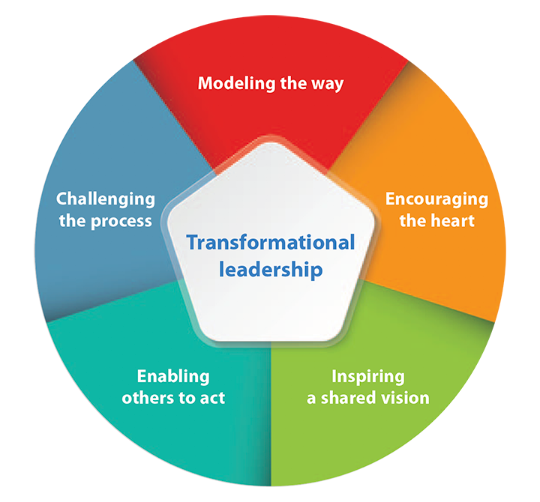

#### Figure 2.4: Transformational leadership

(Source: Self-developed)

**“Health Promotion Model (HPM)”**

The model is designed to develop a counterpart for the health protections of the patients and rising care strategy. According to the view of Gabriel *et al.* (2019), this model focuses on *“cognitive-perceptual factors and variables influencing”* related to the likelihood of the activities. HPM is focusing on the level of well-being of the patients with the support of the multi-dimensional nature. Therefore, the application of HPM helps to improve effective care for arthritis patients by focusing on the well-being of the individual.

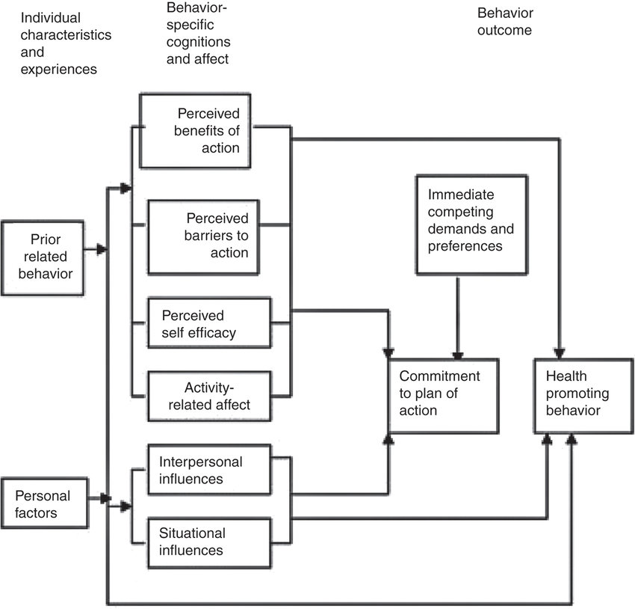

#### Figure 2.5: Health Promotion Model (HPM)

(Source: Gabriel *et al.* 2019)

## 2.6 Literature Gap

This literature review has identified the positive impacts of leaders in providing effective services to individuals who are suffering from arthritis. However, it has not identified the negative impacts in a detailed manner due to the lack of information available in the existing literature. The strategies for mitigating the problems regarding financial assistance have not been clearly stated in this existing literature review. The lack of information available in the existing literature is the main cause of the elimination of negative impacts of leaders in providing services.

## 2.7Chapter Summary

Healthcare associates can take effective measures for care seekers who are suffering from arthritis. These lead to ineffective care for the care seekers which can enhance their problems in health. Training under professional experts can be ensured to mitigate the problems in providing therapies in the treatment of arthritis. The next chapter has highlighted the results part and discussed the findings of quantitative data.

# 3. Methodology

## Research design and approach

The research design is known as the framework of the research methods which helps to identify the required tools for research development. The common types of research designs are *“descriptive, correlational, experimental, and diagnostic designs”* (Snyder, 2019). This research is conducted with the use of the *descriptive research design* which helps to measure the role of healthcare leadership in improved care for arthritis patients. Therefore, the selection of the descriptive design is appropriate for the identification of supportive roles and impacts of healthcare service leadership based on the description of the existing phenomenon.

The appropriate *“research design”* can help to ensure the proper connection between the specific research aims as well as research objectives. As per the views of Yao *et al.* (2022), the selection of a *“descriptive research design”* helps to describe a specific situation or population systematically and accurately. The completion of the research study did not include other “research designs” as this is a   
“Secondary quantitative method”. The application of *“descriptive research design”* is ensured the successful identification of different factors that are related to *“healthcare leadership”.*

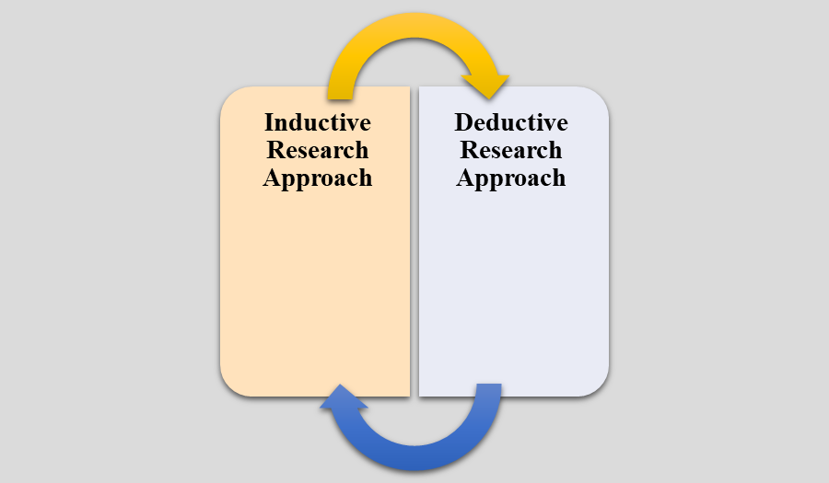

#### Figure 3.1: Research approaches

(Source: Self-developed)

The procedure of collection and interpretation of the research data is identified as the research approach. *“Deductive and inductive”* approaches are two types of research approaches and this research is conducted with a *deductive research approach* (Leatherdale, 2019). The development of the scientific investigation of the research data is known as the deductive research process which follows the measured impacts of the healthcare leadership to care for arthritis patients.

The application of the *“deductive research approach”* helps in gaining more factual knowledge on the topic of the research study. This can help in understanding the role of *“healthcare leadership practices”* to provide proper care to *“old service users of arthritis disease”.* As per the viewpoint of Cillis *et al.* (2022), the application of the *“deductive research approach”* helps in explaining the relationship between concepts as well as variables. The *“Inductive Research Approach”* has not been selected in this research study as there is no need to build any new theory and there is no inclusion of the idea of “emerging new theories”.

## Research method

In the dissertation, research methods are measured as the way to effective collection and interpretation of the collected data. The common methods of the research are *“qualitative, quantitative, and mixed methods”* and this research is developed as a *“quantitative study”* (Sileyew, 2019). The whole research has been conducted with the use of *secondary quantitative data* from existing sources relevant to healthcare leadership and arthritis. Observation of *“statistical, mathematical, or numerical analysis of data”* is defined as the quantitative research method which is followed in the present research (Leatherdale, 2019). Therefore, investigation of the relevant statistical data related to the healthcare service leadership and effective care service development for patients. The use of pre-existing sources of numerical data helps in the development of the quantitative study which investigates the challenges of healthcare service leadership in the development of care for arthritis.

*“Research Methods”* are mainly the different ways of collecting as well as analyzing gathered data accurately. The *“quantitative method”* has been selected for this specific research study as this can help in analyzing data that are effectively related to healthcare leadership. The main purpose of the selection of *“quantitative research”* is to gain *“greater knowledge”* and suitably understand the entire social world. Based on the views of Bosnjak *et al.* (2022), the researchers have used the *“quantitative research method”* to observe a specific situation in a better manner by which there is the production of objective data. On the other hand, the *“qualitative method”* has not been included in this research study as there is the presence of time limitation and the researcher wants to provide a better viewpoint by selecting the *“quantitative research method”.* Moreover, the *“mixed method”* has also not been selected as this specific method is time-consuming in nature.

## Sampling

In the development of research, sampling is defined as the selection of the actual group which provided data for the development of the study. The common sampling methods are *“systematic sampling, stratified sampling, cluster, and simple random sampling”* (Hill *et al.* 2021). This research is conducted with a *random sampling* process which helps to collect *8 quantitative articles* for collecting appropriate data on healthcare leadership and arthritis care. Use of the key terms such as *“healthcare and leadership, effective care of arthritis and healthcare leadership in arthritis”* helps to select relevant articles from search engines such as *Google Scholar*. The relevant research which was developed with interview and survey data are selected from the last five years.

Sampling means the selection of a particular group that has been used by the researcher to collect data for the successful development of the research study. On the other hand, *“sampling”* is the process in a different “statistical analysis process” where the researcher has taken a lot of observations that are predetermined in nature from a *“larger population”.* According to the viewpoint of Moll *et al.* (2022), the selection of the *“random sampling process”* ensures that the specific result that has been obtained from the particular sample would be the same in case there is the measuring of the “entire population”. *“8 articles”* have been selected for conducting this research study through the application of a *“random sampling process”.* The articles that have been included in this research study are published after the year 2019 and are in the English language. The articles that are excluded from this research study are published before 2019 and not related to the topic of the research paper.

## Data collection methods

Gathering information from relevant sources for identifying solutions to the research problem is known as the data collection method. Appropriate selection of the data collection methods helps to evaluate the effective outcomes of the research problem. The common two types of data collection methods are *“primary and secondary”* methods and this research conducted a secondary method (Leatherdale, 2019). Therefore, research is developed as a secondary quantitative study that helps to identify the impacts of healthcare service leadership on effective care for arthritis patients. The main resources of the secondary data collection are *“newspapers, journals, and articles”* which are used in this study and collected from the appropriate database (Hill *et al.* 2021). Therefore, appropriate data from the last five years are used in the research findings development which identifies challenges and supportive role of healthcare leadership in old arthritis patient care.

The selection of the *“secondary quantitative data collection method”* helps in the identification of data that are related to the topic of the research study appropriately. There is also the inclusion of the *“cost-effectiveness”* nature of the method by which the researcher can save time as well as money in a suitable manner. According to the belief of Miles *et al.* (2022), the selection of the *“secondary data collection method”* can help in making the *“primary data collection method”* more specific. This helps in filling out the gaps as well as deficiencies accurately and effectively. This helps in providing an in-depth analysis of data by which there is the analysis of existing surveys in an accurate manner. The “primary data collection method” has not been selected in this research study as the primary method is time-consuming in nature. Moreover, the selection of a *“secondary data collection method”* can help in making the entire research study more specific and accurate.

## Data analysis methods

The research is developed with secondary quantitative data where the use of the *“thematic analysis”* is appropriate for gathering relevant results from gathered sources. The thematic analysis helps to evaluate secondary research data by *“identifying, analyzing, and reporting repeated patterns”* of the collected research data (Snyder, 2019). Therefore, the use of thematic analysis helps to develop themes relevant to the research objective collected data from the selected articles. The collected statistical data from the existing sources are interpreted critically with the use of the data analysis methods. Those analysis helps to identify supportive strategies for the management of the challenging factors associated with healthcare leadership and arthritis patient care.

The application of *“thematic analysis”* can help in gaining knowledge on the aspect of the research study. The identification of accurate themes can enable the identification of a proper pattern that is related to the research study. The development of an accurate theme can help in understanding the research topic in a better manner. An appropriate *“thematic analysis”* helps this research study to understand the importance of *“healthcare leadership”* to provide care to service users of a specific hospital. As per the opinion of Ataman and Tuncer (2022), a proper approach towards the *“research study”* through the inclusion of an accurate thematic analysis can help in gaining more “factual knowledge” in a better manner. The appropriate inclusion of *“thematic analysis”* can help out in the identification of data by which there is the exclusion of “repeated patterns”. Common themes have been identified from 8 different journal articles where there is the inclusion of newspaper articles. Different types of data that are gathered from different “secondary sources” are analyzed in an appropriate manner through the accurate *“data analysis method”.*

# Ethical Considerations

The appropriate citation of the authors with the use of the *“Harvard referencing style”* is done in this study development. *“Data Protection Act, 2018”* is considered during the research and collection of the data where sources for the data collection are informed effectively (Legislation.gov.uk, 2020). According to the present act, one individual is required to inform the source of the data which is used and those are informed of the data sources while the collection of the data. Development of the research is considered *“informed consent, risk of harm, confidentiality, and anonymity, and conflict of interest”* as the principles of ethical consideration (Barton *et al.* 2021). Adoption of the present participle and legislation reduced risk of the ethical biases in the research process.

The proper and accurate *“data protection framework”* can help to ensure all data has been stored in an appropriate manner. The researcher has also followed different guidelines of *“The General Data Protection Regulation (GDPR) 2018”* for maintaining proper ethics within a research study. The different guidelines of GDPR have mainly been used for appropriate, explicit, and specified purposes (Gov.uk, 2023). The different “data protection principles” that are included in the *“Data Protection Act 2018”* have been followed in this research study in an effective manner. AI has an effective potential for changing and revolutionising the healthcare system by enabling effective prediction of the emergence of cardiac arrest. The early intervention of this disease can be effective for enhancing the potential in maintaining ethical transparency in the research.

The primary ethical perspectives such as elimination of bias in collecting the data related to AI algorithm have been maintained in the research. The biases in regulating the research can cause disparities in maintaining the healthcare outcomes. Receiving information based on AI prediction can be effective for undertaking a research in an efficient manner. Introducing the findings related to AI algorithms based on assumptions can be a constraint in reducing ambiguity in the research. The accuracy of algorithms and ethical transparency can be maintained in the research to extract the findings based on the healthcare system. The ethical consideration such as privacy has been maintained in the research to ensure the data transparency in research orientation. The research resign has been maintained with necessary requirements in order to implement the AI algorithm for treating cardiac arrest. The data manipulation has been maintained by formulating proper structure based on the research components. These ethical considerations have been formulated and maintained in order to maintain transparency.

# 4: Results

## 4.0 Introduction

Leaders can maintain their effective care for care seekers who are suffering from old arthritis. Different healthcare sectors such as hospitals have regulated their services to provide effective care to care seekers. The quantitative study of different leadership roles for providing effective care to care, seekers, has been undertaken in this research. Individuals who are providing effective leadership in their health service can ensure positive responses from individuals who are suffering from the disease. Different newspapers and articles have been reviewed to collect quantitative data regarding the topic.

## 4.1 Findings

Role of leaders in providing health service to individuals who are suffering from old Arthritis

AT (Advanced Therapy) can be provided by leaders in healthcare organizations in the UK when there is an effective financial contingency. As per the opinion of Foo *et al.* (2023), the cost of drugs can be carried out at a high proportion which ranges from 28.9% to 30.4% in different scenarios and different years of assessment. The service utilization for curing individuals who are suffering from old arthritis includes direct medical costs. The cost for direct medical services improved to 19% for maintaining the AT. The leaders can maintain their effective services to ensure differential productivity in providing care to care seekers. Care seekers have maintained advanced therapies for 7.8 million individuals for ensuring the increased rate of curing of individuals (Foo *et al.* 2023). Sustainable development of the healthcare system includes the effective optimization of cumulative drug costs for care seekers.

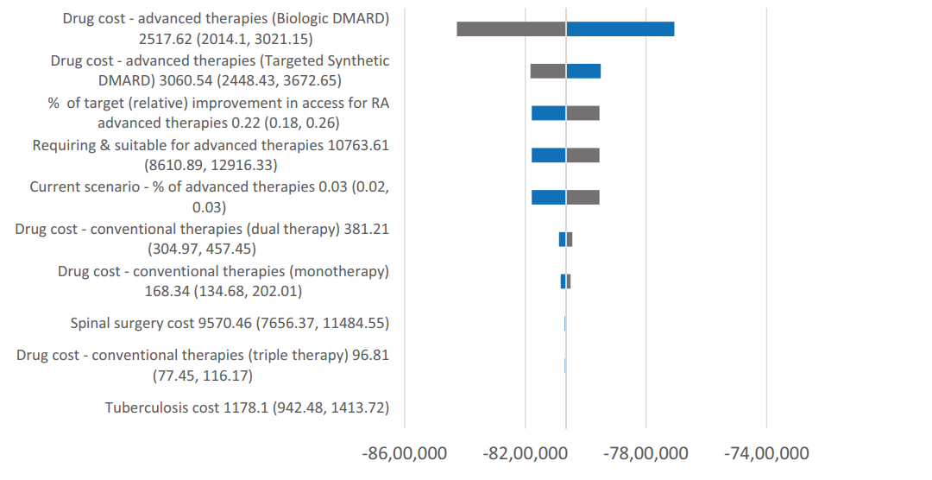

#### Figure 4.1: Maintenance of drug costs in providing services to care seekers suffering from Arthritis

(Source: Foo *et al.* 2023)

Leaders are effectively trying to focus on obesity, overweight, and physical activities in terms of addressing arthritis issues. Apart from that, healthcare leaders are supporting these care seekers by maintaining dietary plans so that care seekers do not face any issues while continuing physical exercise. Approximately, *1.3 million individuals* are facing painful arthritis issues in their life. In that case, healthcare leaders are accelerating medicines partnership with the “*National Institutes of Health*” in terms of providing arthritis development and drug discovery (Arthritis.org, 2021). Alongside, leaders help to manage mental health and physical activity, mitigate pain symptoms, and reduce drug management to improve excess pain.

Issues faced by leaders in providing effective care to care seekers suffering from Arthritis in the UK healthcare organizations

The survey conducted in the UK has depicted that individuals are facing *major chronic illnesses for arthritis*. As opined by Mahmood *et al.* (2022), slum dwellers have less access to healthcare services during the pandemic period. *476 households are interviewed and among them, 50% of the population in slum areas* are facing problems in maintaining services of effective care due to arthritis (Mahmood *et al.* 2022). 82.5% of the population in the healthcare sector has faced problems with general illness because of this arthritis. Leaders in different healthcare organizations are facing *problems in providing details of the negative impact of arthritis* on care seekers.*Utilizing more painkillers is destructive* for the health of care seekers. Leaders are facing problems in providing therapies for care seekers who are practiced with taking painkillers. *40% of the adults in the UK are facing problems due to Arthritis* and its long-term illness (News-medical.net, 2023). *Lack of care to care, seekers,*is harmful to them in mitigating long-term illness.

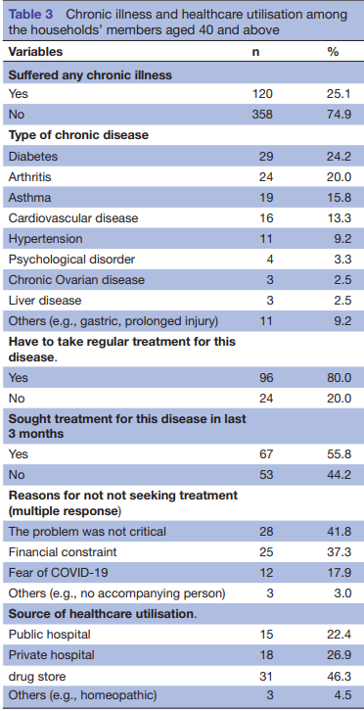

#### Figure 4.2: The interview conducted in households

(Source: Mahmood *et al.* 2022)

Impact of “healthcare leadership” on providing appropriate care to “old arthritis care seekers”

An appropriate approach towards *“healthcare leadership”* can organize different things that are related to providing accurate treatment to the care seekers of arthritis disease. There is a positive impact of the overall *“healthcare leadership”* on providing appropriate as well as effective treatment to *“old arthritis care seekers”.* The old care seekers can be operated effectively by the leaders in healthcare sectors by maintaining the operational procedures. As per the ideas of Paterson *et al.* (2022), wearing *“motion control walking shoes”* is helping in the reduction of “knee pain” where there is the inclusion of *“lateral knee osteoarthritis (OA)”.* Leaders can ensure the proper functioning of these shoes to provide treatment to the care seekers suffering from arthritis.

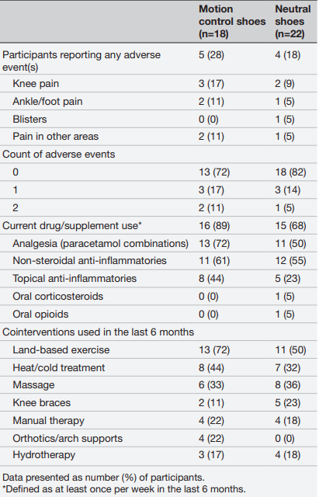

#### Figure 4.3: Sample characteristics that are based on *“adverse events”* and *“co-interventions”* at the follow-up stage

(Source: Paterson *et al.* 2022)

As per the above figure, it has been found that the total number of participants in this survey was *“18”* where the number of “female participants” was 11 and “male participants” was 7. There is the presence of knee pain among 3 of the total participants. There is no existence of blisters on any of the participants. On the other hand, Godziuk *et al.* (2022) further mentioned that in the *“12-week interventions”* the “total number of participants” was *“53”* whereas *“bilateral knee OA”* was present in almost *“37 participants”.* Effective leaders of different healthcare sectors can manage these interventions stringently to reduce the existence of ambiguity in organizational procedures.

Investigation of different challenges that are related to “healthcare leadership”

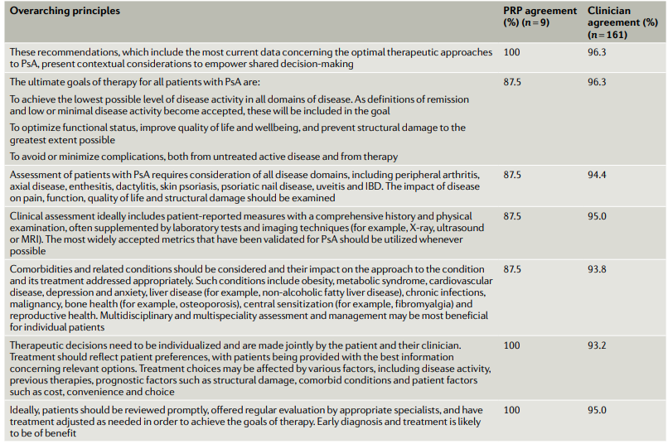

#### Figure 4.4: Different Kinds of Overarching Principles

(Source: Coates *et al.* 2022)

There is the presence of different challenges that are specifically related to the concept of *“healthcare leadership”* such as ineffective leadership practices, poor training for the nurses, and many other challenges*.* Based on the viewpoint of Coates *et al.* (2022), the existence of *“Psoriatic arthritis (PsA)”* is mainly a specific heterogeneous condition or situation that is associated with the *“high burden of disease”.* As per the above figure, it can be considered that there is a need to optimize the functional status, improvement of the *“quality of life and well-being”* and other things. The score of the *“PRP Agreement”* is *“87.5%”.* This agreement can be managed by the leaders in healthcare sectors in terms of including their effective contingencies in PsA.

Evaluating some strategies to manage challenging healthcare leadership factors in arthritis patient care

Leaders of healthcare organizations have faced difficulties in terms of managing the technological systems to provide treatments for arthritis patients. In that case, the *data activation framework* can create a path for a cultural workplace, skill development, technology intervention, revenue generation, goal setting, and data management practices (Deloitte.com, 2023). In context, leaders need to learn radiology practices, software practices, and other technical systems by taking the help of technical experts or engineers. Therefore, technological knowledge, leadership gaps, and workforce shortage can be reduced by developing patient-centric skills and technology intervention skills.

Leaders need to focus on treatment facilities through marketing procedures so that they can accelerate the promotional activities of healthcare organizations. In that case, leaders need to highlight the *brand construction strategy* in terms of achieving financial growth. It is known that technology development activities can accelerate medical growth by showing the brand, service provisions, and product quality (Thedrum.com, 2022). The annual growth rate of revenue in the healthcare industry of the UK is 6.29% (Statista.com, 2023). The project market volume of US$2,370 of the healthcare sectors by the year 2027 can be achieved by maintaining the leadership contingencies in the organisational practices of the healthcare organizations. The role of leaders in the organizational practices can be ensured for maintaining the strategic operational procedures in the organizational practices.

## 4.2 Analysis

Leadership in the maintenance of drug costs

AT has a huge role in maintaining the services for care seekers who are suffering from old Arthritis. As per the opinion of Foo *et al.* (2023), leaders can ensure the maintenance of financial contingencies of healthcare organisations for providing this therapy to care seekers in a timely manner. On the other hand, the higher cost of drugs has increased problems for service providers as care seekers are unable to use them due to financial hindrances. 20% of the healthcare organizations in the UK have reduced their cost of drugs for maintaining effective financial contingencies (Foo *et al.* 2023). On the other hand, decreasing the cost of drugs can be detrimental to healthcare organizations because it can hamper financial growth. The increased financial stability of healthcare organizations can be beneficial for the leaders in providing services of AT for care seekers.

Issues faced by leaders in providing healthcare services due to lack of concern and wealth

The leaders are unable to provide effective care to care seekers because of the higher cost of therapies. As opined by Mahmood *et al.* (2022), 90% of local drug stores are providing painkillers for care seekers which late to the *problem of ineffective care* for the disease. On the other hand, a lack of understanding of the critical nature of arthritis among care seekers can be an issue among the leaders in healthcare organizations. It is because the leaders are not able to *maintain effective communication* to care seekers who are accustomed to taking painkillers for arthritis (Mahmood *et al.* 2022). Lack of wealth among the individuals in taking the therapies for curing arthritis can be detrimental to healthcare organizations in providing the services efficiently.

The below average income of individuals is increasing problems in maintaining the services for curing arthritis. Individuals in the age group of 45 to 64 are facing problems of *long-term illness due to arthritis* (News-medical.net, 2023). Reduction of health inequalities in healthcare organizations for care seekers can be beneficial for providing services due to arthritis. The “Government of the UK” has put their notice on the individuals of the low-income bracket to increase the association of healthcare organizations in providing therapy. On the other hand, *a lack of information available to care seekers* on their health can be detrimental to the process of curing disease. 11.7% of the individuals who live in deprived areas are suffering from arthritis (News-medical.net, 2023). Strategic contingencies of managers in providing effective therapies to the individual can be beneficial for increasing health growth.

Impact of “Healthcare Leadership”

The most significant impact of *“healthcare leadership”* is the improvement of the overall *“quality of care”* in an effective manner. On the other hand, poor management of leadership of *“healthcare leaders”* can facilitate improper communication among different caregivers (Paterson *et al.* 2022). Hence, the overall *“productivity rate”* can be increased by the effective management of “leadership quality” within the healthcare sectors of the UK. As per the judgment of Paterson *et al.* (2022), the usage of *“motion control shoes”* is not superior to the usage of *“neutral shoes”.* Both shoes can help in the improvement of *“knee pain”* on walking in a specific *“symptomatic radiographic lateral tibiofemoral joint OA”* in an appropriate manner.

The inclusion of proper ability towards *“healthcare leadership”* can help in providing *“quality patient care”* by removing different issues from the system of healthcare. On the other hand, Godziuk *et al.* (2023), the specific *“12-week digital multimodal intervention for knee OA”* has been accepted by different kinds of care seekers as there is the presence of accurate effectiveness that is preliminary in nature. This intervention helps in the improvement of *“self-efficacy”, and “quality of life”* and the reduction of specific interest in *“Total Knee Arthroplasty (TKA)”.*

Challenges Related to “Healthcare Leadership”

Various challenges are related to *“Healthcare Leadership”* such as *“workforce shortage”, “technological implications”, leadership gap,* and many others. The most significant challenge that has been faced by the *“healthcare industry”* in the present era is the *“labour shortage”* (Coates *et al.* 2022)*.* There is the absence of qualified nurses, pharmacists, “imaging technicians” and nursing assistants. According to the belief of Coates *et al.* (2022), there is the addition of different kinds of *“therapeutic approaches”* to the concept of PsA where there is the existence of different kinds of *“treatment options”.* The range of different clinical options can create several different challenges for the selection of *“optimal therapies”* for various care seekers.

There is a vast impact of *“labour shortage”* on the overall industrial growth of “the healthcare sector”. There is also the presence of a challenge that is related to *“healthcare leadership” which* is the existence of a huge *“leadership gap”.* Based on the judgment of Coates *et al.* (2022), due to the absence of proper training, there is the creation of a *“leadership gap”* among different healthcare leaders. Hence, there is no implementation of strategies towards maintaining accurate uncertainty in the “job field” of the “healthcare industry”.

Technology advancement and service provision practices increase treatment facilities for arthritis service users

Leadership activities are the basic and essential area for business and healthcare development because they are positively creating opportunities for arthritis patients. However, the improvement of leadership practices can change the healthcare structure by incorporating technology developmental activities. In that case, leaders need to highlight their technical intervention and radiology practices so that they can provide better arthritic treatments to all patients. Contextually, the data activation framework can help leaders in terms of gaining knowledge of digital systems (Deloitte.com, 2023). The data activation framework helps to enhance the skills of data protection and is inspired to learn technical activities to ensure all data storage so that leaders can properly maintain the walking culture within the workplace (Deloitte.com, 2023). However, it is needed to implement in the healthcare organization by which leaders can provide arthritis treatment by developing radiology services. Additionally, they can improve digital skills by taking the help of technical experts or engineers so that leaders can get to know about arthritis treatment procedures for all patients.

Along with that leaders also need to focus on healthcare marketing by showing their service qualities in terms of attracting lines or patients. This practice can help those service users who are facing arthritis; in that case, showing brands and service quality can ensure patients and clients make a positive image regarding the healthcare organization (Thedrum.com, 2022). Leaders are willing to improve their financial growth and service quality in that case they can adopt a brand construction strategy in terms of making a good position in the UK market. However, the implementation of technology skills and brand improvement practices are positively progressing the health care services which can reflect positively on financial growth (Thedrum.com, 2022). This procedure can change leadership practices to improve the healthcare infrastructure and develop the technical knowledge of all health workers.

## 4.3 Chapter Summary

It is summarized that leaders have to highlight the brand management practices by showing their service qualities so that patients can understand the healthcare intervention of leaders regarding arthritis problems. It has been found that leaders are always focusing on their roles and responsibilities to provide excellent treatment for arthritis care seekers. Apart from that, technology intervention issues, marketing, and other healthcare issues can be found in leadership practices. In that case, the data activation framework and brand construction strategies are needed to adopt to change the leadership practices. It can resolve leadership activities and enhance digital competencies to accelerate healthcare services to arthritis patients.

# 5: Discussion

## 5.0 Discussion

AT can be provided to care seekers who are suffering from arthritis. The therapies are very costly for care seekers who have a low-income range in their livelihood. As per the views of Foo *et al. (*2023), the cost of drugs is carried out at a higher proportion in different healthcare organizations of the UK. On the other hand, the higher cost of drugs is hindering its use for individuals who are suffering from arthritis because of their lack of financial assistance. 7.8 million Individuals have faced an increased rate of curing from arthritis in the UK (Foo *et al.* 2023). However, the higher cost of health care services proves to be detrimental for care seekers and leaders. It is because lack of association of money of care seekers in using therapies can be detrimental for leaders in maintaining the financial contingencies of healthcare organizations.

The UK Government is providing effective discounts for care seekers in using drugs and therapies for curing their arthritis. The sustainable development of drug cost for care seekers can be beneficial for leaders in providing effective services and direct medicinal drugs for improving the health of individuals (Foo *et al.* 2023). On the other hand, 476 households were interviewed and among them, most of the individuals are facing problems due to the lack of money (Mahmood *et al.* 2022). *“Health Promotion Model (HPM)”* can be developed as a counterpart for protection in healthcare organizations (Gabriel *et al.* 2019). Effective development of healthcare services can be ensured by recognizing the cognitive perceptual differences among the care seekers. This model is effective for promoting healthcare services in different regions of a country.

The factors and variables that are influencing cognitive perceptual differences in livelihoods can be considered for the support of the multi dimensional nature of the disease called arthritis. In this context, the well-being of different individuals who are suffering from arthritis can be ensured by the leaders by providing drugs and therapies at a lower cost in different healthcare organisations (Barber et al. 2020). Thus, an effective association of leaders with the care services can be considered for increasing the understanding of care seekers about the well-being of their health. Effective investment and training facilities available in healthcare organisations can be beneficial for the leaders in improving the health and well-being of individuals suffering from arthritis.

The leaders are having the most effective role in terms of providing proper “health service” to all individuals. The researchers have determined that the care seekers of Arthritis who are belonging to the category of *“low socioeconomic status”* die early and the percentage is 46 (News-medical.net, 2023). It also has been found that *“40%”* population of the UK is having the problem of Arthritis. Hence, it can be stated that there is a presence of many populations who are facing problems with the disease of arthritis in the UK. As per the ideas of Bennett *et al.* (2022), the application of *“Transformational Leadership Theory”* helps in the improvement of health outcomes in the industry of healthcare in an effective manner. In addition to this, care seekers are the most important stakeholder for different healthcare organizations. Hence, *“transformational leaders”* can provide proper value to all the stakeholders including the care seekers who are having arthritis disease. On the other hand, the application of *“Transformational Leadership Theory”* can be used by caregivers for their own needs such as taking “self-promotion” within a specific organization.

The important role of *“healthcare leaders”* is to promote a proper *“communication process”* within a specific healthcare organization in an effective manner. This can assist in providing proper and *“quality patient care”* by removing the issues that have occurred in the earlier phase. In these specific situations, vital roles are played by the presence of proper *“communication process”* as well as *“efficiency”* of an organization, which belongs to the industry of healthcare. Based on the belief of Mahmood *et al.* (2022), there is the existence of different “slum dwellers” that are having less access to various different *“healthcare services”* such as taking notes of medicines and others. On the other hand, another role of an effective *“healthcare leader”* is the creation of *“adaptable leaders”* effectively and accurately.

The most accurate role of *“healthcare leadership”* is to bring proper trust as well as transparency among all kinds of stakeholders who are present within the healthcare sectors. Hence, there is a need for a *“constant communication process”* within an effective leadership style or model. Based on the judgment of Gabriel *et al.* (2019), the successful application of the *“health promotion model (HPM)”* can help out in the development of different factors that are *“cognitive or perceptual in nature”.* The implementation of HPM helps in understanding the *“physical as well as mental well-being of care seekers”.* Hence, the application of HPM is helpful for the improvement of overall *“care seekers’ care”* by keeping the focus on their well-being. On the other hand, *“lack of experience and lack of knowledge”* can become barriers to the effective application of HPM in the *“healthcare industry”.* Hence, The healthcare staff and the care seeker can have differences in their opinions or “priorities” in terms of different topics that are related to health.

Knee OA is mainly a specific as well as painful condition of people generally the older ones where there is a presence of the *“Mixed Compartmental OA”.* According to the views of Paterson *et al.* (2022), it has been found from different *“biomechanical studies”* that footwear with a *“stiff midsole”* redistributes loads of knee for the people who are having knee OA. Participants in the survey are mainly selected in a random manner where the ratio is 1:1. The absence of *“symptomatic benefits”* with specific kinds of *“motion control shoes”* can suggest that these types of shoes are not helping to redistribute the knee loads (Paterson *et al.* 2022). On the contrary, it has been found that in case there is a presence of openness towards any kind of feedback then there is an improvement in the overall *“healthcare leadership”.*

An accurate *“leadership and Management”* helps in the establishment of better healthcare support to all care seekers within the “healthcare industry” in a suitable manner. There is a need to produce *“innovative leaders”* within the sectors of healthcare by which there is the retention of potential medical practitioners (Laukka *et al.* 2021). The reduction of *“healthcare leaders”* means the creation of a painful situation. Hence, in this manner, “healthcare professionals” can provide better care to all the care seekers who are dealing with arthritis. According to the viewpoint of Loyola-Sanchez *et al.* (2020), the appropriate and effective support that comes from *“healthcare leaders”* can promote a proper as well as positive “healthcare environment”. This helps in the promotion of the experience of the care seekers in different healthcare organizations (Godziuk *et al.* 2023). On the other hand, care for the service users who are dealing with Arthritis is dependent on the effective management of *“healthcare leaders”* successfully and effectively.

Technological challenges are also present in the *“healthcare industry”* by which there is an increment in the overall cost of a specific medicine. There is a requirement to provide proper *“training”* to all medical practitioners to improve their technical skills appropriately. As per the statement of Coates *et al.* (2022), different kinds of safety issues can often have an impact on the *“potential therapeutic choices”* that are related to OA. The usage of different technologies such as robotics, *“Artificial Intelligence (AI)”, “personalized medicine”* and many others are increasing the overall cost as well as the *“complexity of the healthcare industry”.* There is also a need for highly skilled employees to implement the aforementioned technologies accurately.

It is important to enhance leadership practices in terms of gaining success for healthcare organizations. According to Dostálová *et al.* (2022), leaders are often facing technology challenges while they are supporting arthritis service users. Apart from that they lacked the executive experience to support patients psychologically. These are the major gaps that have been found in leadership practices. Additionally, leaders can also get support from healthcare policies such as the “*Care Act 2014, Health and Care Act 2022*” and other healthcare policies effectively helping to improve the medical science and enhance the protective practices of leaders. These healthcare policies create a communicative structure in terms of making a good relationship with leaders.

It is important to focus on nursing activities in terms of taking care of all arthritis patients. In that case, handing over all healthcare practices of patients to nurses can mitigate the physical problems because nurses are positively highlighting the medication process ti, punctuation, dressing process, and other healthcare activities (Zhang *et al.* 2021). Due to this reason, leaders need to provide their skills to all nurses so that they can enhance their competencies in terms of providing arthritis treatment to all patients. Additionally, leaders also need to create a positive environment for care seekers who are already suffering from arthritis (Hennekam *et al.* 2021). However, a lot of arthritis patients do not pay attention to their health development practices.

The effectiveness of the training provision practices to all health workers can accelerate arthritis treatment procedures. As per the view of Chuah *et al.* (2019), due to having technology and training provision competencies, leaders can easily improve healthcare procedures by incorporating new technology, psychological care, and other physical development activities through their training procedures. However, the data activation framework can enhance technical skills and improve the knowledge of leaders (Deloitte.com, 2023). Along with that, the brand construction strategy can also enhance healthcare service provision activities to extend the reputation of healthcare organizations (Thedrum.com, 2022). Therefore, leaders can overcome their skill gaps by focusing on these strategies for further arthritis treatment development.

## 5.1 Research Limitations

Mainly, this study has been focused on leadership roles and challenging activities to provide arthritis treatment. During proceeding with this study, the secondary quantitative data collection method has been considered by using Google Scholar, websites, newspapers, and articles. However, primary data collection procedures have not been considered in this research, where interview or survey processes could be added to get current data on leadership practices.

## 5.2 Future Research

It has been found that leadership practice is having discord properly by showing their positive impact on healthcare organizations. Along with that, leadership practices influence arthritis patients; however, financial assistance has not been discussed clearly. This study could cover the mixed methods to know leadership activities. In that case, future research will be highlighted those data collection techniques in order to collect accurate data from leaders andcare seekers.

# 6. Conclusion

It can be concluded that leaders are positively taking care of arthritis patients and their caretaking activities. Based on this topic this research has been conducted to highlight the role of leadership impact on leadership practices challenges and associated strategies in terms of mitigating leadership issues. The role of leadership practices provides benefits regarding training provision, patient-centric activities, and organisational development. This objective has been made in the point of an overview of health services by leaders. On the other hand, the impact of leadership and the challenges have been found where technical issues, lack of marketing financial knowledge, and other relevant issues have been highlighted in this study. However, these challenges have been mitigated by using head care policies, data activation framework, brand construction strategies and other procedures so that leaders can improve their treatment practices for arthritis patients.

# Reference

*Selected*

Barton, C.J., Kemp, J.L., Roos, E.M., Skou, S.T., Dundules, K., Pazzinatto, M.F., Francis, M., Lannin, N.A., Wallis, J.A. and Crossley, K.M., 2021. Program evaluation of GLA: D® Australia: Physiotherapist training outcomes and effectiveness of implementation for people with knee osteoarthritis. *Osteoarthritis and Cartilage Open*, *3*(3), p.100175. [Accessed 1 March 2023]

Bennett, S.E., Zangi, H.A., Larsson, I., Beauvais, C., Boström, C., Domján, A., van Eijk-Hustings, Y., Van der Elst, K., Fayet, F., Ferreira, R.J. and Fusama, M., 2022. Assessing acceptability and identifying barriers and facilitators to implementation of the EULAR recommendations for patient education in inflammatory arthritis: a mixed-methods study with rheumatology professionals in 23 European and Asian countries. *Annals of the rheumatic diseases*, *81*(10), pp.1348-1357. [Accessed 1 March 2023]

Dostálová, V., Bártová, A., Bláhová, H. and Holmerová, I., 2022. The experiences and needs of frail older people receiving home health care: A qualitative study. *International journal of older people nursing*, *17*(1), p.e12418. [Accessed 1 March 2023]

Gabriel, L., Casey, J., Gee, M., Palmer, C., Sinha, J., Moxham, J. and Colegate-Stone, T.J., 2019. Value-based healthcare analysis of joint replacement surgery for patients with primary hip osteoarthritis. *BMJ Open Quality*, *8*(2), p.e000549. [Accessed 1 March 2023]

Laukka, E., Kujala, S., Gluschkoff, K., Kanste, O., Hörhammer, I. and Heponiemi, T., 2021. Leaders' support for using online symptom checkers in Finnish primary care: A survey study. *Health Informatics Journal*, *27*(4), p.14604582211052259. [Accessed 1 March 2023]

Loyola-Sanchez, A., Pelaez-Ballestas, I., Crowshoe, L., Lacaille, D., Henderson, R., Rame, A., Linkert, T., White, T. and Barnabe, C., 2020. “There are still a lot of things that I need”: a qualitative study exploring opportunities to improve the health services of First Nations People with arthritis seen at an on-reserve outreach rheumatology clinic. *BMC Health Services Research*, *20*(1), pp.1-14. [Accessed 1 March 2023]

Walker, A., Boaz, A. and Hurley, M.V., 2022. The role of leadership in implementing and sustaining an evidence-based intervention for osteoarthritis (ESCAPE-pain) in NHS physiotherapy services: a qualitative case study. *Disability and Rehabilitation*, *44*(8), pp.1313-1320. [Accessed 1 March 2023]

*Others*

Barber, C.E., Twilt, M., Pham, T., Currie, G.R., Benseler, S., Yeung, R.S., Batthish, M., Blanchette, N., Guzman, J., Lang, B. and LeBlanc, C., 2020. A Canadian evaluation framework for quality improvement in childhood arthritis: key performance indicators of the process of care. *Arthritis Research & Therapy*, *22*, pp.1-9. [Accessed 1 March 2023]

Hill, A.D., Johnson, S.G., Greco, L.M., O’Boyle, E.H. and Walter, S.L., 2021. Endogeneity: A review and agenda for the methodology-practice divide affecting micro and macro research. *Journal of Management*, *47*(1), pp.105-143. [Accessed 1 March 2023]

Leatherdale, S.T., 2019. Natural experiment methodology for research: a review of how different methods can support real-world research. *International Journal of Social Research Methodology*, *22*(1), pp.19-35. [Accessed 1 March 2023]

Nikiphorou, E., Lempp, H. and Kohrt, B.A., 2019. Treatment failure in inflammatory arthritis: time to think about syndemics?*Rheumatology*, *58*(9), pp.1526-1533. [Accessed 1 March 2023]

Sileyew, K.J., 2019. *Research design and methodology* (pp. 1-12). Rijeka: IntechOpen. [Accessed 1 March 2023]

Snyder, H., 2019. Literature review as a research methodology: An overview and guidelines. *Journal of business research*, *104*, pp.333-339. [Accessed 1 March 2023]

*Websites*

Cdc.gov, 2022. *Arthritis Related Statistics* [online]. Available at:<https://www.cdc.gov/arthritis/data_statistics/arthritis-related-stats.htm#:~:text=Of%20people%20aged%2018%20to,ever%20reported%20doctor%2Ddiagnosed%20arthritis.&text=Of%20people%20aged%2045%20to,ever%20reported%20doctor%2Ddiagnosed%20arthritis>. [Accessed 1 March 2023]

Statista.com, 2022. *England: Arthritis among over the 50s in 2018/19, by gender and age* [online]. Available at:<https://www.statista.com/statistics/983315/england-arthritis-among-older-people/> [Accessed 1 March 2023]

Legislation.gov.uk, 2022. *Care Act 2014* [online]. Available at:<https://www.legislation.gov.uk/ukpga/2014/23/contents/enacted> [Accessed 1 March 2023]

Legislation.gov.uk, 2020. *Data Protection Act 2018* [online]. Available at:<https://www.legislation.gov.uk/ukpga/2018/12/contents/enacted> [Accessed 1 March 2023]

References for Literature Review

Berrou, I., Hamilton, K., Cook, C., Armour, C., Hughes, S., Hancock, J., Quigg, S., Hajinur, H., Srivastava, S., Kenward, C. and Ali, A., (2022). Leaving No One Behind: Interventions and Outcomes of the COVID-19 Vaccine Maximising Uptake Programme. Vaccines, 10(6), p.840. Available through: https://www.mdpi.com/1647378 [Accessed 8 March 2023]

Bolshakova, M., Bluthenthal, R. and Sussman, S., (2019). Opioid use and misuse: health impact, prevalence, correlates, and interventions. Psychology &Health, 34(9), pp.1105-1139. Available through: https://www.tandfonline.com/doi/abs/10.1080/08870446.(2019).1622013 [Accessed 8 March 2023]

Bolshakova, M., Bluthenthal, R. and Sussman, S., (2019). Opioid use and misuse: health impact, prevalence, correlates, and interventions. Psychology &Health, 34(9), pp.1105-1139. Available through: https://www.tandfonline.com/doi/abs/10.1080/08870446.(2019).1622013 [Accessed 8 March 2023]

Byrne, S.J., Bellairs-Walsh, I., Rice, S.M., Bendall, S., Lamblin, M., Boubis, E., McGregor, B., O’Keefe, M. and Robinson, J., (2021). A qualitative account of young people’s experiences seeking care from emergency departments for self-harm. International journal of environmental research and public health, 18(6), p.2892. Available through: https://www.mdpi.com/1031044 [Accessed 8 March 2023]

Cdc.gov, (2023). *Arthritis Types.* Available at: <https://www.cdc.gov/arthritis/basics/types.html> [Accessed 8 March 2023]

Chuah, F.L.H., Tan, S.T., Yeo, J. and Legido-Quigley, H., (2019). Health system responses to the health needs of refugees and asylum-seekers in Malaysia: a qualitative study. International journal of environmental research and public health, 16(9), p.1584. Available through: https://www.mdpi.com/457300 [Accessed 8 March 2023]

Daugherty, M.L., (2021). Small business marketing strategies for physical therapy practice owners. International Journal of Healthcare Management, 14(3), pp.710-716. Available through: https://www.tandfonline.com/doi/abs/10.1080/20479700.(2019).1692505 [Accessed 8 March 2023]

Henderson, L.A., Canna, S.W., Friedman, K.G., Gorelik, M., Lapidus, S.K., Bassiri, H., Behrens, E.M., Ferris, A., Kernan, K.F., Schulert, G.S. and Seo, P., (2020). American College of Rheumatology clinical guidance for multisystem inflammatory syndrome in children associated With SARS–CoV‐2 and hyperinflammation in pediatric COVID‐19: version 1. Arthritis & Rheumatology, 72(11), pp.1791-1805. Available through: https://onlinelibrary.wiley.com/doi/abs/10.1002/art.41454 [Accessed 8 March 2023]

Hennekam, S., Follmer, K. and Beatty, J.E., (2021). The paradox of mental illness and employment: a person-job fit lens. The International Journal of Human Resource Management, 32(15), pp.3244-3271. Available through: https://www.tandfonline.com/doi/abs/10.1080/09585192.(2020).1867618 [Accessed 8 March 2023]

Kiselev, N., Pfaltz, M., Haas, F., Schick, M., Kappen, M., Sijbrandij, M., De Graaff, A.M., Bird, M., Hansen, P., Ventevogel, P. and Fuhr, D.C., (2020). Structural and socio-cultural barriers to accessing mental healthcare among Syrian refugees and asylum seekers in Switzerland. European Journal of psychotraumatology, 11(1), p.1717825. Available through: https://www.tandfonline.com/doi/abs/10.1080/20008198.(2020).1717825 [Accessed 8 March 2023]

Ly, T.D.A., Dao, T.L., Braunstein, D., Brouqui, P., Lagier, J.C., Parola, P. and Gautret, P., (2020). The pattern of infections in French and migrant homeless hospitalized at Marseille infectious disease units, France: a retrospective study, 2017–2018. Travel Medicine and Infectious Disease, 36, p.101768. Available through: https://www.sciencedirect.com/science/article/pii/S1477893920302568 [Accessed 8 March 2023]

Ma, R., Zhang, M., Oakman, J.M., Wang, J., Zhu, S., Zhao, C., Hu, Z. and Buchanan, N.T., (2021). Eating disorders treatment experiences and social support: Perspectives from service seekers in mainland China. International Journal of Eating Disorders, 54(8), pp.1537-1548. Available through: https://onlinelibrary.wiley.com/doi/abs/10.1002/eat.23565 [Accessed 8 March 2023]

Majumder, M.A.A., Rahman, S., Cohall, D., Bharatha, A., Singh, K., Haque, M. and Gittens-St Hilaire, M., (2020). Antimicrobial stewardship: Fighting antimicrobial resistance and protecting global public health. Infection and drug resistance, pp.4713-4738. Available through: https://www.tandfonline.com/doi/abs/10.2147/IDR.S290835 [Accessed 8 March 2023]

Mayra, K., Matthews, Z. and Padmadas, S.S., (2022). Why do some healthcare providers disrespect and abuse women during childbirth in India? Women and Birth, 35(1), pp.e49-e59. Available through: https://www.sciencedirect.com/science/article/pii/S1871519221000329 [Accessed 8 March 2023]

Patel, J., Ladani, A., Sambamoorthi, N., LeMasters, T., Dwibedi, N. and Sambamoorthi, U., (2021). A machine learning approach to identify predictors of potentially inappropriate non-steroidal anti-inflammatory drugs (NSAIDs) use in older adults with osteoarthritis. International Journal of Environmental Research and Public Health, 18(1), p.155. Available through: https://www.mdpi.com/938768 [Accessed 8 March 2023]

Tuzovic, S. and Kabadayi, S., (2021). The influence of social distancing on employee well-being: A conceptual framework and research agenda. Journal of Service Management, 32(2), pp.145-160. Available through: https://www.emerald.com/insight/content/doi/10.1108/JOSM-05-(2020)-0140/full/html [Accessed 8 March 2023]

Zhang, X., Li, C., Yue, C., Jiang, X., Cao, J. and Ten Cate, O., (2021). Why clinical training in China should improve: a cross-sectional study of MD graduates. BMC Medical Education, 21(1), pp.1-11. Available through: https://bmcmededuc.biomedcentral.com/articles/10.1186/s12909-021-02647-2 [Accessed 8 March 2023]

References for Methodology

Ataman, C. and Tuncer, B., (2022). Urban interventions and participation tools in urban design processes: a systematic review and thematic analysis (1995–2021). *Sustainable Cities and Society*, *76*, p.103462. Available through: https://www.researchgate.net/profile/Cem-Ataman/publication/355525252_Urban_Interventions_and_Participation_Tools_in_Urban_Design_Processes_A_Systematic_Review_and_Thematic_Analysis_1995_-_2021/links/6183d6883c987366c3258b2b/Urban-Interventions-and-Participation-Tools-in-Urban-Design-Processes-A-Systematic-Review-and-Thematic-Analysis-1995-2021.pdf [Accessed: 8 March 2023]

Bosnjak, M., Fiebach, C.J., Mellor, D., Mueller, S., O'Connor, D.B., Oswald, F.L. and Sokol, R.I., (2022). A template for preregistration of quantitative research in psychology: Report of the joint psychological societies preregistration task force. *American Psychologist*, *77*(4), p.602. Available through: https://psycnet.apa.org/journals/amp/77/4/602.pdf [Accessed: 8 March 2023]

Cillis, G., Statuto, D., Schettini, E., Vox, G. and Picuno, P., (2022). Implementing a GIS-Based Digital Atlas of Agricultural Plastics to Reduce Their Environmental Footprint; Part I: A Deductive Approach. *Applied Sciences*, *12*(3), p.1330. Available through: https://www.mdpi.com/2076-3417/12/3/1330/pdf [Accessed: 8 March 2023]

Gov.uk, (2023). *Data protection.* [Online] Available at: https://www.gov.uk/data-protection#:~:text=The%20Data%20Protection%20Act%202018%20is%20the%20UK's%20implementation%20of,used%20fairly%2C%20lawfully%20and%20transparently [Accessed: 8 March 2023]

Miles, A.J., Ramalli, S.G. and Wallace, B.A., (2022). DichroWeb, is a website for calculating protein secondary structure from circular dichroism spectroscopic data. *Protein Science*, *31*(1), pp.37-46. Available through: https://onlinelibrary.wiley.com/doi/pdf/10.1002/pro.4153 [Accessed: 8 March 2023]

Moll, O., Bastani, F., Madden, S., Stonebraker, M., Gadepally, V. and Kraska, T., (2022), May. Example: Efficient searches on video repositories through adaptive sampling. In *(2022) IEEE 38th International Conference on Data Engineering (ICDE)* (pp. 2956-2968). IEEE. Available through: https://arxiv.org/pdf/2005.09141 [Accessed: 8 March 2023]

Yao, J., Ziapour, A., Abbas, J., Toraji, R. and NeJhaddadgar, N., (2022). Assessing puberty-related health needs among 10–15-year-old boys: a cross-sectional study approach. *Archives de Pédiatrie*, *29*(4), pp.307-311. Available through: https://www.researchgate.net/profile/Jonathan-Zhang-4/publication/350714741_EXPRESS_How_Physical_Stores_Enhance_Customer_Value_The_Importance_of_Product_Inspection_Depth/links/6312f9961ddd4470212f3c1f/EXPRESS-How-Physical-Stores-Enhance-Customer-Value-The-Importance-of-Product-Inspection-Depth.pdf [Accessed: 8 March 2023]

References for Findings and Analysis

Arthritis.org, (2021). Arthritis Foundation 2021 Annual Report. Available at: https://www.arthritis.org/getmedia/8e12b9d1-6fbd-4c48-a2fa-af7c6ccabb03/2021-Annual-Report-Final-Web_9-29-22.pdf [Accessed 27 March 2023].

Coates, L.C., Soriano, E.R., Corp, N., Bertheussen, H., Callis Duffin, K., Campanholo, C.B., Chau, J., Eder, L., Fernández-Ávila, D.G., FitzGerald, O. and Garg, A., (2022). Group for Research and Assessment of Psoriasis and Psoriatic Arthritis (GRAPPA): updated treatment recommendations for psoriatic arthritis 2021. *Nature Reviews Rheumatology*, *18*(8), pp.465-479. Available through: https://www.nature.com/articles/s41584-022-00798-0 [Accessed: 8 March 2023]

Deloitte.com, (2023). *Digital Transformation Through Data for News and Media Companies*. Available at: https://www2.deloitte.com/us/en/pages/consulting/articles/digital-transformation-through-data-for-news.html [Accessed 8 March 2023].

Foo, C.Y., Mansor, N.A.N., Ch’ng, S.S. and Mohd Zain, M., 2023. Projecting direct medical costs and productivity benefits of improving access to advanced therapy for rheumatoid arthritis: a projection modeling study. Journal of Market Access & Health Policy, 11(1), p.2173117. Available through: https://www.tandfonline.com/doi/abs/10.1080/20016689.2023.2173117 [Accessed 8 March 2023]

Godziuk, K., Prado, C.M., Quintanilha, M. and Forhan, M., (2023). Acceptability and preliminary effectiveness of a single-arm 12-week digital behavioral health intervention in patients with knee osteoarthritis. *BMC Musculoskeletal Disorders*, *24*(1), p.129. Available through: https://link.springer.com/article/10.1186/s12891-023-06238-8 [Accessed: 8 March 2023]

Mahmood, S.S., Hasan, M.Z., Hasan, A.R., Rabbani, M.G., Begum, F., Yousuf, T.B., Hanifi, S.M.A., Reidpath, D.D. and Rasheed, S., (2022). Health system impact of COVID-19 on urban slum population of Bangladesh: a mixed-method rapid assessment study. BMJ open, 12(2), p.e057402. Available through: https://bmjopen.bmj.com/content/12/2/e057402.abstract [Accessed 8 March 2023]

News-medical.net, (2023). *What are the Health Effects of Poverty?* Available at: <https://www.news-medical.net/health/What-are-the-Health-Effects-of-Poverty.aspx> [Accessed 8 March 2023]

Paterson, K.L., Bennell, K.L., Metcalf, B.R., Campbell, P.K., McManus, F., Lamb, K.E. and Hinman, R.S., (2022). Effect of motion control versus neutral walking footwear on pain associated with lateral tibiofemoral joint osteoarthritis: comparative effectiveness randomized clinical trial. *BMJ open*, *12*(9), p.e061627. Available through: https://bmjopen.bmj.com/content/12/9/e061627.abstract [Accessed: 8 March 2023]

Statista.com, (2023). *Health Care - United Kingdom.* Available at: https://www.statista.com/outlook/dmo/ecommerce/beauty-health-personal-household-care/health-care/united-kingdom#:~:text=Revenue%20is%20expected%20to%20show,US%242%2C370.00m%20by%202027. [Accessed 27 March 2023].

Thedrum.com, (2022). *Brands as acts of leadership: balancing power and responsibility*. Available at: https://www.thedrum.com/opinion/2022/12/09/brands-acts-leadership-balancing-power-and-responsibility [Accessed 8 March 2023].