**SUCCESSFUL LEADERSHIP & MULTICULTURAL COMMUNICATION OF BRITISH TELECOM**

Table of Contents

Introduction 2

Main Body 2

Conclusion 9

Reference List 11

Appendices: 14

Appendix 1: Multicultural diversity in BT 14

Appendix 2: Ethnicity pay gap in BT 15

Appendix 3: Revenue of BT 16

# Introduction

***“Successful leadership”*** mainly helps an organisation to provide true inspiration, guidance as well as motivation to all the subordinates. This can help in achieving different personal and professional goals of all the employees in an accurate manner. On the other hand, ***“multicultural communication”*** is mainly the specific communication process across different cultures where there is the presence of written and verbal communication among different participants. ***“Multicultural communication”*** helps global leaders for providing accurate functioning on cultures collide. ***“British Telecom (BT)”*** has been selected for conducting this research essay in an appropriate manner. In this essay, there is an analysis of the presence of diversity within leadership practice that can provide in-depth experience as well as perspective. This allows all leaders to achieve a specific and greater ability that is related to the employees as well as clients or customers. The presence of proper ***“multicultural communication”*** where there is the inclusion of accurate ***“multicultural experience”*** helps in the development of leaders who are more effective in nature.

# Main Body

***Overview of multicultural communication and Successful leadership***

Communication is defined as the exchange of information with the use of diverse mediums such as writing or speaking. On the other hand, ***Multicultural communication*** refers to the dynamic communication actress of the culture (Lu *et al.* 2022). The concept of multiculturalism is associated with the relationship of people of different nationalities. As per the view of Page (2022), presence of the different cultural people in an organisation developed the concept of multicultural communication. Therefore, multicultural communications are effectively helpful for raising awareness about the cultural aspect by enhancing communication skills and self-awareness. In addition, the development of successful multicultural communication is possible with the development of ***“listening, conflict resolution and critical thinking”***.

Leadership is the effective ability of an individual to guide and influence others people or their followers. According to the view of Farahnak *et al.* (2020), essential elements of successful leadership are ***“communication, self-awareness, authentic, relation-building strategy and critical thinking skills”***. On the other hand, a lack of effectiveness or skills reduces the effectiveness of the leadership which acts as a barrier to successful leadership. Therefore, in an organisation direct influence of the leaders on the employees is helping the development of successful leadership.

Leadership and communication both strategies are interrelated as both have impacts on the organisational environment. According to Lu *et al.* (2022), ***“multicultural/ cross-cultural communication”*** is an important element of successful leadership as it helps to solve multicultural issues in a team. Therefore, in a multicultural organisation, successful leaders need to be knowledgeable with multicultural communication skills for engaging the employees with reduced conflicts. As an example, the transformational leadership style is effectively helpful for the management of diversity with multicultural communication skills (Lu *et al.* 2022). Successful leadership is linked with multicultural communication skills.

***Multicultural communications and successful leadership in British Telecom***

BT/ British Telecom is the largest telecommunication organisation in the UK which provides multinational solutions. The company identified the strategy of ***“Diversity and Inclusion (D&I)”*** where the organisation's commitment to unwavering and resolute (Bt.com, 2023). In the year 2021, the company announced the organisation as ***“fully diverse and inclusive”*** where the requirement of multicultural communication is identified. In the recent report, in the BT group, ***25%*** of the group members are identified as women and ***6.5%*** of the people are disabled (Bt.com, 2023). In addition, ***10.8%*** of the group people are identified as ***“Ethnic minority”*** and in the ***“Board of Directors” 36%*** of the members are women. Therefore, a high diversity is identified in BT where the high use of the multicultural communication strategy is examined. ***[Refer to appendix 1]***

The ethnicity declaration rate of the company is identified at ***79%*** where successful leadership with multicultural communication skills are required for the management of culturally diverse team members. In the global workplace ambition for cultural diversity in the workplace for BT increased were successful leadership strategies adding value. In addition, the CEO of BT, ***Paul Reynolds*** followed the ***“Growth Through Transformation”*** strategy which presented an effective leadership strategy in the company (Engelsberger *et al.* 2022). Successful leadership is examined in the organisation as the company focuses on large-scale investment for new skill development, new behaviour adaptability and organisational challenges management. According to the view of Pauliene *et al.* (2019), solutions for the challenges of multicultural effective multicultural communication are needed which are supported by a successful leadership strategy. Therefore, a successful leadership strategy is also needed in the selected company.

The D&I approach of the company is identified as ***“evidence-based and intersectional”*** which helps the company to identify the multicultural needs of diverse employees. The company has identified five strategic priorities for the maintenance of the multicultural aspect in communication and successful leadership (Pauliene *et al.* 2019). The first strategy is a ***“balanced workforce”*** for managing diverse societies, the second is ***“inclusive designing”*** of the products for successful customer support, ***“approach to inclusivity”*** is the third approach (Bt.com, 2023). The fourth approach is to ***“improvement of disadvantages in groups”*** and the fifth is ***“external recognition”.*** Therefore, effective strategic support is present in BT for the implementation of multicultural communication and successful leadership.

Support of the company for inclusion and diversity rising multicultural aspects in the organisation were successful leadership also effectively helpful. In 2021, the ***“Ethnicity pay gap”*** is ***-2.7%*** which triggers issues for several cultural groups such as ***“Asian British, Caribbean British, and mixed ethnic groups”*** (Bt.com, 2023). On the other hand, successful leadership helps in the management of multicultural issues where multicultural communications are adding effective values. However, in the BT group multicultural communication and successful leadership are identified due to the highly diverse ethnic group presence. ***[Refer to appendix 2]***

***Advantages of successful leadership and Multicultural communication in British Telecom***

Successful leadership along with multicultural communications are identified in British telecom as a diverse team identified in the organisation. In the year 2021, up to ***2.5%*** growth in the revenue of BT is identified which is possible with a successful leadership approach (Statista.com, 2023). ***[Refer to appendix 3]*** Therefore, the advantages are listed below;

*Supportive working environment:*

The application of the successful leadership approach in BT promotes a supportive working environment by creating respect and trust between multicultural employees. As per the view of Asbari (2020), ***“transformational leadership”*** is a successful leadership model which mitigates organisational needs and rising success for the future. In addition, leaders of BT identified transformational objectives for the implementation of multicultural communication. Therefore, the application of transformational leadership will help the organisation to develop a positive working environment. The advantages of a successful leadership-supportive working environment are included where multicultural communication skills provide effective support.

*Promoting collaboration among team members:*

In British Telecom a high ethnic diversity is examined where the implementation of multicultural communication is adding positive values. According to Maddux *et al.* (2021), ***“Hall's context theory of culture”*** helps in the understanding of the multicultural aspect of communications where two different cultures in communications are examined. On the other hand, ***“communicate explicitly (low-context culture) and communicate implicitly (high-context culture)”*** are two ways of multicultural communication which can be applied in BT. In the D&I strategy of BT application of these theoretical beliefs helps to raise collaboration between team members (Farahnak *et al.* 2020). However, a successful leader with theoretical beliefs in multicultural communications is engaging the team members and influences collaborations.

*Motivations of a diverse team and increased productivity:*

Successful leadership with a positive leadership style such as transformational leadership helps one individual to motivate the workers. High rates of culturally diverse workers are present in BT where successful leaders with multicultural communications motivate the employees. ***“Cross-cultural adaptation theory”*** focuses on the internal equilibrium of an organisation with the tendency of the undynamic unfolding of several communities (Bierwiaczonek and Kunst, 2021). Therefore, in the company, multicultural communication and successful leadership provide advantages to motivate the employees which helps to raise the engagement of the employees. Increased employee engagement and motivation helped to drive the productivity of the employees at BT.

*Effective teamwork and improved brand value:*

The development of a positive working environment and diverse culture support the productivity of the employees which supports brand value. On the other side, overall team productivity is raised due to the supportive motivation of the transformational or successful leaders of BT (Engelsberger *et al.* 2022). Improved productivity and efficiency of each member with multicultural communication support helps to raise the efficiency of each team member which helps in the implementation of effective teamwork. Therefore, an effective team reduces the chances of errors and conflicts in the work along with team development and all the factors influencing positive brand value.

*Reduction of absenteeism and increased employee retention:*

Effective multicultural communications raise a ***“sense of inclusion”*** in BT which boosts employee retention. On the other side, employees feel valued and included in multicultural communication in an organisation (Page, 2022). Successful leadership with multicultural communication skills engaging team members which help to reduce absenteeism. Therefore, the inclusion of multicultural communication in BT provides advantages for the overall organisation by improving working culture and company engagement. Reduction of absenteeism increased overall organisational productivity which raised the market position of British Telecom in the global market.

The discussed advantages of successful leadership are examined clearly in the selected organisation where the diversity of several ethnic groups is managed with multicultural communications. As stated by Rüth and Netzer (2020), ***“Improved creativity, productivity, reputation and reduced conflicts”*** are some advantages of the application of multicultural communication. In consequence, successful leadership styles such as the transformational leadership model raise opportunities for the personal and professional growth of the employees in BT. In the future by ***2030***, the target of diversity in BT is increased gender split up to ***50%***, in the employee inclusion of ***25%*** minority groups and ***17%*** disability (Bt.com, 2023). The future inclusion plan of British Telecom's “successful leadership and multicultural communication” provides advantages with engaging driver groups of employees. Therefore, theoretical beliefs help to understand the advantages of leadership along with communications in the development of team engagement.

***Barriers to implementing and maintaining “successful leadership and multicultural communication” in British Telecom***

There is the presence of different barriers while implementing ***“successful leadership as well as multicultural communication”*** in the organisation of British Telecom. As per the views of Khalid *et al.* (2023), the presence of ***“multicultural communication”*** is complex in nature where ***“intercultural interactions”*** is mainly accompanied by different difficulties. These kinds of difficulties are seen within the organisation of ***“British Telecom (BT)”.***  Effective leaders are “knowledgeable” as well as “open-minded” about several different cultures, which helps in understanding the employees in a better manner. In the year 2021, BT is mainly facing a ***“class action lawsuit”*** over different claims when the organisation has failed to provide compensation to different “elderly customers”. The amount of the lawsuit was ***“600 million pounds”*** for overcharging the landlines for several years (Bbc.com, 2021). For this specific reason, the company, ***“British Telecom”*** has reduced the overall price of different landline services by ***“£7 per month”*** (Bbc.com, 2021)***.*** Hence, it can be stated that there is the presence of different leadership challenges that can affect the overall growth of the organisation. The reduction of the overall pricing is also not sufficient for providing compensation to the loyal customers of this organisation.

There is the existence of different kinds of ***“leadership challenges or barriers”*** that can affect the overall organisational growth of BT in the upcoming years. For instance, the ***absence of proper “vision”*** can create challenges within the leadership practices by which the leader cannot articulate the outcome of different leadership strategies. ***The absence of proper goals*** also can create barriers while implementing successful leadership within an appropriate multicultural communication process. As per the statement of Anjum *et al.* (2022), setting accurate goals helps in targeting better outcomes in the future by which there is the generation of more profit in case the organisation has followed an appropriate “leadership style”. On the other hand, a ***lack of leadership skills*** such as ***“communication skills”, “problem solving skills”, “decision-making skills”, “time management skills”, “relationship building skills”*** and many other skills can create barriers towards the successful implementation of leadership practice where there is the presence of “multicultural communication”.

There is also the presence of different kinds of barriers within the implementation of the ***“multicultural communication process”.*** The presence of ***“psychological barriers”*** is also can create challenges while setting an appropriate communication process within multicultural presentations. The presence of ***“psychological barriers”*** within ***“multicultural communication”*** can hamper the overall ***“employee engagement level”*** within the organisation of British Telecom. Based on the viewpoint of Adaba *et al.* (2022), the presence of a ***“psychological barrier”*** can create different kinds of mental limitations that can affect the physical as well as mental well-being of a specific employee. On the other hand, the presence of a “language barrier” also can become a challenge while implementing ***“multicultural communication”*** within the organisational processes of BT. The presence of a ***“language barrier”*** within the organisation of BT can create miscommunication by which there is the reduction of overall ***“employee productivity”.*** This barrier also can lead to the generation of communication gaps during different kinds of “group discussion processes”.

The presence of different kinds of ***“leadership challenges”*** such as not developing an accurate team can affect the overall organisational growth of BT in the UK. The poor development of a specific team can hamper the performance level of the employees within the organisation of BT. On the other hand, ***“poor team performance”*** can lead to ineffective team management by which there is a reduction of the level of “team morale”. According to the belief of Adler *et al.* (2022), the presence of appropriate ***“team performance”*** can help an organisation to increase its productivity rate in an effective manner. Poor “team performance” also can affect the overall efficiency level of all the employees in the organisation of BT in the competitive market.

***Present recommended strategies for improvement of successful leadership and multicultural communication in British Telecom***

**Presence of a clear vision for leaders**

There is a need to present a “clear vision” to the leaders of the organisation, BT as it can help in providing clear communication among different employees. As per the opinion of Larisu and Mona (2022), the presence of a vision that is clear as well as well-communicated in nature can help a leader in the achievement of his or her personal as well as professional goals. This also can help in gaining proper and accurate support by acquiring the trust of the followers. On the other hand, Park *et al.* (2022) further mentioned that the presence of an accurate vision can help a specific leader to provide motivation as well as inspiration to the employees of an organisation. Hence, in this manner, the organisation, BT can motivate its employees to work hard for the increment of organisational growth in an accurate manner. The employees are also fulfilling their targets in a better and more suitable manner.

**Setting accurate goals for leaders**

There is a requirement to set accurate and appropriate goals for all the leaders who are associated with the organisation of BT. As per the judgment of Saleemad *et al.* (2022), setting accurate “leadership goals” can help a leader to improve his or her decision-making skills. There is a need to take opinions from each of the team members before setting professional goals for leaders. The appropriate ***“leadership goals”*** can help the organisation, BT to fulfil all the business goals of the organisation. The efficiency and effectiveness of leaders in BT also can be increased by setting some clear goals for leaders. On the other hand, Sjöblom *et al.* (2022) further observed and highlighted that setting effective ***“leadership goals”*** can help an organisational leader in the maintenance of ***“high-level performance”.*** The ***“high-level performance”*** of the organisation, BT can also ensure the increment of the performance level of the employees. Setting appropriate goals by the leaders who are associated with the organisation of BT can help in the improvement of the ***“decision-making process”*** in an accurate manner.

**Coping with the language barrier**

The organisation, BT needs to focus on the removal of the barrier which is related to language that can hamper the overall ***“multicultural communication process”*** within the organisation. Based on the belief of Whitaker *et al.* (2022), it is estimated that the removal of the ***“language barrier”*** can help in the improvement of the overall ***“communication process”*** that is related to ***“multicultural communication”*** within a specific organisation. In order to remove the ***“language barrier”,*** BT can arrange different kinds of ***“face-to-face meetings”*** as well as a ***“group discussion process”.*** This can help the organisational leader to improve the overall ***“communication process”*** among different team members who are belonging to different cultures”. On the other hand, Chowdhury *et al.* (2022) further stated that the successful removal of the “language barrier” can help a business organisation to build transparent relationship among team members who belong to different cultural background. The arrangement of ***“group discussion”*** can help the business organisation, BT to provide value to opinions of all the team members by which there is the generation of accurate ***“team engagement level”.***

**Improvement of the team performance**

There is a need to improve the ***“team performance”*** within the ***“multicultural team”*** in order to improve the overall “communication process”. As per the observation of Nguyen *et al.* (2022), the improvement of the overall ***“team performance”*** can help an organisation to increase its efficiency as well as productivity level. Hence, in this manner, there is the enhancement of the ***“organisational performance”*** of ***“British Telecom”*** in the country of the UK. On the other hand, Vătămănescu *et al.* (2022) further mentioned and highlighted that the presence of proper ***“team performance”*** can help in building accurate “teamwork” by which there is the sharing of different ideas as well as responsibilities. Hence, in this manner, the organisation, BT can ensure proper reduction of stress levels by which there is the generation of a proper ***“productivity level”.***

# Conclusion

It can be concluded that the development of accurate and effective ***“multicultural communication”*** can be possible with the successful development of ***“conflict resolution”*** as well as ***“critical thinking ability”.*** The presence of successful leadership helps in providing guidance to different team members in an effective manner. The business organisation, BT has also identified the specific strategy of ***“Diversity and Inclusion (D&I)”*** for providing accurate guidance towards multicultural teams. Different kinds of advantages that are related to ***“leadership and multicultural communication”*** are the presence of a working environment that is supportive in nature, the promotion of team collaboration and many others.

There is the existence of different kinds of barriers that are creating challenges for the successful development of ***“leadership as well as multicultural communication”.*** The absence of proper leadership skills also can create barriers towards the appropriate implementation of accurate leadership practice. The existence of a “language barrier” also can create challenges while implementing as well as maintaining ***“multicultural communication”.*** The arrangement of ***“group discussion”*** and ***“face-to-face meetings”*** can help in the removal of the ***“language barrier”*** by which there is the improvement of ***“team engagement level”.*** Setting accurate ***“leadership goals”*** can help an organisation to fulfil different kinds of business goals. This helps in the maintenance of the ***“high-level performance”*** of the employees.

# Reference List

Adaba, G.B., Wilson, D.W. and Sims, J., (2022). The impact of national culture on strategic IT alignment: a multiple-case study of subsidiaries of multinational corporations. *Information Systems Management*, *39*(4), pp.288-304.

Adler, N.J., Sackmann, S.A., Arieli, S., Akter, M.M., Barmeyer, C., Barzantny, C., Caprar, D.V., Lee, Y.T., Liu, L.A., Magnani, G. and Marcus, J., (2022). The Grand Challenge None of Us Chose: Succeeding (and Failing) Against the Global Pandemic 1. In *Advances in global leadership* (Vol. 14, pp. 3-85). Emerald Publishing Limited.

Anjum, S., Bhatti, R.U. and Iqbal, M.J., (2022). A study of communication barriers in open distance learning system of education. *Pakistan Journal Of Distance And Online Learning*, *6*(1).

Asbari, M., (2020). Is transformational leadership suitable for future organizational needs?. *International Journal of Social, Policy and Law*, *1*(1), pp.51-55.

Bbc.com, (2021). *BT faces £600m lawsuit over 'overcharging'.* Available at: https://www.bbc.com/news/business-55699033 [Accessed on: 25.03.2023]

Bierwiaczonek, K. and Kunst, J.R., (2021). Revisiting the integration hypothesis: Correlational and longitudinal meta-analyses demonstrate the limited role of acculturation for cross-cultural adaptation. *Psychological Science*, *32*(9), pp.1476-1493.

Bt.com, 2023. Diversity & Inclusion. Available at: <https://www.bt.com/about/bt/our-people/diversity-and-inclusion> [Accessed on: 25 March 2023]

Chowdhury, S., Gonzalez, K., Aytekin, M.Ç.K., Baek, S.Y., Bełcik, M., Bertolino, S., Duijns, S., Han, Y., Jantke, K., Katayose, R. and Lin, M.M., (2022). Growth of non‐English‐language literature on biodiversity conservation. *Conservation Biology*, *36*(4), p.e13883.

Engelsberger, A., Cavanagh, J., Bartram, T. and Halvorsen, B., (2022). Multicultural skills in open innovation: relational leadership enabling knowledge sourcing and sharing. *Personnel Review*, *51*(3), pp.980-1002.

Farahnak, L.R., Ehrhart, M.G., Torres, E.M. and Aarons, G.A., (2020). The influence of transformational leadership and leader attitudes on subordinate attitudes and implementation success. *Journal of Leadership & Organizational Studies*, *27*(1), pp.98-111.

Khalid, A., Dong, Q., Chuluunbaatar, E., Haldane, V., Durrani, H. and Wei, X., (2023). Implementation Science Perspectives on Implementing Telemedicine Interventions for Hypertension or Diabetes Management: Scoping Review. *Journal of Medical Internet Research*, *25*, p.e42134.

Larisu, Z. and Mona, L., (2022). Commodification of media in helping public relations performance in the regional development sector in Indonesia: Multicultural communication humanization. *Linguistics and Culture Review*, *6*(S3), pp.158-175.

Lu, J.G., Swaab, R.I. and Galinsky, A.D., (2022). Global leaders for global teams: Leaders with multicultural experiences communicate and lead more effectively, especially in multinational teams. *Organization Science*, *33*(4), pp.1554-1573.

Maddux, W.W., Lu, J.G., Affinito, S.J. and Galinsky, A.D., (2021). Multicultural experiences: A systematic review and new theoretical framework. *Academy of Management Annals*, *15*(2), pp.345-376.

Nguyen, N.T., Yadav, M., Pande, S., Bhanot, A. and Hasan, M.F., (2022). Impact of diversity management on organizational performance in hotel organizations: a conceptual framework. *International Journal of System Assurance Engineering and Management*, pp.1-11.

Page, J.T., (2022). Evaluate-Create: Developing Multicultural Perspectives and Approaches for Strategic Visual Communication. *Journal of Public Relations Education*, *8*(3), pp.79-88.

Park, J.J., Handley, M., Lang, D. and Erdman, M.A., (2022). Engineering Leadership Development: Contribution of Professional Skills to Engineering Undergraduate Students' Leadership Self-Efficacy. *International Journal of Educational Methodology*, *8*(1), pp.69-80.

Pauliene, R., Diskiene, D. and Matuzeviciute, E., (2019). Complex approach on multicultural teams management & leadership. *Journal of Educational and Social Research*, *9*(2), p.8.

Rüth, R. and Netzer, T., (2020). The key elements of cultural intelligence as a driver for digital leadership success. *Leadership, Education, Personality: An Interdisciplinary Journal*, *2*(1), pp.3-8.

Saleemad, K., Noklang, S. and Dudsdeemaytha, J., (2022). Leadership Characteristics for Muslim School Leaders in a Multicultural Context in Thailand. *International Journal of Instruction*, *15*(2), pp.293-306.

Sjöblom, K., Juutinen, S. and Mäkikangas, A., (2022). The importance of self-leadership strategies and psychological safety for well-being in the context of enforced remote work. *Challenges*, *13*(1), p.14.

Statista.com, 2023. BT Group: Adjusted revenues 2008-2022. Available at: <https://www.statista.com/statistics/290320/bt-group-adjusted-revenues/> [Accessed on: 25 March 2023]

Vătămănescu, E.M., Dinu, E., Stratone, M.E., Stăneiu, R.M. and Vintilă, F., (2022). Adding knowledge to virtual teams in the new normal: from leader-team communication towards the satisfaction with teamwork. *Sustainability*, *14*(11), p.6424.

Whitaker, K.L., Krystallidou, D., Williams, E.D., Black, G., Vindrola-Padros, C., Braun, S. and Gill, P., (2022). Addressing language as a barrier to healthcare access and quality. *British Journal of General Practice*, *72*(714), pp.4-5.

# Appendices:

## Appendix 1: Multicultural diversity in BT

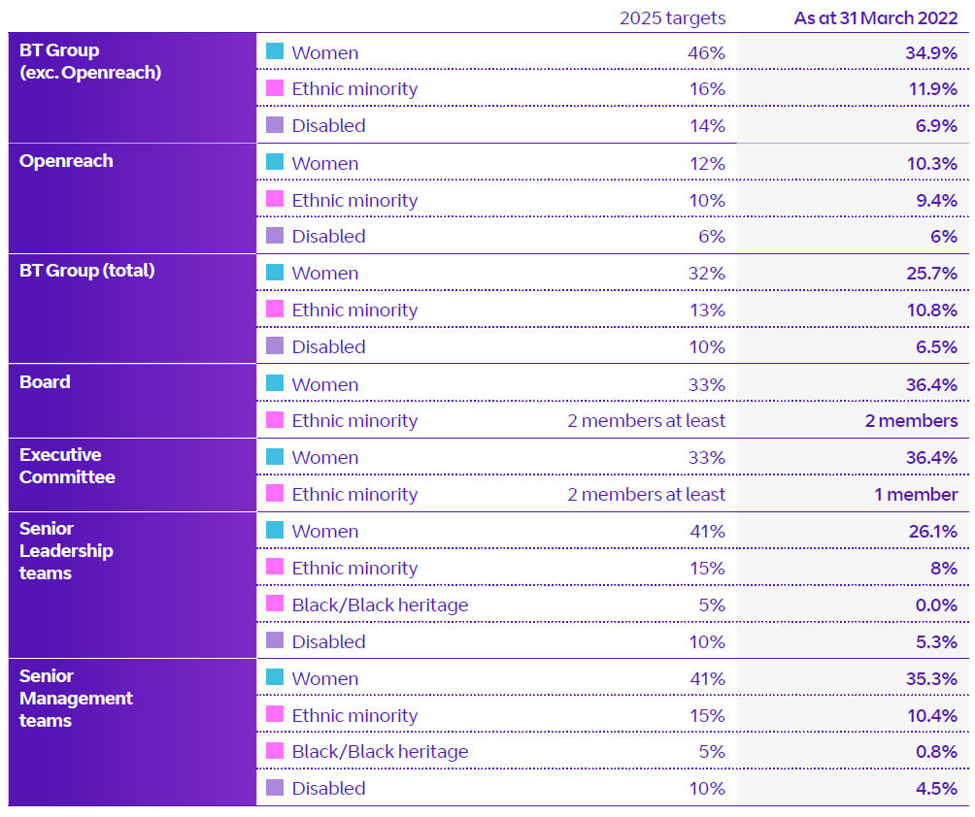

(Source: Bt.com, 2023)

## Appendix 2: Ethnicity pay gap in BT

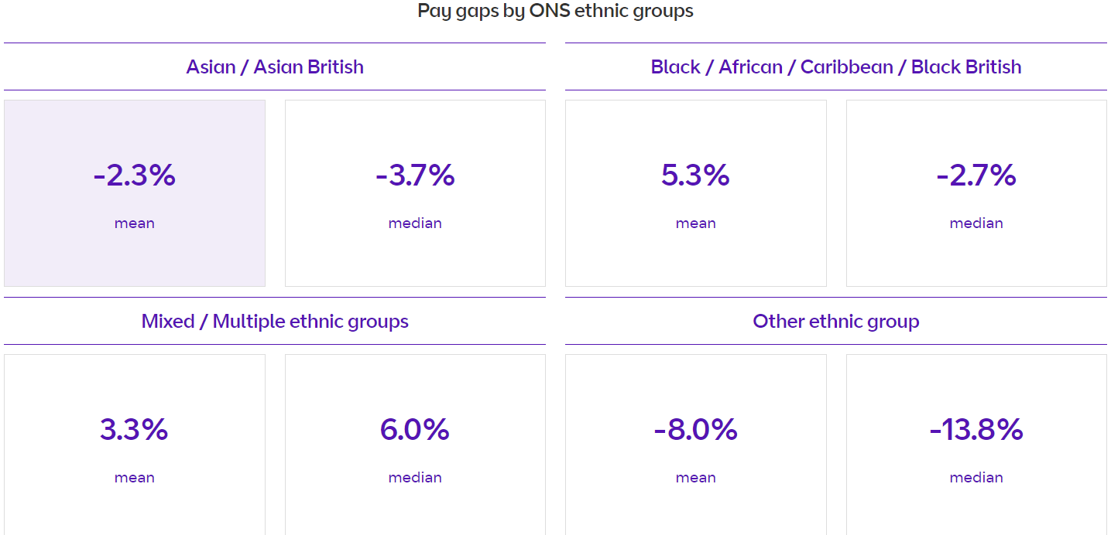

(Source: Bt.com, 2023)

## Appendix 3: Revenue of BT

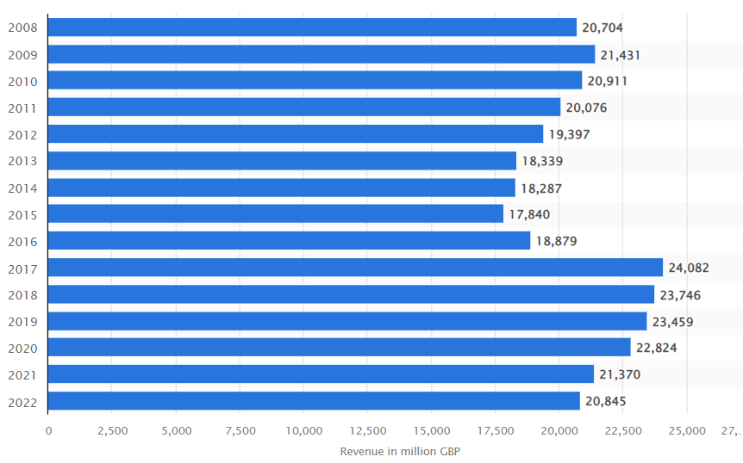

(Source: Statista.com, 2023)