**INFORMATION SYSTEMS AND DIGITAL TRANSFORMATION**

**Table of Contents**

Task 1 Blog 2

Blog 1 -Usage of information systems in business 2

Blog 2 - Critique on “What the Paper Says” 4

Blog 3- Reflecting on using Python, and Microsoft Power BI for data analysis 7

Task 2 Report: Producing a digital transformation advisory based on Case Study Brief: Digital app Vs Paper 11

Introduction 11

Analysing the existing receipt process status in the retail sector 11

SWOT on the existing receipt process for retailer owners and their customers 13

Suggesting DIGI on adopting a digital transformation roadmap 14

Accelerating and Measuring the implemented process 14

Advising a business process model for the future prediction state of DIGI after transformation 15

Conclusion 15

References 17

# 

# Task 1 Blog

## Blog 1 -Usage of information systems in business

In the advent era of digitalisation, the importance of information systems has been growing in the business sector in a noticeable manner. The use of different types of information system tools such as ***artificial intelligence (AI), machine learning, social media marketing tools, and robotics*** has been observed to be growing in a rapid manner to manage all business processes faster. IS allows the business leader to collect and store necessary data to manage the organisational process. Using artificial intelligence, a huge number of organisations have become able of managing a large amount of data efficiently. It also allows business leaders to perform different kinds of functions within the organisation in an organised way to develop faster.



**Figure 1: Artificial intelligence**

(Source: Sankara.ac.in 2023)

There are numerous uses of information systems that have been utilised by organisations to manage their data and enhance their productivity along with monitoring the operation of processes and key activities of the companies. Data shows that the global market for the use of artificial intelligence has been growing in the retail sector and was valued at about 3 billion US dollars in the year 2019 (Statista.com, 2023). It is also predicted that the use of AI can reach 23.32 billion US dollars by the year 2027. The popularity of using AI and other information systems in the business sector has been observed to be growing in a rapid manner. It can be assumed that the role of Information System plays a crucial role in managing different activities of business organisations. It also can be said that the use of IS become mandatory to maintain business agility and sustainability.



**Figure 2: Machine learning**

(Source: News-medical.net, 2023)

Business enterprises are focusing mainly to adopt the usage of information systems to manage resources and improve the overall efficiency of the organisations. Using different components of IS such as machine learning, blockchain or different social media marketing tools has enabled business organisations to contact their customers and make them aware of their product features or services. Using various tools like machine learning or blockchain business organisations are able to directly communicate with their consumers and avail of taking their feedback. The customer-centric approach can be developed by using this information system and make the business leaders able to know about the market.



**Figure 3: Information system**

(Source: Study.com, 2023)

Using different social media platforms such as Facebook, WhatsApp, Twitter and others by businesses organisations to promote their specific production services to attract the attention of their potential customers. This effective method can help organisations to enhance their sales and engage more customers in their business process. A highly competitive advantage can be gained by organisations that use these ***social media marketing tools*** through using different IS tools. This big data analytical process is used by business organisations to promote their production services along with different seasonal offers provided by them. Sales and profit margin. Using big data analysis organisations become able to collect data about the market trends that can help in remaining up to date to the organisations. Different organisations also use this information system to reinforce the security of the necessary data and information.



**Figure 4: Use of Artificial Intelligence in social media**

(Source: Rav.ai, 2023)

This helps in securing the data and makes the faster processof operations through making faster decision for the organisation. Data shows that in the year 2019, the total spending to enhance cyber security in the business industry reached around 240.8 billion US dollars in the world (Statista,com, 2023). The acceptability of using artificial intelligence for machine learning has been observed to be increasing day by day as it provides enormous benefits to business organisations. It also helps in improving the business and engaging more customers to the business to enhance their sales and profit margin.

## Blog 2 - Critique on “What the Paper Says”

This paper highlights the importance of using information systems in the business process. It highlights the major importance of information System that keeps the performance of the institutions progressive. The operational process of various enterprises is improved by using different ***information systems tools like artificial intelligence, blockchain, machine learning, and cloud computing and other systems.*** It helps in gathering data about the market and helps in providing the up-to-date information to the organisations about the market. Organisations become able to ***enhance operational efficiencies by*** using the data that are collected from the market by using information system tools.

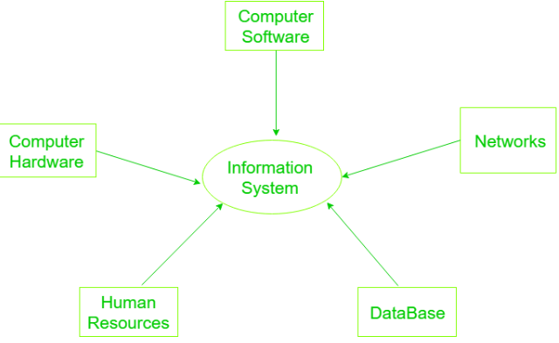

**Figure 5: Components of IS**

(Source: Geeksforgeeks.org, 2023)

Custom data can be produced by using an information system that helps in ***managing a specific task*** or helps in ***making a decision in a first manner*** to enhance the organisational process. Using different information systems allows business organisations to ***reduce the cost of their operations***. It can ***perform faster than human labour***. It ***saves time in operation*** and ***provides more accurate data*** along with ***reducing the chances of making an error*** in terms of conducting any task. ***Better customer services*** can be provided by business organisations through using AI or other big data analytical systems that help in monitoring the organisational process along with consumer purchasing behaviour.

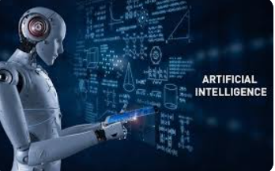

**Figure 6: Artificial Intelligence**

(Source: Geeksforgeeks.org, 2023)

This paper also highlights that a huge number of retail organisations in the UK have been focusing on using cloud computing to make faster processes for enterprises and reduce the cost of operations and increase profit levels. It enables the business organisation to eliminate the expenses of running an independent IT infrastructure. It also improves the performance of the organisations along with enhancing flexibility in business operations. These information system organisations become able to scale the resources in a short time and are able to access the shortage of sources that have high demand within the business market.

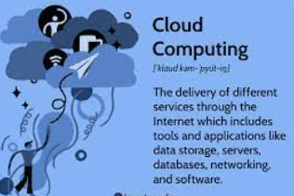

**Figure 7: Cloud Computing**

(Source: Geeksforgeeks.org, 2023)

Cloud computing has been observed as the most important tool that allows enterprises to improve their supply chain activities. It enables them to provide timely delivery of products and services to consumers in an effective manner. It also enables retail organisations to access the data shortage, servers, or databases and manage networks to access the information within a second. It helps in making faster processes of business along with creating better collaboration with the consumers through enhancing communication with them. Cloud storage in enterprises makes available the necessary data from anywhere on devices like mobile, computer or other using the internet. People can be able to gather information on global data and store the data in a safe way. Therefore, this paper has highlighted the rapid use of the information system in different activities by various business organisations to enhance their data security.



**Figure 8: Information Technology**

(Source: Ox.ac.uk, 2023)

The use of information systems has been observed to be growing in a faster manner by a large number of business organisations. Many of them are focusing now on developing personal apps, or websites to provide more facilities to their customers. In the case of retail organisations, most of organisations are now focusing on using business intelligence to provide information to their potential consumers. This paper says that business ability has been enhanced through using different information system tools that enable the organisational leaders to manage the operational process effectively. It also facilitates enterprises to access a large volume of data in a shorter span of time. Therefore, the performances of the enterprises are observed to be managing effective customer relations and developing strategies to enhance the sales and profit margin of the companies.

## Blog 3- Reflecting on using Python, and Microsoft Power BI for data analysis

Data analysis is the most important factor that has been observed for managing business processes effectively. Business performance is developed by using different business intelligence tools like python or Microsoft Power BI, that help in analysing the vast amount of data to run business agility. Microsoft Power BI is considered an interactive data analysis process that helps in visualisation. It can be used with python and the combined usage of these technologies exaggerated the power of business intelligence for ingestion of the data or transforming it. It enhances the visualisation capabilities of organisations to explore or identify the flaws of business operations.

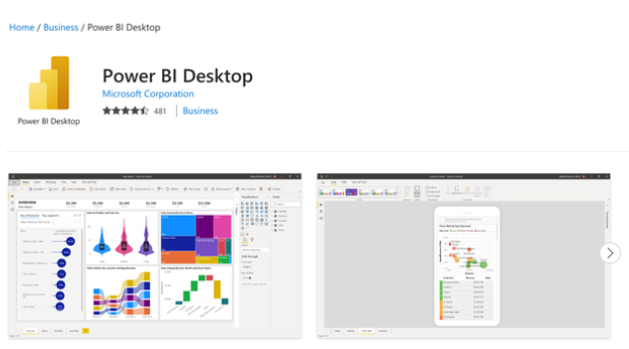

**Figure 9: Power BI Desktop**

(Source: Ox.ac.uk, 2023)

The most important use of python in making advanced data analysis processes of business enterprises and helps in enhancing the speed of work operation. In simple words, it can be said that by using python business enterprises become able to group and merge the necessary data from an ample amount of information used in business. The power vi also helps in increasing accessibility of the data and information and it is designed to use a graphical interface that helps in a clear understanding of the key processes of managing business. Clear understanding can help in enhancing business performance and increase the speed of business processes. It enables business leaders to make important decisions for the necessary changes or other factors that are beneficial for their organisation. Business organisations become a well of bringing complex algorithms by shifting it from python's numerous “data science” and “machine learning libraries” to “power BI”. It can be reflected that by using these tools organisations become able to enhance the speed of managing data and information.

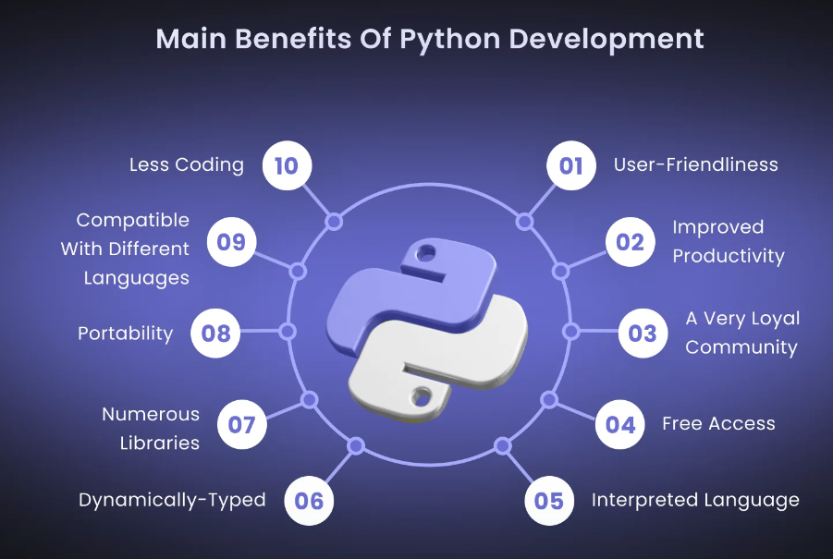

**Figure 10: Benefits of python development**

(Source: Ox.ac.uk, 2023)

It also helps in designing the organisational process in a more accurate way that provides normal business profits through the organisations. Specifically, one can utilise Python as a “data source” to pack or develop datasets. Business organisations can benefit from installing power in their system which helps in ensuring the automatic and quick updates of the latest information. In addition, it helps in enhancing the stability in the performance of the business. The main purpose of using python or Microsoft BI in the business process is to gain the support of various kinds of data analytics activities such as data collection analysis or modelling or visualisation. This exercise supports a system of business analytical tools that become for business organisations in the current age of digitisation.

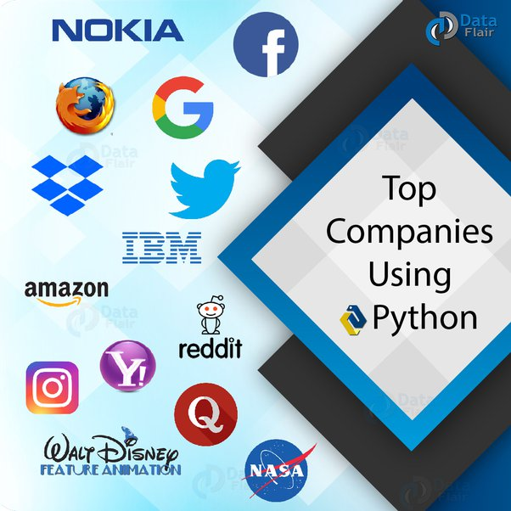

**Figure 11: Information System**

(Source: Quora.com, 2023)

Different organisations such as Nokia, Google, and Amazon, are using python in their operation and system. this helps in supporting business intelligence tools used by organisations to remain up to date and enhance the security of their organisation. This programming language is used in software development or web development and managing data science. Business organisations are using this python or Microsoft Power BI for developing their personal websites. Artificial intelligence (AI) systems monitor the ample amount of data of the organisations and data security to the organisation by keeping the data secure. It helps to maintain the privacy of the business organisation and business ethics can be followed up by using all of these information systems. Therefore, it can help in enhancing business performance by gaining competitive advantages in an effective way. The organisational process also improved by using different information systems.



**Figure 12: Power BI**

(Source: Aptude.com, 2023)

Therefore, business organisations become able to analyse faster data to manage their organisation and process. It also enables them to gain information about the current market, strategies, and recently used technologies as well. Therefore, the business can be improved by using this information system within business organisations.

## 

# 

# PRODUCING A DIGITAL TRANSFORMATION ADVISORY BASED ON CASE STUDY BRIEF: DIGITAL APP VS PAPER (TASK 2 REPORT)

**Executive Summary**

This report highlighted the case studyanalysis of Digi organisation based on UK theorganisation focused on developing payment app that can make faster process of payment Along with providing security of the record. It also provides different offers to the customers through discounts and considered as environment friendly method of payment. This study highlighted the sustainability of this payment app along future f growth in the retail sector. In this context, this also highlighted a flowchart to analyses the popularity of the app in future.in addition, it also conducted a SWOT analysis to understand its existing system process.

## Introduction

Digital transformation of the business helps in enhancing business performance through managing organisational processes and improving customer experiences. This report has been focused on sharing information about Digi, a company based in the UK. The company is focusing on developing a personal mobile app that enables customers to manage their digital receives and manage the data with one tape in one place. In this context, the study analysed the existing receipt status of the organisation Digi and conducted a SWOT analysis to understand its existing system process. In addition, from the case study analysis of Digi, this study suggests the company adopts a digital transformation roadmap to improve its operational process. It also advises a business model process to predict the future state of the company after adopting that transformation within the business process.

## Analysing the existing receipt process status in the retail sector

The vulnerability in managing the payment receipts based on paper has been observed to be growing among the retail sectors in an effective manner. In this context, the performances of the different retail organisations lack due to an increased number of complications in managing data. Additionally, in the advent era of digitalisation, almost all retail organisations have been observed to be surrounded by various digital tools. However, stool different activities in the retail sector are done manually like receiving payment slips for the purchased products. Based on the view of Attaran, (2020) digitalisation helps in enhancing the pace of operational work along with managing tasks effectively within the retail sector.

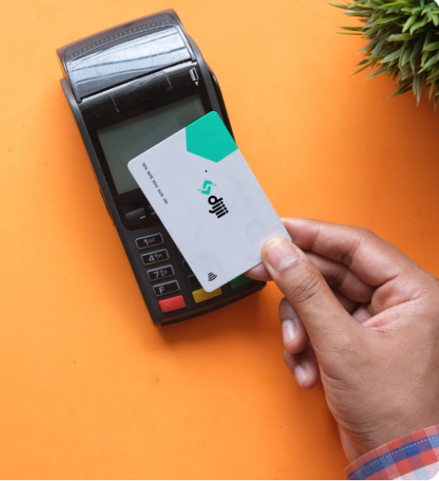

**Figure 13: Digi payment card**

(Source: Dijii.co.uk, 2023)

It has been observed from the case study that, retail organisations face issues in managing people's waste receipts that can be discarded or in the hands of hackers. Thus, the probability of the closing date of the customers along with gaining access to the hackers to get the details of the purchasing history or payment records of the customers can be easily used using paper-based payment methods. On the other hand, it has also been that people-based receipt systems are not actually environmentally friendly. Based on the view of Driga&Drigas, (2019) a number of forests are cut to produce a paper that is actually harmful to our environment.

In this context, the organisation's ***Digi*** has been focusing on developing mobile apps that deal with the issue faced by the retail organisation. Therefore, ***Digi*** has been focusing on developing an app that can provide a contactless method of payment through an app that connects retailers and customers to save time, and also save paper and money. This contact list method of paying system enables the retailers to make faster processor payments and also be able to manage the digital receives by using one tap in one place. Hence, it mobilises the operational process of business of the retailers along with enhancing the royalty on this digital payment method. Based on the view of Alzoubi et al. (2022) digital method of payment in the business organisation develops the organisational process along with providing safety and security of the payment records and then important details of the customers. Therefore, digital receives can be managed easily by retail organisations and the records can be accessed with one tap. In addition, it also provides different offers or discounts to customers regarding their preferred products or services. Hence this revolutionary transformation in the sector provides the customers and normal benefits and helps in exploring the benefits of digital transformation. However different risks are also observed that need to deal with following bitter changing policies that can make the process more accurate.

## SWOT on the existing receipt process for retailer owners and their customers

|  |  |
| --- | --- |
| **Strengths**   * A new method to connect retailers and customers * Eco-friendly way payment method * User-Friendly * Saves time of payment * Secure data * Revolutionary innovation | **Weaknesses**   * Need more update in system * Chances of fraud * Data security * Lack of adopting till now * Need more personalisation of features * Internet dependence |
| **Opportunities**   * High chances of future growth * User-friendly method of payment * Provides security of data with keeping record | **Threats**   * High chances of hacking the data * Need to secure and maintaining privacy policies * Access verification required to secure the process |

**Table 1: Swot analysis of Digi**

(Source: Created by author)

**Analysis**

Based on the SWOT analysis it can be reflected that the digit payment method system has the strength of its user-friendliness along with revolutionary innovation process. This method fails in connecting the retailers and customers in an effective way by saving time the payment. It is also eco-friendly as the paper waste method can be diminished through using this online payment method by using this app. This can help in enhancing the security of the data and also provides different offers to the customers regarding payment discounts. However, some weakness of this method has been observed such as it needs more updating to secure the data. This payment method depends on the use of the internet. Chances of hacking can be assumed as they need more personalisation features to secure the system. In this contact different opportunities have been observed as it is an eco-friendly method and also user-friendly. Therefore, there is a high chance of adopting this new payment method as it helps in making the business process faster. The threat of hacking of the data can be dealt with through a biting verification system within the app which helps in providing security of the record of the customers.

## Suggesting DIGI on adopting a digital transformation roadmap

Digital transformation of the business can be done by using different digital tools that enable the business organisations to make the process faster. In this case, transformation in the payment system can be done by retail organisations following four states ***planning, implementation, acceleration and measurement.*** Organisations can be able to manage business processes or transform the payment system to digital payment methods by developing plans to ***use different digital technology like AI, and big data analysis,*** which can help in the security of the data and information along with managing the process in an efficient way.

**Planning and implementation process**

In this context, organisations are required to implement effective strategies to adopt these technologies. Based on the comment of Khan et al. (2021), ***hiring technological experts*** within a business process inverse the business organisation to manage the data and enhance the security of data. Hence, efficient employees can perform effective monitoring of the organisational process and the chances of hacking or theft of data can be reduced through regular monitoring of the organisational process. Therefore, retail organisations can be available to develop their relationships with their potential customers in an effective way. In addition, using these system organisations can be able to follow business ethics and maintain environmental rules and norms effectively.

## Accelerating and measuring the implemented process

On the other hand, organisations are able to develop their business process by managing the entire payment method and providing security to their customers. Thus, the acceleration of the payment system can be developed by adopting digital transformation in the payment system. Hence, measuring the acceptance of digital payment methods can be determined by innovative systems. Therefore, the measuring the acceleration of the business process by following the states of the digital transformation road map organisations can be able of meeting their short-term or long-term this is business goals Based on the view of Hillmann & Guenther (2021) analysing the current state of the organisation and ***developing a vision and strategies*** through planning and implementation process that transformation of the business can be done effectively.

In this context, implementing effective strategies can help organisations deal with the potential of data theft. Thus, the potential risk of losing data or hacking the information can be reduced by hiring technical experts who can monitor the entire payment process on a daily basis. In addition, organisations are becoming able to deal with any critical issues through developing papa strategies to implement digital transformation within the business process. It can help in the security of the data of the payment process and make the organisation trustworthy in front of its potential customers. Therefore, a long-lasting relationship can be sustained by ensuring a secure payment system.

## Advising a business process model for the future prediction state of DIGI after transformation

**Figure 14: Flow chart**

(Source: Created By author)

***Flow chart technique***

The organisation can use a process technology that is a graphic representation that represents how the business process of the company Digi can be done in future after the transformation. The digital transformation of payment makes the company DG capable of growing in future. The ***user-friendly method*** can be ***easily acceptable by different organisations*** as well as customers. In addition, it also provides different types of lucrative offers by organisations through using this app to ***ensure more customer engagement***with the business process. Therefore, the future of the digital payment app ***can sustain for a long time*** in different industries, especially in the retail sector (De Vass, Shee& Miah, 2021). It can be used for saving time on a payment and ***avoiding the complicacy of the vulnerability of data.*** On the other hand, being a digital method, the use of paper-based payment methods can be reduced by using this technology. Thus, this eco-friendly method can be acceptable by all in the future and future growth sustained by this digital payment.

## Conclusion

Discussion it can be said that organisation and process can be improved by implementing digitalisation within the business process. In this context, the information system plays an important role in developing the performance of the business companies to increase productivity and make the process of business faster. In this context, organisations can be able to develop their payment system by using digital payment apps. Analysing the case study of the Digi organisation, it has been observed that digital payment methods make the process faster and provide security to the payment record of the customers. Therefore, organisations are enhancing their relationship with their potential customers by using digital payment apps. On the other hand, it also provides the customers with different other offers and discounts for using this app. Hence, this user-friendly method has a strong future for development in all industries, especially in the retail sector.

## References

**Blog 1**

News-medical.net, (2023). *Machine learning highly effective at identifying SARS-CoV-2 variants.* Retrieved on: from:<https://www.news-medical.net/news/20220209/Machine-learning-highly-effective-at-identifying-SARS-CoV-2-variants.aspx>

Rav.ai, (2023). *Application of AI in social media in 2023.*<https://rav.ai/blog/application-of-ai-in-social-media/>

Sankara.ac.in (2023). *B.Sc. Computer Science*.https://www.sankara.ac.in/science-and-commerce/department/b-sc-computer-science/

Statista.com, (2023). *Size of the global Artificial Intelligence (AI) market in the retail industry in 2020, with a forecast up to 2028.*[https://www.statista.com/statistics/1256646/ai-in-retail-marketsize/#:~:text=The%20global%20market%20for%20the,billion%20U.S.%20dollars%20by%202027](https://www.statista.com/statistics/1256646/ai-in-retail-market%20size/#:~:text=The%20global%20market%20for%20the,billion%20U.S.%20dollars%20by%202027).

Study.com, (2023). *Implementation of an Information System in Business.*<https://study.com/academy/lesson/implementation-of-an-information-system-in-business.html>

**Blog 2**

Aptude.com, (2023). *Power BI and Data Support Services.*<https://aptude.com/services/business-intelligence/business-intelligence-support/>

**Blog 3**

Geeksforgeeks.org, (2023). *Components Of Information System*:<https://www.geeksforgeeks.org/components-of-information-system/>

Ox.ac.uk, (2023). *DPhil in Computer Science.*<https://www.ox.ac.uk/admissions/graduate/courses/dphil-computer-science>

Quora.com, (2023). *Which companies are using the Python language?*<https://www.quora.com/Which-companies-are-using-the-Python-language>

**Report**

Agostino, D., Arnaboldi, M., &Lema, M. D. (2021). New development: COVID-19 as an accelerator of digital transformation in public service delivery. *Public Money & Management*, *41*(1), 69-72.<https://www.tandfonline.com/doi/abs/10.1080/09540962.2020.1764206>

Alzoubi, H., Alshurideh, M., Kurdi, B., Alhyasat, K., & Ghazal, T. (2022). The effect of e-payment and online shopping on sales growth: Evidence from banking industry. *International Journal of Data and Network Science*, *6*(4), 1369-1380.<http://growingscience.com/beta/ijds/5567-the-effect-of-e-payment-and-online-shopping-on-sales-growth-evidence-from-banking-industry.html>

Attaran, M. (2020, July). Digital technology enablers and their implications for supply chain management. In *Supply Chain Forum: An International Journal* (Vol. 21, No. 3, pp. 158-172). Taylor & Francis.<https://www.tandfonline.com/doi/abs/10.1080/16258312.2020.1751568>

De Vass, T., Shee, H., & Miah, S. J. (2021). Iot in supply chain management: a narrative on retail sector sustainability. *International Journal of Logistics Research and Applications*, *24*(6), 605-624.<https://www.tandfonline.com/doi/abs/10.1080/13675567.2020.1787970>

Dijii.co.uk, (2023), *One App. One Tap. No Paper.Retrieved on: 28.03.2023 from:* <https://www.dijii.co.uk/#about>

Driga, A. M., &Drigas, A. S. (2019). Climate Change 101: How Everyday Activities Contribute to the Ever-Growing Issue. *Int. J. Recent Contributions Eng. Sci. IT*, *7*(1), 22-31.[https://www.researchgate.net/profile/Athanasios-Drigas/publication/332029427_Climate_Change_101_How_Everyday_Activities_Contribute_to_the_Ever-Growing_Issue/links/5c9b9997a6fdccd4603f1910/Climate-Change-101-How-Everyday-Activities-Contribute-to-the-Ever-Growing-Issue.pdf](https://www.researchgate.net/profile/Athanasios-%20Drigas/publication/332029427_Climate_Change_101_How_Everyday_Activities_Contribute_to_the_Ever-Growing_Issue/links/5c9b9997a6fdccd4603f1910/Climate-Change-101-How-Everyday-Activities-Contribute-to-the-Ever-Growing-Issue.pdf)

Hillmann, J., & Guenther, E. (2021). Organizational resilience: a valuable construct for management research?*International Journal of Management Reviews*, *23*(1), 7-44.<https://onlinelibrary.wiley.com/doi/abs/10.1111/ijmr.12239>

Khan, S.A.R., Razzaq, A., Yu, Z. & Miller, S., (2021). Industry 4.0 and circular economy practices: A new era business strategies for environmental sustainability. *Business Strategy and the Environment*, *30*(8), pp.4001-4014.<https://onlinelibrary.wiley.com/doi/abs/10.1002/bse.2853>

Statista.com, (2023). *Spending on cybersecurity worldwide from 2017 to 2022.*<https://www.statista.com/statistics/991304/worldwide-cybersecurity-spending/>