**STRATEGIC MARKETING MANAGEMENT**

**Executive summary**

The study has mainly evaluated the present business environment of Kellogg’s. After analysing the present position, the study has conducted the SWOT analysis and PESTLE analysis to identify the internal and external environment. Analysing marketing audit, the study has analysed Porter’s 5 forces, 4 P’s of the marketing mix, BCG Matrix, portfolio models, perceptual mapping, and strategic group mapping. At last, the study has been concluded with suitable recommendations for the future development of Kellogg’s.

Table of Contents

Introduction 4

Evaluation of the current position of Kellogg’s 4

Internal analysis 5

Organisational Culture, mission and Vision 5

Microenvironment analysis 5

SWOT analysis 5

Macro environmental analysis 7

PESTLE analysis 7

Marketing audit 8

Porter’s five forces 8

BCG matrix 9

Marketing mix 10

Portfolio models 11

Perceptual mapping 12

Strategic group mapping 13

Recommendations and Conclusion 13

Reference list 14

# Introduction

A strategic business process assists a company to continue the organisational work process systematically to get a successful future. Kellogg’s is a multinational food manufacturing company, which has followed strategic management to maintain a good organisational culture, macro and microenvironment. Present internal marketing factors of Kellogg’s have analysed the efficient process of organisational management. The external environment of Kellogg’s has influenced the market development of the selected company. Depending on the internal and external environment, market audits of Kellogg’s, such as profit margin and costs have been measured. The present business environment of Kellogg’s can be developed by implementing advanced strategic management. BCG matrix, 4 P’s marketing mix has assisted to Measure Company’s present situation.

# Evaluation of the current position of Kellogg’s

The present position of a business in the global market has depended on its brand value, overall sales and revenue and total assets. Focusing on the present business position of Kellogg’s, it is noted that the brand has achieved a fourth position in the global market by measuring its brand value (Statista.com, 2022). One of the largest companies in North America has a net sale of ***$14.18 billion in 2021,*** which was ***$13,770 billion in 2020*** (Statista.com, 2022). The actual reason for increasing sales is its good quality products and services. The multinational manufacturing company has tried to produce and deliver healthy food products to make the customers healthy. Presently, the organisation has expanded its products and businesses all over 180 countries, which is another strategy to increase sales and have a good position in the global market (Statista.com, 2022). Good quality healthy products have assisted the organisation to have a strong customer base and compete with its competitors.

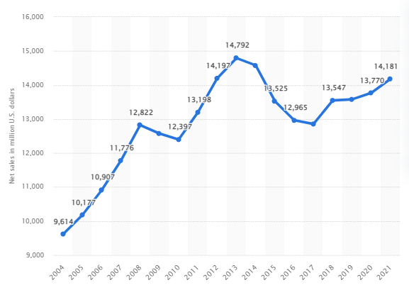

**Figure 1: Net sales of Kellogg’s Company worldwide**

(Source: Statista.com, 2022)

# Internal analysis

## Organisational Culture, mission and Vision

Kellogg’s has maintained a good organisational culture by following ***integrity, accountability, passion, humanity and simplicity***. The vision of the company is ***“A good and just world where people are not just fed but fulfilled”*** (Kelloggcompany.com, 2023). The actual purpose of Kellogg’s is to create a good brand value and customer satisfaction level by creating better days with healthy foods (Kelloggcompany.com, 2023). The present organisational culture has tried to maintain ethics to achieve employee support and continue the work process successfully. In addition, the organisation has also shown passionate behaviour, which has influenced to conduct of regular analyses to develop the present business process.

# Microenvironment analysis

## SWOT analysis

| **Strengths** | **Weaknesses** |
| --- | --- |
| * In 2021, ***Kellogg’s employed 31,000 employees*** worldwide (Statista.com, 2022) * Achieved ***fourth position*** in the global market (Statista.com, 2022) * Annual revenue in 2022 was ***$15.315 billion*** (Statista.com, 2022) | * Mismanagement in covid-19 pandemic * Capital expenditure is ***$488 million*** in 2022 * Lack of innovation |
| **Opportunities** | **Threats** |
| * The profit margin in 2021 was ***$1.75 billion*** (Statista.com, 2022) * A strong presence on Facebook, Twitter, Pinterest and Google. * Huge customer base with satisfied customers | * Technologically advanced market * A lot of competitors include “General Mills”, “Kraft Heinz”, “PepsiCo”, “Seneca Foods”, “Tyson Foods”, “Mondelez International” and ***“Nestle”***. * ***Flavour and odour issues*** of Kellogg’s products |

**Table 1: SWOT analysis of Kellogg’s**

(Source: Created by author)

***Analysis***

Kellogg’s present business environment has a lot of strengths, which has assisted to develop business more in future. In the year 2021, the organisation employed almost 31,000 employees, who are the future strength of Kellogg’s (Statista.com, 2022). On the other hand, the overall capital expenditure of the manufacturing company decreased to ***$488 million in 2022***. In addition, Kellogg’s has not included advanced technologies, which is one of its most important weaknesses. The factor has also been recognised as a future threat as the competitive advantage of Kellogg’s has decreased. The present competitors, such as Nestle and others have implemented modern technologies. Competing with these efficient competitors, the organisation has to use its social media platforms and customer support to expand more in the global market (Berndt, 2019). Present increasing profit margin has developed future opportunities for Kellogg’s as overall revenue has also been developed for this factor.

# Macro environmental analysis

## PESTLE analysis

***Political factors***

The UK has a strong political background by maintaining a good relationship with its neighbour countries, such as US. In the opinion of Thew *et al.* (2020), the UK government is a permanent member of the United Nations (UN), for which the country has taken a big part in the time of taking global decisions. The Brexit facility before 2021 has provided a chance for the UK population to play an active role.

***Economic factors***

The UK’s economy is the 6th largest economy in the world, which has assisted companies to implement effective technologies successfully. The GDP rate of the UK is increasing in the present era and it is estimated that the range will be increased up to 2027 (Statista.com, 2023). The annual inflation rate of the UK is ***6.1%***, which increased during the global pandemic time and the rate was ***9.1%*** and the corporate tax rate is 19% in 2023 (Statista.com, 2023).

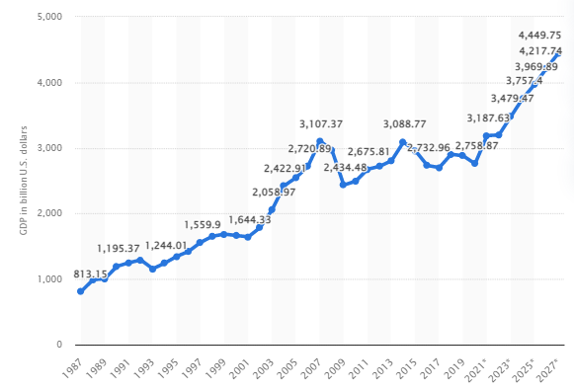

**Figure 3: Present GDP rate of the UK**

(Source: Statista.com, 2023)

***Social factors***

Most of the UK population is literate enough and the present literacy rate is 99%, which can improve present economic growth. The total population of the UK was 6.73 crores in 2021 and it is increasing in this present era to ***68,884,833 in 2023*** (Worldometers.info, 2023). In addition, individuals are health-conscious in the UK and can deliver efficient service to organisations.

***Technological factors***

UK organisations have focused on social media marketing strategies to promote businesses in an advanced way. Present research and development ***(R & D***) expenditure of the UK government is ***£15.3 billion in 2020*** (Ons.gov.uk, 2023).This factor can increase future business opportunities. Organisations of the developed country have achieved great value by applying technology development factors.

***Legal factors***

The developed country has maintained an ethical nature in every organisation to maintain a satisfied employee base. After applying the ***“Employment Act 1996”***, the overall unemployment rate decreased (Legislation.gov.uk, 2023). In addition, the ***“Equality Act 2010”*** has also been applied to maintain gender equality, racial equality, wage equality and others.

***Environmental factors***

Air pollution rate in the UK is very high because of the increasing rate of black smoke from manufacturing companies. On the other hand, the UK organisations have followed sustainable development processes, such as 3R strategies, waste management and net-zero carbon emission to decrease environmental degradation.

# Marketing audit

## Porter’s five forces

The model has mainly focused on 5 factors related to the business environment, in which, stakeholder power, product substitution and market competition are included.

***The threat of new entrants***

Present food production market of the UK tries to produce organic foods to provide a good experience of a healthy lifestyle to the customers. In the opinion of Juanamasta *et al.* (2019), having a good customer base and high-profit margin, Kellogg’s competitive advantage has been developed. The threat of new entrants is high in this market, but Kellogg’s can manage this threat through its effective strategic management process.

***The threat of substitutes***

Kellogg’s has a moderate threat of substitutes in the global market. Nestle and other competitors can increase the threat by producing good quality products (Deepa and Geeta, 2021). Kellogg’s product quality can increase its competitive advantage, by which, it can overcome the threat of substitutes.

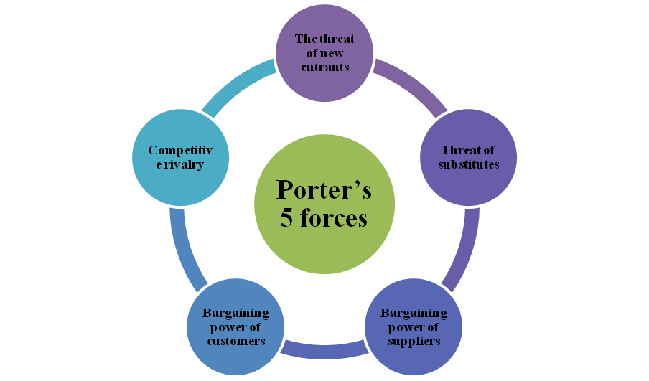

**Figure 4: Porter’s 5 forces model**

(Source: Created by author)

***Bargaining power of suppliers***

Majority of the suppliers have offered low differentiation products, for which, the organisation cannot produce different products. The organisation has planned to integrate the customers to get the effective result and produce various products with different tastes.

***Bargaining power of customers***

The loyal customers of the organisation are mainly given importance to the product quality, not to the product price. In view of Deepa and Geeta (2021), Kellogg’s new marketing strategy to deliver innovative products has provided a good customer experience. The company has also offered a discount to customers, which has decreased the threat to the bargaining power of customers.

***Competitive rivalry***

Kellogg’s has a lot of competitors in the existing market, among them, “Seneca Foods”, “Tyson Foods”, “Mondelez International” and “Nestle” are important. The competitive rivalry of the organisation is so high in this present context, which can be managed by applying advanced strategic management.

## BCG matrix

The mentioned matrix has focused on 4 factors to identify product quality and its importance for the company’s growth. ***Kellogg’s special K*** is marked as the star product of this organisation, which has a high growth rate to develop the present revenue of the organisation. The market share of the ***morning foods and Kashi segments*** of Kellogg’s has declined by 6 % in 2019, which has been included in this section. All-Bran and Mini-Wheats are two Kellogg’s products, which are listed in this part for low market growth rate and high market share. At last, ***Choices mint magic*** is this type of product which has a low growth rate and low market share.

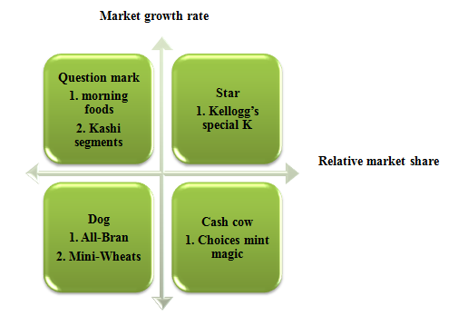

**Figure 5: BCG matrix**

(Source: Created by author)

## Marketing mix

The marketing mix has mainly analysed the main 4 factors of a business, such as product, price, place and promotion. Kellogg’s marketing strategy has tried to manage all of these factors to have a better result in future.

***Product***

The company has produced and delivered good quality products to give a healthy lifestyle to its present customers. Kellogg’s chocos, Keebler, Pop-Tarts, Eggo and Cheez-It are popular products of Kellogg’s (Kelloggs.co.uk, 2023). Maintaining a good quality and including variety with innovation, the product development strategy has been followed properly.

***Price***

Product price of the company is not reasonable, but Kellogg’s has provided discount facilities to its customers to enhance customer satisfaction level. In the opinion of Alzoubi *et al.* (2022), maintaining a reasonable price range of the products has assisted an organisation to achieve a satisfied customer base. Providing good quality products by maintaining a ***moderate price range*** (Guiné *et al.* 2020). Kellogg’s can make a balance between customer satisfaction and the company’s profit margin.

***Place***

The global multinational organisation has expanded its business to the ***urban areas*** of 180 countries, including developed countries, such as the UK, USA and others. The places have provided extra opportunities to the company.

***Promotion***

Promotional strategies of Kellogg’s have been continued by following the social media development policies. The company has a good customer base on Facebook, Twitter, Instagram and other social media platforms (Pour *et al.* 2021). Selling products through Amazon, Flipkart and other online marketing sites, the present business sales have been increased.

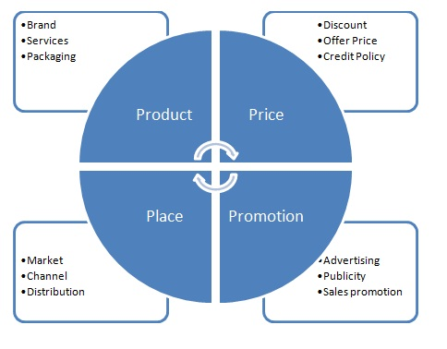

**Figure 6: 4 P’s marketing mix**

(Source: Othman *et al.* 2019)

## Portfolio models

| **Business model** | **Resources** | **Capabilities** | **Performance** |
| --- | --- | --- | --- |
| Model 1 | Technology | Adopting and implementing modern technologies | Delivering innovative services |
| Model 2 | Production process | Increase workers’ efficiency | Producing good quality products |
| Model 3 | HR management | Engaging all employees in decision-making procedure | Communication management |

**Table 2: Business portfolio models**

(Source: Created by author)

## Perceptual mapping

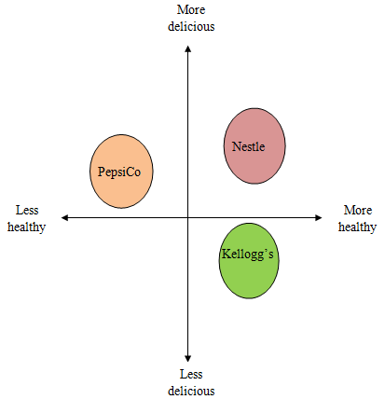

**Figure 7: Perceptual mapping of Kellogg’s**

(Source: Created by author)

Kellogg’s has produced and delivered more healthy and less delicious foods to its customers. PepsiCo and Nestle, its competitors have provided more delicious foods to attract new customers, but the healthiness of those products are not equal to Kellogg’s.

## Strategic group mapping

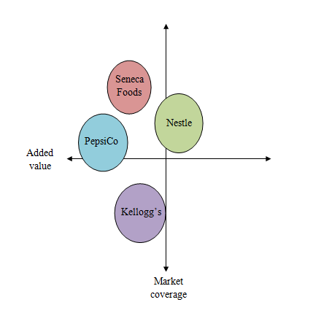

**Figure 8: Strategic group mapping of Kellogg’s**

(Source: Created by author)

Kellogg’s has high market coverage to expand present business all over 180 countries. On the other hand, the added value of products is also very high. However, its competitors cannot touch the success level of this organisation.

# Recommendations and Conclusion

After analysing the internal and external market analysis of Kellogg’s, it is recommended to ***make more research on advanced strategies***, such as ***artificial intelligence (AI)*** to develop the business successfully. Another recommendation is to ***develop workers’ efficiency*** to adopt change management and increase competitive advantage. At last, it can be concluded that Kellogg’s present strategic management can grow its future opportunities by continuing regular analysis of everyday work processes. Issues in product development can be managed by applying some advanced methods in the production process and diversifying products by nutritional value and taste. Strategic management in product development and marketing has brought effective opportunities to Kellogg’s future growth.

# Reference list

Alzoubi, H., Alshurideh, M., Kurdi, B., Akour, I. and Aziz, R., (2022). Does BLE technology contribute towards improving marketing strategies, customers’ satisfaction and loyalty? The role of open innovation. *International Journal of Data and Network Science*, *6*(2), pp.449-460.

Berndt, A., (2019). BREAKFAST GONE BAD… the case of Kellogg’s rice Krispies®. *Emerald Emerging Markets Case Studies*, *9*(3), pp.1-23.

Deepa, D.E. and Geeta, D.M., (2021). Success Of New Product Launch By New Process Flow. *European Journal of Molecular & Clinical Medicine*, *7*(7), pp.6690-6697.

Guiné, R.P., Florença, S.G., Barroca, M.J. and Anjos, O., (2020). The link between the consumer and the innovations in food product development. *Foods*, *9*(9), p.1317.

Juanamasta, I.G., Wati, N.M.N., Hendrawati, E., Wahyuni, W., Pramudianti, M., Wisnujati, N.S., Setiawati, A.P., Susetyorini, S., Elan, U., Rusdiyanto, R. and Astanto, D., (2019). The role of customer service through customer relationship management (Crm) to increase customer loyalty and good image. *International Journal of Scientific and Technology Research*, *8*(10), pp.2004-2007.

Kelloggcompany.com, (2023). *Kellogg’s,* Available at:<https://www.kelloggcompany.com/en_US/about-kellogg-company/vision-purpose-values.html#:~:text=Through%20integrity%2C%20accountability%2C%20passion%2C,thrive%20and%20success%20can%20flourish>. [Accessed on: 11th April, 2023]

Kelloggs.co.uk, 2023.*Kellogg’s,* Available at:<https://www.kelloggs.co.uk/en_GB/home.html> [Accessed on: 11th April, 2023]

Legislation.gov.uk, (2023). *Employment Act 1996*, Available at:<https://www.legislation.gov.uk/ukpga/1996/18/contents> [Accessed on: 11th April, 2023]

Legislation.gov.uk, (2023). *Equality Act 2010,* Available at:<https://www.legislation.gov.uk/ukpga/2010/15/contents> [Accessed on: 11th April, 2023]

Macrotrends.net, (2023). *Kellogg Revenue,* Available at:<https://www.macrotrends.net/stocks/charts/K/kellogg/revenue> [Accessed on: 11th April, 2023]

Ons.gov.uk, (2023). *Research and development expenditure by the UK government: 2020,* Available at:<https://www.ons.gov.uk/economy/governmentpublicsectorandtaxes/researchanddevelopmentexpenditure/bulletins/ukgovernmentexpenditureonscienceengineeringandtechnology/2020> [Accessed on: 11th April, 2023]

Othman, B., Harun, A., Rashid, W., Nazeer, S., Kassim, A. and Kadhim, K., (2019). The influences of service marketing mix on customer loyalty towards Umrah travel agents: Evidence from Malaysia. *Management Science Letters*, *9*(6), pp.865-876.

Pour, M.J., Hosseinzadeh, M. and Mahdiraji, H.A., (2021). Exploring and evaluating success factors of social media marketing strategy: a multi-dimensional-multi-criteria framework. *foresight*, *23*(6), pp.655-678.

Statista.com, (2022). *Gross domestic product (GDP) in current prices of the United Kingdom (UK) from 1987 to 2027,* Available at:<https://www.statista.com/statistics/263590/gross-domestic-product-gdp-of-the-united-kingdom/> [Accessed on: 11th April, 2023]

Statista.com, (2023). *Annual inflation rate of the Consumer Price Index in the United Kingdom from 2000 to 2027,* Available at:<https://www.statista.com/statistics/306720/cpi-rate-forecast-uk/#:~:text=In%202023%2C%20the%20annual%20inflation,when%20it%20reached%204.5%20percent>. [Accessed on: 11th April, 2023]

Thew, H., Middlemiss, L. and Paavola, J., (2020). “Youth is not a political position”: Exploring justice claims-making in the UN Climate Change Negotiations. *Global Environmental Change*, *61*, p.102036.

Worldometers.info, (2023). *U.K. Population,* Available at:<https://www.worldometers.info/world-population/uk-population/> [Accessed on: 11th April, 2023]