**MARKETING REPORT OF NEXT PLC**

Table of Contents

Introduction 3

Company profile 3

Analysis of digital marketing environment- an online marketplace 5

Micro-environment analysis 5

Customers 5

Competitors 5

Suppliers 6

Macro-environment analysis 7

Social/Cultural 7

Economic 8

Technological 9

Analysis of integrated marketing communication 9

Advertising 9

Sales Promotion 10

Direct and Digital Marketing 11

Discussion of the online integration and traditional media 11

In-depth analysis of the way Next Plc integrates online and offline media 11

Conclusion 14

References 15

**Executive Summary**

This report had highlighted the importance of marketing strategy of a business to ensure growth in the competitive market. In this context, here had been discussed the effective strategies of UK based retailing company Next Plc. In this context, the background of the company had discussed in this study. Next Plc has been managed sales promotions, advertisement, and direct marketing procedures by following communication mix. The micro analysis has also promoted the effect of customers, competitors, and suppliers on the business attributes of the company. In that case, the DRIP model has been used to manage this communication mix to attract customers. This organisation has been managed in-store and online store operational activities by supporting customers’ needs.

# Introduction

Marketing strategy has been considered as the essential factor that provides a clear framework to reach the target audience and present the products and services to engage them with the business. In this here has selected the UK-based retailing organisation ***“Next Plc”*** as their leaders have always focused on developing the best strategy to achieve competitive advantages. Moreover, the “micro and macro environmental analysis” that has impacted the business as well as the importance of “integrated marketing communication” has also been illustrated in this study. Besides this, different types of marketing campaigns along with the “social media metrics” of Next Plc has evaluated in this study.

# Company profile

Next Plc is seen as one of the best retailers that offer a huge range of products from accessories to beauty and home ware products for customers. The main aim of this company is to meet customers' expectations by providing quality products as per their requirements at cost-effective prices. Next Plc has distributed its products through three main channels such as ***“Next Retail”***, ***“Next Directory”***, and ***“Next International”*** and expanding the business by maintaining ***700 stores*** across the world (Next.co.uk, 2023). The main strategy of this company is that they have targeted customers between 20 to 46 years and enhance the customer’s services to respond to their queries within the stipulated time frame.

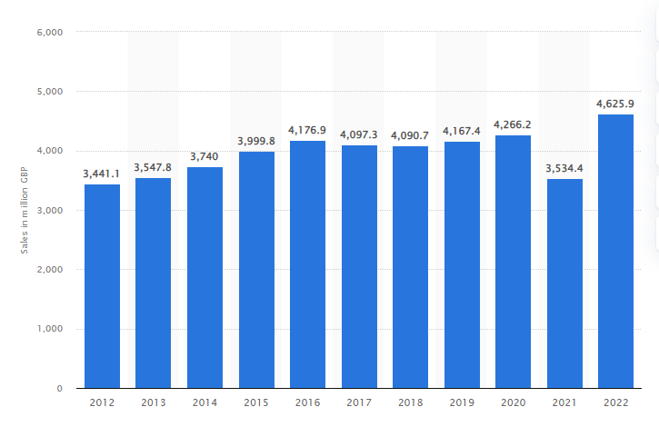

**Figure 1: “Growth of Next Plc”**

(Source: Statista.com, 2023)

Figure 1 has clearly portrayed that Next Plc by providing services through online and offline stores has drastically increased its profit percentages. According to a report, in 2022, this company generated revenue of approximately 4.9 billion British pounds in the market (Statista.com, 2023). Besides this, the leadership management team of Next Plc has committed to maintaining business-related social and environmental responsibilities by maintaining waste management through their operating process.

**Figure 2: “Capability pyramid of Next Plc”**

(Source: “Self-developed”)

This UK-based company has always tried to differentiate its business by maintaining the distribution network and developing relationships with suppliers to reach potential markets. However, this company has faced competition in the market from adjacent companies such as ***“Marks &Spencers”*** and ***“Dunelam Group Plc”*** which provide unique products to the customers as well (Next.co.uk, 2023). This is the reason that the managing authority of Next Plc maintained the highly skilled workforce by providing them with effective training in terms of increasing the profit percentages. Furthermore, the best thing is that the company has utilised different technologies such as ***“Microsoft hyper-v-server”***, ***“web analysis”***, and ***“programming languages”*** to understand the market demand and manufacture those items for enhancing the brand reputation in the global market.

# Analysis of digital marketing environment- an online marketplace

## Micro-environment analysis

“Porter’s five forces” is defined as an important tool to analyse the competitive force and address the pinpoint areas to improvise the strategies. Moreover, this has provided ideas that where the business has stood by understanding the customer’s and suppliers' power, analysing the threats of substitute products and rivalry in the business market.

### Customers

The market in which Next Plc has operated customers can find a number of options to buy their necessary products. Therefore, the "bargaining power of customers" is seen as high for this company. On the other hand, customers have a tendency of selecting items which are low in price and provide a certain quality aspect. Furthermore. the company has been operating in a very competitive market which has also increased the bargaining power of the customers. Besides this, Zara has been recognised as the main competitor of the company which has developed its business based on customer-changing trends (Riaz *et al*. 2021). This has also provided customers with the option of buying trendy clothes at low prices.

The “bargaining power” of customers has also increased due to the changing trends in customer behaviour. As opined by Cao *et al*. (2021), the changing trends in the market have been influenced by social media and customer choices. In this context, the bargaining power of customers has been elevated due to the continuous change in the trending qualities of social media attributes. This has also negatively affected the controlling power of Next Plc over its customers' bargaining power. In addition, it can be concluded that customers are very important in retail businesses such as “Next Plc” and the consumer spending trends have also promoted an essential impact on the sales of the company.

### Competitors

The porter five forces analysis has also highlighted the effect of exiting as well as new competitors in the market. As mentioned by Ridwan (2022), the existing customers in the market have promoted the most vital competition to the retail organisation. It has been observed that “Marks and Spencer’s (M&S)” has been recognised as one of the crucial competitors of “Next Plc”. “M&S” has also promoted quality products with effective pricing in the UK. This increased the customers’ expectations from the retail organisation in the UK. On the other hand, it has been found that other competitors such as “Zara” have also provided effective competition to “Next Plc.”

Zara has been promoting its items at a very low price and changing the designs of the products in a very quick way. As per the views of Gazzola*et al*. (2020), the changing trends in customers’ purchasing conditions have elevated the possibility of entering new competitors in the market. On the other hand, existing competitors can improve their technological implementations which can promote difficulties for “Next Plc”. In addition, new entrants can also develop effective market analysis strategies to improve their position in the existing market. This can also provide “Next Plc” with a competitive backdrop in the market.

### Suppliers

The “bargaining power of suppliers” has not promoted any significant effect on the retail market. However, the critical aspect of supplying raw materials has been dependent on the suppliers. As opined by Taleizadeh*et al*. (2021), the bargaining power of the suppliers has not been effectively seen in the retail sector due to the number of suppliers in the market. On the other hand, “Next Plc” can suffer with the quality of the raw materials. The downgrade of the quality of products can negatively affect the sales of the company. In this context, it can be said that the bargaining power of the suppliers has a significant role in the marketing processes of “Next Plc”. In addition, the suppliers can collectively increase the price of the raw material which can also negatively impact the operational costs of the company and the profitability can reduce due to this. It can be observed from the discussion that “Next Plc” has to analyse the “bargaining power” of the suppliers and promote effective relationships with its suppliers to maintain the pricing rate low and attract more customers.

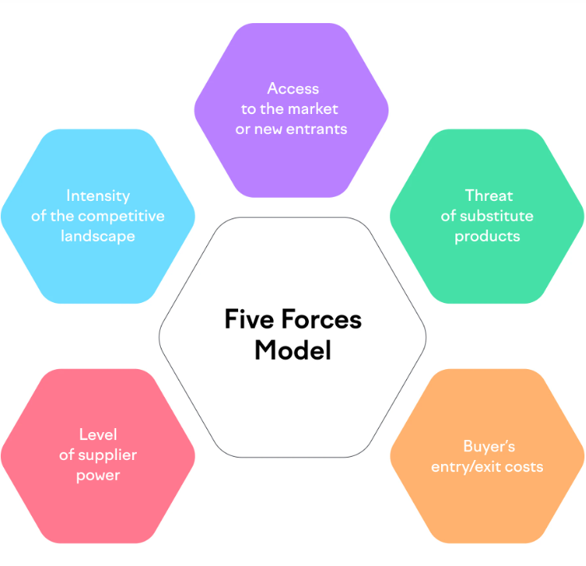

**Figure: “Porter’s Five Forces”**

(Source: Gazzola*et al*. 2020)

## Macro-environment analysis

***Analysis of the SLEPTS approach***

This approach stands for social, legal, economic, political, technological and sustainability; these elements can help Next Plc to understand their external environment for marketing feasibility.

### Social/Cultural

The e***mployment rate in the UK is 75.7%*** from 2022 to 2023 which is 0.1% higher than the previous year. Additionally, the payroll has ***increased by 30.0 million***. As compared to the ***3.7% of the unemployment*** rate, higher employability has been found in the UK market (Ons.gov.uk, 2023). On the other hand, the ***literacy rate is 99%*** and 1% of the population is struggling with reading and writing issues (Una.org.uk, 2023). This ratio of social factors is depicting a positive scenario of the UK market where a maximum number of individuals are employed and they are educated. Among the 99% of literacy rate, more than ***3 million employees*** are associated with the UK retail industry ***which is approximately 8%*** (Brc.org.uk, 2023). Along with that, the cultural scene is also good, where ***89% of individualism, 51% of long-term orientation, 66% of masculinity and 35% of uncertainty avoidance*** are included (Hofstede-insights.com, 2023). This cultural scenario demonstrates that the UK has an interdependent society to maintain all individuals or citizens.

### Economic

The ***GDP rate of the UK was 3.61%; currently, 0.32% has increased in 2023***. However, the growth rate of the UK is not growing in the right way to enhance the economy (Statista.com, 2023). On the other hand, the GDP ***per capita was £31,814 in 2021*** and the last ***per capita rate is £32,904*** (Statista.com, 2023). Thus, the growth of the nation is moving forward in a positive way. Alongside this, the UK ***inflation rate fluctuated by 9.2% in 2022*** (Ons.gov.uk, 2023). Despite having the inflation rate, the UK retail ***industry faced 11.1% of CPI*** and it ***was reduced by 10.1% in 2023*** (Reuters.com, 2023). However, inflation is hitting the retail industry due to increasing the price of fuel, oil and gas by which retailers are proceeding with transportation operations.

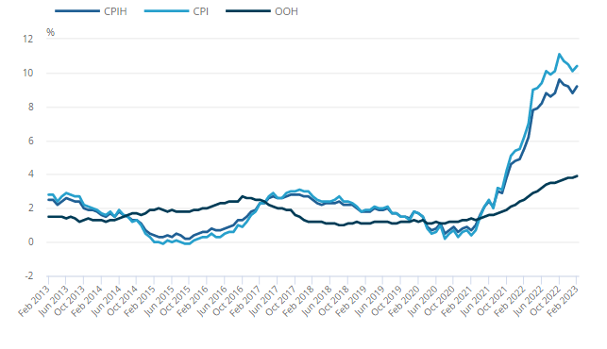

**Figure 3: CPI rate in the UK**

(Source: Ons.gov.uk, 2023)

The inflation rate enhancement affects household purchasing behaviour, where food, grocery products, clothing and non-alcoholic beverages products are included in the retail industry.

### Technological

The UK government has pledged to fund around £1 billion for science and technology. On the other hand, the chancellor of the UK has funded £3.5 billion in terms of supporting the ambitions of the UK government (Gov.uk, 2023). All funds and campaigns have been formed for the “***science and technology framework***”. Approximately ***26 transformative projects have been imposed in R&D*** development which is used in the retail industry. However, the R&D expenditure of the UK retail and wholesale industry has been projected by ***£1.7 billion in 2021 in terms of proceeding with retail operations*** (Statista.com, 2022). On the other hand, ***digital technology influenced by 33%*** in the UK retail industry for sales operations and online purchasing ***behaviour has increased by 175%*** (Bl.uk, 2023). This is the way the UK retail industry has acquired facilities from the external environment due to managing several digital technologies.

# Analysis of integrated marketing communication

**Definition of integrated marketing communication (IMC)**

The IMC is a plan for interacting with customers where marketers are designing products and brands to perceive opinions from customers. With the help of marketing campaigns, marketers are showing their brands to customers to communicate with regional and international customers. Due to managing online marketing operations, Next Plc has ***increased by 17% in 2019*** (Marketingweek.com, 2021). Mainly, Next Plc is targeting 20 to 50 years of adults to proceed with that clothing marketing campaigns.

**Marketing Communication Mix with DRIP model analysis**

***Defining DRIP model***

The DRIP model stands for “***Differentiate***”, “***Reinforce***”, “***Inform***” and “***Persuade***” which helps to boost brand loyalty, and promotional activities, increase brand awareness, re-engage customers and many other facilities can be attained through this model. The DRIP model is going to be implemented in the marketing communication mix tools that have been adopted by Next.

## Advertising

Next Plc has proposed their brand images through the advertisement process where digital marketing procedures have been included in terms of increasing sales operations. The advertisement is supporting the ***persuade strategy*** of the DRIP model where Next is attracting customers by offering ***50% discounts on shoes, clothes, homeware and electrical products*** (Next.co.uk, 2023). This discount facility attracts customers to improve their purchasing behaviour and increase online and offline sales. According to Glaser and Reisinger (2022), persuade strategy helps to improve product developmental operations by changing the brand attitude through advertisement procedures. This is the way Next Plc proceed with its advertisement operations for digital marketing.

## Sales Promotion

Next has added value to their products and brands in terms of creating online sales growth. Evidently, more than £500 million has been acquired by this organisation by taking the help of third parties where UK distributors, suppliers and other shareholders are included through third party warehouses. They are also promoting products through a website marketing process to service 5 million UK customers who are purchasing products online. On the other hand, 1.5 million overseas customers have also purchased Next’s branded products.

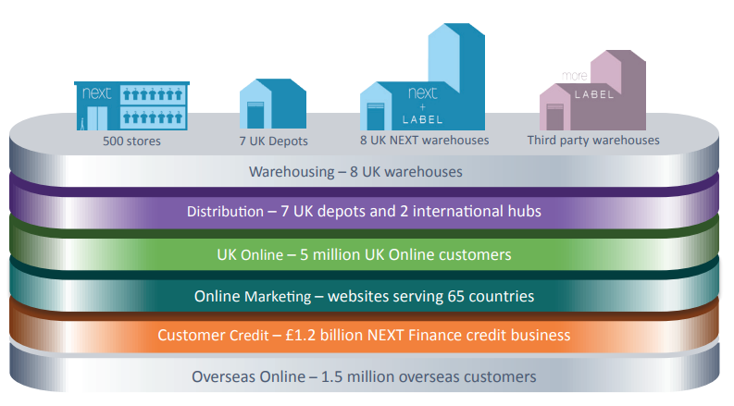

**Figure 4: Online marketing sales promotions**

(Source: Nextplc.co.uk, 2021)

It is important to focus on the customer's purchasing behaviour by which a company can promote their brand to support customer demands. Contextually, Widayati*et al.* (2019) mentioned that the implementation of the product-promoting aspects informs customers to buy their required products in terms of increasing sales. This strategy is supporting the ***inform strategy*** of the DRIP model. This process influenced Next Plc to improve its performance for sales promotions.

## Direct and Digital Marketing

The direct marketing process indicates door-to-door visits, email campaigns, target audience and other procedures. However, Next Plc has used ***2.38% of email marketing*** procedures so that they can improve marketing procedures (Mailcharts.com, 2023). This organisation has profited ***£4 million in 2021*** through their online or digital marketing. In that case, they focused on investment for the physical store management (Marketingweek.com, 2021). With the help of the store's operational activities, Next has increased their ***offline sales by £50 billion***. In that case, ***33% of customers wanted*** to pay for digital marketing procedures (Bl.uk, 2023).

***Critical analysis of the way Next Plc blended all marketing tools to communicate with customers for engagement***

All marketing communication tools are used for advertisement procedures in terms of managing sales promotions. At this point, Chukwu *et al.* (2019) mentioned that the implementation of the advertisement process influences customers so that they can purchase their demanded brands. Contextually, Next Plc has positively managed their business growth by developing international sales operations whereas 35% of overseas growth occurred due to digital marketing and sales promotional activities (Marketingweek.com, 2019). These sales operations are effectively helping to establish customer engagement.

# Discussion of the online integration and traditional media

## In-depth analysis of the way Next Plc integrates online and offline media

***Analysis of marketing campaigns and data analytical influences in Next Plc***

Next only focuses on digital marketing where they ***spent £36 million in 2019***. Along with that, this organisation has made a plan with their stakeholders and increase 28% of financial growth, which ***shows £46 million in 2020*** (Campaignlive.co.uk, 2019). This organisation proposed their advertisement for digital marketing and containing through direct posters and print so that they can increase revenue to create a well-known position in the UK market. According to MacInnis *et al.* (2020), marketing campaigns include National and international customers and stakeholders so that they can join the organisation programs to know details of the products or brands. Contextually, Bazuhair (2023) stated that digital marketing prices increase sales growth by developing promotional activities. However, Next Plc has adopted this strategy in their digital marketing so that they direct sales to their customers. This activity increases financial growth through sales operations. Mainly online marketing has become popular in the UK and international markets because they adopted a suitable sourcing strategy to provide branded quality products to all customers.

The use of mobile individual marketing has become an important part whereas ***70% of customers visit online*** and ***55% of customers*** focus on online sales. The impact of the digital marketing company positively grew online users because Next Plc invested £57 million in the online system in 2020 (Campaignlive.co.uk, 2019). Along with that, Next Plc organised an online survey in terms of knowing their purchasing behaviour whereas ***200,000 customers ordered Next's products from their stores*** (Nextplc.co.uk, 20232 This activity depicts that the maximum number of customers are willing to have online products based on the digital marketing process.

***The online and offline-media integration process with its impact and significance***

Next Plc has become successful to serve 8 medium online customers in over 70 countries. Due to having overseas customers, this organisation focused on customer engagement by creating 12 million contacts over online posts, telephone and feedback processes (Nextplc.co.uk, 2022). On the other hand, this organisation collects all feedback from their customers in terms of managing their in-store operations. Furthermore, Next has focused on a “***responsible sourcing strategy***” for offline sense or in-store management operations so that they can increase sales operations (Nextplc.co.uk, 2022). The impact of online and offline media positively influences this organisation because Next Plc is majorly focusing on the online sales by which they can connect directly to the UK and overseas customers. Due to this reason, online and traditional media integration processes have been considered in this retail organisation.

***Analysis of social media metrics***

The social media metrics depict that Next Plc has 3,266,559 Followers and 3,253,098 individuals who liked Next’s Facebook page. Along with that, 2.5 million followers on Instagram, 16.8K subscribers on YouTube, 275472 followers on LinkedIn and 276.7K followers on Twitter.

**Figure 5: Followers of Next Plc**

(Source: Facebook.com, 2023)

Among all these platforms, customer reach is high on Facebook where major customers are following them.

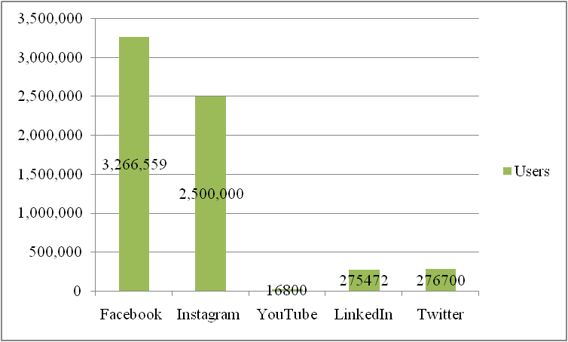

**Figure 6: Social media metrics**

(Source: Facebook.com, 2023)

***Analysis of the reading***

Next has also focused on the customers' feedback from social media platforms to know the satisfaction level regarding their brands and products. Social media platforms are the basic area for digital marketing. Contextually, Lad-Khairnar (2021) mentioned that Facebook, Instagram, YouTube and other platforms are associated with digital marketing by which customers can interact with the business members due to implementing the B2C strategy. This organisation has also adopted a different social media platform, which makes a clear concept of their digital marketing process in terms of increasing sales growth. The entire study of the digital marketing of Next Plc demonstrated that the maximum level of customers is online users who won their products online.

# Conclusion

***Key findings***

It can be concluded that Next has the ability to proceed with the digital marketing process where they adopted the IMC tool where advertisements, sales promotion and direct or digital marketing procedures are incorporated. As compared to the digital marketing process, the in-store operation has not become popular with UK customers.

This organisation has highlighted the competitors, suppliers and customers in terms of managing the internal environment. On the other hand, economic, social/cultural and technological aspects have been discussed to analyse the external environment where the impact of economic factors has impacted positively as well as negatively. Apart from that, Next Plc managed their in-store and online marketing process; however, online marketing processes have become popular with UK customers.

Next has become successful in managing the digital marketing process, email marketing and campaign operations because they manage advertising sales promotions and direct selling functions.

This report is important because it makes a clear concept of the procedure of digital marketing to attract customers.

# References

Bazuhair, N.A.S., 2023. Awareness of business administration students of the role of digital marketing in the growth of e-commerce. *International Journal of Professional Business Review, 8*(2), pp.e01123-e01123.

Bl.uk, (2023). *British Library*. Available at: https://www.bl.uk/collection-items/digital-influence-in-uk-retail-the-true-value-of-digital-instore#:~:text=The%20influence%20of%20digital%20devices [Accessed 12 April 2023].

Brc.org.uk, (2023). *The UK retail industry*. Available at: https://brc.org.uk/climate-roadmap/section-1-context/12-the-uk-retail-industry/#:~:text=The%20retail%20industry%20in%20the [Accessed 12 April 2023].

Campaignlive.co.uk, (2019). *Next boosts digital marketing to £46m as it delivers ‘higher returns’*. Available at: https://www.campaignlive.co.uk/article/next-boosts-digital-marketing-46m-delivers-higher-returns/1579874 [Accessed 13 April 2023].

Cao, D., Meadows, M., Wong, D. and Xia, S., (2021). Understanding consumers’ social media engagement behaviour: An examination of the moderation effect of social media context. Journal of Business Research, 122, pp.835-846.

Chukwu, B.A., Kanu, E.C. and Ezeabogu, A.N., 2019. The impact of advertising on consumers buying behaviour. *International Journal of Arts and Commerce, 8*(1), pp.1-15.

Facebook.com, (2023). *Next*. Available at: https://www.facebook.com/nextofficial/ [Accessed 13 April 2023].

Gazzola, P., Pavione, E., Pezzetti, R. and Grechi, D., (2020). Trends in the fashion industry. The perception of sustainability and circular economy: A gender/generation quantitative approach. Sustainability, 12(7), p.2809.

Glaser, M. and Reisinger, H., (2022). Don’t lose your product in story translation: How product–story link in narrative advertisements increases persuasion. *Journal of Advertising, 51*(2), pp.188-205.

Gov.uk, (2023). *Government commits up to £3.5 billion to future of tech and science*. Available at: https://www.gov.uk/government/news/government-commits-up-to-35-billion-to-future-of-tech-and-science [Accessed 12 April 2023].

Hofstede-insights.com, (2022). *United Kingdom - Hofstede Insights*. Available at: https://www.hofstede-insights.com/country/the-uk/ [Accessed 12 April 2023].

Lad-Khairnar, M.D., (2021). Social Media Marketing: An Overview. *Vidyabharati International Interdisciplinary Research Journal*, *12*(1), pp.172-175.

MacInnis, D.J., Morwitz, V.G., Botti, S., Hoffman, D.L., Kozinets, R.V., Lehmann, D.R., Lynch Jr, J.G. and Pechmann, C., (2020). Creating boundary-breaking, marketing-relevant consumer research. *Journal of Marketing*, *84*(2), pp.1-23.

Mailcharts.com, (2023). *Companies tracked by MailCharts: View any company’s email program*. Available at: https://www.mailcharts.com/companies/next-uk-email-marketing [Accessed 13 April 2023].

Marketingweek.com, (2019). *Next opts for targeting over mass reach to boost sales*. Available at: https://www.marketingweek.com/next-brand-targeting/ [Accessed 13 April 2023].

Marketingweek.com, (2021). *Next continues to ramp up digital marketing spend as online sales surge*. Available at: https://www.marketingweek.com/next-digital-marketing-online-sales/ [Accessed 12 April 2023].

Next.co.uk, (2023). *Be In The Know.* Available at: https://www.next.co.uk/ [Accessed on: 12.04.2023]

Next.co.uk, (2023). *Next Official Site: Shop for Clothes, Shoes, Electricals, Homeware & More*. Available at: https://www.next.co.uk/nextsale [Accessed 12 April 2023].

Nextplc.co.uk, (2021). *Business Model*. Available at: https://www.nextplc.co.uk/~/media/Files/N/Next-PLC-V2/documents/company-meetings/business-model-2021.pdf [Accessed 12 April 2023].

Nextplc.co.uk, (2022). *O U R C U STO M E R S AND PRODUCTS*. Available at: https://www.nextplc.co.uk/~/media/Files/N/Next-PLC-V2/documents/corporate-responsibility/cr-2022-our-customers-and-products.pdf [Accessed 13 April 2023].

Ons.gov.uk, (2023). *Consumer price inflation, UK - Office for National Statistics*. Available at: https://www.ons.gov.uk/economy/inflationandpriceindices/bulletins/consumerpriceinflation/february2023#:~:text=Since%20October%202022%2C%20the%20CPIH [Accessed 12 April 2023].

Ons.gov.uk, (2023). *Unemployment - Office for National Statistics*. Available at: https://www.ons.gov.uk/employmentandlabourmarket/peoplenotinwork/unemployment#:~:text=The%20UK%20employment%20rate%20was [Accessed 12 April 2023].

Reuters.com, (2023). UK retailers and consumers continue to feel pinch of rising costs - BRC. 1 Mar. Available at: https://www.reuters.com/world/uk/uk-retailers-consumers-continue-feel-pinch-rising-costs-brc-2023-03-01/#:~:text=Britain [Accessed 12 April 2023].

Riaz, H., Baig, U., Meidute-Kavaliauskiene, I. and Ahmed, H., (2021). Factors effecting omnichannel customer experience: evidence from fashion retail. Information, 13(1), p.12.

Ridwan, M., (2022). Purchasing Decision Analysis in Modern Retail. AKADEMIK: JurnalMahasiswa Ekonomi &Bisnis, 2(1), pp.1-9.

Statista.com, (2022). *Wholesale and retail trade: R&D expenditure 2018-2021*. Available at: https://www.statista.com/statistics/411891/wholesale-and-retail-trade-united-kingdom-uk-research-and-development-spend/#:~:text=R%26D%20expenditure%20in%20the%20UK [Accessed 12 April 2023].

Statista.com, (2023). *Annual revenue of Next plc from financial year 2012 to 2022 in the United Kingdom (UK).* Available at: https://www.statista.com/statistics/544243/next-annual-revenue-uk/  [Accessed on: 12.04.2023]

Statista.com, (2023). *UK GDP per capita 2022*. Available at: https://www.statista.com/statistics/970672/gdp-per-capita-in-the-uk/#:~:text=In%202022%2C%20gross%20domestic%20product [Accessed 12 April 2023].

Statista.com, (2023). *United Kingdom - Gross Domestic Product (GDP) Growth Rate 2024 | Statista*. Available at: https://www.statista.com/statistics/263613/gross-domestic-product-gdp-growth-rate-in-the-united-kingdom/ [Accessed 12 April 2023].

Taleizadeh, A.A., Shahriari, M. and Sana, S.S., (2021). Pricing and coordination strategies in a dual channel supply chain with green production under cap and trade regulation. Sustainability, 13(21), p.12232.

Una.org.uk, (2023). *International Literacy Day - Factsheet*. Available at: https://una.org.uk/international-literacy-day-factsheet [Accessed 12 April 2023].

Widayati, C.C., Ali, H., Permana, D., Riyadi, M., Mercu, U. and Jakarta, B., (2019). The Effect of Visual Merchandising, Sales Promotion and Positive Emotion of Consumers on Impulse Buying Behavior. Journal of Marketing and Consumer Research, 60, pp.56-65.