**TOU4224**

**“DESTINATION MANAGEMENT”**

**Executive Summary**

The report has appraised certain theoretical approaches along with the challenges which can be resolved by respective stakeholders conducted through the articulation of a stakeholder analysis. On the other hand, the report articulated the "Segmentation, Targeting and Positioning (STP)" strategies along with the application and understanding of branding procedures associated with the topical context. In this context, the report considered ***Pattaya City*** as the considered destination. Moreover, the dumping of garbage and faecal wastes accumulated through corresponding contaminants has thus deteriorated the aquatic bodies. In this context, officials and residents are advised to remain indoors and avoid strenuous outdoor activities. However, the DMO can play a significant role in communicating with the associated stakeholder related to tourism. The contributions can be instrumental in accomplishing the goals through the development of travel packages and maintaining crises.

The study appraised the implementation of geographic segmentation which has been instrumental in attracting Chinese tourists on a large scale. This helps in determining the preferences of the customers towards certain services provided by the company compared to the competitors. Furthermore, the study entailed that the hotels hailed at Pattaya City target those customers who love travelling to faraway places in search of leisure or attending business meetings. The study appraised the application of the “6 A's Framework” of Tourism, which facilitates the inclusion of certain aspects which can drive the success of the associated organisation and increase the destination's competitiveness in the tourism sector. On the other hand, the aspect of enhancing the brand image as mentioned in this report played a key role in providing a detailed description of a place, along with products, services and experiences that can be availed by customers. Furthermore, the articulation of the theory of Customer-Oriented Research provided an optimised set of services, which can be instrumental for the tourism companies in Pattaya in generating better organisational value. on the other hand, Digital and Direct Marketing entailed the aspects of cost-effectiveness aided with enhanced management of promotional aspects that can help in attracting a large number of customers.

**Table of Contents**

1. Brief Introduction 3

2 Overview of the Destination and its Analysis 3

1.1 Key Stakeholders 4

1.2 Key Challenges 6

1.3 Macro and Micro Forces 8

2. "Segmentation, Targeting and Positioning (STP)" 10

2.1 Segmentation 10

2.2 Targeting 11

2.3 Positioning 11

2.4 6 A's Framework 11

3. Destination Branding 14

3.1 The Theory of Customer-Oriented Research 15

4 Digital and Direct Marketing 16

4.1 Digital Marketing 17

4.2 Direct Marketing 17

5. Conclusion 17

Bibliography 19

# 1. Brief Introduction

Destination Management entails the overarching methodologies encapsulated within the respective attributes of the destination. The aspects play a significant role in unlocking organisational benefits where bespoke outcomes are subject to render an increase in revenue. The report has considered ***Pattaya City*** as the destination where the report shed light on the analysis of its overview.

# 2 Overview of the Destination and its Analysis

The city of Pattaya is located on the eastern Gulf coast of ***Thailand*** and is well-known for its beaches. A ***quiet fishing village*** oriented in the ***60s*** is now transformed into an immaculate region comprising resorts, cabaret bars and 24-hour clubs and high-rise condos.

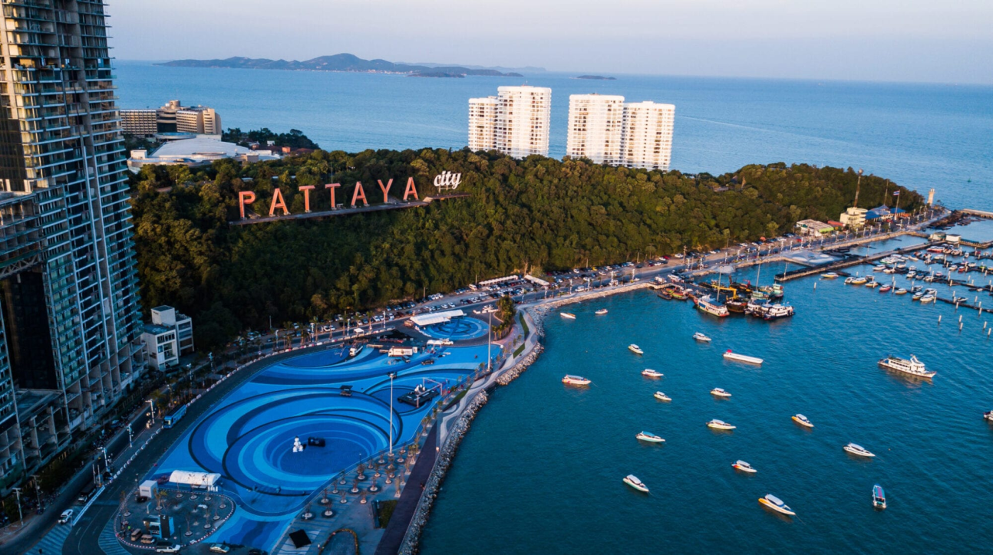

**Figure 1: “Pattaya City”**

(Source: Influenced by Poster)

The ***“Wat Phra Yai Temple”*** colloquially as the ***18 m tall Buddhist Temple*** is located in this city. ***“Cycling”, “skydiving”, “go-Karting”, “Muay Thai”*** and ***“Bungee jumping”*** are certain activities acknowledged by the residents of Pattaya (tourismthailand.org, 2022). On the other hand, the ***fat-stretched golf course and the greenery*** has been key attribute of the destination thus appraising its beauty and reputation.

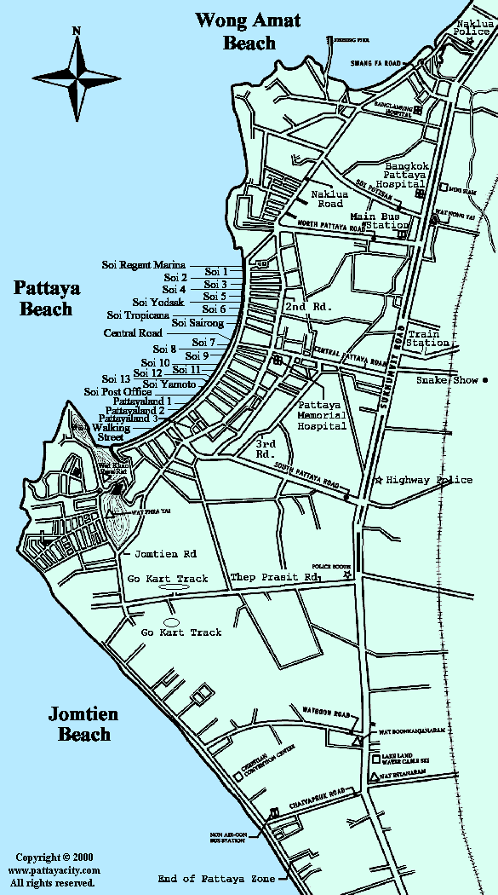

**Figure 2: “Map of Paytay City”**

(Source: Pattayacity.com, 2023).

## 1.1 Key Stakeholders

Key stakeholders entail the group of individuals whose contributions amplify the enforcement of potential strategies for managing the ethos of the business so conducted. Based on the views of Dafel *et al.* (2021), the application of the ***“Stakeholder’s Wheel”*** plays an indispensable role in appraising their contribution towards the development of a concerned organisation. In this context, stakeholders associated with tourism can be classified as individuals who rely upon the work functions conducted in a concerned organisation for accomplishing the objectives.

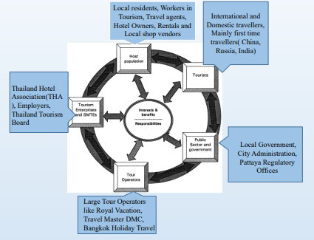

**Figure 3: “Stakeholder’s Wheel”**

(Source: Adapted from Buhalis and Fletcher, 1995)

**Stakeholder Matrix**

| **“POWER”** | **“Keep satisfied”**   * Large Tour Operators * International and Domestic Travellers | **“Managed Closely”**   * Pattaya Regulatory Offices and Local Shop Vendors * Local Residents * The DMO |
| --- | --- | --- |
| **“Monitor”**   * Local Government and City Administrators * Rentals, Workers and Travel Agents | **“Keep Informed”**   * Hotel Owners and Enterprises * Employees and Thailand Hotel Association * The DMO |
| **“INTEREST”** | | |

**“Table” 1: “Stakeholder Matrix”**

(Source: “Created by Author”)

***Analysis***

The aforementioned tabulation has identified potential stakeholders who can contribute towards the development of business regarding Tourism.

***“Keep satisfied”***

“***Large Tour Operators”*** can provide airline, train, and bus facilities for fostering development in Tourism. In addition, International and Domestic Travellers can provide adequate funds for enhancing infrastructural growth and keep the customers and employees satisfied.

***“Managed Closely”***

***“Pattaya Regulatory Offices”*** and ***“Local Shop Vendors”*** can distribute food and promote community welfare. In addition, the Local Residents can manage the work progress facilitated by the corresponding hotels at Pattaya for providing socio-cultural resilience within the organisational architecture.

***“Monitor”***

***“Local Government”*** and ***“City Administrators”*** can deploy potential policies concerning tourism while monitoring the work progress. On the other hand, Rentals, Workers and Travel Agents can provide adequate tourism packages while monitoring the changes in business trends.

***“Keep Informed”***

***“Hotel Owners and Enterprises”*** keep informed clients by enhancing the official tourism platforms for attracting tourists. Based on the views of Gössling and Higham (2021), the employees and Thailand Hotel Association can provide detailed reports of their working progress across their hierarchy. Moreover, the DMO can leverage good communications among stakeholders in the news and the local tourist business.

## 1.2 Key Challenges

***1.2.1 Presence of contaminated water supplies***

The prevalence of infected water has been espoused due to tourism due to the contamination of water with foreign substances. According to the poster, poor infrastructure has witnessed the inception of the ***flow of untreated wastewater*** across Pattaya Beach. On the other hand, ***FY 2021*** has witnessed ***44%*** of the ***presence of fair water sources in Thailand*** (Statista.com, 2023). The reason for the deterioration of surface water has identified ***tourist attractions*** and ***industrial and agricultural areas*** as the corresponding attributes. In this context, Pattaya City has also been impacted due to this challenge.

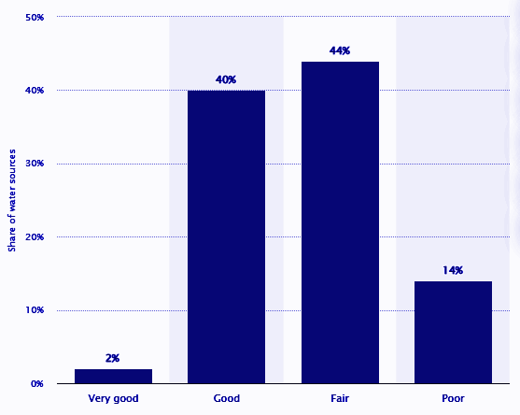

**Figure 5: Quality of Water in Thailand as of FY 2021**

(Source: Statista.com, 2023)

***1.2.2 Toxicity in Air***

“Air pollution” is another challenge faced by the residents of Pattaya City which entailed a significant impact on the ecological aspect of the region. On the other hand, as per the views of Crotts *et al.* (2022), the ***growing economy*** followed by the ***increasing volume of air pollutants*** has wreaked a significant accumulation of toxic products in Thailand. However, Bangkok and nearby Thai provinces have witnessed the ***presence of unsafe levels of air*** quality.

***1.2.3 Environmental Erosion***

Thailand has witnessed significant changes in its coastline since the genesis of its ***economic development***. For instance, the ***prevalence of coastal erosion*** across the ***Gulf of Thailand*** has reached up to ***14.26 %*** of the total shoreline of Thailand which accounted for ***376 KM*** (Ilo.org, 2023). On the contrary, the coastal region of Thailand is exposed to ***industrialization*** and the ***modernization of society.*** Moreover, the existence of mankind has generated an impetus towards the ***fragility of the terrestrial ecosystem***. As commented by Le *et al.* (2022), the construction of major dams in the upper land has worsened the erosion of the coastal soil. According to the poster, experts have predicted the evaporation of the beach in the ***next 5 years***. The reason is the impact of the erosion that led to the disappearance of the beach soil at a rate of ***1.8 Metres annually.*** As opined by Van der Zee *et al..* (2020), the activities of human beings have generated unprecedented changes and land use which have deteriorated the loss of mangrove plantations. Consequently, the degrees of land erosion have resulted in an upsurge of land erosion.

***1.2.4 Prevalence of Adultery***

The cases concerned with juvenile trafficking and the spread of ***sexually transmitted diseases*** have accelerated the inception of societal consequences. According to the poster, ***FY 2014*** has witnessed that ***one-third*** of all human trafficking victims are ***sexually exploited***. In this regard, sexual exploitation committed among children by traffickers has been a critical concern which has petrified a majority of Thai and Laotian females.

## 1.3 Macro and Micro Forces

Macro and Micro environmental forces are subject to altering the fame of the destination due to the unprecedented and unexpected exposure to the decline of politico-economic and socio-environmental factors. In this context, attractiveness to tourists is subject to decline steadily.

***1.3.1 Macro Forces***

Macro forces refer to the major aspect which is concerned with external and uncontrollable factors which impact the decision-making ability of the employees associated with an organisation. On the other hand, based on the views of de Bruyn and Meyer (2022), the deployment of three forces plays a significant role in fostering stability within the function bestowed over the respective employees. The respective forces are ***“Demographic”, “Economic”, “Natural”, “Technological”, “and Competitive” and “Cultural environments”.***

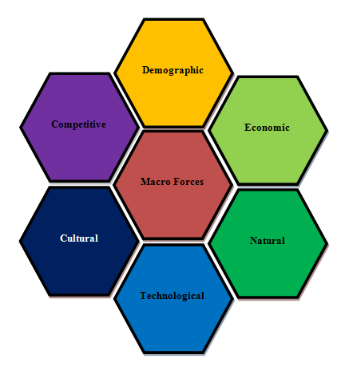

**Figure 6: Macro forces that impact the destination attributes**

(Source: “Created by Author”)

***1.3.2 Micro Forces***

Micro forces that can impact the tourism business entail the aspects instrumental in fostering direct contact with the activities so conducted in that business. As per the views of Aguiar and Szekut (2019), the collection of the respective forces influences the performance including the conduction of daily activities. The respective components are ***“Company”, “Suppliers”, “Distribution Channels”, “Competitors”, “General Public” and the “Customers”.***

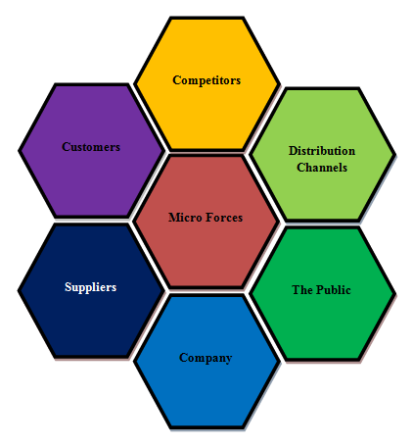

**Figure 7: Micro forces that impact the destination attributes**

(Source: “Created by Author”)

In the context of the aforementioned Micro forces, the DMO can play a significant role in collaborating with interested parties, specialists, and the government. The strategy can help address unprecedented conflicts which are subject to deteriorating the quality of the business outcomes.

# 2. "Segmentation, Targeting and Positioning (STP)"

## 2.1 Segmentation

The hotels and destination lounges at Pattaya City have witnessed the conduction of ***geographical segmentation***, where ***40 million domestic and international tourists*** are welcomed. Moreover, ***FY 2019*** has witnessed ***Chinese Tourism*** have established its dominance in Thailand. On the other hand, ***37% of total visitor*** visits have mentioned ***China, Russia, Korea*** and ***Germany*** as the top foreign feeder markets for Pattaya.

## 2.2 Targeting

Pattaya City targets customers who belong to segregated age groups in the context of the hyper-competitive sector. As commented by Higuchi and Yamanaka (2019), this signifies that both domestic and international customers are welcome. However, the modification of the target markets is still being monitored for detecting possible opportunities to sustain organisational growth. On the other hand, the strategy to select the respective market segments, size, growth potential and structural attractiveness are considered potential aspects required for gaining the desired segments of customers. In this regard, the DMO can identify possible hindrances and prioritise the necessary strategies to address them. Moreover, the DMO can track the alteration of the perception of the customers for providing satisfactory services and gaming loyalty.

## 2.3 Positioning

Positioning market strategy appraises the interventions acknowledged in defining those aspects which play an indispensable role in establishing and maintaining a reputation in the market. As opined by Beritelli *et al.* (2019), the strategies for providing sustainable offerings to the costumes upload the degree of effectiveness of this market strategy. In this regard, the DMO in collaboration with marketers can look out for potential aspects which can appraise a higher brand image. This strategy can drive an impetus for gaining a competitive advantage. On the other hand, based on the views of Michálková and Gáll (2021), the core elements of enhancing the brand image can be reinstated by gaining an insight into the marketing respective mixes which deliver attractiveness among customers. The positioning strategies can be acknowledged by the DMO by gaining an insight into the perception of the customers by gaining the respective feedback.

## 2.4 6 A's Framework

The “6 A's Framework” comprises ***“Attractions”, “Accessibility”, “Amenities”, “Available Packages”, “Activities”,*** and ***“Ancillary Services”.*** As per the views of Purnomo *et al.* (2019), the application of this framework plays a significant role in consolidating the uniqueness and identity of the organisation which provides tourism services. The inherent set of attributes thus encapsulated in the framework provides an impetus towards fostering tremendous growth opportunities and embracing smarter ways of conducting business.

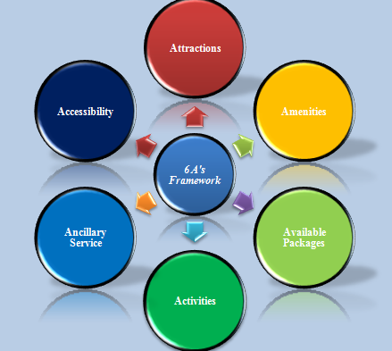

**Figure 8: "6 A's Framework in Tourism"**

(Source: “Created by Author”)

| ***Factors*** | ***Descriptions*** |
| --- | --- |
| ***“Attractions”*** | * “Nong Nooch Tropical Garden” * “Big Buddha” * “Regions Floating Market” * “Sanctuary of Truth Museum, Art in Paradise Pattaya |
| ***“Accessibility”*** | * “Golf courses” * “High-rise condos” * “Spas” * “Hotels” * “Guest houses” * “Resorts” |
| ***“Amenities”*** | * “Pattaya Cruise Tour” * “Sriracha Tiger Zoo” * “Bungee Jumping in Pattaya” * “Cabaret Shows” * “Skydiving” * “Canopy tour” * “Dolphin World” * “Flight of the Gibbon” * “Esykart go-karting” * “Flyboard’ * “Khao Chi Chan” |
| ***“Available Packages”*** | * “Full Day Island Tour” * “Temples” * “City Tours” * “Family Holidays” * “Ziplining Adventures” * “Golf Tour” * “Coral Island Tour by Speedboat” * “Skydiving” * “Cultural Tour” |
| ***“Activities”*** | * "Air transport" * “Railway Transport” |
| ***“Ancillary Services”*** | * Car hire * Motorbike Rental * Luggage transportation * International Hospitals * Travel exchange * Airport hotels * Tour guides |

**Table 1: "6 A's Framework in Pattaya Tourism"**

(Source: As mentioned in Poster)

***Analysis***

The aforementioned tabulation has provided the aspect of fostering better tourism facilities by the provisions of the corresponding facilities. The articulation can be analysed that the aforementioned destination services can be instrumental in attracting a large number of customers. The provision of the services can help in ushering significant revenue and gaining a competitive advantage in both domestic and international markets.

# 3. Destination Branding

Destination Branding entails the amalgamation of corresponding products of marketing along with the offers which appraise a better ambience of people’s culture and environment. As commented by Topalović (2021), respective branding strategies are undertaken by corresponding marketers. Moreover, the concepts of branding consolidate the integral tourism facilities which can help in retaining enough customers. On the other hand, as opined by Kaszás and Keller (2023), destination branding provides for maintaining the aspects of the uniqueness of the services which differentiate from the competitors. In this regard, the hotels at Pattaya City can appraise this strategy in distinguishing the services in comparison to the competitors which further paves the way towards maintaining a stable position in the market. The provision of ***“Bungee Jumping in Pattaya'', “Cabaret Shows'', "Family Holidays'', “Ziplining Adventures'', “Golf Tour''*** and much more can be significant aspects for gaining a larger number of customers. These services help Pattaya hotels to maintain a profitable position in the market and also help in emphasising the preservation of the city’s heritage and consolidating destination sustainability.

## 3.1 The Theory of Customer-Oriented Research

The conduction of corresponding branding strategies can be accelerated by considering a theory which can facilitate the managers of the Hotels at Pattaya to gain a competitive advantage in the market. Based on the views of Ivars-Baidal *et al..* (2021), the application of "Customer-Oriented Research" can be significant for addressing unprecedented complexities. In addition, the application of the theory facilitates offering tourism facilities by combining intangible, sensual, and psychological benefits. On the other hand, as per the views of Femenia-Serra and Gretzel (2020), the creation of prerequisites for sustaining adequate user experience can be segregated into separate modules where each entity aims in extending adequate services for patent customers.

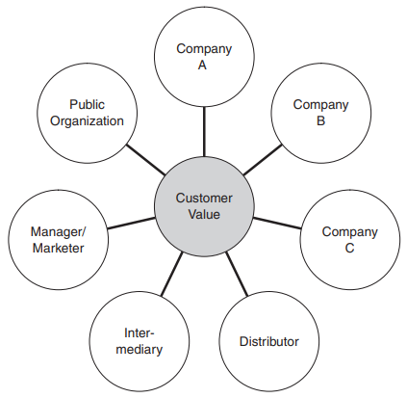

**Figure 9: The Theory of the "Customer-Oriented Approach"**

(Source: Saraniemi and Kylänen, 2011)

The significance of application of this theory can be beneficial for marketers in targeting specific customers. Based on the views of Baidal *et al,* (2012), the role played by deterministic models of the evolution of mass tourism has been significant in providing strategies for addressing the evolution and restructuring policies of mature destinations. In this context, the application of the “Customer-Oriented Approach" plays a key role in interacting with the global socio-economic environment and the existing tourism market. As commented by Sitepu (2019), the philosophical and epistemological aspects regarding the reviewing of the marketer–consumer relationships can be appraised by the application of this theory. On the other hand, the applicability of this theory can be indispensable for the appraisal of the resources, activities, and experiences, which can be evaluated for generating better outcomes.

# 4 Digital and Direct Marketing

Digital and Direct Marketing appraises a combination of activities that are conducted by the DMOs for enhancing the property of inculcating competitive advantage. On the other hand, as opined by Ghimire and Baral (2022), the aspects of destination management heavily link to the tactics appraised while conducting digital and direct marketing. The strategic efforts acknowledged by the DMO can be instrumental in fostering enhanced visibility and reducing overhead expenses.

## 4.1 Digital Marketing

This digital marketing entails popular methods of business techniques which utilise the Internet for holistically analysing business trends. As opined by Onat, and Karakuş (2021), the corresponding marketers can target end users using cost-effective methods and social media platforms such as Instagram, Twitter or Facebook. The methods of promoting the business can be sustained and diversified across large distances. In this context, the DMO can Publish the services of their organisation across platforms such as MakeMyTrip, Instagram and Youtube. On the other hand, the conduct of digital marketing can attract a large number of customers. Based on the views of Ivars-Baidal *et al.* (2021), the DMO can collaborate with social media influencers who can play a significant role in disseminating awareness of the services across various parts of the world. Moreover, the interface between customers and their official platforms can be enhanced to a further extent.

## 4.2 Direct Marketing

The conduction of Digital Marketing signifies the conduction of digital marketing methods encompassing the engagement of specific customers without considering intermediate mediums. As per the views of Femenia-Serra and Gretzel (2020), this aspect is considered instrumental for maintaining adequate customer relationships among customers. This helps in driving an impetus in enhancing ROI and responses from corresponding tourism campaigns. As commented by Novotny and Dodds (2022), the DMO can Promote direct offers related to the destination through catalogues, brochures, exhibits as well as road maps. On the other hand, the DMO can contact customers directly through telephone calls or by sending emails.

# 5. Conclusion

The study has concluded that destination Management plays a significant role in architecting a sustainable business plan for a concerned organisation in the future. On the other hand, the overarching methodologies encapsulated within the respective attributes of the destination can be generated with this aspect. Pattaya City has been regarded as a quiet fishing village oriented in the 60s which transformed into an immaculate region comprising resorts, cabaret bars and 24-hour clubs and high-rise condos. However, major challenges such as contamination of dust particles, erosion, whoredom and polluted water have caused hindrances among customers. Moreover, the “Stakeholder’s Wheel” has been instrumental in appraising the contribution of the aforementioned stakeholders towards the development of a concerned organisation. In addition, it has been concluded that Macro and Micro Forces have been instrumental in accomplishing the goals through the provision of bespoke customer experience and redressal of unprecedented circumstances. On the other hand, it has been concluded that Pattaya City has witnessed the conduction of geographical segmentation by the hotels. Furthermore, the respective DMOs have contributed their expertise in enhancing the marketing tactics for sustaining competitiveness. Furthermore, the branding strategies and theoretical application have been instrumental in maintaining equanimity and gaining a competitive advantage in the market.

# Bibliography

Aguiar, A.B. and Szekut, A., (2019). BIG DATA AND TOURISM: opportunities and applications in tourism destination management. Applied Tourism, 4(2), pp.36-47.

Baidal, J.A., Sanchez, I.R. and Reboil°, J.F. (2012). The evolution of mass tourism destinations: New approaches beyond deterministic models in Benidorm (Spain). Tourism Management, Vol. 34, pp. 184-195

Beritelli, P., Crescini, G., Reinhold, S. and Schanderl, V., (2019). How flow-based destination management blends theory and method for practical impact. Tourist Destination Management: Instruments, Products, and Case Studies, pp.289-310.

Crotts, J.C., Magnini, V.P. and Calvert, E., (2022). Key performance indicators for destination management in developed economies: A four pillar approach. Annals of Tourism Research Empirical Insights, 3(2), p.100053.

Dafel, A., Speechley, M., Mohan, N. and Alcock, D., (2021). CASE 5: A Stakeholder Analysis: Developing an Indigenous-Specific Intercultural Competency Training Module (Part A). Western Public Health Casebooks, 2021(1), p.10.

de Bruyn, C. and Meyer, N., (2022). Tourism and destination management: determining the viability of tourism development in local regions. Polish Journal of Management Studies, 25(2), pp.123-137.

Femenia-Serra, F. and Gretzel, U., (2020). Influencer marketing for tourism destinations: Lessons from a mature destination. In Information and Communication Technologies in Tourism (2020): Proceedings of the International Conference in Surrey, United Kingdom, January 08–10, (2020) (pp. 65-78). Springer International Publishing.

Femenia-Serra, F. and Gretzel, U., (2020). Influencer marketing for tourism destinations: Lessons from a mature destination. In Information and Communication Technologies in Tourism (2020): Proceedings of the International Conference in Surrey, United Kingdom, January 08–10, (2020) (pp. 65-78). Springer International Publishing.

Ghimire, A. and Baral, D.K., (2022). Destination Management for Sustainable Tourism: A Case Study of Bungamati and Khokana. Interdisciplinary Journal of Innovation in Nepalese Academia, 1(1), pp.1-15.

Gössling, S. and Higham, J., (2021). The low-carbon imperative: Destination management under urgent climate change. Journal of Travel Research, 60(6), pp.1167-1179.

Higuchi, Y. and Yamanaka, Y., (2019). The potential value of research-based evidence in destination management: the case of Kamikawa, Japan. Tourism review, 74(2), pp.166-178.

Ilo.org, (2023). *Challenges from coastal erosion* Available at: http://ilo.org/wcmsp5/groups/public/---asia/---ro-bangkok/---ilo-manila/documents/presentation/wcms_163796.pdf [Accessed on: 13.04.2023]

Ivars-Baidal, J.A., Celdrán-Bernabeu, M.A., Femenia-Serra, F., Perles-Ribes, J.F. and Giner-Sánchez, D., (2021). Measuring the progress of smart destinations: The use of indicators as a management tool. Journal of Destination Marketing & Management, 19, p.100531.

Ivars-Baidal, J.A., Celdrán-Bernabeu, M.A., Femenia-Serra, F., Perles-Ribes, J.F. and Giner-Sánchez, D., (2021). Measuring the progress of smart destinations: The use of indicators as a management tool. Journal of Destination Marketing & Management, 19, p.100531.

Kaszás, N. and Keller, K., (2023). Crisis Communication of National Destination Management Organizations before and during the Coronavirus Pandemic. Periodica Polytechnica Social and Management Sciences.

Le, A.T., Kunasekaran, P., Rasoolimanesh, S.M., AriRagavan, N. and Thomas, T.K., (2022). Investigating the determinants and process of destination management system (DMS) implementation. Journal of Organizational Change Management, 35(2), pp.308-329.

Michálková, A. and Gáll, J., (2021). Institutional Provision of Destination Management in the Most Important and in the Crisis Period the Most Vulnerable Regions of Tourism in Slovakia. European Countryside, 13(3), pp.662-684.

Novotny, M. and Dodds, R., (2022), May. Developing a Destination Management Information System: A Case Study of Ottawa, Canada. In International Conference on Tourism Research (Vol. 15, No. 1, pp. 278-285).

Onat, G. and Karakuş, Y., (2021). Using digital technologies in destination management. Ed: Krystev, V., Çelik Uğuz, S., Efe, R., Kapluhan, E. içinde, Tourism Stuiıes And Social Sciences, ST. Kliment Ohridski University, pp.119-133.

Pattayacity.com, (2023). Pattaya City Maps - Main Map Available at: http://www.pattayacity.com/maps.html [Accessed on: 13.04.2023]

Purnomo, S., Rahayu, E.S. and Riani, A.L., (2019, November). Tourism village management based on information technology with destination management system. In Proceeding of International Conference on Science, Health, And Technology (pp. 229-233).

Saraniemi, S. and Kylänen, M., (2011). Problematizing the concept of tourism destination: An analysis of different theoretical approaches. Journal of travel research, 50(2), pp.133-143.

Sitepu, E.S., (2019). Improving Destination Management Through Sustainable Tourism Development Model: A Case Study of Taman Simalem Resort. International Journal of Applied Sciences in Tourism and Events, 3(1), pp.38-53.

Topalović, S., (2021). Destination management organisation literature categorisation 2016-(2020). Zbornik Ekonomskog fakulteta u Zagrebu, 19(2), pp.111-130.

Tourismthailand.org, (2023). *Highlights* Available at: https://www.tourismthailand.org/Destinations/Provinces/Pattaya/469 [Accessed on: 13.04.2023]

Van der Zee, E., Bertocchi, D. and Vanneste, D., (2020). Distribution of tourists within urban heritage destinations: A hot spot/cold spot analysis of TripAdvisor data as support for destination management. Current Issues in Tourism, 23(2), pp.175-196.