**TITLE: IMPACT OF CONSTRUCTIVE VOICE BEHAVIOUR FOR SOCIAL CHANGE ON SOCIAL NETWORKING SITES: A DISCUSSION ON MORAL IDENTITY**

Table of Contents

Introduction 2

Rationale 2

Research objective/questions 3

Theoretical background 3

Conceptual model 4

Hypotheses 6

Research Methodology 6

References 8

# Introduction

Social media is seen as essential in today’s age which allows people to share stories and support each other to build strengths in numbers. Furthermore, it helps people to raise awareness against situations that have negatively impacted society or human life.

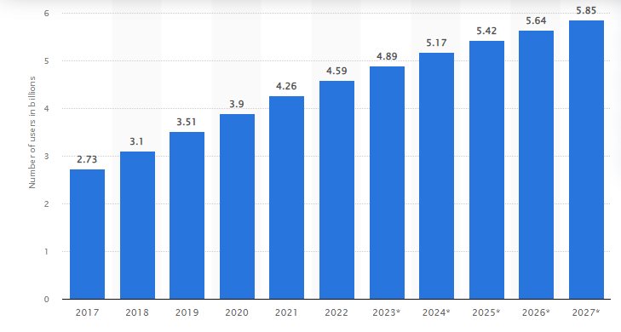

**Figure 1: “Use of social media”**

(Source: Statista.com, 2023)

The figure has highlighted the utilisation of social media has increased day by day as they have shared their views in the simplest way. According to a report, in 2021 over 4.26 billion people have utilised social media platforms (Statista.com, 2023). This is the reason that people have preferred to utilise social networking sites (SNS) to reach many audiences when they have gone through any harmful or negative consequences in society. In this context, here has conducted a survey among 51 participants to analyse their responses on the positive impact of SNS on their life.

# Rationale

In today's age, the utilisation of social media has increased its popularity as it allows people to share problems and analyse social issues to a broader extent (Ronaldo and Putra 2022.). However, in society, there have been seen several problems that affect the life of the people such as war, and the government’s intolerance policy. The case study has also discussed that in 2018 the CEOs of major companies such as “Google” and “Face book” has protested against the “US government’s policy on separating children from their parents (Bhatti *et al.* 2020). Other than this, in past when a person has been deprived by any situations or unforeseen outcomes they have to spend more effort and time asking for help to overcome the problems. In this context, this research sheds light on the positive impact of SNS to gather more information and speak out about their issues in the easiest way in front of global audiences.

# Research objective/questions

**Objectives**

* To amylase the impact of SNS to improve the mitigation strategy of issues and enhance moral identity.
* To describe the challenges faced by people to utilise social media and share their problems.

**Questions**

1. What is the impact of SNS to improve the mitigation strategy of issues and enhance moral identity?
2. What are the challenges faced by people to utilise social media and share their problems?

# Theoretical background

**Positive Impacts of social media to improve moral identity**

Information and communication technology has changed rapidly over the past few years and the development of mobile technology has increased the utilisation of social media. As per the view of Mahfud and Winnarko (2023), the main advantage of SNS is that people without any hassle have shared their problems and draw the attention of the higher authority. Contrarily, business owners have often failed to identify the customer’s choice and the reputation of the business in the market. On the contrary, Fajrin *et al.* (2021) have opined that each person with their marginal views has created posts to improve visibility and break into the mainstream. According to the case study, SNS are the most used technology with 2.23 billion users and this allows users to voice their issues in multiple ways such as through status, messages, and tweets (Bhatti *et al.* 2020). Hence, the advancement of SNS has created a new pathway for people to analyse what is happening in society and share the problems with the global audience. As stated by Kircaburun *et al.* (2020), social media platform allows everyone from all sides to make freedom of speech and vital information accessible to all. The main thing is that through SNS the posting of texts, videos and users’ generated content has created advantages for people to discuss that situation and bring social change. Therefore, it can be stated that with the social media platform people within the minimum time frame easily protested against any problems and findings solutions in a more effective way.

***Challenges of social media utilisation***

In today’s age, social media has provided huge advantages such as understanding social and cultural issues and presenting their problems in front of global audiences. The main challenges are created for the people to identify the proper platform and design the voices in the best possible ways. As per the views of Boer *et al.* (2022), people with low-level of moral identity have often lacked to recognize and voice against violations of social moral values in society. Therefore, the behaviour pattern of SNS has varied from person to person and they have responded to challenging situations in different ways. On the contrary, Süral *et al.* (2019) have opined that some individuals who have high in moral identity have less preferred to raise their voices in terms of avoiding debate and differences. Other than this, in our society, there have seen many people who for their own intentions have misused the SNS network and this has made a negative impact on society. In this context, the ***“self-consistency theory”*** has helped a lot to shape the understanding to improve moral identity. Therefore, it can be stated the proper utilisation of social media has created many possibilities to solve challenging issues but people through their moral identity have to identify the real problems to deal with them in better ways.

# Conceptual model

**“Theory of planned behaviour”**

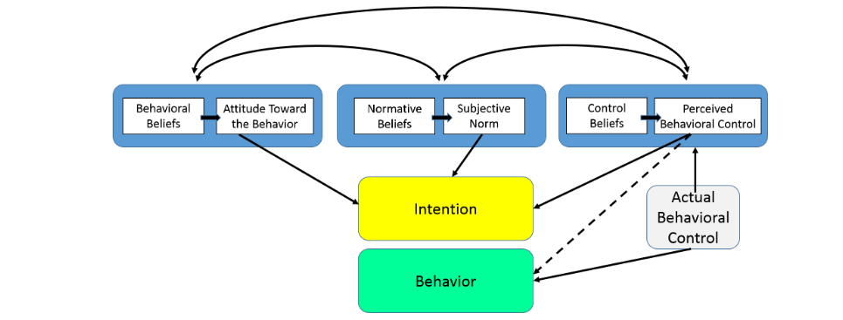

**Figure 2: “Theory of planned behaviour”**

(Source: Sok *et al.* 2021)

The “theory of planned behaviour” (TPB) is seen as the “psychology theory” that maintains three components such as “attitude”, “subjective norms”, “and perceived behavioural control” that shape the intention of an individual. Based on the views of Sok *et al.* (2021), this provided ideas to individuals about the decisions and their engagement with the specific incident. Social media is considered the ***independent variable*** because the post of the individuals on this media has illustrated the incident. In this context, when people have raised their concerns about any situation they have to depend on SNS to present the issues in front of a larger audience. Customer utilisation of the social media channel is seen as the ***dependent variable*** because of the high moral identity has reshaped the planned action and behaviours (Abbasi *et al.* 2021). The main thing is that by analysing the problems on SNS the individual has responded to the situation in a different manner. Therefore, the adaptation of this theory has enabled the prediction of the behaviour and enhanced control depending on the situation.

**“Theory of reasoned action”**

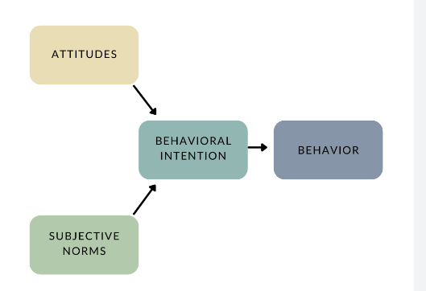

**Figure 3: “Theory of reasoned action”**

(Source: Awadallah and Elgharbawy, 2021)

The “theory of reasoned action (TRA)” has suggested that a person’s behaviour is shaped and determined by the intention and situations. Based on the views of Awadallah and Elgharbawy (2021), if people have suggested the behaviour as positive, they tend to perform this which results in the ultimate motivation. Therefore, as in social media, there have seen several posts available, thus the application of this theory people have identified others’ intentions and behaviour as well as responded to them in the proper manner. In this context, the ***dependent variable*** of this theory is the customer’s intentions because this has based on behavioural norms or subjective intentions.

***“Multiattribute attitude model”***

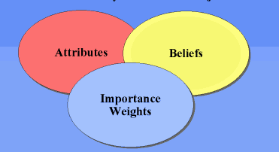

**Figure 4: “Multiattribute attitude model”**

(Source: Agustia *et al.* 2020)

The “multiattribute model” has broken the consumer’s overall attitude into smaller components. As per the views of DS Agustia *et al.* (2020), the components of this model have included the “perceived benefits”, “product features” and “product attributes”. This model has stated that a person’s overall attitude toward the object is the sum of the attributes depending on the belief and circumstances. In this context, the mediating variable has linked the independent and dependent variables and shaped people’s behaviour in using social media channels. Contrarily, the use of the mediating variable has helped to analyse the various types of responses of the people that have taken place in SNS. Therefore, it can be stated that the control variable has discussed ideas about the situation and helps to analyse the adaptation of this model in a better way.

# Hypotheses

H0: The utilisation of social media has negatively impacted raising concern over any social issues.

H1: The utilisation of social media has positively raised concern over any social issues.

# Research Methodology

The “research methodology” has been based on utilising the ***“primary quantitative data collection method”*** to understand the impact of social media networks on social change. In this context, here will be select ***“positivism research philosophy”*** along with the “descriptive research design” to collect data about different human actions. Moreover, the survey will be conducted with ***51 participants with 8 close-ended questions*** and thematic analysis to develop an in-depth understanding of the people about the utilisation of SNS to raise their concerns against any social issues. The data will be protected by the ***“data protection act of UK of 2018”*** to ensure safety (Gov.uk, 2023). Furthermore, research ethics have been maintained with considering the concerns and willingness of respondents to the survey. In addition to this, a “simple random probability sampling method” will be selected to analyse the survey responses and completed the research in a more effective way.

***Survey Questions***

1. Do you agree that the demand for social media platforms has increased day by day?
2. Do you agree that SNS has created opportunities to solve social issues?
3. Do you agree that SNS has helped to present your problems in front of a larger audience?
4. Do you think that different types of behaviour of person affect social media posts?
5. Do you think that SNS has helps companies to understand market trends?
6. Do you think that the SNS has negatively impacted the lives of people?
7. Do you think that SNS has been seen as less time-consuming and cost-effective to share problems?
8. Do you think that the high moral identity people have less preferred to raise their voice against any issues?

# References

Abbasi, G.A., Kumaravelu, J., Goh, Y.N. and Singh, K.S.D., (2021). Understanding the intention to revisit a destination by expanding the theory of planned behaviour (TPB). Spanish Journal of Marketing-ESIC, 25(2), pp.282-311.

Awadallah, E. and Elgharbawy, A., (2021). Utilizing the theory of reasoned action in understanding students’ choice in selecting accounting as major. Accounting Education, 30(1), pp.86-106.

Bhatti, Z.A., Arain, G.A., Akram, M.S., Fang, Y.H. and Yasin, H.M., (2020). Constructive voice behavior for social change on social networking sites: A reflection of moral identity. Technological Forecasting and Social Change, 157, p.120101.

Boer, M., Stevens, G.W., Finkenauer, C. and van den Eijnden, R.J., (2022). The complex association between social media use intensity and adolescent wellbeing: A longitudinal investigation of five factors that may affect the association. Computers in Human Behavior, 128, p.107084.

DS Agustia, E., Haryono, D. and Nugraha, A., (2020). Sikap dan Kepuasan Konsumen Ayam Probio di Kota Metro dan Bandar Lampung. Jurnal Ilmu Ilmu Agribisnis, 8(4), pp.418-422.

Fajrin, H.R., Rachmawati, P. and Lagaendo, A.F., (2021). Strategi Pemasaran Dan Promosi Produk Umkm 3D Ngudi Rejeki Di Era Pandemi Covid-19. JMM (Jurnal Masyarakat Mandiri), 5(5), pp.2266-2272.

Gov.uk, (2023). *Data protection.* Available at: https://www.gov.uk/data-protection#:~:text=Under%20the%20Data%20Protection%20Act,access%20personal%20data[Accessed on: 14.04.2023]

Kircaburun, K., Alhabash, S., Tosuntaş, Ş.B. and Griffiths, M.D., (2020). Uses and gratifications of problematic social media use among university students: A simultaneous examination of the Big Five of personality traits, social media platforms, and social media use motives. International Journal of Mental Health and Addiction, 18, pp.525-547.

Mahfud, T. and Winnarko, H., (2023). Analisis Penerimaan Teknologi Zoom dalam Pembelajaran Online Mahasiswa Selama Covid-19: Pendekatan Technology Acceptance Model (TAM). JSHP: Jurnal Sosial Humaniora dan Pendidikan, 7(1), pp.1-17.

Ronaldo, C. and Putra, W.P.S.J., (2022). Analisis Brand Identity di Jejaring Sosial Instagram (Studi Kasus Kopi Lain Hati PIK). Kiwari, 1(2), pp.244-251.

Sok, J., Borges, J.R., Schmidt, P. and Ajzen, I., (2021). Farmer behaviour as reasoned action: a critical review of research with the theory of planned behaviour. Journal of Agricultural Economics, 72(2), pp.388-412.

Statista.com, (2023). *Number of social media users worldwide from 2017 to 2027.* Available at: https://www.statista.com/statistics/278414/number-of-worldwide-social-network-users/#:~:text=How%20many%20people%20use%20social,almost%20six%20billion%20in%202027. [Accessed on: 14.04.2023]

Süral, I., Griffiths, M.D., Kircaburun, K. and Emirtekin, E., (2019). Trait emotional intelligence and problematic social media use among adults: The mediating role of social media use motives. International Journal of Mental Health and Addiction, 17, pp.336-345.