**A DIGITAL MARKETING ANALYTICS -BASED STORY**

**Table of Contents**

Author’s profile 3

Executive Summary 3

Infographics and Commentary 4

Conclusion 13

References 14

# Author’s profile

PRME has focused on providing training to students belonging to business schools to instigate innovative leadership. The primary aim of PRME is to promote the goals adopted in the SDGs of the United Nations. Digital skills are considered key to “***digital transformation***” within an individual to promote sustainable goals and economic balance. A few digital skills are developed such as “***search engine optimisation***”, “***online communication***”, and “***promotion on social media***”. The development of digital skills for enhancing the skills of leadership is beneficial for business progress. These skills primarily help in the incorporation of sustainable goals of development and economic balance.

# Executive Summary

The Author’s profile ha included the primary focus area of PRME based on SDGs adopted by the UN. The motive of PRME has resulted in the development of leadership characteristics among students of business schools. Digital skills are instigated for promotion digital transformation among individuals. Various skills such as “***online communication***”, “***promotion of social media***” and “***SEO***” are promoted. Infographic themes are developed based on digital marketing in relation to sustainable development goals. Total 10 themes are developed in the report analytically explaining the functions of digital marketing in sustainability. Infographic 1 has focused on the importance of digital and social marketing in the world today. Infographic 2 has focuses on the issues related to digital and social marketing of businesses. One of the identified challenges is unfollowing of brands by consumers on platforms of social media.

Infographic 3 has aimed at explaining sustainable approaches of social media marketing and digital marketing. It has informed that representatives of companies are digitally upskilled. The concept of green marketing is promoted in business. Infographic 4 has revealed that digital marketing has promoted the SDGs goal of quality education for all. Infographic 5 has highlighted that digital marketing has pleated an important role in the wide spread of knowledge regarding sustainability. Infographic 6 has explained the effect of digital marketing on global business performance in the context of implementation of sustainable innovations. Infographic 7 has revealed the challenges faced in the promotion of the goals of SDGs with the use of digital marketing. Infographic 8 has informed about prompting SDG elements using technological innovations as a global scenario. Infographic 9 has highlighted information related to sustainability with the promotion of digital communication. Finally, Infographic 10 has explained about the strategies of PRME for the development of sustainable goals in the digital marketing era of the world today.

# Infographics and Commentary

**Theme 1: Importance of Social and digital marketing in present days**

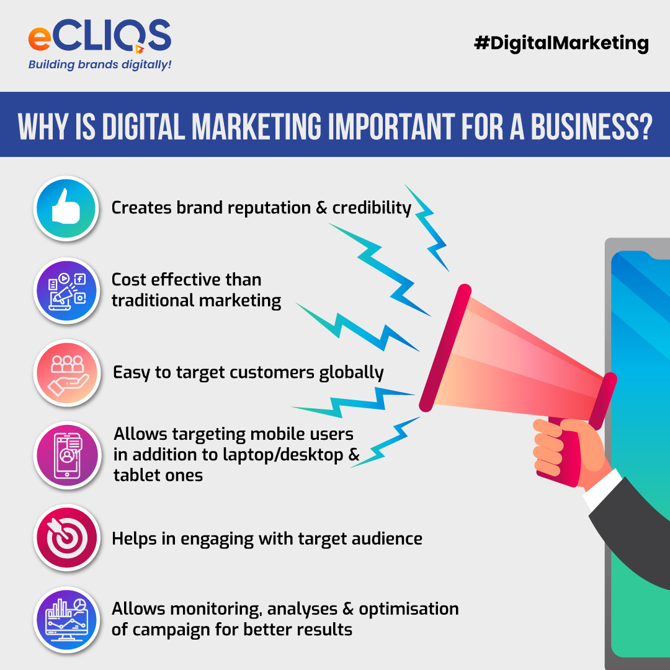

**Infographic 1: Importance of social marketing**

(Source: Hasan, 2020)

Based on the present day, social media and digital marketing play a crucial role in the present day. For instance, digital marketing is more cost-effective than traditional marketing and it helps companies to engage with target audiences (Djakasaputra*et al.* 2021). Allowing analysing as well as campaigning for a good result, customers can enrich their required products in an effective product. With the help of digital marketing, customers can grab their required information regarding products as well as services in a tech-based manner (Mukherjeea, 2021). Similarly, traditional marketing is quite costly which sometimes makes a gap in traditional marketing. Hence, during the session, companies utilise digital or online marketing, and companies can target their customers in the easiest manner.

**Theme 2: Evaluating the issues of digital as well as social marketing**

There are different issues of digital marketing which reduce the ethics of marketing. In this context, poor customer service, irrelevant content, maximum advertisements, and maximum promotional advertisements are some of the challenges which are encountered by customers regarding digital marketing. On the other hand, with excessive promotional posts, irrelevant or lack of digital literacy among customers as well as marketing agents, an organisation can be faced with different challenges of digital marketing (Dwivedi *et al.* 2023). As per empirical evidence, approximately, 56% of customers were not able to find enriched customer service, and 43% of service users also faced issues due to maximum promotional posts. In this context, during the session, companies try to enrich digital marketing in their business, and the firms need to focus on adequate advertisements. Unnecessary and excessive advertisements on a chosen brand or concept irritate customers regarding a company.

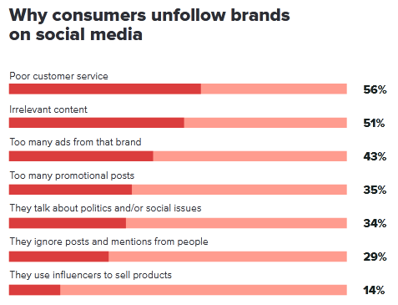

**Infographic 2: Issues of social marketing**

(Source: Media.sproutsocial.com, 2023)

**Theme 3: Analysing sustainable digital and social media marketing**

Sustainable marketing is crucially important for digital marketing as well as social media marketing. Using predictive analysis, integrating video as well as interactive content, and engaging on social media in an effective manner, companies who implement digital marketing can find maximum advantages regarding digital or social media marketing. On the other hand, sometimes a lack of digital marketing skills, among employees an organisation is not able to enrich their marketing in an adequate manner (Wang, 2020). In this context, by upgrading the skills of employees, an organisation can maximise the resilience of digital marketing in an effective manner. On the other hand, a large number of customers are unable to find the best customer service and are also unable to share their personal issues with representatives of companies. As a result of these digitally upskilled representatives, companies can solve all the queries of staff and engage those staff in the marketing process (Jaiswal *et al.* 2022). This customer engagement process supports customers to enhance their consumer behaviour in an effective manner and maximise the number of satisfied customers for the business. Similarly, the green marketing concept plays a crucial role in business and with the help of green marketing; an organisation can reduce the effects of environmental impact from the marketing process.

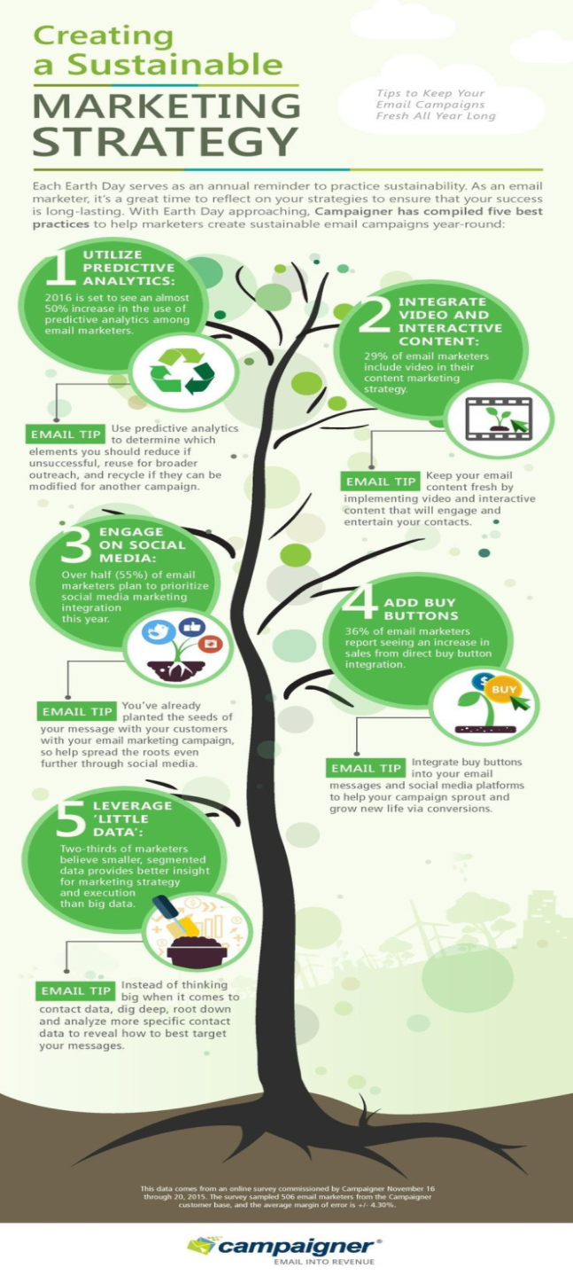

**Infographic 3: Sustainable marketing factors**

(Source: Jung *et al.* 2020)

**Theme 4: Role of digital marketing in promoting quality education SDG**

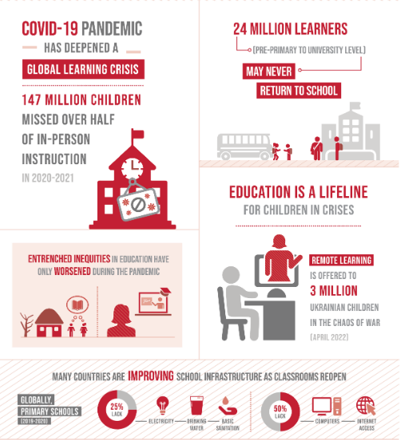

**Infographic 4: Quality Education of SDG**

(Source: Sdgs.un.org, 2023)

The UN has adopted the goal of providing quality education to all children across the world. Digital marketing has played a crucial role in the development of the education sector around the globe. It has ensured the improvement of the infrastructure of schools with the inclusion of ***computers*** and ***internet access*** for children (Sdgs.un.org, 2023). Digitisation has warded off the “***entrenched inequities in education***” that prevailed during the COVID-19 pandemic. Remote learning has promoted the education system of children at the time of both the pandemic and the Russia-Ukraine war. It is therefore evident that digital marketing has promoted the SDG goal of quality education.

**Theme 5: Spreading awareness for sustainability with digital marketing**

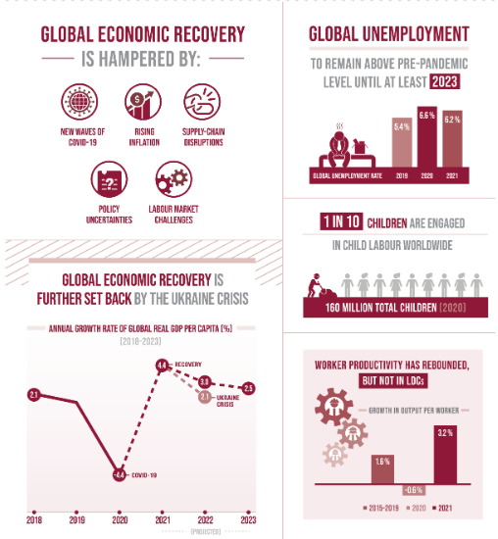

**Infographic 5: Global economic recovery and global unemployment**

(Source: Sdgs.un.org, 2023)

Digital marketing has aided in promoting the circular economy of the country which has helped in successful recovery of the global economy. The green economy is promoted with the use of internet technology and other digital innovation such as social media. The use of technological innovation in marketing has enabled combating challenges namely inflation and disruption of the supply chain (Sdgs.un.org, 2023). Global Unemployment is another challenge which is brought under consideration by launching online campaigns. Spreading awareness regarding the sustainable economy, unemployment and social protection is conducted using digital marketing platforms. Therefore, it can be inferred that awareness is created regarding the green economy and sustainable promotion of employment using digital marketing.

**Theme 6: Impact of digital marketing on the sustainable performance of Businesses**

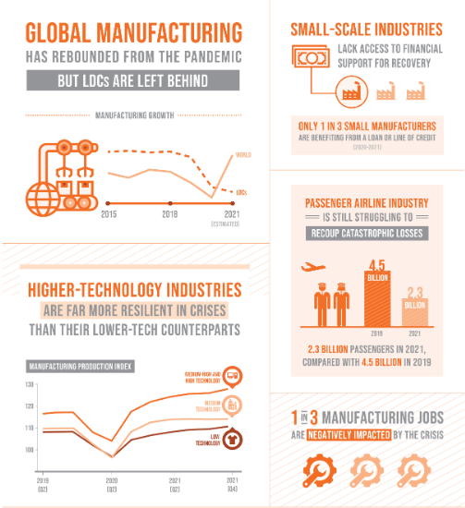

**Infographic 6: Global manufacturing, innovation and technology industry**

(Source: Sdgs.un.org, 2023)

The promotion of sustainable industrialisation of UN SDG is enabled by the use of technological innovations. Digital marketing has enhanced the global manufacturing process of businesses and industries. Resilient infrastructure is built using digitisation in businesses. Digital marketing has ensured the digital promotion of small-scale businesses and aided in financial recovery as well (Sdgs.un.org, 2023). High-grade technologies have inducted resilience in the operations of both small and large-scale industries around the globe. Digital marketing found to be beneficial for increasing the rate of employability in industries. The increasing rate of promotion of technological innovations has resulted in enhanced marketing of business today. Therefore, it can be inferred that digital marketing has played an important role in enhancing the market and employability of industrious with the implementation of technology.

**Theme 7: Challenges in promoting SDGs with digital marketing**

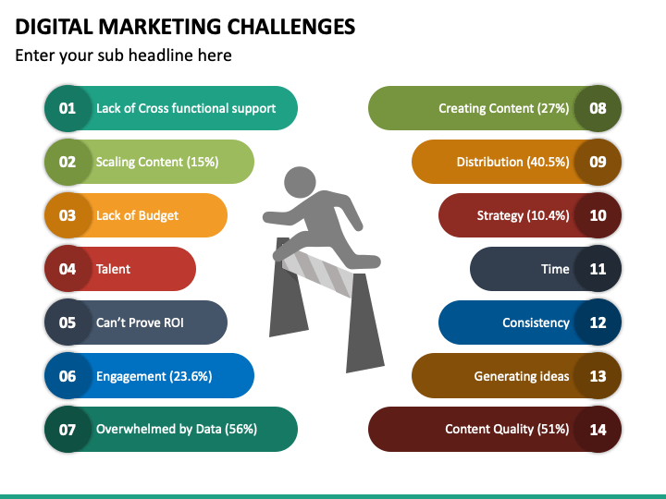

**Infographic 6: Challenges of digital marketing**

(Source: Saura *et al*. 2020)

Digital marketing is observed to be challenging for the promotion of sustainability using SDGs. One of the identified challenges is the “***lack of cross-functional support***”. This has resulted in poor collaboration in teamwork which resulted in disrupted productivity of workers in the business. The rate of engagement of employees is observed to be deteriorating over time. The inclusion of advanced technology in business practices is found to be a “***lack of budget***”. The poor budget of a business is, therefore, recognised as another challenge of digital marketing (Saura *et al*. 2020). SDGs adopted by the United Nations have focused on the inclusion of digital innovation in both small and large businesses. Lack of budget has caused a low rate of development of infrastructure and poor resilience in the marketing and production sector of industries. Poor strategic implementation of digital marketing has also caused a hindrance to the time, operation, distribution and content quality of a business in the context of sustainability.

**Theme 8: Strategies for prompting elements of SDGs in a global scenario**

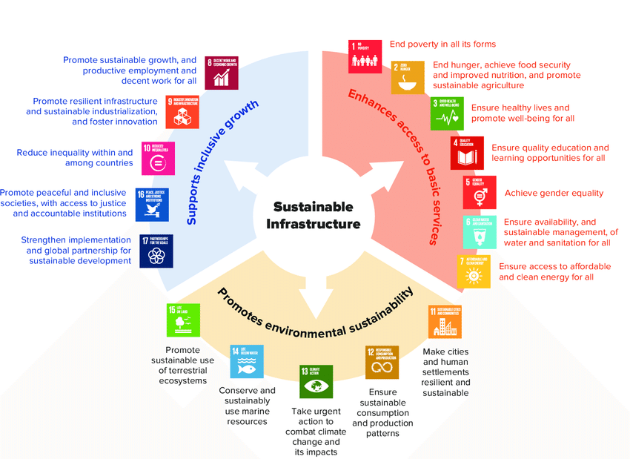

**Infographic 8: Elements of SDGs**

(Source: Hidayat *et al*. 2022)

The various elements of SDGs are promoted using a digital marketing strategy. SDGs have aimed at supporting inclusive growth of the economy and businesses globally. The promotion of the sustainable growth of the economy and business is inspired by the use of digital technologies. The global enhancement of sustainability has induced productive employment with the inclusion of decent working conditions. Increased employability is encouraged through SDGs across the world. Implementation of resilience in building an innovative infrastructure is focused on the use of high-technologies (Hidayat *et al*. 2022). The elements of SDGs have also focused on the promotion of a sustainable environment. Protection of the biosphere and maintenance of ecological balance is prioritised in SDGs. Digital campaigns on awareness related to sustainability and conservation of the environment and its aesthetics are launched. The elements of environmental sustainability have included the protection of life on water and land and climatic actions in a global scenario.

**Theme 9: Promotion of digital communication for sustainability**

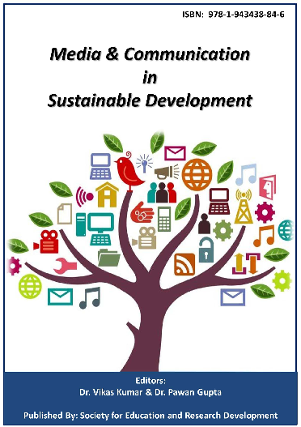

**Infographic 9: Communication and media in sustainable development**

(Source: Al-Rahmi *et al*. 2020)

Digital communication for SDGs promotes sharing of knowledge regarding the sustainability goals adopted by the United Nations. The promotion of digital communication has forced on the social processes. Digital communication is promoted with the increased use of instant messaging applications and social media platforms. Social media is considered one of the platforms that engage a large number of people. Wide varieties of people are involved in social media (Al-Rahmi *et al.* 2020). Media has played an important role in the sustainable development by widening the zone of communication globally.

**Theme 10: Strategies of PRME to Develop Sustainable development goals**

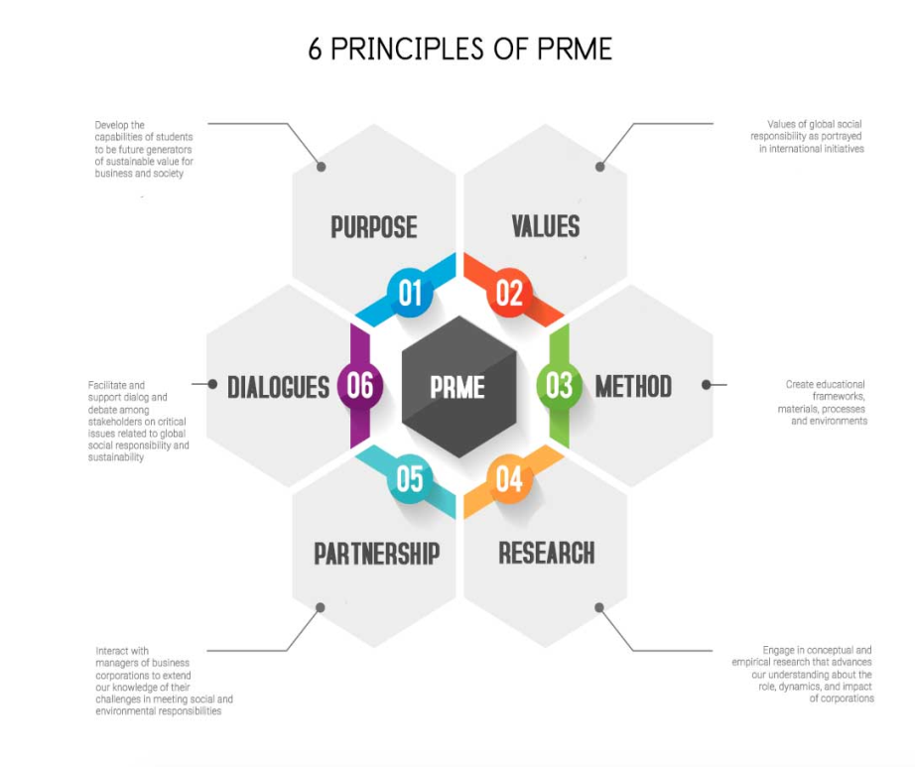

**Infographic 9: Six principles of PRME**

(Source: Unprme.org.uk, 2023)

PRME has adopted six principles for the development and promotion of sustainable goals. The target of PRME is to successfully the six principles including “***Purpose***”, “***Values***”, “***Method***”, “***Research***”, “***Partnership***” and “***Dialogue***”. These principles have developing skills of responsible managers and leadership to induce sustainability in the company. It has focused on incorporation of the values of economic, social, sustainable and environmental. It has also focused on the promotion of effective communication for the implementation of sustainable values. Therefore, it is evident that PRME has aimed applying various for the promotion and development of the goals of sustainability that are adopted by the United Nations.

# Conclusion

SDGs are implemented in digital skill development in leadership which improves digital marketing skills. Digital skills have aided in the development of the knowledge of sustainability and improved the balance of the economy in business today. Enhancement of leadership skills is achieved with the inclusion of digital innovation. It has provided information on responses of customers regarding products and services that are technology-based. The promotion of sustainability using digital marketing strategy is commented using images and themes. Social media and digital marketing has promoted businesses with sustainable innovations of digitisation in the world today. It is therefore concluded that PRME has aimed in the promotion of the UN SDGs and promotes economic balance.

# References

Al-Rahmi, W.M., Alzahrani, A.I., Yahaya, N., Alalwan, N. and Kamin, Y.B., (2020). Digital communication: Information and communication technology (ICT) usage for education sustainability. Sustainability, 12(12), p.5052.

Djakasaputra, A., Wijaya, O., Utama, A., Yohana, C., Romadhoni, B. and Fahlevi, M., (2021). An empirical study of Indonesian SMEs sales performance in digital era: The role of quality service and digital marketing. *International Journal of Data and Network Science*, *5*(3), pp.303-310.

Dwivedi, Y.K., Hughes, L., Wang, Y., Alalwan, A.A., Ahn, S.J., Balakrishnan, J., Barta, S., Belk, R., Buhalis, D., Dutot, V. and Felix, R., (2023). Metaverse marketing: How the metaverse will shape the future of consumer research and practice. *Psychology & Marketing*, *40*(4), pp.750-776.

Hasan, M., (2020). Social marketing: an Islamic perspective. *Journal of Islamic Marketing*, *11*(4), pp.863-881.

Hidayat, M., Salam, R., Hidayat, Y. S., Sutira, A., and Nugrahanti, T. P. (2022). Sustainable Digital Marketing Strategy in the Perspective of Sustainable Development Goals. Komitmen: Jurnal Ilmiah Manajemen, 3(2), p.100-106.

Jaiswal, A., Arun, C.J. and Varma, A., (2022). Rebooting employees: Upskilling for artificial intelligence in multinational corporations. *The International Journal of Human Resource Management*, *33*(6), pp.1179-1208.

Jung, J., Kim, S.J. and Kim, K.H., (2020). Sustainable marketing activities of traditional fashion market and brand loyalty. *Journal of Business Research*, *120*, pp.294-301.

Media.sproutsocial.com (2023), Sprout-Social-Index-2019. Available at: https://media.sproutsocial.com/uploads/Sprout-Social-Index-2019.pdf [Accessed on: 15.04.2023]

Mukherjeea, S., (2021), September. Challenges to Indian micro small and medium enterprises during the post covid era. In *RSEP CONFERENCES* (p. 198).

Saura, J. R., Palos-Sanchez, P., and Rodríguez Herráez, B. (2020). Digital marketing for sustainable growth: Business models and online campaigns using sustainable strategies. Sustainability, 12(3), p.1003.

Sdgs.un.org, 2023, Ensure inclusive and equitable quality education and promote lifelong learning opportunities for all, Available at: https://sdgs.un.org/goals/goal4, [Accessed on: 15 April 2023]

Sdgs.un.org, 2023, Promote sustained, inclusive and sustainable economic growth, full and productive employment and decent work for all, Available at: https://sdgs.un.org/goals/goal8, [Accessed on: 15 April 2023]

Unprme.org.uk, 2023, *Six Principles*, Available at: https://www.unprme.org.uk/six-principles, [Accessed on: 15 April 2023]

Wang, F., (2020). Digital marketing capabilities in international firms: a relational perspective. *International Marketing Review*, *37*(3), pp.559-577.