**DESIGN AN APPROACH TO DEVELOPING AND RETAINING YOUR TEAM IN AN**

**INTERNATIONAL CONTEXT**

**Table of Contents**

Introduction 2

Background of the company 2

Critically evaluating the approaches taken by Amnesty International regarding staff development and retention 2

Critically analyse the role of the manager or leader in employee development and retention 4

Critically assessing challenges faced by the organisation regarding employee retention and development 5

Considering theories and models regarding employee development and retention 400 6

Assessing the ways to apply these theories in the organisational context 8

Significance of the theories on the organisation 8

Conclusion 9

References 10

# Introduction

Employees play a crucial role in a business and with the help of a productive workforce, an organisation can enrich organisational productivity, as well as satisfy staff in a better context. However, due to lack of retention rate among employee groups can reduce the value of organisations in the international competitive environment. In this context, leaders of an international organisation need to focus on employee development programmes like training sessions, upgrading and upskilling of employees. In this context, the study has tried to focus on the significance of employee retention as well as the development of an organisation. For instance, the study has chosen Amnesty International which is a UK-based international non-government organisation.

# Background of the company

Amnesty International is one of the international, non-governmental organisations in the UK which help individuals to find their human rights in an effective manner. The organisation has helped UK based as well as global individuals to find their human rights in an effective manner. The organisation has operated in more or less 150 countries around the globe and tackles human rights issues from all over the world. Amnesty International has more or less 2000 staff who work in approximately 70 countries around the globe (Amnesty.org, 2023). Based on the year 2023, the income of the international organisation has reached €279 million (Amnesty.org, 2023). Sacha Deshmukh is the recent CEO of the international organisation and approximately 10 million individuals who faced injustice involved with the Amnesty International NGO (Amnesty.org, 2023). Amnesty is the world's largest human rights organisation which plays a crucial role to find human rights for individuals around the globe.

# Critically evaluating the approaches taken by Amnesty International regarding staff development and retention

**Providing adequate packages and remuneration**

Amnesty International is one of the International NGOs which help global people to find their human rights and combat injustice in a significant manner. Due to helping individuals, the organisation needs to handle a large number of staff. Providing adequate remuneration with other different benefits, the NGO has managed staff retention. For instance, by providing 37 days of annual leaves (inclusive of public holidays and grace days), and arranging different employee assistant programs along with pension schemes, the organisation has motivated its employees (Amnesty.org, 2023). By finding these integrated and high-end facilities, employees of the firm retain their work motivation along with productivity and maintain international business operations with high-end confidence.

**Providing training to staff**

Amnesty is a group which not only focused on physical threats of violence but also tried to reduce digital unlawful threats from society. Providing job training to the employees of Amnesty's Tech lab, the company has upskilled all the workers who are doing as tech-based workers in the Tech Lab in Amnesty (Careers.amnesty.org, 2023). Similarly, the organisation also provided community development training to its workforce which helps employees to provide more high-end services to global individuals. Hence, by providing different on-job training, community development and engagement training, and digital or tech-based training to the workforce, managers of the firm have managed its employees for the international business operation.

**Focusing on diversity and inclusion**

Amnesty International is one of the international NGOs which has focused on diversity and inclusion while emphasising staff development and retention. Focusing on diversity and inclusion, the firm has engaged LGBT employees and made a Prisma as well as an LGBT employee support group. Similarly, focusing on health and benefits among employees, managers have made a "peer-to-peer mental health group" which helps employees to maintain mental well-being and health in an integrated manner (Amnesty.org, 2023). The union of the Amnesty Group has worked with anti-racist working groups and also takes language initiatives for its staff who are from different socio-cultural backgrounds. Hence, managers of the international NGO have focused on inclusion, and diversity, by reducing racial discrimination and cross-cultural discrimination and trying to provide a healthy workplace culture for employee engagement for better work in an international business context.

**Maintaining the Human Resources group**

Human Resources Management (HRM) plays a crucial role in an organisation. On the other hand, due to an inefficient HRM, an organisation may be unable to reach employees and not able to retain them in a team (Bilan *et al*. 2020). In this context, Amnesty has a crucial team of International HRM which help the firm maintain the working environment and handle all employee queries in a better way (Comparably.com, 2023). The key responsibility of an HR manager is to maintain the working environment for each employee after knowing needs and serving those needs in an adequate manner. The international HRM of the International NGO has managed the international working environment for its staff and helped them to find the necessary amenities along with benefits from the firm. Hence, by making an efficient HRM, serving employees in an appropriate manner, and maximising staff productivity by fulfilling their needs, managers of the firm maintain team productivity for the broader business context.

**Providing rewards to employees**

Amnesty is the largest human rights organisation in the UK as well as around the globe. In certain circumstances, companies are unable to retain employee motivation due to a lack of employee remuneration or benefits (Tien *et al*. 2021). Amnesty not only provides adequate remuneration to its employees but also delivers different extra rewards like health insurance, health and wellness security, life assurances and other attractive rewards to its employees (Amnesty.org, 2023). Finding these rewards from the company, employees of the group have maximised the level of retention and reduced the job place changing or leaving mentality from their mind palace. This productive and engaging mentality among staff helps the company to maximise productivity, challenge mentality among staff and engage the team for a better and broader international business context.

The above-mentioned employee development as well as retention approaches not only support the firm to maximise staff retention but also support the firm to enrich organisational competitiveness in the global competitive era. Grabbing a productive employee group, upskilling them with different upskilling training sessions, and engaging them in international business operations, the organisation has filed the international business operations.

# Critically analyse the role of the manager or leader in employee development and retention

**Focusing on communication**

A good leader is a good communicator and by focusing on communication a leader can reshape employee productivity in an effective manner. For instance, by emphasising communication, leaders can reach each individual staff and can define their different expectations. After knowing and fulfilling the expectations, leaders or managers can motivate those staff for their work responsibilities (Armstrong, 2017). By increasing motivation, employees can engage in their own job roles. Thus, by communicating with each team member in a continual manner, and focusing on private as well as open communication processes, managers or leaders of Amnesty can maximise work motivation among its employees.

**Identifying strengths and weaknesses among the workforce**

During the session a leader maintains a good and friendly relationship with other co-workers, this relationship helps employees to share their personal needs and work regarding queries with leaders. On the other hand, sometimes due to the autocratic behaviour of leaders, staff are unable to share their issues with leaders. As per empirical evidence, a friendly relationship helps leaders to identify strengths as well as limitations among workers (Hayat Bhatti *et al.* 2020). Defining loopholes or limitations among staff, after that, helping those staff with their requirements, leaders or managers can maximise working capabilities among employees of the international business operation.

**Setting goals and fulling expectations for staff**

In order to set goals in front of employees, leaders or managers can share organisational objectives with staff in a transparent way. On the other hand, by knowing the organisational goal, workers also can understand the way they need to fulfil the goal. In this context, managers or leaders of the Amnesty group have communicated with its staff to share their goals. On the other hand, due to a lack of interaction among staff, managers are unable to detect specific expectations among different team members (Newman and Ford, 2021). As per empirical evidence, the goal, as well as the objective of Amnesty International, is to "prevent and end grave abuses of human rights and to provide justice for the deprived section of the community" (Amnesty.org, 2023). Sharing this goal with workers, managers of the firm have shown a transparent way to fulfil the organisational goal with greater confidence.

**Building engagement**

Building employee engagement is one of the potential roles or responsibilities of a leader or manager of a firm. By engaging employees with great benefits, adequate remuneration, and maintaining a work-life balance, an organisation can engage and influence employees to remain in the workplace (Strassburger *et al.* 2023). On the other hand, due to a lack of employee engagement, an organisation may be unable to retain the maximum number of staff in the workplace which makes an unstable situation for a firm. In this context, managers or leaders of Amnesty have provided adequate parks as well as benefits to employees along with 37 casual leaves which help the firm to build employee engagement in an effective manner.

# Critically assessing challenges faced by the organisation regarding employee retention and development

**Selection bias**

Recruitment and selection are the potential factors which help an organisation find a range of productive employees in the firm. On the other hand, as per empirical evidence, Amnesty the international human rights NGO has faced some selection bias regarding its employee recruitment process (Scoble and Wiseberg, 2019). This incident reduced the value of the firm in front of globally competitive talented employees. Due to this reason, managers of the firm need to maintain a transparent way of selection and recruitment process which not only increases the ethical value of the firm but also delivers an ethical and similar way to provide employment facilities to each applicant.

**Inappropriate organisational culture**

Amnesty has more or less 2000 staff who have worked in more or less 70 countries around the globe. The firm tries to expand its business in a greater context, and due to this, the firm needs to maintain an adequate workplace culture. As per empirical evidence, Amnesty has a "toxic workplace culture" which raises a question mark on the organisational ethical context (Theguardian.com, 2023). Due to this inappropriate or toxic workplace culture, the organisation has effects on employee emotions which reduces the working mentality among staff. As per empirical evidence, Amnesty has blamed "Overspending by the organisation's senior leadership team’ blamed for £17m budget deficit” (Theguardian.com, 2023). As a result of this, the international organisation has redundant more or less 100 employees which raises a question mark on the sustainable and ethical behaviour of the firm (Theguardian.com, 2023). Hence, due to a toxic work culture, the organisation has reduced team productivity as well as decrease the value of the firm in the present competitive market. Similarly, due to a lack of effective work culture, staff are unable to work with the NGO which unstable the staff retention and development of the firm.

**Maximum stress and work pressure**

As Amnesty International is the largest human rights-related NGO in the globe, due to this reason, the firm needs to handle a huge workload. In certain circumstances, due to high work pressure in a continuous manner, the staff of an organisation are faced with the-motivation and severe anxiety (Dou *et al*. 2022). In this context, the workforce of the firm needs to be confronted with crucial work pressure which maximises the anxiety, and restlessness among employees. Due to workplace anxiety and severe workload, employees are unable to produce high-end work and which reduces the satisfaction of service users. In this context, by providing attractive packages, maintaining a work-life balance for employees, and providing adequate benefits like leaves, companies like Amnesty International can enrich their workforce productivity and develop the team for global operations.

# Considering theories and models regarding employee development and retention 400

**Resource-based employee retention theory**

The resource-based theory is one of the potential theories which help an organisation to provide support to employees with different resources. On the other hand, due to a lack of resources, employees are unable to retain their working mentality along with work motivation which reduces the number of teammates in a team. In this context, the resource-based staff retention framework has focused on four factors compensation, performance appraisals, training as well as development, and working environment (Nair and Bhattacharyya, 2019). Focusing on these four factors leaders of an organisation can enrich the motivation of staff.

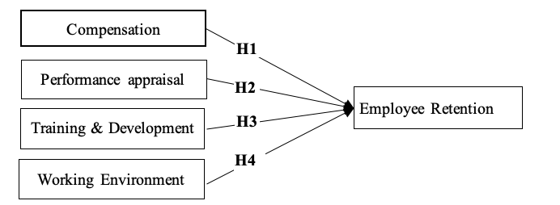

**Figure 1: Resource-based employee retention theory**

(Source: Kurdi and Alshurideh, 2020)

By grabbing adequate compensation from the organisation, and achieving performance appraisals after some stipulated time, employees can find more confidence to do work in a more effective manner. On the other hand, due to a lack of training and development, an organisation is unable to maximise the capabilities and skills of employees which is extremely necessary for the organisation in the present competitive era. In this context, by grabbing adequate and efficient resources from the management, employees can find full of confidence and leaders can handle a team more efficiently.

**Herzberg's theory of employee motivation**

Herzberg’s two-factor theory is another potential framework which helps leaders to retain employees by maximising motivation and reducing the job-changing mentality in their minds. The theory has focused on two factors of motivation like "poor hygiene factors" and "motivating factors" (Nagpaul *et al.* 2022). For instance, due to poor hygiene factors, like a lack of employee health and safety framework, employees are unable to fulfil their work in a satisfactory manner which reduces the number of employees in the workplace. As Amnesty International has huge work pressure along with a lack of work-life balance among staff and also has a toxic work culture, this affects staff satisfaction.

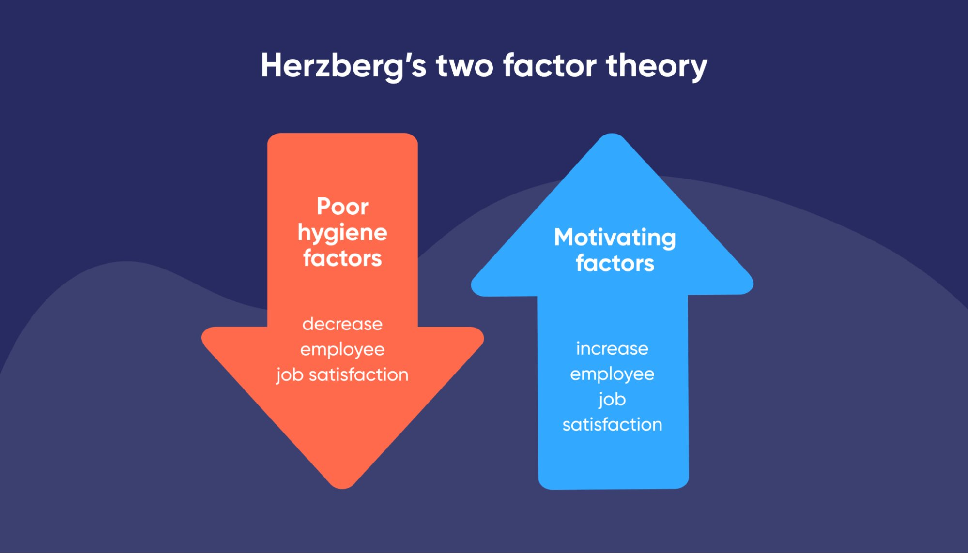

**Figure 2: Herzberg's two-factor theory**

(Source: Thant and Chang, 2021)

Focusing on the health and safety needs of employees by maintaining work-life balance, and providing life assurance, and health insurance, leaders of the company retain employee motivation. Similarly, by arranging different employee assistance sessions like upskilling sessions, and training sessions to provide new knowledge to each staff member, the company not only enriches employee motivation but also develops or upgrades the capabilities of staff. Hence, Herzberg’s two-factor theory can support managers of the respective NGO to develop their team and maximise the competitive advantages for the international operation of the business.

# Assessing the ways to apply these theories in the organisational context

The resource-based theory is one of the potential theories which delivers a framework which helps an organisation to increase the ability in order to prevent employee turnover and maximise employee retention in a similar manner. Focusing on the resource-based theory, employees can find their satisfaction through high compensation, job appraisals, on-job training and other perks as well as benefits. For employees who try to change or leave their job in a certain period due to lack of satisfaction, this framework supports those employees to change their job-changing mentality. Using this employee motivational and development framework, managers can find the A-Z strategies to manage a team in a more strategic manner and be a respectful managers in the workplace (Armstrong, 2017). Similarly, during the session, leaders try to maintain this framework of staff retention and development, leaders need to enrich their own skills along with the staff. By increasing communication skills, Emotional Intelligence skills, and team management skills, leaders can identify or define staff needs (Stoyanova-Bozhkova *et al.* 2022). Hence, by increasing leadership capabilities, and staff capabilities, by focusing on their requirements, leaders can find a better team management framework.

Herzberg's theory is another crucial employee management theory. During the team or employee management session, this theory influences leaders to detect staff needs like health and safety requirements, required skills, necessary environment and others. There are two dimensions "hygiene as well as motivation", which are quite beneficial for team management in an organisation (Koncar *et al*. 2022). As Amnesty has some potential issues regarding employee retention and cultural problems, Herzberg's theory helps the NGO to reshape employee motivation along with organisational culture. Detecting the issues of employee satisfaction like lack of salary, increasing employee shortage, and reducing the quality of services, leaders need to focus on motivational factors as well as skills along with capabilities of the workforce. In this context, motivators like achievement, rewards, and employee awards make workers more confident and productive which maximises a committed mentality as well as creativity among staff.

# Significance of the theories on the organisation

Resource-based theory and Herzberg’s theory both are crucially important for workforce management. As Amnesty has some employee management issues regarding its toxic culture and decreasing employee retention, it maximises the chances of organisation risk for the venture and its international business operation. Due to using the resource-based theory, organisations need to provide adequate remuneration to staff and need to also deliver performance appraisal steps for each employee in a firm (Yong *et al*. 2020). Similarly, this theory also focused on employee skills and capabilities which support each worker to handle a huge number of tasks within a stipulated time and maintain a high-end quality. The resource-based framework can help Amnesty to provide different training sessions for each staff with increasing the abilities of staff to maintain the present market trend and maximise the comparative advantages of organisations in the present competitive market.

During the session work for management, some of the companies are not focusing on employee health and safety which sometimes raises a question mark on the ethical behaviour of an organisation. As Amnesty is an international organisation due to this reason, employees of the permanent staff handle huge work pressure which sometimes creates constraints for their health and safety. In this context, Herzberg's theory can help leaders of the firm to retain employees in the workplace by emphasising their health, and safety and upskilling sessions by increasing their benefits and arranging training sessions.

# Conclusion

Workers are the most inseparable part of an organisation since employees support an organisation to maximise the business productivity of a firm. On the other hand, due to improper work culture, and irrelevant team management, managers are unable to retain employees in the workplace. Amnesty NGO is the largest NGO in the globe which focuses on human rights and injustice among global individuals. However, based on present days, the firm has faced employee issues which reduced the number of employees in a continuous manner. In this context, the "Herzberg Theory", and "Resource-based motivation theory" can help the international NGO to successfully handle the needs of the workforce and retain those employees for international business management.

# References

Adair, J.E. (2016) Developing Your Leadership Skills. 3rd edition. London: Kogan Page.

Amnesty.org (2023), *Amnesty International is a global movement of more than 10 million people who take injustice personally. We are campaigning for a world where human rights are enjoyed by all.* Available at: https://www.amnesty.org/en/who-we-are/#:~:text=Amnesty%20International%20is%20a%20global,people%20who%20take%20injustice%20personally. [Accessed on: 19.04.2023]

Amnesty.org (2023), *BENEFITS AND STAFF GROUPS*. Available at: https://www.amnesty.org/en/careers/benefits/ [Accessed on: 19.04.2023]

Amnesty.org (2023), *FINANCES AND PAY*. Available at: https://www.amnesty.org/en/about-us/how-were-run/finances-and-pay/#:~:text=Amnesty%20International%20is%20the%20world's,2500%20staff%20in%2070%20Countries. [Accessed on: 19.04.2023]

Armstrong, M. (2016) Armstrong’s handbook of management and leadership for HR: developing effective people skills for better leadership and management. 4 th edition. London: Kogan Page.

Armstrong, M. (2017) How to be an even better manager: a complete A-Z of proven techniques and essential skills, 10 th ed. London: Kogan Page.

Bilan, Y., Mishchuk, H., Roshchyk, I. and Joshi, O., (2020). Hiring and retaining skilled employees in SMEs: problems in human resource practices and links with organizational success. *Business: Theory and Practice*, *21*(2), pp.780-791.

Bratton, J. (2017) Human Resource Management: Theory and Practice. 6 th edition. Basingstoke: Palgrave McMillan.

Careers.amnesty.org (2023), *TRAINING AND COMMUNITY ENGAGEMENT LEAD (3692).* Available at: https://careers.amnesty.org/vacancy/training-and-community-engagement-lead-3692/3720/description/ [Accessed on: 19.04.2023]

Comparably.com (2023), *Amnesty International.* Available at: https://www.comparably.com/companies/amnesty-international/human-resources [Accessed on: 19.04.2023]

Dou, G., Li, G., Yuan, Y., Liu, B. and Yang, L., (2022). Structural Dimension Exploration and Measurement Scale Development of Employee Involution in China’s Workplace Field. *International Journal of Environmental Research and Public Health*, *19*(21), p.14454.

Hayat Bhatti, M., Akram, U., Hasnat Bhatti, M., Rasool, H. and Su, X., (2020). Unraveling the effects of ethical leadership on knowledge sharing: the mediating roles of subjective well-being and social media in the hotel industry. *Sustainability*, *12*(20), p.8333.

Koncar, P., Santos, T., Strohmaier, M. and Helic, D., (2022). On the application of the Two-Factor Theory to online employer reviews. *Journal of Data, Information and Management*, *4*(1), pp.1-23.

Kurdi, B. and Alshurideh, M., (2020). Employee retention and organizational performance: Evidence from banking industry. *Management Science Letters*, *10*(16), pp.3981-3990.

Mullins, L. J. (2019) Organisational behaviour in the workplace. 12th Edition, Harlow: Financial Times Prentice Hall.

Nagpaul, T., Leong, C.H., Toh, C.S., Amir, A.B., Chin, R. and Tan, S., (2022). Exploring Job Satisfaction and Intentions to Quit among Security Officers: The Role of Work Hygiene and Motivator Factors. *Social Sciences*, *11*(11), p.497.

Nair, A.K. and Bhattacharyya, S.S., (2019). Mandatory corporate social responsibility in India and its effect on corporate financial performance: perspectives from institutional theory and resource‐based view. *Business Strategy & Development*, *2*(2), pp.106-116.

Newman, S.A. and Ford, R.C., (2021). Five steps to leading your team in the virtual COVID-19 workplace. *Organizational Dynamics*, *50*(1), p.100802.

Scoble, H.M. and Wiseberg, L.S., (2019). Problems of comparative research on human rights. In *Global human rights: Public policies, comparative measures, and NGO strategies* (pp. 147-171). Routledge.

Stoyanova-Bozhkova, S., Paskova, T. and Buhalis, D., (2022). Emotional intelligence: a competitive advantage for tourism and hospitality managers. *Tourism Recreation Research*, *47*(4), pp.359-371.

Strassburger, C., Wachholz, F., Peters, M., Schnitzer, M. and Blank, C., (2023). Organizational leisure benefits–a resource to facilitate employees’ work-life balance?. *Employee Relations: The International Journal*, *45*(3), pp.585-602.

Thant, Z.M. and Chang, Y., (2021). Determinants of public employee job satisfaction in Myanmar: Focus on Herzberg’s two factor theory. *Public Organization Review*, *21*, pp.157-175.

Theguardian.com (2023), *Amnesty International has toxic working culture, report finds*. Available at: https://www.theguardian.com/world/2019/feb/06/amnesty-international-has-toxic-working-culture-report-finds [Accessed on: 19.04.2023]

Theguardian.com (2023), *Amnesty International to make almost 100 staff redundant*. Available at: https://www.theguardian.com/global-development/2019/jun/06/amnesty-international-to-make-almost-100-staff-redundant [Accessed on: 19.04.2023]

Tien, N.H., Jose, R.J.S., Ullah, S.E. and Sadiq, M., (2021). Development of human resource management activities in Vietnamese private companies. *Turkish Journal of Computer and Mathematics Education (TURCOMAT)*, *12*(14), pp.4391-4401.

Torrington, D. (2020) Human resource management, 11 th ed. Harlow, UK: Pearson Education Limited.

Yong, J.Y., Yusliza, M.Y., Ramayah, T., Chiappetta Jabbour, C.J., Sehnem, S. and Mani, V., (2020). Pathways towards sustainability in manufacturing organizations: Empirical evidence on the role of green human resource management. *Business Strategy and the Environment*, *29*(1), pp.212-228.