**ASSESSMENT**

**Table of Contents**

Part 1-Literature Review 2

Introduction 2

The Changing Nature of Global Landscape in International Business 2

Impact of the Changing Landscape of global business on the Retail Industry 6

Theoretical Perspectives 8

Summary and Conclusion 9

Reference List 11

# Part 1-Literature Review

## Introduction

The rapid spread of the internet, massive globalisation and the sudden outbreak of the Covid-19 pandemic have significantly altered the landscape of global business in the present times. Accordingly, the study aims to critically evaluate the changing landscape of global business in recent times and analyse how these changes have brought both challenges as well as opportunities to Tesco Plc, the leading force in the UK retail sector. In this regard, the study has reviewed the existing literature and analysed the impact of rapid digital transformation and new approaches in strategic and managerial implementations from a theoretical perspective. In addition, the study has also identified the gaps in existing literature.

## The Changing Nature of Global Landscape in International Business

**Rapid Digital Transformation**

The rise of advanced technologies such as artificial intelligence (AI), Blockchain, Machine Learning (ML), Cloud Computing, Big Data analytics, Internet of things (IoT) along with Virtual and augmented reality (VR/AR) following the industrial revolution 4.0 has accelerated digital transformation in the global business landscape. According to the findings of Ulas (2019), the introduction of the Internet economy along with electronic commerce and social media platforms has made contemporary business solely relies on the transmission and processing of digital data. As a result, most of the global business organisations have adopted a digital transformation to develop an intelligent enterprise.

**Figure 1: Latest Technologies of Digital Transformation**

(Created by Author)

On the other hand, Correani *et al.* (2020) have observed that the rapid digitalisation in the global business landscape has increased flexibility in developing products and services with a scope of continuous development. In addition, digital transformation has also helped in lowering barriers while setting connections or exchanging information with continuous access to accurate and reliable data streams.

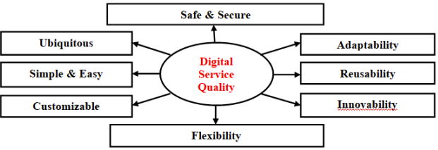

**Figure 2: Benefits of Digitisation in Global Business**

(Source: Aithal and Aithal, 2019)

**Increased Rate of Inflation and lack of supply chain security**

The subdued growth in the international economy followed by the global pandemic and the war between Russia and Ukraine has increased the rate of inflation on the global platform. The rise of the Covid-19 pandemic has increased the inflation rate by 4.7% in 2021 and it is estimated that the rate of global inflation will increase by 8.75% by the end of 2027 (Sttaista.com, 2023). According to the findings of Hang *et al.* (2020), the increased rate of inflation includes a potential risk of reducing economic growth and declining the rate of employment. As a result, it can be stated that a rise in global inflation can affect the growth of global business by reducing organisational productivity and the flow of work.

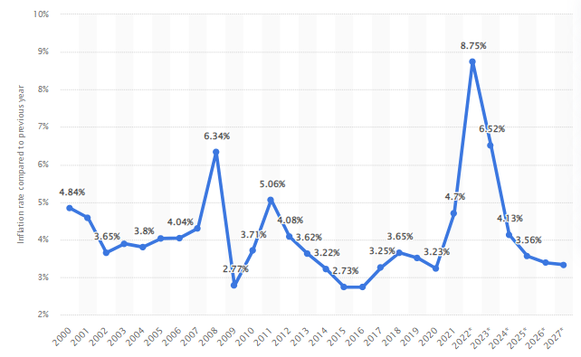

**Figure 3: Global Rate of Inflation**

(Source: Statista.com, 2023)

On the other hand, Ulussever *et al.* (2023) have observed that an increased rate of inflation also affects the volatility of the international market by increasing the pricing of essential commodities and raw materials. As a result, managing the supply chain on global platforms can also be affected due to increased costs of local logistics management and supply shortages. Accordingly, it is essential for global organisations to increase resilience in SCM and increase security by deploying local alternatives. As per the findings of Dev and Sengupta (2022), in the post-Covid-scenario, most of the international logistics and SC agencies are affected by zero-Covid policies. As a result, increasing resilience within the global SCM can help international business organisations to reduce their exposure to volatile market scenarios.

**Enhanced focus on Sustainability**

Climate change has been a major threat to global business management as it has posed a threat to the successful management of manufacturing and logistics provisions. Accordingly, Findla and Hoekman (2021) have observed that the right social and environmental credentials have become the primary parameter for increasing engagement with a global business for both consumers as well as investors. Hence, it can be stated that the global business landscape prioritises attaining sustainability and reducing the negative impact on the surrounding ecology. In order to achieve sustainability in a global business scenario, the importance of ESG Governance has significantly increased.

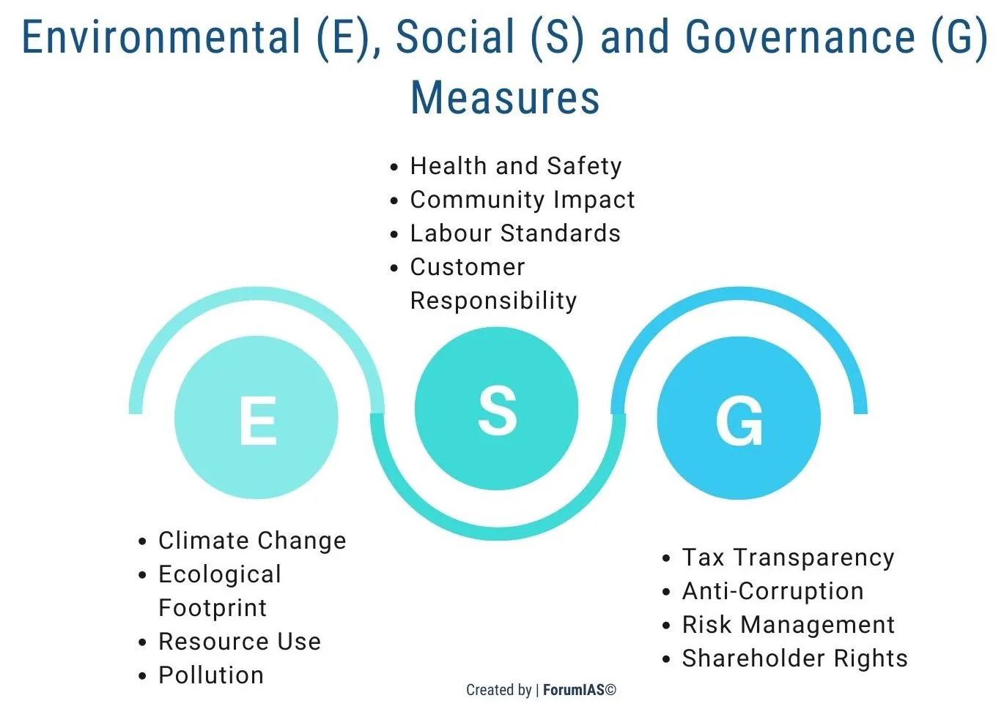

**Figure 4: ESG Framework and its Domains in Global Business Management**

(Source: Hristov *et al.* 2021)

As per the views of Hristov *et al.* (2021), the Environment, Social and Governance framework helps to develop a clear goal in respect of a predetermined time frame and increases transparency in its managerial approaches. As a result, in recent global business, the ESG framework has become applicable to both strategic management as well as supply chain management as it helps in streamlining the channel structure. In addition, the mutually supporting system associated with the ESG framework has shifted the trade perceptions in the international markets. Both promotional activities and advertising strategies have focused more on local sustainability along with cultural integration.

**Emphasis on Enhanced Customer Experience**

The major change in the global business landscape in 2023 can be best observed in the case of its rising focus on enhancing the experience of the customers. In the modern business scenario, an enhanced customer experience relies beyond pricing and quality. According to the findings of Thakur (2021), the rapid spread of digitisation and e-Commerce in the global scenario has established a focus on increasing customer experience in respect of personalisation. As a result, in modern business practice, global business organisations have focused on deploying a metaverse to enhance the buying experience of the customers.

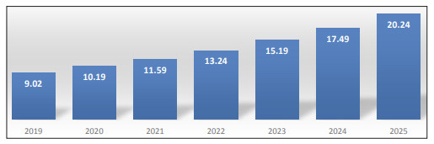

**Figure 5: The rise of the international e-Commerce Market between 2019 to 2025**

(Source: Thakur, 2021)

On the contrary, Aithal and Aithal (2019) have observed that strategic tools such as after-sales support or AI predictive tools along with a 3D buying environment with the help of VR have also been effective in enhancing consumer experience within the global platforms. Accordingly, it is assumed the market of VR projection in the global business scenario is supposed to increase by 13.06% by the end of 2027 (Sttaista.com, 2023). Thus, it can be stated that the latest trend of enhancing consumer experience within the global business landscape has become a foundational aspect of the modern business strategy for increasing consumer engagement.

## Impact of the Changing Landscape of global business on the Retail Industry

The changing landscape in the global business environment in respect of increased digitisation, rapid globalisation and increased concern about customer experience along with an increased rate of inflation has brought both challenges as well as opportunities in the business environment. The UK retail sector has also been no different in this case. For instance, the retail industry in the UK has accounted for 22% of automation in the global scenario based on its latest technological solutions such as IoT, AR, VR and AI (Statista.com, 2023). Similarly, the UK retail sector has also invested around 702.4 million GBP in order to establish sustainable management of its supply chain and logistics procedure (Statista.com, 2023). Accordingly, leading UK retail organisations such as Tesco Plc have faced both opportunities for growth and challenges in recent times with rising changes in global business scenarios.

**Opportunities**

Tesco Plc has made significant use of the latest and advanced technologies such as AI, Big data and Cloud computing for increasing the growth of their digital venture in the last five years. In 2022, the organisation has allocated an annual expenditure worth 2.2 billion USD to improving tier IT infrastructure. The adoption of this massive digital transformation has also helped Tesco Plc ***increase its share profit and internal revenue***. For instance, in 2020, the profit of Tesco Plc through their online sales almost doubled with an increased sales of 28.7% (Bbc.com, 2023). Besides, in the case of Tesco plc the application of digital technologies along with the ESG framework has also helped to ***increase sustainability in its SCM***. For instance, the organisation has focused on developing a sustainable SCM with the help of three pillars including “Action Collaboration and Transformation Framework” (Tescoplc.com, 2022). The application of this framework in SCM has brought the opportunity for partnering with local small-scale farmers and suppliers and avoiding sudden disruptions in global SCM.

On the other hand, the application of the latest technologies such as AI, AR and VR in the shopping experience of Tesco has also helped the organisation to ***increase its customer base***. For instance, reinvesting in VR applications within the e-Commerce section and analysing consumer requirements with Big Data analytics has helped Tesco Plc to increase its consumer base by 83% in the last five years (Tescoplc.com, 2022). Accordingly, with the increased customer base, the ***group sales of Tesco have also increased*** by 3% in 2022 (Tescoplc.com, 2022). Thus, it can be stated that adopting the changes in the global business scenario has helped Tesco Plc to improve its business operations by increasing profit, group sales and sustainability in SCM.

**Challenges**

Besides the above-stated opportunities, the rising changes in the global business landscape have also presented challenges in the strategic operation of Tesco Plc. According to the findings of Okereafor and Adelaiye (2020), the excessive application of digital technology has increased the challenge of sudden technological disruption and cyberattacks. A recent example of ***technological disruption*** in online sales of Tesco Plc during Christmas 2022. The absence of a virtual waiting room within the eCommerce platform of Tesco Plc disrupted the online order-taking service for around 5 hours on Christmas Eve. This ***affected the sales*** of Tesco Plc in Q4 by 1.2% (Tescoplc.com, 2022). On the other hand, during a ***cyberattack*** at the end of 2021, the organisation faced a total loss worth 3 million GBP as all online transactions were subjected to a forced suspension by the hackers (Forbes.com, 2021). Besides technical disruption and cybersecurity threats, the organisation has also been affected by the increased rate of inflation. For instance, with the increased rate of global inflation, the organisation has been forced to ***cut down 2100 job roles*** including 1750 managerial posts (Bbc.com, 2023). This massive cut-off in the internal workforce has reduced its organisational productivity by reducing cash flow from 1.8 billion GBP to 1.4 billion GBP (Tescoplc.com, 2022). On the other hand, due to the increased rate of inflation, Tesco Plc has also ***increased the price of its grocery section*** by 5% (Theguardian.com, 2022). Thus, it can be stated that the increased price and decrease in internal workforce has thus affected the target productivity of the organisation.

## Theoretical Perspectives

**Technology Acceptance Model**

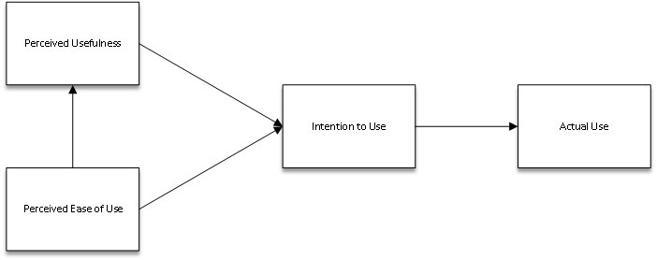

**Figure 6: Technology Acceptance Model**

(Source: Sun and Gao 2020)

The Technology Acceptance Model proposes a theory on information systems that helps to determine the acceptance of recent technology and improve its utilisation. According to the findings of Sun and Gao (2020), the acceptance of technology is determined by two intrinsic factors including perceived ease of use and perceived usefulness. Accordingly, the application of the latest digital technologies such as AI, VR and AR helps to increase consumer experience and improve the acceptance of business on global platforms. Hence, the application of this theoretical model can help global business platforms to improve their digital transformation and manage an automated supply chain.

**Value-Perception Theory**

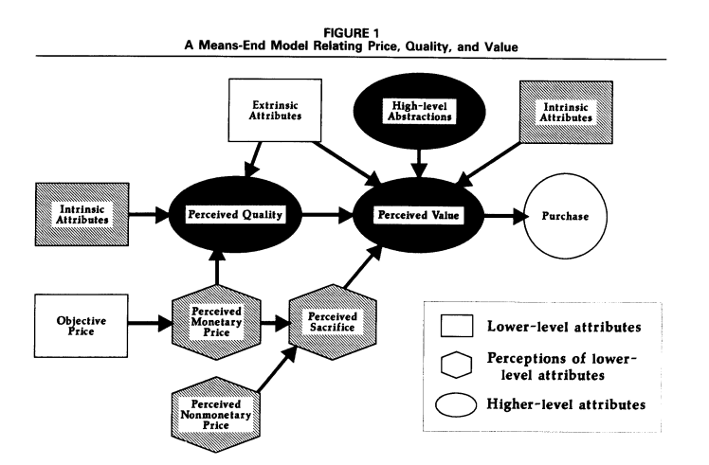

**Figure 7: The value perception theory**

(Source: Luo *et al.* 2022)

The value perception theory suggests that the value of customer perception is dependent on two intrinsic factors including the ideal value and the actual value. According to the findings of Luo *et al.* (2022), the least difference between the actual value of a product or service in comparison to its ideal value helps to increase the customer’s experience with a particular product accordingly, the consideration of this theory becomes essential in enhancing consumer perspective by analysing their requirements and improving the service quality.

## Summary and Conclusion

Based on the above findings, it can be concluded that the global business environment has undergone a massive change in recent years due to the pandemic, war, economic depression and climate change. In addition, the rise of electronic commerce and the internet economy has also introduced changes such as rapid digitisation, sustainable SCM and increasing customer experiences. These changes have brought opportunities along with challenges in business operations and management. For instance, digital transformation has increased online sales and enhanced the customer base with engagement. On the other hand, it also posed a threat of financial loss due to cyber-attacks and technical disruptions. Similarly, the increased inflation has also increased the threat of declined productivity and increased prices. However, though the existing literature has focused on the changes in the global business landscape it has manifested a gap in analysing how these changes have affected organisational sustainability and corporate governance.

# Reference List

Aithal, P.S. and Aithal, S., (2019). Management of ICCT underlying technologies used for digital service innovation. *International Journal of Management, Technology, and Social Sciences (IJMTS)*, *4*(2), pp.110-136.

Bbc.com (2023), *Tesco profits surge as online orders double*, Available at: https://www.bbc.com/news/business-54445399 [Accessed on: 19.04.2023]

Bbc.com (2023), *Tesco: More than 2,000 jobs set to go due to store changes*, Available at: https://www.bbc.com/news/business-64463060 [Accessed on: 19.04.2023]

Correani, A., De Massis, A., Frattini, F., Petruzzelli, A.M. and Natalicchio, A., (2020). Implementing a digital strategy: Learning from the experience of three digital transformation projects. *California Management Review*, *62*(4), pp.37-56.

Dev, S.M. and Sengupta, R., (2022). *Covid-19 pandemic: Impact, recovery, and the road ahead for the Indian Economy*. Indira Gandhi Institute of Development Research.

Findlay, C. and Hoekman, B., (2021). Value chain approaches to reducing policy spillovers on international business. *Journal of International Business Policy*, *4*, pp.390-409.

Forbes.com (2021), *Tesco Blames Cyberattack for Day-Long Website Outage*, Available at: https://www.forbes.com/sites/barrycollins/(2021)/10/24/tesco-website-suffers-day-long-outage/ [Accessed on: 19.04.2023]

Hang, T.T.B., Nhung, D.T.H., Huy, D.T.N., Hung, N.M. and Pham, M.D., (2020). Where Beta is going–case of Viet Nam hotel, airlines and tourism company groups after the low inflation period. *Entrepreneurship and Sustainability Issues*, *7*(3), p.2282.

Hristov, I., Appolloni, A., Chirico, A. and Cheng, W., (2021). The role of the environmental dimension in the performance management system: A systematic review and conceptual framework. *Journal of Cleaner Production*, *293*, p.126075.

Luo, L., Qiao, D., Tang, J., Wan, A., Qiu, L., Liu, X., Liu, Y. and Fu, X., (2022). Training of Farmers’ Cooperatives, Value Perception and Members’ Willingness of Green Production. *Agriculture*, *12*(8), p.1145.

Okereafor, K. and Adelaiye, O., (2020). Randomized cyber attack simulation model: a cybersecurity mitigation proposal for post covid-19 digital era. *International Journal of Recent Engineering Research and Development (IJRERD)*, *5*(07), pp.61-72.

Statista.com (2023), *Global inflation rate from 2000 to 2021*, with forecasts until 2027, Available at: statista.com/statistics/256598/global-inflation-rate-compared-to-previous-year/ [Accessed on: 19.04.2023]

Statista.com (2023), *VR Software – Worldwide*, Available at: https://www.statista.com/outlook/amo/ar-vr/vr-software/worldwide [Accessed on: 19.04.2023]

Sun, Y. and Gao, F., (2020). An investigation of the influence of intrinsic motivation on students’ intention to use mobile devices in language learning. *Educational Technology Research and Development*, *68*, pp.1181-1198.

Tescoplc.com (2022), *Annual Report 2022*, Available at: https://www.tescoplc.com/media/759057/tesco-annual-report-(2022).pdf [Accessed on: 19.04.2023]

Tescoplc.com (2022), *Sustainable livelihoods - supply chain strategy*, Available at: https://www.tescoplc.com/sustainability/documents/policies/sustainable-livelihoods-supply-chain-strategy/ [Accessed on: 19.04.2023]

Thakur, A., (2021). Trends and Analysis of E-Commerce Market: A Global Perspective. *INTERNATIONAL JOURNAL OF APPLIED MARKETING*, p.11.

Theguardian.com (2022), *Tesco chairman warns of food price inflation at 5% by spring*, Available at: https://www.theguardian.com/business/2022/feb/06/tesco-chair-warns-food-price-inflation-of-5-is-just-around-the-corner [Accessed on: 19.04.2023]

Ulas, D., (2019). Digital transformation process and SMEs. *Procedia Computer Science*, *158*, pp.662-671.

Ulussever, T., Ertuğrul, H.M., Kılıç Depren, S., Kartal, M.T. and Depren, Ö., (2023). Estimation of impacts of global factors on world food prices: a comparison of machine learning algorithms and time series econometric models. *Foods*, *12*(4), p.873.