**MANAGEMENT AND ORGANISATIONAL BEHAVIOUR**

**Executive summary**

The study highlights the organizational as well as management behaviour of British Petroleum. The study also showcases how organizational culture, political power, and climate politics can put an influential impact on the business organization. Additionally, this study also shows how two different motivational theories can help in inducing employee interest as well as employee motivation. The study showcases the implementation of motivational theories like "Maslow's Hierarchy of Needs", "Self- determination theory” and "McClelland's Theory of Needs". The study also focuses on integral team arrangements of British Petroleum like Virtual team arrangements, problem-solving team arrangements and self-managed team arrangements. This study also shows how this team arrangement can help an organization in reaching the height of organizational success.

Table of Contents

Introduction 4

Definition and Influence of Culture, power and political power over a business organization 4

Introducing the influential impact of organizational culture, climate politics, as well power over an individual and behaviour of a team in BP Plc 4

Evaluating the application of motivational theories as well as Techniques 5

Defining 3 organizational team arrangements and their application with examples 6

Analyzing improvement in work culture with the help of "Path-Goal Leadership" (PGL) and SLT or "Situational Leadership Approach" 7

Conclusion and Recommendations 8

References: 8

Appendices 10

# Introduction

Organizational behaviour is indicated as a field that identifies groups, and individuals as well as the structural impact on organizational behaviour to apply knowledge to induce organizational efficiency.

# Definition and influence of culture, power and political power over a business organization

**Culture**

Culture is referred to as a company's beliefs, attitudes as well as values that influence the behaviour of the employee individual. Influenced by the idea of Malec *et al.* (2021), power is more often recognized as the managerial ability of an individual to direct instructions and orders among subordinates. Additionally, power cannot be disclosed on a chart and can be both informal as well as formal from a broader aspect. Political power refers to the ability to undergo certain changes that benefit the business organization with the help of social networking and power.

# Introducing the influential impact of organizational culture, climate politics, as well power over an individual and behaviour of a team in BP Plc

Power can indirectly contribute towards organizational behavioural changes. As per the views of Istanti *et al.* (2020), organizational culture, power and political power often puts an influential impact on the business organization while reshaping organizational structure. The efficiency of power primarily depends on the individual applying it. The CEO of BP has undergone the execution of comprehensive systems to evaluate internal control as well as the risk management framework of BP. British Petroleum (BP) is among the major producers in delivering unified oil and gas. BP has set out new purposes to renovate energy for individuals to become a net zero company by 2050 (Bp.com, 2023). Power reflects the capability to influence decisions while controlling potential resources.

There is no direct correlation between the position as well as power which implies that the employee individuals can be able to employ pressure on employers on the arrival of certain circumstances. As opined by Sovacool, (2021), climate politics refers to the aggregation of opinions and moods concerning certain circumstances. Organizational politics comes into account due to competency in managing positions and scarce resources with a limitation towards upward mobility. Organizational politics typically includes a hierarchical structure with a concentration of power at the top. Organizational politics is more commonly recognized as informal terms with exclusion in merit and luck by which power is acquired in an individual business organization. After the evaluation of working processes in 2021, BP has executed new changes in 2022 intending to improve board processes that are associated with working style and understanding opportunities of growth prospects.

# Evaluating the application of motivational theories as well as techniques

**Focusing on “McClelland’s Theory of Needs” (MTM):** MTM typically focuses on three different needs that are “need for achievement ” (nAch), “need for power” (nPow) and the "need for affiliation " (nAfl). nAch refers to achievement following stipulated standards, striving towards success and development. nPow highlights the need to let other individuals behave while maintaining certain standards. nAfl depicts the desire to take part in interpersonal relationships. As per the views of Acquah *et al.* (2021), certain research showcases the interrelation between job performance and nAch along with the concepts of nAff and nPow. Individuals who are successful in meeting the criteria of nAch have a positive mood and also show greater interest to undertake assigned tasks. Additionally, these employees’ individuals also perform well under unfriendly circumstances. BP offers flexible working patterns for its employee’s individuals intending to enforce agile working patterns in organizational structure.

**Considering “Self-determination theory” (S D T):** S D T states that the performance and well-being of the employee primarily depend on the nature of motivation to undertake the assigned job. Motivation can be regulated or has an autonomous nature. As per the views of Qian *et al.* (2022), three major aspects of SDT are Cognitive evaluation theory (CET), Self-concordance theory (SCT) and Regulatory focused theory (RET). CET states the situation when individuals are paid for work, these individuals start recognizing certain things which need to be done. As opined by Ntoumanis *et al.* (2021), SCT highlights the intensity of reasons to undertake assigned goals which are constant concerning an individual interest and goals. Additionally, SDT also signifies that there are certain psychological needs like the "need for Autonomy" and "need for Competence” affecting work motivation. BP delivers fantastic career progression opportunities for its employee’s individuals to generate desire and build interest to increase work efficiency.

**Applying “Maslow's Hierarchy of Needs” (MHN)”**

*(Refer to appendix I)*

MHN highlights five different needs like Self actualization, social-belongingness, esteem needs, safety-security, psychological needs which reflects in motivation theory for employee motivation. BP offers healthcare facilities like medical, eyesight care and dental health facilities to its employees. Priorly, BP also offers protection against disability, accident and life coverage to its employee’s individuals, which delivers access to long-term saving plans like retirement, Moreover, BP offers work-life balance and paid time off for the beneficiary of its employees.

# Defining 3 organizational team arrangements and their application with examples 350

**Problem-solving team arrangement (PTA)**

PTA helps in the collaboration of team members with leaders to reform an organizational structure that is focused on solving a specific problem. Based on the views of Annosi *et al*. (2020), the benefits of problem solving team arrangements include forming a stronger social network, resilient business organization, and increased unit of problem solvers along with increased abilities as well as skills. PTA approach also draws various influences on the business organization like improving communication skills, better understanding among the peer group. BP aims to be accountable to track the working progress in order to meet the organizational objective.

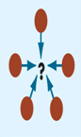

**Figure 1: Problem Solving Team Arrangement**

(Source: Lecture Note)

**Self-managed team arrangement (STA)**

STA refers to the group of employees, individuals, who intend to work collaboratively to improve group efforts, such that the probable outcome does not include any interference from the boss. Influenced by the ideas of Davidavičienė *et al.* (2020), the majority of the employees within your business organization are much more likely to practice a certain degree of self collaboration. BP intends to prioritise team effort for effective collaboration and honest feedback, such that it can help in recognizing drawbacks in the working processes (Bp.com, 2023). Additionally, prioritizing team efforts can help to find out potential opportunities that can help to stay ahead of the business competition.

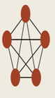

**Figure 2: Self Managed Team Arrangement**

(Source: Lecture Note)

**Considering “Virtual team arrangement” or VTA**

VTA is recognized as a group of working individuals, who are coming from different geographic locations with the help of electronic communications. As per the views of Castellano *et al.* (2021), VTA helps in increasing work efficiency of business organizations as the employees individuals tend to feel relaxed. Companies with VTA also enjoy the benefit of saving operational costs as the major burden of operational expenses gradually starts reducing. Additionally, these companies also come across potential growth opportunities to meet future growth prospects. As opined by Castellano *et al.* (2021), maintaining VTA in the business organization also helps in leveraging global talent, where expertise as well as specialists comes across together for a better collaboration, leading to the development of innovative ideas. BP offers a flexible working structure for its employees such that employees can enjoy work-life balance while delivering and contributing towards meeting organizational objectives.

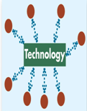

**Figure 3: Virtual Team Arrangement**

*(Source: Lecture Note)*

# Analyzing improvement in work culture with the help of "Path-Goal Leadership" (PGL) and SLT or "Situational Leadership Approach"

**PGL**

PGL helps to determine a specific leadership style for the situation as well as the individuals in which leadership is undertaken. Influenced by the ideas of Saleem *et al.* (2020), the leadership style of PGL includes four different styles participative leadership, supportive leadership, achievement oriented leadership and directive leadership. It helps to provide specific recommendations depending upon subordinates and tasks. Additionally, the PGL approach helps to find out various situations in which those proposed recommendations can be effective. BP follows Laissez Faire leadership style, which had significant drawbacks like lower awareness in job roles, increasing conflicts and lowering overall productivity. Applying the PGL approach could have helped BP in delivering effective collaboration among the employee individuals.

**SL:**

SL means adapting the leadership style with respect to certain situations in order to meet the needs of team members. Based on the views of Daniëls *et al.* (2019), there are two different leadership styles in SL like “task” or “directive” behavior and “relationship” or "supportive" behavior. “Directive behavior” (DB) is the behavior in which a leader directs its individuals about job roles. “Supportive behavior” (SB) refers to the leadership, in which the leadership engages with its subordinates, actively listens about task related problems and provides necessary suggestions. Applying SL in the organizational structure of BP could ensure that the company enjoys flexibility in leadership at certain situations.

# Conclusion and recommendations

It can be concluded that BP employs PTA, VTA and SRA which can assist in meeting growth prospects of the organization. BP has strategized new policies and reorganized the company structure in order to achieve its goal of being a net zero company (Bp.com, 2023). Due to proper unawareness about job roles, it will be hard for the employee individuals to successfully complete the assigned jobs. Unsuccessful accomplishments in the assigned jobs will lead to ineffective communication leading towards conflicts. Hence the organizational working structure as well as the working processes will get hampered. Therefore, it is highly recommended that employee individuals need to undergo certain job training programs in order to meet the ends while finishing the job.

# References

Acquah, A., Nsiah, T.K., Antie, E.N.A. and Otoo, B., (2021). Literature review on theories of motivation. EPRA International Journal of Economic and Business Review, 9(5), pp.25-29.

Annosi, M.C., Monti, A. and Martini, A., (2020). Individual learning goal orientations in self‐managed team‐based organizations: A study on individual and contextual variables. Creativity and Innovation Management, 29(3), pp.528-545.

Bp.com, (2023), Our beliefs and code of conduct, Available At: https://www.bp.com/en/global/corporate/who-we-are/our-beliefs-and-code-of-conduct.html [Accessed on 21.04.2023]

Bp.com, (2023), Our sustainability aims, Available At: https://www.bp.com/en/global/corporate/sustainability/our-aims.html [Accessed on 21.04.2023]

Castellano, S., Chandavimol, K., Khelladi, I. and Orhan, M.A., (2021). Impact of self-leadership and shared leadership on the performance of virtual R&D teams. Journal of Business Research, 128, pp.578-586.

Daniëls, E., Hondeghem, A. and Dochy, F., (2019). A review on leadership and leadership development in educational settings. Educational research review, 27, pp.110-125.

Davidavičienė, V., Al Majzoub, K. and Meidute-Kavaliauskiene, I., (2020). Factors affecting knowledge sharing in virtual teams. Sustainability, 12(17), p.6917.

Istanti, E., Sanusi, R. and Daengs, G.S., (2020). Impacts of price, promotion and go food consumer satisfaction in faculty of economic and business students of Bhayangkara University Surabaya. Ekspektra: Jurnal Bisnis dan Manajemen, 4(02), pp.104-120.

Malec, M., Kinelski, G. and Czarnecka, M., (2021). The impact of COVID-19 on electricity demand profiles: A case study of selected business clients in Poland. Energies, 14(17), p.5332.

Ntoumanis, N., Ng, J.Y., Prestwich, A., Quested, E., Hancox, J.E., Thøgersen-Ntoumani, C., Deci, E.L., Ryan, R.M., Lonsdale, C. and Williams, G.C., (2021). A meta-analysis of self-determination theory-informed intervention studies in the health domain: Effects on motivation, health behavior, physical, and psychological health. Health psychology review, 15(2), pp.214-244.

Qian, T.Y., Wang, J.J., Zhang, J.J. and Hulland, J., (2022). Fulfilling the basic psychological needs of esports fans: A self-determination theory approach. Communication & sport, 10(2), pp.216-240.

Saleem, A., Aslam, S., Yin, H.B. and Rao, C., (2020). Principal leadership styles and teacher job performance: Viewpoint of middle management. Sustainability, 12(8), p.3390.

Sovacool, B.K., (2021). Who are the victims of low-carbon transitions? Towards a political ecology of climate change mitigation. Energy Research & Social Science, 73, p.101916.

# Appendices

***Appendix I – Maslow's Hierarchy OF Needs***

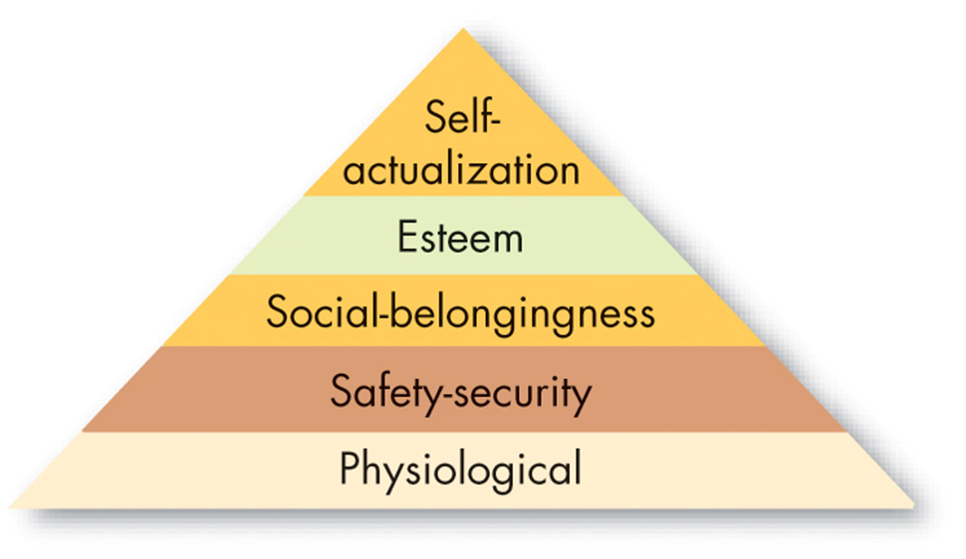

*(Source: Lecture Note)*