**ASSIGNMENT 2- INDIVIDUAL BUSINESS DISSERTATION**

**STAGE SUBMISSION 1: LITERATURE REVIEW**

**A STUDY INTO HOW COMPANIES INFLUENCE TECHNOLOGY AND INNOVATION WITHIN SUPPLIERS: CASE OF APPLE AND SAMSUNG**

**Table of Contents**

Chapter 2: Literature Review 3

2.1 Role of suppliers in electronic businesses 3

2.2 Issues faced by suppliers and their impact on electronics businesses 4

2.3 Influencing factors of using technologies for suppliers 4

2.4 Benefits of fostering technologies and innovation among suppliers 8

2.5 Challenges faced by suppliers to adapt technology and innovation 10

2.6 Strategies to mitigate the identified challenges 11

2.7 Theoretical Discussion 12

2.8: Literature Gap 15

Reference 17

# Chapter 2: Literature Review

## 2.1 Role of suppliers in electronic businesses

A supplier is a person or an entity that delivers products and services at a reasonable cost to another entity for sale (Durmić, 2019). Suppliers in the electronics business must abide by all applicable laws and regulations, including those about child labour and the protection of human rights (Alghababsheh*et al.* 2021). Suppliers should provide equal opportunities to all retailers and treat them fairly and equally, regardless of their backgrounds. The below figure shows the role of suppliers in Supply Chain Management.

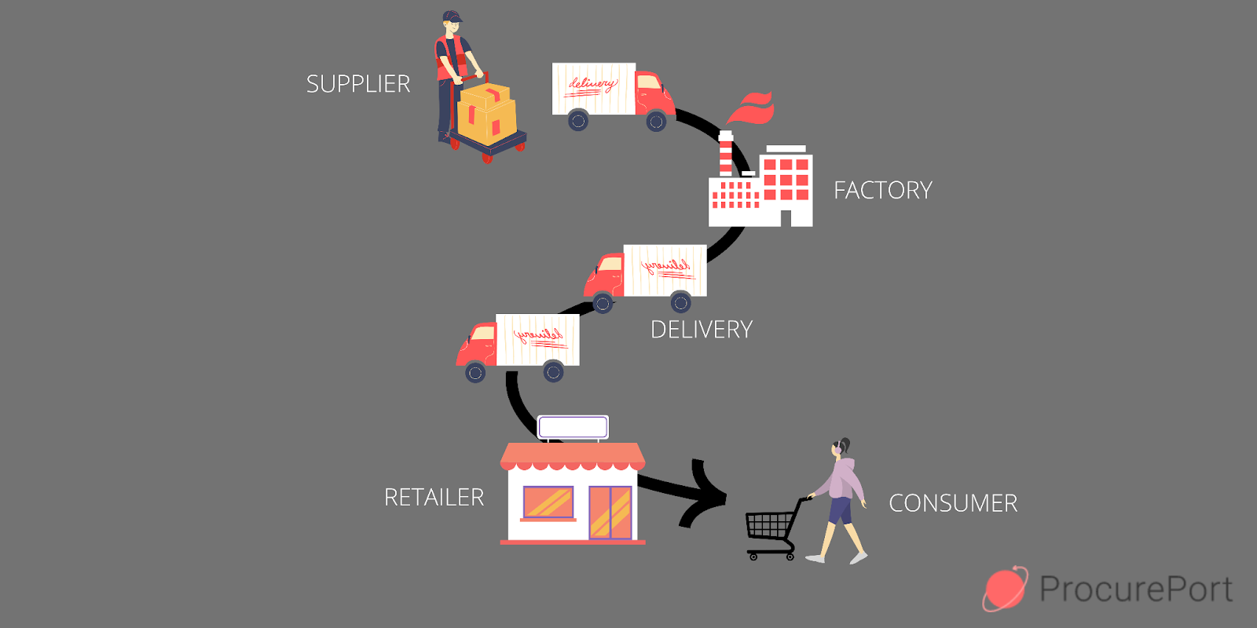

**Figure 2.1: The role of suppliers in Supply Chain Management.**

(Source: Ellram*et al.* 2019*)*

In order to keep merchants' trust, suppliers must guarantee them the product's quality and price and also present goods and services of high quality at reasonable prices which helps to enhance the future business of electronic goods. Suppliers use different modes of transportation to deliver goods within time at distribution centres, factories and warehouses. The practice of stock management enables suppliers to keep track of the product. This essential tracking system makes sure that the supply chain is not hampered by a shortage of products or raw materials for electronic goods. As per Ingaldi and Ulewicz (2019), one of the main responsibilities of suppliers in the electronics business is to fulfil the requirements of organizations by accepting, packing, and shipping orders for particular products and services.

## 2.2 Issues faced by suppliers and their impact on electronics businesses

The issues faced by the suppliers of electronic businesses include competition, order fulfilment, issue of quality and more. As per Alzoubi*et al*. (2022), the competition in electronics technology is developing day by day as electronics businesses play a vital role in the development of other businesses. Therefore the competition in the electronic business in the market is high and the suppliers face issues as the competition in the electronic business increases. Hence the competition creates a big impact on the sales of electronic products. The second issue faced by the suppliers' of electronic businesses is order fulfilment as the demand for electronic technologies is very high. Therefore it creates problems for the suppliers of electronic businesses to fulfil the orders required by the consumers and retailers. As per Fabeil*et al*. (2020), lack of order fulfilment creates a big impact on electronic businesses as it cannot satisfy the customers which can affect the business. Finding the right market is also a big issue faced by the suppliers of electronic businesses. The supplier also faced the issue of quality of electronic products as the customers purchase the electronics products from the suppliers. However, as per Wang *et al*. (2020), the quality issues of the electronics products can affect the supplier. Hence the quality issues of the electronic products have a big impact on the electronic businesses of suppliers as it decreases the brand value and the sales of the electronic goods which creates losses for the electronic businesses of the suppliers.

## 2.3 Influencing factors of using technologies for suppliers

Here some factors have been discussed that influence suppliers by using technologies.

**Quality of products**

It is observed that technological innovation practices can affect product quality. Using technology in the products and services can help consumers to get the desired quality of the product. Product quality can enhance the product market position which helps to increase the market share of the electronic industry as well. The below figure shows the effectiveness of technology in service quality.

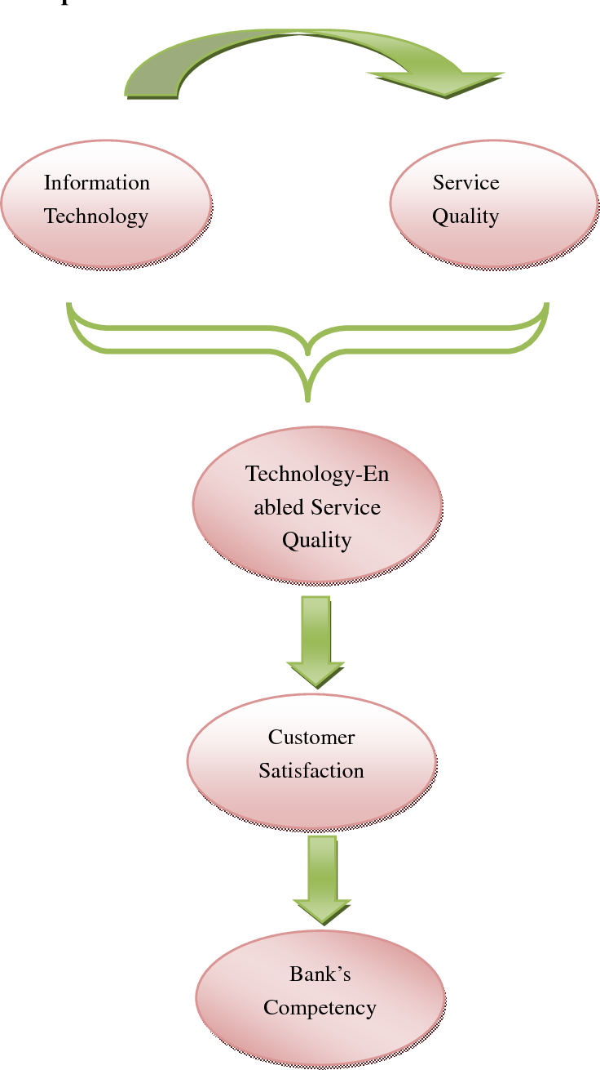

**Figure 2.3.1: The effectiveness of technology in service quality.**

(Source: Olimovich*et al.* 2020)

**Delivery**

With the help of technology, the delivery of any product is fulfilled within less amount of time which helps to meet the satisfaction level of clients. Therefore it can be said that an increased level of technology, will increase the efficiency of the product and service delivery as well.

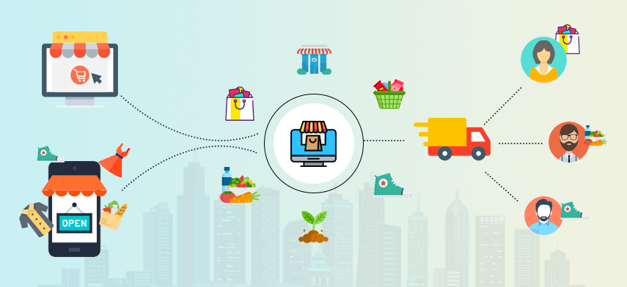

**Figure 2.3.2: The delivery model on consumer demand**

(Source: Yang *et al.* 2020)

The above figure shows the delivery model on consumer demand. Demand planning and forecasting technology and software help suppliers to improve their forecasts, assure the supply and demand of authentic products, and on-time delivery of products and services is also done which provides a positive impact on the client's experience.

**Cost**

Prices of any products or services are dependable on product quality, market and competitive factors. Technology helps to filter and sort the prices of all products and services which helps the consumers to get an overview of the product prices. The consumer will demand more products if the price of that product is low compared to others. On the other hand, providing offers on different products and services can also increase demand. The below figure shows the impact of information technology on reducing the cost.

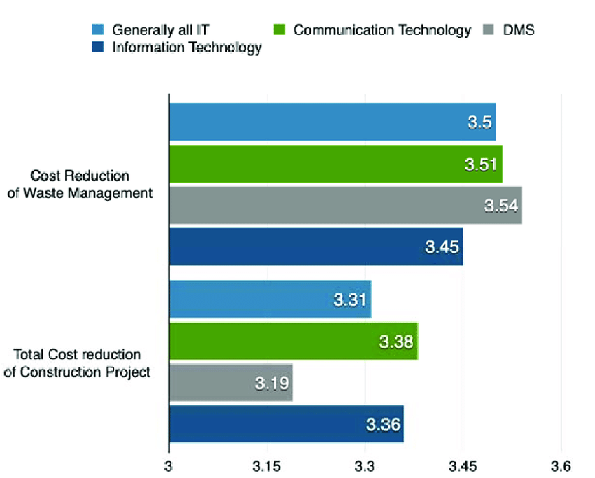

**Figure 2.3.3: The impact of information technology on reducing the cost**

(Source: Tallon*et al.* 2019)

**Competitive Market**

Technology helps to gather information about the target market. The below figure shows some importance of Technology in Marketing.

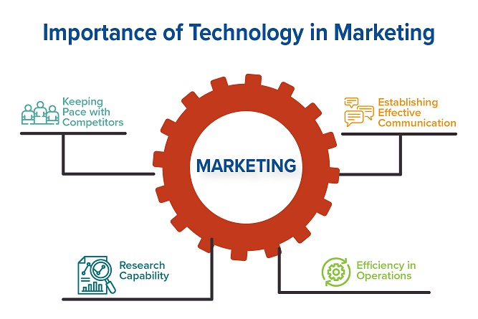

**Figure 2.3.4: Importance of Technology in Marketing**

(Source: Vlačić*et al.*  2021)

After knowing about the competitors, it is required to change the marketing strategy so that the demand for the product and services is increased compared to others which will lead to gaining a competitive advantage.

## 2.4 Benefits of fostering technologies and innovation among suppliers

The benefits of fostering technologies and innovation among suppliers are improved productivity, reduce costs, help to increase brand value and more. As per Aghion*et al*. (2021), fostering technologies and innovation helps and benefits the suppliers as it improves productivity. Therefore by adopting the technologies and innovation, the suppliers produce huge productivity of electronic goods which helps them to increase sales and also help to increase profitability. However, as per Suchek*et al*. (2021), the adoption or fostering of technology and innovation among suppliers also reduces the costs as the cost of adopting technologies and innovation is quite expensive.

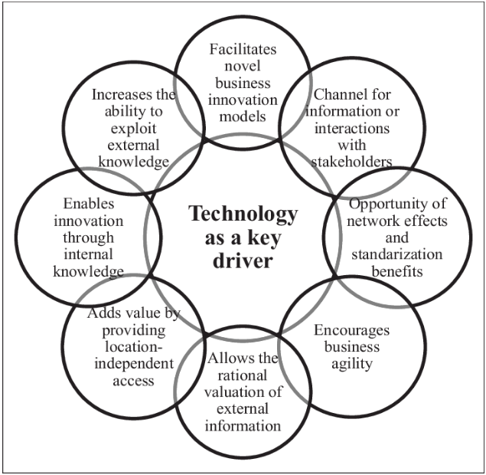

**Figure 2.4.1: Benefits of technology and innovation**

(Source: Hensen and Dong, 2020)

However, by adopting technologies and innovation the suppliers decrease human labour costs as the technologies provide more productivity than the workers which saves them money of the supplier than giving wages every month to the employees. As per Demartini*et al*. (2019), the adoption of technologies and innovation helped and benefited the suppliers to increase profitability with fewer expenses. The adoption or fostering of technology and innovation among suppliers also improves the brand value of the supplier businesses as with the help of modern technology and innovation, the suppliers provide quality and efficient products at the right time. However, as per He *et al*. (2020), providing customers high quality and efficient products at the right time helps to satisfy the need and demands of the customers which increases the brand value of the businesses of suppliers. Hence the adoption or fostering of technology and innovation benefited the suppliers as it increased the brand value of the supplier businesses by providing the customers with quality goods and services and fulfilling the requirements of the customers at the right time.

## 2.5 Challenges faced by suppliers to adapt technology and innovation

The challenges faced by suppliers to adopt technology and innovation include high cost, lack of technically skilled employees and demand for new technologies to compete with competitors. As per Ullah*et al.* (2021), the high cost of technology and innovation is a big challenge faced by the suppliers while adopting the technology and innovation as the modern technologies and innovation cost is high, therefore it is hard for moderate suppliers to adopt the technology and innovation with such big investment.

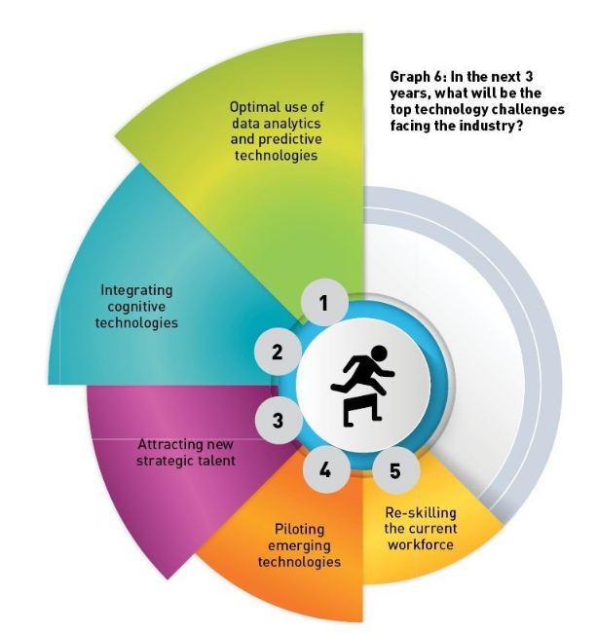

**Figure 2.5.1: Challenges of adopting technology**

(Source: Makhdoom*et al. 2*019)

Hence the high cost of technology and innovations is a crucial challenge for the suppliers while adopting it. Technologies and innovation need technically skilled employees for using and adopting them appropriately. However as per Kazancoglu*et al*. (2022), the lack of technically skilled employees creates problems for the suppliers as without technically skilled labours, the suppliers cannot perform their technology and innovation well. Hence the lack of technically skilled employees is a big challenge for suppliers while adopting technology and innovation. Technologies and innovation modify every day with new and updated versions as the updated version of the technology have many more facilities and advantages than the older versions. Therefore the updated version of technology and innovation by the competitors of the supplier's business increases the speed of the competitors as they have better technology and innovation. Hence the demand for new technology and innovation is also a big factor faced by the suppliers while adopting it.

## 2.6 Strategies to mitigate the identified challenges

The strategies to mitigate the identified challenges such as high cost while adopting technology and innovation by the supplies. As per Sahoo*et al*. (2023), suppliers can use strategic alliances with other supplier businesses to increase their investment power and purchase technology and innovation.

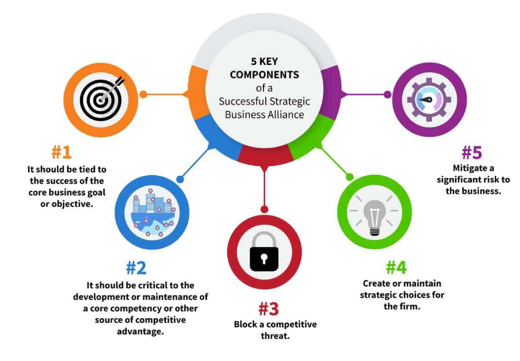

**Figure 2.6.1: Key components of strategic alliance**

(Source: Elia*et al,* 2019)

Hence merging with other suppliers can mitigate the high-cost challenges faced by the suppliers while adopting technology and innovation. The second strategy to mitigate the second challenge faced by suppliers is to find technically skilled labourers to perform the technology and innovation the suppliers need to provide well-skilled technical employees. However, as per Killip*et al.* (2020), the supplier needs to find employees who have knowledge and experience regarding the technology as it helps to improve and increase the sales and profit of the suppliers. Hence finding technically skilled labours will help the suppliers to perform well and it will also mitigate the lack of skilled employees’ challenges faced by the suppliers. The third strategy to mitigate the third challenge faced by the suppliers is to continuously update the technology and innovation. As per Khanfar*et al*. (2021), the update of technology by other competitors creates problems in the competition for the suppliers as the rival competitors have better-advanced technology which helps in more efficient and quality work. The better quality and efficient work by the rival competitors with the help of updated technology affects the suppliers who use old technology. However, as per Brandenburger and Nalebuff (2021), the supplier should always update their technology to compete with the rival competitors. Hence updating the technology and innovation will help the suppliers to compete with the rival competitors and help to maintain sales and profitability.

## 2.7 Theoretical Discussion

***Stakeholder Management Theory***

According to Flak and Rose (2005), Stakeholder Management theory is a theory of business ethics and capitalism that interconnects a relationship between a business and its consumers, suppliers, investors, local communities, employees and others who have a stake in that organization shown in the below figure.

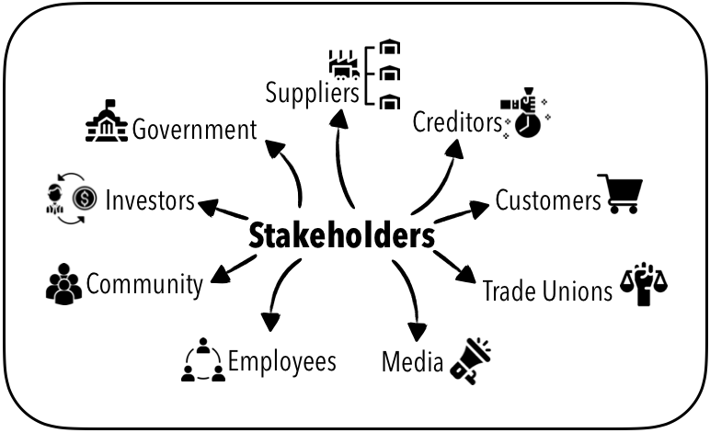

**Figure 2.7.1: Overview of Stakeholders**

(Source: Pedrini and Ferri, 2019)

The electronic industry can increase its market growth with the help of the Stakeholder Management Theory. This theory helps electronics companies to expand their business by increasing productivity, lowering turnover rates and improving employee satisfaction. The below figure shows six principles in stakeholder theory.

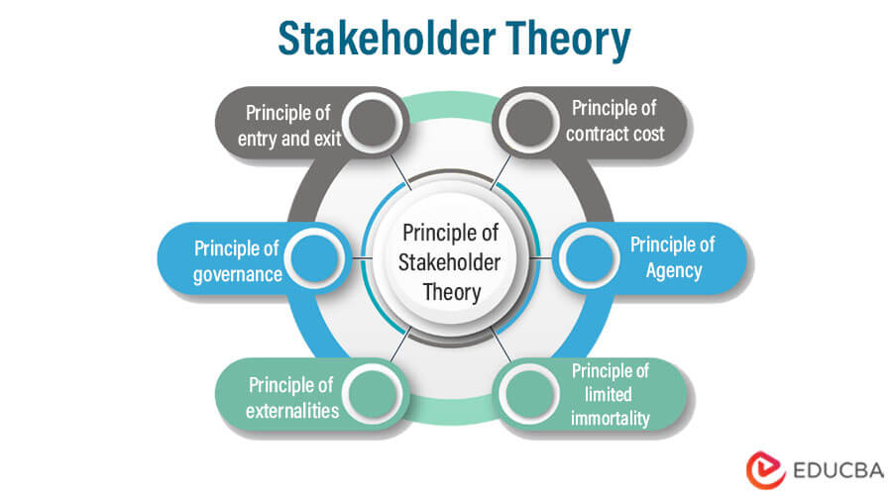

**Figure 2.7.2: Principal of Stakeholder Theory**

(Source: Srinivasan and Dhivya, 2020)

Considering employees of electronics companies to their stakeholders, employees feel valued and motivated. Hence, it helps to get a more productive outcome from them that is beneficial for the electronics industry. As per Hanaysha and Alzoubi (2022), an increased productivity rate helps electronics companies to provide better products and services to consumers in less time. With the improved outcome, electronics companies get customer loyalty and consumers become one of the stakeholders of the company. Whenever electronics companies meet the customer satisfaction level, the value of their companies also increases. Hence, investors who are the most important stakeholder of a company, invest money in the product that helps electronics companies to grow in the market and gain a competitive edge (Kölbel *et al.* 2020). Besides productivity and profit, stakeholder theory provides ethical benefits as well. Improvement of mental health of the workforce is noticed because of increased job satisfaction of the employees. This theory also helps to promote the social-economic status of electronics companies in the local community which helps to create healthy competition among other companies.

***Diffusion of Innovation Theory***

Diffusion of Innovation is a theory that states the speed and pattern at which innovation and technology spread. According to Rogers, there are five established adopter categories which are Innovators, Early Adopters, Early Majority, Late Majority, and Laggards.

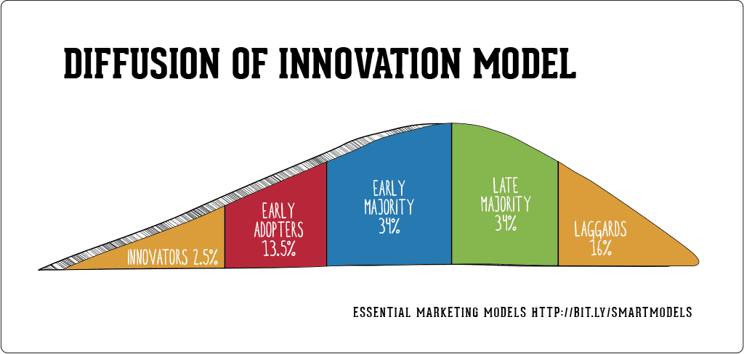

**Figure 2.7.3: Model of Diffusion of Innovation**

(Source: Choi *et al.* 2023)

The above figure shows the model of Diffusion of Innovation. The diffusion of innovation is influenced by 4 elements which are Innovation, time, communication channels and social system (Ilias *et al.* 2021). These 4 elements help the electronics industry to expand its business in the market. As per Van de Kaa *et al.* (2019), innovation in the electronic industry includes compatibility, adaptability, and complexity which helps companies to anticipate market changes more quickly and get ahead of opportunities. Adoption of innovation always takes time. Hence time is an important factor in this theory. In order to gather knowledge about new technology and concepts in the electronics industry, communication plays a major role. The social system includes groups, people or organizations which are important in the theory of diffusion of innovation because it helps to facilitate the innovation and technologies that are beneficial for the growth of the electronics industry.

## 2.8: Literature Gap

Previously multiple scholars discussed the issues faced by the suppliers of the electronics industry and their impacts on the business. The studies also provide ideas about the factors of using technology that influence the suppliers of the electronics industry. The benefits of fostering technologies and innovation among the suppliers of the electronics industry have also been discussed by scholars. Moreover, the studies also provide information about the challenges faced by the suppliers to adopt the innovation and also strategies to mitigate those challenges. However, the previous scholars have not discussed in detail the primary challenges that are faced by suppliers of the electronics industry while adapting new technologies and innovation. Hence, some primary challenges are discussed in this chapter for the benefit of the suppliers of the electronics industry.

# Reference

Aghion, P., Cherif, R. and Hasanov, F., 2021. Competition, innovation, and inclusive growth. IMF Working Papers, 80, pp.1-7.

Alghababsheh, M. and Gallear, D., 2021. Socially sustainable supply chain management and suppliers’ social performance: The role of social capital. *Journal of Business Ethics,* 173, pp.855-875.

Alzoubi, H., Alshurideh, M., Kurdi, B., Alhyasat, K. and Ghazal, T., 2022. The effect of e-payment and online shopping on sales growth: Evidence from banking industry. *International Journal of Data and Network Science, 6*(4), pp.1369-1380.

Brandenburger, A. and Nalebuff, B., 2021. The rules of co-opetition. *Harvard Business Review, 99*(1), pp.48-57.

Choi, J.O., Jin, K. and Yu, U., 2023. Induced diffusion percolation model: Examining the role of superactive nodes in the diffusion of innovations. *Communications in Nonlinear Science and Numerical Simulation*, 120, p.107154.

Demartini, M., Evans, S. and Tonelli, F., 2019. Digitalization technologies for industrial sustainability. *Procedia manufacturing, 33*, pp.264-271.

Durmić, E., 2019. Evaluation of criteria for sustainable supplier selection using FUCOM method. *Operational Research in Engineering Sciences: Theory and Applications,* 2(1), pp.91-107.

Elia, S., Petruzzelli, A.M. and Piscitello, L., 2019. The impact of cultural diversity on innovation performance of MNC subsidiaries in strategic alliances. *Journal of Business Research, 98*, pp.204-213.

Ellram, L.M. and Murfield, M.L.U., 2019. Supply chain management in industrial marketing–Relationships matter. *Industrial Marketing Management*, 79, pp.36-45.

Fabeil, N.F., Pazim, K.H. and Langgat, J., 2020. The impact of Covid-19 pandemic crisis on micro-enterprises: Entrepreneurs’ perspective on business continuity and recovery strategy. *Journal of Economics and Business, 3*(2).

Flak, L.S. and Rose, J., 2005. Stakeholder governance: Adapting stakeholder theory to e-government. *Communications of the Association for Information Systems,* 16(1), p.31.

Hanaysha, J.R. and Alzoubi, H.M., 2022. The effect of digital supply chain on organizational performance: An empirical study in Malaysia manufacturing industry. *Uncertain Supply Chain Management,* 10(2), pp.495-510.

He, J., Evans, N.M., Liu, H. and Shao, S., 2020. A review of research on plant‐based meat alternatives: Driving forces, history, manufacturing, and consumer attitudes. *Comprehensive Reviews in Food Science and Food Safety, 19*(5), pp.2639-2656.

Hensen, A.H. and Dong, J.Q., 2020. Hierarchical business value of information technology: Toward a digital innovation value chain. *Information & Management, 57*(4), p.103209.

ILIAS, A., GHANI, E.K. and AZHAR, Z., 2021. XBRL Adoption Process in Malaysia Using Diffusion of Innovation Theory. *The Journal of Asian Finance, Economics and Business,* 8(2), pp.263-271.

Ingaldi, M. and Ulewicz, R., 2019. How to make e-commerce more successful by use of Kano’s model to assess customer satisfaction in terms of sustainable development. *Sustainability,* 11(18), p.4830.

Kazancoglu, I., Kazancoglu, Y., Kahraman, A., Yarimoglu, E. and Soni, G., 2022. Investigating barriers to circular supply chain in the textile industry from Stakeholders’ perspective. *International Journal of Logistics Research and Applications, 25*(4-5), pp.521-548.

Khanfar, A.A., Iranmanesh, M., Ghobakhloo, M., Senali, M.G. and Fathi, M., 2021. Applications of blockchain technology in sustainable manufacturing and supply chain management: A systematic review. *Sustainability, 13*(14), p.7870.

Killip, G., Owen, A. and Topouzi, M., 2020. Exploring the practices and roles of UK construction manufacturers and merchants in relation to housing energy retrofit. *Journal of Cleaner Production, 251*, p.119205.

Kölbel, J.F., Heeb, F., Paetzold, F. and Busch, T., 2020. Can sustainable investing save the world? Reviewing the mechanisms of investor impact. *Organization & Environment,* 33(4), pp.554-574.

Makhdoom, I., Abolhasan, M., Abbas, H. and Ni, W., 2019. Blockchain's adoption in IoT: The challenges, and a way forward. *Journal of Network and Computer Applications, 125*, pp.251-279.

Olimovich, D.I. and Khudoynazarovich, S.A., 2020. The cost-effectiveness of improving the quality of hotel services. *Academy,* (4 (55)), pp.40-42.

Pedrini, M. and Ferri, L.M., 2019. Stakeholder management: a systematic literature review. *Corporate Governance: The International Journal of Business in Society,* 19(1), pp.44-59.

Sahoo, S., Kumar, A. and Upadhyay, A., 2023. How do green knowledge management and green technology innovation impact corporate environmental performance? Understanding the role of green knowledge acquisition. *Business Strategy and the Environment, 32*(1), pp.551-569.

Srinivasan, N.P. and Dhivya, S., 2020. An empirical study on stakeholder management in construction projects. *Materials Today: Proceedings,* 21, pp.60-62.

Suchek, N., Fernandes, C.I., Kraus, S., Filser, M. and Sjögrén, H., 2021. Innovation and the circular economy: A systematic literature review. Business Strategy and the Environment, 30(8), pp.3686-3702.

Tallon, P.P., Queiroz, M., Coltman, T. and Sharma, R., 2019. Information technology and the search for organizational agility: A systematic review with future research possibilities. *The Journal of Strategic Information Systems,* 28(2), pp.218-237.

Ullah, F., Sepasgozar, S.M., Thaheem, M.J. and Al-Turjman, F., 2021. Barriers to the digitalisation and innovation of Australian Smart Real Estate: A managerial perspective on the technology non-adoption. *Environmental Technology & Innovation, 22*, p.101527.

Van de Kaa, G., Fens, T., Rezaei, J., Kaynak, D., Hatun, Z. and Tsilimeni-Archangelidi, A., 2019. Realizing smart meter connectivity: Analyzing the competing technologies Power line communication, mobile telephony, and radio frequency using the best worst method. Renewable and Sustainable Energy Reviews, 103, pp.320-327.

Vlačić, B., Corbo, L., e Silva, S.C. and Dabić, M., 2021. The evolving role of artificial intelligence in marketing: A review and research agenda. *Journal of Business Research,* 128, pp.187-203.

Wang, L., Wang, X. and Yang, W., 2020. Optimal design of electric vehicle battery recycling network–From the perspective of electric vehicle manufacturers. *Applied Energy, 275*, p.115328.

Yang, Y., Liu, H. and Chen, X., 2020. COVID-19 and restaurant demand: early effects of the pandemic and stay-at-home orders. *International Journal of Contemporary Hospitality Management*