**A STUDY INTO HOW COMPANIES INFLUENCE TECHNOLOGY AND INNOVATION WITHIN SUPPLIERS: CASE OF APPLE AND SAMSUNG**

**Table of Contents**

Chapter 4: Analysis and Findings 3

References 9

# Chapter 4: Analysis and Findings

**Theme 1: The adoption of technological innovation among suppliers of Apple and Samsung helped the brands to evolve their respective SCM**

According to Carter *et al.* (2020), the evolution of supply chain management is defined by the increasing integration of different tasks. Apple and Samsung both have their inventory management that helps to innovate new products with the help of technology to meet the customer requirement and demand. Apple manufactures its own chips and produces processors for using it in its own laptop and desktop. In order to manage the global supply chain network Samsung uses block chain technology that helps to keep track of all shipments and reduce costs as well. The suppliers of Apple and Samsung comprehend the demand of the company and ensure to delivery of the product without any delay. That helps to evolve the supply chain management of Apple and Samsung.

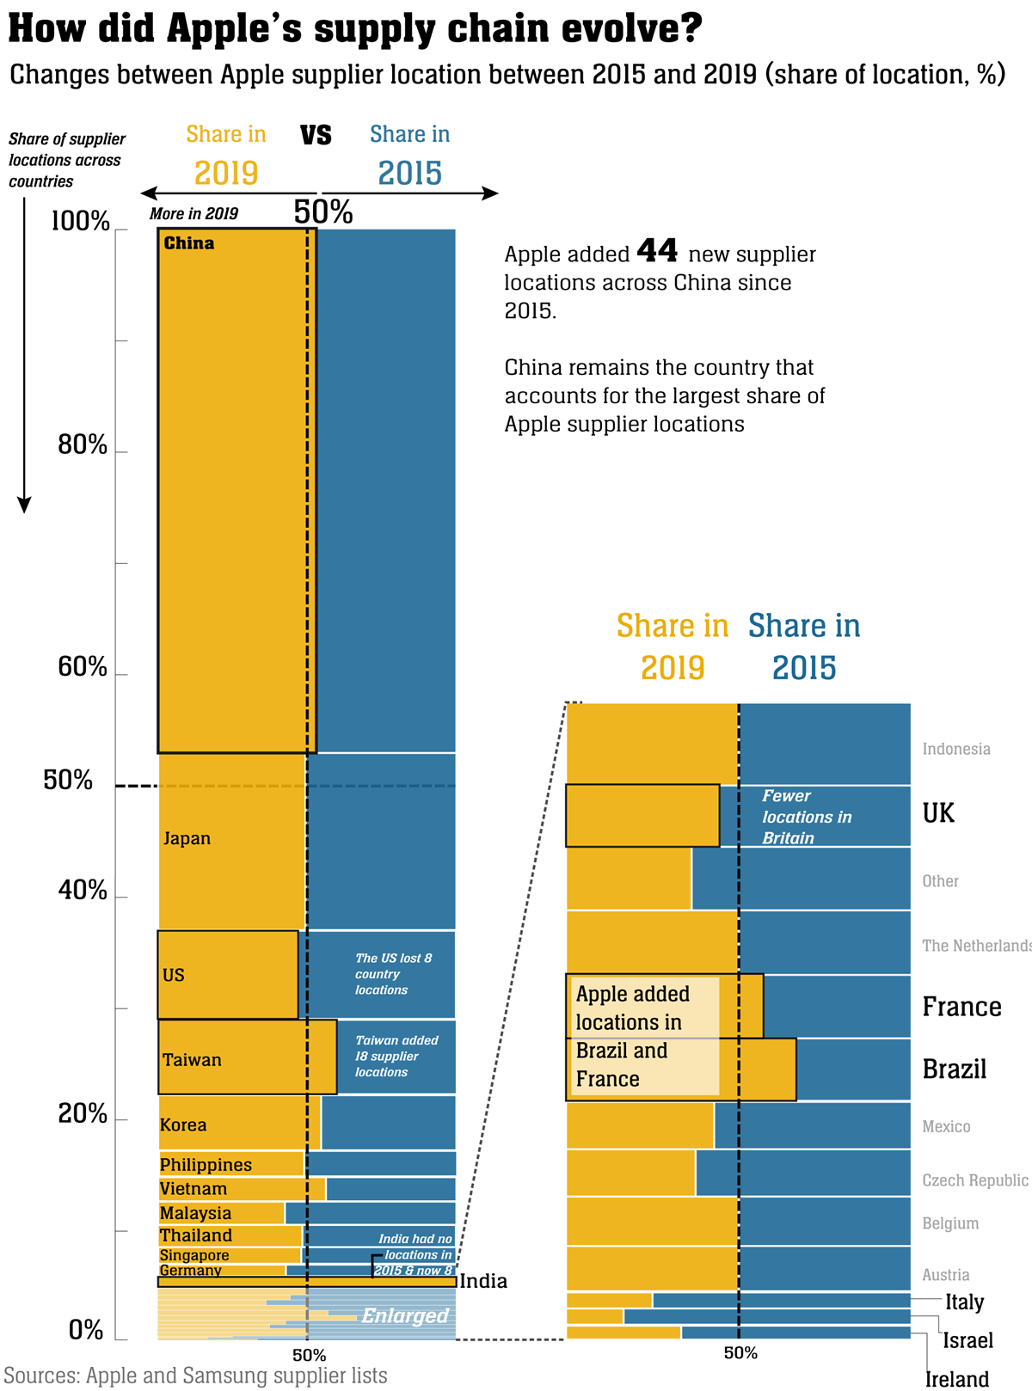

**Figure 4.1: Location of Apple suppliers**

(Source: E&T, 2023)

The above figure shows the changes in the location of Apple suppliers from 2015 to 2019. The Apple suppliers have considerably been changing their locations till 2019 and around 50 new locations have been added. The presence of Apple suppliers in China surged to 47% in 2019 which is 3% more than in the last 4 years. Till 2019, Apple has added 44 new supplier locations across China and some new Apple suppliers are also added in Brazil and France as well. The largest share of Apple suppliers is found in China. Hence it can be said that Apple suppliers are spread throughout the world which helps Apple to expand their business worldwide. Better supply chain management helps Apple and Samsung to develop their innovation by using technology that helps to get a productive output and fulfil the requirements of customers. Fulfilling customers' requirements can help to increase the market value of Apple and Samsung. Therefore, investors invest money in the business that helps to increase the profit margin of Apple and Samsung. Hence it can be said that technological innovation can help to evolve the supply Chain of Samsung and Apple and influence suppliers of Apple and Samsung to increase market growth.

**Theme 2:** **A high number of suppliers of Samsung and Apple influenced the brand to promote the use of technological innovation among the suppliers**

An increased number of suppliers of Samsung and Apple can help to grow their business. Customers feel confident because of the higher number of suppliers as customers feel assured about the product which is sold by many suppliers. Larger suppliers can help to gain a competitive advantage because of better opportunities and more sales. As per Rezaei and Fallah Lajimi (2019), a high number of suppliers leads to sustained profitable growth by introducing new products to the customers in a short time, increasing the margins of products and many more. A large number of suppliers of Apple and Samsung can provide different kinds of rebates and deals that lead to more sales and high profitability. An increased number of suppliers in Samsung and Apple can help to maintain a good customer relationship that maximizes the competitive advantage. In order to fulfil all these above requirements, suppliers of Samsung and Apple should adopt technological innovation.

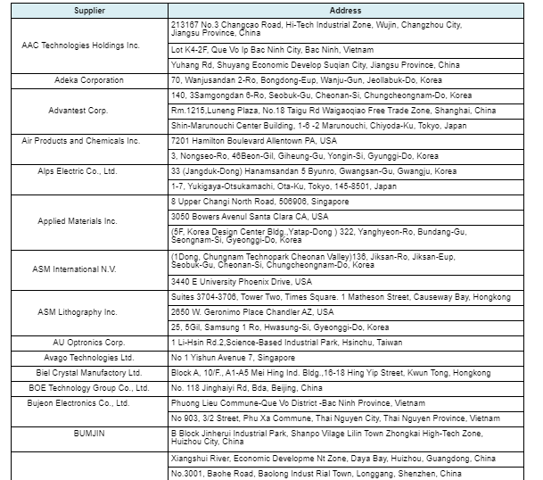

**Figure 4.2: Supplier List of Samsung**

(Source: Samsung, 2023)

The above figure shows the list of Samsung suppliers. With the help of the right supply chain strategy and network, Samsung establishes a high supplier base that helps to supply raw materials for manufacturing its products of Samsung. This strategy also helps Samsung to form a better relationship with suppliers that helps to manage the performance and efficiency of the suppliers. With a high number of suppliers, Samsung can enhance production and sale with the help of technological innovation that helps Samsung to expand its market globally.

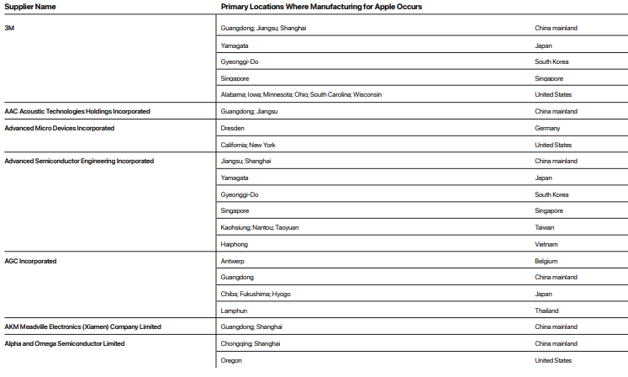

**Figure 4.3: Supplier List of Apple**

(Source: Apple, 2022)

The above figure shows the list of Apple suppliers. According to the supplier list released by Apple in 2021, Apple has around 180 suppliers (WSJ, 2022). A high number of suppliers help Apple to be knowledgeable about their customer demand which helps Apple to produce more innovative products. This helps Apple to meet customer satisfaction and gain a profitable margin. Customers can get the products that are innovated by Apple, at a lower cost in less time because of the high number of customers. With the help of a Supplier management strategy, Apple can manage their huge number of suppliers to gain a competitive edge. Hence, It is observed that with the help of technological innovation, the suppliers of Samsung and Apple can increase their market value and stretch their business across the world.

**Theme 3: High net sales and revenue of Samsung and Apple help the brands to influence suppliers to improve their supply through technological innovation**

Jihadi *et al.* (2021) stated a strong business always generates more revenue and high net sales. High net sales and revenue of Samsung and Apple help their business to turn into higher profit margins. This kind of situation occurs whenever companies lower their expenses and generate the same revenue or increase the expenses more slowly than equivalent sales increases. Apple and Samsung can lower their expenses by adapting innovation and technology that helps Apple and Samsung to generate more revenue. Apple innovates their chips, processors and many more that help to minimize expenses. Samsung gets the raw materials efficiently from their suppliers which helps to reduce expenses. Hence it can be said that technological innovation helps Samsung and Apple to get high net sales and revenue.

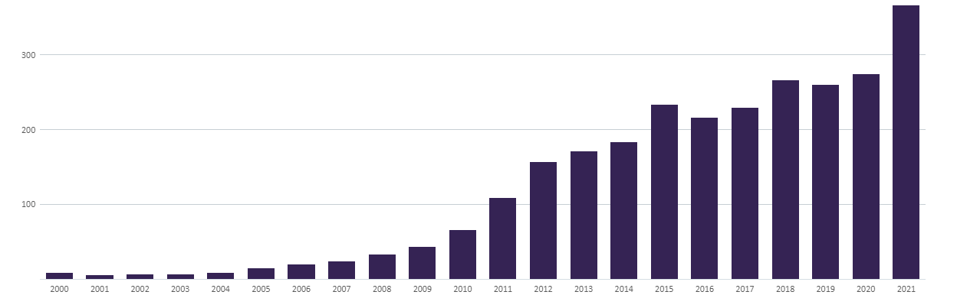

**Figure 4.4: Annual Net Sales of Apple (2000 - 2021, $ billion)**

(Source: GlobalData, 2023)

In 2018, Apple's market capitalization was $1 trillion, in 2020 it increased to $2 trillion and in 2022 it became $3 trillion. The net sale of Apple in 2020 was $274 billion and $365 billion in 2021 which is 33% more than the previous year (GlobalData, 2023). Products and services of Apple are iPhone, Mac, iPad, Services, Home, Wearables, and Accessories. IPhones accounted for Apple's more than half of Apple's net sales and sales of Mac and iPad accounted for 10% and 9% of Apple's net sales. Hence it can be said technology is responsible for Apple's high net sales and revenue.

In 2022, Samsung reported consolidated sales of KRW 70.46 trillion and an operating profit of KRW 4.31 trillion. It reported a record-breaking 302.23 trillion in yearly sales for the entire year, along with an operating profit of KRW 43.38 trillion (SamsungNewsroom, 2023). Hence, it is observed that with technological innovation Samsung and Apple gain high net sales that influence the supplier to foster technological innovation.

**Theme 4: High market competition is a primary challenge for the suppliers of Samsung and Apple to adopt technological innovation**

A Highly competitive market is an important challenge faced by the suppliers of Apple and Samsung to implement technological innovation. As per Banka *et al*. (2022), technology is growing day by day so the suppliers also have to invest a lot more in the research and development of their products. The Samsung and Apple companies are producing products of the same efficiency in the market therefore the suppliers face high competition among the suppliers of Samsung and Apple. Customer needs and preferences are evolving in price and brands of the products change consumers' needs and preferences.

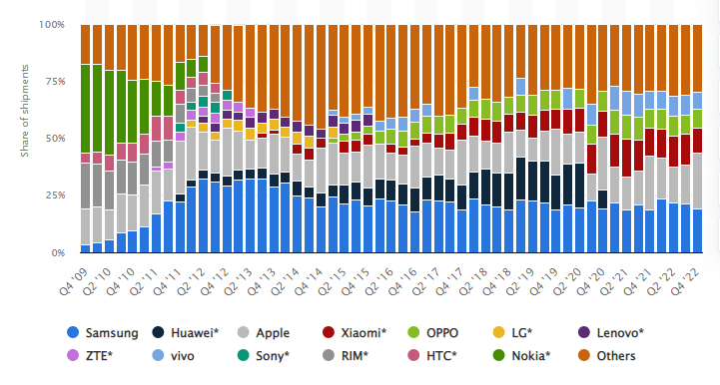

**Figure 4.5: Global 4th quarter share of smartphones from 2009 to 2022.**

(Source: Statista, 2023)

According to the graph above, the main line of Samsung is the Galaxy series which was released in the month of April 2009. The brand Samsung also suffered from a drop-down in shipments during the time of the pandemic. As in the second quarter of 2019, Samsung shipped 75.5 million units which fell to 54.2 million units in the second quarter of 2020. Samsung later reduced smartphone shipments from 2020 to 2022 to recover the losses. However, according to the graph above, Apple is the major manufacturer in the world as they have shipped more than 225 million iPhones all over the world. They launch and sell their products in the fourth quarter as their first quarter shipped around 84 million units.

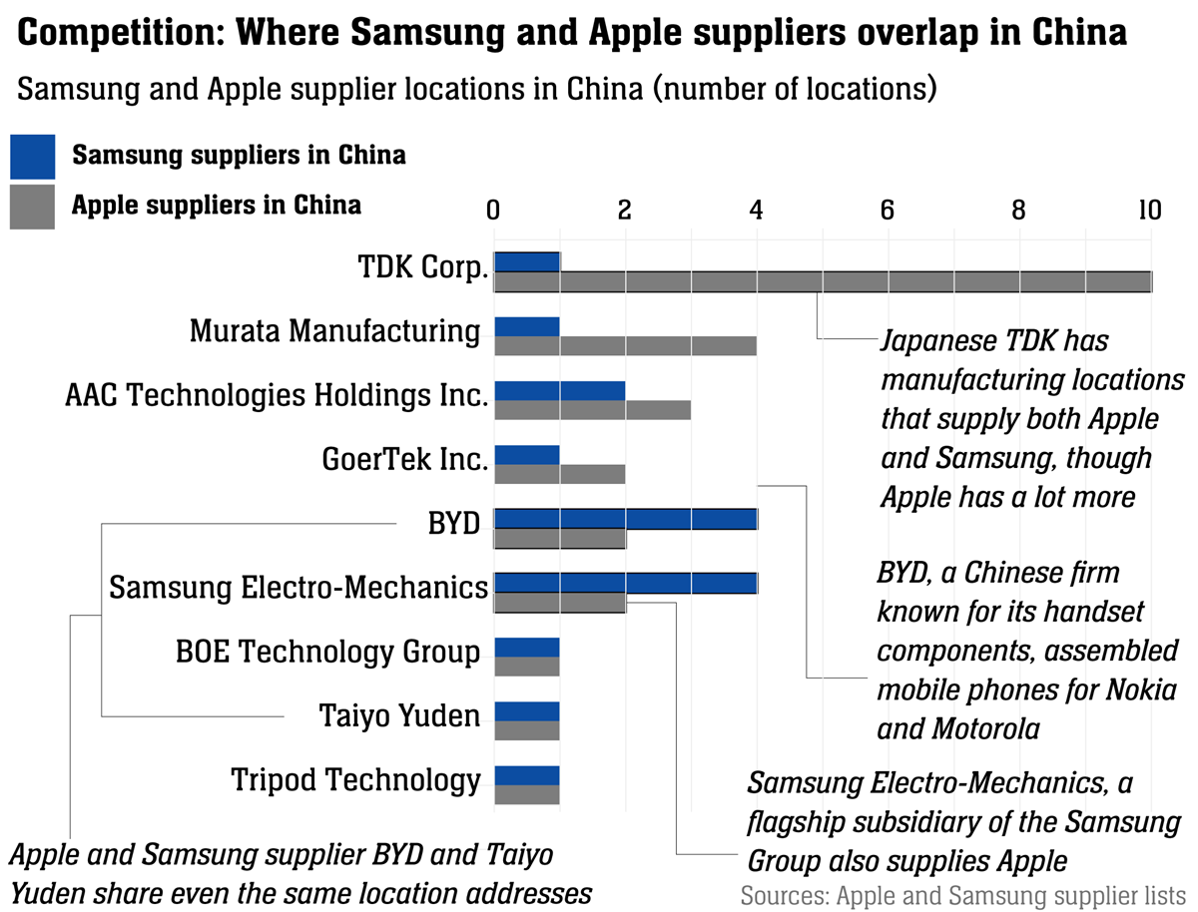

**Figure 4.6: Supply Chain evolve of Apple**

(Source: Engineering and Technology, 2020)

**Theme 5: The chip shortage issue decrease the net sales of smartphone brands like Samsung and Apple**

The smartphone is created with several types of chips which helps them to perform efficiently without any obstacle. As per Komkaite *et al*. (2019), chips in smartphones are the heart of the phones without the chips the smartphones are worthless as they will not work. Thus the chips of smartphones are necessary as all the parts in the smartphones have chips. Therefore the chip shortage issues create problems and decrease the net sales of smartphone brands like Samsung and Apple.

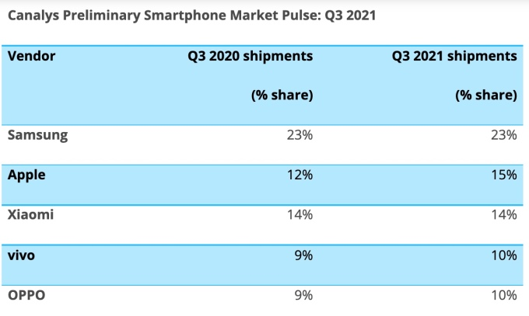

**Figure 4.7: Shipment table of smartphones**

(Source: Joint TechCrunch, 2021)

According to the table shown above, the global sales of smartphones are 6% in the quarter due to the lack of chip shortage. As per the table the market of smartphones in past quarters as Samsung steadily held 23% from year to year however apple sales increased to 3 per cent which is 155 in the quarter. Moreover, Xiaomi also continues steadily and has its position in third place with a sales of 14% year-to-year constant. Therefore, due to cheap shortages the brands like Samsung and Apple face problems regarding their sales as they make their chips still face the shortage of chips. The brands like Samsung and Apple have their manufacturer as well as suppliers, thus they still face issues regarding the chip shortage. Hence Samsung and Apple need to sustain the relationship with their suppliers to increase the number of chips as it helps them to recover their losses and increase the profitability of the brands like Samsung and Apple. Therefore it is observed that the shortage of chips decreases the net sales of Samsung and Apple and it's a primary challenge faced by the brands.

**Theme 6: Delivery delays also influence suppliers to adopt technological innovation in Apple and Samsung**

Time is a crucial factor in any business as the delivery of products at the right time increases the brand value, attracts customers, and increases the sales of brands like Samsung and Apple. As per Chen and Yao (2022), the delays in the delivery of chips and other phone products delay the whole system from manufacturing to selling the products. Therefore to avoid or ignore the delays the supplier should adopt technological innovation as it helps in fast and efficient work which benefited the brands such as Samsung and Apple to increase sales and make more profits.

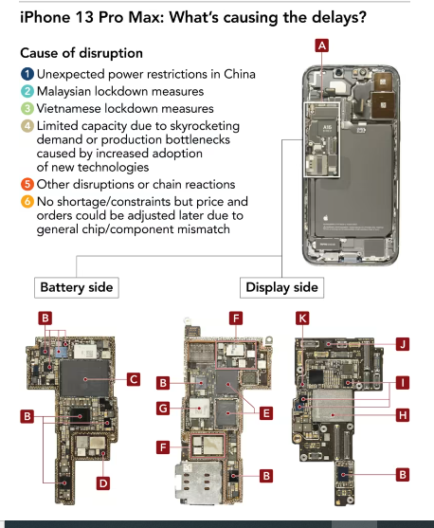

**Figure 4.8: Delays and disruption of iPhone 13 Pro max**

(Source: Nikkei asia, 2021)

According to the table above, China shut down their factories at the time of the golden week. Thus the important suppliers of Apple were not present at that time which created a huge problem for the brand Apple as they worked 24 hours to fulfil and capture the holiday demand of the customers. Due to China and the shortage of chips, the assembly was halted for many days for the delays in the delivery of chips and other components. One of the causes of the delay of the iPhone 13 is the A15 core processor provided by the supplier TSMC as they faced the issue of price and orders. Therefore it is observed that the delay in delivery influences the suppliers to adopt technological innovation.

**Samsung:**

Samsung is suspending orders for several days due to the lack of components and chips. As Samsung had reduced its production of smartphones. The orders of Samsung were halfway in 2022 as they produce 230 million units of smartphones as their year target was 310 units. Samsung also ignores the orders of Ac, Tvs and more. Thus the suppliers planned a shipment which was scaling down 50%. Hence it is observed that the delay in delivery influences suppliers of Samsung to adopt technological innovation.

**Theme 7: Providing training to the suppliers can help in improving supplier-business relationships in Apple and Samsung**

Training can be provided to the suppliers to improve the supplier's business relationship with Apple and Samsung. As per Fearne *et al*. (2021), the companies must train the suppliers to make timely payments which is a very crucial role. Timely payments impact the good services of Apple and Samsung. They must be trained to prioritize the values of the product over the prices. The suppliers must provide efficient service to their customers. The price must not be the main factor as the suppliers of Apple and Samsung must be trained to use advanced technology to increase the sales of the Apple and Samsung brands.

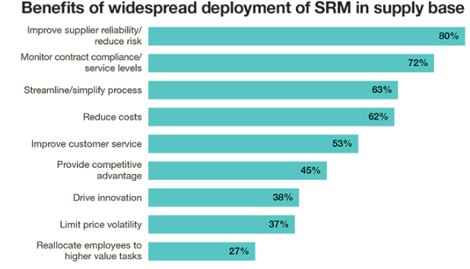

**Figure 4.9: Benefits of SRM in the supply base**

(Source: Supply chain management review, 2019)

The above figure shows the benefits of SRM in Apple and Samsung which includes improvement of suppliers' ability by 80%, monitoring contract by 72%, streamlining processes by 63%, reduce cost by 62%, improvement of service by 53%, competitive advantage by 45%, drive innovation by 38%, limit price by 37% and reallocate employees by 27%. The benefits of using SRm in supporting supplier business relationships of Apple and Samsung as it improves customer reliability and introduces certain measures to motivate the performance of suppliers of Apple and Samsung. The brands' Apple and Samsung also consider the capability to monitor a supplier's compliance with the contract. It also considers its capacity to streamline monitoring processes which benefits Apple and Samsung with the help of SRM.

The SRM helps in reducing the cost of Apple and Samsung by implementing various price-controlling measures such as pricing control and innovation. It also improves the service of the suppliers in the Apple and Samsung companies as it provides a competitive advantage, drive innovation, pricing control and the potential to relocate employees and suppliers to advanced tasks of Apple and Samsung brands. Hence it is observed that providing training to the suppliers can help in improving supplier-business relationships between Apple and Samsung.

# References

Apple, 2022. *2022 Apple Supplier List*. Available at: <https://www.apple.com/supplier-responsibility/pdf/Apple-FY21-Supplier-List.pdf> [Accessed on 11 April 2023]

Banka, M., Tien, N.H., Dao, M.T.H. and Minh, D.T., 2022. Analysis of business strategy of real estate developers in Vietnam: the application of QSPM matrix. *International journal of multidisciplinary research and growth evaluation, 3*(1), pp.188-196.

Carter, C.R., Hatton, M.R., Wu, C. and Chen, X., 2020. Sustainable supply chain management: continuing evolution and future directions. *International Journal of Physical Distribution & Logistics Management,* 50(1), pp.122-146.

Chen, X. and Yao, L., 2022, March. Analysis of Game Cooperation in the Manufacturing Industry Under the Impact of Covid-19 on Global Supply Chain Based on Dynamic Game. *In 2022 7th International Conference on Financial Innovation and Economic Development (ICFIED 2022*) (pp. 2825-2831). Atlantis Press.

E&T, 2023. *How did Apple’s supply chain evolve?* Available at: <https://eandt.theiet.org/content/articles/2020/07/a-visual-analysis-of-how-apple-s-supply-chain-evolved-and-what-this-means-for-competition-with-samsung/> [Accessed on 11 April 2023]

Engineering and technology, 2020. *How did Apple’s supply chain evolve?* Available at: <https://eandt.theiet.org/content/articles/2020/07/a-visual-analysis-of-how-apple-s-supply-chain-evolved-and-what-this-means-for-competition-with-samsung/> [Accessed on 11 April 2023]

Fearne, A., Wagner, B., McDougall, N. and Loseby, D., 2021. The power of purpose–lessons in agility from the Ventilator Challenge. *Supply Chain Management: An International Journal, 26*(6), pp.753-766.

GlobalData, 2023. *Apple’s Annual Net Sales (2000 – 2021, $ Billion).* Available at:<https://www.globaldata.com/data-insights/technology--media-and-telecom/apples-annual-net-sales/> [Accessed on 11 April 2023]

Jihadi, M., Vilantika, E., Hashemi, S.M., Arifin, Z., Bachtiar, Y. and Sholichah, F., 2021. The effect of liquidity, leverage, and profitability on firm value: Empirical evidence from Indonesia. *The Journal of Asian Finance, Economics and Business*, 8(3), pp.423-431.

Joint techcrunch, 2021. *Smartphone sales down 6% as chip shortages begin to impact market.* Available at: <https://techcrunch.com/2021/10/15/smartphone-sales-down-6-as-chip-shortages-begin-to-impact-market/?guccounter=1&guce_referrer=aHR0cHM6Ly93d3cuZ29vZ2xlLmNvbS8&guce_referrer_sig=AQAAAAUg075pdadDmnT6ReIpzckJgxQfIjCH9vXTosM4Xn76teGYMMxBajVzXWkGENbP7Y-a4n1En-dtsJdU9xvQIKYScXWcKe2kCCX9O736PB6RvfQD4u094-KOJ7vG1fTbcCdqyxcqnT3WtCXPUFQA_XDqVDhp5BRGcYqO3Vgx-OWM> [Accessed on 11 April 2023]

Komkaite, A., Lavrinovica, L., Vraka, M. and Skov, M.B., 2019, May. Underneath the skin: An analysis of youtube videos to understand insertable device interaction. *In Proceedings of the 2019 CHI conference on human factors in computing systems* (pp. 1-12).

Nikkei asia, 2021. *Apple's nightmare before Christmas: Supply chain crisis delays gift deliveries.* Available at: <https://asia.nikkei.com/Spotlight/The-Big-Story/Apple-s-nightmare-before-Christmas-Supply-chain-crisis-delays-gift-deliveries> [Accessed on 11 April 2023]

Rezaei, J. and Fallah Lajimi, H., 2019. Segmenting supplies and suppliers: bringing together the purchasing portfolio matrix and the supplier potential matrix. *International Journal of Logistics Research and Applications,* 22(4), pp.419-436.

Samsung, 2023. *Listed in order of name of suppliers in 80% of Samsung Electronics’ transaction volume who agreed to be disclosed.* Available at: <https://www.samsung.com/us/aboutsamsung/sustainability/supply-chain/supplier-list/> [Accessed on 11 April 2023]

SamsungNewsroom, 2023. *Samsung Electronics Announces Fourth Quarter and FY 2022 Results.* Available at: <https://news.samsung.com/global/samsung-electronics-announces-fourth-quarter-and-fy-2022-results#:~:text=The%20Company%20posted%20KRW%2070.46,43.38%20trillion%20in%20operating%20profit>. [Accessed on 11 April 2023]

Statista, 2023. *Global smartphone market share from 4th quarter 2009 to 4th quarter 2022*. Available at: <https://www.statista.com/statistics/271496/global-market-share-held-by-smartphone-vendors-since-4th-quarter-2009/> [Accessed on 11 April 2023]

Supply chain management review, 2019. *Enhance the value of your supplier relationships*. Available at: <https://www.scmr.com/article/enhance_the_value_of_your_supplier_relationships> [Accessed on 11 April 2023]

WSJ, 2022. *Apple Suppliers Add Manufacturing Sites in U.S., With Focus on California.* Available at: <https://www.wsj.com/articles/apple-suppliers-add-manufacturing-sites-in-u-s-with-focus-on-california-11664884045> [Accessed on 11 April 2023]