**DATA DRIVEN DECISION FOR BUSINESS**

Table of Contents

Task 1: Introduction and project plan 2

Task 2: Data quality issues and remedies 2

Task 3: Data analysis and commentary 3

Task 4: Data charting and commentary 6

Task 5: Conclusions and recommendations 8

References 9

Appendices 10

# Task 1: Introduction and project plan

The key purpose of the report is analysing whether the marketing campaign formed a positive impact on the performance of sales in the UK. For attaining this purpose this report will target using the PPDAC project framework using five key stages – problem identification, planning, data presentation, analysis and conclusion.

In order to complete this project first the key problems presented in the given dataset will be highlighted along with planning how to correct or deal with those mistakes. Following the data correction data will be presented with the help of relevant tables and using relevant explanatory statistical methods (such as ranges, min and max, averages and others) analysis will be performed. In this analysis process data charting will also be performed using relevant graphs (such as bar charts, column charts, trend evaluations and others).

In this process, the use of the stated PPDAC framework of data analysis will be helpful to maintain a proper flow of activities. This is because the provided dataset consists of a large amount of data and also certain errors were present which could be effectively dealt with by using the planning aspect of the framework. Following that, using this framework will also support in identifying strategic KPIs which could be used to measure and maintain the data effectiveness. Further, this framework will support identifying the key processes of analysis which could be used in the process for answering the given question appropriately.

The KPIs of BIJ’s own business performance are-

- Change % in the sales volume and value;

- Variation in overall market demand;

- Trend analysis of demand of different product subtypes in different markets; and

- Overall influence of marketing campaign in the sales growth.

In this scenario improved analytics will be effective in enabling the improvements against these KPIs as such enhanced analytics would deliver a proper means of assessing the existing organisational performance and compare the same with its past results. Following that, using statistical analytic indicators would be effective in terms of determining the underlying market trend in relation to different product subtypes, markets and periods.

# Task 2: Data quality issues and remedies

In the data analysis process, certain key generic problems could be identified and those could be highlighted as follows-

|  |  |  |
| --- | --- | --- |
| **Generic problems** | **Process of identification** | **Different options to resolve those issues** |
| Spelling error | Using the data categorisation process | Upon recognising the error adopt corrective measures like using functions or manual changes (Qureshi, 2022) |
| Incomplete data | Identifying fields with null values (Yellowfin, 2022) | Adopting a proper data validation process |
| Data duplicity | Determining nearly or exactly the same data points and assessing their accuracy (Memon, 2023) | Cross-checking the data points |
| Data inconsistency | Recognising the points of variation | Implementing proper data sorting techniques and tools |
| Human errors | Comparing acquired data from different points (Reno, 2023) | Use of automation in data entry or performing periodical review with a single point access |

Referring to the developed Appendix 1 number of data problems could be identified with the given dataset of BIJ. Spelling errors, currency variations and negative sales value are the key problems found in the provided dataset. In order to identify these problems table segmentation of categorisation has been used which helped in identifying the existing mismatches, such as spelling errors for products, value changes and others.

In this process, the values consisting of negative sales figures and sales values are avoided or excluded from the estimation. Following that the misspelled items are replaced with correct spellings and in order to maintain currency consistency the values provided in USD form are transformed to GBP using the present rate of currency exchange.

# Task 3: Data analysis and commentary

|  |  |  |  |  |  |  |  |  |
| --- | --- | --- | --- | --- | --- | --- | --- | --- |
|  | **2018** |  | **2019** |  | **2020** |  | **Total Sum of Sales Volume** | **Total Sum of Sales Value** |
| **Row Labels** | **Sum of Sales Volume** | **Sum of Sales Value** | **Sum of Sales Volume** | **Sum of Sales Value** | **Sum of Sales Volume** | **Sum of Sales Value** |  |  |
| January | 921 | £11,30,076 | 757 | £8,74,614 | 671 | £7,94,774 | 2349 | £27,99,464 |
| February | 961 | £11,77,381 | 874 | £9,83,676 | 815 | £9,38,390 | 2650 | £30,99,447 |
| March | 885 | £10,59,922 | 870 | £9,48,787 | 795 | £9,09,133 | 2550 | £29,17,842 |
| April | 747 | £8,50,250 | 644 | £7,62,149 | 480 | £5,94,548 | 1871 | £22,06,948 |
| May | 763 | £9,77,122 | 787 | £9,29,960 | 908 | £10,60,178 | 2458 | £29,67,260 |
| June | 1031 | £13,45,447 | 1333 | £17,75,571 | 1234 | £14,46,306 | 3598 | £45,67,324 |
| July | 754 | £9,08,012 | 859 | £10,28,322 | 854 | £9,63,146 | 2467 | £28,99,480 |
| August | 767 | £8,90,290 | 793 | £9,32,342 | 705 | £7,83,033 | 2265 | £26,05,665 |
| September | 1144 | £13,80,851 | 1093 | £12,30,021 | 956 | £11,51,916 | 3193 | £37,62,789 |
| October | 587 | £6,89,467 | 560 | £6,28,350 | 501 | £5,60,401 | 1648 | £18,78,218 |
| November | 689 | £7,92,090 | 598 | £6,77,058 | 568 | £6,37,605 | 1855 | £21,06,753 |
| December | 1077 | £12,74,698 | 868 | £10,20,628 | 533 | £6,61,289 | 2478 | £29,56,615 |
| **Grand Total** | **10326** | **£1,24,75,608** | **10036** | **£1,17,91,479** | **9020** | **£1,05,00,719** | **29382** | **£3,47,67,806** |
| **% change in sales volume and value - by years** | **-** | **-** | **-3%** | **-5%** | **-10%** | **-11%** |  | |
| **Max** | **1144** | **£13,80,851** | **1333** | **£17,75,571** | **1234** | **£14,46,306** | **3598** | **£45,67,324** |
| **Min** | **587** | **£6,89,467** | **560** | **£6,28,350** | **480** | **£5,60,401** | **1648** | **£18,78,218** |
| **Range** | **557** | **£6,91,384** | **773** | **£11,47,222** | **754** | **£8,85,904** | **1950** | **£26,89,107** |
| **Average** | **861** | **1039634** | **836** | **982623** | **752** | **875060** | **2449** | **2897317** |
| **Standard Deviation** | **163** | **215265** | **204** | **285644** | **213** | **249143** | **524** | **696566** |

**Table A**

(Source: Self-created)

The above Table (Table A) showed the sales volume and value of the company over the considered analysis period on a monthly basis. In 2018 the company reported the maximum sales in September whereas for 2019 and 2020 the sales of the firm were observed to be the highest in June. In 2018 and 2019 in October the organisation witnessed the lowest sales whereas in 2020 it recorded the lowest sales in April. The table also highlights that the over the years the sales of the company declined significantly as compared to 2019 the sales volume reduced by 10% in 2020 whereas a fall of 11% was observed for the total sales value.

|  |  |  |  |  |  |  |  |  |  |  |  |  |
| --- | --- | --- | --- | --- | --- | --- | --- | --- | --- | --- | --- | --- |
|  | **Accessory** |  | **Ankle bracelet** |  | **Bracelet** |  | **Hair band** |  | **Necklace** |  | **Ring** |  |
| **Row Labels** | **Sum of Sales Volume** | **Sum of Sales Value** | **Sum of Sales Volume** | **Sum of Sales Value** | **Sum of Sales Volume** | **Sum of Sales Value** | **Sum of Sales Volume** | **Sum of Sales Value** | **Sum of Sales Volume** | **Sum of Sales Value** | **Sum of Sales Volume** | **Sum of Sales Value** |
| **2018** | **15** | **£21,311** | **10** | **£2,500** | **2572** | **£22,63,345** | **5029** | **£69,69,882** | **1732** | **£22,79,355** | **968** | **£9,39,215** |
| 1-3 | 9 | £11,212 |  |  | 662 | £5,96,980 | 1361 | £19,18,523 | 470 | £5,97,604 | 265 | £2,43,061 |
| 4-6 | 1 | £911 | 10 | 2500 | 611 | £5,40,007 | 1195 | £17,35,817 | 488 | £6,72,402 | 236 | £2,21,183 |
| 7-9 | 3 | £5,365 |  |  | 701 | £6,23,076 | 1270 | £17,09,124 | 455 | £5,98,269 | 236 | £2,43,321 |
| 10-12 | 2 | £3,823 |  |  | 598 | £5,03,281 | 1203 | £16,06,419 | 319 | £4,11,080 | 231 | £2,31,650 |
| **2019** | **121** | **£2,16,503** |  |  | **3653** | **£32,20,874** | **4191** | **£59,43,248** | **1147** | **£15,62,377** | **924** | **£8,48,477** |
| 1-3 | 2 | £4,147 |  |  | 940 | £7,99,770 | 1000 | £13,73,347 | 316 | £3,96,779 | 243 | £2,33,034 |
| 4-6 | 11 | £20,018 |  |  | 943 | £8,80,926 | 1314 | £19,56,962 | 275 | £3,86,253 | 221 | £2,23,521 |
| 7-9 | 91 | £1,56,417 |  |  | 962 | £8,40,814 | 1110 | £15,52,814 | 284 | £3,73,281 | 298 | £2,67,359 |
| 10-12 | 17 | £35,921 |  |  | 808 | £6,99,364 | 767 | £10,60,124 | 272 | £4,06,064 | 162 | £1,24,563 |
| **2020** | **440** | **£7,93,713** |  |  | **4661** | **£43,63,028** | **2346** | **£32,19,163** | **1121** | **£17,22,204** | **452** | **£4,02,611** |
| 1-3 | 81 | £1,39,675 |  |  | 1051 | £8,85,349 | 678 | £9,81,658 | 367 | £5,61,620 | 104 | £73,995 |
| 4-6 | 138 | £2,54,492 |  |  | 1363 | £12,31,852 | 640 | £9,22,110 | 383 | £5,93,409 | 98 | £99,168 |
| 7-9 | 112 | £2,02,292 |  |  | 1433 | £14,49,456 | 508 | £6,65,902 | 292 | £4,30,919 | 170 | £1,49,526 |
| 10-12 | 109 | £1,97,255 |  |  | 814 | £7,96,371 | 520 | £6,49,492 | 79 | £1,36,256 | 80 | £79,921 |
| **Grand Total** | **576** | **£10,31,528** | **10** | **£2,500** | **10886** | **£98,47,247** | **11566** | **£1,61,32,293** | **4000** | **£55,63,936** | **2344** | **£21,90,302** |
| **Max** | **138** | **254492** | **10** | **2500** | **1433** | **1449456** | **1361** | **1956962** | **488** | **672402** | **298** | **267359** |
| **Min** | **1** | **911** | **10** | **2500** | **598** | **503281** | **508** | **649492** | **79** | **136256** | **80** | **73995** |
| **Range** | **137** | **253580** | **0** | **0** | **835** | **946175** | **853** | **1307470** | **409** | **536146** | **218** | **193363** |
| **Average** | **48** | **85961** | **10** | **2500** | **907** | **820604** | **964** | **1344358** | **333** | **463661** | **195** | **182525** |
| **S.D.** | **53** | **96191** | **-** | **-** | **272** | **279121** | **322** | **470782** | **112** | **147416** | **71** | **71605** |

**Table B**

(Source: Self-created)

Table B focused on showing the category performance of the company over the focused analysis period on a quarterly basis. The table highlights the maximum number of accessories sold by the firm in the second quarter of 2020 and bracelets in the third quarter of 2020. Although, the maximum number of hairbands sold by the firm in 2018, the maximum sales revenue from hairbands was achieved by it in the second quarter of 2019. On the other hand, the lowest sales volume and sales value in hairbands, i.e., one of the major revenue-generating products, was witnessed by the organisation in the third and fourth quarters of 2020, respectively.

|  |  |  |  |  |  |  |  |  |
| --- | --- | --- | --- | --- | --- | --- | --- | --- |
|  | **Sum of Sales Volume** |  |  |  | **Sum of Sales Value** |  |  |  |
| **Row Labels** | **Japan** | **United Kingdom** | **US** | **USA** | **Japan** | **United Kingdom** | **US** | **USA** |
| **2018** | **4168** | **2303** |  | **3855** | **£61,21,066** | **£19,33,006** |  | **£44,21,536** |
| 1-3 | 1188 | 577 |  | 1002 | £17,46,972 | £4,70,865 |  | £11,49,542 |
| 4-6 | 1014 | 664 |  | 863 | £15,39,189 | £5,67,073 |  | £10,66,558 |
| 7-9 | 1032 | 614 |  | 1019 | £15,04,393 | £5,26,319 |  | £11,48,441 |
| 10-12 | 934 | 448 |  | 971 | £13,30,512 | £3,68,748 |  | £10,56,995 |
| **2019** | **4085** | **2247** |  | **3704** | **£60,02,612** | **£17,94,417** |  | **£39,94,451** |
| 1-3 | 892 | 601 |  | 1008 | £12,69,047 | £4,56,562 |  | £10,81,469 |
| 4-6 | 1201 | 567 |  | 996 | £18,76,260 | £5,08,052 |  | £10,83,369 |
| 7-9 | 1204 | 640 |  | 901 | £17,09,749 | £5,02,576 |  | £9,78,361 |
| 10-12 | 788 | 439 |  | 799 | £11,47,556 | £3,27,228 |  | £8,51,252 |
| **2020** | **2782** | **2583** | **478** | **3177** | **£41,32,431** | **£22,59,426** | **£5,10,340** | **£35,98,522** |
| 1-3 | 747 | 576 | 478 | 480 | £11,74,799 | £4,65,340 | £5,10,340 | £4,91,818 |
| 4-6 | 824 | 883 |  | 915 | £12,67,487 | £7,53,063 |  | £10,80,481 |
| 7-9 | 675 | 725 |  | 1115 | £9,66,392 | £6,72,868 |  | £12,58,835 |
| 10-12 | 536 | 399 |  | 667 | £7,23,753 | £3,68,155 |  | £7,67,388 |
| **Grand Total** | **11035** | **7133** | **478** | **10736** | **£1,62,56,109** | **£59,86,849** | **£5,10,340** | **£1,20,14,508** |
| **Max** | **1204** | **883** | **478** | **1115** | **1876260** | **753063** | **510340** | **1258835** |
| **Min** | **536** | **399** | **478** | **480** | **723753** | **327228** | **510340** | **491818** |
| **Range** | **668** | **484** | **0** | **635** | **1152507** | **425835** | **0** | **767018** |
| **Average** | **920** | **594** | **478** | **895** | **1354676** | **498904** | **510340** | **1001209** |
| **S.D.** | **217** | **132** | **-** | **176** | **336841** | **123425** | **-** | **207599** |

**Table C:**

(Source: Self-created)

The above Table C compared the sales condition of the company over the period among different markets on a quarterly basis. In Japan, the company witnessed the maximum sales volume in 3rd quarter of 2019 whereas registered the minimum sales in 4th quarter of 2020. In the UK market, the highest and lowest sales occurred in the 2nd and 4th quarters of 2020, respectively. For the USA market, the lowest sales were registered in quarter 1 of 2020 whereas the highest sales were generated in quarter 3 of 2020.

# Task 4: Data charting and commentary

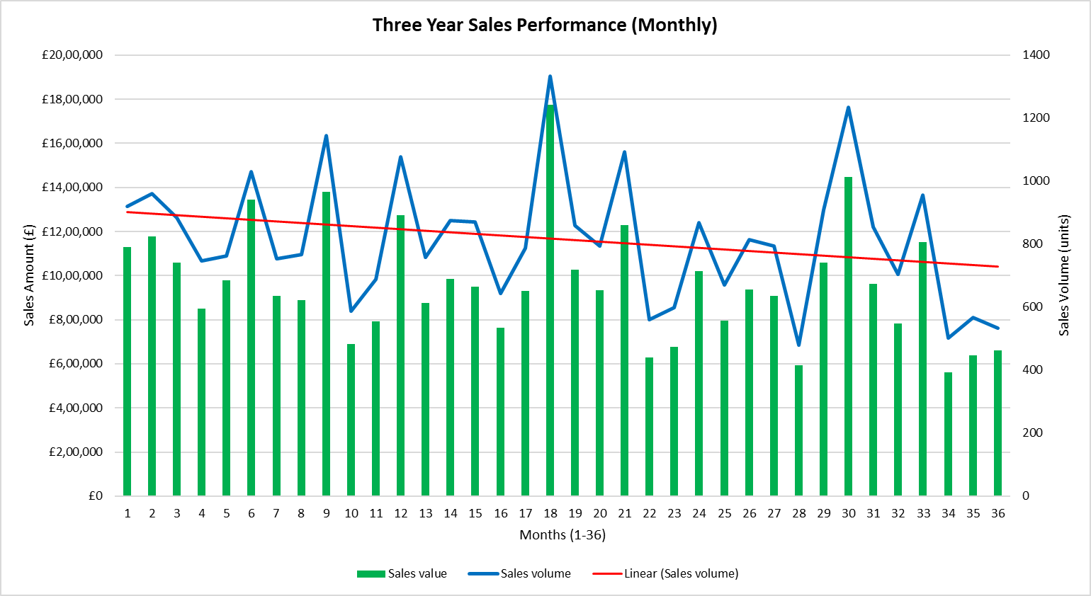

**Chart A**

(Source: Self-created)

From the above Chart A, a comparison of sales value is identified considering the focused 36 months. The trend line highlighted a declining slope in the overall sales aspect of the company. This means that the overall sales performance of the company reduced significantly over the past 36 months. Here the most sales achieved by the company in 18th month.

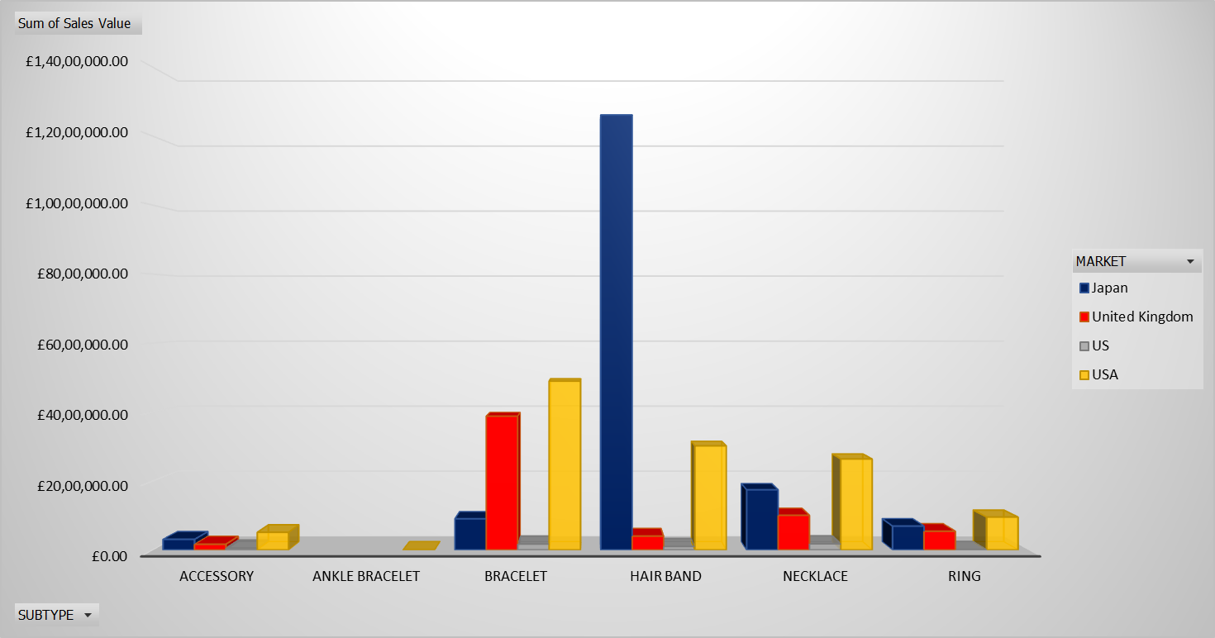

**Chart B**

(Source: Self-created)

The above Chart B showed the comparison of category performance levels between the markets. In Japan, the firm observed the most sales of hairbands followed by necklaces and rings. In the UK market, the company recorded strong demand for bracelets, necklaces and rings. Apart from that, in the USA market necklace holds the highest demand for the organisation compared to other markets.

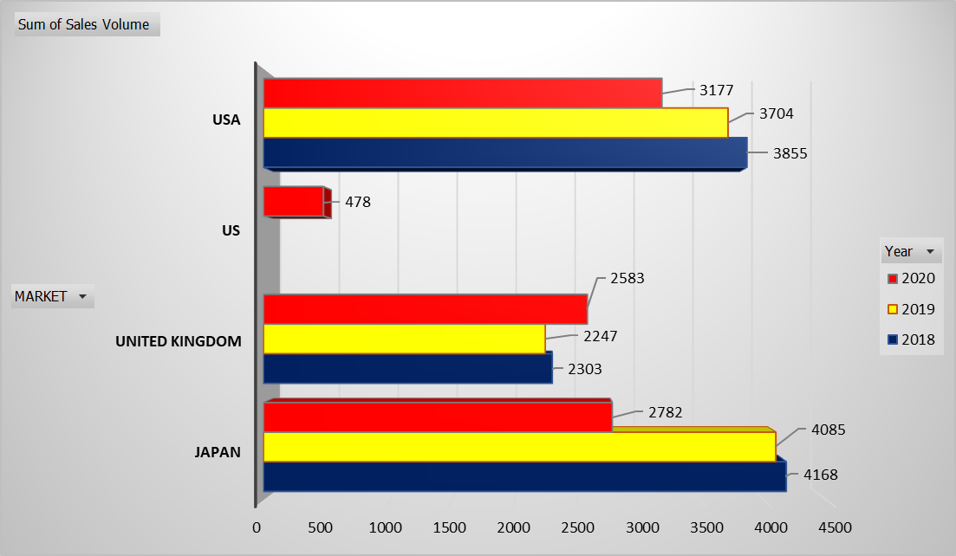

**Chart C**

(Source: Self-created)

Based on above Chart C the impact of the marketing campaign in the UK could be observed. In 2020 except for the UK market, the other markets showed a strong declining trend. Although the UK showed a decline in performance in 2019, following the application of the marketing campaign in 2020 the overall sales showed a strong performance growth.

# Task 5: Conclusions and recommendations

The analysis of the dataset showed a declining business performance of BIJ. The major decline in its largest market, i.e., Japan, is a key concerning factor for the company and it denotes an operations decline as well. Further, a fall in the overall sales performance in the USA could also be identified for the focused organisation. However, the identified growth in sales in the UK confirms that the used marketing campaign was a success for the company and hence it is needed to be implemented by the company in other markets to boost its sales.

In this regard, the following recommendations could be made to the management of BIJ-

a. Developing a suitable strategic approach for developing effective marketing strategies in the other markets of the company. This will help the firm to improve its sales performance.

b. The jewellery market is highly competitive and it is essential for companies to comply with the changing market demand. Hence, it could be recommended to the organisation incorporate a strategic market analysis process to determine the overall needs of the markets in Japan and the USA to introduce product lines accordingly.

c. It is also recommended to the company adopt suitable business data analytics in its data acquisition, presentation and analysis process for securing long-term growth.

# References

Data quality: 7 key issues &amp; best practices to avoid: Yellowfin 2022. Yellowfin BI. Available at: <https://www.yellowfinbi.com/best-practice-guide/data-preparation-enrichment-performance/data-quality> (Accessed: April 26, 2023).

Memon, M. 2023. 6 data quality issues in reporting and best practices to overcome them: Databox blog, Databox. Available at: <https://databox.com/data-quality-issues-in-reporting> (Accessed: April 26, 2023).

Qureshi, H. 2022. Top 15 most common data quality issues (and how to fix them), Medium. Towards Data Science. Available at: <https://towardsdatascience.com/top-15-most-common-data-quality-issues-and-how-to-fix-them-c1ef0854dca6> (Accessed: April 26, 2023).

Reno, G. 2023. 10 common data quality issues (and how to solve them), FirstEigen. Available at: <https://firsteigen.com/blog/10-common-data-quality-issues-and-how-to-solve-them/> (Accessed: April 26, 2023).

# Appendices

***Appendix 1: Correction sheet***

