**A STUDY INTO HOW COMPANIES INFLUENCE TECHNOLOGY AND INNOVATION WITHIN SUPPLIERS: CASE OF APPLE AND SAMSUNG**

**STAGE SUBMISSION 2: METHODOLOGY**

**Table of Contents**

Chapter 3: Research Methodology 3

3.1 Research paradigm 3

3.2 Research Strategy 4

3.3 Data collection method 4

3.4 Sampling Size and Method 5

3.5 Validity and Reliability of the Research 5

3.6 Data Analysis 6

3.7 Ethical consideration 6

3.8 Research limitations 6

References 8

# Chapter 3: Research Methodology

## 3.1 Research paradigm

The concerned research was conducted by following the Saunders research methodology framework which helped to devise the strategies and steps of the research precisely. This framework also helped the researcher to address every layer as shown in the below figure.

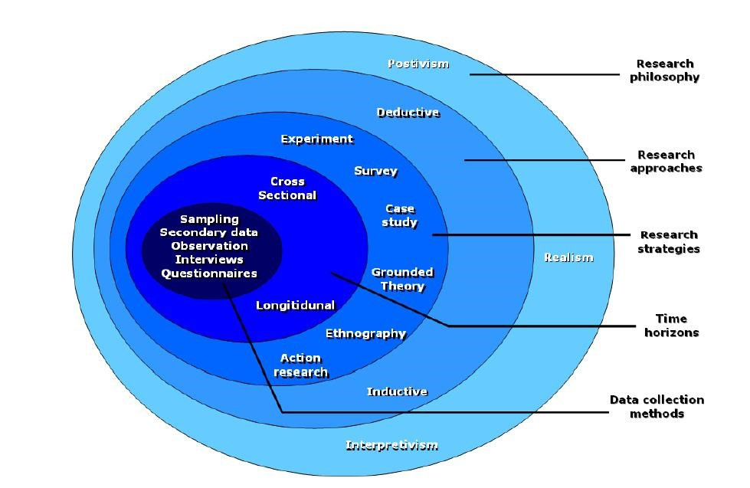

**Figure 3.1: Saunders research methodology**

(Source: Chong and Plonsky, 2023)

Concerning this research framework, the paradigm includes philosophy, approach and design. All three methods were used in this research. As per Rothstein (2021), philosophy refers to the method or the belief through which the researchers collect information in their respective research studies. The philosophy method was helpful as this helped in avoiding non-relevant secondary data sources. However, three forms of research philosophies were known which are realism, interpretivism and positivism. As the research aimed to relate the factors with the influencing levels of suppliers while adopting technological innovation, hence, the researcher focused on using interpretivism research philosophy as this method helped in relating the key factors with social and professional behaviours of the suppliers associated with Samsung and Apple. Moreover, positivism was avoided in this case for excluding biased information as this method could not provide strategic solutions for the primary challenges faced by the suppliers while adopting technological innovation.

In terms of approach method, this helped the researcher to break down the overall research processes into different milestones. As per Peloquin *et al.* (2020), inductive, abductive and deductive are the three forms of the research approach. An inductive research approach was applied in this case as this method helped to critically analyse the factors which influence the suppliers of Samsung and Apple to adopt technological innovation. Other approaches were avoided in this research as they could include biased findings in the research.

In terms of research design, Nguyen *et al.* (2021), stated that the use of this research method helps in formulating the research processes for analysing the data collection. Descriptive design was primarily followed in this research where this method helped to showcase the findings with evidence in a descriptive manner. Hence, it is expected that the use of descriptive design helped the researcher to address every research area like supplier relationship management, technological innovation adaptation in Samsung and Apple and many more. In addition, descriptive information was also helpful to answer the above research questions with key evidence too.

## 3.2 Research Strategy

As per the concern of Hernández Valdés *et al.* (2020), research strategy refers to the overall research process including execution, planning and monitoring. This method was applied or followed in this research as it helped to guide the researcher to complete the study within the expected timeline as well as helped in processing the research data for answering the key question concerning the key factors which influence the suppliers of Samsung and Apple to use technological innovation for the betterment of their supply strategy. However, Rothwell *et al.* (2019), two forms of research strategy were known which are namely, quantitative and qualitative. Qualitative research strategy deals with the processes of research which focus on non-numeric information related to the research context while quantitative research strategy refers to the amalgamation of numeric data and their use for meeting the research objectives. However, in this research prospect, a qualitative research strategy was primarily followed as this helped to underpin several research questions to identify the pattern and the strategy used by Apple and Samsung to sustain their long-term relationship with their key suppliers.

## 3.3 Data collection method

Data collection in a research study is required for analysing the key facet related to the key research contexts. As per Spector-Bagdady (2021), data in research can be accumulated in two various forms which are namely, primary and secondary research data. Secondary data sets refer to the information which is pre-published or already available to the researcher while in terms of primary research data, it deals with the accumulation of real-time information from human participants.

As the research focused on analysing various factors which influence suppliers of Samsung and Apple to use or adopt technological innovations, hence, use of primary research data collection, in this case, was avoided as this process could result in accumulating biased information. However, as per Pitoglou *et al.* (2022), the secondary data collection process involves extracting key information from pre-published data sources where the researcher has the authority to validate the main findings presented in those data sources. Hence, in this research, a secondary data collection process was followed where 50 secondary sources were selected initially which consisted of online journals, news articles and organisational reports of Samsung and Apple. Keyword searching technique was primarily deployed for accessing such data sources where keywords like "suppliers ', "technological innovation" and many more were used or searched on authentic websites and in Google scholar.

## 3.4 Sampling Size and Method

As per the concern of Soini (2020), sampling refers to the method which describes a process followed by a researcher to select data sources from a vast population. In this case, the sampling method was applied for avoiding biased data related to the factors which influence the key suppliers of Apple and Samsung to adopt technological innovation. In this prospect, a purposive sampling method was applied as this method helped the researcher to select the secondary data sources as per their relevance and validity. An exclusion and inclusion criteria were also applied in this case where data sources which were published before 2018 were excluded and data sources having citations and no copyright issues were included in this research. This criterion helped the researcher to analyse the most updated and relevant issues that are faced by the suppliers of Apple and Samsung.

## 3.5 Validity and Reliability of the Research

A validity and reliability check was performed while conducting this particular research as this check helped the research to include the most relevant and adequate data sources in the study. In addition, cited articles were chosen for providing an insight analysis of the key benefits gained by the suppliers of Apple and Samsung while using technological innovation in their supply management. The inclusion of data sources which were published after 2018 ensured that the key information used in this research was updated and hence, none of the outdated information regarding the business-supplier relationship between Apple and Samsung was covered or used in this research. In addition, the use of multiple authentic secondary data sources in research also implies that the key findings of this research can also be used by other organisations for influencing their suppliers to use technological innovation for sustaining their supply management.

## 3.6 Data Analysis

Data analysis is considered one of the key research methods which refer to the processing and analysing of the collected data for answering the key research questions. In regards, Popa (2020), identified multiple techniques which were used for analysing data in a research context statistical data analysis, narrative data analysis, regression analysis and many more. As the research did not involve primary data collection, hence, statistical data analysis process was not followed, rather a thematic analysis approach was adopted where several themes were identified and discussed based on the collected secondary data sources. As per McGrane *et al.* (2022), the thematic analysis approach helps identify the patterns of the research areas or contexts. In regards, discussion of themes in a narrative approach helped the researcher to address the key research objectives and also helped to answer the research questions too. Hence, the use of thematic analysis in this context was justified and useful for identifying the factors which indulge the suppliers of Samsung and Apple to use technological innovation in their operations.

## 3.7 Ethical consideration

Several ethical considerations were followed while conducting this research as this helped to avoid misinterpretation of the key findings of this research. As per Richter *et al.* (2021), ethical considerations in research also help researchers to influence and engage the audience or readers in resting the findings with the research objectives. In regards, while selecting the secondary sources, cited articles were chosen and in the thesis, an adequate citation method was used for appraising the contribution of previous scholars.

## 3.8 Research limitations

As the research was fully conducted based on secondary data, it can be expected that the collection of primary data through surveys and interviews could influence the findings more as this could help in analysing real-time factors which influence suppliers of Apple and Samsung to use technological innovation. As per the concern of Nordfalk and Ekstrøm (2019), primary data collection consumes a huge time and also requires consent from human participants. As research was conducted by following a strict timeline, hence, primary data collection was not used in this case as this could delay the research work. However, it can be expected that the collection of real-time information could help in identifying the primary challenges faced by the suppliers while adopting technological innovation.

# References

Chong, S.W. and Plonsky, L., 2023. A typology of secondary research in Applied Linguistics. *Applied Linguistics Review*, (0).

Hernández Valdés, J., Juárez Nájera, M., Bustos Aguayo, J.M., Bermúdez Ruíz, G., Quintero Soto, M.L., Rosas Ferrusca, F.J., Rincón Ornelas, R.M. and García Lirios, C., 2020. Proposing categories for retrospective secondary research on treatment adherence. *Revista Med*, *28*(2), pp.11-24.

McGrane, N., Dunbar, P. and Keyes, L.M., 2022. To summarise the approach to and findings of the PPIE undertaken as part of a programme of secondary research with a vulnerable, hard to reach population during the COVID-19 pandemic.

Nguyen, N.Y., Kha, D.D. and Ichikawa, Y., 2021. Developing a multivariable lookup table function for estimating flood damages of rice crop in Vietnam using a secondary research approach. *International Journal of Disaster Risk Reduction*, *58*, p.102208.

Nordfalk, F. and Ekstrøm, C.T., 2019. Newborn dried blood spot samples in Denmark: the hidden figures of secondary use and research participation. *European Journal of Human Genetics*, *27*(2), pp.203-210.

Peloquin, D., DiMaio, M., Bierer, B. and Barnes, M., 2020. Disruptive and avoidable: GDPR challenges to secondary research uses of data. *European Journal of Human Genetics*, *28*(6), pp.697-705.

Pitoglou, S., Filntisi, A., Anastasiou, A., Matsopoulos, G.K. and Koutsouris, D., 2022. Measuring the impact of anonymization on real-world consolidated health datasets engineered for secondary research use: Experiments in the context of MODELHealth project. *Frontiers in Digital Health*, *4*, p.177.

Popa, A., 2020. Supporting secondary research in early drug discovery process through a Natural Language Processing based system. In *Proceedings of the International Conference on Applied Statistics* (Vol. 2, No. 1, pp. 254-267).

Richter, G., Borzikowsky, C., Hoyer, B.F., Laudes, M. and Krawczak, M., 2021. Secondary research use of personal medical data: patient attitudes towards data donation. *BMC medical ethics*, *22*(1), pp.1-10.

Rothstein, M.A., 2021. Informed consent for secondary research under the new NIH data sharing policy. *Journal of Law, Medicine & Ethics*, *49*(3), pp.489-494.

Rothwell, E., Johnson, E., Riches, N. and Botkin, J.R., 2019. Secondary research uses of residual newborn screening dried bloodspots: a scoping review. *Genetics in Medicine*, *21*(7), pp.1469-1475.

Soini, S., 2020. The GDPR, secondary research purposes and global data sharing—one-wheel too many. *European Journal of Human Genetics*, *28*(6), pp.694-694.

Spector-Bagdady, K., 2021. Governing secondary research use of health data and specimens: the inequitable distribution of regulatory burden between federally funded and industry research. *Journal of Law and the Biosciences*, *8*(1), p.lsab008.