PROJECT MANAGER’S LEADERSHIP CORE COMPETENCIES

**Table of Contents**

Chapter 1- Introduction 3

1.1 Introduction 3

1.2 Aims and objectives 3

1.3 Research questions 3

1.4 Synopsis of chapters 4

# Chapter 1- Introduction

## 1.1 Introduction

Leadership competencies help in analysing and taking important decisions in project management. Leadership qualities are required so that proper guidance and control should be provided to employees working. As per the view of Alvarenga *et al.* (2019), the core competencies are broken into six major areas such as ***“execution, decision making, communications, strategy development, team management and business acumen.”*** This ultimately helps in delivering successful projects and meeting all criteria of clients. This section provides a broad undertaking of leadership competencies that are used for project management. Leaders who are selected for project management should have qualities such as team building, communication and a grasp over their team (Zuo *et al.* 2018). There should be regular communication between leaders and their teams so that issues can be solved easily. This allows proper workflow in the whole project without communicational challenges in the internal structure.

## 1.2 Aims and objectives

***Aims***

This research paper aims to evaluate leadership core competencies that are required in project handling and project for its successful completion.

***Objectives***

* ***To evaluate the importance of leadership competencies in project management and its successful completion***
* ***To identify challenges that are faced by project management without leadership competencies***
* ***To analyse mitigation steps of challenges faced it project management for its successful delivery***
* ***To determine factors which are significant for project management in its aims and objective criterion***

## 1.3 Research questions

* What is the importance of leadership competencies in the successful completion of projects?
* How lack of leadership competencies creates challenges in terms of project management?
* What are the initiation steps for challenges faced during project management and handling?
* What is the necessary factor for project management that should be taken into consideration for its successful competition?

## 1.4 Synopsis of chapters

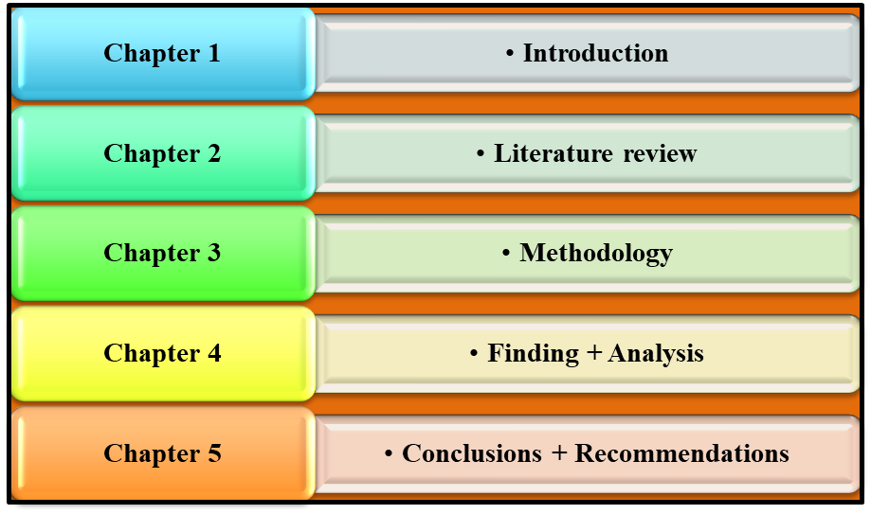

Figure 1: Thesis structure

(Source: Created by learner)

The chapter that is included in this study are introduction, literature review, methodology, research finds and analysis and recommendations and conclusion. The inclusion of these chapters provides a broad understanding of research topic as every minor detail is included in them by creating subpoints. The introduction provides a broad understanding of background, rationale and scope of a research topic. The literature review discusses challenges faced by leadership competencies and their mitigation steps (Pham and Kim, 2019). The methodology describes types of methods used for extracting information. The findings are provided to provide an analysis of findings that have been done through primary and secondary data collection. The conclusion and recommendation provide steps for formulation of strategies in project management.

# References

Alvarenga, J.C., Branco, R.R., Guedes, A.L.A., Soares, C.A.P. and e Silva, W.D.S., 2019. The project manager core competencies to project success. International Journal of Managing Projects in Business.

Pham, H. and Kim, S.Y., 2019. The effects of sustainable practices and managers’ leadership competences on sustainability performance of construction firms. Sustainable Production and Consumption, 20, pp.1-14.

Zuo, J., Zhao, X., Nguyen, Q.B.M., Ma, T. and Gao, S., 2018. Soft skills of construction project management professionals and project success factors: A structural equation model. Engineering, Construction and Architectural Management.