**ACADEMIC YEAR AND TERM: 2022/2023 – SEMESTER 2 (SPRING)**

**MODULE TITLE: FINANCIAL PERFORMANCE MANAGEMENT**

**Table of Contents**

1.0 Introduction 3

1.1 Size of companies and their employee numbers 3

1.2 Company History 3

1.3 How are they similar? Why are they in the same business industry? 3

2.0 Financial performance using ratio Analysis 5

2.1 Analysis of the Profitability and liquidity ratios 8

3.0 Balanced scorecard for Costco Corporation 10

4.0 Impact of the coronavirus pandemic on financial performance 14

5.0 Summary 16

# 1.0 Introduction

## 1.1 Size of companies and their employee numbers

In the case of Costco Wholesale Corporation, the organisation operates as an international chain of membership operations. That carries quality, brand name, and merchandising strategies for substantially lower prices across the globe for retail and wholesale use (Costco, 2022). There are 585 locations in which the business is currently conducting affairs, and with its main hub being in the US, it manages responsibilities through 203000 full-time executives (Costco, 2022).

Walmart on the other hand, is comparatively larger compared to Cotsco but believes in a value more than retail distribution. This allows them to serve communities across the globe beyond the physical walls of the stores. Approximately 2.1 million workers are aiding the organisation in this pursuit, with 1.6 million in the US (Careers.walmart.com, 2022).

## 1.2 Company History

The first location of Costco Wholesale Corporation ran its operations in 1976, under a price club name. Ever since then, the company’s general philosophy got developed that vouched to keep its costs lower and focus on quality and efficiency of production. It also managed to pass the savings to other members. That resulted in greater profits by 1997, along which time Costco's name became famous and accumulated more than $64 billion (Costco, 2023).

Walmart opened its first store in 1962, and ever since that time, the organisation has looked to increase its profits through the usage of innovation. The company began slowly amassing features to convert its business into a digital enterprise, and this resulted in the company's first distribution centre getting launched in 1970. Whereby beyond the 1980s the company began generating a yearly $1 billion in profits (Walmart, 2022).

## 1.3 How are they similar? Why are they in the same business industry?

|  |  |  |
| --- | --- | --- |
| **Michael Porter’s five forces elements** | **Costco Corporation** | **Walmart** |
| **Bargaining power of buyers** | Suppliers conducting business with the organisation have increased their prices by 2.4% which allows their bargaining power to remain high (Zimmerman, 2022). | Suppliers have been demanding higher prices from Walmart as well, which has increased their prices by 3-4%. Bargaining power is higher for suppliers considering the above principle (Layne, 2015). |
| **Bargaining power of suppliers** | Price adjustment is demanded by Costco customers that allows them to reduce prices below 12% of the markup costs. The bargaining power of customers is high (Carlino, 2022). | Due to the low-price leadership of Walmart, net margins have fallen below 1.49% and this allows the company to keep the customers faithful. The bargaining power of suppliers for this retailer is minimal (Walmart, 2022, p 45). |
| **Threat of substitution** | Differences in products remain to be poor, and this allows the threat of substitution to grow for the company (Costco, 2022, p 32). | Walmart has several substitute products available in the market that affects their pricing ability for certain products. For instance homeware, groceries, and clothing. The threat remains high (Walmart, 2022, p 57). |
| **Competitive Rivalry** | Main competitors include Kroger, Amazon, Walmart, and Target which increases competitive rivalry (Costco, 2022, p 30). | Amazon, Alibaba, Costco, Home Depot, and others. The competitive rivalry for this retailer is far more than its rival (Walmart, 2022, p 55). |
| **The threat of new entrants** | New retailers with modern supply chain networks might create a problem for the company. Although, the issue remains non-existent for Cotsco Corporation (Barr, 2023). | Being a trusted brand, many new retailers are unlikely to create the same brand value as Walmart. The threat remains negligible for this reason (Walmart, 2022, p 55). |

# 2.0 Financial performance using ratio analysis

|  |  |  |  |  |
| --- | --- | --- | --- | --- |
| **Costco Corporation (In millions)** | | | **Walmart (In millions)** | |
| **Data input for profitability ratios** | **2022** | **2021** | **2022** | **2021** |
| **Net Sales** | 222,730 | 192,052 | 567,762 | 555,233 |
| **Operating profit** | 7793 | 6708 | 25942 | 22548 |
| **Net profit** | 5844 | 5007 | 13673 | 13510 |
| **Profitability Ratios** |  |  |  |  |
| **Operating profit Ratio=Operating profit/ Net Sales*100** | 7793/222730*100=3.50% | 6708/192052*100=3.49% | 25942/567762*100=4.56% | 22548/555233*100=4.06% |
| **Net profit Ratio=Net profit/ Net Sales*100** | 5844/222730*100=2.62% | 5007/192052*100=2.60% | 13673/567762*100=2.41% | 13510/555233*100=2.43% |
| **Liquidity**  **Current Assets** | 32696 | 29505 | 81070 | 90067 |
| **Current Liabilities** | 31998 | 29441 | 87379 | 92645 |
| **Current Ratio=Current Assets/Current Liabilities** | 32696/31998=1.02 | 29505/29441=1.00 | 81070/87379=0.92 | 90067/92645=0.97 |
| **Inventories** | 17907 | 14215 | 56511 | 44949 |
| **Acid-Test Ratio=Current Assets-Inventories/Current Liabilities=** | 32696-17907/31998=0.46 | 29505-14215/29441=0.52 | 81070-56511/87379=0.28 | 90067-44949/92645=0.48 |

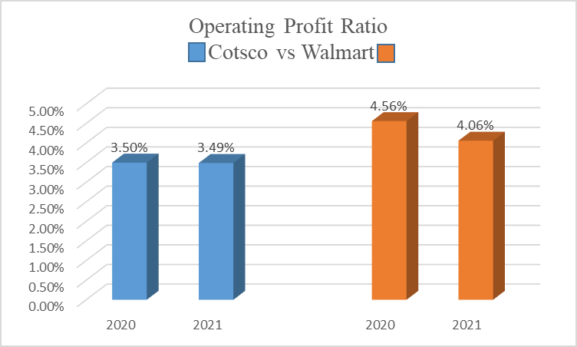

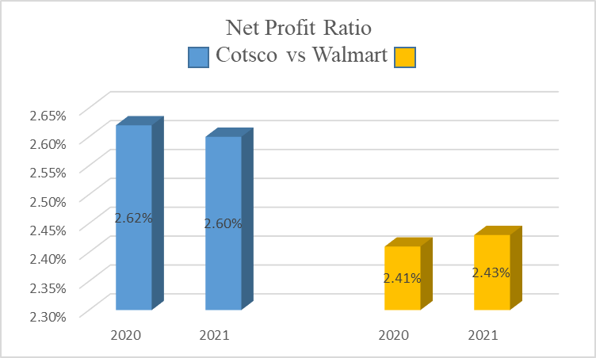

**Figure 1: Profitability Ratios**

(Source: Excel)

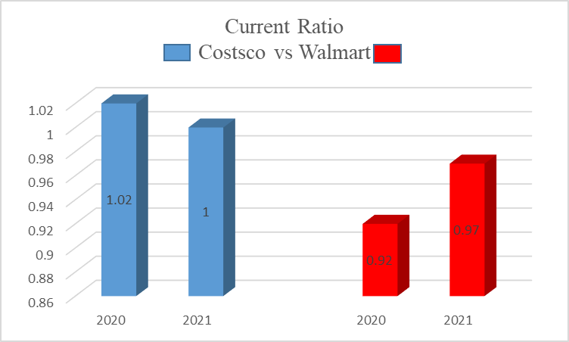

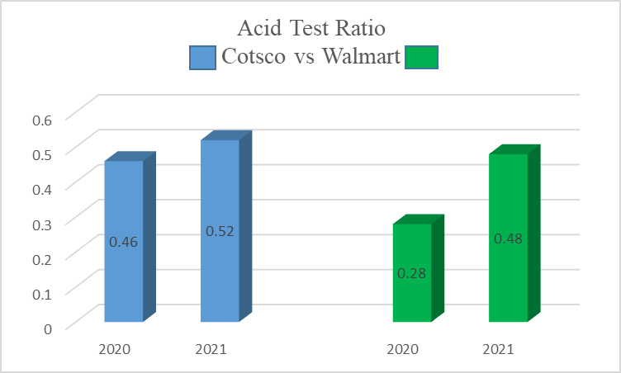

**Figure 1: Liquidity Ratios**

(Source: Excel)

## 2.1 Analysis of the Profitability and liquidity ratios

The operating profit ratio tries to measure the earnings generated by an organisation, through its core business operations for a given period. That is excluding the deduction for administrative and selling and distribution costs. Comparing both organisations, the primary company Costco Wholesale Corporation has shown a decline in its operating profitability. There has also been negligible change in one year for the company, with a 0.1% dip experienced in the operating profit ratio. This clarifies that operating expenditure has been growing for the firm that is resulting in lesser sales that can be converted into profits. The company has to manage this ratio, in such a manner whereby their operating expenditure does not lead them to a loss (Costco, 2022, p 60-64). Whereas, in the case of Walmart the operating profit ratio has also shown a decline that is more than Costco. However, their operating profit ratio in overall comparison to the latter company is more. This is seen by a 4.56% operating profit ratio for the year 2020 (Chen *et al.,* 2016). The operating profit ratio diminished by 0.50% which is comparatively more than Cotsco, and in that case, operating expenditure has been growing for some time. It could also indicate that the operating expenditure has been directly associated with the company operations of Walmart (Walmart, 2022, p 78-87). This unprecedented growth in the operating expenses needs to be stemmed for bringing more operating profit into the company.

The net profit ratio is the percentage of net profit extracted through the net sales, after excluding taxes and other factors. The net profitability ratio for Cotsco has grown by 0.06% within one year. This is inclusive from 2020 to 2021. It shows that the revenue is growing for the company which is getting converted to net profits. The net profit ratio for the retailer shows that it has not surpassed expectations about a rise in profitability. For Walmart, the year 2020 to 2021 shows that the net profit ratio has been considerably lower in one year (Costco, 2022, p 60-64). A 0.02% net profit ratio has seen to have grown for Walmart. This is extensively poor considering the stature of the organisation, along with its market reputation. It shows that overall expenditure management is still improper for the company of Walmart which is generating poor net sales. Concerns related to such net sales, need to be addressed especially about net profit generation.

The current ratio is a liquidity ratio that measures the organisational capability for meeting short-term obligations. These obligations might get due within a year. In the case of Costco Wholesale Corporation, the current ratio is at an ideal position i.e. above 1. This shows that with financial resources wise the company is solvent, and it has the resources to pay up its obligations (Chen *et al.,* 2016). Meanwhile, the current ratio for 2021 represented by Costco saw a -0.02 decline that further indicated that the enterprise is losing its ability to meet its short-term obligations. In comparison, Walmart has a current ratio below 1 (Walmart, 2022, p 78-87). That shows that it is not solvent, and is experiencing difficulties to come up with its short-term obligations. This needs to be changed over a period. However, long-term solvency-related problems might be addressed, but before that short-term matters need to be resolved within a period.

Through the acid-test ratio, short-term assets need to be configured for reducing their short-term liabilities. Considering the same feature, the years 2020 to 2021 show that Costco Warehouse Corporation experienced a decline of 0.06, with the ratio also below 1. This diminishes its capability to amass enough short-term assets for mitigating its short-term liabilities (Costco, 2022, p 61). Furthermore, Walmart saw a decline in the current ratio by 0.20 within one year. Meanwhile, Walmart's acid-test ratio was also below 1, which shows their ability to meet their immediate obligations using short-term assets is problematic. The short-term assets are not converting net sales that can create better fund consolidation, resulting in obligation management.

# 3.0 Balanced scorecard for Costco Corporation

|  |  |  |  |  |
| --- | --- | --- | --- | --- |
| **Balanced scorecard dimensions** | **Objectives** | **Measures** | **Targets (Goals)** | **Initiatives** |
| Financial | Selling fewer branded items increases sales volume over time directly driving discounts and contributing to the revenue of Costco Warehouse corporation. For instance, Costco deals in a limited number of brands, especially considering toothpaste as well (Lutz, 2014). | Firstly, evaluating the progress of sales volume for a few branded products including toothpaste brands.  Secondly, reducing the operating expenses in such a manner, allows the sales to get maximised over a period (Lutz, 2014).  Thirdly, ensuring a few of the brands available in limited volumes are discounted over time gives the organisation an advantage to complement additional costs getting assigned to other non-selling products. In short, performing better cost management through product distribution (Lutz, 2014). | Firstly, increasing the sales volume by more than 10% to give stern competition to the likes of Walmart, Target, and others.  Secondly, reducing the operating expenditure by 7% at least directly gets generated from the sale of non-popular retail items (Lutz, 2014).  Thirdly, increasing discounts for popular branded products by 3-5% enables better sales over a specific period. | -Developing new streams of revenue, especially through the branded products that are popular within Costco Corporation.  -Organising meetings with the shareholders, by involving the financial manager in deliberating ways of mitigating the rising operating expenditures.  -Setting up reports that provide an idea of product position in the market and its reception with regards to the customers looking to buy the same representing diverse brands, and isolating the tactics that can facilitate discounts for specific products obtained by the customers. |
| Customer | Focusing on the annual membership-related offers for customers, that enable the gradual sale of different product types among classes. These include the likes of clothing, diamond rings, toiletries, and other electronic-related items (Clifford, 2019). | Firstly, analysing consumer choices by going through their purchase histories, thereby providing better membership services that can cater to their ideals or demands (Clifford, 2019).  Secondly, the climate of in-house stores needs to be sanitised with minimum hygiene to be maintained, which appeals to customers that the company is concerned about their welfare first before engaging any product worth buying (Clifford, 2019).  Thirdly, better handling of both offline and online complain handling, through different staff members that features customer executive managers and other offline store representatives. | Firstly, ascertaining customer scores delivered through ratings and reviews. That needs to be 53% on the positive side (Clifford, 2019).  Secondly, getting above 40% score for overall cleanliness management for Costco stores, and maintenance of hygiene that allows customers to return to the stores in the future.  Thirdly, hiring 35% or more staff members whose overall behaviour towards customers is amicable (Clifford, 2019). | -Launching initiatives within social media handles like Instagram or Facebook that can motivate customers more over a period.  -Toilet facilities, as well as usage of Wi-fi and other leisure activities that customers can enjoy should observe a modicum of respect for both sexes i.e. male and female groups.  -Customer executives should report every week, the attitude of customers and their personal experiences regarding the features provided by Costco. |
| Internal Processes | Organising store designing concepts that standardises operational choices including empowerment of staff, offering less volume of products, and accepting operational slacks (Relihan, 2018). | Firstly, ensuring that the store designs provide ample space for customers to manoeuvre, including browsing, navigating, and communicating with store managers without too many hindrances (Relihan, 2018).  Secondly, the upkeep of limited products and making them available for customer viewing does not allow for too much complaining regarding the inventory. Also, ensuring that it becomes ample according to customer requirements (Relihan, 2018).  Thirdly, experiencing random problems due to valuable staff getting exited, machines getting broken down, and other factors. | Firstly, making sure that new store designs are supported with innovative ideas that give ample scope for technology deployment resulting in smart services that need to be increased by 67%. Smart services will ensure less over-crowding can occur within the stores (Relihan, 2018).  Secondly, keeping a handful of product varieties for premium brands does not confuse the customers and make them suffer from want of choice. Moreover, customers can get dissuaded upon seeing too many brands brought into view. The product varieties are thus to be diminished by 70% at least.  Thirdly, unexpected issues need to be reported by the staff to the management. That allows the management to prepare special reports listing the cause of the problems and then release the same for shareholder viewing. Such reports need to increase by 40%. | -Modern store concepts are inspired by the latest architecture-style magazines for retailers and other artist's related contributions within the industry. The company can affiliate with such members of society for better installation of concepts.  -Some product brands include Kirkland, Horizon Organic, and others that can have few goods available in each store.  -Regular maintenance needs to be made in Costco corporation stores every month that can help in identifying arising within its functioning. |
| Learning and Growth | Shaping a better pay structure for the workers, management members, leaders, and managers enables them to increase productivity which is further improved through training programs (Business Insider, 2023). | Firstly, creating a database of staff members, leaders, managers, and other administrative constituents who need to experience pay hikes in a sooner time (Business Insider, 2023).  Secondly, introducing specific training regimes that try to address the worker requirements. For instance, a staff member might be experiencing problems communicating directly with customers, therefore specific training regimes need to be made for such workers (Business Insider, 2023).  Thirdly, ensuring that employees, managers, and other types of workers receiving better pay are working to deserve the same pecuniary results. | Database reports featuring information about workers, staff members involved in the administration, and managers need to increase by 90% (Business Insider, 2023).  Training regimes need to be maximised by 45-50% based on the types of problems experienced by the workers, and their overall functioning.  Thirdly, check the progress reports of all the management staff within the company, every quarter. The progress report inspection needs to be increased by 25% (Business Insider, 2023). | -Initiatives related to employee satisfaction reviewing the need to be organised by Costco corporation every 6 months.  -Training regimes need to be versatile, and before launching the initiatives, planning needs to be administered that is before release after every 4 months.  -Allowing the majority of the performing workers, to aid the underperforming half of the organisation enables better team building. |

# 4.0 Impact of the coronavirus pandemic on the financial performance

As per the notions of Sayyida *et al.* (2021), consumer behaviour has transformed in the digital before the onset of the pandemic. Their behaviours thus can be grouped into four categories that include pure offline shopping, pure online shopping, showrooming, and webrooming. These enabled the customers to rely upon a specific behaviour and conduct their business by utilising a single channel (Harvey, 2021). However, the pandemic disrupted these behaviours and made the consumer rely on online based shopping itself. Online retail sales within the US proved a self-evident instance indicating the above factor. The overall online sales increased by 14.5% in 2020, from 3.5% in 2019. The highest proportion of retail sales occurred within the second quarter of 2020 which reached close to 16.5%. During this period, consumers being riled up by excessive concerns decided to pursue their products and purchase the same in large quantities (Harvey, 2021). For instance from detergent products to household appliances, from grocery products to normal clothing. All product types experienced shortages and problems that were unaccounted for before they reached the recipient. This shift in consumer behaviour occurred at the pre-purchase stage courtesy of the drastic influence of information technology. Furthermore, with larger social distancing occurring in countries and forcing customers away from witnessing products, its brands, and other forms of versatility it has to offer in the market. It created problems for organisations like Costco, which offered to pay premium wages to their workers after the outbreak occurred in March 2020 (Reuters, 2021). The minimum wage for the staff surpassed $16 over competitors Amazon, and Target Corporation. Meanwhile, the company invested in a personal blend of offline and online-related shopping experience creation. This form of market-related changes only brought them a handful of sales through the online medium. Even if the overall online sales jumped by 75.8% during the later quarters, it was still below that of its competitors.

According to He *et al.,* (2021), order fulfilment became a cause of concern for multiple retailers operating within the sector. They have not only tried ship-to-store and direct dropping, pick-up in-store features, and even shipping directly to the recipient via stores. The issue centring the above elements has been identifying a continuously dynamic program, that minimises supply chain costs. A drop shipping supply chain-related distribution allows a customer to receive an order and the supplier to fill the same. This got altered spontaneously after the pandemic started straining the operational commitments of organisations. Even if the company of Costco benefited from higher sales during the pandemic, figures speculated later revealed that the enterprise had accounted for $281 million in expenses. That featured the likes of hazard pay, sanitation costs, and other safety protocol-related expenses that were never accounted for by the corporation (Isidore, 2020). The shopping schemes as identified by retailers like Sam's Club and BJ's Wholesale have found ways to increase revenue by over $52 billion. The online sales also re-doubled by 90% during the earlier periods of 2020. Revenue for Costco also worsened after the initial periods before covid-19, the expenditure grew by $226,448 billion. Sales are also increasing by 11.67% on a year-over-year basis. However, due to sudden changes in business operations related to the retail organisation, Costco has been unable to stem the operating expenses further due to its reliance on a lower volume of retail products (Isidore, 2020). Covid-19 impacted the transactions undertaken by Costco, especially with average transactions experienced worldwide only growing by 7.3%. Considering the US market, only 5.7% of the transactions were experienced by the company. This was comparatively lower than earlier expectations as established by the firm (Macrotrends.net, 2023). Also, e-commerce-related ventures only increased by 38.2% during the earlier periods when the pandemic raged on. All these factors together have contributed negatively in the context of the company considering the pandemic years. It was observed that sales should have grown higher within the periods.

Also, Schleper *et al.*, (2021), further pointed out that many retailers did not see their logistics as the competitive lever for connecting with better online sales. They believed too much in their in-house delivery services similar to Amazon which did not work during the pandemic even with higher delivery fees. The delivery fees only worsened the profit expectations that could be accounted for within the company. Costco tried to optimise their membership plans but had to inject higher costs in the annual fees that came to about $901 million within a year. This dissuaded many customers to further continue in the retail firm, and looking for other ways to control the costs related to the management of distribution (Katelijn Quartier *et al.*, 2021, p 345). It was no wonder that both product characteristics and delivery systems need to be made, which allowed the creation of a better experience for the customers. This was greatly absent throughout the year mainly in the case of Costco, whereas other retailers somehow managed to consolidate their sales better. Costco, could not maintain its higher sales revenue during the period.

# 5.0 Summary

The above report concludes that after a comparison of both organisations Costco and its competitors Walmart, net profitability wise the former is head of the latter. Although, their management of operating expenses still requires better reviewing, that puts Walmart ahead in terms of the operating profit ratio. However, with liquidity wise Costco can better leverage their resources to pay off its short-term obligations but still needs to look towards its inventories. The same cannot be said in the case of Walmart, which is not solvent based on the ratio analysis made in the report. The report further summarises that the balanced scorecard on Costco identified that the company was looking to create versatility among its product brands, but eyeing a lesser degree of sales towards the same. That was to focus on the discounting factor. Also, they wanted to ensure that staff were adequately trained in addressing consumer needs and mitigating the problems they might have experienced. Moreover, diverse training regimes were likely to create a competitive attitude among the workers which was the main emphasis of Costco. The pandemic created massive issues concerning revenue for the retailer, but somehow also increased its online sales. However, due to the accountability of certain miscellaneous costs it was facing hard to convert revenue into profits. In the current period, after the pandemic, the retailer has somehow managed to improve its retail sales by concentrating on their targeted business model. This allows the company to embark on a future filled with better promises.

**References**

Barr, S. (2023). *How New Entrants Are Shaping The Future Of Retail*. [online] Forbes. Available at: https://www.forbes.com/sites/stevenbarr/2018/07/30/how-a-brand-breaks-into-retail-today/?sh=5bc26e865a20 [Accessed 3 Apr. 2023].

Business Insider (2023). *It’s official: Costco workers are paid to be nice to you*. [online] Business Insider. Available at: https://www.businessinsider.in/retail/news/costco-employee-handbook-requires-workers-to-greet-every-member-with-a-smile-and-give-them-sincere-gratitude/articleshow/98162044.cms [Accessed 17 Apr. 2023].

Careers.walmart.com (2022). *Walmart History | Walmart Careers*. [online] careers.walmart.com. Available at: https://careers.walmart.com/history#:~:text=Walmart%20started%20with%20one%20man [Accessed 3 Apr. 2023].

Carlino, N. (2022). *This is what you need to know about Costco price adjustments and price matching*. [online] 21Oak. Available at: https://www.21oak.com/hacks-how-tos/costco-price-adjustment-policy-exception/ [Accessed 3 Apr. 2023].

Chen, Z., Han, B. and Zeng, Y. (2016). Financial Hedging and Firm Performance: Evidence from Cross-border Mergers and Acquisitions. *European Financial Management*, 23(3), pp.415–458. doi:https://doi.org/10.1111/eufm.12103.

Clifford, C. (2019). *How Costco uses $5 rotisserie chickens and free samples to turn customers into fanatics*. [online] CNBC. Available at: https://www.cnbc.com/2019/05/22/hooked-how-costco-turns-customers-into-fanatics.html [Accessed 3 Apr. 2023].

Costco (2022). *About | Costco*. [online] Costco.com. Available at: https://www.costco.com/about.html [Accessed 3 Apr. 2023].

Costco (2022). *Costco Wholesale-Annual Report 2022*. [online] *https://s201.q4cdn.com*, Washington: s201.q4cdn.com, pp.1–76. Available at: https://s201.q4cdn.com/287523651/files/doc_financials/2022/ar/Costco-2022-Annual-Report.pdf [Accessed 3 Apr. 2023].

Costco (2023). *Costco Wholesale Corporation - Company Profile*. [online] Investor.costco.com. Available at: https://investor.costco.com/company-profile/default.aspx [Accessed 3 Apr. 2023].

Harvey, C. (2021). *Big Retail Beyond 2021: A Stronger Costco Emerges Amid the Pandemic*. [online] HomePage News. Available at: https://www.homepagenews.com/featured-news/big-retail-beyond-2021-a-stronger-costco-emerges-amid-the-pandemic/ [Accessed 3 Apr. 2023].

He, B., Mirchandani, P., Shen, Q. and Yang, G. (2021). How should local Brick-and-Mortar retailers offer delivery service in a pandemic World? Self-building Vs. O2O platform. *Transportation Research Part E: Logistics and Transportation Review*, [online] 154, p.102457. doi:https://doi.org/10.1016/j.tre.2021.102457.

Isidore, C. (2020). *Pandemic shopping pushes Costco to a record profit but also raises costs by millions*. [online] CNN. Available at: https://edition.cnn.com/2020/09/25/business/costco-earnings-pandemic-shopping/index.html [Accessed 3 Apr. 2023].

Katelijn Quartier, Petermans, A., Melewar, T.C. and Dennis, C. (2021). *The Value of Design in Retail and Branding*. Emerald Group Publishing.

Layne, N. (2015). *Wal-Mart puts the squeeze on suppliers to share its pain as earnings sag*. [online] Reuters. Available at: https://www.reuters.com/article/us-wal-mart-suppliers-insight-iduskcn0sd0cz20151019 [Accessed 3 Apr. 2023].

Lutz, A. (2014). *Costco’s Simple Strategy For Outperforming Wal-Mart And Target*. [online] Business Insider. Available at: https://www.businessinsider.in/retail/costcos-simple-strategy-for-outperforming-wal-mart-and-target/articleshow/43915666.cms [Accessed 17 Apr. 2023].

Macrotrends.net (2023). *Costco Operating Expenses 2010-2023 | COST*. [online] www.macrotrends.net. Available at: https://www.macrotrends.net/stocks/charts/COST/costco/operating-expenses#:~:text=Costco%20operating%20 expenses%20for%20the%20twelve%20 months%20 ending%20 February%2028 [Accessed 3 Apr. 2023].

Relihan, T. (2018). *How Costco’s obsession with culture drove success | MIT Sloan*. [online] MIT Sloan. Available at: https://mitsloan.mit.edu/ideas-made-to-matter/how-costcos-obsession-culture-drove-success [Accessed 3 Apr. 2023].

Reuters (2021). The pandemic shoots up costs for Costco, profit misses estimates. *Reuters*, [online] 4 Mar., pp.1–2. Available at: https://www.reuters.com/business/retail-consumer/costco-beats-quarterly-revenue-estimates-pandemic-boost-2021-03-04/ [Accessed 3 Apr. 2023].

Sayyida, S. *et al.* (2021) “The impact of the COVID-19 pandemic on Retail Consumer Behavior,” *Aptisi Transactions on Management (ATM)*, 5(1), pp. 79–88. Available at: https://doi.org/10.33050/atm.v5i1.1497.

Schleper, M.C., Gold, S., Trautrims, A. and Baldock, D. (2021). Pandemic-induced knowledge gaps in operations and supply chain management: COVID-19’s impacts on retailing. *International Journal of Operations & Production Management*, 41(3). doi:https://doi.org/10.1108/ijopm-12-2020-0837.

Walmart (2022). *About*. [online] Corporate - US. Available at: https://corporate.walmart.com/about#:~:text=We%20are%20creating%20opportunities%20and [Accessed 3 Apr. 2023].

Walmart (2022). Walmart-Annual Report 2022. [online] https://s201.q4cdn.com, Arkansas: Walmart, pp.1–96. Available at: https://s201.q4cdn.com/262069030/files/doc_downloads/LatestReports/WMT-FY2022-Annual-Report.pdf [Accessed 3 Apr. 2023].

Zimmerman, S. (2022). *Costco says higher supplier wages to keep prices elevated*. [online] Supply Chain Dive. Available at: https://www.supplychaindive.com/news/costco-inflation-supplier-wages-labor-prices/632593/ [Accessed 3 Apr. 2022].