**BSS052-6 PROJECT AND OPERATIONS MANAGEMENT**

**ASSIGNMENT 1 – OPERATIONS MANAGEMENT REPORT**

**Table of Contents**

Introduction 3

Question 1: Three main operational management areas of Samsung 3

Question 2: Comparison and Contrasts between Samsung and Apple in terms of 4Vs of Operation 6

Question 3: Scope for operational performance improvement for Samsung 9

Conclusion 10

Reference List 11

Appendix: CIP Implementation 16

# Introduction

In this report, the significance of operational management in different areas of business of Samsung has been investigated, analysed and presented with evidence. Headquartered in Seoul, South Korea, Samsung has built up its big empire in the Smartphone and electronics industry by expanding its operational bases in many countries. Currently, they also have many global manufacturing bases around the world where they produce and supply their chips and batteries for electronic items. Samsung has to deal with a large number of operations from product designing, to testing, assembling, manufacturing and finally distributing them. In their store operations, inventory management is also a crucial operation that needs to be handled well. Thus in this report, the different operational management processes of Samsung have been elaborated with their effective strategies to handle them.

# Question 1: Three main operational management areas of Samsung

Samsung is a giant in the consumer and industrial electronics industry that is having a big market share in the electronic gadget market with a huge net capital. Currently, Samsung has a market capitalisation of $312.55 billion which makes Samsung the world’s 25th most valuable company (Companiesmarketcap, 2022). They are also currently having 287,000 employees in 74 countries who handle different types of their operations (Statista, 2022). In Seoul only, Samsung attained revenue of 320 billion KRW for their semiconductor sales with 28 billion operating profit in 2018 (Businesswire, 2018). This is shown in the below figure.

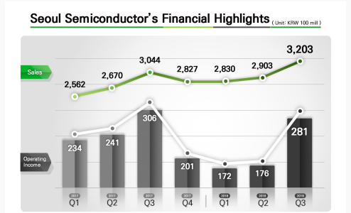

**Figure 1: Samsung’s Growing Sales and Operating profit**

(Source: Businesswire, 2018)

Globally, their flagship sales also have driven an overall profit of 32.21 trillion of revenue and an operating profit of 3.24 trillion KRW this year (News Samsung, 2022). Thus, a company this big needs to manage its operations in the vast array of its processes. The three major areas of operations of Samsung are- ***supply-logistics management, design-quality management and inventory management*** are discussed below:

***Supply Chain Management (SCM) and logistics of Samsung***

As per Schiffer (2021), the ***Triple Bottom Line*** of sustainability or CSR operations for “***People, Profit and Planet”*** can help a firm to attain great CSR value. Samsung has always sustained its supply operations by taking care of its economic, social and environmental activities. Samsung has secured its economic activities in supply through its cost management system (Samsung Ads, 2022). It has also incorporated the latest technologies and also utilised its agile HRM to maximise efficiency and synergy with its suppliers. Samsung has set strict codes of conduct for reinforcing social responsibilities in their supply (Samsung, 2022a). Samsung has also worked with eco-partner-certified suppliers only to less affect the environment.

Samsung’s SDS, which is one of the best logistics companies in South Korea and around the world, has built up a ***smart logistics system*** with the help of an integrated IT-based network for tracking and monitoring their SCM/ logistics activities (Samsung Ads, 2022). Their integrated platform or Cello has helped Samsung build smooth logistics operations with their tightened global digital network across thirty-six countries. They also have incorporated fourth-party logistics (4PL) along with their previous 3PL format of logistics with end-to-end tracking and monitoring activities (Samsung Ads, 2022). Samsung's smart logistics system also covers 24/7 risk management with their multimodal transports internationally through air, land or water for securing their logistic operations.

***Design-quality management***

Even though product designs and quality management are two different operational activities, they are intertwined with each other. As per Sony *et al.* (2020), a viable and quality product design determines a lot of its quality as quality equipment is needed to suit that design. Samsung has built up its design in-house innovation centre ***Samsung Design Innovation Center*** (SDIC) for overseeing each step of its product development with an effective strategy (Samsung, 2022b). SDIC has employed mostly experts at their workplace, who take care of their designing, making prototypes, modifying them with engineering and also testing them out before getting any final approval. In this way, Samsung has been able to bring exclusive software and hardware components for the products through its innovative designs.

Samsung’s product designing team helps make all the concepts of the new products. Their team for industrial design takes care of the designing to be industrially suitable with new commercialised features to attract more customers. Their user experience team (UX team) helps transform their product ideas into prototypes to the final finished products (Samsung, 2022b). Through their product designs, they are aimed to provide their consumers with some cutting-edge user experiences by incorporating new innovative technologies. They also have reduced their lead times and maintenance costs for manufacturing using ***VR, ML and Big data*** (Samsung, 2022b). Thus, quality management in their manufacturing process is also necessary to pan out this idea into their final products.

Samsung needs to install all the right technologies at the right places in its manufacturing operations to meet its product design requirements. Thus, Samsung also has always taken care of its product quality management process and maintains ***IATF 16949 and ISO 9001*** standards in its production (Sütőová and Kóča, 2022). Samsung's semiconductor has continuously improved their overall quality with its sound quality policies (Semiconductor, 2022). As per Syreyshchikova *et al.* (2021), TQM can be an effective way to ensure consumer satisfaction with great production output by reducing errors in production. Samsung has also enforced its total ***Quality Management (TQM)*** by implementing its quality policies to incorporate the KPIs in their production (Jibril, 2019). Samsung has made a ***continuous improvement program (CIP)*** for making its production consistent by detecting and managing out-of-control situations or improving production yields (Semiconductor, 2022) ***[Refer to Appendix]***.

***Inventory management***

As per Buchholz *et al.* (2022), the current global inflation all around the world is causing immense price hikes for raw materials and thus enforcing the manufacturing companies to cut their overheads. Samsung also has taken viable measures for lean manufacturing in their inventory management. Inventory management is a crucial operation for any OEM (original equipment manufacturer), for maintaining cash liquidity and managing unused or unsold materials, and their shortages. According to Jackson *et al.* (2020), the ***Inventory Control Theory*** states that the number of products to be ordered must be pre-decided to meet the ongoing demands. If they are not properly managed, there might be delays in product deliveries, warehousing and stocking in turn impacting their sales and hampering consumer satisfaction.

In order to avoid those risks, Samsung has built a lean ecosystem for its inventory management with smart procurement and warehousing by using a barcode scanner with Knox capture (Insights, 2021). Those have helped Samsung to have quick scanning for managing inventories. This technology is also helping inventory management of Samsung to easily detect its demands or scopes for procurements and order its supply accordingly (Insights, 2022). They also have implemented a track and trace system for their warehousing to track their supply activities by pointing out their current locations creating more transparency in their inventory management. Their inertia mobile technology has also ensured safety for its inventory workers on the go by alleviating their accidents from distracted driving.

# Question 2: Comparison and Contrasts between Samsung and Apple in terms of 4Vs of Operation

According to Ye *et al.* (2019), this ***4Vs model*** can help manufacturers analyse their own and others’ business strengths and weaknesses regarding other operational aspects. Thus, comparing and contrasting the 4Vs of operations between Samsung and Apple can help assess their strengths and weaknesses.

***Volume of Samsung vs Apple***

Volume is known to be the number of products manufactured by manufacturing organisations. Samsung is a high-volume manufacturing company that successfully manufactured 300 million smartphones in the previous year (Thelec, 2021). More than 238 million units were made by their production plants and more than 60 mn units have been produced by their joint development manufacturers as per their growing demand. Over 200mn units have been shipped throughout the world. Apple has also manufactured 2.2 billion units. Samsung has also sold 314 million units and shipped 74.5 million units, whereas Apple has also shipped 57 million iPhones (Strategy Analytics, 2022). Thus, it is evident that Samsung has got a huge competitive edge over Apple in terms of its production volume and shipment sales as shown in the below figure.

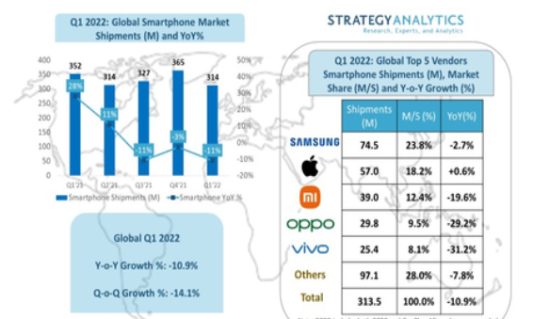

**Figure 2: Samsung vs Apple Shipment Volume**

(Source: Strategy Analytics, 2022)

***Varieties of Samsung vs Apple***

Variety is defined as the differentiation in the services or the products manufactured or offered by a firm (Udugama *et al.* 2022). Samsung has adopted a broad differentiation strategy for its products, as they produce Smartphones, smart TVs, tablets, computer monitors, smart watches, earphones and myriads of other electronic gadgets. They have differentiated their smartphones into many different price categories and designs which meet the demands of both the high and the low-economic masses providing people with many options to buy (Radić, 2021). Apple has less differentiation and has only focused on scaling its iPhone sales and others are for their MacBook, iPads and other accessories (Tien *et al.* 2019). Thus Samsung provides better options to its consumers than Apple, which also ensures Samsung’s competitive advantage over Apple as they acquire more consumers and market shares than them as shown in the below figure.

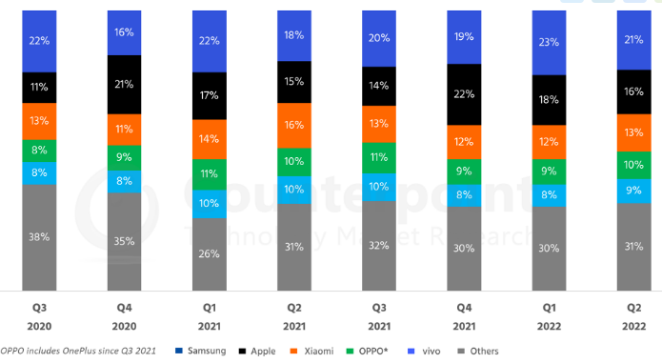**Figure 3: Global Market Share of Samsung vs Apple and others**

(Source: Counterpoint Research, 2022)

***Variations of Samsung vs Apple***

Variation regards the level of predictability or unpredictability of the consumers and their demands for a certain product or brand (Rossi and Lanzetta, 2020). Samsung has high variability for its products as it is highly flexible in its manufacturing approaches and changes its designs immediately as per demand (Jalari and Marimin, 2022). Apple, on the other hand, has also stuck to their unique designs and continuously improved its operating systems, features and its designs (Qin *et al.* 2019). Thus, it is obvious that Samsung tries to meet the demands of its consumers with the flowing trends and update its design to be relevant enough to enhance the attractiveness of its products.

***Visibility of Samsung vs Apple***

Visibility refers to the exposure of a company to its valuable consumers which can build a strong emotional bond with the consumers (Qi and Tao, 2018). High visibility or exposure through various market promotional activities can help companies to stay close to their consumers and persuade them to buy their products. Samsung is one of the most visible companies that is promoted through omnichannel approaches and celebrity endorsements (Singer and Hidayat, 2021). Its perceived visibility to its consumers is situated in a high-pricing range although Samsung has high popularity towards the middle-economic background people too. Samsung has more than three thousand walk-in stores worldwide which are easily accessible to its consumers (Samsung Biologics, 2021). Apple also has great visibility nowadays towards its consumers through omnichannel and influencer marketing strategies. They have more than five hundred stores worldwide (Annual Reports, 2021). Thus, it shows Samsung has greater visibility than Apple.

# Question 3: Scope for operational performance improvement for Samsung

Although Samsung has integrated all its supply operations and built a near-perfect and highly efficient operational management, they still have some scope for improvement. As far as the recent issues of high prices in raw materials and labour shortages are concerned after Covid-19, manufacturing companies are trying to lessen their costs in many ways (Paul *et al.* 2021). Many companies are ***outsourcing their manufacturing plants*** as per the availability of their raw materials in low-cost countries which is helping them reduce their manufacturing costs (Arrigo, 2020). Samsung also can outsource its manufacturing plants to lower economic countries to reduce its supply costs and taxes implied overseas.

During this current era of recovering supply-chain from its broken situation and inflation after the pandemic, manufacturers are finding it hard to manage their supply activities (Ramani *et al.* 2022). In this situation, ***boosting domestic capacities by on-shoring and off-shoring supply activities*** can help mend the situation a bit. Samsung can also manage its supply costs by on-shoring and off-shoring its supply operations to lower-cost locations so that it can reduce its overall costs. Apart from their supply operations, they also can outsource their CRM and HRM processes for reducing their operational costs by acquiring labourers at minimal wage rates.

In order to mitigate the issues of labour shortage, companies can ***seek employees through their advertisements*** in online job portals (Rios *et al.* 2018). Using them, Samsung can clearly state their recruitment criteria based on the skills they need in their operations so that the candidates can submit their CVs and certifications to their respective HRs. Samsung’s HRs can help ***optimise their onboarding process*** by establishing goals using some digital onboarding software. As per Ali and Anwar (2021), ***collaborative teamwork*** can help motivate and retain employees more, providing better job satisfaction. Thus, Samsung's leaders can also yield better teamwork by enhancing their team collaboration through communication. Samsung can also run regular training and development schemes for developing the skills of its existing employees.

A large variety of products in a single segment somehow lowers the interest of the consumers and devalues the products (Magnier and Mugge, 2022). Thus, Samsung's consumers also can lose interest in their models easily as there are many at a certain price range. Moreover, people have had issues as Samsung phones do not last long (Olaleye *et al.* 2019). Thus, Samsung can make their phones a bit more sturdy and long-lasting so that they can satisfy their consumers. Thus, Samsung must ***hire the best design experts from around the world*** and make a few variations for each brand with compact designs and supporting secured apps that can last longer. As per Nascimento *et al.* (2018), ***sustainable practices for mobile manufacturing*** can be done through ***selective waste collection, sorting and treating*** them. Samsung can also practise its manufacturing operations in this manner for creating sustainability in its process.

Samsung can also improve its logistics chain by including ***technical support and responsible labour sourcing***. As per Rogers (2020), maintaining the labour law states about not recruiting workers aged fewer than 18 in many parts of the world. Thus, Samsung’s HRs must take care of them while hiring their logistics workers. They can also ***improve policies for logistics management*** which can continuously help their employees’ upskill themselves with health and safety training. Lalou *et al.* (2020) stated that forecasting sales, inventory management and other operational activities can reduce operational errors and costs by understanding the current capacity or market trends. Samsung can also create a ***viable forecasting system*** for tracking current trends and thus managing its inventory.

# Conclusion

After having a vast discussion on the topic, it can be concluded that Samsung championed their consumers’ acquisition retention process making millions of loyal global consumers from whom they are earning billions of revenue and a continued cash flow. The company is also having a broad differentiation for their products and also they have myriads of price ranges suitable for all demographics to buy. Samsung has got an immense advantage in the current competitive market of electronics through its technological applications in the SCM, logistics, capacity management and product design and quality control activities. Samsung has also got the edge over Apple in terms of reaching the masses through promotions and its large variety of products. Finally, Samsung has been recommended to develop its SCM and logistics to mitigate price rise and labour shortage issues.

# Reference List

Ali, B.J. and Anwar, G., (2021) An empirical study of employees’ motivation and its influence job satisfaction. *Ali, BJ, & Anwar, G.(2021). An Empirical Study of Employees’ Motivation and its Influence Job Satisfaction. International Journal of Engineering, Business and Management*, *5*(2), pp.21-30. Available from: <https://dx.doi.org/10.22161/ijebm.5.3.2> [Accessed: 3rd December, 2022]

Annual Reports, (2022) *Apple Plc.* Available from: <https://www.annualreports.com/Company/apple-inc> [Accessed: 3rd December, 2022]

Arrigo, E., 2020. Global sourcing in fast fashion retailers: Sourcing locations and sustainability considerations. *Sustainability*, *12*(2), p.508.

Buchholz, P., Schumacher, A. and Al Barazi, S., (2022). Big data analyses for real-time tracking of risks in the mineral raw material markets: implications for improved supply chain risk management. *Mineral Economics,* 35(3), pp.701-744. Available from: https://doi.org/10.1007/s13563-022-00337-z [Accessed: 3rd December, 2022]

Businesswire, (2018)*. Seoul Semiconductor Achieves KRW 320 Billion in Revenue for Third Quarter 2018 and KRW 28 Billion in Operating Profit.* Available at: <https://www.businesswire.com/news/home/20181029005283/en/Seoul-Semiconductor-Achieves-KRW-320-Billion-Revenue-for-Third-Quarter-2018-and-KRW-28-Billion-in-Operating-Profit> [Accessed: 3rd December, 2022]

Companies Market Cap, (2022). *Market capitalization of Samsung.* Available at: <https://companiesmarketcap.com/samsung/marketcap/> [Accessed: 3rd December, 2022]

CounterPoint Research, (2022). *Global Smartphone Market Share: By Quarter.* Available at:<https://www.counterpointresearch.com/global-smartphone-share/#:~:text=Q1%202022%20Highlights&text=Its%20market%20share%20rose%20to,from%20Apple%20in%20Q1%202022.&text=Apple's%20shipments%20declined%20by%201,quarterly%20shipment%20decline%20of%2028%25>. [Accessed: 3rd December, 2022]

Insights, (2021). Inventory management gets a reboot in the age of lean manufacturing. Available at: <https://insights.samsung.com/2021/08/27/inventory-management-gets-a-reboot-in-the-age-of-lean-manufacturing-2/> [Accessed: 3rd December, 2022]

Insights, (2022). Safety first: How Samsung’s Inertia mobile solution reduces distracted driving on forklifts. Available at: <https://insights.samsung.com/2022/08/31/safety-first-how-samsungs-inertia-mobile-solution-reduces-distracted-driving-on-forklifts/> [Accessed: 3rd December, 2022]

Jackson, I., Tolujevs, J. and Kegenbekov, Z., (2020). Review of inventory control models: a classification based on methods of obtaining optimal control parameters. *Transport and Telecommunication,* 21(3), pp.191-202. Available from: https://hdl.handle.net/10125/79578 [Accessed: 3rd December, 2022]

Jalari, M. and Marimin, A., (2022). Testing Product Mix Against Brand Trust in the Digital Era. *International Journal of Seocology*, pp.054-064. Available from: <https://hdl.handle.net/10125/79578> [Accessed: 3rd December, 2022]

Jibril, Y.M., 2019. A meta-analytical review of the relationship between total quality management practices and the operational performance of manufacturing companies.pp. 1-15. Available from: https://acikerisim.sakarya.edu.tr/bitstream/handle/20.500.12619/69078/T08141.pdf?sequence=1 [Accessed: 3rd December, 2022]

Lalou, P., Ponis, S.T. and Efthymiou, O.K., (2020). Demand Forecasting of Retail Sales Using Data Analytics and Statistical Programming. *Management & Marketing*, *15*(2). Available from: 10.2478/mmcks-2020-0012 [Accessed: 3rd December, 2022]

Magnier, L. and Mugge, R., (2022) Replaced too soon? An exploration of Western European consumers’ replacement of electronic products. *Resources, Conservation and Recycling*, *185*, p.106448. Available from: [Accessed: 3rd December, 2022]

Nascimento, D.L.M., Alencastro, V., Quelhas, O.L.G., Caiado, R.G.G., Garza-Reyes, J.A., Rocha-Lona, L. and Tortorella, G., (2018) Exploring Industry 4.0 technologies to enable circular economy practices in a manufacturing context: A business model proposal. *Journal of Manufacturing Technology Management*, *30*(3), pp.607-627. Available from: 10.1108/JMTM-03-2018-0071 [Accessed: 3rd December, 2022]

News Samsung, (2022). Samsung Electronics Announces Third Quarter (2022) Results. Available at: <https://news.samsung.com/global/samsung-electronics-announces-third-quarter-2022-results> [Accessed: 3rd December, 2022]

Olaleye, S.A., Ukpabi, D., Karjaluoto, H. and Rizomyliotis, I., (2019). Understanding technology diffusion in emerging markets: The case of Chinese mobile devices in Nigeria. *International Journal of Emerging Markets*. Available from: https://doi.org/10.1108/ijoem-01-2018-0055 [Accessed: 3rd December, 2022]

Paul, S.K., Chowdhury, P., Moktadir, M.A. and Lau, K.H., (2021) Supply chain recovery challenges in the wake of COVID-19 pandemic. *Journal of Business Research*, *136*, pp.316-329. Available from: <https://doi.org/10.1016%2Fj.jbusres.2021.07.056> [Accessed: 3rd December, 2022]

Qi, Q. and Tao, F. (2018) Digital twin and big data towards smart manufacturing and industry 4.0: 360 degree comparison. *Ieee Access*, *6*, pp.3585-3593. Available from: https://ieeexplore.ieee.org/iel7/6287639/6514899/08258937.pdf[Accessed: 3rd December, 2022]

Qin, Y., Shi, L.H., Stöttinger, B. and Cavusgil, E., (2019) Neither an authentic product nor a counterfeit: the growing popularity of Shanzhai products in global markets. *Canadian Journal of Administrative Sciences/Revue canadienne des sciences de l'administration*, *36*(3), pp.306-321. Available from: 10.1002/CJAS.1501 [Accessed: 3rd December, 2022]

Radić, M., (2021). Business strategy and management method on the example of Samsung. *International Journal of Contemporary Business and Entrepreneurship*, *2*(2), pp.33-49. Available from: <https://doi.org/10.47954/ijcbe.2.2.3> [Accessed: 3rd December, 2022]

Ramani, V., Ghosh, D. and Sodhi, M.S., (2022) Understanding systemic disruption from the Covid-19-induced semiconductor shortage for the auto industry. *Omega*, *113*, p.102720. Available from: <https://doi.org/10.1016%2Fj.omega.2022.102720> [Accessed: 3rd December, 2022]

Rios, J.A., Ling, G., Pugh, R., Becker, D. and Bacall, A., (2020). Identifying critical 21st-century skills for workplace success: A content analysis of job advertisements. *Educational Researcher*, *49*(2), pp.80-89. Available from: <https://doi.org/10.3102/0013189X19890600> [Accessed: 3rd December, 2022]

Rogers, B., (2020) The law and political economy of workplace technological change. *Harv. CR-CLL Rev.*, *55*, p.531. Available from: [10.2139/SSRN.3327608](https://doi.org/10.2139/SSRN.3327608) [Accessed: 3rd December, 2022]

Rossi, A. and Lanzetta, M., (2020). Integration of hybrid additive/subtractive manufacturing planning and scheduling by metaheuristics. *Computers & Industrial Engineering*, *144*, p.106428. Available from: <https://doi.org/10.1016/j.cie.2020.106428> [Accessed: 3rd December, 2022]

Samsung Biologics, (2021). *Annual report.* <https://samsungbiologics.com/ir/financial-info/annual-business-report> [Accessed: 3rd December, 2022]

Samsung, (2022a). *Supply Chain Managment Strategy.* Available at: <https://www.samsung.com/us/sustainability/sustainable-supply-chain/> (Accessed on: 3rd Deember, 2022).

Samsung, (2022b). *Samsung Design Innovation Center.* Available from: <https://design.samsung.com/global/contents/sdic/> [Accessed: 3rd December, 2022]

Samsungads, (2022). Smart Logistics. Available from <https://www.samsungsds.com/en/logistics/logistics.html> [Accessed: 3rd December, 2022]

Schiffer, L., (2021). People, Purpose, Planet: Adopting a Triple Bottom Line to Make the Nonprofit Arts Sector More Environmentally Sustainable.pp. 1-12. Available at: https://mdsoar.org/bitstream/handle/11603/21646/People%20Purpose%20Planet.pdf?sequence=1 [Accessed: 3rd December, 2022]

Semiconductor, (2022). *Continuous improvement program.* Available at: <https://semiconductor.samsung.com/support/quality-support/quality-management/> [Accessed: 3rd December, 2022]

Singer N.G. and Hidayat, Z., (2021). Influencing Factors in Fans' Consumer Behavior: BTS Meal Distribution in Indonesia. *Journal of Distribution Science*, *19*(9), pp.113-123. Available from: <http://dx.doi.org/10.15722/jds.19.9.202109.113> [Accessed: 3rd December, 2022]

Sony, M., Antony, J. and Douglas, J.A., (2020). Essential ingredients for the implementation of Quality 4.0: a narrative review of literature and future directions for research. *The TQM Journal.* Available from: <http://researchonline.ljmu.ac.uk/id/eprint/12549> [Accessed: 3rd December, 2022]

Statista, (2022). *Samsung Electronics - statistics & facts.* Available at: <https://www.statista.com/topics/985/samsung-electronics/#:~:text=Samsung%20Electronics%20is%20a%20global,287%2C000%20employees%20in%2074%20countries>. [Accessed: 3rd December, 2022]

Strategy Analytics, (2022). Samsung Hits Highest Global Smartphone Market Share in Five Years in Q1 2022. Available at: <https://news.strategyanalytics.com/press-releases/press-release-details/2022/Strategy-Analytics-Samsung-Hits-Highest-Global-Smartphone-Market-Share-in-Five-Years-in-Q1-2022/default.aspx> [Accessed: 3rd December, 2022]

Sütőová, A. and Kóča, F., (2022). Corporate Social Responsibility Standards: Is it Possible to Meet Diverse Customer Requirements?. *Management Systems in Production Engineering*, *30*(1), pp.54-61. Available from: 10.2478/mspe-2022-0007 [Accessed: 3rd December, 2022]

Syreyshchikova, N.V., Pimenov, D.Y., Yaroslavova, E.N., Gupta, M.K., Sharma, S. and Giasin, K., (2021). Product quality planning in laser metal processing based on open innovation using quality function deployment. *Journal of Open Innovation: Technology, Market, and Complexity,* 7(4), p.240. Available from: <https://doi.org/10.3390/joitmc7040240> [Accessed: 3rd December, 2022]

Thelec, (2021). Samsung manufactured 300 million smartphones in 2021. Available at: <https://thelec.net/news/articleView.html?idxno=3767> [Accessed: 3rd December, 2022]

Tien, N.H., Dat, N.V. and Chi, D.T.P., (2019). Product policy in international marketing comparative analysis between Samsung and Apple. *International Journal of Research in Marketing Management and Sales*, *1*(2), pp.129-133. Available from: <https://www.academia.edu/download/63438772/1-2-4-89720200526-9263-im9uiy.pdf> [Accessed: 3rd December, 2022]

Udugama, A., Öner, M., Lopez, P.C., Beenfeldt, C., Bayer, C., Huusom, J.K., Gernaey, K.V. and Sin, G., (2021). Towards Digitalization in Bio-Manufacturing Operations: A Survey on Application of Big Data and Digital Twin Concepts in Denmark. *Front. Chem. Eng*, *3*, p.727152. Available from: <https://doi.org/10.3389/fceng.2021.727152> [Accessed: 3rd December, 2022]

Ye, Y., Wang, M., Yao, S., Jiang, J.N. and Liu, Q., (2019). Big data processing framework for manufacturing. *Procedia CIRP*, *83*, pp.661-664. Available from: http://dx.doi.org/10.1016/j.procir.2019.04.109 [Accessed: 3rd December, 2022]

# Appendix: CIP Implementation

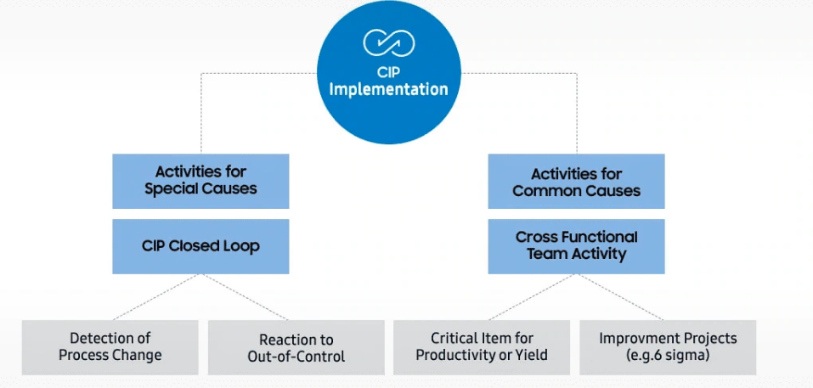

(Source: Semiconductor, 2022)