**AN EMPIRICAL EVALUATION OF SUSTAINABLE AND GREEN MANAGEMENT OF SUPPLY CHAIN: A CASE STUDY REGARDING UK CONSTRUCTION SECTOR**

**Abstract**

The construction sector, which also generates waste and depletes resources, is a significant contributor to the emission of greenhouse gases on a worldwide scale. The industry has been designated as a priority area for addressing the sustainability challenges due to the noticeable significant impact it has on society and the environment. Nowadays, "green and sustainable supply chain management" is being adopted more frequently in the building industry in order to lessen the sector's negative social and environmental impacts. This study aims to provide an empirical evaluation of the implementation of "green and sustainable supply chain management" in terms of the UK's constriction sector. In addition to producing waste and using up resources, the building industry contributes significantly to the global emission of greenhouse gases. A priority area for tackling the sustainability challenges has been set aside for the industry because of the obvious and significant effects it has on society and the environment. In order to lessen the construction industry's detrimental social and environmental impacts, "green and sustainable supply chain management" is now being used more frequently. The purpose of this research is to offer an empirical assessment of the adoption of "green and sustainable supply chain management" in the UK's constriction industry.

**Acknowledgement**

The work “would not have been possible” without the contribution of **(project teacher name)** of the university **(insert college/university name)**. I am indebted to **(insert other teachers who have some contribution)** who have offered continuous support while preparing the project.

I am also grateful to all those "with whom" I had the opportunity to do the work and complete the project. 'Each member" of the "dissertation committee" have offered and provided' "professional guidance" and have given me great advice while completing the project.

On a personal note, I am also grateful to my family members who have offered me continuous support while I was completing the project. Without the help and support of them, this project would not have been completed.

Table of Contents

“Chapter 1”: “Introduction” 7

1.1 “Introduction” 7

1.2 Background of the study 8

1.3 Research aim 9

1.4 Research objective 9

1.5 Research question 10

1.6 Research hypothesis 11

1.7 Research rationale 12

1.8 Research Significance 14

1.9 Framework of the research 15

1.10 Conclusion 16

“Chapter 2: Literature review” 17

2.1 “Introduction” 17

2.2 Empirical study 17

2.3 Theories and models 22

2.4 Literature gap 24

2.5 Conceptual framework 25

2.5.1 Dependent variable 25

2.5.2 Independent variable 26

2.6 Conclusion 31

Chapter 3: Methodology 32

3.1 Introduction 32

3.2 Method outline 33

3.3 Research philosophy 34

3.4 Research approach 35

3.5 Research Design 36

3.6 Research Strategy 36

3.7 Research method 36

3.8 Method of data collection 37

3.9 Research ethics 37

3.10 Research limitation 38

3.11 Time horizon 38

3.12 Conclusion 38

Chapter 4: Findings and analysis 39

4.1 Introduction 39

4.2 Analysis 39

4.2.1 Secondary analysis 39

4.3 Discussion of the findings 46

4.3.1 Secondary analysis 46

4.4 Conclusion 52

Chapter 5: Conclusion 52

5.1 Introduction 52

5.2 Linking with objectives 52

5.3 Recommendation 57

5.4 Conclusion 58

Reference list 59

Appendices 76

**List of tables**

Figure 1: Background of study 8

Figure 2: Research objective 9

Figure 3: Research question 10

Figure 4: Research Hypothesis 11

Figure 5: Research Rationale 13

Figure 6: Research Significance 14

Figure 7: Research Significance 16

Figure 8: Conclusion 16

Figure 9: Empirical study 18

Figure 10: Theories and model 22

Figure 11: AIDA model 23

Figure 12: Literature Gap 24

Figure 13: Conceptual framework 25

Figure 14: Method Outline 33

Figure 15: Research Philosophy 34

Figure 16: Research approach 35

Figure 17: Time Horizon 38

# “Chapter 1”: “Introduction”

## 1.1 “Introduction”

Regarding the emission of global green gas, the construction industry is a major contributor including waste generation and deletion of resources. In the form of a priority area, the sector has been identified for addressing the challenges of sustainability for on the society and environment the presence of considerable impact that is noticed. The adoption of “green and sustainable supply chain management” is getting done increasingly nowadays in the industry of construction to reduce the social impact of the sector and to reduce the negative environmental impact of the sector. In this research, it is aimed to be provided a “green and sustainable supply chain management” implementation empirical evaluation in terms of the construction industry in the UK. The case study approach is going to be used in this research for the examination in terms of the “green and sustainable supply chain management” work implementation, and in this regard, the UK is taken regarding construction projects. The effectiveness of “green and sustainable supply chain management” is going to be assessed in this research for the promotion of sustainability and key barriers and drivers identification to their adoption. In this chapter of the research the background of this research, the “research aim”, the “research objective” the “questions of this research”, the “hypothesis of this research”, the research rationale, the importance of this study, the “framework of this study” and the conclusion is needed to be implemented.

## 1.2 Background of the study

#### Figure 1: Background of study

(Source: In MS Word self created)

This research background is mainly concentrated on the evaluation and implementation of practices of “green and sustainable supply chain management” within the construction industry of the UK. On the environment, the major impact is noticed by the construction industry for the operation that is very much resource intensive, and a huge waste is also generated from this sector. That is the reason in the construction industry the implementation of sustainable practices is getting increased day by day for the negative impact reduction on the environment. One of the major approaches is considered the practices of “green and sustainable supply chain management” for the environmental impact reduction of the industry of construction. Environmental integration is involved in this approach and in this regard disposal, transportation, manufacturing, and sourcing are involved. This research makes the evaluation of the practices of “sustainable and green supply chain management”. In this research, the findings that are going to be done by the construction companies help is going to be provided a better understanding of the challenges and benefits of practices of “green and sustainable supply chain management” implementation and their successful implementation strategies are also going to be developed through the findings of this research.

## 1.3 Research aim

For this research, the aim is taken regarding the effectiveness and implementation of the evaluation empirically of “green and sustainable practices of supply chain management” in the industry of construction in the “United Kingdom”.

## 1.4 Research objective

#### Figure 2: Research objective

(Source: In MS Word self created)

* To evaluate daily activities' investigation that is the main objective of the industry of construction in the UK.
* To evaluate the aim in this regard which is required to implement and examine environmentally friendly and sustainable practices of supply chain management in the UK.
* To evaluate the purpose in this regard is to explore the transformation and construction industry development in the UK over time.
* To evaluate the major focus of this research that is put forward regarding “green and sustainable supply chain management” practices and principles.
* To evaluate the major aim in this regard that is set regarding the way “green and sustainable supply chain management” is applied within the industry regarding construction.
* To evaluate the goal of this research that is needed to analyze the “green and sustainable supply chain management” impact in terms of the sector of “construction” in the UK.

## 1.5 Research question

#### Figure 3: Research question

(Source: In MS Word self created)

Q1: How operation is done in the construction industry of the UK?

Q2: How the application of “green and sustainable supply chain management” is done in terms of the UK?

Q3: What impact does “sustainable and green supply chain management” have on the sector of construction in terms of the UK?

Q4: How over time the sector of construction in the UK has evolved?

Q5: What is the meaning of “sustainable and green supply chain management” in this study?

Q6: How does “sustainable and green supply chain management” apply in the “construction industry” of the UK?

## 1.6 Research hypothesis

#### Figure 4: Research Hypothesis

(Source: In MS Word self created)

The research hypothesis is mentioned below.

H0: An overview of the operation in the construction sector of the UK is provided.

H1: An overview of the operation in the construction sector of the UK is not provided.

H0: Application of “green and sustainable supply chain management” is done in terms of the UK.

H1: Application of “green and sustainable supply chain management” is not done in terms of the UK.

H0: The impact of “sustainable and green supply chain management” is present in the industry of “construction” in the UK.

H1: The impact of sustainable and green supply chain management is not present in the sector of construction in the UK.

H0: Overtime sector of construction in the UK has evolved.

H1: Overtime sector of construction in the UK has not evolved.

H0: The meaning of “sustainable and green supply chain management” in term of the UK is very important.

H1: The Meaning of sustainable and green supply chain management in the UK is not very important.

H0: “Green and “sustainable supply chain management” in terms of the UK gets applied in the construction industry in the UK majorly.

H1: “Green and sustainable supply chain management” in terms of the UK has not to get applied in the construction industry in the UK majorly.

## 1.7 Research rationale

#### Figure 5: Research Rationale

(Source: In MS Word self created)

For conducting this research the rationale behind it is “green and sustainable supply chain management” empirical evaluation in the industry of construction in the UK in multifold.

Towards the degradation of the environment in the form of major contributors the construction industry works and this accounts for a significant portion of environmental degradation with the presence of waste generation, emission of greenhouse gas, and depletion of resources. That is the reason there are noticed a significant need for the practices of green and sustainable practices in the sector for the mitigation of these impacts.

In the other hand for the improvement of sustainability in the form of the major area, the supply chain management works. All activities encompassed in the supply chain in the delivery and production of services and goods are involved, and it can have an impact on the society and environment majorly. That is the reason the extent to which “green and sustainable supply chain management” practices are integrated into the sector of constriction into “supply chain management is very much important”.

The lack of empirical research noticed in this regard on the impact and application of “green and sustainable supply chain management” in the construction industry in the UK. A good deal of research is conducted on the practices of sustainable construction and that is the reason in this regard extended research is required that mainly focuses on supply chain management and the opportunities and challenges associated with it with the sustainable and green practices implementation in this research.

If judged on an overall basis, on the “sustainable and green supply chain management” in the UK constriction industry the empirical evaluation that is done will provide valuable insight into the sustainable practices' current state in the industry with the enablers and barriers to their implementation. To inform practice and policy the use of this information is done and towards a more resilient and sustainable sector of construction it helps to drive the transition.

## 1.8 Research Significance

#### Figure 6: Research Significance

(Source: In MS Word self created)

The title of this research is “An Empirical Evaluation of Sustainable and Green Chain of Supply Chain Management: A Case Study of the UK Construction Sector” and in “supply chain management” and sustainability, it has major importance. There are many reasons present behind it and these are mentioned here.

The first reason is timeliness. The environmental challenges are faced currently by the world and example regarding it is pollution, depletion of resources, and change and climate. That is the reason for the sustainable solutions there is noticed the presence of urgent need mainly in the industry of constriction that put on the environment a significant impact. By focusing on the UK construction sector the issues are addressed in this research.

The second reason is practicality. Globally one of the largest industries is the industry of construction and in the development of the economy, it plays a major role. That is the reason depending on the stakeholders the findings of this research will have major implications which include consumers, suppliers, construction companies, and policymakers. The way “green and sustainable supply chain management” work regarding it a major insight is provided by it and into the construction practices it can be incorporated.

The third reason is innovation. In its approach, this research is innovative for the evaluation of “green and sustainable supply chain management”. For the investigation of the implementation of sustainable practice in the UK empirical methods is used by it. For future research by doing this, it provides the basis and in the construction industry, it also provides sustainable development practices.

The fourth reason is transferability. To other sectors or industries, the findings of this research are transferable. In this research “green and sustainable supply chain management” practices are identified and can be implemented and adapted by other industries for environmental impact reduction.

If judged on an overall basis the significant nature is noticed in this research because critical issues are addressed here and this research has an innovative approach and practical implications and also includes transferable findings also.

## 1.9 Framework of the research

#### Figure 7: Research Significance

(Source: In MS Word self created)

The framework of this research is the “introduction”, “literature review”, “methodology”, “findings and analysis”, and “conclusion”.

## 1.10 Conclusion

#### Figure 8: Conclusion

(Source: In MS Word self created)

Detailed insight is provided by this chapter into major areas depending on which this research is based. The objective and the aim that is set for this research have been identified to provide a major look at the primary goals of this research. The background of this research is also covered which has a major emphasis on the construction sector in the UK and on “green and sustainable supply chain management”. The background related to the research area is effectively described in this chapter and the presentation of the research question is done that has a major link up with the research objective of this research. The associated issue in this research is related to the UK construction industry and to “green and sustainable supply chain management”. Further, in this chapter, the research significance is also presented including the specific areas of the research which will help to explore the UK construction industry more effectively. In this chapter finally, the overall framework of this research is going to be followed for conducting this research.

# “Chapter 2: Literature review”

## 2.1 “Introduction”

A detailed look is given forward through the literature review chapter and with the area of this research the critical aspect that is associated is also discussed in this chapter. By various authors, this research is conducted regarding the UK industry of construction and sustainable and green supply chain management is also discussed in this chapter with the help of various journals of the authors. The models and theories that are used in this research are demonstrated in this chapter effectively, through which subjective evaluation can be done effectively of the secondary information.

## 2.2 Empirical study

#### Figure 9: Empirical study

(Source: In MS Word self created)

The empirical literature review provides the basis for the initial understanding and development of the various aspects that are to this research is very important, and from the methods and approaches of understanding that in this research is used are implemented for the area of investigation related to this research. The identification of the major area of this research is done through this research. The formal procedure is also substantiated by them in terms of gaining subsequent knowledge that will help in this research to proceed further.

According to Newman *et al.* (2021) in various terms for industry, the rise of digital technology is known which includes the fourth industrial revolution or industry 4.0, and it is simply also termed number 4 (Newman *et al.* 2021). In this concept, the presence of encapsulated that is noticed is the attempt through which a complex array of digital technologies, programming languages, and tools complex array are integrated into the form of unison acts. Within this manuscript, the use of terminology 14 is going to be done for brevity.

According to Balasubramanian *et al.* (2021) for addressing the sector of construction worldwide major actions are taken by governments all around the world, and the most prominent action is taken by the government of the UK (Balasubramanian *et al.* 2021). For the construction industry, various issues arise and the major issues that come forward in the UK are related to the safety and health risk, emission of high carbon, increased costs, and low productivity. In the UK in the industry of construction, the application industry 4.0 that is done might address some specific concerned areas. Regarding this, however, limited understanding is present, and in terms of interrelationships and technologies, the previous work regarding it is fragmented largely.

According to Osobajo *et al.* (2022), from the industrial ecology field, the presence of a circular economy is noticed. This economy in the current situation is perceived to emerge and the attention of the practitioners also gained by it, which includes scholars and policymakers from different fields of industry and research. This has a significant impact on "green and sustainable supply chain management" and the UK construction sector (Osobajo *et al.* 2022). The fundamental desire and need for an alternative approach can be linked to the linear model that is traditional of linear or growth economy of disposing of, making, and taking of the materials in the construction industry in different sectors and mainly in the construction sector or industry. The concept has been accepted around the world including in the UK for sustainability promotion. More waste is produced in the industry of construction than in any other industry or sector. Though the activities of construction generate more waste and because of this industry of constriction a major impact is noticed that affects the economy, society, and environment. In this regard within the construction industry application, limited research is conducted. The suggestion is provided in this research that the strategies must be adopted appropriately to counter the waste and emission of carbon in the UK in construction.

According to Onat and Kucukvar (2020) all around the world sustainable development has become a major concern. Regarding sustainable development, the major definitions that can be used are taken from the Brantland Commission report in 1987 (Onat and Kucukvar, 2020). The statement provided in it is related to the sustainable development realization in the present time that in the future time needed to be considered also. Regarding the green economy sustainable development is a concept and over time it is gaining more attention, majorly in the economy that is growing exponentially.

According to Skouloudis *et al.* (2020), the aim set by the researchers regarding the “green and sustainable supply chain management” in the industry of construction in the UK with the barriers and drivers for their adoption. The collection of data is done by the author of the constriction companies around 152 followed by 20 of these companies. In this research, it is found that in the industry of construction in the UK the presence of “green and sustainable supply chain management” is noticed that is currently in the early stage is present. Regarding the importance of “green and sustainable practices,” there is noticed growing awareness (Skouloudis *et al.* 2020). In this regard, it is found by the author that reporting has been done by the companies for the significant proportion of implementation of the “green and sustainable supply chain practices” in various forms. In this research by the author, several drivers' identification is noticed for the “green and sustainable practices adoption. It includes reputation management, demands of the clients, and regulatory requirements. By the author it also found that there are some obstacles are also present in terms of adoption. It includes the absence of awareness, “sustainable and green practices” understanding, the absence of resources, and the existing practices showing reluctance in changing. If judged on an overall basis this research provides important information regarding the present “sustainable and green supply chain management” state in the industry of construction in the UK. For policymakers, these findings are very much useful. For the other stakeholders and companies for the initiatives and strategies development, the findings are also very much important for the “green and sustainable practices” promotion in the industry.

According to Shooshtarian *et al.* (2020)in this research author aims to examine the “sustainable and green practices” implementation in the industry of construction in the UK. The author followed the case study approach regarding this research for the investigation of the “practices of supply chain management” in the UK regarding a leading company of construction. This research is done by the author regarding the “sustainable and green supply chain management practices” and it is revealed from this that various implementation of the “green and sustainable supply chain management” is the by the construction companies in its chain of supply (Shooshtarian *et al.* 2020). In this research current areas are also identified where the improvement scope of the company is present. An example regarding it is renewable sources of energy increase and more effective reporting and monitoring mechanism presence. The conclusion made from this research by the author is for the industry of construction “sustainable and green supply chain management is very much important. It is important not only for the reasons of the environment but also for a social reason and economic reasons also. The holistic approach must be adopted by the companies and with their partners of supply chain collaboratively work must be done for the sustainable practices' implementation through the whole chain of supply. If judged on an overall basis valuable information is provided in this research into “sustainable and green practices of management” in the industry of construction in the UK and regarding sustainable practices, adoption importance is also highlighted in the industry.

According to Reklitis *et al.* (2021) regarding the “sustainable and green practices of management,” empirical evaluation in the chain of supply of the industry of construction in the UK are presented and discussed by the author. In the construction industry, the author has highlighted the “green and sustainable practices of management” importance in terms of its major impact on the environment (Reklitis *et al.* 2021). Findings that are done in this research of author it is found that in the UK industry of construction, “sustainable and green practices” adoption is noticed at a higher rate, but regarding improvement, there is still the presence of room is noticed. Many barriers are identified by the authors for the “green and sustainable practices of management”. It includes the absence of regulation, absence of awareness, and lack of cost. The conclusion is made by the author that among the stakeholders there is always a greater need present in terms of collaboration in the chain of supply in construction for the “green and sustainable practices” promotion. The recommendation is made by the author that the government of the UK must introduce regulations strongly for “green and sustainable practices adoption encouragement in the industry of construction. If judged on an overall basis through this research important information regarding the “green and sustainable practices” current position is identified in the industry of construction in the UK and for the further, it also highlights the importance and action for the sustainability promotion in the industry of construction.

According to NaBholz *et al.*  (2020), the present state of “green and sustainable management of the chain of supply and the practices of green management in the industry of construction in the UK is discussed by the authors (NaBholz *et al.* 2020). In the construction companies of the UK, the author conducted a case study for the examination of the “practices of management of the chain of supply” and the opportunity identification regarding environmental performance and sustainability improvement. From this research by the author, the result that is derived indicates that the major efforts are made by the companies in the industry of construction in its chain of supply.

## 2.3 Theories and models

#### Figure 10: Theories and model

(Source: In MS Word self created)

In this research, the models and theories that are used are implemented mostly for the concept and ideas development for providing the platform the theories are responsible also, and depending on that regarding the issue appropriate justification is provided in this research. That is the reason to the construction sector of the UK and in terms of the green and sustainable development; the theories are made relatable in this research to present the observed situation’s absolute justification. In this research, the theories that are going to be used are “self-persuasion theory” and “theory of persuasion knowledge (Burton *et al.* 2021).

#### Figure 11: AIDA model

(Source: In MS Word self created)

The model that is going to be used in this research is regarding the AIDA model. In this model four aspects are included and these are attraction, action, desire, and interest. In terms of making decisions sequential flow of the model of AIDA is very important and depending on this the “green and sustainable supply chain management” and the UK construction sector discussion is done.

## 2.4 Literature gap

#### Figure 12: Literature Gap

(Source: In MS Word self created)

Although sufficient information is present that is for performing this research is very much helpful, some limitations and drawbacks are also notified by the empirical literature in this regard, and that to the present research will provide a major direction in the literature that is studied by filling up the gaps (Badi & Murtagh, 2019). The limitation or gap that is noticed in this research is majorly present in researchers because, on the secondary data analysis, they are majorly dependent. In the collection of data major limitation is noticed because in this research is focused only on the UK construction sector or industry and except for the UK no other countries are considered in this research. In this research, the only consideration is given to the construction sector or industry, and expects that no other sector or industry is considered. This research only discusses “green and sustainable supply chain management” and expects that no other “supply chain management” is covered in this research (Murtagh *et al.* 2020). This is also a major gap or limitation in this research. For further analysis and aspects of this research, the limitations are considered in the favor of the UK construction industry or “industry” in terms of green and sustainable development.

## 2.5 Conceptual framework

**Environmental policies and regulations**

**Stakeholder collaboration**

**Dependent Variables**

**Independent Variable**

**Intelligent Transportation System**

**Availability of green materials andtechnolohu**

**Engagement and education**

#### Figure 13: Conceptual framework

(Source: In MS Word self created)

In this research, “sustainable and green supply chain management” is the dependent variable and various factors are included in the independent variable that affects the green and supply chain management these are environmental policies and regulations, availability of green materials and technology, stakeholder collaboration, and engagement and education and training on sustainable practices.

### 2.5.1 Dependent variable

#### 2.5.1.1 “Sustainable and green supply chain management”

In this research, the dependent variable is “sustainable and green supply chain management”. The strategies and practices that the companies adopted refer to that for ensuring that operations of the supply chain are responsible socially and sustainable environmentally. In this regard fair practices of labor, waste minimization, recycling promotion, and carbon emission reduction are included (Giorgi *et al.* 2022). The practices of “sustainable and green supply chain management” effectiveness are evaluated in this research in the sector of construction in the UK. On the practices of the supply chain, this involves data collection of companies' samples in this sector. In this regard to identify trends and patterns the data analysis is done regarding the sustainable and green practices impact also draws conclusions. The examination of possible independent variables that are done in this research includes renewable energy sources adoption, sustainable material usage, ethical practices of labor implementation, and eco-friendly method of transportation adoption (Stanitsas & Kirytopoulos & Leopoulos, 2021). The other factors that are considered in this regard are the culture of an organization, the norms of an industry, and the regulatory framework that works in the form of variables that are explanatory.

If judged on an overall basis the empirical evidence is deemed to be provided in this research on the challenges and benefits of the green and sustainable implementation of the “supply chain management” practices in the sector of “construction”. In this research, the findings that are done might inform practices and policies in this sector, and to the growing body of knowledge the major contribution is noticed in supply chain management eventually. ***[Referred to appendix 1]***

### 2.5.2 Independent variable

#### 2.5.2.1 Environmental policies and regulation

Among all sectors, one of the significant sectors is the construction industry which contributes to the degradation of the environment. For global water generation, water consumption, and \emission of carbon a large percentage is noticed of environmental degradation. That is the “sustainable and green management” implementation practices in the supply chain become for the industry a major concern. Several regulations and policies have been put in place by the government of the UK through which environmental impact aimed to be reduced in the construction sector. 2008 climate change act is one of the major policies that for the greenhouse gas emission sets binding targets by 2050 of around 80% compared to levels of 1990. Many initiatives are introduced by the government additionally that includes the strategy of Construction 2025 through which the construction industry vision is set to achieve efficient and sustainable practices by the year 2025 (Zhang & Olanipekun & Bai, 2019). By researchers, a case study was conducted at the “Manchester University” for the implementation of “sustainable and green practices of management” in the supply chain of the UK. On three major areas, this research is focused on, and these areas are the consumption of water, management of waste, and emission of carbon. In the reduction of carbon emissions although the industry of construction has made some progress, in this regard more progress is required to be made. To increase the efficiency of energy, more focus is required in this sector. In this regard renewable sources of energy increase and reduction in the intensity of carbon material that in the construction is required to be used are also needed to be kept in focus more.

Over the years with the decrease in waste to landfill, in this regard, major progress is noticed in the construction industry in terms of waste management. For improvement there is still the presence of room is noticed in waste generation amount reduction and in the reuse and recycle material increase.

In terms of the consumption of water in this research, it is found that the industry of constriction in this area has made little progress with various companies that are using practices that are water intensive. On the use of water-efficient technologies and practices increase this industry is required to stay focused more and by the researchers, it is suggested also.

If judged on an overall basis this research is done while the industry of constriction of the UK has made progress in “green and sustainable practices of management” implementation that has improvement room still (Scott & Broyd & Ma, 2021). The recommendation provided by the researchers is that in the industry companies are required to have stayed focused on sustainability integration into their major practices of business and the approach of the lifecycle is also adopted for the impact reduction on the environment, resource efficiency reduction, and other stakeholders and suppliers collaboration for the sustainable goal achievement. ***[Referred to appendix 2]***

#### 2.5.2.2 Availability of green materials and technology

In many industries “sustainable and green supply chain management is becoming important increasingly which includes the industry of construction in the UK. For management one of the major aspects is green technology and materials availability. In this regard, an empirical evaluation is going to be done regarding the use and availability of green technologies and materials in the industry of construction in the UK.

As per research on green technology and material, availability has increased significantly in recent years. Many companies of construction are using nowadays materials that are sustainable and the example regarding it is reclaimed wood, bamboo, and recycled steel (Vasilca *et al.* 2021). Green technologies in addition to that are becoming popular increasingly in the industry of construction. Example of it is the geothermal system, wind turbines, and solar panels. The environmentally friendly nature is noticed in these technologies and the construction companies' energy costs are also reduced.

Eco-friendly products are offered nowadays by many suppliers furthermore to meet the demand for sustainable technologies and management. In this regard, insulation materials are produced by some manufacturers from recycled materials is used while adhesives and VOC paints are offered by others. The availability is increasing regarding green technologies and materials, and because of this for construction companies, it is getting easier to adopt in their supply chains in terms of sustainable practices.

However, the adaptation of practices that are “green and sustainable” in the industry of construction in the UK is facing major challenges still. In the first stage of green technology and material, the cost is higher often rather than the alternatives which are traditional in nature (Kesidou & Sovacool, 2019). Because of this for the companies, investment justification is getting very much difficult which leads to disruption in the potential supply chain.

From the above discussion, it can be determined that in the industry of construction in the UK green technology and material, availability is getting increased, and from the empirical evidence it is shown. Because of this in the supply chains companies have adopted practices that are green and sustainable. In this regard challenge still remains regarding the potential disruption in the supply chain with the green technology and materials costs. It is required to be ensured in this situation that the widespread adoption of “green and sustainable” work must be addressed. ***[Referred to appendix 3]***

#### 2.5.2.3 Waste minimization

The prevalence of waste minimization is noted for the "green and sustainable" supply chain management in the UK construction sector as a significant component. Regarding waste reduction, this approach is taken in the process of construction with the recycling of waste materials and reusing waste materials possible whenever (Wang *et al.* 2019). Regarding the industry of construction in terms of waste minimization, many strategies are adopted and these are mentioned here. The first strategy is taken regarding the deconstruction design. Designing structures and buildings is involved in this approach by keeping in mind their lifecycle end. Materials are used and selected in a way that they can be disassembled and recycled and reused easily when the need of the building is not required anymore. The second strategy is regarding lean construction. The process of construction gets optimized with the involvement of this approach in terms of efficiency maximization and waste elimination. For the reduction of waste in this regard technique of prefabrication is going to be used and with that coordination and communication improvement is also done among the stakeholders of the project for delays and error minimization (Mellado & Lou, 2020). The fourth strategy is regarding waste minimization taken in hazardous waste management. The proper disposal and identification are done regarding hazardous waste materials, and example regarding it is asbestos and chemicals for the environment and workers' protection.

If judged on an overall basis in the form of “sustainable and green management of supply chain” a major aspect of the presence of waste management is noticed in the industry of construction in the UK (Ogunsanya *et al.* 2022). Through these strategies' implementation, environmental impact can be reduced by the companies' construction efficiency can be improved, and in the form of responsible corporate citizens' reputations can be enhanced also. ***[Referred to appendix 4].***

#### 2.5.2.4 Recycling promotion

For the “sustainable and green supply chain management” in form of an important aspect the presence of recycling promotion is noticed in the industry of construction in the UK. Encouragement regarding waste materials are involved in the promotion of recycling that is during the process of construction is generated.

The generation of waste can be reduced significantly with the help of the promotion of recycling and empirical studies show that. It also helps in the reduction of the footprint of carbon and converse resources of the activities related to the construction. In the construction industry of the UK, a case study is conducted in which it is found that 85% of waste generation reduction can be a result of the help of effective promotion of recycling. In the supply chain for the promotion of recycling various strategies must be implemented by the companies of constriction and these are mentioned here. Educating and training the employees on the recycling importance and the training regarding proper disposing and sorting of waste materials are also required to be provided to the employees (Ogunsanya *et al.* 2022). For reduction in waste and for recycling prioritization it is required to be ensured that the subcontractors and suppliers collaboration must be made. Plans regarding the waste management are required to be implemented that prioritize the reuse of materials and recycling (Khahro *et al.* 2021). A system of waste tracking is required to be implemented to monitor the generation of waste and area identification where efforts of waste reduction must be improved. With local communities, it is required to get engaged more including the stakeholders to increase awareness and the promotion of recycling in terms of the sustainable practices of construction benefits.

If judged on an overall basis in the form of major components the presence of recycling is noticed for the “sustainable and green supply chain management in the industry of construction in the UK (Maskuriy *et al.* 2019). With the implementation of effective strategies of the promotion of recycling the impact on the environment can be reduced by the companies of construction, and the construction companies also provide help regarding the sustainable future contribution and converse resources. ***[Referred to appendix 5]***

#### 2.5.2.5 Carbon emission reduction

To the emission of carbon one of the major contributors is the industry of construction worldwide and this industry in terms of carbon emission is responsible for around 38%. That is the reason the “sustainable and green practices of management in the chain of supply can reduce the footprint of carbon significantly of the industry.

In the supply chain “green and sustainable practices” of management” gas empirical studies that it can help to reduce the emission of carbon significantly. An example regarding it is in the industry of construction in the UK research that is done, from that it is found that the sustainable and green practices of management will result in the emission of carbon reduction by 10% (Rogerson & Parry, 2020). From further research, it is come to know that sustainable building materials can be used with efficient transportation and renewable sources of energy and because of this in this industry of construction carbon footprint will be get reduced significantly. In this regard in the industry of construction in Australia, another research is conducted and in that research, it is revealed that by 4.4% the carbon emission reduction is noticed by the “green supply chain” adoption” (Antwi & Ng & Hossain, 2021). Renewable energy sources usage is revealed in further research and in the carbon emission reduction the major contribution is provided by the system of logistics and efficient transportation adoption.

If judged on an overall basis it can be said that demonstration is done by the empirical studies regarding the “green and sustainable supply chain management” adoption that to the carbon emission reduction will provide significant reduction. In these types of practices efficient systems of transportation, renewable sources of energy and sustainable building materials are included (Micheli *et al.* 2020). That is the reason in the construction industry companies it is very much required that “green and sustainable practices” of management must be embraced in the operations of the supply chain to reduce the footprint of carbon and to the changes in the climate must provide fight with a major contribution. ***[Referred to appendix 6]***

## 2.6 Conclusion

The major aspect of the UK industry of construction and “green and sustainable supply chain management” is explained successfully with the full review and evaluation of the sources of literature by the authors shown those who are very much eminent. The based of this research is dependent on the concept of understanding that has developed effectively throughout this chapter (Lahane & Kant & Shankar, 2020). The models and theories are also covered in these chapters that develop an idea regarding the UK construction industry and “green and sustainable supply chain management practices” are very much important. The concept of the independent variable and dependent variable are presented effectively in this chapter depending on which this full research is developed.

# Chapter 3: Methodology

## 3.1 Introduction

The process is described with the help of the methodology in which the full research is done. Various techniques and procedures are present in the methodology during the research performance of this research is adopted. In the planning of the strategies the steps that are taken in this research are described in the methodology section in terms of the different process implementation and method of the research in regard to the obtaining of the result, the performance of the analysis, and collection of data. All related areas are covered in this chapter majorly in terms of the research performance method. Regarding the research strategies, methods, approaches, design, and philosophy an overview is provided with the help of methodology. The chapter on methodology also provides the data collection method details and the details regarding the analysis that is done in this research. Regarding ethical considerations, a detailed overview is provided with the help of this chapter, and the procedure limitation is also provided in this chapter. The flow of different stages is indicated with the help of a timeline in terms of the research method of this research.

## 3.2 Method outline

#### Figure 14: Method Outline

(Source: In MS Word self created)

A procedure systematically is followed in this research to the exact result obtained from planning on the objective that has been established already. Different strategies and approaches are identified and determined through the planning phase of this research that to reach the correct goals must be undertaken and the objectives of this research must be fulfilled by it. Based on the appropriate strategies' selection with the approaches and methods the initiation of the process of collection of data is done. An important area is formed by the process of collection of data that impacts all the information and based on that the findings and results are obtained. After the collection of data is done from the exact sources that the researchers identified related to it proper information is analyzed and recorded using the techniques that are correct and by which the most appropriate results can be yielded for answering the question of the research and hypothetical statement test that for the research is developed. That is the reason in this research the outline of the method that is done it indicates major stages that are numbered five and these stages are correct methods, resources, strategies, approaches, obtaining of results, analysis of data, and collection of data.

## 3.3 Research philosophy

#### Figure 15: Research Philosophy

(Source: In MS Word self created)

Depending on the various philosophy the research can be based on, and those philosophies is related to the researchers to reach the objective that is perfect strategically that is defined based on the purpose and problem of this research. It gets very easy to determine this research and other progressing aspects with the help of proper research philosophy identification and the example regarding it is methods, strategies, and approaches. For conducting research various philosophies can be adopted and those philosophies are “realism”, “positivism”, “interpretivism”, “constructivism”, “pragmatism” and “objectivism”. In this research “positivism” and “realism” philosophy is used and the use of these philosophies will be based on the research question, hypothetical statement analysis, and test that for this research is developed and qualitative explanation must be provided regarding the backgrounds well-prepared knowledge in terms of this research. Based on the data that are measurable and based on the data that are not measurable this research is based on the important areas of analysis regarding the UK industry of construction and “green and sustainable supply chain management”.

## 3.4 Research approach

#### Figure 16: Research approach

(Source: In MS Word self created)

For analysis of the data and for the performance of this research the use of much research can be done in research. The most two important approaches in this regard are the present “inductive approach” and the “deductive approach the theories exist already based on that research the use of the deductive approach is done. New results and theories are produced in research by the inductive approach. The appropriate approach to this research selected is dependent majorly on the philosophy of the researchers who developed these research philosophies. In this research, the use of the deductive approach is done with the help of “positivism philosophy”. Based on the base of knowledge and information that is existed already this research is done. By this, in the upcoming stages, strategic analysis is done to generate major results that can address and explain the research question. That is the reason the correct approach for this research is the deductive approach.

## 3.5 Research Design

In quantitative and qualitative research analysis both the classification of the research design is done in research mainly. Regarding the data and the resources, perception-based analysis and observation-based analysis are done. While measurable and statistical outcomes are provided with the help of quantitative research from research. Based on the philosophy, the design of this research is based including regarding this research the approach that is taken. On the positivist philosophy and realism philosophy, this research is based that provides importance regarding results development from the information that exists already on the basis of the knowledge that the deductive approach gets correspondent and that for this research is chosen.

The qualitative research analysis method is used in this research and the use of this research method is going to be done in this research because in terms of providing applicable outcomes it supplements limitations. With the help of this research analysis method, the research quality of this research is going to be improved in terms of the findings of this research, and information reliability helped to be validated from the secondary sources that are gathered through an evaluation strategically.

## 3.6 Research Strategy

The technique that for this research is used is explained in the research strategy that the researchers used to collect appropriate information that to the area of research is appropriate. Various strategies are involved in research that helps to analyze and gather a huge amount of data for the desired outcomes' development. On the research philosophy, the strategies' selection is dependent majorly on the overall study adoption in this research. On the positivism philosophy, this research is based on, and from this indication is gathered that resources that are collected from those appropriate outcomes will be generated, and depending on the present base of knowledge this is developed. For the secondary data collection, of this research the strategy that is used is named “archival research strategy”.

## 3.7 Research method

In research, various methods of research are possibly to be used, and those methods are named “multi-method”, “mixed method” and “mono method”. The major aspect of this research is depending on the UK industry of construction and “green and sustainable supply chain management” and taking this the whole research is carried out. In this research, mainly qualitative data is used to explore from a common viewpoint respective area. The explanation is provided by it “mono method” is used for this research and to get effective results from this research it is a very much appropriate option. Regarding the area of this, a large area is indicated also by it that with the help of the “mono method” is going to be covered to correct result regarding this research.

## 3.8 Method of data collection

The data collection method of this research presents the resources and total performed of the analysis of this research is done with the help of the collection of appropriate data procedure. Mainly secondary data analysis method is used in this research for gaining the findings of this research. From the various secondary sources based on strategic research, the collection of the secondary data is done, and the sources that are going to be used in this regard are various reports of the construction companies in the UK including online articles, websites, and journals. Regarding the industry of construction in the UK and regarding “green and sustainable supply chain management” major aspects are pointed out in this research.

## 3.9 Research ethics

In the research many stages are involved that are termed values and ethics and those values and ethics are required to abide by the procedures and standards of the performance of this research. With the ethical consideration, this research is incorporated effectively and these are mentioned in this section. The chosen strategy and procedure of this research for analysis and data collection comply with all the standards and policies of conducting research. The collection of data that is done is only related to the UK industry of construction and regarding the “green and sustainable supply chain. Regarding data privacy and standards of confidentiality, this research complies. For conducting this research in any environment or community no harm is caused. With the collection of secondary data regarding this research, no application of discrimination is done. With honesty and truthfulness, this research is done and no type of manipulation of data is done for gaining that from the analysis obtained.

## 3.10 Research limitation

The adequate nature is noticed in the process of this research. For the appropriate result development through the use of techniques and strategies that are effective in the overall procedure of this research. In the research in the collection of data a major limitation is formed which is based on the UK industry of construction and “green and sustainable supply chain management,” The areas that are stringent are failed to be indicated in this research that the companies of construction industry of UK are needed to be improved for grain base of the customers and workers in the industry and to improve the net profit and to gain larger base of customer.

## 3.11 Time horizon

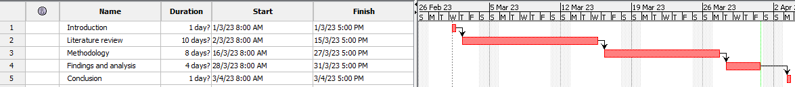

#### Figure 17: Time Horizon

(Source: In Project libre self created)

## 3.12 Conclusion

For conducting this research detailed information is provided in this chapter. In this chapter significant design, methods, strategies, philosophy, and approaches used that by the researchers are followed. Regarding this in this chapter demonstration is also done systematically. The task overflow is provided in the methodology section. By this fulfilment of the objective is done and for the sequential stages, this chapter discussion is considerable of the planning of this research analysis and collection of data. Regarding the distinct stages, further explanation in this research is also provided. The ethical factors are highlighted in this research and these are in this research are considered while doing this research and related to the method of this research presentation the limitation of this research.

# Chapter 4: Findings and analysis

## 4.1 Introduction

Regarding this research major part is done in this chapter. For the obtaining of the result, the secondary data analysis method is used in this chapter using the secondary data sources that have been collected. The “qualitative research analysis method is used in this research and analysis is also done regarding the results that are obtained (Ortiz *et al.* 2021). The discussion of the results is also done in this chapter and the findings that are done regarding it a thorough statement is also provided in terms of the findings from which this research major part is formed. Based on the objective that is defined the ultimate result is provided in this section including a statement of the hypothesis that is tested strategically.

## 4.2 Analysis

### 4.2.1 Secondary analysis

#### 4.2.1.1 Increase emphasis on “sustainable and green management of supply chain

In the UK industry of construction in terms of the “sustainable and green management of supply chain,” an empirical evaluation is noticed. It involves the assessment of the construction companies in the construction industry those are making the implementation of the “sustainable and green practices” in their management of supply chain processes (Cousins *et al.* 2019). With the help of a case study the explanation of it will be done in a better way.

For conducting that case study the approach that is taken is for the sample identification in the UK construction sector companies and on their “supply chain management practices” gathering of data is also done (Bekrar *et al.* 2021). With the help of analysis of documents and with the help of the journal, articles and websites the collection of the data can be done.

In the analysis of documents the reports of the company reviewing is the major part, and it also includes other required documents and reports of sustainability for the identification of major “green and sustainable management” initiatives that implementation is done by the companies in the chain of supply.

When the collection of the data is done, after that the analysis of those data is going to be done for the common trends and theme identification in “sustainable and green management of supply chain” work among the companies that are present in the industry of construction in the UK (Abbasi *et al.* 2021). The challenges or barriers can be revealed with the help of this analysis faced by the companies in the “green and sustainable practices” in their management of the supply chain.

From the case study the findings that are done those findings can be used for the recommendation development for companies in the industry of construction in the UK. for the improvement in the “green and sustainable management practices of the supply chain (Fraser & Müller & Schwarzkopf, 2020).” The initiatives of the industry and the policies of the government are also informed with the help of these recommendations that aimed at the “green and sustainable practices” promotion in the industry.

#### 4.2.1.2 Benefit of the “Sustainable and green practices of management in the chain of supply

There are various benefits present in the “green and sustainable practices of management” in the chain of supply for the business and in this regard majorly for the construction industry businesses that in the UK are present.

In “supply chain” the “sustainable and green practices of management can provide help towards supply chain carbon footprint minimization with the converse resources and reduced waste. The regulations of the environment can be met by the business with the help of this (Lim *et al.* 2021). This also provides help in terms of the local ecosystem and communities' impact reduction and to a more sustainable future by making more contributions.

In terms of the “sustainable and green practices of management,” another major benefit is the improved reputation (Malik *et al.* 2019). Other stakeholders, investors, and customers are looking increasingly for businesses that produce a commitment to implementing sustainability towards sustainable practices in the chain of supply, and the image of the brand and the reputation of the company get improved with the help of this (Meng 2019).

In the final stage the “practices of green and sustainable management” can help also in the cost reduction in the chain of supply.

If judged on an overall basis the “practices of green and sustainable management can provide help to the business towards more efficient operation, environmental impact reduction and among the stakeholders increasing the reputation.

#### 4.2.1.3 The “sustainable and green practices of management” in the chain of supply is low in the UK industry of construction

Regarding the “sustainable and green practices of management” the importance is getting increased day by day in the management of chain of supply majorly in the industry of construction. In the UK these practices' adoption is low relatively in the industry of construction (Núñez *et al.* 2020). For the “green and sustainable practices of management” present state evaluation in the construction industry of UK an implementation of the case study can be done for the opportunities and challenges examination for the companies that are present in this industry. The empirical analysis can be included by this research of construction organization sample. This examines the “sustainable and green practices” adoption level with the factors through which adoption are influenced.

The challenges and benefits are also identified in these researches that are related with the “sustainable and green practices of management” implementation in the chain of supply with the key stakeholders' roles. An example regarding it is customers and suppliers by this sustainability are promoted.

The awareness from that research can be increased with the findings of the “green and sustainable practices of management” in the industry of construction and insight is also provided in terms of the way companies can get through the barriers to adoption (Bayramova & Edwards & Roberts, 2021). The increased adoption will happen because of this, and the more environmentally friendly and sustainable industry of construction contributes more.

#### 4.2.1.4 The main barriers to the “sustainable and green practices of management” adoption in the chain of supply

The statement that is going to be discussed that confirms from this research generally consistent findings are done through which barriers are examined to the green and sustainable management practices adopted in the chain of supply, majorly in the industry of construction in the UK.

In this, it can be said that published research that is named in 2017, and it is a journal, and it is Cleaner production that identifies awareness lack, incentives lack, and collaboration lack in the form of major barriers among the stakeholders to the sustainable and green practices of management adoption in the sector of construction in the UK (Papachristos *et al.* 2020). A combination of lack of incentives from the economy and the stakeholder's limited knowledge is noted in this research in terms of the “green and sustainable practices of management” in the industry of construction in the UK’s chain of supply might make the adoption discouragement adoption (Yusuf *et al.* 2020). In addition to that it is found from this research that among the stakeholders the collaboration lack that is noticed can create barriers majorly in “sustainable and green practices” implementation throughout the chain of supply.

In 2018 another published research which is named “International Journal of Production” also made the identification of barriers that are identical to the “green and sustainable practices of management” adoption in the industry of construction in the UK chain of supply. In this research, it is found that understanding and awareness of “sustainable and green practices of management was a major obstacle. It happens majorly to medium and small-sized organizations in the industry of construction (Innella & Arashpour & Bai, 2019). From this research, it is also found that both in regulatory and economic the incentives lack are noticed is a major barrier to the “green and sustainable practices adoption”

If it is summarized then it can say that incentives lack, awareness lack and collaboration lack among the stakeholders have made the identification major obstacles to the “green and sustainable practices of management” adoption in the industry of construction’s chain of supply.

#### 4.2.1.5 Implementation of various stages in practices of “green management” in the chain of supply

Regarding the construction industry of UK the presence of case study that is noticed highlights the obstacles to the “sustainable and green practices of management” in the chain of supply (Vu & Ghadge & Bourlakis, 2021). To overcoming these barriers the implementation of many stages can be and those types of practices adoption promotion are also done in this regard.

Increasing awareness is one of the major strategies regarding the “green and sustainable practices of management” adoption in the chain of supply. With the help of campaigns, this can be done through which different stakeholders are targeted, and the example regarding it is customers, contractors, and suppliers (Jraisat *et al.* 2021). The understanding and knowledge will get increased because of the campaigns in terms of “green and sustainable practices” and in this regard to take action, the stakeholders are also encouraged.

Another strategy that is very much important is a program regarding education and trading, and it is required to be provided also that focus on “green and sustainable practices of management”. The design of these programs is done to meet various stakeholders' particular requirements and through a variety of methods, it can be delivered. An example of it is various stakeholders that through a variety of methods can deliver (Mastrocinque *et al.* 2020). With the skills and knowledge that stakeholders are equipped at that time “green and sustainable practices” must be adopted. In terms of adoption, the barriers can be overcome with the help of these programs. The importance of initiatives is noticed, which is required all around the industry for the “sustainable and green practices of management” adoption promotion in the chain of supply (Roh *et al.* 2022). The stakeholders are bought together with the help of these initiatives from all around the industry for the best practices and knowledge sharing and based on the initiatives collaboration is also done that promotes the protection of the environment and sustainability (Li & Greenwood & Kassem, 2019). With collaborative work, the common barriers can be overcome by the stakeholders, and the adoptions of “green and sustainable practices” are also promoted.

If judged on an overall basis it can be determined implementation can be done for the “green and sustainable practices of management” adoption in the chain of supply. The programs regarding education and training by awareness rising are conducted effectively (Mc *et al.* 2021). In this regard, industry-wide initiatives are also supported and to get out of the barriers together stakeholders can work and the sector of construction sustainability is also promoted beyond and in the sector of construction.

#### 4.2.1.6 Sustainable supply chain building through traceability of product

The industry of construction puts a major impact on the society and environment of the resources high consumption and waste that come from production (Munaro & Tavares & Bragança, 2020). That is the reason regarding the “green and sustainable management of the chain of supply” in this industry the requirement is getting increased day by day.

For achievement of this one way is the traceability of the products, which refers to the movement tracking ability of products to the end users from the sources. Transportation and production are ensured with the help of traceability of the products in a sustainable environment and in a socially responsible way.

In terms of “sustainable and green management,” a presence of empirical evaluation is noticed of the chain of supply in the industry of construction in the UK that in the approach of a case study can be involved; where for the analysis specific construction companies or projects are selected (Cai & Waldmann, 2019). The effectiveness can be evaluated with this research in terms of the traceability of the product in sustainability goals achievement through the various examination and these are mentioned here.

The first examination is going to be done regarding the transparency of the supply chain. This research makes the level assessment of the transparency in the chain of supply which includes product ability tracking to the end user from the supplier. The analysis can be involved in it in terms of the accuracy and availability of the information on distribution, transportation, the process of production, and suppliers' information.

The second examination is done regarding the impact on the environment. The impact on the environment can be evaluated with this research in terms of the company or project of construction, which includes the consumption of energy, production of waste, usage of water, and emission of carbon (Rejeb *et al.* 2021). The analysis in this regard can be involved regarding the practices of waste management, methods of transportation, and materials of sustainability.

The third examination is going to be done regarding social responsibility. Social responsibility can be assessed in this research in terms of the company or projects that are related o the construction which includes community engagement, practices, fair labour, and safety of workers. The analysis can be involved in this regard in terms of practices and policies of the company or companies related to the development of the community, ethical sourcing, and human rights.

If judged on an overall basis regarding the “sustainable and green management of chain of supply the presence of empirical evaluation that is done in the industry of construction in the UK can provide effective insights regarding the traceability of the products in sustainability goals achievement (Herrmann *et al.* 2021). From this research, the findings that are done, from that best practices development can be informed for the “sustainable management of the chain of supply in the sector of the construction and to the overall goal it can contribute also in terms of the more responsible and sustainable industry achievement.

#### 4.2.1.7 Evaluation of “green and sustainable supply chain management” using the modeling of the structural equation

The model of the structural equation can be done using the effectiveness of “sustainable and green supply chain management” evaluation practices in the UK sector of constriction (Wang & Chen & Zghari, 2021). In the form of a statistical method, the presence of SEM is noticed that the relationship analysis can be used between the theoretical model's tests and multiple variables.

For the “green and sustainable supply chain management practices” evaluation many steps are required to be followed and these are mentioned here.

The first step is that variables are required to be defined. In this research, the variables include the selection of suppliers' criteria, practices of green procurement, practices of sustainable transportation, practices of management of waste, and indicators of environmental performance.

The second step is data collection (Pan & Chen & Zhan, 2019). With the help of the internet through various journal websites and articles, the collection of data is done and in this regard databases and reports of the companies are also considered.

The third step is data analysis. Using SEM analysis of the data can be done that is analyzed, through which evaluation is allowed of both indirect and direct effects of variables of each other.

The fourth step is the result interpretation (Le 2020). The SEM analysis results can provide insight into the “green and sustainable supply chain management practices” effectiveness” in the sector of construction in the UK.

In the construction industry of UK the “green and sustainable supply chain management practices” evaluation that is noticed can provide industry environmental impact insights and for the improvement, it also provides help regarding the opportunity identification. For the relationship among the analysis of the variables, the use of SEM is done by the researchers and a better understanding can be gained of the factors that the environmental and sustainable friendly practices of the supply chain contribute also (Steinhardt *et al.* 2020). For effective guidelines and policy development, the use of the information can be done for the industry, which leads to more environmentally sustainable responsibility in the industry of construction that covers a broader section.

## 4.3 Discussion of the findings

### 4.3.1 Secondary analysis

Of the “green and sustainable management of the chain of supply the emphasis is getting increased in terms of the findings that are done in the UK sector of construction. It is not a surprising aspect in this regard in terms of the sustainability trend that is provided and regarding the recognition impact increase on the environment, the business has. This emphasis is driven by factors that include initiatives of industry, the demand of the customer, and regulation of the government. These factors are very much important and accountability must be taken by the businesses when strategies of sustainability are developed by them. An important role must be played by the regulations of government for the “green and sustainable practices” in the sector of construction. Many regulations are implemented by the government of the UK towards carbon footprint reduction this government aimed majorly. It included the new home requirement to be free of carbon fully from the year 2016 and the strategy of construction in 2025. For the sector of construction, it sets out a major vision in terms of the emission of the greenhouse gas reduction by 2025 by around 50%.

In the industry of construction on sustainability, the major emphasis is driven by the help of the demand of customers. Customers are becoming more and more aware of the services and products they use and how they affect the environment on a daily basis in this instance. The “green and sustainable” services and products are looked forward to increasingly by the customers and for those services and products; the premium is willingly paid by the customers. Initiatives of the industry and the example regarding it “Supply Chain Sustainability School” and “UK Green Building Council” are playing an important role also in this regard for the green and sustainable practices” promotion in the sector of construction. The other stakeholders, experts of the industry, and businesses are brought together with the help of these initiatives to share best practices and knowledge regarding making sustainability initiatives making the collaboration.

If judged on an overall basis the suggestion is gathered from the findings that the importance of “green and sustainable management” are recognized increasingly in the chain of supply and to incorporate sustainability it is taking important steps into its practices of business. In the form of positive development, this emerged that provides a benefit to the environment and industry both in the long run.

From the case study the findings that are done suggested that “green and sustainable practices in the chain of supply” can have benefits on a larger scale in the industry of construction in the UK. In this research, one of the important identified benefits is the environmental impact reduction of the sector of construction. In this regard conserving resources, waste minimization, and emission of gas are included. The “green and sustainable practices” adopted in the industry of construction companies regarding long-term sustainability promotion and environment protection can provide help.

Regarding the “sustainable and green practices” another major benefit in the chain of supply is improvement in the reputation of the company. Stakeholders and consumers regarding the issues of the environment are getting concerned increasingly and companies, it more wants to do business in which sustainability is prioritized more. With the “sustainable and green practices” adoption in the industry of construction companies can make enhancements regarding their differentiation and reputation from competitors.

In the final stage of this research, it is found that “sustainable and green practices of management can also do sayings from the cost. Through efficiency improvement, resource conversion, and waste reduction the operating costs can be decreased by the organizations, and by doing this profitability of those organizations gets increased also. In the cost-sensitive and competitive industry of construction, it is very much important.

If judged on an overall basis from this research the findings that are derived, from that research suggestion can be gathered regarding the “sustainable and green practices of management” that for the companies have a major benefit in the industry of construction in the UK. Through these practices' adoption, the impact on the environment can be reduced by companies, and by doing this their costs are going to be saved and also their reputation going to be improved. All these activities are done while long-term sustainability promotion is done.

The empirical evaluation findings indicate that “sustainable and green management practices” adoption in the industry of construction in the UK is low still relatively. The lack of resources, skills, and knowledge is present in the form of attributes among the companies for effective practices implementation. A significant nature is noticed in these findings because the company's needs are highlighted through it in the industry of construction to invest more in the green and sustainable practices of management for the long-term “sustainability practices” assurance. The low rate of adoption of the “green and sustainable practices of management” in the industry of construction in the UK happened for the presence of various factors. Awareness lack is one of the major factors in this regard between the companies regarding the “green and sustainable practices of management” benefits. Increased loyalty towards the customer, the reputation of brand improvement, and cost savings are included in it.

Skill and knowledge lack is another factor between the organizations for the “sustainable and green practices of management effectively. This includes required regulation understanding absence, absence of technical expertise in the “green and sustainable practices of management, and clear roadmap absence for the “practices of green and sustainable management” implementation.

In the final stage, the resource absence in the form of a major barrier is also present to the “green and sustainable practices” adoption in the industry of construction in the UK. The financial resources might not be present in the companies and for the investment in the “green and sustainable practices of management” they do not have funding access or the required technology and infrastructure is not present to provide support to those types of practices.

From the discussion above it is come to know that regarding the “green and sustainable management practices” the low rate of adoption that is noticed in the industry of construction in the UK is a major concern in this regard. In “sustainable and green practices of management” the investment must be done by the companies to assure that “long-term sustainability” must be retained and the construction industry the challenges it is facing must be addressed effectively. In this regard development and training of the staff, regarding the “green and sustainable practices” presence of benefit that is noticed in terms of it the awareness must be increased and resources and funding must be accessed to provide support to these types of practices implementation are included.

There are various barriers are present that are related to the “sustainable and green practices of management” in the chain of supply in the sector of construction in the UK. This is suggested by the case study findings in this regard, It includes among the stakeholders lower collaboration and in incentives lack of presence of awareness. In the form of a major obstacle the lower awareness presence is noticed because various individuals and companies in the industry of construction might not have adequate understanding and knowledge of the “green and sustainable practices of management. To adopt those types of practices lower awareness lead to reluctance, this is very much costly and time-consuming.

Another major barrier is the lower incentives depending on which “sustainable and green practices of management” is adopted. In the industry of construction, many companies provide priority to gains that are coming to them within a short period, and because of this, they overlook “goals of sustainability” that present for a longer period. Without the proper incentives, companies might be very much reluctant in terms of “green and sustainable practices of management. An example regarding it is regulations of government and incentives of tax.

In the final stage, another major barrier that is noticed is related to the stakeholders' absence of collaboration that is noticed for the “green and sustainable practices of management. In the supply, the presence of collaboration is required very much to assure that together all stakeholders work towards goals of sustainability that are very much common among them. However, regarding the sector of construction, the presence of fragmented nature is noticed majorly, and collaboration can get challenging in this regard in terms of its chain of supply.

If judged on an overall basis from the case study the findings that are derived highlight these barriers' importance to encourage the “green and sustainable practices of management” in the industry of construction in the UK in its chain of supply. With the help of increased awareness, giving incentives, and collaboration promotion among the stakeholders the industry of construction can lead upfront towards a more environmentally and sustainable friendly nature for the future.

From the case study, the findings that are derived from that suggestion are gathered that the industry of construction in the UK faces major obstacles in terms of “green and sustainable practices” adoption in the chain of supply (Habibi & Mojtahedi & Ostwald, 2021). Lack of regulatory incentives, cost concern, the limited collaboration of stakeholders, and absence of awareness and knowledge are included in it. To get away from these barriers the recommendation is provided by this research that various strategies must be implemented. The campaigns regarding awareness are required to be launched for stakeholders' education regarding the “sustainable and green practices of management”. In this regard benefits of the economy and society, environmental impact positively, the image of the brand, and the way these practices' adoption can improve the reputation of the company are included in it.

In the second stage programs regarding education and training can be given to the other stakeholders and suppliers to make sure that they have the required knowledge and skills in terms of “green and sustainable practices of management” in the process of work. Online courses of training, seminars, and workshops are included in these programs that cover energy efficient techniques of construction, sustainable procurement, and management of the environment.

In the third stage, the development of the initiatives can be done for the “sustainable and green practices of management” adoption promotion throughout the total chain of supply (Karji & Namian & Tafazzoli, 2020). The example regarding it is regulators and industry association that could make the collaboration for the standards and guidelines developed for the practices of “sustainable construction”, the certificate schemes development is included in this regard and the example regarding it is BRE EAM that reward and recognize companies that implement “green and sustainable practices of management”. If it is summarized then it can be mentioned that the suggestion is provided by the case study that is promoting the “green and sustainable practices of management” in the chain of supply in the industry of construction needed effort of collaboration between stakeholders. Through these strategies' implementation, it is possible to get away from these barriers to promote and adopt “sustainable and green practices of management” throughout the chain of supply.

In the construction industry of the UK, the case study that is conducted highlights the “sustainable and green management of the chain of supply. From this research the findings that are gathered is the product traceability significance in building a “sustainable chain of supply”. The identification is allowed with the help of traceability of the product origin. In this regard, environmental impact and production are involved in this process (Galati *et al.* 2020). Through traceability incorporation into the “practices of management of a chain of supply” is done in companies of construction can make sure that the sourcing of the products is done by suppliers who are responsible environmentally (Tezel *et al.* 2021). In this regard, energy-efficient processes of production are included that are supplied by the suppliers who reduce waste and use materials that are sustainable. With the help of traceability, the companies of construction enable tracking and monitoring of suppliers' performance in the environment. The assessment can be done through this information regarding the suppliers' impact on the environment and area identification is also done where there is a chance of improvement is present. By following this process between the suppliers and companies of construction partnership and collaboration are facilitated with the help of traceability and by this “practices of sustainability” are promoted.

If judged on an overall basis from the case study the findings that are done from that suggestion gathered that a major role is played by traceability in terms of “sustainable chain of supply” building in the industry of construction (Rogerson & Parry, 2020). With the help of collaboration, accountability, and transparency promotion the companies of construction will be provided help through traceability to achieve the goals of sustainability and the overall environment's well-being contributing.

Regarding “green and sustainable management” the empirical evaluation that is done of the chain of supply in the industry of construction in the UK has provided many findings that are very much important with the help of modeling of the structural equation.

In the first stage of this research, it is found that a “sustainable chain of supply practices can have a major impact positively on the performance of the environment with the outcomes that are economically and socially justified. In a win-win situation, the “sustainable supply chain management” implementation is suggested. In this regard, the goals of the business can be achieved by the companies while contributing to the broader environmental and societal objectives.

In the second stage of this research, it is found that the “sustainable supply chain practices of management adoption have major differences between the companies and industry. From this suggestion can be gathered that a tailored approach is required in this regard to “management of the sustainable chain of supply”. It takes the specific characteristics and context of each company and industry.

If judged on an overall basis the suggestion is gathered from the findings that “practices of the sustainable chain of supply can have major benefits for both society and companies fully and the tailored and holistic approach is required to the “sustainable management of the chain of supply.” The structural equation modeling usage provides an evidence-based rigorous approach for the “sustainable supply chain management practices” evaluation in terms of the effectiveness of it. From this help can be provided to the improvement areas identification and it also helps in more effective strategies of sustainable development and improvement. ***[Referred to appendix 15]***

## 4.4 Conclusion

Regarding the secondary analysis this chapter provides analysis in a detailed form. For the performance of the secondary analysis, the strategic use of the data is done using the data from various journals, articles, and online websites Based on the secondary information that is gathered, the secondary analysis is done. This is done in terms of the results that are gathered through the data analysis, findings from the discussion, and critical evaluation that is shown.

# Chapter 5: Conclusion

## 5.1 Introduction

Regarding the total research the conclusion is provided in this chapter, and it is the final or ending chapter of this research. An overall summary of this research is presented in this chapter the findings and the researches from the analysis of this research are obtained. With the objectives, the findings that are linked regarding those findings outline is provided in this chapter for the determination of the analysis effectiveness in meeting the research aim. The recommendation in this chapter is also provided depending on the research limitation of this research with the development areas that are very much important.

## 5.2 Linking with objectives

With the research and objective findings the findings and analysis are linked for the proper validation of the analyzed results and to get a better understanding of effectively addressing is done in this research is done or not of all question of research and the framing of this research is done based on the questions of this research.

1. **How operation is done in the construction industry of the UK?**

Yes, an overview is possible to be provided in the industry of construction in the UK. In the UK the industry of construction is one of the biggest industries in the world. In this regard, 2.4 million people are approximately employed, and the GDP contribution is made by people's employment around 6% of the country. Into many sub-industries, the industry of construction is divided which includes infrastructure, industrial, and complex of housing. Among all the sub-industry the sector of housing is one of the largest industries and of the total output of construction it is accounted for around 38%. The second-largest industry is the commercial sector by the industrial sector and the infrastructure sector are followed.

In the current times, the UK industry of construction has faced many challenges and the example regarding it is skilled workers, the shortage of workers, carbon emission reduction, and absence of investment (Li *et al.* 2019). To point out these challenges the “sustainable and green practices of management are adopted in this industry for the improvement in the “sustainability and efficiency” in the chain of supply.

In this regard, some examples are demonstrated here in terms of the green and sustainable practices of management in the industry of construction in the UK (Zhan & Pan, 2020). It includes the implementation of techniques related to construction and design, renewable sources of energy, and reduction in the recycling and waste materials. In addition to that on the sustainable practices of procurement, the increased focus is noticed substantially. It includes the suppliers' selection that proceeds to the ethical and sustainable standards. If judged on an overall basis the industry of construction in the UK move forward to a more green and sustainable future by environmentally responsible practices adoption and regarding its chain of supply major focus is also shown. ***[Referred to appendix 14]***

1. **How the application of “green and sustainable supply chain management” is done in terms of the UK?**

Regarding the implementation of the “green and sustainable management of the chain of supply,” the industry of construction in the UK is focusing on majorly to reduce the impact on the environment of its activities. The empirical evaluation is done in the case study for the application understanding of these practices in the industry of construction in the UK through the eco-friendly materials' usage (Das *et al.* 2021). With a low carbon footprint, the use of products and materials is done in this regard that is recycled. Renewable energy sources promotion is also done in the industry of construction and the example regarding it is solar and wind power to carbon emission reduction (Olanrewaju *et al.* 2021).

Regarding the “sustainable supply chain management,” another major aspect in the UK industry of construction is waste reduction. In this regard strategies of reduction in waste implementation during the process of construction, all stages are included from design to construction and demolition (Farrukh *et al.* 2020). Through innovative techniques of construction usage, this is done and example regarding it is prefabricated component usage and modular construction. In the further stage, the construction industry of the UK has been implementing practices of sustainable procurement policies to assure that the services and products' environmental impact is making the decision of procurement (Zubairu *et al.* 2021).

If judged on an overall basis the “green and sustainable supply chain management practices” application in the sector of construction in the UK is providing help to reduce the impact of the environment. With that cost-effectiveness and efficiency of its operation are also improved by it. ***[Referred to appendix 12]***

1. **What impact does “sustainable and green supply chain management” have on the sector of construction in terms of the UK?**

A major impact is noticed from the “sustainable and green practices of management” on the industry of construction in the UK (Garzon *et al.* 2019). For significant contribution, the industry of construction is known for the emission of greenhouse gas, and in this regard, “sustainable and green management practices make a major target.

The “green and sustainable practices of management” implementation can lead to the carbon emission reduction, reduction in waste and lower consumption of resources in the industry of construction (Li *et al.* 2020). With the help of this in this industry reputation is going to be improved with increased efficiency, innovation fostering, and reduced cost.

Moreover, the companies of construction also get help through “sustainable and green supply chain management practices” to comply with the requirements of the regulation, and with the stakeholders’ relationship are also improved because of this (Fallahpour *et al.* 2021). It includes local communities, investors, suppliers, and customers.

If judged on an overall basis the “green and sustainable supply chain management” adoption can impact positively the industry of construction in the UK that lead to improved performance of the environment, increased satisfaction of the stakeholders, and better management of resources. ***[Referred to appendix 11]***

1. **How over time the industry of construction in the UK has evolved?**

In the UK industry of construction has undergone through various changes over time. One of the major changes that are noticed in this regard is related to the “green and sustainable management practices” in the chain of supply (Liu *et al.* 2020). Because concerns regarding the environment is getting increased day by day, that is the reason the importance of it has also increased significantly. Because of this, the regulation has become very strict (Carter *et al.* 2020).

In the UK industry of construction in the past was characterized by techniques of traditional building and those buildings are often unsustainable and inefficient. However, when the way time passed by new practices and technologies have been developed an example regarding it is the use of prefabricated components of buildings that lead to sustainable and efficient processes of construction (Dey *et al.* 2019). In addition to that regarding waste reduction the growing emphasis is noticed, and this growing emphasis is also noticed regarding resource efficiency improvement in the industry of construction. By the regulation of government it is driven, and it includes “WRAP” or “Waste and Resource Action Program” through which sustainable resources promotion is done with waste reduction in the industry of construction.

Furthermore, towards partnership and collaboration, there is noticed a shift among different stakeholders in the industry of construction. It includes clients, contractors, and suppliers. By this more “green and sustainable practices of management” are promoted throughout the chain of supply.

If judged on an overall basis the industry of construction in the UK over time has evolved to get more focused on the “practices of green and sustainable management” (Oti *et al.* 2022). By the regulatory pressure by combination, this has been driven, and it also includes innovation in the technology and attitudes that are changing to the environment and sustainability. ***[Referred to appendix 10]***

1. **What is the meaning of “sustainable and green supply chain management” in the study?**

In this research on “sustainable and green supply chain management” provides a reference to the implementation of the environmentally friendly practice including the social and economic consideration of sustainability through the process of a chain of supply in the industry of construction in the UK. In this regard carbon emission reduction using ethical labor practices implementation and pollution and waste reduction. The research of this aim is to evaluate the practices of effectiveness in the “green and sustainable management practices” promotion of the industry of construction in terms of the chain of supply. ***[Referred to appendix 9]***

1. **How does “sustainable and green supply chain management” apply in the “construction industry” of the UK?**

In the industry of construction in the UK in terms of “sustainable and green supply chain management,” the reference is provided regarding the implementation of the environment-friendly practice throughout the entire supply chain of construction to the management of waste from sourcing raw materials (Thorisdottir & Johannsdottir, 2020). The consideration is taken in this approach regarding the construction activities' impact on the economy, society, and environment.

For the “green and sustainable supply chain management” application in the industry of construction, various practices can be adopted by the companies and example regarding it is the use of eco-friendly material, emission and waste reduction, construction waste recycling, renewable sources usage, and sustainable transportation promotion.

An example can be taken in this regard in the UK industry of construction regarding the “sustainable and green supply chain management” for sustainable material use. It includes recycled concrete and steel, sustainably sourced wood and low-carbon cement (Saka & Chan, 2021). The environmental impact can be reduced by the companies by the transport route optimization and lower emission vehicle usage.

Furthermore, to sustainability contribution is provided more by the construction industry by implementing sustainable practices in construction and design. In this regard, renewable energy usage, energy-efficient building design, and green infrastructure implementation are included. Examples of green infrastructure in this regard are rain gardens and green roofs.

If judged on an overall basis the importance of green and sustainable practices is noticed majorly in the industry of construction in the UK for the environmental impact reduction, sustainable and greener future contribution, and sustainable growth assurance. ***[Referred to appendix 8]***

## 5.3 Recommendation

Depending on the case study that is related to the “sustainable and green management of the chain of supply” for the industry of construction in the UK various recommendations are provided in this section. The main recommendation for the UK's construction sector is to implement a holistic approach to "green and sustainable supply chain management." The adoption is required to be done more by the industry of construction approaches that are very much comprehensive to the “green and sustainable management” in the chain of supply which considers the total products processes and lifecycle to the end-of-life disposal from the extraction of raw material. Coordination and collaboration are required in this regard between all stakeholders which includes customers, contractors, manufacturers, and suppliers.

For industry of construction n the UK, it is recommended that clear metrics and goals of sustainability must be developed. Measurable and clear goals of sustainability must be developed for companies of construction, for example, it is carbon emission reduction, consumption of water, generation of waste, and progress tracking. These examples are taken from relevant metrics usage of these goals. This will provide assurance regarding the objectives of sustainability that into the overall strategy of the company are integrated with the process of decision-making.

For the industry of construction in the UK another recommendation is green procurement practices promotion. In the chain of supply a major role is played by procurement and green practices of procurement must be adapted by the companies of construction. It includes factors of the environment that is considered in this regard in the evaluation and selection of the suppliers. Sustainability and the performance of the environment are assessed in this regard. The assessment is also done regarding the practices of sustainability and packaging and designing of the product considering other applicable factors.

Another recommendation for the industry of construction in the UK is stakeholder engagement. With the stakeholders companies of construction must engage include local communities, customers, and suppliers for awareness rising in terms of the “green and sustainable supply chain management” and “incentives of sustainability by proving feedback and input. The trust will be built by this, the reputation is going to be enhanced of the company and a sustainability culture is going to be fostered throughout the chain of supply. ***[Referred to appendix 7]***

## 5.4 Conclusion

Regarding this research in this chapter summarization is provided. The analysis and the comparison are done strategically for the evaluation taking the objectives and questions of this research that during the starting phase has been set for this research. Effectively the discussion, analysis, and collection are done regarding all secondary sources, which are judged with the linking with an objective process of the findings that to satisfy the goals of this research is presented in terms of the understanding the “green and sustainable supply chain management” and the impact of it in the industry of construction in the UK. The various aspects of UK construction industry are highlighted in this research that is influenced by “green and sustainable supply chain management. Regarding this research appropriate recommendation is also provided in the chapter.

# Reference list

**Journal**

Abbasi, M. H., Abdullah, B., Ahmad, M. W., Rostami, A., & Cullen, J. (2021). Heat transition in the European building sector: Overview of the heat decarbonisation practices through heat pump technology. *Sustainable Energy Technologies and Assessments*, *48*, 101630, retrieved from, http://researchonline.ljmu.ac.uk/15607/1/Manuscript-AcceptedVersion.pdf [Retrieved on 4.3.2023]

Adjei-Bamfo, P., Maloreh-Nyamekye, T., & Ahenkan, A. (2019). The role of e-government in sustainable public procurement in developing countries: A systematic literature review. *Resources, Conservation and Recycling*, *142*, 189-203, retrieved from, https://www.oneplanetnetwork.org/sites/default/files/from-crm/2.%2520The%2520role%2520of%2520e-government%2520in%2520sustainable%2520public%2520procurement%2520in%2520developing%2520countries%2520A%2520systematic%2520literature%2520review.pdf [Retrieved on 14.2.2023]

Antwi-Afari, P., Ng, S. T., & Hossain, M. U. (2021). A review of the circularity gap in the construction industry through scientometric analysis. *Journal of cleaner production*, *298*, 126870, retrieved from, https://drive.google.com/file/d/1c31_bX1VkIQnC-Fvl2vLzaC1HWANG_M_/view [Retrieved on 21.1.2023]

Badi, S., & Murtagh, N. (2019). Green supply chain management in construction: A systematic literature review and future research agenda. *Journal of cleaner production*, *223*, 312-322, retrieved from, https://discovery.ucl.ac.uk/id/eprint/10070233/1/_JCP_Manuscript_2nd%20revesion_FINAL.pdf [Retrieved on 7.1.2023]

Balasubramanian, S., Shukla, V., Islam, N., & Manghat, S. (2021). Construction industry 4.0 and sustainability: an enabling framework. *IEEE transactions on engineering management*, retrieved from, https://ore.exeter.ac.uk/repository/bitstream/handle/10871/126992/FINAL%20VERSION.pdf?sequence=1 [Retrieved on 2.1.2023]

Bamgbade, J. A., Nawi, M. N. M., Kamaruddeen, A. M., Adeleke, A. Q., & Salimon, M. G. (2022). Building sustainability in the construction industry through firm capabilities, technology and business innovativeness: empirical evidence from Malaysia. *International journal of construction management*, *22*(3), 473-488, retrieved from, https://www.researchgate.net/profile/Aq-Adeleke-2/publication/334667652_Building_sustainability_in_the_construction_industry_through_firm_capabilities_technology_and_business_innovativeness_empirical_evidence_from_Malaysia/links/5d5273c84585153e5950747d/Building-sustainability-in-the-construction-industry-through-firm-capabilities-technology-and-business-innovativeness-empirical-evidence-from-Malaysia.pdf [Retrieved on 17.1.2023]

Bayramova, A., Edwards, D. J., & Roberts, C. (2021). The role of blockchain technology in augmenting supply chain resilience to cybercrime. *Buildings*, *11*(7), 283, retrieved from, https://www.mdpi.com/2075-5309/11/7/283/pdf [Retrieved on 27.1.2023]

Bekrar, A., Ait El Cadi, A., Todosijevic, R., & Sarkis, J. (2021). Digitalizing the closing-of-the-loop for supply chains: A transportation and blockchain perspective. *Sustainability*, *13*(5), 2895, retrieved from, https://www.mdpi.com/2071-1050/13/5/2895/pdf [Retrieved on 24.1.2023]

Burton, E., Edwards, D. J., Roberts, C., Chileshe, N., & Lai, J. H. (2021). Delineating the implications of dispersing teams and teleworking in an Agile UK construction sector. *Sustainability*, *13*(17), 9981, retrieved from, https://www.mdpi.com/2071-1050/13/17/9981/pdf [Retrieved on 5.1.2023]

Cai, G., & Waldmann, D. (2019). A material and component bank to facilitate material recycling and component reuse for a sustainable construction: Concept and preliminary study. *Clean Technologies and Environmental Policy*, *21*, 2015-2032, retrieved from, https://www.researchgate.net/profile/Gaochuang-Cai-2/publication/335830974_A_material_and_component_bank_to_facilitate_material_recycling_and_component_reuse_for_a_sustainable_construction_concept_and_preliminary_study/links/5d80f0d492851c22d5dec4c1/A-material-and-component-bank-to-facilitate-material-recycling-and-component-reuse-for-a-sustainable-construction-concept-and-preliminary-study.pdf [Retrieved on 3.2.2023]

Carter, C. R., Hatton, M. R., Wu, C., & Chen, X. (2020). Sustainable supply chain management: continuing evolution and future directions. *International Journal of Physical Distribution & Logistics Management*, *50*(1), 122-146, retrieved from, https://www.researchgate.net/profile/Craig-Carter-3/publication/337091254_Sustainable_supply_chain_management_continuing_evolution_and_future_directions/links/5eaf44ca92851cb26772f8d2/Sustainable-supply-chain-management-continuing-evolution-and-future-directions.pdf [Retrieved on 14.3.2023]

Chalmeta, R., & Santos-deLeon, N. J. (2020). Sustainable supply chain in the era of industry 4.0 and big data: A systematic analysis of literature and research. *Sustainability*, *12*(10), 4108, retrieved from, https://www.mdpi.com/2071-1050/12/10/4108/pdf [Retrieved on 9.2.2023]

Cousins, P. D., Lawson, B., Petersen, K. J., & Fugate, B. (2019). Investigating green supply chain management practices and performance: The moderating roles of supply chain ecocentricity and traceability. *International Journal of Operations & Production Management*, retrieved from, https://www.repository.cam.ac.uk/bitstream/handle/1810/293075/GSCM%20Practices%20IJOPM%20Paper%20FINAL_with%20author%20ID.pdf?sequence=1 [Retrieved on 6.3.2023]

Das, P., Perera, S., Senaratne, S., & Osei-Kyei, R. (2021). Developing a construction business model transformation canvas. *Engineering, Construction and Architectural Management*, *28*(5), 1423-1439, retrieved from, https://www.researchgate.net/profile/Priyadarshini-Das/publication/346411658_Developing_a_Construction_Business_Model_Transformation_Canvas/links/605552c0a6fdccbfeaf0cbc4/Developing-a-Construction-Business-Model-Transformation-Canvas.pdf [Retrieved on 19.3.2023]

Daú, G., Scavarda, A., Scavarda, L. F., & Portugal, V. J. T. (2019). The healthcare sustainable supply chain 4.0: The circular economy transition conceptual framework with the corporate social responsibility mirror. *Sustainability*, *11*(12), 3259, retrieved from, https://www.mdpi.com/2071-1050/11/12/3259/pdf [Retrieved on 18.2.2023]

Dey, P. K., Malesios, C., De, D., Chowdhury, S., & Abdelaziz, F. B. (2019). Could lean practices and process innovation enhance supply chain sustainability of small and medium‐sized enterprises?. *Business Strategy and the Environment*, *28*(4), 582-598, retrieved from, https://publications.aston.ac.uk/id/eprint/37824/1/Could_lean_practices.pdf [Retrieved on 14.3.2023]

Fallahpour, A., Wong, K. Y., Rajoo, S., Fathollahi-Fard, A. M., Antucheviciene, J., & Nayeri, S. (2021). An integrated approach for a sustainable supplier selection based on Industry 4.0 concept. *Environmental science and pollution research*, 1-19, retrieved from, https://etalpykla.vilniustech.lt/bitstream/handle/123456789/79963/2021_Article.pdf?sequence=1&isAllowed=y [Retrieved on 16.3.2023]

Farrukh, M., Meng, F., Raza, A., & Tahir, M. S. (2020). Twenty‐seven years of Sustainable Development Journal: A bibliometric analysis. *Sustainable Development*, *28*(6), 1725-1737, retrieved from, https://drive.google.com/file/d/1PZCZ3Aj5JPEecsR19maUfpSacThEOanp/view [Retrieved on 18.3.2023]

Fei, W., Opoku, A., Agyekum, K., Oppon, J. A., Ahmed, V., Chen, C., & Lok, K. L. (2021). The critical role of the construction industry in achieving the sustainable development goals (SDGs): Delivering projects for the common good. *Sustainability*, *13*(16), 9112, retrieved from, https://www.mdpi.com/2071-1050/13/16/9112/pdf [Retrieved on 15.2.2023]

Fraser, I. J., Müller, M., & Schwarzkopf, J. (2020). Transparency for multi-tier sustainable supply chain management: A case study of a multi-tier transparency approach for SSCM in the automotive industry. *Sustainability*, *12*(5), 1814, retrieved from, https://www.mdpi.com/2071-1050/12/5/1814/pdf [Retrieved on 25.1.2023]

Galati, A., Crescimanno, M., Vrontis, D., & Siggia, D. (2020). Contribution to the sustainability challenges of the food-delivery sector: Finding from the deliveroo italy case study. *Sustainability*, *12*(17), 7045, retrieved from, https://www.mdpi.com/2071-1050/12/17/7045/pdf [Retrieved on 28.3.2023]

Garzon, F. S., Enjolras, M., Camargo, M., & Morel, L. (2019, July). A green procurement methodology based on Kraljic matrix for suppliers evaluation and selection: A case study from the chemical sector. In *Supply Chain Forum: An International Journal* (Vol. 20, No. 3, pp. 185-201). Taylor & Francis, retrieved from, https://www.tandfonline.com/doi/pdf/10.1080/16258312.2019.1622446 [Retrieved on 17.3.2023]

Giorgi, S., Lavagna, M., Wang, K., Osmani, M., Liu, G., & Campioli, A. (2022). Drivers and barriers towards circular economy in the building sector: Stakeholder interviews and analysis of five European countries policies and practices. *Journal of cleaner production*, *336*, 130395, retrieved from, https://repository.lboro.ac.uk/articles/journal_contribution/Drivers_and_barriers_towards_circular_economy_in_the_building_sector_Stakeholder_interviews_and_analysis_of_five_European_countries_policies_and_practices/18319367/1/files/34320641.pdf [Retrieved on 8.1.2023]

González-Sánchez, R., Settembre-Blundo, D., Ferrari, A. M., & García-Muiña, F. E. (2020). Main dimensions in the building of the circular supply chain: A literature review. *Sustainability*, *12*(6), 2459, retrieved from, https://www.mdpi.com/2071-1050/12/6/2459/pdf [Retrieved on 16.2.2023]

Habibi Rad, M., Mojtahedi, M., & Ostwald, M. J. (2021). The integration of lean and resilience paradigms: A systematic review identifying current and future research directions. *Sustainability*, *13*(16), 8893, retrieved from, https://www.mdpi.com/2071-1050/13/16/8893/pdf [Retrieved on 31.3.2023]

Herrmann, F. F., Barbosa-Povoa, A. P., Butturi, M. A., Marinelli, S., & Sellitto, M. A. (2021). Green supply chain management: conceptual framework and models for analysis. *Sustainability*, *13*(15), 8127, retrieved from, https://www.mdpi.com/2071-1050/13/15/8127/pdf [Retrieved on 5.2.2023]

Innella, F., Arashpour, M., & Bai, Y. (2019). Lean methodologies and techniques for modular construction: Chronological and critical review. *Journal of Construction Engineering and Management*, *145*(12), 04019076, retrieved from, https://www.researchgate.net/profile/Associate-Prof-Mehrdad-Arashpour-2/publication/337662848_Lean_Methodologies_and_Techniques_for_Modular_Construction_Chronological_and_Critical_Review/links/5e705660458515eb5aba8616/Lean-Methodologies-and-Techniques-for-Modular-Construction-Chronological-and-Critical-Review.pdf [Retrieved on 29.1.2023]

Jæger, B., Menebo, M. M., & Upadhyay, A. (2021). Identification of environmental supply chain bottlenecks: a case study of the Ethiopian healthcare supply chain. *Management of Environmental Quality: An International Journal*, *32*(6), 1233-1254, retrieved from, https://www.researchgate.net/profile/Mesay-Menebo-2/publication/348187752_Identification_of_environmental_supply_chain_bottlenecks_a_case_study_of_the_Ethiopian_healthcare_supply_chain/links/5ff319aa92851c13feeb0787/Identification-of-environmental-supply-chain-bottlenecks-a-case-study-of-the-Ethiopian-healthcare-supply-chain.pdf [Retrieved on 22.2.2023]

Jayasinghe, R. S., Chileshe, N., & Rameezdeen, R. (2019). Information-based quality management in reverse logistics supply chain: A systematic literature review. *Benchmarking: An International Journal*, retrieved from, https://www.researchgate.net/profile/Nicholas- Chileshe/publication/334263707_Information-based_quality_management_in_reverse_logistics_supply_chain_A_systematic_literature_review/links/5d23c4ed458515c11c1f3b1c/Information-based-quality-management-in-reverse-logistics-supply-chain-A-systematic-literature-review.pdf [Retrieved on 10.2.2023]

Jraisat, L., Upadhyay, A., Ghalia, T., Jresseit, M., Kumar, V., & Sarpong, D. (2021). Triads in sustainable supply-chain perspective: why is a collaboration mechanism needed?. *International Journal of Production Research*, 1-17, retrieved from, https://www.tandfonline.com/doi/pdf/10.1080/00207543.2021.1936263 [Retrieved on 30.1.2023]

Karji, A., Namian, M., & Tafazzoli, M. (2020). Identifying the key barriers to promote sustainable construction in the United States: A principal component analysis. *Sustainability*, *12*(12), 5088, retrieved from, https://www.mdpi.com/2071-1050/12/12/5088/pdf [Retrieved on 30.3.2023]

Kesidou, S., & Sovacool, B. K. (2019). Supply chain integration for low-carbon buildings: A critical interdisciplinary review. *Renewable and sustainable energy reviews*, *113*, 109274, retrieved from, https://www.academia.edu/download/60463432/Kesidou_Sovacool-RSER-Buildings20190902-3246-y7xsyx.pdf [Retrieved on 13.1.2023]

Khahro, S. H., Memon, A. H., Memon, N. A., Arsal, A., & Ali, T. H. (2021). Modeling the factors enhancing the implementation of green procurement in the Pakistani construction industry. *Sustainability*, *13*(13), 7248, retrieved from, https://www.mdpi.com/2071-1050/13/13/7248/pdf [Retrieved on 18.1.2023]

Kühl, C., Bourlakis, M., Aktas, E., & Skipworth, H. (2020). How does servitisation affect supply chain circularity?–A systematic literature review. *Journal of Enterprise Information Management*, *33*(4), 703-728, retrieved from, https://dspace.lib.cranfield.ac.uk/bitstream/handle/1826/14869/How_does_servitisation_affect_supply_chain_circularity-2019.pdf?sequence=1&isAllowed=y [Retrieved on 20.2.2023]

Kusi-Sarpong, S., Gupta, H., & Sarkis, J. (2019). A supply chain sustainability innovation framework and evaluation methodology. *International Journal of Production Research*, *57*(7), 1990-2008, retrieved from, https://fardapaper.ir/mohavaha/uploads/2019/09/Fardapaper-A-supply-chain-sustainability-innovation-framework-and-evaluation-methodology.pdf [Retrieved on 12.2.2023]

Lahane, S., Kant, R., & Shankar, R. (2020). Circular supply chain management: A state-of-art review and future opportunities. *Journal of Cleaner Production*, *258*, 120859, retrieved from, https://srv2.freepaper.me/n/OFB47gjcKFGtdwkshTRIlg/PDF/7c/7c6d5fbb4d26602dfa06c84876acdab6.pdf [Retrieved on 23.1.2023]

Le, T. (2020). The effect of green supply chain management practices on sustainability performance in Vietnamese construction materials manufacturing enterprises. *Uncertain Supply Chain Management*, *8*(1), 43-54, retrieved from, http://growingscience.com/uscm/Vol8/uscm_2019_32.pdf [Retrieved on 7.2.2023]

Lee, P. T. W., Kwon, O. K., & Ruan, X. (2019). Sustainability challenges in maritime transport and logistics industry and its way ahead. *Sustainability*, *11*(5), 1331, retrieved from, https://www.mdpi.com/2071-1050/11/5/1331/pdf [Retrieved on 21.2.2023]

Li, J., & Kassem, M. (2021). Applications of distributed ledger technology (DLT) and Blockchain-enabled smart contracts in construction. *Automation in construction*, *132*, 103955, retrieved from, https://nrl.northumbria.ac.uk/id/eprint/47264/1/Autocon%20-%20Systematic%20Review%20REVISIONS%2031082021.pdf [Retrieved on 24.2.2023]

Li, J., Greenwood, D., & Kassem, M. (2019). Blockchain in the built environment and construction industry: A systematic review, conceptual models and practical use cases. *Automation in construction*, *102*, 288-307, retrieved from, https://nrl.northumbria.ac.uk/id/eprint/38376/1/Li%20et%20al%20-%20Blockchain%20in%20the%20built%20environment%20and%20construction%20industry%20AAM.pdf [Retrieved on 1.2.2023]

Li, L., Collins, A. M., Cheshmehzangi, A., & Chan, F. K. S. (2020). Identifying enablers and barriers to the implementation of the Green Infrastructure for urban flood management: A comparative analysis of the UK and China. *Urban forestry & urban greening*, *54*, 126770, retrieved from, https://eprints.nottingham.ac.uk/61148/1/Li%20et%20al.%2C%202020%2C%20UFUG.pdf [Retrieved on 22.3.2023]

Li, Y., Song, Y., Wang, J., & Li, C. (2019). Intellectual capital, knowledge sharing, and innovation performance: Evidence from the Chinese construction industry. *Sustainability*, *11*(9), 2713, retrieved from, https://www.mdpi.com/2071-1050/11/9/2713/pdf [Retrieved on 26.3.2023]

Lim, M. K., Li, Y., Wang, C., & Tseng, M. L. (2021). A literature review of blockchain technology applications in supply chains: A comprehensive analysis of themes, methodologies and industries. *Computers & Industrial Engineering*, *154*, 107133, retrieved from, https://pureportal.coventry.ac.uk/files/40389150/Binder28.pdf [Retrieved on 26.1.2023]

Liu, N., Liu, C., Xia, Y., Ren, Y., & Liang, J. (2020). Examining the coordination between green finance and green economy aiming for sustainable development: A case study of China. *Sustainability*, *12*(9), 3717, retrieved from, https://www.mdpi.com/2071-1050/12/9/3717/pdf [Retrieved on 23.3.2023]

Malik, S., Fatima, F., Imran, A., Chuah, L. F., Klemeš, J. J., Khaliq, I. H., ... & Bokhari, A. (2019). Improved project control for sustainable development of construction sector to reduce environment risks. *Journal of Cleaner Production*, *240*, 118214, retrieved from, https://drive.google.com/file/d/1TRwL7eiRwO3HVbKnVaJkxfivlv-VDQtg/view [Retrieved on 3.3.2023]

Maskuriy, R., Selamat, A., Maresova, P., Krejcar, O., & David, O. O. (2019). Industry 4.0 for the construction industry: Review of management perspective. *Economies*, *7*(3), 68, retrieved from, https://www.mdpi.com/2227-7099/7/3/68/pdf [Retrieved on 19.1.2023]

Mastrocinque, E., Ramírez, F. J., Honrubia-Escribano, A., & Pham, D. T. (2020). An AHP-based multi-criteria model for sustainable supply chain development in the renewable energy sector. *Expert Systems with Applications*, *150*, 113321, retrieved from, https://www.academia.edu/download/84311391/1_s2.0_S0957417420301469_main.pdf [Retrieved on 31.1.2023]

Mc Loughlin, K., Lewis, K., Lascelles, D., & Nudurupati, S. (2021). Sustainability in supply chains: reappraising business process management. *Production Planning & Control*, 1-34, retrieved from, https://www.tandfonline.com/doi/pdf/10.1080/09537287.2021.1884764?needAccess=true&role=button [Retrieved on 2.2.2023]

Mellado, F., & Lou, E. C. (2020). Building information modelling, lean and sustainability: An integration framework to promote performance improvements in the construction industry. *Sustainable cities and society*, *61*, 102355, retrieved from, https://e-space.mmu.ac.uk/626090/1/SCS_2019_3203_R1%20copy.pdf [Retrieved on 15.1.2023]

Meng, X. (2019). Lean management in the context of construction supply chains. *International Journal of Production Research*, *57*(11), 3784-3798, retrieved from, https://www.researchgate.net/profile/Xianhai-Meng-3/publication/330437089_Lean_management_in_the_context_of_construction_supply_chains/links/6274f9c03a23744a7267fe6c/Lean-management-in-the-context-of-construction-supply-chains.pdf [Retrieved on 7.3.2023]

Micheli, G. J., Cagno, E., Mustillo, G., & Trianni, A. (2020). Green supply chain management drivers, practices and performance: A comprehensive study on the moderators. *Journal of Cleaner Production*, *259*, 121024, retrieved from, https://re.public.polimi.it/bitstream/11311/1133514/1/2020%20-%20JCP%20-%20Micheli%20Cagno%20Mustillo%20Trianni%20-%20post%20print.pdf [Retrieved on 22.1.2023]

Munaro, M. R., Tavares, S. F., & Bragança, L. (2020). Towards circular and more sustainable buildings: A systematic literature review on the circular economy in the built environment. *Journal of Cleaner Production*, *260*, 121134, retrieved from, https://www.academia.edu/download/88201131/j.jclepro.2020.12113420220703-1-s91gc1.pdf [Retrieved on 26.2.2023]

Murtagh, N., Scott, L., & Fan, J. (2020). Sustainable and resilient construction: Current status and future challenges. *Journal of Cleaner Production*, *268*, 122264, retrieved from, https://discovery.ucl.ac.uk/id/eprint/10100432/7/Murtagh_1-s2.0-S0959652620323118-main.pdf [Retrieved on 6.1.2023]

Newman, C., Edwards, D., Martek, I., Lai, J., Thwala, W. D., & Rillie, I. (2021). Industry 4.0 deployment in the construction industry: a bibliometric literature review and UK-based case study. *Smart and Sustainable Built Environment*, *10*(4), 557-580, retrieved from, https://www.researchgate.net/profile/Igor-Martek/publication/341949070_Industry_40_deployment_in_the_construction_industry_a_bibliometric_literature_review_and_UK-based_case_study/links/5ee08afc92851cf1386f5718/Industry-40-deployment-in-the-construction-industry-a-bibliometric-literature-review-and-UK-based-case-study.pdf?_sg%5B0%5D=started_experiment_milestone&origin=journalDetail [Retrieved on 1.1.2023]

Núñez-Merino, M., Maqueira-Marín, J. M., Moyano-Fuentes, J., & Martínez-Jurado, P. J. (2020). Information and digital technologies of Industry 4.0 and Lean supply chain management: a systematic literature review. *International Journal of Production Research*, *58*(16), 5034-5061, retrieved from, https://zaguan.unizar.es/record/101540/files/texto_completo.pdf [Retrieved on 2.3.2023]

Nußholz, J. L., Rasmussen, F. N., Whalen, K., & Plepys, A. (2020). Material reuse in buildings: Implications of a circular business model for sustainable value creation. *Journal of Cleaner Production*, *245*, 118546, retrieved from, https://vbn.aau.dk/ws/files/406785938/Nussholz_et_al_2020_Material_reuse_in_buildings_Implications_of_a_circular_business_model_on_value_creation.pdf [Retrieved on 11.3.2023]

Ogunnusi, M., Omotayo, T., Hamma-Adama, M., Awuzie, B. O., & Egbelakin, T. (2021). Lessons learned from the impact of COVID-19 on the global construction industry. *Journal of engineering, design and technology*, *20*(1), 299-320, retrieved from, https://rgu-repository.worktribe.com/preview/1428369/OGUNNUSI%202022%20Lessons%20learned%20%28AAM%29.pdf [Retrieved on 11.2.2023]

Ogunsanya, O. A., Aigbavboa, C. O., Thwala, D. W., & Edwards, D. J. (2022). Barriers to sustainable procurement in the Nigerian construction industry: an exploratory factor analysis. *International Journal of Construction Management*, *22*(5), 861-872, retrieved from, https://www.academia.edu/download/87040272/15623599.2019.165869720220605-1-1imvgqj.pdf [Retrieved on 16.1.2023]

Oke, A. E., Kineber, A. F., Albukhari, I., Othman, I., & Kingsley, C. (2021). Assessment of cloud computing success factors for sustainable construction industry: the case of Nigeria. *Buildings*, *11*(2), 36, retrieved from, https://www.mdpi.com/2075-5309/11/2/36/pdf [Retrieved on 23.2.2023]

Olanrewaju, O. I., Kineber, A. F., Chileshe, N., & Edwards, D. J. (2021). Modelling the impact of building information modelling (BIM) implementation drivers and awareness on project lifecycle. *Sustainability*, *13*(16), 8887, retrieved from, https://www.mdpi.com/2071-1050/13/16/8887/pdf [Retrieved on 20.3.2023]

Onat, N. C., & Kucukvar, M. (2020). Carbon footprint of construction industry: A global review and supply chain analysis. *Renewable and Sustainable Energy Reviews*, *124*, 109783, retrieved from, https://www.researchgate.net/profile/Murat-Kucukvar/publication/339659449_Carbon_footprint_of_construction_industry_A_global_review_and_supply_chain_analysis/links/626654a4ee24725b3ec529fb/Carbon-footprint-of-construction-industry-A-global-review-and-supply-chain-analysis.pdf [Retrieved on 4.1.2023]

Ortiz-Barrios, M., Cabarcas-Reyes, J., Ishizaka, A., Barbati, M., Jaramillo-Rueda, N., & de Jesús Carrascal-Zambrano, G. (2021). A hybrid fuzzy multi-criteria decision making model for selecting a sustainable supplier of forklift filters: A case study from the mining industry. *Annals of Operations Research*, *307*, 443-481, retrieved from, https://pure.port.ac.uk/ws/portalfiles/portal/22000543/BARBATI_2020_cright_A_Hybrid_Fuzzy_Multi_criteria_Decision_Making_Model_for_Selecting_a_Sustainable_Supplier_of_Forklift_Filters.pdf [Retrieved on 5.3.2023]

Osobajo, O. A., Oke, A., Omotayo, T., & Obi, L. I. (2022). A systematic review of circular economy research in the construction industry. *Smart and Sustainable Built Environment*, *11*(1), 39-64, retrieved from, https://rgu-repository.worktribe.com/preview/963432/OSOBAJO%202022%20A%20systematic%20review%20%28AAM%29.pdf [Retrieved on 3.1.2023]

Oti-Sarpong, K., Pärn, E. A., Burgess, G., & Zaki, M. (2022). Transforming the construction sector: An institutional complexity perspective. *Construction innovation*, *22*(2), 361-387, retrieved from, https://www.repository.cam.ac.uk/bitstream/handle/1810/322509/Transforming%20the%20construction%20sector-An%20institutional%20complexity%20perspective_Accepted160521.pdf?sequence=1 [Retrieved on 24.3.2023]

Pan, W., Chen, L., & Zhan, W. (2019). PESTEL analysis of construction productivity enhancement strategies: A case study of three economies. *Journal of Management in Engineering*, *35*(1), 05018013, retrieved from, https://www.researchgate.net/profile/Le-Chen-15/publication/328063709_PESTEL_Analysis_of_Construction_Productivity_Enhancement_Strategies_A_Case_Study_of_Three_Economies/links/5bb597f6a6fdccd3cb852975/PESTEL-Analysis-of-Construction-Productivity-Enhancement-Strategies-A-Case-Study-of-Three-Economies.pdf [Retrieved on 6.2.2023]

Papachristos, G., Jain, N., Burman, E., Zimmermann, N., Mumovic, D., Davies, M., & Edkins, A. (2020). Low carbon building performance in the construction industry: a multi-method approach of project management operations and building energy use applied in a UK public office building. *Energy and buildings*, *206*, 109609, retrieved from, https://discovery.ucl.ac.uk/id/eprint/10088068/1/manuscript%20EB%20format%20REV1%20track%20changes%20ACCEPTED.pdf [Retrieved on 28.1.2023]

Rejeb, A., Rejeb, K., Simske, S. J., & Treiblmaier, H. (2021). Drones for supply chain management and logistics: a review and research agenda. *International Journal of Logistics Research and Applications*, 1-24, retrieved from, https://www.researchgate.net/profile/Horst-Treiblmaier/publication/354832698_Drones_for_supply_chain_management_and_logistics_a_review_and_research_agenda/links/61a1d3bc7323543e210c7915/Drones-for-supply-chain-management-and-logistics-a-review-and-research-agenda.pdf [Retrieved on 4.2.2023]

Reklitis, P., Sakas, D. P., Trivellas, P., & Tsoulfas, G. T. (2021). Performance implications of aligning supply chain practices with competitive advantage: Empirical evidence from the agri-food sector. *Sustainability*, *13*(16), 8734, retrieved from, https://www.mdpi.com/2071-1050/13/16/8734/pdf [Retrieved on 10.3.2023]

Rogerson, M., & Parry, G. C. (2020). Blockchain: case studies in food supply chain visibility. *Supply Chain Management: An International Journal*, *25*(5), 601-614, retrieved from, https://pdfs.semanticscholar.org/6be7/e43dde7e9d4d98120ccd9a6d4f7ba8aae519.pdf [Retrieved on 20.1.2023]

Rogerson, M., & Parry, G. C. (2020). Blockchain: case studies in food supply chain visibility. *Supply Chain Management: An International Journal*, *25*(5), 601-614, retrieved from, https://pdfs.semanticscholar.org/6be7/e43dde7e9d4d98120ccd9a6d4f7ba8aae519.pdf [Retrieved on 27.3.2023]

Roh, T., Noh, J., Oh, Y., & Park, K. S. (2022). Structural relationships of a firm's green strategies for environmental performance: The roles of green supply chain management and green marketing innovation. *Journal of Cleaner Production*, *356*, 131877, retrieved from, https://www.researchgate.net/profile/Taewoo-Roh/publication/360177780_Structural_relationships_of_a_firm's_green_strategies_for_environmental_performance_The_roles_of_green_supply_chain_management_and_green_marketing_innovation/links/6266cacfbca601538b67953f/Structural-relationships-of-a-firms-green-strategies-for-environmental-performance-The-roles-of-green-supply-chain-management-and-green-marketing-innovation.pdf [Retrieved on 27.2.2023]

Saka, A. B., & Chan, D. W. (2021). Adoption and implementation of building information modelling (BIM) in small and medium-sized enterprises (SMEs): A review and conceptualization. *Engineering, Construction and Architectural Management*, *28*(7), 1829-1862, retrieved from, https://www.researchgate.net/profile/Abdullahi-Saka-2/publication/344755801_Adoption_and_implementation_of_building_information_modelling_BIM_in_small_and_medium-sized_enterprises_SMEs_a_review_and_conceptualization/links/6087cb922fb9097c0c0fd1fe/Adoption-and-implementation-of-building-information-modelling-BIM-in-small-and-medium-sized-enterprises-SMEs-a-review-and-conceptualization.pdf [Retrieved on 13.3.2023]

Scott, D. J., Broyd, T., & Ma, L. (2021). Exploratory literature review of blockchain in the construction industry. *Automation in construction*, *132*, 103914, retrieved from, https://discovery.ucl.ac.uk/id/eprint/10134004/7/Scott_Exploratory%20literature%20review%20of%20blockchain%20in%20the%20construction%20industry.pdf [Retrieved on 11.1.2023]

Shoaib, M., Lim, M. K., & Wang, C. (2020). An integrated framework to prioritize blockchain-based supply chain success factors. *Industrial Management & Data Systems*, *120*(11), 2103-2131, retrieved from, http://text2fa.ir/wp-content/uploads/Text2fa.ir-An-integrated-framework-to.pdf [Retrieved on 13.2.2023]

Shooshtarian, S., Caldera, S., Maqsood, T., & Ryley, T. (2020). Using recycled construction and demolition waste products: A review of stakeholders’ perceptions, decisions, and motivations. *Recycling*, *5*(4), 31, retrieved from, https://www.mdpi.com/2313-4321/5/4/31/pdf [Retrieved on 9.3.2023]

Skouloudis, A., Tsalis, T., Nikolaou, I., Evangelinos, K., & Leal Filho, W. (2020). Small & medium-sized enterprises, organizational resilience capacity and flash floods: Insights from a literature review. *Sustainability*, *12*(18), 7437, retrieved from, https://www.mdpi.com/2071-1050/12/18/7437/pdf [Retrieved on 8.3.2023]

Stanitsas, M., Kirytopoulos, K., & Leopoulos, V. (2021). Integrating sustainability indicators into project management: The case of construction industry. *Journal of Cleaner Production*, *279*, 123774, retrieved from, https://www.academia.edu/download/64660997/1-s2.0-S0959652620338191-main.pdf [Retrieved on 9.1.2023]

Steinhardt, D., Manley, K., Bildsten, L., & Widen, K. (2020). The structure of emergent prefabricated housing industries: a comparative case study of Australia and Sweden. *Construction management and economics*, *38*(6), 483-501, retrieved from, https://www.tandfonline.com/doi/pdf/10.1080/01446193.2019.1588464 [Retrieved on 8.2.2023]

Tezel, A., Febrero, P., Papadonikolaki, E., & Yitmen, I. (2021). Insights into blockchain implementation in construction: models for supply chain management. *Journal of management in engineering*, *37*(4), 04021038, retrieved from, https://publications.aston.ac.uk/id/eprint/43065/1/Insights_into_Blockchain_Implementation_in_Construction.pdf [Retrieved on 29.3.2023]

Tezel, A., Taggart, M., Koskela, L., Tzortzopoulos, P., Hanahoe, J., & Kelly, M. (2020). Lean construction and BIM in small and medium-sized enterprises (SMEs) in construction: a systematic literature review. *Canadian Journal of Civil Engineering*, *47*(2), 186-201, retrieved from, https://cdnsciencepub.com/doi/pdf/10.1139/cjce-2018-0408 [Retrieved on 17.2.2023]

Thorisdottir, T. S., & Johannsdottir, L. (2020). Corporate social responsibility influencing sustainability within the fashion industry. A systematic review. *Sustainability*, *12*(21), retrieved from, 9167, https://www.mdpi.com/2071-1050/12/21/9167/pdf [Retrieved on 12.3.2023]

Tuni, A., Rentizelas, A., & Chinese, D. (2020). An integrative approach to assess environmental and economic sustainability in multi-tier supply chains. *Production Planning & Control*, *31*(11-12), 861-882, retrieved from, https://strathprints.strath.ac.uk/69883/1/Tuni_etal_PPC_2019_An_integrative_approach_to_assess_environmental_and_economic.pdf [Retrieved on 19.2.2023]

Vasilca, I. S., Nen, M., Chivu, O., Radu, V., Simion, C. P., & Marinescu, N. (2021). the management of environmental resources in the construction sector: An empirical model. *Energies*, *14*(9), 2489, retrieved from, https://www.mdpi.com/1996-1073/14/9/2489/pdf [Retrieved on 12.1.2023]

Vu, N., Ghadge, A., & Bourlakis, M. (2021). Blockchain adoption in food supply chains: A review and implementation framework. *Production Planning & Control*, 1-18, retrieved from, https://www.tandfonline.com/doi/pdf/10.1080/09537287.2021.1939902 [Retrieved on 28.2.2023]

Wang, W., Zhang, S., Su, Y., & Deng, X. (2019). An empirical analysis of the factors affecting the adoption and diffusion of GBTS in the construction market. *Sustainability*, *11*(6), retrieved from, 1795, retrieved from, https://www.mdpi.com/2071-1050/11/6/1795/pdf [Retrieved on 14.1.2023]

Wang, Y., Chen, C. H., & Zghari-Sales, A. (2021). Designing a blockchain enabled supply chain. *International Journal of Production Research*, *59*(5), 1450-1475, retrieved from, https://orca.cardiff.ac.uk/id/eprint/134310/1/TPRS-2020-IJPR-0476.R3_accepted%20version.pdf [Retrieved on 25.2.2023]

Yusuf, Y., Menhat, M. S., Abubakar, T., & Ogbuke, N. J. (2020). Agile capabilities as necessary conditions for maximising sustainable supply chain performance: An empirical investigation. *International Journal of Production Economics*, *222*, 107501, retrieved from, https://clok.uclan.ac.uk/30596/1/30596%20ISIR-IJPE%20SI%20Geyi%20AAM.pdf [Retrieved on 1.3.2023]

Zhan, W., & Pan, W. (2020). Formulating systemic construction productivity enhancement strategies. *Journal of construction engineering and management*, *146*(8), 05020008, retrieved from, https://www.researchgate.net/profile/Wenting-Zhan/publication/341755942_Formulating_Systemic_Construction_Productivity_Enhancement_Strategies/links/5ed20a82299bf1c67d27647d/Formulating-Systemic-Construction-Productivity-Enhancement-Strategies.pdf [Retrieved on 25.3.2023]

Zhang, J., Li, H., Olanipekun, A. O., & Bai, L. (2019). A successful delivery process of green buildings: the project owners’ view, motivation and commitment. *Renewable energy*, *138*, 651-658, retrieved from, https://www.researchgate.net/profile/Jingxiao-Zhang/publication/330890039_A_successful_delivery_process_of_green_buildings_The_project_owners'_view_motivation_and_commitment/links/5d649bd4458515d6102666bb/A-successful-delivery-process-of-green-buildings-The-project-owners-view-motivation-and-commitment.pdf [Retrieved on 10.1.2023]

Zubairu, N., Dinwoodie, J., Govindan, K., Hunter, L., & Roh, S. (2021). Supply chain strategies as drivers of financial performance in liquefied natural gas networks. *Supply Chain Management: An International Journal*, retrieved from, https://pearl.plymouth.ac.uk/bitstream/handle/10026.1/16870/Supply+chain+strategies+as+drivers+of+financial+performance+in+LNG+networks+(Zubairu+et+al.+Final).pdf?sequence=4 [Retrieved on 21.3.2023]

# Appendices

**Appendix 1: Biometric analysis of Green Supply Chain Management**

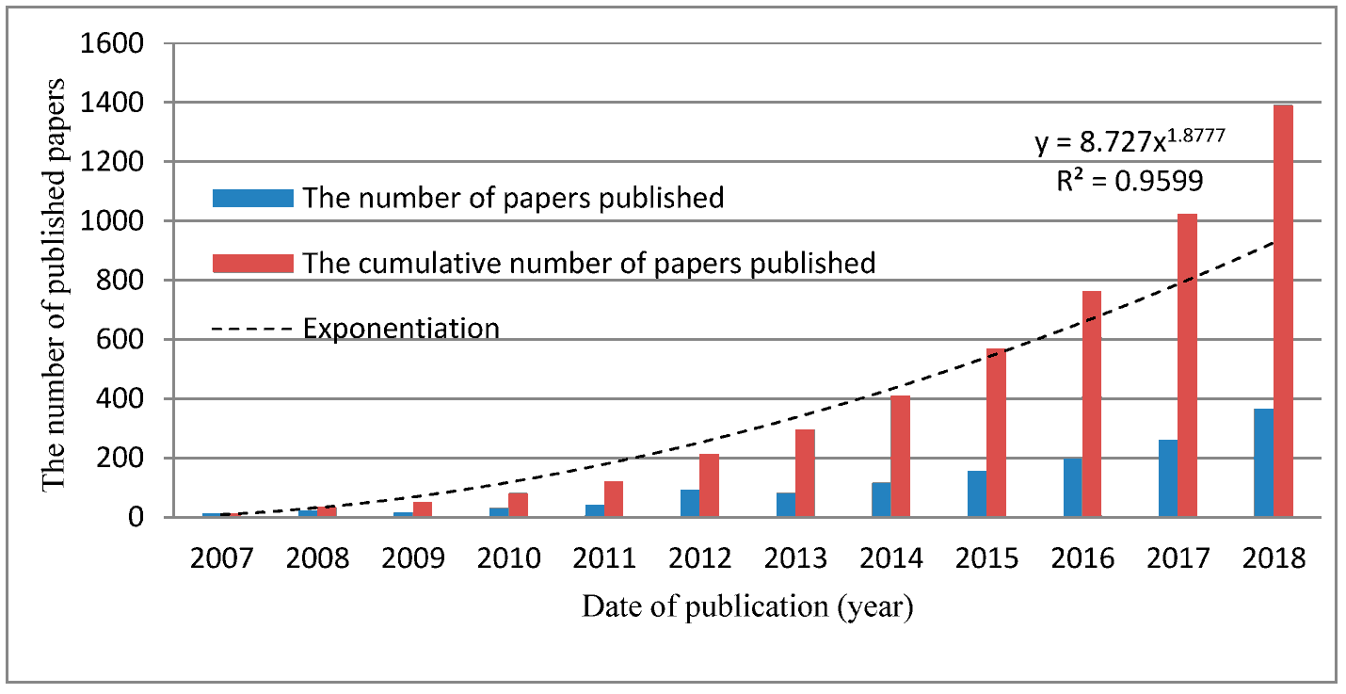

(Source: https://www.mdpi.net)

**Appendix 2: green supply chain management**

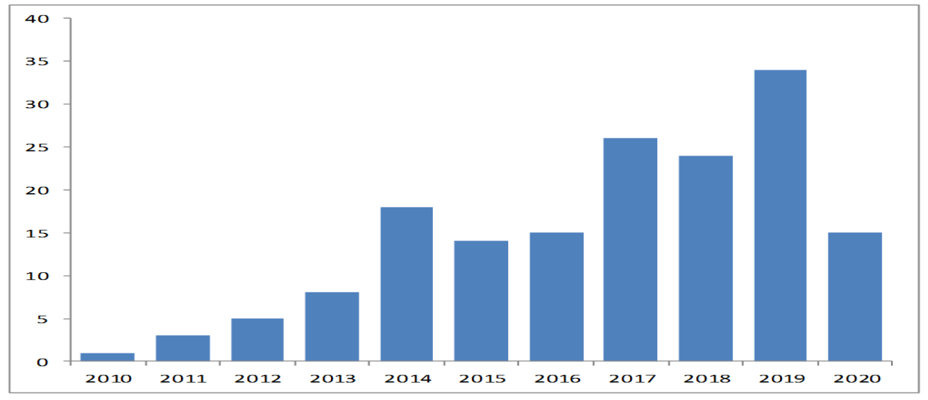

(Source: https://www.mdpi.net)

**Appendix 3: United Kingdom construction industry**

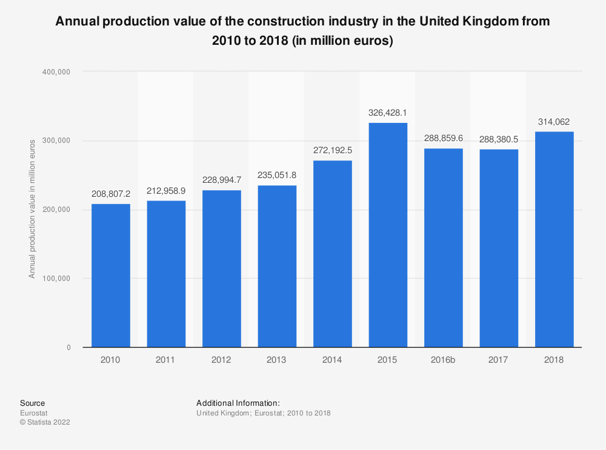

(Source: https://www.statista.net)

**Appendix 4: Composition of UK construction industry**

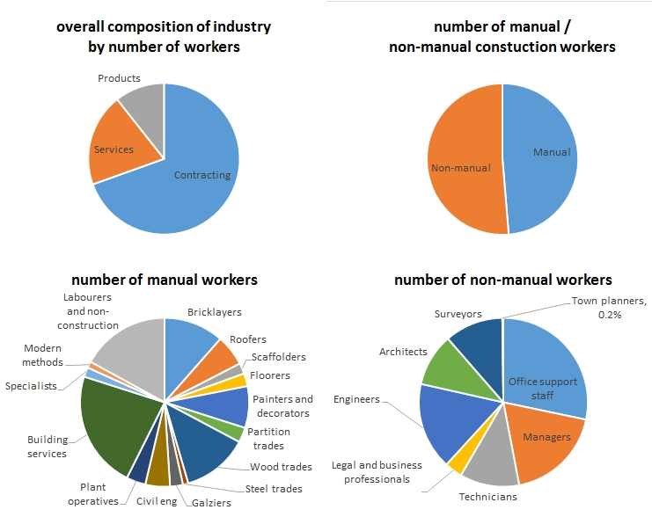

(Source: https://www.designingbuildings.net)

**Appendix 5: UK construction sales growth**

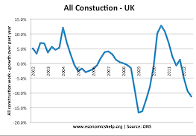

(Source: https://www.economicshelp.net)

**Appendix 6: UK construction sector workers**



(Source: https://cadvantage-knowledge.net)

**Appendix 7: A systematic managerial perspective on the environmentally sustainable construction practices of UK**

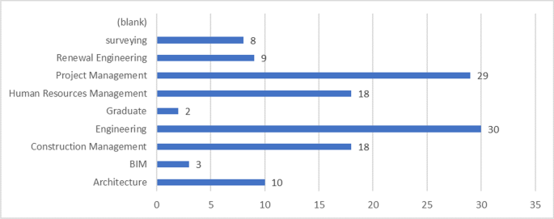

(Source: https://link.springer.net)

**Appendix 8: Embracing sustainability practices in UK construction organizations**

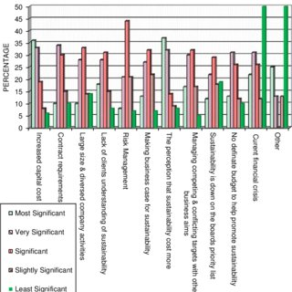

(Source: https://www.researchgate.net)

**Appendix 9: Lifecycle sustainability assessment**

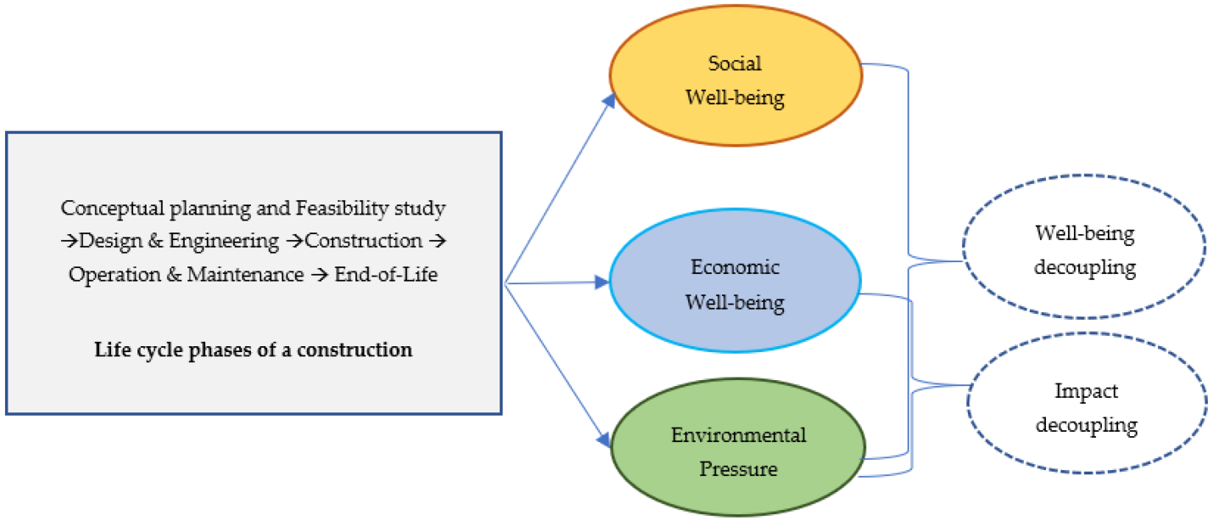

(Source: https://www.mdpi.net)

**Appendix 10: Green technology and sustainable market size report**

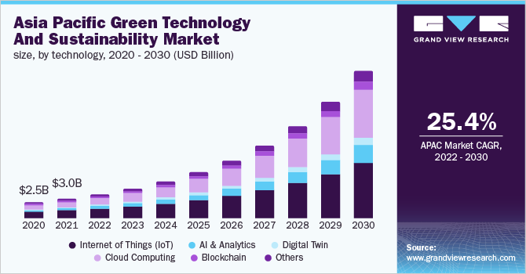

(Source: https://www.grandviewresearch.net)

**Appendix 11: UK construction industry**

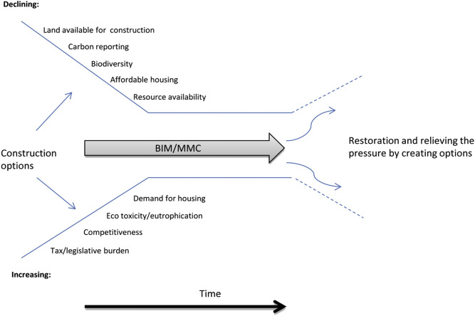

(Source: https://www.sciencedirect.net)

**Appendix 12: Digital transition and waste management**

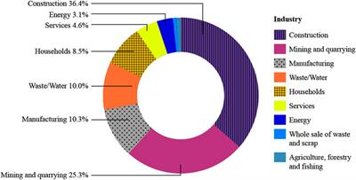

(Source: https://www.frontiersin.net)

**Appendix 13: A systematic managerial perspective on the environmentally sustainable construction practices of UK**

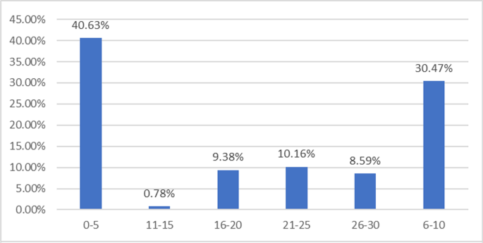

(Source: https://link.springer.net)

**Appendix 14: Carbon footprint**

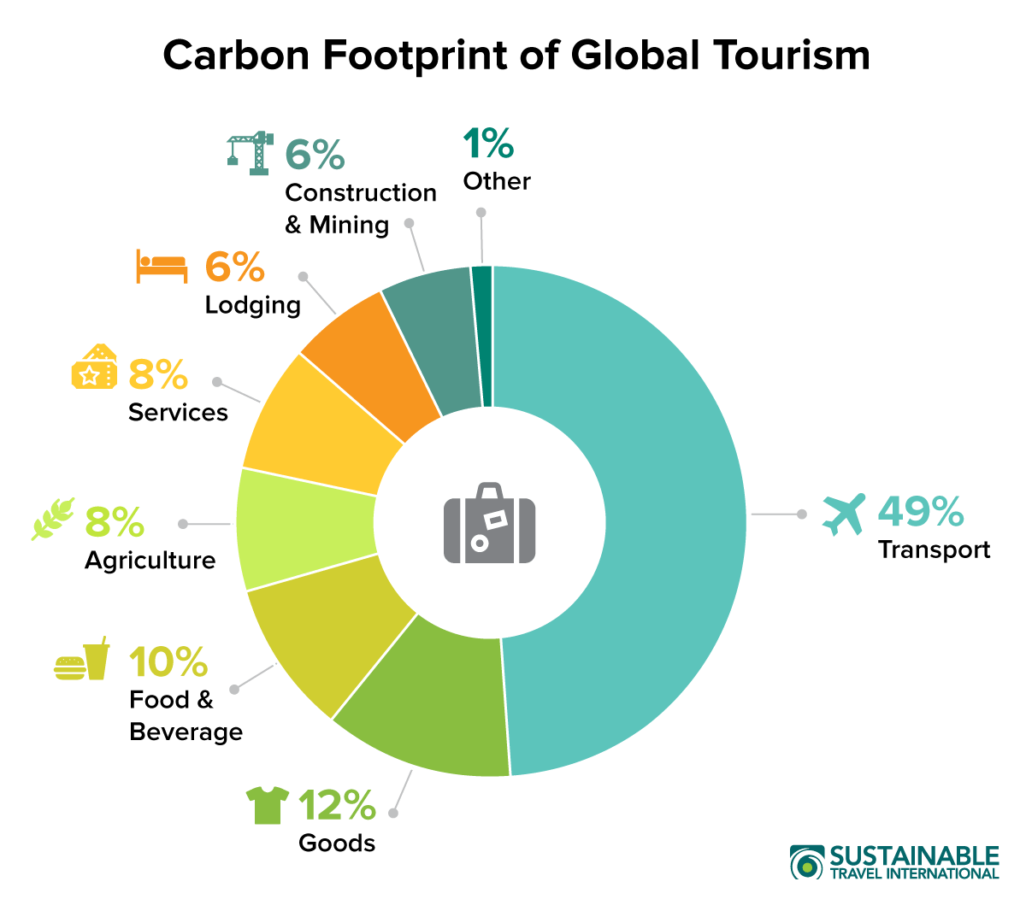

(Source: https://sustainabletravel.net)

**Appendix 15: UK marketing sustainability**

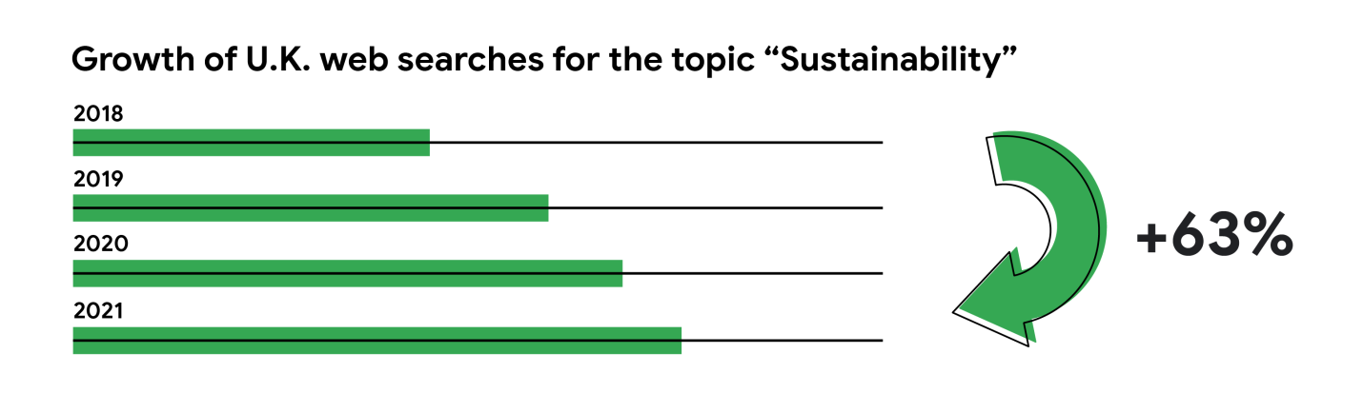

(Source: https://www.thinkwithgoogle.net)