**INVESTIGATION OF THE SCRUM AND SIX SIGMA APPROACHES FOR MANAGING PROJECT MANAGEMENT DELIVERY IN THE IT INDUSTRY**

**TABLE OF CONTENTS**

Chapter 1: Introduction 4

1.1 Introduction 4

1.2 Background of the study 4

1.3 Research Aims 5

1.4 Research Objectives 5

1.5 Research Questions 5

1.6 Research Hypothesis 6

1.7 Research Rationale 6

1.8 Research Significance 7

1.9 Research Framework 8

1.10 Summary 8

Chapter 2: Literature Review 9

2.1 Introduction 9

2.2 Empirical Study 9

2.3 Theories and Models 13

2.4 Literature Gap 15

2.5 Conceptual Framework 16

2.6 Conclusion 16

Chapter 3: Methodology 17

3.1 Introduction 17

3.2 Method outline 17

3.3 Research Philosophy 18

3.4 Research Approach 19

3.5 Research Design 19

3.6 Research Strategy 20

3.7 Research Method 21

3.8 Data Collection Method 22

3.9 Research Ethics 22

3.10 Research Limitations 22

3.11 Time Horizon 23

3.12 Conclusion 23

Chapter 4: Results 24

4.1 Introduction 24

4.2 Analysis 24

**Primary Analysis** 24

4.3 Discussion of Findings 32

**Primary Analysis** 33

4.4 Conclusion 34

Chapter 5: Conclusion 35

5.1 Introduction 35

5.2 linking with Objectives 35

5.3 Recommendation 39

5.4 Conclusion 40

Reference list 41

Appendices 46

**TABLE OF FIGURE**

Figure 1: Research Framework 9

Figure 2: Lean Six Sigma Model 14

Figure 3: Lean Agile Model 16

Figure 4: Conceptual Framework 17

Figure 5: Research Onion 19

Figure 6: Research Design 21

Figure 7: Strategy 22

Figure 8: Time Horizon 24

Figure 9: Output for the Correlation 26

Figure 10: Output for the Non-parametric correlation 26

Figure 11: Descriptive Statistics for Regression 27

Figure 12: Pearson Correlation 28

Figure 13: Regression Analysis 28

Figure 14: Variables entered or removed in correlation 29

Figure 15: Regression Model Summary 30

Figure 16: ANOVA Test for Regression 30

Figure 17: Coefficients for Regression 31

Figure 18: Coefficients for Correlation 32

Figure 19: Bar Graph 33

Figure 20: Similarities between six sigma and Scrum 37

Figure 21: implementation diagram 40

# Chapter 1: Introduction

## 1.1 Introduction

The first chapter contains the opening part of the investigation. The study is based on the “Investigation of the Scrum and Six Sigma approach for project management delivery in the IT Industry. The introduction chapter contains the background of the research. The main goals for the research will also be provided under the aims and objectives section of the research. The questions that will arise while doing the research will be provided in the research questions section. The rationale and the significance of the research will also be provided. A research framework will also be included. Detailed analysis is provided further below about the research.

## 1.2 Background of the study

Scrum and Six Sigma are two well-known techniques used in project the executives, especially in the IT industry. Scrum is a coordinated structure that features collaboration, participation, and iterative development. It includes working in fast runs, normally two to about a month, and zeroing in on conveying working programming toward the finish of each run. The Scrum structure comprises of different jobs, for example, item proprietor, Scrum expert, and improvement group, and explicit services, for example, everyday stand-ups and run audits.

Six Sigma is an information driven approach that spotlights on persistent improvement and deformity decrease. It includes examining information to recognize and eliminate deserts in a cycle, in this manner getting to the next level quality and decreasing variability. Six Sigma utilizes an organized critical thinking approach known as DMAIC to accomplish its objectives.

Both Scrum and Six Sigma have their exceptional qualities and limitations. Scrum is fantastic for projects with evolving necessities and a requirement for fast conveyance, while Six Sigma is best for projects with an emphasis on quality and cycle improvement. In the IT industry, associations frequently utilize a combination of Scrum and Six Sigma procedures to balance the requirement for agility and quality.

The IT industry has been quickly filling in the United Realm, and it is one of the hugest supporters of the economy. As of late, two famous techniques, Scrum furthermore, Six Sigma certainly stand out as powerful apparatuses for overseeing programming advancement projects. Scrum is a nimble structure that stresses cooperation, coordinated effort, and iterative turn of events, while Six Sigma is an information driven move toward that spotlights on consistent improvement and imperfection decrease.

The examination of Scrum and Six Sigma in the IT industry is a significant area of examination, as it can help associations figure out which philosophy is generally suitable for their requirements.

This study plans to investigate the viability of Scrum and Six Sigma in making due programming improvement projects in the IT industry.

## 1.3 Research Aims

The main purpose of the research is to investigate the two different methods which are Scrum and Six Sigma. The research also aims to find the advantages and disadvantages of the two methods. The research aims to justify which method is more suitable and followed in the IT industry. The research aims to implement the two mentioned methods together in the IT industry. These are the aims of the research.

## 1.4 Research Objectives

The objectives of the research are presented in this section. The objectives of the research are:

* To investigate the Scrum and Six Sigma methods.
* To find differences and similarities between six sigma and scrum.
* To find out which method among Scrum and Six Sigma is followed more in the IT industry.
* To find a way to implement both Scrum and the Six Sigma methodology together in the IT industry.

## 1.5 Research Questions

**Q1.** What are the important values and practices of Scrum and Six Sigma, and how do they vary from each other?

**Q2.** What are the interests and negatives of implementing Scrum and Six Sigma in the IT industry?

**Q3:** How do Scrum and Six Sigma influence project success and customer satisfaction in the IT industry?

**Q4:** What are the factors that affect the choice of methodology in the IT industry, and how do organizations decide which methodology to use?

**Q5:** Which methodology can be used to implement Scrum and Six Sigma together in the IT industry?

## 1.6 Research Hypothesis

The hypothesis that has arisen during the research is provided in this section. The hypothesis of the research are:

**H0:** Six Sigma is followed more than the Scrum methodology in the IT industry.

**H1:**  Six Sigma is not followed more than the Scrum methodology in the IT industry.

**H0:**  Scrum is followed more than the Six Sigma methodology in the IT industry.

**H1:** Scrum is not followed more than the Six Sigma methodology in the IT industry.

**H0:** Scrum and Six Sigma are very much dissimilar among themselves.

**H1:** Scrum and Six Sigma are not much dissimilar among themselves.

## 1.7 Research Rationale

The IT industry is exceptionally competitive and continually developing. To stay competitive, organizations in this industry need to persistently work on their cycles and convey excellent items that address the issues of their clients (Laureani, 2021). Two philosophies that have acquired popularity as of late for getting to the next level process proficiency and item quality are Six Sigma and Scrum. In any case, there is limited exploration on the use of these strategies in the IT industry. Consequently, an examination of Six Sigma and Scrum in the IT industry is expected to comprehend their utilization and effect on process proficiency, item quality, and client fulfillment. The rationale for this examination is to distinguish the degree to which Six Sigma and Scrum are being utilized in the IT industry and to look at the benefits and limitations of these approaches in the setting of programming improvement processes. Additionally, this examination means to recognize best practices for consolidating Six Sigma and Scrum procedures in programming advancement projects and to give proposals to IT organizations trying to work on their cycles and convey top notch items.

## 1.8 Research Significance

The examination of Six Sigma and Scrum in the IT industry has significant substances for both scholarly world and industry.

This examination will add to the group of information on programming improvement procedures, explicitly Six Sigma and Scrum. The examination will give bits of knowledge into the utilization of these procedures in the IT industry, and their effect on process proficiency, item quality, and consumer loyalty (Herrera and Van Hillegersberg, 2019). This examination will likewise recognize best practices for consolidating Six Sigma and Scrum philosophies in programming improvement projects, which can help IT organizations to advance their cycles and convey top notch items.

According to an industry point of view, this examination is significant as it will give IT organizations experiences on the best way to work on their cycles and convey top notch items to their clients. By understanding the use of Six Sigma and Scrum strategies in the IT industry, IT organizations can upgrade their cycles and work on their competitiveness on the lookout. Additionally, the examination will recognize best practices for consolidating Six Sigma and Scrum systems, which can help IT organizations to execute these approaches in their undertakings successfully.

In general, the examination of Six Sigma and Scrum in the IT industry has critical ramifications for both scholarly community and industry and can add to the improvement of programming advancement processes and the conveyance of top notch items.

## 1.9 Research Framework

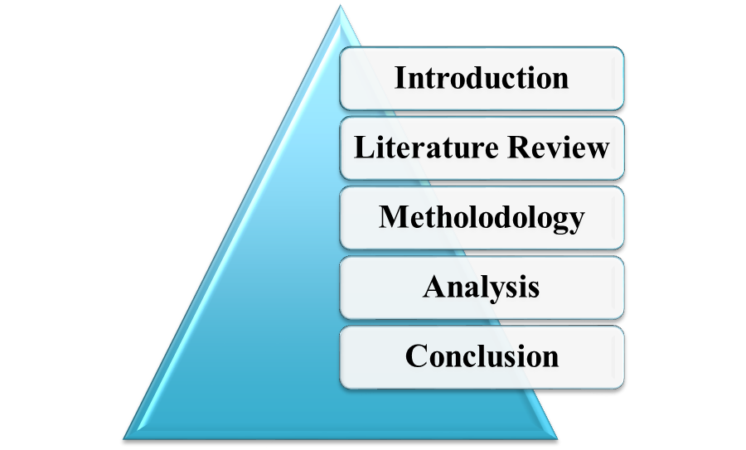

##### Figure 1: Research Framework

(Source: Self-created using MS Word)

## 1.10 Summary

The research's beginning is covered in the first chapter. The study's foundation is an investigation of the effectiveness of the Scrum and Six Sigma project management delivery methodologies in the IT industry. The background context of the research is covered in the introduction chapter. Under the research's aims and objectives section, the study's primary objectives are listed. The section on research questions includes the questions that will come up while doing the study. The Research Hypothesis section contains the most likely hypothesis that can be proposed for the study. Also, the research's justification and importance have been discussed. Moreover, a research framework is provided. Thus the first chapter is concluded.

# Chapter 2: Literature Review

## 2.1 Introduction

A literature review is a critical investigation and assessment of existing literature, research, and other insightful articles on a specific point or subject. It is a fundamental part of scholarly research, as it gives an extensive comprehension of the research region, distinguishes gaps in the current literature, and assists in forming with researching questions and speculations. A literature review regularly includes an efficient and organized way to deal with assemble, dissect and decipher significant literature, and give a combination of the discoveries. The review is frequently directed to help and reinforce the research approach, distinguish potential research gaps, and give bits of knowledge to additional research. In this situation, the literature review will be finished on the examination of Scrum and Six Sigma in the IT industry. The hypotheses and models that can be utilized for the literature review will be furnished alongside the literature hole and a conceptual framework.

## 2.2 Empirical Study

According to Ayesha, 2019, Six Sigma and Scrum are two popular approaches used in various industries to improve quality and efficiency. This literature review aims to investigate the application of Six Sigma and Scrum methodologies in different contexts and their impact on organizational performance.

Six Sigma is an information driven approach that spotlights on lessening surrenders and further developing cycle execution. A few examinations have revealed the viability of Six Sigma in working on different parts of hierarchical execution like consumer loyalty, productivity, and monetary execution. Besides, Six Sigma has been applied in different enterprises like medical care, assembling, and administration areas.

Then again, Scrum is an agile methodology utilized in programming advancement to oversee projects. Scrum depends on the standards of straightforwardness, investigation, and variation. A few examinations have revealed the benefits of involving Scrum in programming improvement undertakings like expanded productivity, quality, and consumer loyalty (Ayesha, 2019). Additionally, Scrum has been applied in different businesses past programming improvement, like promoting, medical care, and training. There has been some exploration investigating the mix of Six Sigma and Scrum. A few examinations propose that the mix of Six Sigma and Scrum can bring about a more extensive way to deal with process improvement and task the board. For instance, Six Sigma can be utilized to recognize and gauge issues, while Scrum can be utilized to create and execute arrangements.

In conclusion, both Six Sigma and Scrum have proven to be effective approaches in their respective fields. Combining these methodologies may result in a more comprehensive approach to process improvement and project management, leading to improved organizational performance (Sharma *et al.* 2020). However, further research is needed to explore the specific benefits and challenges of integrating Six Sigma and Scrum in different contexts.

According to Sarpiri and Gandomani, 2021, software experts have thought about the development and upgrade of the software. In the IT industry, there are many methodologies that are being followed. Two such methodologies are Scrum and the Six Sigma methodology. These two methodologies are used in the IT industry for a long time. Over the past decades, the agile methodology is considered to be the most used methodology in the IT industry. Nowadays, the Scrum and the Six Sigma methodologies have taken the place. The two methodologies are proved to be fruitful for the IT industry. The researchers are finding ways to make a hybrid model which will contain both the Scrum and the Six Sigma methodologies and implement them in the IT industry ***[Refer to Appendix 1].***

IT teams to accomplish specific goals have frequently been made possible by combining various software development methodologies. In reality, IT teams combine various software techniques to profit from each one's advantages. New performance and managing staff ideals and ideas are intermittently combined with tried-and-true methods for developing software in an effort to increase team productivity, customer happiness, and the software development process. One of the best methodologies in the industry, Six Sigma concentrates on reaching predetermined goals like quality management, customer satisfaction, expense reduction, and quality improvement. Six Sigma is viewed as an organizational transformation method that supports the growth of a company's managerial talent. IT projects have lately made use of this line of thinking. Agile software development techniques appear to adhere to the same values and objectives as Six Sigma, upon which they were initially founded. Therefore, combining these two approaches might be beneficial. The overheads for agile development, however, might then deviate from the core principles of quick processes. The meaning of the present investigation was to ascertain how well the Six Sigma methodology worked when it was applied to the IT sector.

According to Salleh and Nohuddin, *2019*, “Requirement engineering is the process of gathering, examining, specifying, validating, and managing requirements in order to meet the needs of end users”. Fundamentally, requirements engineering involves gathering customer requirements and comprehending the difficulties that need to be resolved from a “software engineering standpoint”. Initiatives are very likely to fail if the needs of the stakeholders are not adequately understood. According to the research, between 12% and 71% of project failures can be attributed to inadequate specifications. The current supply chain for the intricate and international business processes demonstrated the need for various elicitation methods to address various requirements and challenges. Getting the essential needs has never been easy. Numerous software methods, including Waterfall, Incremental Prototyping, Agile, Lean Software Development (LSD), and hybrid Lean-Agile, have been developed to help the team comprehend and provide the best solutions. All with the same goals in mind: to raise quality, fulfill client needs, ship software more quickly, and spend less on reworks.

RE is the process of figuring out and understanding "what the consumer wants" and then fulfilling those wishes. The procedure consists of five crucial steps. The foremost governing regulation is to comprehend the topic at hand. The second concept is identifying key actors throughout the absolute “life cycle”. The third idea includes examining the characteristics and behaviors of the parties. In addition, the partners' potential impact on the project's extent must be evaluated. The fourth assumption concerns the operation of RE selection methods (Salleh and Nohuddin, 2019). Obtaining specifications from partners or end users is the fifth piece of advice. In RE, a variety of methods, including interviews, discussions, focus groups, surveys, observations, requirements workshops, and prototyping, are frequently used.

According to Lameijer *et al.* 2021, recently, the methods of Lean and Six Sigma were combined for study and application. In the middle and latter part of the 20th century, Lean Six Sigma (LSS) was extensively adopted by the manufacturing sector, including Toyota, Motorola, and General Electrics. Since that time, the method has been extensively employed in sectors like banking, medicine, and government management. Studies on these implementations show that success depends heavily on changing the methodology given the nature of the company. Digital emerging technologies (DE-TECH) are a market whose size and significance for social daily living are both expanding quickly. In comparison to more traditional industries like construction, retail, and transportation, the information technology industry as a whole is accelerating economic growth (Gubinelli *et al.* 2019). Recently, businesses in the DE-TECH industry have shown a growing interest in adopting LSS. There are surprisingly few studies on the use of LSS in this area. The researcher anticipate that this study will make it simpler for us to comprehend the challenges DE-TECH businesses face when implementing LSS for operational excellence. The traits required for the LSS program have been identified in order to accomplish this.

In this paper, data from various case studies of “DE-TECH industry firms that have started LSS implementation are presented”. On the basis of extensive “semi-structured interviews with LSS implementation executives and practitioners, within- and cross-case studies are carried out”. The researcher start by looking at the study's main achievement factors (Lameijer *et al.* 2021). The LSS methodology should be renamed to reflect the company's shared values, and the LSS training strategy should be rearranged to use a better cumulative, prioritized, on-the-job training approach, according to our results. These previously recognized critical success factors are also frequently present. Modifications to the structured LSS project methods that are frequently observed are among the new results.

## 2.3 Theories and Models

***LSS model (Lean Six Sigma Model)***

Lean Six Sigma is a process improvement methodology that combines the principles of Lean manufacturing and Six Sigma. It is a powerful tool for identifying and eliminating waste, reducing defects, and improving overall efficiency and effectiveness.

“*Lean focuses on identifying and eliminating non-value-added activities in a process, while Six Sigma is a data-driven approach to reducing defects and improving quality*”. Together, they provide a comprehensive framework for process improvement that can be applied to any industry or business function.

The Lean Six Sigma model follows a five-phase approach: Define, Measure, Analyze, Improve, and Control (DMAIC). In the Define phase, the project goals and customer requirements are identified. The Measure phase implicates collecting data to establish a baseline and quantify the problem. The Analyze phase is used to identify the root cause of the problem. In the Improve phase, solutions are developed and implemented, and in the Control phase, the process is monitored to ensure that the improvements are sustained.

Lean Six Sigma has been widely adopted by organizations around the world and has proven to be an effective way to improve quality, reduce costs, and increase customer satisfaction (Dursun and Goker, 2022). It is a continuous improvement process that requires ongoing effort and commitment to achieve the desired results.

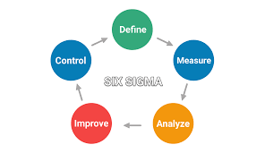

##### Figure 2: Lean Six Sigma Model

(https://kanbanize.com/wp-content/uploads/website-images/kanban-resources/six-sigma-core.png)

***LA model (Lean-Agile Model)***

The Lean-Agile model is a technique for "software development" that features the flexibility, cooperation, and consistent improvement. The model joins the standards of Lean assembling with Agile software development practices to make a structure that is proficient, versatile, and client centered.

In the Lean-Agile model, the development interaction is separated into little, iterative cycles, known as runs. These runs are intended to convey utilitarian software in a brief timeframe, regularly one to about a month. Each run is directed by a bunch of necessities or client stories, which are prioritized by the development group and inspected toward the finish of each cycle.

The Lean-Agile model likewise stresses the significance of cross-useful groups and cooperation. Groups are ordinarily made out of engineers, analyzers, architects, and different partners, who cooperate to guarantee that the software addresses the issues of the client. Consistent improvement is one more key rule of the Lean-Agile model. Groups are urged to consistently survey their cycles and distinguish regions for development, with the objective of making a more proficient and compelling development process.

Generally, the Lean-Agile model is intended to assist associations with conveying top notch software rapidly and proficiently, while likewise encouraging a culture of joint effort and constant improvement.

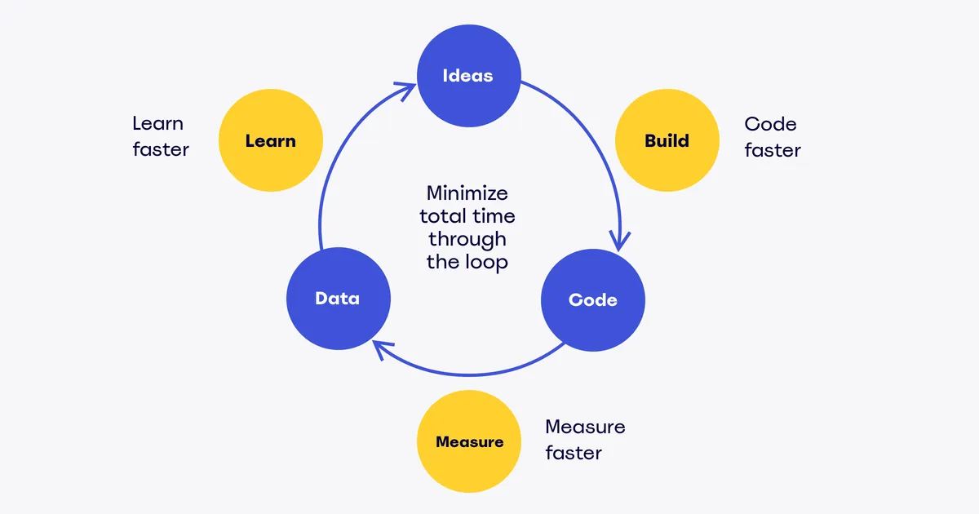

##### Figure 3: Lean Agile Model

(Source: https://miro.com/blog/wp-content/uploads/2017/06/agile-03-2.png)

## 2.4 Literature Gap

There is a literature gap in the investigation of the integration of Six Sigma and Scrum methodologies in software development projects. Six Sigma is a quality administration methodology that expects to limit deformities and varieties in processes, while Scrum is an Agile methodology that spotlights on flexibility and coordinated effort. The two systems have been utilized freely in programming advancement projects, yet little examination has been directed on how they can be coordinated to improve the quality of programming items.

The couple of studies that have been directed on the reconciliation of Six Sigma and Scrum have zeroed in primarily on the distinguishing proof of commonalities and contrasts between the two approaches (Heimicke et al. 2020). In any case, there is an absence of observational examinations that explore the viability of this joining in working on the quality of programming items.

Further examination is expected to investigate how Six Sigma and Scrum can be coordinated to improve programming advancement processes and convey excellent programming items. This can remember observational examinations for the viability of this combination regarding quality, productivity, and cost-adequacy.

## 2.5 Conceptual Framework

**Lean Six Sigma Model**

**Requirements by the IT industry**

**Dependent Variables**

**Independent Variable**

**Hybrid Methodology of Six Sigma and Scrum**

**Lean Agile Model**

**Development of software**

##### Figure 4: Conceptual Framework

(Source: Self-created)

## 2.6 Conclusion

This section contains the overall preview of the Literature Review chapter. The literature review chapter contains the empirical study. The empirical study contains all the research that has been conducted by different journalists, scholars, and researchers. All the information that has been provided in the “empirical study” section is reliable as they are already been researched by renowned researchers. A literature gap is also been provided for explaining the gaps that can occur in the research. The research gaps are provided for the betterment of the research in the future. A conceptual framework is also provided. Thus, the literature review chapter is concluded.

# Chapter 3: Methodology

## 3.1 Introduction

Two well-liked project management delivery approaches, notably inside the software development sector, is Scrum and Six Sigma. Scrum is seen as an agile methodology that emphasizes collaboration, cooperation, and incremental progress. Work is done in brief, two to four-week sprints with the goal of completing each sprint with a functional application. Continual improvement and fault reduction are the two main foci of the data-driven Six Sigma methodology. It entails data analysis to find and fix process flaws, enhancing the quality and lowering variation. This chapter highlights the various necessary components that are required for the successful conduction of the investigation. Therefore this chapter addresses many important components of the research that are essential for the successful mediation of all the research procedures. This chapter is seen to highlight the study’s design, techniques, perspectives, methods, and tactics which are important for the research conduction. Again, the details of the data gathering process and the analysis will be provided within this chapter. Apart from the various procedures that are required for the mediation of the research, important ethical issues that need to be considered for the research are highlighted within this chapter in later sections. Finally, the progression associated with the research is depicted within this section as a research timeline.

## 3.2 Method outline

The research is seen to incorporate the appropriate methodological steps which are seen to range from outlining to achieving that are required to meet the requirements of the investigation in accordance with the set of objectives. This research emphasizes the several phases that take place in illuminating and identifying the various ways and strategies for achieving goals (Pongboonchai *et al.*2023). The process of data collection, which involves acquiring a variety of details related to the project, is crucial since it serves as the foundation for both the evaluation and the conclusion. The data relating to the study are collected effectively, followed by the evaluation through the incorporation of the appropriate methodologies that in turn will help to evaluate the research questions that are set for the investigation and again to look over the various theoretical dissertation that was used for mediation of the study after the successful collection of the data from various sources that are being identified by the various research scholar. Therefore this action will aid in highlighting the various key steps that are seen to be involved in the research. These procedures include the effective planning, tactics, selection of appropriate methodologies, data collection, and result evaluation about the entire research.

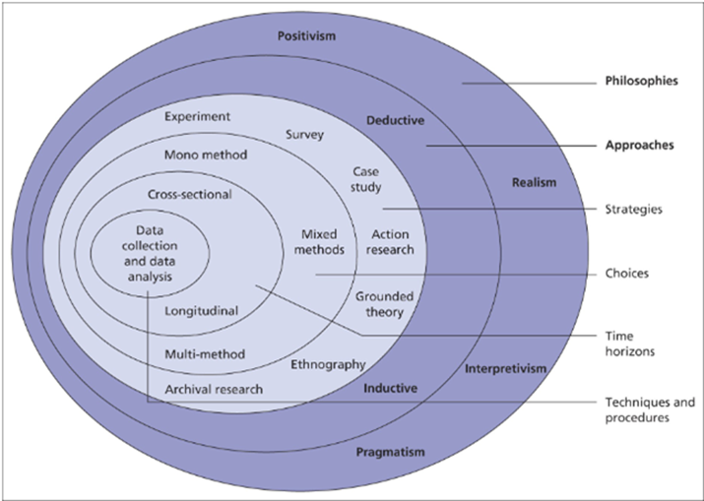

##### Figure 5: Research Onion

(Source:https://research-methodology.net/wp-content/uploads/2012/06/Research-Philosophy.png)

## 3.3 Research Philosophy

Research must be followed by an ideology that helps the researcher to perform the entire study. The research ideology is also known as the philosophy of research guides the researcher to choose another step of the entire study and this also helps the researcher to perform the entire research. However, the adaptation of the philosophy of research totally based on the background of the topic. A strong research philosophy also enables the incorporation of many research methods components, such as research procedures, strategies, designs for the entire study, and research methodologies. The five main research philosophies that are appropriate for research are constructivism, interpretivism, realism, positivism, and pragmatism and all are represented in the research onion.

However, the study is based on the implementation of scrum and six sigma in the management of a project in any IT industry (Dphil, and DIng, 2021). Thus the study of this topic needs such an ideology that follows only the test phenomenon and is based on the hypothetical statement thus it indicates the adoption of the positivism research philosophy. This research philosophy is also highly focused on the more scientific way of research and in this context, the next step is to select the research approach.

## 3.4 Research Approach

A number of methods can be utilized to perform the study and conduct data analysis. The deductive approach and the inductive approach are the two most commonly employed approaches that are utilized for the mediation of the research. The deductive research approach is a scientific method that is used to test a specific hypothesis or theory. It involves a process of reasoning from general principles to specific situations. In this approach, researchers start with a theory or hypothesis and afterward plan a research review to test it (Komkowski et al. 2023). Then again, the inductive research approach is a strategy for leading research that include fostering a theory or hypothesis in view of experimental perceptions and information investigation. At the end of the day, inductive research is a granular perspective, where the researcher first gathers and examines information and afterward fosters a theory or hypothesis in light of the examples and subjects saw in the information. The determination of the suitable research approach will rely upon the methodologies that were set for the conduction of the research. The utilization of the positivist paradigm is seen to place a good emphasis on the need to utilize logical processes for the mediation of the investigation regarding the topic. Thus it can be seen that the research is seen to make use of the provided data as well as information which will enable the strategic evaluation so that prospective analysis within the later phases will help in the identification so that effective management of the problems associated with the research can be mediated. Thus it can be seen that the deductive approach is seen as the best method for the mediation of the investigation.

## 3.5 Research Design

Research should always be planned after choosing an appropriate research philosophy also and appropriate research approach. A study design is one of those steps in the research technique that a researcher uses to ensure that a study is carried out correctly, including the research method and the data gathering process. Whether the research is trustworthy, genuine, correct, or erroneous can be determined by a proper research study. This research design will also be chosen based on the positivism research philosophy and deductive research approach.

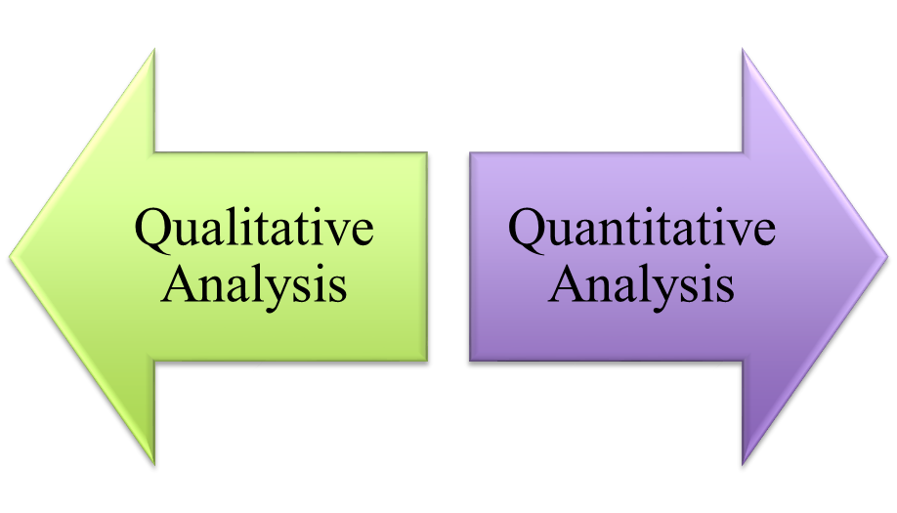

##### Figure 6: Research Design

(Source: Self-created)

A research design often consists of two basic components, such as quantitative research and qualitative research. The hypotheses and data that can be gleaned from earlier study or from primary research are the main emphasis of qualitative research (Jilani and Ikram, 2020). Comparatively, quantitative research will be conducted using numerical data and can therefore produce statistical results. Deductive research has been selected for this study, which adheres to previously published research theories. As a result, this research will also adhere to previously published research theories, from which both quantitative and qualitative data can be gathered to conduct the study's overall analysis.

## 3.6 Research Strategy

A research strategy can be defined as a method that a researcher might use to locate the appropriate information source and gather data in order to answer research questions. To achieve the original study purpose, a variety of research strategies might be used. Yet, the choice of a specific research strategy is greatly influenced by the research background, and positivism research philosophy has been conducted based on this background (Sarpiri and Gandomani, 2021). Hence, the positivist research philosophy places a strong emphasis on gathering data in a way that correctly aligns it with the research context. Yet, this study adhered to the positivism research philosophy and deductive research technique; as a result, it is possible to collect primary data using surveys or interviews, and secondary data using the archive research strategy method.

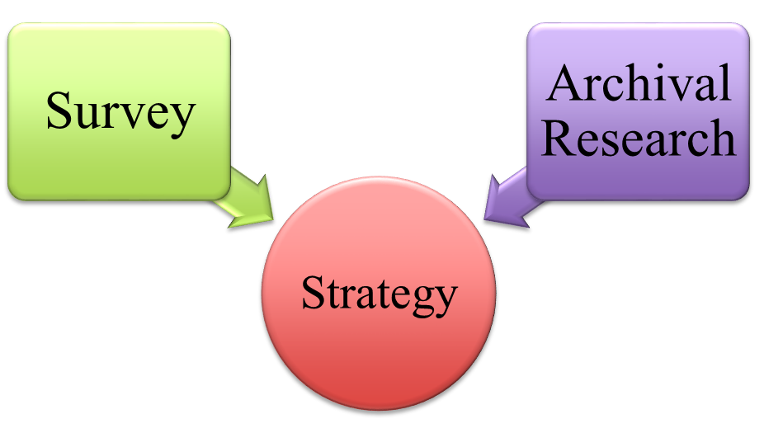

##### Figure 7: Strategy

(Source: Self-created)

However, the data can be collected from primary and as well as secondarily. However the primary data can be collected by questionnaire, or interviews whereas the secondary data can be gathered through archival research strategy.

## 3.7 Research Method

The whole approach taken to conducting the full research can be referred to as the research method. Yet, any research methodology can be used to conduct a single, multiple, or mixed research study. Yet, as this research will be focused on the collection of both quantitative and qualitative data, it can be claimed that this research will be multi-method. Following the qualitative and quantitative research, primary research from the interviews utilizing the questionnaire must be conducted.

## 3.8 Data Collection Method

The most important phase in any study approach is the data collection technique. Data collecting procedures relate to the processes used to obtain information or data for a research investigation. The decision about the data gathering method is dependent on the subject matter, research design, and data type. In this research, both qualitative and quantitative data has been collected to get the right research findings. The data for conducting the analysis this research can be collected primarily from the interviews by using questionnaire thus the interviews can provide both the qualitative and as well as the quantitative information. However, the qualitative data also can be collected from different secondary resources such as research papers, articles, and websites. However, the qualitative data helps to analysis only the theory based information whereas the quantitative data helps to provide the measurable outcomes of the entire study.

## 3.9 Research Ethics

To conduct a research, a researcher must follow some research ethics -

* All necessary rules and standards that are required to mediate the study procedures were seen to be taken into consideration by the strategies and practices that are considered for the research processes and for managing the data gathering.
* The data collection mediated for the completion of the study was covered with the consent of the pertinent authorities and the participants who are seen as affiliated with the research.
* Regarding the records that were collected during the research, upholding standards of confidentiality and data privacy was viewed as mediating how the research was done.

## 3.10 Research Limitations

Research on the implication of Six Sigma and Scrum in the IT industry has some limitations that must be considered.

* First, the results of the study may be affected by the quality of the data collected and the size of the sample.
* Additionally, the effectiveness of Six Sigma and Scrum may vary based on the organization's culture, size, and industry.
* Furthermore, the adoption of these methodologies may require significant changes to the organization's processes and culture, which can be challenging and costly.
* Finally, the study may not take into account other factors that may influence the success of IT development projects, such as team dynamics and project management delivery skills. Therefore, it is important to consider these limitations when interpreting the results of research on the implication of Six Sigma and Scrum in the IT industry.

## 3.11 Time Horizon

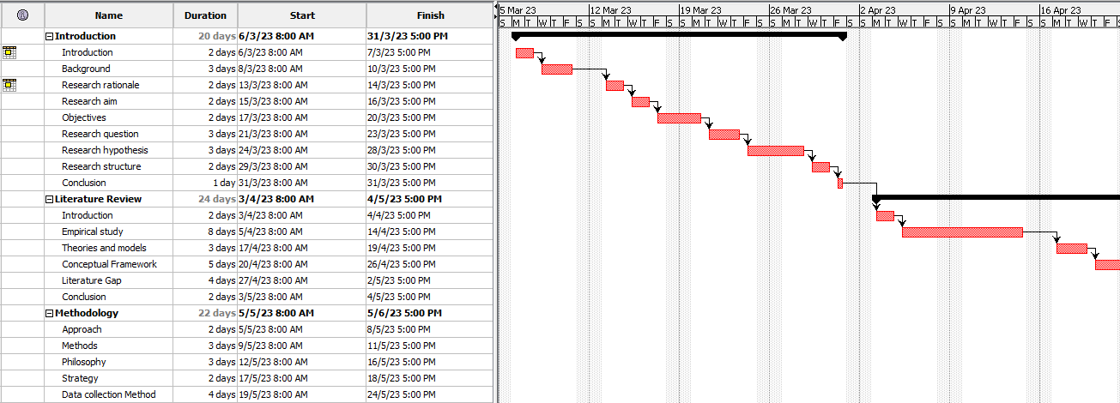

##### Figure 8: Time Horizon

(Source: Self-created in Project Libre)

## 

## 3.12 Conclusion

After discussing the entire methodology, it can be concluded that, the entire study will based on the positivism research philosophy, and by maintaining the deductive research approaches. However, as the deductive research approach follows the study based on previous research theory thus data can be collected from different secondary resources such as pre-existing research journals, articles, etc. On the other hand, the positivism research also emphasizes on more scientific research way thus these quantitative information can be gathered from primary data collection method via the interviews by using questionnaires.

# Chapter 4: Results

## 4.1 Introduction

The major piece of the investigation is driven by this piece of the audit. The "qualitative and quantitative research analysis" results are gained in this part using the fundamental and helper resources that have been amassed. The "emotional and quantitative investigation assessment" is coordinated in this part, and the results of the assessment are presented. Besides, the segment moreover looks at the results and gives a quick and dirty explanation of the legitimate revelations which structure the fundamental piece of the investigation. The fragment gives authoritative results considering the described targets and hypothetical statements which are conclusively attempted.

**SPSS software**

SPSS (Statistical Package for the Social Sciences) is a broadly involved programming for statistical examination in social science research. It gives instruments for information examination, information for the executives, and information perception. SPSS can deal with both basic and complex statistical investigations, including detailed insights, inferential measurements, and multivariate examination.

## 4.2 Analysis

### **Primary Analysis**

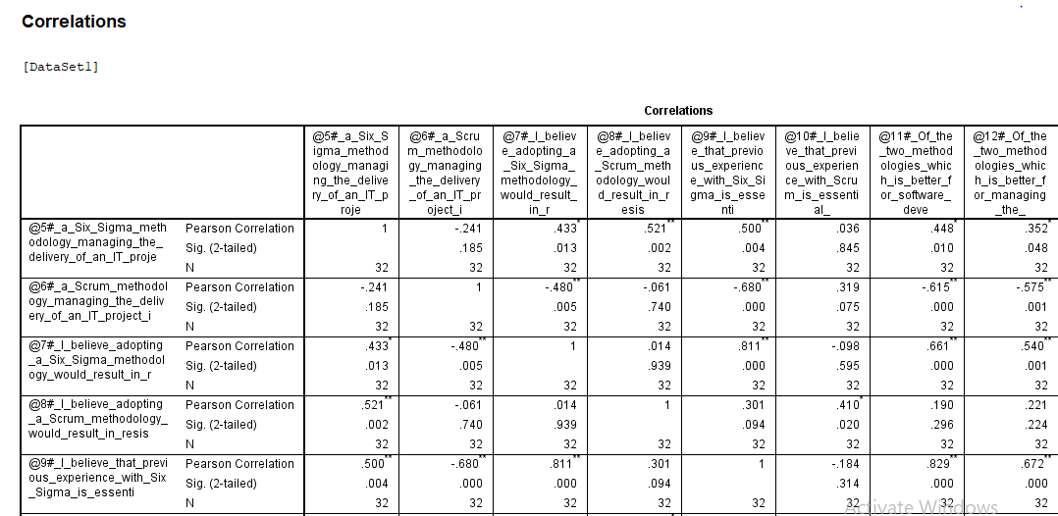

##### Figure 9: Output for the Correlation

(Source: Self-created using SPSS software)

The above output shows the correlations between the different questions in the dataset (Dursun and Goker, 2022). The output gives information about “Pearson’s Correlation”, the significance of the two-tailed test, and the N value for all the questions that have been chosen from the dataset. The analysis has been done using the “SPSS software platform”.

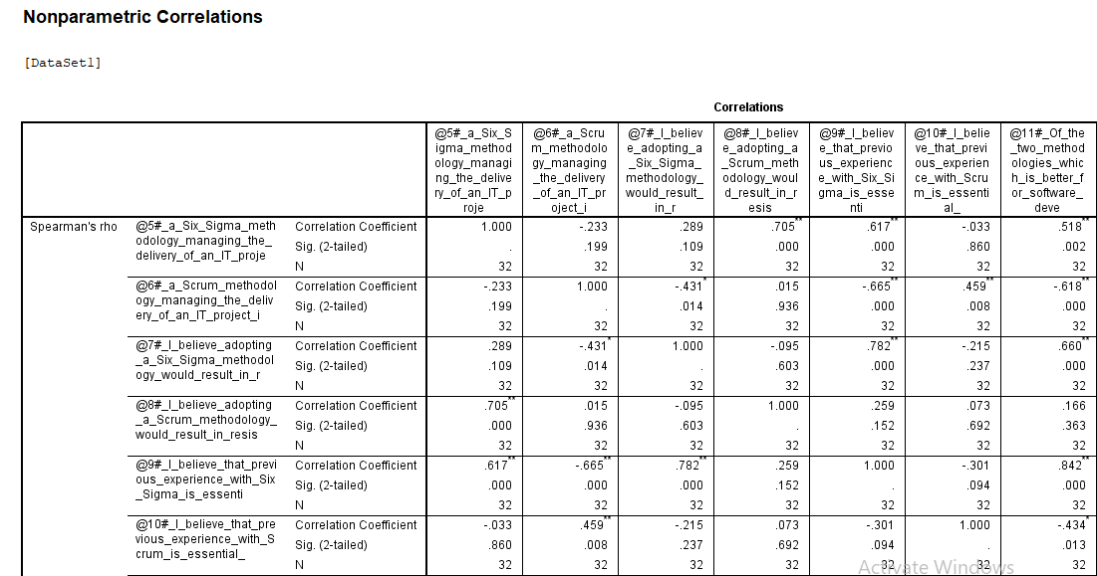

##### Figure 10: Output for the Non-parametric correlation

(Source: Self-created using SPSS software)

The output for the non-parametric correlations has been provided in the above figure. The output gives information about the “Coefficient’s Correlation”, the significance of the two-tailed test, and the N value for all the questions that have been chosen from the dataset (Gubinelli *et al.* 2019). The analysis has been done using the “SPSS software platform”.

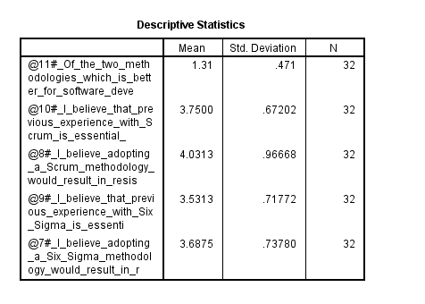

##### Figure 11: Descriptive Statistics for Regression

(Source: Self-created using SPSS software)

Descriptive Statistics have been provided for the "Regression Analysis". The "Regression Analysis" has been done using the “SPSS software platform”. The “Descriptive Statistics” involves the Mean, standard deviation, and N value.

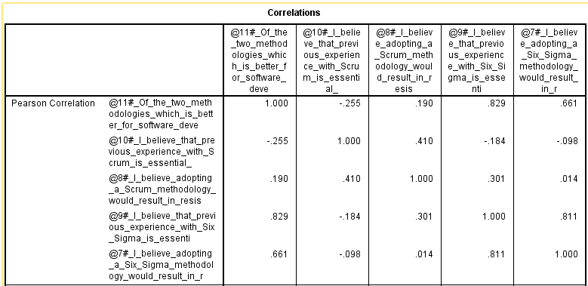

##### Figure 12: Pearson Correlation

(Source: Self-created using SPSS software)

The Pearson Correlation has been obtained during the "Regression Analysis". The Pearson Correlation has been obtained for the different questions that have been chosen from the dataset. The Pearson Correlation has been evaluated using the “SPSS software platform”.

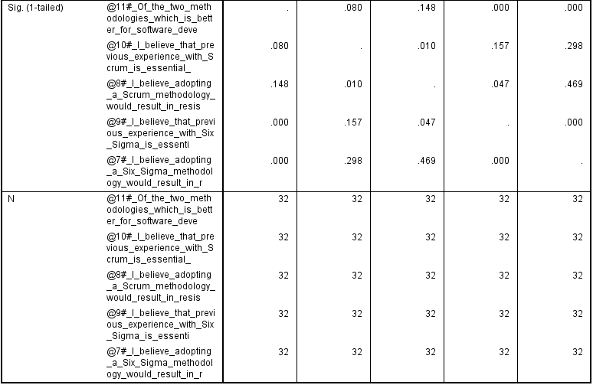

##### Figure 13: Regression Analysis

(Source: Self-created using SPSS software)

The Significance of the 1-tailed test and N value have been obtained during the "Regression Analysis". The Significance of the 1-tailed test and N value have been obtained for the different questions that have been chosen from the dataset (Pishchik *et al.* 2020). The Significance of the 1-tailed test and N value have been evaluated using the “SPSS software platform”.

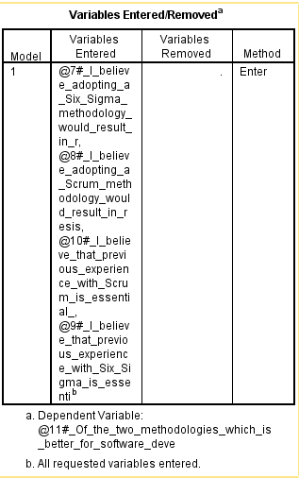

##### Figure 14: Variables entered or removed in correlation

(Source: Self-created using SPSS software)

The above snip describes the number of variables that have been entered or removed during the "Correlation Analysis". The figure describes that only four variables were entered but none were removed during the correlation. The output has been evaluated using the “SPSS software platform”.

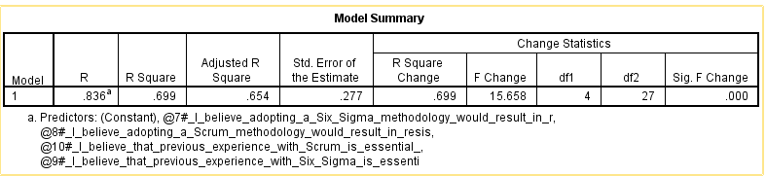

##### Figure 15: Regression Model Summary

(Source: Self-created using SPSS software)

A “summary of the Regression Model” has been provided. The summary explains the R-value and the “R square value”. The “adjusted R square value” is also provided. The standard error for the estimation is also provided. The change in the statistics is also provided. The R square change and the F change are evaluated under the change in statistics (Eddoug *et al.* 2022). The “R-value” is evaluated as 0.836. The “R square value” is computed at 0.699. The “adjusted R square value” is evaluated as 0.654. The “standard error of the estimate” of the model is taken out as 0.277. The value of change in statistics is provided below. The change in the R square is noted as 0.699 and the change in F-value is 15.658.

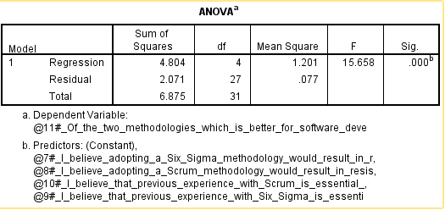

##### Figure 16: ANOVA Test for Regression

(Source: Self-created using SPSS software)

The ANOVA test has been done for the Regression Analysis. The sum of squares for the regression is computed to 4.804. The mean square for the said method is computed to 1.201. The residuals have also been evaluated for the Regression Analysis. The sum of squares for the Residuals is evaluated as 2.071. The mean square value for the residuals is evaluated at 0.077. A dependent variable has been chosen for the Regression Analysis alongside the predictor values (Fernandes *et al.* 2021). The dependent variable and the predictor values have been taken from the questionnaire that has been provided.

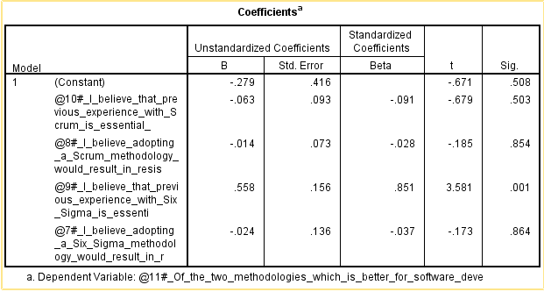

##### Figure 17: Coefficients for Regression

(Source: Self-created using SPSS software)

The coefficients for the Regression Analysis have been analyzed in the above figure. A dependent variable has been chosen for the analysis from the provided questionnaire. Four constant variables have been chosen for the analysis from the questionnaire. The unstandardized coefficients and the standardized coefficients have been analyzed and parameters have been analyzed according to the coefficients (Ackah, 2019). The B value and the standard error have been evaluated for the unstandardized coefficients. In the case of the standardized coefficients, the Beta value. T value and significance have been evaluated. The analysis has been done using the “SPSS software platform”.

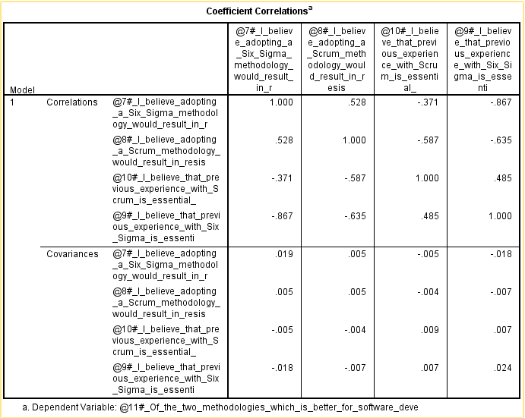

##### Figure 18: Coefficients for Correlation

(Source: Self-created using SPSS software)

The coefficient correlation for the “Regression Analysis” has been obtained using the “SPSS software platform”. The correlations and the covariance are taken for the analysis. The analysis is important to find the values of Regression analysis and show correlations between the different variables chosen from the questionnaire.

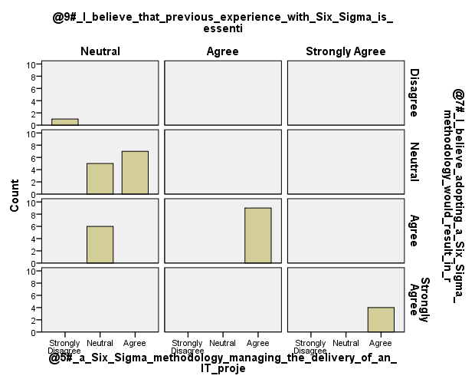

##### Figure 19: Bar Graph

(Source: Self-created using SPSS software)

The bar graph has been created to show the different feedbacks that have been recorded for the different questions that have been recorded for the analysis of Scrum and Six Sigma methodologies for managing project management delivery in the IT industry (de Oliveira Santos, and de Carvalho, 2020). The graph contains many options which are “Strongly Disagree, Disagree, Neutral, Agree, and Strong Agree”. The different spikes respond to different options. The graph has been provided for different questions provided in the questionnaire.

## 4.3 Discussion of Findings

The discussion of results that have been obtained has been discussed in this section. The section provides an overview of what has been obtained in the analysis based on the type of analysis that has been done.

### **Primary Analysis**

In this scenario, primary analysis has been done. The primary analysis is based on quantitative data. The analysis was done on the questionnaire that has been made in MS Excel. The main software that has been used in the analysis is the “SPSS software platform”.

The main analysis that has been done is the Descriptive Analysis, Correlation Analysis, and Regression Analysis.

The bar graph has been created to show the different spikes among the questions that have been asked to participants. The enquiries mostly consist of which process to select among Six Sigma or Scrum in project management delivery (Antypenko *et al.* 2022). The graphs show the conclusion on how many candidates agree or disagree with particular beliefs. It is seen that most people agree on using Scrum over Six Sigma for project management delivery in the IT industry. Many people also believed that Six Sigma is also beneficial in some scenarios. The neutral comment is also provided for 50% of the people who believe that either of the two methodologies can be used in project management delivery in the IT industry.

The Regression Analysis has been done for the questionnaire that has been provided. The Regression Analysis has been done for finding out the different factors between the different questions that have been provided. The questions related to the Scrum and the Six Sigma methodology were given more focus and a relation has been finding out between these two questions. The relation is vital to investigate the more operative methodology among the two chosen methodologies for project management delivery in the IT industry. The different coefficients, correlations and the ANOVA test shows the relation between the chosen questions and also find the significance between those questions chosen for the analysis in SPSS.

The correlation analysis has been done for the different questions based on Scrum and Six Sigma methodology provided in the questionnaire. The correlation analysis has been done in the “SPSS software platform”. The correlation analysis has been done for finding patterns and relationships between the variables that have been chosen for the analysis (Troeung *et al.* 2023). The correlation has been done for the different questions provided in the questionnaire. The correlation between the parametric and the nonparametric variables that have been identified. Descriptive statistics have also been provided to justify the correlation analysis. The one-tailed test has also been done to find out the significance of the variables chosen for the Correlation test.

## 4.4 Conclusion

This section conations the overview of the chapter. The result and analysis chapter is important as it provides a description of the analysis that has been done to justify the goals of the research. The section contains the results and analysis part where information is provided on the results that have been obtained in pictorial format. In this research, a study has been done on which methodology is better among Scrum and Six Sigma in project management delivery in the IT industry. According to the responses collected, a questionnaire has been made in the Excel sheet. Further analysis will be done on the “SPSS software platform”.

A discussion section is also provided which explains the results that have been provided in the results section. In this scenario, the descriptive analysis has been done first. The bar graph has been made to show the various spikes among the inquiries that have been posed to members. The inquiries mainly include which procedure to pick among Six Sigma or Scrum in project management delivery. The graphs show the end on the number of competitors that concur or contradict specific convictions. It is seen that the massive popular settle on using Scrum for project management delivery in the IT industry. The independent remark is likewise given to half of the entities who accept that either of the two viewpoints can be utilized in project management delivery in the IT industry. The Regression Analysis has been finished for the poll that has been given. The Regression Analysis has been finished for figuring out the various elements between the various inquiries that have been given. The inquiries connected with the Scrum and the Six Sigma techniques were given more clarity of mind and a connection has been figuring out between these two inquiries. The connection is essential to dissect the more successful technique among the two picked strategies for projecting the board in the IT business. The various coefficients, correlations and the ANOVA test shows the connection between the picked questions and furthermore find the importance between those questions picked for the analysis in SPSS. The correlation analysis has been done for the different requests considering Scrum and Six Sigma reasoning given in the survey. The correlation analysis has been done in the "SPSS software platform". The correlation analysis has been done for finding models and associations between the elements that have been chosen for the analysis. The correlation has been done for the different requests given in the review. The correlation between the parametric and the nonparametric elements that have been perceived. Descriptive estimations have moreover been given to legitimize the correlation analysis. The one-followed test has in like manner been done to sort out the importance of the variables picked for the Correlation test. Thus the results section has been concluded.

# Chapter 5: Conclusion

## 5.1 Introduction

This is the final chapter of the research. It focuses on the details insight to complete the project or the research. This represents all of the details of the summary of the research. It fulfills the summary of the research. That makes the optimal path to the success of the research. This chapter covers the finding of the research. It makes the best possible news to complete the research in a particular way. It meets or satisfies the linking with the objective a part of the research. It brings the best of the possible chances to complete the project. This chapter even provides a recommendation section that meets the purposes of the research. The limitation part is also included here to complete the structure of the research. This section also meets the research finding that makes the efficiency of the research.

## 5.2 linking with Objectives

This chapter is very important that displays the chances to satisfy the objective part of the research. It brings the approach that meets with the objectives of the research. This chapter also included the best way that makes the proper efficiency the research. That offers the proper framework for the research.

**To investigate the Scrum and Six Sigma methods.**

The information-driven Six Sigma methodology focuses on reducing surrenders and improving cycle execution. The viability of Six Sigma in working on various aspects of hierarchical execution, such as customer loyalty, productivity, and financial execution, has been demonstrated by a few studies. Additionally, Six Sigma has been utilized in a variety of industries, including manufacturing, administration, and medical care. On the other hand, Scrum is a spry strategy used in programming headway to regulate projects. The principles of simplicity, investigation, and variation underpin Scrum (Heimicke *et al.* 2020). It has been applied in various organizations' past programming improvement, such as advancing, clinical consideration, and preparing. There has been some investigation into the possibility of combining Scrum and Six Sigma. A couple of assessments recommend that the blend of Six Sigma and Scrum can achieve a greater method for managing process improvement and errand the board. Scrum, on the other hand, can be used to create and implement plans, while Six Sigma can be used to identify and measure problems.

**To find differences and similarities between six sigma and Scrum.**

**Similarities between six sigma and Scrum**

Six Sigma and Scrum, both are used in the manufacturing process. Both of them are used for the improvement of the operation process of the task. They are used for the better quality of the products and also focus on reducing waste (Mahajan, 2019). That makes the process efficient. This process aids to reduce the defects that provide the optimal chances for the options process in the building of the products.

##### Figure 20: Similarities between six sigma and Scrum

(Source: Self-created)

**Differences between six sigma and Scrum**

|  |  |
| --- | --- |
| Six Sigma | Scrum |
| Six Sigma also focuses on controlling the method of the system. This even reduces the seismic error from the system. | Where Scrum assists in the development of the software that impacts the working process of the software. This follows the repetitive progress of the method. |
| It is established on the DMAIC principle. | This is established on the Agile principle. |
| Here are no requirements for the teammates. | Here is also a need for good teammates. |
| This also improves the process of the system with the help of the elimination of waste. | This process also analysis the project in the form of sprints. |

**To find out which method among Scrum and Six Sigma is followed more in the IT industry.**

The IT sector has used these two approaches for a long time. Over the course of the last many years, the deft technique is viewed as the most involved procedure in the IT business. The Scrum and Six Sigma methodologies of today have replaced them. The IT sector reaps the benefits of the two approaches. The scientists are tracking down ways of making a half-and-half model which will contain both the Scrum and the Six Sigma systems and carry out them in the IT business. Combining various software development methodologies has frequently made it possible for IT teams to achieve specific objectives. In fact, IT teams combine various software techniques to take advantage of their strengths. In an effort to increase team productivity, customer satisfaction, and the software development process, new performance and managing staff ideals and ideas are occasionally combined with tried-and-true software development methods. Six Sigma is one of the industry's best methods because it focuses on achieving predetermined objectives like quality management, customer satisfaction, cost reduction, and quality improvement (Wittman and Brown, 2020). Six Sigma is regarded as a strategy for organizational transformation that encourages the development of managerial talent within a business. IT projects have of late utilized this logic. Agile software development methods appear to attach to the same principles and goals as Six Sigma, which was their foundation. Thusly, consolidating these two methodologies may be valuable. However, this may lead to overheads for agile development that depart from quick processes' fundamental principles. The purpose of this investigation was to determine how effectively the IT sector utilized the Six Sigma methodology.

**To find a way to implement both Scrum and the Six Sigma methodology together in the IT industry.**

For the purpose of research and application, the Lean and Six Sigma strategies were consolidated. In the middle and latter part of the 20th century, Toyota, Motorola, and General Electric utilized Lean Six Sigma (LSS) extensively in the manufacturing sector. From that point forward, the methodology has been broadly utilized in banking, medical care, and government the board. The company's nature necessitates a significant shift in success methodology, according to these implementation studies. The market for computerized emerging innovations (DE-TECH) is rapidly expanding in both size and significance for social everyday life. When compared to more conventional industries like transportation, retail, and construction, the information technology industry as a whole is accelerating economic growth. Based on the findings, the LSS training strategy should be reorganized to employ a more effective cumulative, prioritized, on-the-job training approach and the LSS methodology should be renamed to reflect the company's shared values. Additionally, these previously acknowledged essential success factors are frequently present (Vaštakaitė, 2022). To assist the team in comprehending and providing the best solutions, numerous software methods, such as Waterfall, Incremental Prototyping, Agile, Lean Software Development (LSD), and hybrid Lean-Agile, have been developed. All in view of similar objectives: to raise quality, satisfy client needs, transport programming all the more rapidly, and save on updates. In an effort to increase team productivity, customer satisfaction, and the software development process, new performance and managing staff ideals and ideas are occasionally combined with tried-and-true software development methods.

##### Figure 21: implementation diagram

(Source: Self-created)

Perhaps of the best technique in the business, Six Sigma focuses on arriving at foreordained objectives like quality administration, consumer loyalty, cost decrease, and quality improvement. Six Sigma is regarded as a strategy for organizational transformation that encourages the development of managerial talent within a business. This way of thinking has recently been used in projects involving IT.

## 5.3 Recommendation

Both practices have positive effects on the IT industry. The researchers are looking into ways to create a half-and-half model that uses both the Scrum and Six Sigma methodologies in the IT industry. Consolidating different programming advancement techniques has habitually made it workable for IT groups to accomplish explicit goals. In fact, IT teams utilize their strengths by combining various software techniques (Ussui, 2021). New performance and management staff ideals and concepts are occasionally combined with tried-and-true software development methods in an effort to increase team productivity, customer satisfaction, and the software development process. Six Sigma is one of the business' best techniques since it centers on accomplishing foreordained targets like quality administration, consumer loyalty, cost decrease, and quality improvement. A strategy for organizational transformation known as Six Sigma encourages the growth of managerial talent within a company.

## 5.4 Conclusion

A summary of the study of the research is suggested in this chapter. This meets the research objectives that make the efficiency of the research. It displays all the possible chances to satisfy the research. It allows the purposes to the meeting stage of the research. The linking with the objectives parts is very important to satisfy the goals of the research. It makes all of the changes that help to provide a proper conclusion a part of the research. Consolidating different programming advancement techniques has habitually made it workable for IT groups to accomplish explicit goals. In fact, IT teams utilize their strengths by combining various software techniques. New performance and management staff ideals and concepts are occasionally combined with tried-and-true software development methods in an effort to increase team productivity, customer satisfaction, and the software development process. Six Sigma is one of the business' best techniques since it centers on accomplishing foreordained targets like quality administration, consumer loyalty, cost decrease, and quality improvement. A strategy for organizational transformation known as Six Sigma encourages the growth of managerial talent within a company.

# Reference list

**Journal**

Sarpiri, M.N. and Gandomani, T.J., 2021. A case study of using the hybrid model of scrum and six sigma in software development. International Journal of Electrical & Computer Engineering (2088-8708), 11(6).

Salleh, N.M. and Nohuddin, P.N., 2019. Comparative study between lean six sigma and lean-agile for quality software requirement. International Journal of Advanced Computer Science and Applications, 10(12).

Lameijer, B.A., Pereira, W. and Antony, J., 2021. The implementation of Lean Six Sigma for operational excellence in digital emerging technology companies. Journal of Manufacturing Technology Management, 32(9), pp.260-284.

Ayesha, A., An Empirical Study On Six Sigma Approach To Improve The Quality Of Process Outputs.

Laureani, A., 2021. Agile and Lean Six Sigma Integration: a Leadership Framework.

Herrera, M. and Van Hillegersberg, J., 2019, July. Using metamodeling to represent lean six sigma for IT service improvement. In 2019 IEEE 21st Conference on Business Informatics (CBI) (Vol. 1, pp. 241-248). IEEE.

Sharma, M., Sharma, S. and Sahni, S., 2020. Structured Problem Solving: combined approach using 8D and Six Sigma case study. Engineering Management in Production and Services, 12(1), pp.57-69.

Gubinelli, S., Cesarotti, V. and Introna, V., 2019. The evolution of Project management delivery(PM): How Agile, Lean and Six Sigma are changing PM. The Journal of Modern Project Management, 7(3).

Dursun, M. and Goker, N., 2022. Evaluation of Project management deliveryMethodologies Success Factors Using Fuzzy Cognitive Map Method: Waterfall, Agile, And Lean Six Sigma Cases. International Journal of Intelligent Systems and Applications in Engineering, 10(1), pp.35-43.

Heimicke, J., Chen, R. and Albers, A., 2020, May. Agile meets plan-driven–hybrid approaches in product development: a systematic literature review. In Proceedings of the Design Society: DESIGN Conference (Vol. 1, pp. 577-586). Cambridge University Press.

Sarpiri, M.N. and Gandomani, T.J., 2021. A case study of using the hybrid model of scrum and six sigma in software development. *International Journal of Electrical & Computer Engineering (2088-8708)*, *11*(6).

Pongboonchai-Empl, T., Antony, J., Garza-Reyes, J.A., Komkowski, T. and Tortorella, G.L., 2023. Integration of Industry 4.0 technologies into Lean Six Sigma DMAIC: a systematic review. *Production Planning & Control*, pp.1-26.

Misra, S., Integrating the Scrum Framework and Lean Six Sigma.

Gubinelli, S., Cesarotti, V. and Introna, V., 2019. The evolution of Project management delivery(PM): How Agile, Lean and Six Sigma are changing PM. *The Journal of Modern Project Management*, *7*(3).

Salleh, N.M. and Nohuddin, P.N., 2019. Comparative study between lean six sigma and lean-agile for quality software requirement. *International Journal of Advanced Computer Science and Applications*, *10*(12).

Herrera, M. and Van Hillegersberg, J., 2019, July. Using metamodeling to represent lean six sigma for IT service improvement. In *2019 IEEE 21st Conference on Business Informatics (CBI)* (Vol. 1, pp. 241-248). IEEE.

Dphil, A.V. and DIng, J.H.C.P., 2021. INDUSTRY 4.0-ARTIFICIAL INTELLIGENCE (AI) CONTRIBUTION TO CAPABILITY MATURITY. In *Proceedings of the International Annual Conference of the American Society for Engineering Management.* (pp. 1-10). American Society for Engineering Management (ASEM).

Komkowski, T., Antony, J., Garza-Reyes, J.A., Tortorella, G.L. and Pongboonchai-Empl, T., 2023. A systematic review of the integration of Industry 4.0 with quality-related operational excellence methodologies. *Quality Management Journal*, *30*(1), pp.3-15.

Jilani, M. and Ikram, N., 2020. Investigating the Gap between Scrum Theory and Practice in Pakistan. In *ICSOFT* (pp. 180-186).

Viljoen, A.J., Vermeulen, A. and Pretorius, J.C., 2019. The efficient and precision nature within the cyber physical systems (CPS) and Industry 4.0 technologies in industry operations. In *Proceedings of the International Conference on Industrial Engineering and Operations Management* (pp. 23-26). Pilsen: IEOM Society International.

Younus, A.M., Alaghaa, M. and Alshuaibi, M.S.I., EFFECTIVE IMPLEMENTATION OF AGILE CONSTRUCTION MANAGEMENT IN INDONESIAN CONSTRUCTION PROJECTS: CORE VALUES, AND PRINCIPLES.

Καμπούκος, Δ., 2023. Innovative anthropocentric methodologies for project & infrastructure management in the Healthcare sector.

Ussui, P.R., 2021. *Product Development Methods for the Agile Transformation* (No. 2020-36-0029). SAE Technical Paper.

Vaštakaitė, G., 2022. Customized Manufacturing Project Management in Furniture Industry.

Wittman, J.D.P. and Brown, K.K., 2020. A Comparative Study on Process Optimization and the Modern Law Library’s Involvement in Achieving Efficiency at the Law School in Times of Change.

Mahajan, M.R.A., 2019. *DEVELOPING QUALITY COMPREHENSIVE MODEL FOR SOFTWARE PROJECT MANAGEMENT CYCLE USING SCRUM STRATEGY* (Doctoral dissertation, SHRI JAGDISHPRASAD JHABARMAL TIBREWALA UNIVERSITY).

Aziz Butt, S., Piñeres-Espitia, G., Ariza-Colpas, P. and Tariq, M.I., 2022, January. Project management issues while using agile methodology. In *Lean and Agile Software Development: 6th International Conference, LASD 2022, Virtual Event, January 22, 2022, Proceedings* (pp. 201-214). Cham: Springer International Publishing.

Heimicke, J., Chen, R. and Albers, A., 2020, May. Agile meets plan-driven–hybrid approaches in product development: a systematic literature review. In *Proceedings of the Design Society: DESIGN Conference* (Vol. 1, pp. 577-586). Cambridge University Press.

Salama, T. and Said, H., 2023. Agility assessment framework for modular and offsite construction. *Construction Innovation*.

Toomey, E., 2021. The project management challenges, benefits, risks and limitations of adopting agile methodologies for a multiphase ERP program.

Wielicka-Gańczarczyk, K., 2020. Place of social responsibility in project management. *Zeszyty Naukowe. Organizacja i Zarządzanie/Politechnika Śląska*.

Dursun, M. and Goker, N., 2022. Evaluation of Project management delivery Methodologies Success Factors Using Fuzzy Cognitive Map Method: Waterfall, Agile, And Lean Six Sigma Cases. International Journal of Intelligent Systems and Applications in Engineering, 10(1), pp.35-43.

Gubinelli, S., Cesarotti, V. and Introna, V., 2019. The evolution of Project management delivery (PM): How Agile, Lean and Six Sigma are changing PM. The Journal of Modern Project Management, 7(3).

Pishchik, V., Belousova, A., Rashchupkina, Y. and Shorokhov, A., 2020. Methodology of project management delivery and type of economic mentality of managers of x and y generations. In E3S Web of Conferences (Vol. 175, p. 13012). EDP Sciences.

Eddoug, F.Z., Benhra, J. and Benabbou, R., 2022. Hybrid Project management delivery Model Based on Lean and Agile Approach. International Journal of Industrial and Manufacturing Engineering, 16(12), pp.800-805.

Fernandes, S., Dinis-Carvalho, J. and Ferreira-Oliveira, A.T., 2021. Improving the performance of student teams in project-based learning with scrum. Education sciences, 11(8), p.444.

Ackah, D., 2019. Project management delivery Methods, Methodologies, and Frameworks: An Exploration for Study Guild for Project management delivery Practitioners of Ghana. Project management delivery Scientific Journal, 1(5), pp.61-66.

de Oliveira Santos, P. and de Carvalho, M.M., 2020. Lean and agile project management: An overview of the literature exploring complementarities. The Journal of Modern Project Management, 8(2).

Antypenko, N., Lozhachevska, O., Velychko, O. and Melnyk, O., 2022. Project management delivery of innovation-oriented organisations in the context of financial risks insurance, decentralisation policies and the sustainable development of a region.

Piven, B., 2022. International Project management delivery (on the Example of Specific Project)(on the basis of Novo Box entering the Moldovan market) (Doctoral dissertation, Private Higher Educational Establishment-Institute “Ukrainian-American Concordia University”).

Troeung, L., Tshering, G., Walton, R., Martini, A. and Roberts, M., 2023. Optimizing the Quality of Clinical Data in an Australian Aged Care and Disability Service to Improve Care Delivery and Clinical Outcomes: Protocol for an Agile Lean Six Sigma Study. JMIR Research Protocols, 12(1), p.e39967.

# Appendices

**Appendix 1: Six Sigma DMAIC and DMADV process**

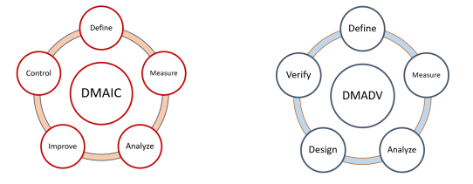

(Source: www.researchgate.net)