**GLOBAL BUSINESS IN CONTEXT: PART 1 LITERATURE REVIEW**

**Table of Contents**

Changing nature of the global landscape in 2023 for international business 3

Challenges for the textile industry based on international business environment 7

Opportunities for the textile industry based on international business environment 7

References 9

# Changing nature of the global landscape in 2023 for international business

The trend of globalisation, urbanisation, sustainability and free trade agreement (FTA) are impacting the global landscape of the textile industry. The production capacity of raw materials such as cotton also becomes a vital factor for the growth of the textile industry businesses. As per the views of Cavusgil *et al.* (2020), the economic condition acts as one of the major external forces and should be evaluated in a country before attempting to make an entry into the country for business in any domain. Halley Stevensons is known as the world's leading innovator and manufacturer of waxed cotton and waterproof fabrics. The major operations of the brand are carried out at Baltic Works in Dundee, UK (Halley Stevensons, 2023). Since 1864, the brand has invested in the idea of producing the finest textile materials with craft and consistent quality. This has also assured the company of having a wide range of products that appeal to apparel designers on a global scale. Technology comes across as a crucial success driven when brands are looking to invest in the idea of expanding globally. The availability of advanced technological solutions, efficient supply chain and distribution channels, and automated machines invite the growth of textile companies worldwide. In the UK, access to these technologies remains in plenty. This has assured the use of ISO 9002 standards for Halley Stevensons. The optimised technological resources in the textile industry remain crucial for long-term success and Halley Stevensons also relies on the same theme. The brand has managed to showcase the fabrics in different geographic locations such as London, Paris, New York, Munich and Milan due to excellence in the textile industry. As mentioned by Kaur (2021), the lack of plants and machinery for textile industry manufacturing and production could be seen as a technological factor that holds back the expansion of business services across some parts of the world. However, developed economies and the rapid trend of urbanisation are making sure that access to modern equipment and machinery is ample to catalyse textile industry services.

As stated by Collinson *et al.* (2020), in an attempt to expand business in new economies, the rate of inflation and degree of currency exchange rate fluctuations are required to be evaluated to know about the economic feasibility of doing business in a country. This also gives the scope to accurately predict the purchasing capacity of the general public and shape product prices accordingly. The annual GDP growth rate in the UK stood to be 7.5% in the year 2021. This highlighted the UK to share of the economic stability required to boost production and manufacturing within the textile industry.

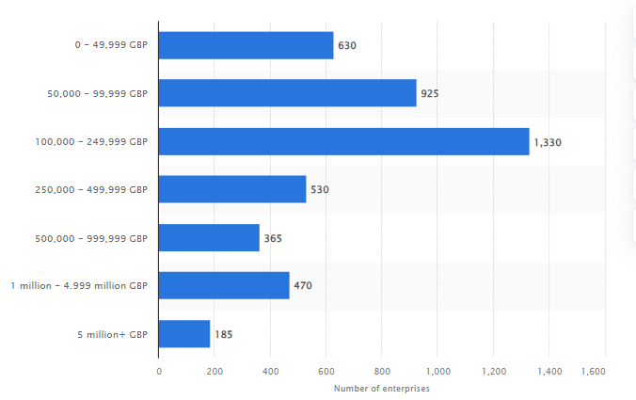

**Figure 1: Number of VAT/PAYE enterprises in the textile manufacturing sector in the UK**

(Source: Clark, 2022)

As per current reports, there remained 185 enterprises with a turnover of more than 5 million GBP in the textile manufacturing sector in the UK, as these are within the VAT and/or PAYE-based enterprises (Clark, 2022). This is suggestive of the fact that the UK sponsors tax relief for textile companies. This helps in the process of growing the business systematically to promote the industry standards further. However, the overall political landscape is not entirely positive for the textile businesses, as a flow of materials and trade restrictions cripple the growth opportunities to a large degree. Political stability in the UK could be certified as moderate as the exit from European Union (EU) during late 2019 and early 2020 with the application of Brexit caused havoc trouble to the textile industry services. As per the views of Harrison *et al.* (2019), the FTA will draw high-volume investments in the field of the textile industry, thereby paving way for faster expansion of the business in several foreign countries. It can be evaluated that the FTA between UK and India seems to be valuable in the coming time. Hence, the global landscape from the political side would be favourable for the textile industry, thereby referring to the increase in the export and import levels of textile fabrics.

The acceptance among social groups for apparel products across a wide range of categories is adequate in the UK market. On a global scale, textile-based products such as jackets, footwear, and luggage are going to remain popular as these products are not going to be replaced by any other alternative product. The consumer market for apparel products is going to witness an incremental rise in market share as there are plenty of brands operating in the textile industry including Halley Stevensons. According to the study by Morrison (2020), the global business environment is leaning towards sustainability as the trend for circular business models is getting popularized. As in the case of Halley Stevensons, the products manufactured in the textile industry remain in ample demand across the UK textile industry for which international success is expected in more countries apart from the ones where it is already functional. As per the study by Forsman *et al.* (2020), waxed-based garments have grown in popularity in the recent period as these garments could be regularly reproofed to keep the performance intact for a long period. According to the case of Halley Stevensons, the production of wax cotton works as a specialised textile which excels in the process of developing apparel products such as footwear, jackets, and luggage.

Sustainability stands to be a key factor for businesses operating in the textile industry as wastes generated from the manufacturing of raw materials for apparel negatively impact the environment. According to the views of Chen *et al.* (2021), a low-impact process is required to manufacture waxed cotton in the textile industry and this material is gentle to the environment and causes less pollution. For example, wax cotton-based textile products are fully biodegradable, thereby allowing Halley Stevensons to be a sustainable brand.

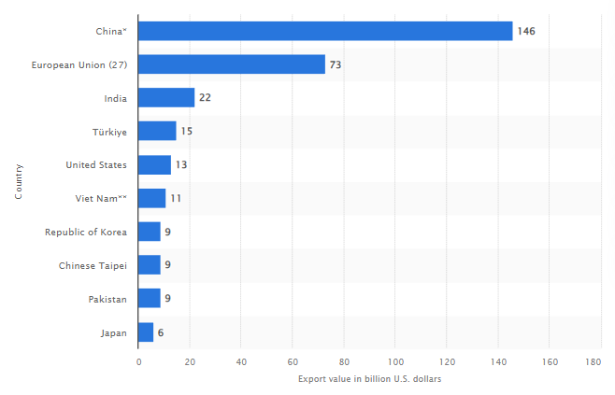

**Figure 2: Top textile exporting countries worldwide 2021**

(Source: Sabanoglu, 2022)

The UK as compared to some of the developing countries such as China, India, and Vietnam is lagging in terms of textile export values. Therefore, a company functional in the UK has greater scope to expand in foreign countries. As per current statistics, China managed to export $146 billion worth of textile products, while the EU gained the second spot based on the value of leading global textile export countries (Sabanoglu, 2022). Therefore, low cost and vast labour could be identified as key economic metrics that enables China to be a dominant force in the textile industry. On the contrary, the UK is not having access to cheap labour and carries a greater degree of commercial barrier when compared with developing countries. Hence, even from a legal perspective, the UK struggles to compete with countries such as China and India when it comes to textile industry growth.

As stated by Asgary *et al.* (2021), culture is recognised as a major external business factor that influences the sales of products and services of modern-day businesses as they look to follow the trend of globalisation. As in the case of Halley Stevensons,

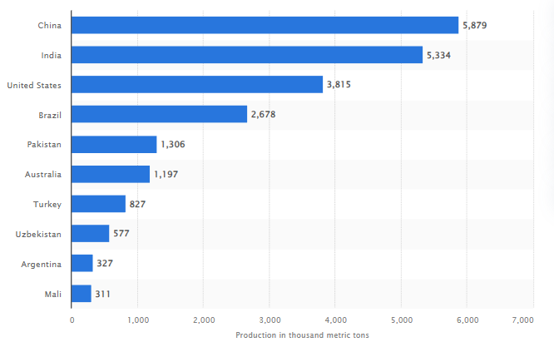

**Figure 3: Leading cotton-producing countries worldwide in 2021/2022**

(Source: Shahbandeh, 2022)

The production of cotton in a country is as important as the level of infrastructure it shares to process the cotton to make apparel products of varied kinds. As per recent reports, China stays at the top in terms of cotton production, with around 5.88 million metric tons production, as compared to 5.34 million metric tons for India (Shahbandeh, 2022). This goes to indicate that the developing countries are leading the cotton production and the developed countries are required to import most of the raw materials, thereby leading to an increase in costs during textile industry operations. As viewed by Voss *et al.* (2019), the legal code of conduct limits the sourcing capacity of certain materials during the operational processes in the textile sector. According to the case of Halley Stevensons, the UK Modern Slavery Act is followed alongside the wage distribution protocols to ensure no form of discrimination among the workforce and zero use of child labour, even under supplier sources. Therefore, the global business landscape is changing rapidly, but with an optimised set of business resources, there are higher success chances.

# Challenges for the textile industry based on the international business environment

There is a lack of digital presence for textile industry businesses, which creates the challenge of lack of brand awareness. The currency exchange rate variations could disrupt the flow of operations. As per the views of Nielsen and Marinova (2022), internationalisation strategies are adopted by businesses based on external business factors and internal business capabilities. Similarly, a business is expected to face challenges at the time of internationalising due to a lack of market knowledge and a poorly optimised resource base. As per the study by Batas *et al.* (2022), being unable to identify the megatrends in a business sector refers to a poor business outing for any company. As seen for Halley Stevensons, the issue of talent acquisition could be there as the existing design team would not be enough to handle new international orders. According to the study by Mithani *et al.* (2022), established businesses in the global market often face the crisis of poor profit margins as this tends to increase liabilities in the business as compared to the assets. In the long-term, this causes a lack of shareholder confidence in the business as the shareholders see a decline in the value-generative possibilities in the business. As per the study by Seidu *et al.* (2023), the COVID-19 pandemic impacted the textile industry in a challenging manner as it disrupted the supply chains, reduced the profit margins, halted employment and slowed down the delivery of products to customers. However, the pandemic has slowly faded away and signified the importance of a resilient supply chain to follow for business success internationally.

# Opportunities for the textile industry based on the international business environment

Marketing intelligence, efficient risk management, the growth of the textile industry, the emergence of new products, intercultural competence, infrastructure, intellectual property, and FTA between countries presents an ample degree of internationalisation opportunity. As mentioned by Davide *et al.* (2022), cross-border innovation is noticed to be popularised in the current period as brands have managed to export products to foreign locations and extract valuable business outcomes. Similarly, the textile industry follows direct exporting measures to capitalise on cross-border innovation processes. According to the views of Rana and Shrivastava (2021), doing business in emerging markets reflects operating in an economy that is growing faster, with GDP values remaining strong. For example, India could be seen as an emerging international market for Halley Stevensons, where the brand could succeed with its textile operations. In addition, the opportunity to source cheap labour as compared to that in the UK would possibly ensure higher profit margins. As viewed by Patel and Salih (2022), cultural favourability to do business needs to be thoroughly checked to assure sustainable growth. Since the textile industry leans towards the production of household items and non-replaceable essentials such as clothes, cultural acceptance would be a major factor. However, tools such as Hofstede cultural dimensions help predict the degree of cultural acceptance and social group response in foreign countries, thereby retaining the scope for internationalisation. As stated by Nambisan and Luo (2022), the digital presence of a business and familiarity with eCommerce sales needs to be there for a business to exponentially grow sales and become a sustainable brand in the international field. There is an opportunity for textile brands to create better brand awareness and increase brand visibility with the help of social media marketing via Facebook, Instagram, and Twitter.

According to the views of Tucci (2022), the Bartlett and Ghosal model makes it easy to identify the suitable internationalisation strategy for a business as it relies on two parameters and four specific internationalisation strategies. These two parameters are seen as cost pressure and local-responsiveness pressure, while the internationalisation strategies are known as multi-domestic strategy, global strategy, international strategy, and transnational strategy. Among these, a favourable internationalisation strategy remains an international strategy as this allows low cost and low local responsiveness to keep a standardised flow of operations. However, a transnational strategy can be also applied as it deals with cost and local responsiveness in a balanced way, thereby avoiding cultural backlash. As per the views of Sitkin and Mangion-Thornley (2020), the ethical grounds of a business need to be strong to cope with international business regulations and avoid complexities. Once a business achieves ethical clearance, it gets the opportunity to gain community support and grabs a bigger market share. Hence, opportunities for Halley Stevensons tend to be a lot more than the challenges, as the 2023 international business landscape holds positive outcomes in the textile industry.

# References

Asgary, N.H., Samii, M.V. and Varamini, H., 2021. *Global Business: An Economic, Social*. IAP.

Batas, S., Kuivalainen, O. and Sinkovics, R.R., 2022. *Megatrends in International Business: Examining the Influence of Trends on Doing Business Internationally*. Springer International Publishing AG.

Cavusgil, S.T., Knight, G. and Riesenberger, J.R., 2020. International business: the new realities, global edition. *Harlow, England: Pearson*.

Chen, X., Memon, H.A., Wang, Y., Marriam, I. and Tebyetekerwa, M., 2021. Circular Economy and sustainability of the clothing and textile Industry. *Materials Circular Economy*, *3*, pp.1-9.

Clark, D., 2022. *Number of VAT/PAYE enterprises in the textile manufacturing sector in the United Kingdom 2022, by turnover size band.* Statista. Available at: https://www.statista.com/statistics/320318/uk-enterprises-in-the-manufacture-of-textiles-by-turnover/ [Accessed on 20th February 2023]

Collinson, S., Narula, R., Qamar, A. and Rugman, A.M., 2020. *International business*. Pearson UK.

Davide, C., Alessandra, P., Scalera, V.G. and Zanfei, A., 2022. Cross-Border Innovation in a Changing World. Players, Places, and Policies.

Forsman, N., Johansson, L.S., Koivula, H., Tuure, M., Kääriäinen, P. and Österberg, M., 2020. Open coating with natural wax particles enables scalable, non-toxic hydrophobation of cellulose-based textiles. *Carbohydrate polymers*, *227*, p.115363.

Halley Stevensons, 2023. *About Waxed Cotton.* Available at: https://halleystevensons.co.uk/about/about-waxed-cotton/ [Accessed on 20th February 2023]

Harrison, J., Barbu, M., Campling, L., Ebert, F.C., Martens, D., Marx, A., Orbie, J., Richardson, B. and Smith, A., 2019. Labour standards provisions in EU free trade agreements: reflections on the European commission's reform agenda. *World Trade Review*, *18*(4), pp.635-657.

Kaur, K., 2021. The early impact of COVID-19 on textile industry: an empirical analysis. *Management and Labour Studies*, *46*(3), pp.235-247.

Mithani, M.A., Narula, R., Surdu, I. and Verbeke, A., 2022. Unique Implications of Crises and Disruptions for International Business: How Established MNEs Are Exposed to Crises and Mitigate Their Effects. In *Crises and Disruptions in International Business: How Multinational Enterprises Respond to Crises* (pp. 3-18). Cham: Springer International Publishing.

Morrison, J., 2020. *The Global business environment: towards sustainability?*. Bloomsbury Publishing.

Nambisan, S. and Luo, Y., 2022. *The Digital Multinational: Navigating the New Normal in Global Business*. MIT Press.

Nielsen, C. and Marinova, S.T. eds., 2022. *Business models and firm internationalisation*. Abingdon: Routledge.

Patel, T. and Salih, A.M. eds., 2022. *Cultural Spaces in International Business: Theories and Applications*. Routledge.

Rana, S. and Shrivastava, A.K., 2021. Doing business in emerging markets: progress and promises: An introduction. In *Doing Business in Emerging Markets* (pp. 1-9). Routledge India.

Sabanoglu, T., 2022. *Top textile exporting countries worldwide 2021.* Statista. Available at: https://www.statista.com/statistics/236397/value-of-the-leading-global-textile-exporters-by-country/ [Accessed on 20th February 2023]

Seidu, R.K., Jiang, S.X., Tawiah, B., Acquaye, R. and Howard, E.K., 2023. Review of effects of COVID-19 pandemic on the textile industry: challenges, material innovation and performance. *Research Journal of Textile and Apparel*.

Shahbandeh, M., 2022. *Leading cotton producing countries worldwide in 2021/2022.* Statista. Available at: https://www.statista.com/statistics/263055/cotton-production-worldwide-by-top-countries/ [Accessed on 20th February 2023]

Sitkin, A. and Mangion-Thornley, K., 2020. *Absolute essentials of international business*. Routledge.

Tucci, C.L., 2022. The Many Sides of Business Model Innovation. *Management and Organization Review*, *18*(1), pp.209-211.

Voss, H., Davis, M., Sumner, M., Waite, L., Ras, I.A., Singhal, D.I.V.Y.A. and Jog, D., 2019. International supply chains: compliance and engagement with the Modern Slavery Act. *Journal of the British Academy*, *7*(s1), pp.61-76.