

**SG7002 – Applied Business Project Front Sheet**

**Student Number:…U2213228……………………………**

|  |  |  |  |
| --- | --- | --- | --- |
| **Component** | **Comments** | **Weight** | **Actual Mark** |
| **Introduction**  *Identification of a valid topic, research question and objectives framed to Masters Level standard with academic rationale developed, clear industry contextualisation of the research topic* |  | **10%** |  |
| **Critical Literature Review**  *Depth and breadth of literature search, engagement with seminal authors and papers, evidence of a critical approach toward the scholarly literature* |  | **25%** |  |
| **Research Methodology**  *Evaluation of research philosophies and perspectives. Justification of methodological approach, sampling strategy, data analysis and reliability and validity measures as applicable* |  | **15%** |  |
| **Data Analysis and Interpretation**  *Evidence of rigor in data analysis and interpretation procedures, identification of key patterns and themes in the research data, integration of academic theory into explanation of findings* |  | **35%** |  |
| **Conclusions and Recommendations**  *Research question and objectives addressed with implications to theoretical and managerial concepts considered. Recommendations provided for theory, practice and future research* |  | **10%** |  |
| **Organisation, presentation and references.**  *Well structured and ordered dissertation with correct use of grammar and syntax. In-text citation and bibliography conforming to “Cite Them Right”* |  | **5%** |  |
| **Total** |  | **100%** |  |
| **General Comments:** | | **Agreed Mark:** | |

**ADVANTAGES AND CHALLENGES FOR MNCS TO USE SMARTPHONE APPS TO ATTRACT AND RETAIN NEW CUSTOMERS: CASE STUDY OF TESCO**

A dissertation submitted in partial fulfilment of the requirements of the Royal Docks School of Business and Law, University of East London for the degree of **[MSC International Business Management]**

**[MAY 2023]**

**[6000]**

I declare that no material contained in the thesis has been used in any other submission for an academic award

Student Number:__U2213228_____________________ Date:_____________________

**Dissertation Deposit Agreement**

***Libraries and Learning Services at UEL is compiling a collection of dissertations identified by academic staff as being of high quality. These dissertations will be included on ROAR the UEL Institutional Repository as examples for other students following the same courses in the future, and as a showcase of the best student work produced at UEL.***

***This Agreement details the permission we seek from you as the author to make your dissertation available. It allows UEL to add it to ROAR and make it available to others. You can choose whether you only want the dissertation seen by other students and staff at UEL (“Closed Access”) or by everyone worldwide (“Open Access”).***

I DECLARE AS FOLLOWS:

* That I am the author and owner of the copyright in the Work and grant the University of East London a licence to make available the Work in digitised format through the Institutional Repository for the purposes of non-commercial research, private study, criticism, review and news reporting, illustration for teaching, and/or other educational purposes in electronic or print form
* That if my dissertation does include any substantial subsidiary material owned by third-party copyright holders, I have sought and obtained permission to include it in any version of my Work available in digital format via a stand-alone device or a communications network and that this permission encompasses the rights that I have granted to the University of East London.
* That I grant a non-exclusive licence to the University of East London and the user of the Work through this agreement. I retain all rights in the Work including my moral right to be identified as the author.
* That I agree for a relevant academic to nominate my Work for adding to ROAR if it meets their criteria for inclusion, but understand that only a few dissertations are selected.
* That if the repository administrators encounter problems with any digital file I supply, the administrators may change the format of the file. I also agree that the Institutional Repository administrators may, without changing content, migrate the Work to any medium or format for the purpose of future preservation and accessibility.
* That I have exercised reasonable care to ensure that the Work is original, and does not to the best of my knowledge break any UK law, infringe any third party's copyright or other Intellectual Property Right, or contain any confidential material.
* That I understand that the University of East London does not have any obligation to take legal action on behalf of myself, or other rights holders, in the event of infringement of intellectual property rights, breach of contract or of any other right, in the Work.

I FURTHER DECLARE:

* That I can choose to declare my Work “Open Access”, available to anyone worldwide using ROAR without barriers and that files will also be available to automated agents, and may be searched and copied by text mining and plagiarism detection software.
* That if I do not choose the Open Access option, the Work will only be available for use by accredited UEL staff and students for a limited period of time.

**Dissertation Details**

|  |  |
| --- | --- |
| **Field Name** | **Details to complete** |
| Title of thesis  *Full title, including any subtitle* | Advantages and challenges for MNCs to use smartphone apps to attract and retain new customers: case study of Tesco |
| Supervisor(s)/advisor  *Separate the surname (family name) from the forenames, given names or initials with a comma, e.g. Smith, Andrew J.* |  |
| Author Affiliation  *Name of school where you were based* |  |
| Qualification name  *E.g. MA, MSc, MRes, PGDip* | MSC |
| Course Title  *The title of the course e.g.* |  |
| Date of Dissertation  *Date submitted in format: YYYY-MM* |  |
| Does your dissertation contain primary research data? (If the answer to this question is yes, please make sure to include your Research Ethics application as an appendix to your dissertation) | Yes No |
| *Do you want to make the dissertation Open Access (on the public web) or Closed Access (for UEL users only)?* | Open Closed |

**By returning this form electronically from a recognised UEL email address or UEL network system, I grant UEL the deposit agreement detailed above. I understand inclusion on and removal from ROAR is at UEL’s discretion.**

Student Number: ...U2213228...................................................

Date: ..............................

**Abstract**

A key factor driving the power of mobile marketing is its omnipresence and reliance on substantial information. Application of mobile marketing by brands fosters the scope for bringing them extensively closer to their target customer base. This holds a range of advantages for MNCs on grounds of constant visibility, affordability, and easy access. Contrary to this, using smartphone applications for attracting and engaging customers also entail certain limitations like privacy concerns, unplanned data cost, market sat

**Table of Contents**

Chapter 2: Critical Literature Review 9

2.0 Introduction 9

2.1 Conceptual Framework 9

2.2 Current Market Trend of Smartphone Application in Marketing 11

2.3 Significance of Using Smartphone Apps for Customer Attraction and Engagement 12

2.4 Factors Driving the Need for Smartphone Usage by MNCs for Customer Engagement 13

2.5 Challenges Concerning the Application of Smartphone Apps by MNCs for Customer Engagement 14

2.6 Theoretical Perspectives 15

2.6.1 Technology Acceptance Model (TAM) 15

2.6.2 Relationship Marketing Theory 16

2.7 Gap in Literature 17

2.8 Summary 17

Reference List 18

**List of Figures**

Figure 2.1: Conceptual Layout 11

Figure 2.2: Popular Mobile Applications in UK 11

Figure 2.3: Technology in Marketing 12

Figure 2.4: Advantages of Mobile Marketing 13

Figure 2.5: Limitations of Mobile Marketing 14

Figure 2.6: Technology Acceptance Model 15

Figure 2.7: Relationship Marketing Theory 16

# Chapter 2: Critical Literature Review

## 2.0 Introduction

Multinational companies (MNCs) are extensively focusing on smartphone users as a way of designing their marketing strategies. This also sheds light on the significant need for brands to stress more on the customer segments failing to own a standard mobile phone. Based on this preliminary insight, the following chapter is aimed at carrying out a critical literature review regarding smartphone application in marketing. This is directed towards using existing published academic sources for developing an understanding of the contribution towards smartphone apps to customer engagement.

## 2.1 Conceptual Framework

The following figures illustrates that mobile apps are helping businesses and organisations to build brand loyalty by attracting more customers. This, in turn, is causing more customers to spend more time on devices for purchases. This has, however, become a personalised strategy using which MNCs like Tesco are receiving push notifications at least once a day.

**Unplanned Data Costs**

**Market Saturation**

**Privacy Concerns**

**Analysis Paralysis**

**Personalised Strategies**

**Mobile Application for Marketing by MNCs**

**Increased Time Spent on Devices**

**In-store Purchases**

**Broader Market Reach**

#### Figure 2.1: Conceptual Layout

(Source: Self-created)

## 2.2 Current Market Trend of Smartphone Application in Marketing

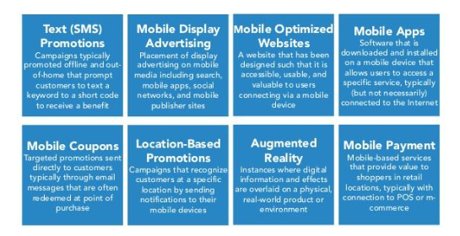

#### Figure 2.2: Types of mobile marketing

(Source: Inspired by Djordjevic, 2022)

Mobile marketing serves as an advertising activity involving the use of mobile devices like text applications and promos through push notifications. Eze *et al*. (2019) mentioned that Application of mobile marketing devices enables scope for companies to boost sales promotion strategies. On the contrary, there tends to be limited emphasis towards development of a suitable Framework that can enable shared understanding and evaluation of influencing factors. Smartphones tend to be undertaken as a crucial device for online operations in UK. It is supported by the usage statistics of mobile Internet highlighting that less than 5% of Internet users tend to access the Internet, only through computers (Djordjevic, 2022). On the contrary, majority UK customers spend about 2 hours and 44 minutes on daily online functions with the aid of smartphones. An example is that of Facebook as an MNC generating 70% of the revenue from advertisement viewership concerning mobile users.

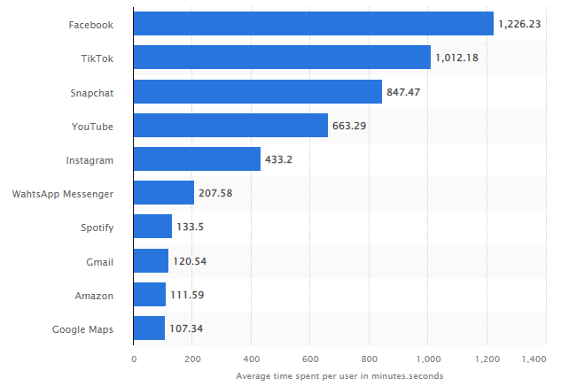

#### Figure 2.3: Popular Mobile Applications in UK

(Source: Ceci, 2023)

Determined from Figure 2.2 the attribute of mobile marketing by MNCs is incomplete without the help of social media. As of December 2022, Facebook is identified as one of the leading engaging mobile applications in UK. This gets supported by figures enlightening UK consumers spend about 1,226 minutes on average regarding social media platforms (Ceci, 2023). It is also followed by TikTok ranking second and Snapchat ranking third with average user spending of about 1,000 and 847 minutes respectively. In this regard, Djordjevic (2022) asserted that mobile marketing statistics of 2019 highlight mobile advertising making up for about 56% of digital advertisement expenditure in UK. This potentially relates to the figure of about 89.3% UK consumers using mobile applications for accessing the internet.

## 2.3 Significance of Using Smartphone Apps for Customer Attraction and Engagement

Current marketing strategies by leading brands and MNCs aim at using major technologies. This accounts for producing a range of benefits like accessing big data, improved customer experience along with a better understanding of trigger concerns and risk assessment (Grewal *et al*. 2020). Referring to this a wider application of mobile marketing by brands and MNCs is subject to reach a highly targeted customer segment and engage with them through personalised campaigns. This paves the way for an immediate and accessible customer base with a rapid way of communication. However, Jocevski *et al*. (2020) argued that adaptation of mobile marketing is highly dependent on the choice of scope concerning geographic availability. Measuring the success and the development of an effective strategy often pose challenges for mobile marketing.

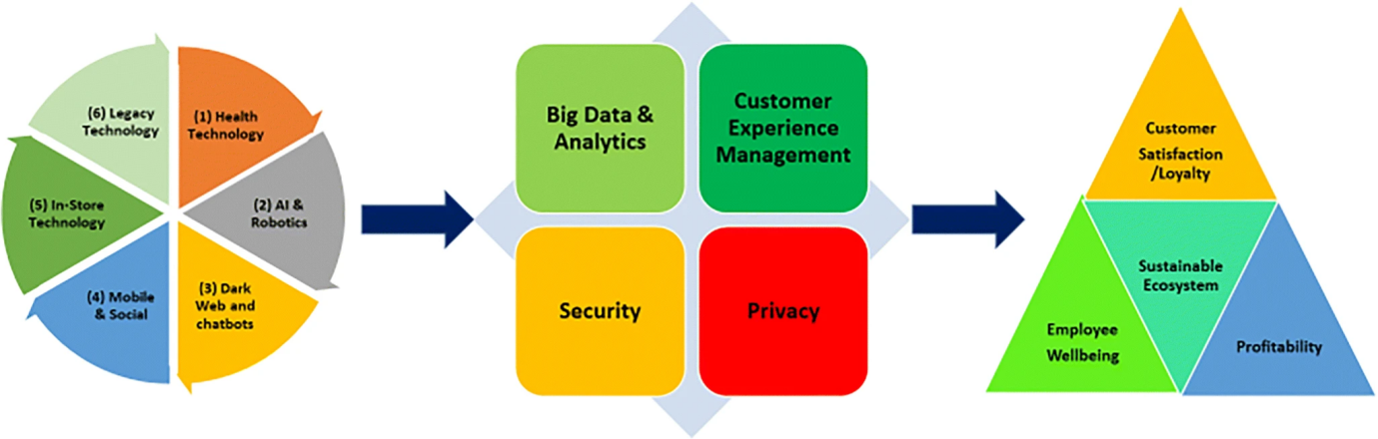

#### Figure 2.4: Technology in Marketing

(Source: Obtained from Grewal *et al*. 2020)

In this view, mobile marketing is identified to be highly essential going to its affordability and significant effectiveness. As in the figure above by Grewal *et al*. (2020), the application of technology in marketing holds potential challenges on grounds of privacy and security. However, it is also contradicted that given the extent of content completed by mobile advertisements with online ones, mobile marketing campaigns hold little scope for error (Djordjevic, 2022). It is believed that with smartphones being a common preference for all customer segments, the existing trends in mobile marketing make a major focus on micro-movements. The same is also supported by the perspective of Devi and Nivethitha (2018) stating that usage ease and processing speed serves as potential driving factors for customers to frequently use their smartphones. This leverages a potential scope for brands to reach their target customers at decisive times.

## 2.4 Factors Driving the Need for Smartphone Usage by MNCs for Customer Engagement

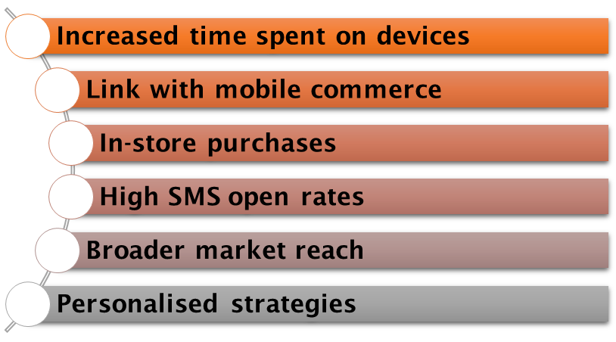

#### Figure 2.5: Advantages of Mobile Marketing

(Source: Cited by Meyer, 2019)

A leading driving factor for brands and MNCs in using mobile marketing for customer attraction and engagement is the ***increasing time spent*** by these segments on mobile devices. Fischer-Grote *et al*. (2019) opined that the percentage of mobile users specifically among minors is witnessing a potential growth. Although this can be a significant driving factor for MNCs to reach target customers, associated psychological issues and strict parenting can impose challenges for this base (Ghosh *et al*. 2018). Furthermore, the ***correlation*** between mobile marketing and mobile commerce serves as a leading driving factor for e-commerce platforms like Amazon, Walmart, eBay, and others. This is based on the figure that about 60% of e-commerce visits tend to start on smartphone devices (Meyer, 2019). In addition, the ***opportunity rendered by mobile technology*** towards shopping and comparison during in-store visits makes it advantageous for customers and brands alike.

Search Engine Optimisation (SEO) followed by easy navigation of websites makes it an advantage for MNCs in attracting potential customers and keeping them engaged for a purchase. In this matter, Ojugo and Eboka (2020) pointed out that “Short Message Service” (SMS) tends to have a substantially higher open rate in comparison to emails. Therefore, ***tailoring SMS messages*** that can appeal to potential customers renders advantages for MNCs like Whirlpool to guide them in researching the services or products (Fareri *et al*. 2020). Subsequently, lighter, cheaper, portable, and smaller attributes of smartphones make them extensively available to a ***wider market*** and prospective for brands to target and keep them engaged. Also, Grewal *et al*. (2020) put forward that growth concerning mobile technology applications and data is directing the way for personalised strategies of mobile marketing. This ***personalisation*** is contributing a scope for MNCs in increased customer engagement and satisfaction (Kumar and Mittal, 2020). Despite these contributing towards the adoption of mobile marketing, the extent is potentially dependent on technology, environment, value anticipation, and organisations.

## 2.5 Challenges Concerning the Application of Smartphone Apps by MNCs for Customer Engagement

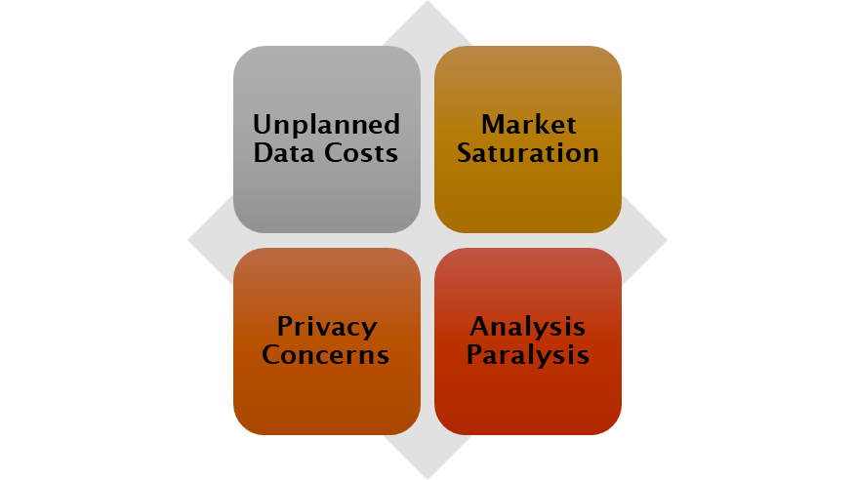

#### Figure 2.6: Limitations of Mobile Marketing

(Source: Cited by Djordjevic, 2022)

Irrespective of the advantages of mobile marketing driving its adoption rate, a leading limitation is ***privacy concerns*** among consumers. Eze *et al*. (2019) supported this with the argument that an unsafe approach to mobile marketing applications with the risk of losing confidential information reduces the risk of its adoption. Moreover, it is also addressed that the possibility of ***unplanned data cost*** imposes challenges for MNCs for using mobile marketing to target customers. This is in the context of risk imposed by consumers accounting for clicking video advertisements while using their mobile data (Djordjevic, 2022). Accordingly, the aspect of ***market saturation*** drives the way for posing barriers against the advantages of mobile marketing. A possible product or service stagnation can make a challenge for the MNC in gaining new customers through applied mobile marketing strategies.

Subsequently, the aspect of ***low error tolerance*** serves as a substantial challenge for MNCs aiming at using smartphone advertisements. This is relevant to the aspect of TripAdvisor having no significant insight into its “via mobile” label on potential customers (Grewal and Stephen, 2019). Localisation tends to impose an insignificant impact on customer loyalty over the positive impacts of personalization, convenience, and interactivity by mobile marketing (Al-Hawary and Obiadat, 2021). Although brands like Netflix, Uber and Slack make a proper use of localisation, others like Electrolux faced major challenges in introducing their tagline to the American market. Additionally, MNCs also face issues in the context of deciding on the channels to be used for launching relevant mobile marketing strategies along with provisioning for their codes (Gladwin, 2022). This is substantially accompanied by the challenge of ***analysis paralysis*** in deciding an effective way to implement the strategies and justifying their investments. This is highly illustrated by the belief of Peltonen and Peltonen (2019) regarding analysis paralysis being a major reason for Nokia’s downfall.

## 2.6 Theoretical Perspectives

### 2.6.1 Technology Acceptance Model (TAM)

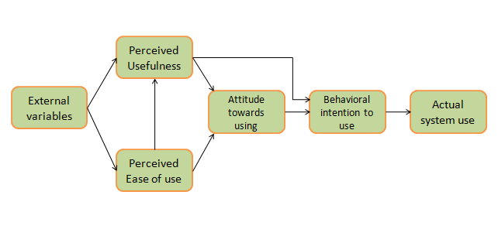

#### Figure 2.7: Technology Acceptance Model

(Source: Influenced by Alsharida *et al*. 2021)

The following theoretical component of TAM involves being designed for measuring the adoption of newer technologies depending on customer attitudes. Alsharida *et al*. (2021) established that TAM widely contributes towards increasing the credibility of adopting a model by explaining the intentions of users concerning the adaptation of technology. The following theoretical context can be widely undertaken by MNCs currently using mobile applications and the ones aiming at future adoption to have a detailed understanding of customer preferences. Henceforth, from the Figure 2.1, the following theoretical context can widely contribute towards the mitigation of challenges concerning mobile marketing by MNCs.

### 2.6.2 Relationship Marketing Theory

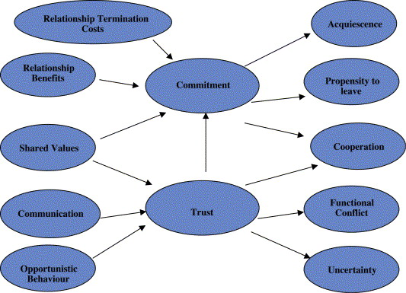

#### Figure 2.8: Relationship Marketing Theory

(Source: Influenced by Razmus, 2021)

The concerned perspective of relationship marketing aims at the creation of a strategy and approach that can account for generating customer retention. This involves a major shift towards a single sales strategy from a traditional marketing attribute for treating sales as an initiation of customer relationship (Razmus, 2021). The same can be potentially undertaken by MNCs at customer attraction for creating a continuous relationship and delivery. along with their offering and products in securing a positive customer experience. Henceforth, the mentioned theory can be stated to be helping MNCs to mitigate challenges concerning mobile marketing by means of commitment through relationship building and trust through clear and transparent communication. Doing so will enhance customer satisfaction, improve retention rates and higher conversion rates.

## 2.7 Gap in Literature

The following literature review concerning the role of smartphone marketing for MNCs to target customer segments and keep them engaged has accounted for a certain range of academic sources. This has involved the use of trusted academic published articles along with credible website sources for understanding the key concept of this subject. However, a major limitation witnessed as part of this review is insufficient research activities conducted regarding the challenges associated with mobile marketing.

## 2.8 Summary

Digital marketing is witnessing a constant evolution with mobile marketing playing a key role in this particular strategy. The shift and preference by leading brands and MNCs towards mobile devices are expected to be progressing. Gleaned from this aspect, the following literature review has inferred that MNCs require ensuring a cohesive marketing plan for connecting with digital consumers and keeping them engaged. Conversely, this chapter has also deduced that as a need for getting mobile marketing right, MNCs require a potential emphasis on the appointment challenges. Compliance with the theoretical contexts has further concluded the effectiveness of mobile marketing for MNCs in the present-day need for customer attraction and engagement.

# Reference List

Al-Hawary, S.I.S. and Obiadat, A.A., (2021). Does mobile marketing affect customer loyalty in Jordan? *International Journal of Business Excellence*, *23*(2), pp.226-250.

Alsharida, R., Hammood, M. and Al-Emran, M., (2021). Mobile learning adoption: A systematic review of the technology acceptance model from 2017 to 2020. *International Journal of Emerging Technologies in Learning (iJET)*, *16*(5), pp.147-162.

Ceci, L. (2023). *Leading mobile apps in the UK 2022, by average time spent*. Available at: <https://www.statista.com/statistics/1282100/top-mobile-apps-uk-by-time-spent/> [Accessed on: 01 April 2023]

Devi, S.R. and Nivethitha, V. (2018). A study on Brand preference of Smart Phones among Customers at Vellore District. *International Journal of Multidisciplinary*, pp.129-133.

Djordjevic, M. (2022). *20+ Intriguing Mobile Marketing Statistics: How Effective Is Mobile Marketing in 2023?*Available at: <https://fashiondiscounts.uk/mobile-marketing-statistics/#:~:text=Mobile%20marketing%20statistics%20show%20that,devices%20to%20access%20the%20internet>. [Accessed on: 01 April 2023]

Eze, S.C., Chinedu-Eze, V.C., Bello, A.O., Inegbedion, H., Nwanji, T. and Asamu, F., (2019). Mobile marketing technology adoption in service SMEs: a multi-perspective framework. *Journal of Science and Technology Policy Management*, *10*(3), pp.569-596.

Eze, S.C., Chinedu-Eze, V.C., Bello, A.O., Inegbedion, H., Nwanji, T. and Asamu, F., (2019). Mobile marketing technology adoption in service SMEs: a multi-perspective framework. *Journal of science and technology policy management*, *10*(3), pp.569-596.

Fareri, S., Fantoni, G., Chiarello, F., Coli, E. and Binda, A., (2020). Estimating Industry 4.0 impact on job profiles and skills using text mining. *Computers in industry*, *118*, p.103222.

Fischer-Grote, L., Kothgassner, O.D. and Felnhofer, A., (2019). Risk factors for problematic smartphone use in children and adolescents: a review of existing literature. *Neuropsychiatrie*, *33*(4), p.179.

Ghosh, A.K., Badillo-Urquiola, K., Rosson, M.B., Xu, H., Carroll, J.M. and Wisniewski, P.J., (2018, April). A matter of control or safety? Examining parental use of technical monitoring apps on teens' mobile devices. In *Proceedings of the 2018 CHI Conference on Human Factors in Computing Systems* (pp. 1-14).

Gladwin, A. (2022). *Mobile Marketing: Challenges and opportunities*. Available at: <https://www.marketingmag.com.au/featured/mobile-marketing-challenges-and-opportunities/> [Accessed on: 02 April 2023]

Grewal, D., Hulland, J., Kopalle, P.K. and Karahanna, E., (2020). The future of technology and marketing: A multidisciplinary perspective. *Journal of the Academy of Marketing Science*, *48*, pp.1-8.

Grewal, L. and Stephen, A.T., (2019). In mobile we trust: The effects of mobile versus nonmobile reviews on consumer purchase intentions. *Journal of Marketing Research*, *56*(5), pp.791-808.

Jocevski, M., Ghezzi, A. and Arvidsson, N., (2020). Exploring the growth challenge of mobile payment platforms: A business model perspective. *Electronic Commerce Research and Applications*, *40*, p.100908.

Kumar, V. and Mittal, S., (2020). Mobile marketing campaigns: practices, challenges and opportunities. *International Journal of Business Innovation and Research*, *21*(4), pp.523-539.

Meyer, E. F. (2019). *Five Reasons Mobile Marketing Is Becoming Even More Important*. Available at: <https://www.forbes.com/sites/forbesagencycouncil/2017/05/31/five-reasons-mobile-marketing-is-becoming-even-more-important/?sh=58f8d323abb4> [Accessed on: 02 April 2023]

Ojugo, A.A. and Eboka, A.O., (2020). Memetic algorithm for short messaging service spam filter using text normalization and semantic approach. *International Journal of Informatics and Communication Technology (IJ-ICT)*, *9*(1), pp.9-18.

Peltonen, T. and Peltonen, T., (2019). Case Study 4: The Collapse of Nokia’s Mobile Phone Business. *Towards Wise Management: Wisdom and Stupidity in Strategic Decision-making*, pp.163-188.

Razmus, W., (2021). Consumer brand engagement beyond the “likes”. *Frontiers in Psychology*, *12*, p.692000.

Tong, S., Luo, X. and Xu, B., (2020). Personalised mobile marketing strategies. *Journal of the Academy of Marketing Science*, *48*, pp.64-78.