|  |  |
| --- | --- |
| Programme |  |
| Module name | Executive Leadership and Governance |
| Schedule Term |  |
| Student Reference Number(SRN) |  |
| Report/AssignmentTitle | **DISNEY LEADERSHIP AND RISK MANAGEMENT REPORT** |
| DateofSubmission  *(Pleaseattachtheconfirmationofanyextensionreceived)* |  |
|  | |
|  | |
| Declaration of Original Work:  I hereby declare that I have read and understood BPP’s regulations on plagiarism and that this is my original work, researched, undertaken, completed and submitted in accordance with the requirements of BPP School of Business and Technology.  The word count, excluding contents table, bibliography and appendices, is 4843 words. Student Reference Number: Date: | |
| By submitting this course work you agree to all rules and regulations of BPP regarding assessments and awards for programmes. **Please note, submission is your declaration you are fit to sit.**  BPP University reserves the right to use all submitted work for educational purposes and may request that work be published for a wider audience.  **BPP School of Business and Technology** | |

**Table of Contents**

PART A: Board Review Report for new and existing Board Members 3

1) Business Culture and Board role 3

2) Corporate Governance 4

3) Regulatory Landscape and Management of Risk 5

PART B: Leadership Report 6

Introduction 6

Task 1: Leadership and management 6

1.1 Leadership and management style in Disney 7

1.2 Comparative analysis of the leadership style of Disney and its challenge 9

1.3 Strategies of Disney to Mitigate Challenges 10

Task 2: Leadership for performance 11

2.1 Balanced scorecard for Disney 11

2.2 Role of Leadership in performance approaches to achieve objectives for Disney 13

Task 3: Financial leadership 14

3.1 Identification of key sources of financial and non-financial information 14

3.2 Factors led to dramatic changes that affect the Performance of Disney 14

Task 4: Ethical leadership 16

4.1 Evaluation of past ethical decision-making of Disney 16

4.2 Identification of Ethical Issue affects the Performance of Disney and recommended strategy to Resolve the Challenge 17

Conclusion 18

References 19

# PART A: Board Review Report for new and existing Board Members

## 1) Business Culture and Board role

***Leadership style and organisational culture evaluation at Disney***

The size of a business impacts leadership practices as the decision-making process has to be handled differently to meet the expectation of varied stakeholders. As seen in the case of Disney, innovation, creation, and excellence are the major values shared by business leaders. The Chief Executive Officer of Disney ROBERT A. IGER manages to guide the business in a successful route by following these principles. As per the study by Sriyakul et al(2019), there are different leadership styles applicable to modern-day business leaders such as democratic, autocratic, delegative, transactional, situational, and transformational business leadership style. The business as of the present day carries the autocratic form of leadership as a result of domineering and controlling actions over the business projects. In terms of the organisational structure, there is the presence of a decentralised cooperative multidivisional structure. Since the core focus of the business structure is to be functional across the globe and deliver entertainment with quality content, it aligns accurately with the international-level operational values of the decentralised cooperative multidivisional structure. As of the current day, the presence of hierarchical culture is there within the company.

***Core duties of the board***

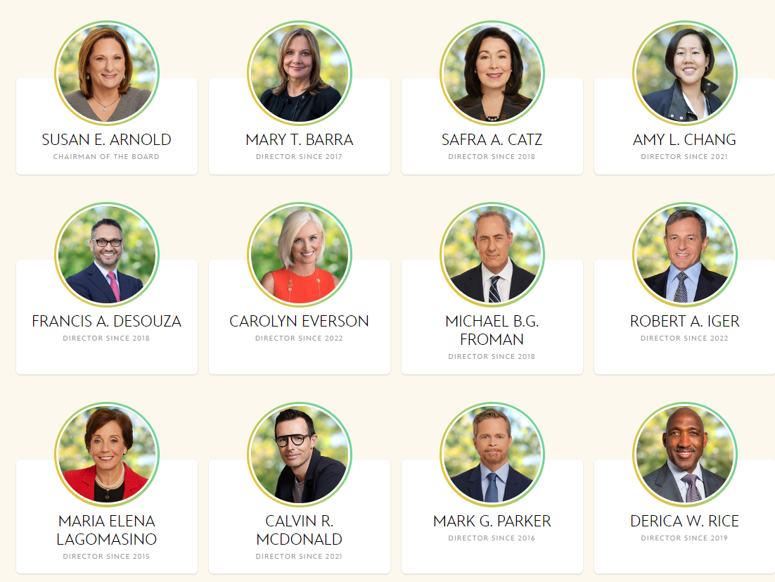

**Figure 1: Board of Directors**

(Source: Disney, 2022)

The individuals part of the board of directors in the company stand as Chairman of the board-SUSAN E. ARNOLD and Director-MARY T. BARRA, since 2017 for the company(Disney, 2022). Financial information disclosure within time is one of the major responsibilities of the board of directors. According to the views of Bommaraju et al(2019), observing actions transparently and ensuring long-term value generation is done from business practices remain to be the core theme for the board of directors. In recent times, addition is made in the form of two new non-executive directors to strengthen the corporate decision making abilities of the company.

***Elements within the Annual Report***

Accessing key financial and operational data is possible from the annual reports of a company. As per reports, unresolved staff comments, properties, risk factors, legal proceedings, data related to the executive officers, financial statements, qualitative and quantitative disclosure based on the market risks, executive compensation, and corporate governance-related information are present within the annual report (Disney, 2022).

## 2) Corporate Governance

***Corporate Governance framework***

Ethical decision-making in a business is sponsored by corporate governance frameworks. According to the study by Chams and García-Blandón (2019), accountability, transparency, fairness, and responsibility are seen to be the four key driving factors of a corporate governance body. The agency theory is indicative of the problem that could be faced during principal-agent interactions. However, a properly structured corporate governance framework enables better dealing with the principal-agent problem and keeps the relationship strong. As evident from the case of Disney, the inclusion of diversified working officials and maintaining 36% ethnic diversity and 64% gender diversity are helping the company maintain sustainable operations and strong corporate governance.

***Remuneration committee’s role at Disney***

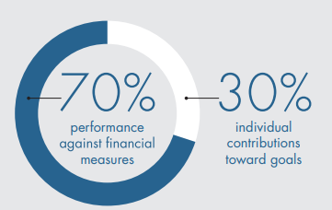

**Figure 2: Performance-Based opportunities in the company**

(Source: Disney, 2022)

The remuneration committee shares the role of suggesting the suitable actions needed by the board members to ensure the transparent delivery of remuneration in a structured manner. At Disney, the compensation committee plays the role of a remuneration committee. In the year 2021, 90% or more of Mr. Iger’s and Mr. Chapek’s target annual total direct compensation remained as a part of the equity compensation. Furthermore, the application of two new non-executive directors in the committee can allow Disney to properly handle executive pay and several other financial aspects of the business.

## 3) Regulatory Landscape and Management of Risk

***Board’s responsibility for risk management***

The stability of financial business decisions, secured transactions, and better internal control is achieved with the proper responsible actions of the board members. According to the study by Martinez-Jimenez et al(2020), risk management is done by the end of board members to establish better business resilience. As witnessed in the case of Disney, the Governance and Nominating Committee shares the major responsibility of dealing with the variety of risks in governance programs, environmental dealings, and social actions. The workforce quality is measured and assured risk-free by the compensation committee. The audit committee plays a vital role in ensuring that there are no risks in the domain of data security as cyber security vulnerabilities are rising for modern-day businesses. The executive compensation program in the business also carries certain risk areas that are governed by the compensation committee.

***The regulatory landscape for Disney and success impact***

As per the views of Vitolla et al(2020), ethical business actions are boosted when there is a follow-up of regulations and legal codes. Disney looks to rely on the idea of maintaining a strong code of ethics but fails to execute authentic business actions as past data suggests. However, the basic regulations are followed aptly by the company as the Communications Act of 1934 is complied with to promote content in various parts of the United States.

***Risks faced by Disney and its evaluation***

|  |  |  |  |  |
| --- | --- | --- | --- | --- |
| **Risk elements** | **Likelihood** | **Severity** | **Impact** | **Mitigation** |
| Reporting of the financial statements | High | High | High | Auditing standards betterment |
| Cybersecurity dependent flaws | High | High | High | Use of secured blockchain technology |
| High operational costs | Medium | Medium | Medium | Predictive analysis tools |
| Legal code compliance | High | Medium | High | Standardised governance reporting |

**Table 1: Risk register**

***Recommendations to face the top 3 risks at Disney***

As per the study by Naciti (2019), identification of the risks based on their future implications helps a business respond to the risks and negate the negative implications. For Disney, the challenge remains in tackling the three major risks in the form of financial statement planning, cybersecurity-oriented information technology management, and high level of operational costs. The corporate governance committee and board members are required to play a collective role in reducing unethical practices. This would help form financial statements without the presence of misleading information. The blockchain-dependent security measures hold plenty of value for digital content management and digital ledgers, which would allow Disney to secure servers and carry the business sustainably. Legal code compliance checks would require the company of establishing standardised governance reporting measures.

# PART B: Leadership Report

## Introduction

Executive leadership is the capability of the person who can manage the employees within the company in order to influence or motivate them. These strategic leaders are also responsible for fulfilling the organisational goal, helping in strategic development planning for the company, and in the decision-making procedure, by which the organisation can achieve its organisational mission and goal significantly. Executive leaders also help in regulating effective corporate governance in the company. Corporate governance is the combination of specific systems, rules, regulations, and principles that have been followed by all business entities. Along with that, executive leaders also assist the company in the risk management process, and also in developing an effective organisational culture in the workplace. Regulation of good organisational culture is important for every company because it signifies the management system, employee motivation and satisfaction, and the growth of the company. Moreover, executive leadership is an important strategic factor, by which the overall performance of the company can be improved. Therefore, in this report, the leadership and management strategy of Disney has been significantly discussed. The present report also includes the financial leadership and ethical leadership of Disney by which the overall leadership strategy of Disney could be identified.

## Task 1: Leadership and management

### 1.1 Leadership and management style in Disney

Leadership and management of them are the most crucial factors by which the performance of the company can be enhanced. In this context, the leadership style has been segmented into 4 factors such as autocratic leadership style, transformational leadership style, transactional and democratic leadership style. In the words of Salvatico and Spencer (2019), these different leadership strategies have been used in different organisations in order to enhance or boost the performance level of the employees in the company. These four leadership styles are combined together and are commonly called a leadership model. Using this leadership model organisation can select the leadership strategy by which the company can achieve its main aim.

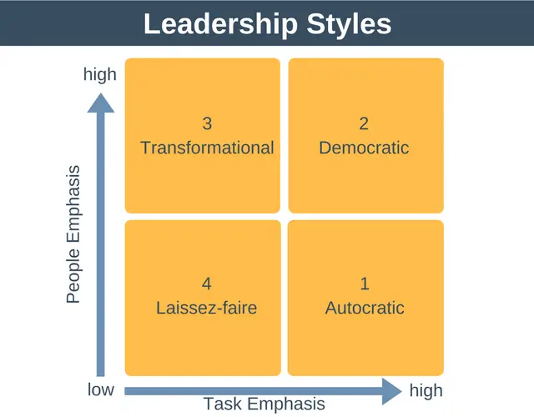

**Figure 1.1.1: Leadership model**

(Source: Salah, 2020)

The above figure represents the leadership model. With the help of this model, organisations can choose leadership strategies according to their preferences. In this context, in the 1st stages of Disney, Walt Disney adopted the autocratic leadership style. According to Agnihotri and Bhattacharya (2022), autocratic leadership refers to the pattern in which all controls and authority of the company have been taken over by only one person. In this system, the leader of the organisation has taken all the decisions for regulating the business and only takes a very small amount of input from other people in the organisation. In the case of Disney, during the starting phase, Walt Disney did not want any intervention of other employees in the process of decision-making. However, he collaborated with a very small number of people to discuss his plan to regulate the business of Disney (Walt Disney, 2022). On the contrary, in the present day, the CEO of Disney, Robert Allen Iger, has adopted the transformational leadership strategy (Walt Disney, 2022). As per Iger (2019), in this leadership strategy, leaders help the employees to inspire, motivate and influence other employees in order to follow the new path of innovation to grow their business. This transformational leadership strategy of Disney has helped the company to enhance its business and now Disney has a certain number of subchannels such as Disney International HD, Disney Junior, Disney Channel HD, Hungama TV, Disney Hotstar, and many more (Walt Disney, 2022).

The primary goal of Disney is to make dreams come true. The mission statement of Disney is ***“Make dreams come true”.*** Along with that, the net income of Disney is around 3.19 Billion USD in the year 2022 (Walt Disney, 2022). The annual revenue growth of Disney has increased since the year 2021. This inclination needs a strong management system within the company. The biggest family of Disney is the customers. In this context, Disney uses the Peter Drunker management model, by which the company has increased the connection between the management and the employees. As an effect, it has positively impacted the customers.



**Figure 1.1.2: Peter Drucker’s Management Model**

(Source: Leader, 2019)

The figure signifies Peter’s model that has been used by Disney. It has been identified from the above figure that the managerial department has different functions such as organising, leading, and monitoring the employees, planning an effective strategy, and employing efficient employees for the company (Leader, 2019). Henceforth, in this aspect, Disney has adopted this model, and using this model the company has enhanced its work efficiency of employees and it also increases the connections between the employees and management. As a result, the content that has been made by Disney has improved day by day and the content has made the customers happy. In this way, it has enhanced its customer satisfaction.

### 1.2 Comparative analysis of the leadership style of Disney and its challenge

From the above discussion, it has been identified that leadership strategy and effective management have enhanced the efficiency power of Disney. However, in the age of digitalisation, there are several other channels that have become competitors of Disney. From the recent data, it has been observed that ***Sony, Time Warner, and Viacom CBS***  are the main competitors of Disney. Along with that ***Netflix and Amazon*** are the main steaming service competitors of Disney (Daniel, 2021).

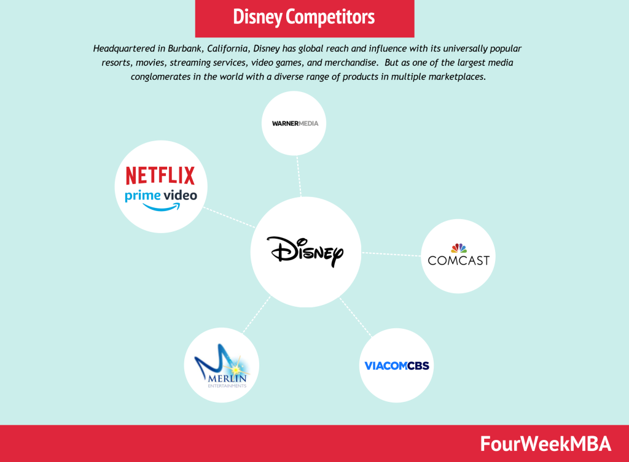

**Figure 1.2.1: Competitors of Disney**

(Source: Li, 2021)

Disney used the autocratic leadership strategy in the 1st phase of its operation, however, in present days, it uses the transformational leadership strategy for regulating the business. While, in the case of Amazon and Netflix, they use a ***laissez-faire*** leadership approach in which leaders have trust and reliance on their employees (Kweon and Kweon, 2021). The leaders of Amazon and Netflix have included their employees in the process of decision-making. They do not provide much information to their employees and let the employees use their personal skills, knowledge, creativity, and their resources to boost employee motivation and improve organisational performance. On the other hand, Sony and Time Warner also use the ***Laissez-faire*** strategy to improve the overall performance of the organisation (Fuller and Hansen, 2019). Therefore, in this respect, it can be said that the effective adaptation of strategic approaches of these channels has empowered them to make more profit by improving their streaming operations.

In this context, the most crucial challenge that has been faced by Disney is the decline in the growth of operating income. From the year 2020, the operating income growth has started to decline.

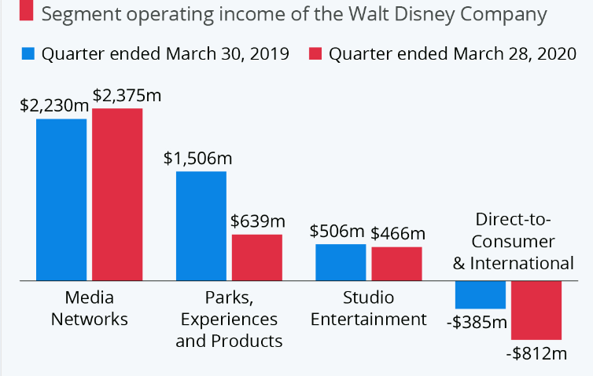

**Figure 1.2.2: Operating income of Disney**

(Source: Statista, 2021)

The above graph represents the most challenging issue that has been faced by Disney. It has been identified from the above graph, that in the year 2019, the income rate from perks, experiences, and products was about 1506 million USD, and in the year 2020, the income growth rate sharply declined and it has been degraded to 639 million USD. The income from studio entertainment has also declined to 466 million USD, and the income growth of a decline in the product has also been degraded (Statista, 2021). Therefore, in this respect, it can be said that, in recent days, the company is facing issues in regard to the decline in the net income rate.

### 1.3 Strategies of Disney to Mitigate Challenges

In this aspect, Disney can adopt the strategic business approach, by which the company can enhance its growth and revenue. Disney has high advantages in pricing power and it has a strong presence in the stock market. Therefore, it is important for Disney to grow its revenue with the help of enhancing its subscribers. Effective subscriber rate can be an important factor for Disney, by which it can generate its effective income. In this aspect, the CEO of Disney, Bob Iger has said that the company has seen a really tough time in the last 15 years, including economic downturns, and other unforeseen events, however, the company has an optimistic view to resolve the challenge as soon as possible. Therefore, in this respect, it can be said that the implementation of strategic changes in leadership style can make the company more empowered and this factor can also assist the organisation to increase its subscriber rate and to increase its gross revenue as well.

## Task 2: Leadership for performance

### 2.1 Balanced scorecard for Disney

|  |  |  |  |  |  |  |  |  |  |  |  |  |  |  |  |
| --- | --- | --- | --- | --- | --- | --- | --- | --- | --- | --- | --- | --- | --- | --- | --- |
| **Proposed Balanced Scorecard for Walt Disney Corporation** | | | | | | | | | | | | | | | |
|  |  |  |  |  |  |  |  |  |  |  |  |  |  |  |  |
|  |  |  |  |  |  |  |  |  | **Targets** | | |  |  |  |  |
|  | **Strategic Objectives** | | | | **Measurements** | | | | **2023** | **2024** | **2025** | **Initiatives** | | | |
|  |  | | | | *sales percentage (%)* | | | | *12%* | *15%* | *19%* | *1. quality contents with originality to attract customers* | | | |
| *F2: Improve sales from Disney+* | | | | *activity perception percentage (%)* | | | | *7%* | *12%* | *14%* | *2.decraese of operational cost* | | | |
| **Financial** | *F1:Total growth of revenue* | | | | *increase number of customers globally* | | | | *200 million* | *300 million* | *500 million* | *1. Implementation of predictive analysis* | | | |
| *c2: Offering high quality services* | | | | *incraese of theme part constructed* | | | | *7* | *9* | *11* | *2, modification of customer services and increase of theme parks* | | | |
| **Internal Processes ->** | *i1. removal of operational risks* | | | | *issues of HR and operational practices* | | | | *-15%* | *-25%* | *-35%* | *1. Reducing Operational Costs.* | | | |
| *i2increase of profit* | | | | *operational profitability* | | | | *10%* | *20%* | *30%* | *2. Minimising operational cost with incraese of profit* | | | |
| **Learning ->** | *L advancement of technology* | | | | *trained team members (%)* | | | | *87%* | *95%* | *99%* | *1. Conducting effective training programs.* | | | |
| *L2 management of cross culture* | | | | *employee engagemnet ratio(%)* | | | | *94%* | *96%* | *98%* | *2. Managing human resources by maintaining seamless omnichannels.* | | | |

**Table 2: Scorecard for Disney**

(Source: Self-developed)

The above-demonstrated scorecard has been developed to integrate strategic objectives to establish a link between performance measurement parameters. In terms of financial strategy, it has been evaluated that the total increase in revenue is the major target that can increase the percentage of cells by taking the initiative of content originality and maintenance of quality. Sales can be increased when the initiative is taken to reduce the operational cost that can activate the percentage of viewers and subscribers. In terms of customers, the strategic objective is to satisfy their demand by increasing the implementation of predictive analysis. Customers can be satisfied with high-quality services with the commitment to increasing theme parks. Regarding internal processing, it can be evaluated that Disney should remove operational risk by balancing issues of HR and operational practices. It can eventually contribute to the reduction of operational costs. It can be evaluated from the balanced scorecard that advancement of technology should be trained to employees and management of the cross culture operations can be tackled by the increase of employee engagement. It can be revised with the initiative to process omnichannel stream less operations. In this way, Disney can adopt technology-enabled business operations with an increase of capacity to promote creativity in HR operations for the development of new products, customer satisfaction and attainment of a competitive edge.

### 2.2 Role of Leadership in performance approaches to achieve objectives for Disney

The leader has an effective role in the attainment of desired organisational performance and remains committed to attaining strategic objectives for the organisation. As per Paais and Pattiruhu (2020), performance leadership is considered a result-oriented approach to the attainment of competitive advantage. Considering the case of Disney it can be evaluated that they can improvise the range of leadership in performance strategy for the attainment of the above-mentioned strategies in the balanced scorecard. The company can be suggested to apply ***Mint berg’s 5 p strategic models*** regarding the initiative to achieve organisational objectives systematically.

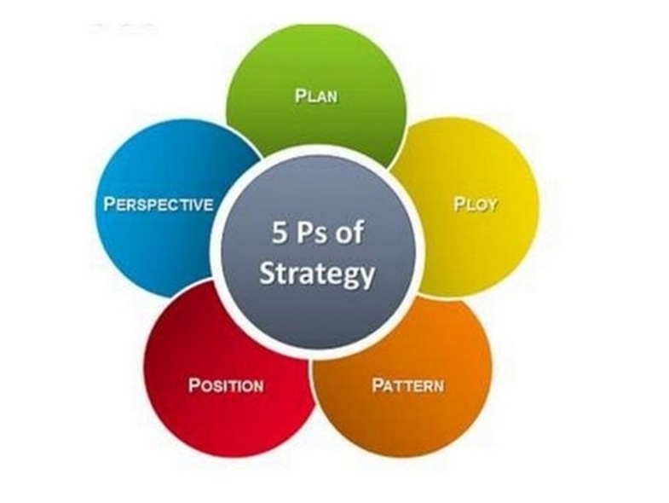

**Figure 2.2.1: Mintzberg's 5 p strategic model**

(Source: WenJun, 2019)

It can be evaluated from the above figure that there are five ways to improvise the strategies and initiate actions to attain organisational objectives. It has been evaluated that in the planning approach, the company is in need to develop a long-term growth-oriented approach to increase its sales with an increased customer base with satisfactory service and quality. It is the orientation of the leaders of Disney to look after the internal and external capabilities of the organisation and then develop the strategies and adoption of resources to target product development and inclusion of technological ability (Tamunomiebi and Worgu, 2020). The stage of ploy ensures that Disney is in need to implement specific actions such as increased customer engagement to improvise the experience of post-purchasing quality service. It can eventually lead to an increase in customer engagement and can assist in retaining customers with the target to attain a competitive edge. Eventually, a strategic approach can be linked with the emergence of internal and external patterning after assessing the need of customers for creative content and the increase of theme parks. It can gradually be noticed with the application of the strategic model that Disney need to position itself within the targeted customers and have to take initiative to fulfil the market demand (Li, 2023). It can assist the brand to evaluate the financial performance of the company. In the 5th stage of the model, it can be evaluated that organisational culture has to be revised to develop a link between the quality performance of the organisation and the development of the organisational perspective.

## Task 3: Financial leadership

### 3.1 Identification of key sources of financial and non-financial information

Disney launched the Disney+ streaming services in the year 2019. The financial resources that have been used for launching this service are the revenues of 2018 which have been generated by Disney. The amount was around 59 billion. Along with that, Disney has made its resources from one of the most favourite sports channels, ESPN. ESPN was included in Disney in 1995 (Walt Disney, 2022). Along with these financial resources, Disney has used its goodwill, linear networks, Disney parks, and experiences as non-financial resources in order to launch Disney+ (Walt Disney, 2022).

In order to compete with the Netflix streaming services, Disney has launched this new Disney+. The usage of revenue, profit, and non-financial resources has not greatly impacted Disney as during the periods of a pandemic, due to a lack of technological support, and due to lack of ad-free online streaming operation, the company made a huge loss in the 1st quarter of 2020. The company has lost many subscribers due to the above-mentioned reasons. Therefore, the importance of these resources in Disney has degraded and the reliability of these resources has also significantly declined.

### 3.2 Factors led to dramatic changes that affect the Performance of Disney

From the case study, it has been identified that Disney made a loss of 2.8 billion USD in the year 2020. In the year 2019, they made a profit of 11 billion USD. The main factors that affect the performance of Disney are the degradation of cable subscriptions, huge streaming losses, an increase in labour disputes, enhancement of activist shareholders, and layoffs in factories. Along with the above-mentioned factors the company also has faced a political battle in the USA which adversely affects the growth of its business of Disney (CNN, 2022). Degradation of subscriber rate is one of the most crucial challenges that has been faced by the company in recent days. During the period of Covid 19 pandemic, with the surging growth of other online streaming channels, consumers have started to switch their options to subscribe to other online streaming channels. Due to this reason, Disney has faced huge losses, and the income rate of Disney has also got affected. On the other hand, it has been said by Tenorio and Bjorn (2019), the rate of labour disputes is increasing day by day and due to critical working conditions in the workplace, due to low wages, the issues like strike rates have increased significantly. Along with that, the incident like layoff by employers has also increased in recent days.

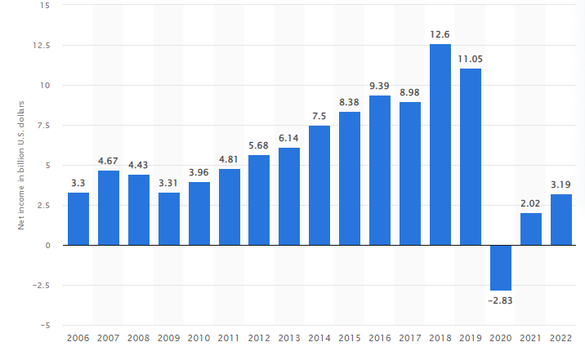

**Figure 3.2.1: Net Income growth rate of Disney**

(Source: Statista, 2023a)

The above figure represents the declining growth rate of Disney. On the other hand, it has been identified from recent data that other online streaming channels like Netflix have increased their net income significantly and it has been observed that the annual net income growth rate of Netflix has enhanced to 2500 million USD in the year 2020 and from 2020, Netflix is growing its annual net income rate significantly (Statista, 2023).

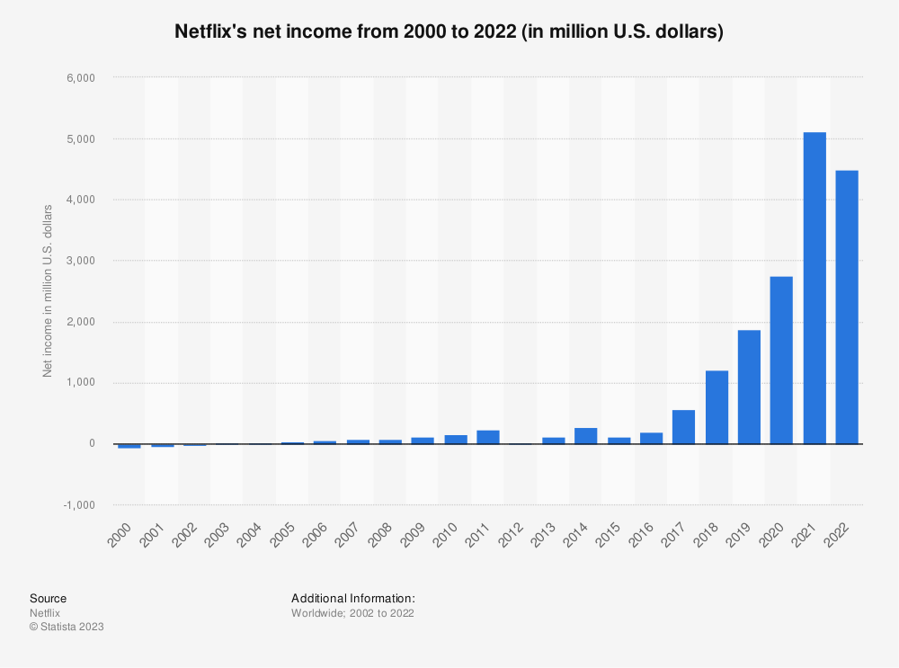

**Figure 3.2.2: Net Income growth rate of Netflix**

(Source: Statista, 2023b)

Hence, from the above discussion, it has been evaluated that the competitors of Disney, such as Netflix have enhanced its effective growth and development with its effective streaming operations. The performance level of Netflix has enhanced as compared to Disney in the year 2020. Due to the pandemic, the overall operation of Disney has declined and due to a lack of implementation of effective strategies, the growth of Disney has become stagnant. On the other hand, due to the implementation of an effective technology strategy during the lockdown, Netflix has upgraded its streaming operations and this is the main reason the company has enhanced its subscriber base effectively.

## Task 4: Ethical leadership

### 4.1 Evaluation of past ethical decision-making of Disney

In recent days, Disney has faced an ethical issue regarding the Use of Supplier sweatshops. In the words of Cardenas (2021), the word sweatshops were 1st coined in 1850. It defines the workplace, as where the workers are treated badly and unfairly. In this case, the workers have faced many difficulties working in the factory such as working at low wages and working in the factory for very long hours. Sometimes, they have been exposed to toxic chemicals while working in the factory and they have not been given any proper training sessions. Sometimes, companies use this procedure in order to reduce manufacturing costs. Workers have been given only one single dormitory by the management of the factory which all the workers have adjusted to arrange their sleeping arrangements. Companies use this procedure in order to maximise the profit rate. However, it creates a serious ethical issue regarding the human rights factor. Basic human rights can be degraded by using this process. Hence, it is important for all companies to protect basic human rights by giving proper accommodation, wages, and working hours in order to gain sustainability in society.

From the current data, it has been identified that Disney has faced an ethical issue regarding the use of sweatshops. Workers of Disney worked for 11 hours per day with wages of 1.32 dollars per hour. The workers were forced to stay in the overcrowded dormitory and sometimes, they were not given the proper training sessions in order to produce the toys for the company (Miller, 2019). The workers were exposed to toxic chemicals, which had adversely reacted to the skin. The workers of Disney were forced to sign away their rights while joining the company. Investigations in Disney’s supplier factory reveal there are multiple abuse cases of workers. In recent days, it has been identified that the incidents regarding labour abuses in the supply chain of Disney (Miller, 2019). Therefore, from the above discussion, it has been identified that Disney has faced critical issues in regard to ethical problems, which have created the unsustainability of the company in society. On the other hand, this certain ethical issue has also adversely impacted the brand image of Disney and as a result, to some extent, the brand image of Disney has been downgraded due to the above-mentioned reason.

### 4.2 Identification of Ethical Issue affects the Performance of Disney and recommended strategy to Resolve the Challenge

The above discussion signifies the most crucial ethical challenge that has been faced by Disney in recent days. The human rights of the workers in the supplier factory of Disney have been downgraded due to the usage of the procedure of sweatshops. The social sustainability of Disney has declined to die for this reason. Hence, it is important for the company to mitigate this crucial challenge with its effective strategy. The company can resolve this challenge with the help of incorporating CSR activities within the company. According to Nazir and Islam (2020), CSR is the procedure or systematic activities that can be adopted by any company in order to increase their responsibility towards the society and environment. This factor also enhances the productivity of the company and it helps to regulate the effective organisational culture within the company. By incorporating this activity, the organisation can enhance its sustainability in society. CSR also helps to make the employees of the company socially and environmentally responsible. CSR (Corporate Social Responsibility) can help to implement strict rules, principles, and regulations for the company and also can imply rules to protect the basic human rights of the workers in the organisations (Kim and Lee, 2019). Hence, it can be said that CSR has been considered one of the important factors by which any organisation can enhance its sustainability and responsibility towards society. Henceforth, it is recommended to Disney implement this CSR activity by which the company can implement the basic rules and guidelines for the workers and can also protect the rights of the employee. With the help of this process, the company can upgrade its brand image effectively and this factor also helps to motivate the employees in order to enhance their efficiency. As stated by Lo (2020), along with the CSR activities, the management of the company can incorporate effective training sessions for the employees, by which the employees can gain their personal skills and knowledge and also can increase their confidence in order to produce more effective products for the company. Rewarding the workers on the basis of their performance can also help the employees to enhance their confidence. Hence, from the above discussion, it has been identified that proper and effective training sessions for the employees, incorporation of CSR activities, and rewarding programs for the workers can help Disney to overcome the above-mentioned challenge in regard to ethical issues.

## Conclusion

The above report signifies the evaluation of the leadership and management strategies of Disney. From the above report, it has been identified that Disney has adopted the autocratic leadership strategy, however in a later stage, in recent days, the company has adopted the transformational leadership strategy, by which the company has gained effective competitive advantages in the market. The biggest competitors of Disney are Amazon, Netflix, Sony, Viacom CBS, and many more which are using the laissez-faire leadership model to enhance their productivity. From 2020, the net income of Disney has downgraded and the company is suffering from a low subscriber rate. Hence, in this aspect, the company can adopt the new leadership strategy by which the company can regain its sustainability in the market and they also can enhance its revenue. On the other hand, one of the most crucial ethical issues that have been faced by Disney in recent days is that the company has used the procedure of sweatshops in order to maximise its profit. It has been adversely affecting the basic human rights of the employees. Hence, it is recommended to the company that they can incorporate CSR activities by which Disney can enhance its sustainability in society.

# References

Agnihotri, A. and Bhattacharya, S., (2022). *Disney: Restructuring for success with video streaming service disney+.* In SAGE Business Cases. SAGE Publications: SAGE Business Cases Originals.

Bommaraju, R., Ahearne, M., Krause, R. and Tirunillai, S., (2019). Does a customer on the board of directors affect business-to-business firm performance?. *Journal of Marketing*, *83*(1), pp.8-23.

Chams, N. and García-Blandón, J., (2019). Sustainable or not sustainable? The role of the board of directors. *Journal of cleaner production*, *226*, pp.1067-1081.

Daniel, D., (2021). *Disney Plus: Launch & Beyond.* California State University, Los Angeles).

Disney, (2022). *INVESTOR RELATIONS.* Available at: https://thewaltdisneycompany.com/investor-relations/ [Accessed on 2ndMarch 2023]

Fuller, R. and Hansen, A., (2019). Disruption ahead: Navigating and leading the future of nursing. *Nursing administration quarterly, 43(3),* pp.212-221.

Iger, R., (2019). *The Ride of a Lifetime: Lessons in Creative Leadership from 15 Years as CEO of the Walt Disney Company.* Random House.

Kim, S. and Lee, H., (2019). *The effect of CSR fit and CSR authenticity on the brand attitude. Sustainability, 12(1),* p.275.

Kweon, H.J. and Kweon, S.H., (2021). Pricing strategy within the US streaming services market: A focus on Netflix’s price plans. *International Journal of Contents, 17(2),* pp.1-8.

Leader, C.F., (2019). *Branding the Disney princess: Femininity, family, and franchising.* The University of Wisconsin-Madison.

Li, H., (2023), February. Disney Market Positioning Analysis and Competitive Strategy Research. In *2022 4th International Conference on Literature, Art and Human Development (ICLAHD 2022)* (pp. 301-313). Atlantis Press.

Li, W.Y., (2021). *Can Netflix Beat Disney in Business Operation-Evidence from the Streaming Media Competition.*

Lo, A., (2020). Effects of customer experience in engaging in hotels’ CSR activities on brand relationship quality and behavioural intention. *Journal of Travel & Tourism Marketing, 37(2),* pp.185-199.

Martinez-Jimenez, R., Hernández-Ortiz, M.J. and Cabrera Fernández, A.I., (2020). Gender diversity influence on board effectiveness and business performance. *Corporate Governance: The international journal of business in society*, *20*(2), pp.307-323.

Miller, J., (2019). *“We're All Gonna Die” Death and the Cycle of Life in Disney. Disney and Philosophy: Truth, Trust, and a Little Bit of Pixie Dust,* pp.271-281.

Naciti, V., (2019). Corporate governance and board of directors: The effect of a board composition on firm sustainability performance. *Journal of Cleaner Production*, *237*, p.117727.

Nazir, O. and Islam, J.U., (2020). Effect of CSR activities on meaningfulness, compassion, and employee engagement: A sense-making theoretical approach. *International Journal of Hospitality Management, 90,* p.102630.

Paais, M. and Pattiruhu, J.R., (2020). Effect of motivation, leadership, and organizational culture on satisfaction and employee performance. *The Journal of Asian Finance, Economics and Business*, *7*(8), pp.577-588.

Salah, N., (2020). *Emerging Themes in the Visionary Leadership of Milton Hershey, Walt Disney, and Steve Jobs.* Dallas Baptist University.

Salvatico, Y.M. and Spencer IV, F.W., (2019). Disney’s workforce of the future: from HR initiative to organizational culture. Futures Thinking and Organizational Policy: *Case Studies for Managing Rapid Change in Technology, Globalization and Workforce Diversity,* pp.347-375.

Sriyakul, T., Singsa, A., Sutduean, J. and Jermsittiparsert, K., (2019). Effect of cultural traits, leadership styles and commitment to change on supply chain operational excellence. *Journal of Computational and Theoretical Nanoscience*, *16*(7), pp.2967-2974.

Statista, (2021). *Operating profit.* Available at:<https://www.statista.com/chart/21613/disney-operating-profit-by-segment/>[Accessed on: 17-04-2023].

Statista, (2023a). *Net income rate of Walt Disney.* Available at:<https://www.statista.com/statistics/273556/net-income-of-the-walt-disney-company/>[Accessed on: 17-04-023].

Statista, (2023b). *Net income of Netflix.* Available at:<https://www.statista.com/statistics/272561/netflix-net-income/>[Accessed on: 17-04-2023].

Tamunomiebi, M.D. and Worgu, V.O., (2020). Talent management and organizational effectiveness. *Journal of Contemporary Research in Social Sciences*, 2(2), pp.35-45.

Tenório, N. and Bjørn, P., (2019). Online harassment in the workplace: The role of technology in labour law disputes. *Computer Supported Cooperative Work (CSCW), 28(3-4),* pp.293-315.

Vitolla, F., Raimo, N., Marrone, A. and Rubino, M., (2020). The role of board of directors in intellectual capital disclosure after the advent of integrated reporting. *Corporate Social Responsibility and Environmental Management*, *27*(5), pp.2188-2200.

Walt Disney, (2022). *About us.* Available at:[https://thewaltdisneycompany.com/about/#:~:text=Our%20Mission,the%20world's%20premier%20entertainment%20company](https://thewaltdisneycompany.com/about/" \l ":~:text=Our%20Mission,the%20world's%20premier%20entertainment%20company).[Accessed on: 17-04-2023].

WenJun, J., (2019). Reinterpretation of the Strategic Concept Based on Mintzberg's Strategic 5p Model. *The Frontiers of Society, Science and Technology*, *1*(6).