**A PATIENT LEAFLETS**

***Table of Contents***

Introduction 3

Physiological disorders in general 3

Disorder of the respiratory system 3

The organization of the body and Life Processes 6

Physiology of the Respiratory System 7

Homeostatis on co2/oxygen regulation 8

Care and treatment 12

Who will be involved in your care and the appropriate strategies to enable you to live to your full potential 13

How can I get support to help myself 14

How might I feel after my diagnosis 14

How can I get help about returning to work 14

What information should I receive 16

16

*Where can I find out more* 16

16

Conclusion 16

Reference list 18

# Introduction

This is a patient leaflet based on the structure and role of the respiratory system. Through this leaflet, the presence of systems in the human body will be demonstrated. This leaflet will help the patient to gather knowledge regarding this. For the control of blood gasses, the role of the organs within the human body will be identified and this will help to understand “inter-relationships' ' of these organs. This leaflet will also help to understand the homeostatic mechanism which is very important for blood temperature regulations. Through this leaflet, external and internal factors will be described which will further help to understand its effect on the process of homeostasis. This leaflet will attract more audiences to know about the whole-body system.

# Physiological disorders in general

Alteration of normal physiological states caused by the condition/disease can result in a variety of symptoms, such as fatigue, changes in appetite, difficulty sleeping, changes in body temperature, and changes in mood. In some cases, more serious complications can arise, such as organ failure, increased risk of infection, and increased risk of developing other diseases.

* **Respiratory Disease:**

This disease is a broad term that covers many different types of “lung diseases”. These cover some diseases such as “chronic obstructive pulmonary disease”, tuberculosis, pneumonia, and asthma.

* **Coronary Heart Disease:**

This disease is a type of cardiovascular disease caused by the accumulation of plaque in the arteries that provide blood to the heart. The symptom of this disease is “chest pain” or “tightness known as angina”.

# Disorder of the respiratory system

“Chronic obstructive pulmonary disease (COPD)” is a developing lung disease that causes difficulty breathing. Treatment of COPD typically involves medications, lifestyle changes, and oxygen therapy (Di Ciaula *et al*. 2020). In some cases, surgery may be necessary. It is important to take steps to prevent COPD, such as quitting smoking and avoiding exposure to air pollution. It is also necessary to look for medical attention if any one experience any symptoms of this disease.

* **Signs and symptoms of the disorder**

Symptoms of COPD include shortness of breath, chest tightness, and coughing. Additional symptoms may include wheezing, fatigue, and an increased risk of infection.

* **Causes of the disorder**

It is usually caused by “long-term exposure to irritants” such as other airborne toxins, cigarette, air pollution, and smoke. COPD is characterized by a narrowing of the airways, which can lead to breathing difficulties.

* **What to expect on the assessment day**

The person may be aware of their respiratory disorder by noticing symptoms such as frequent coughing, wheezing, and shortness of breath, especially during physical activities, can indicate COPD. Other signs may include fatigue, chest tightness, and an increased production of mucus. This disease can diagnose through physical exam, pulmonary function tests.

The peak flow meter is a handheld device used to measure the airflow from the lungs. The patient blows into the meter, and this is measured in liters per minute (L/min). the peak flow meter can be used to detect the presence of COPD by providing a quantitively measure of the patient’s ability to move air from their lungs. A lower than the normal peak flow reading indicates COPD, and changes in the reading can also be used to diagnose and track the progression of the disease.

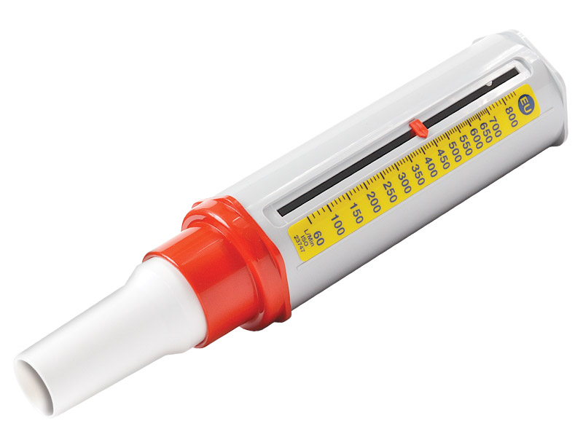

**Figure 1: Peak flow meter**

(Source: Wells, & Joo, 2019)

Yes, there are other tools present for determination/examination/measurements of lung capacity and COPD. Spirometry can be used to measure the volume and flow of air exhaled from the lungs and can be used for the diagnosis of COPD.

**How the disorders affect the body systems**

The principal origin of this disease is “smoking”, air pollution, and occupational displays to dust, fumes, and chemicals. Common “signs and symptoms” of this disease include chronic cough, chest tightness, fatigue, shortness of breath, and wheezing (Wells, & Joo, 2019). People with this disease may also experience an increased production of mucus, which can lead to chest infections and further difficulty breathing. This disease causes inflammation and narrowing of the airways, leading to a decrease in the amount of air that can pass through them. This can lead to an increase in airway resistance, resulting in an increase in airway pressure. This airway may become clogged with mucus, making it harder for air to pass through them.

COPD affects homeostasis by altering the body's ability to maintain a balanced state. It disrupts the respiratory system, reducing airflow and leading to difficulty breathing. This affects the exchange of oxygen and carbon dioxide, making it harder for the body to regulate its pH balance and temperature.

# The organization of the body and Life Processes

**Cardiovascular System:**

This system works for the transportations of hormones, nutrients and O2 by the help of body, as well as helping in regulations of the body temperature.

**Muscular System:**

This system works by providing gestures to the body (Sendak *et al*. 2020). It consists of muscles, and ligaments. Muscles attach to bones, and the contraction and relaxation of the muscles is what enables movement.

**Nervous System:**

This system consists of the brain, nerves, and spinal cord. It works for enhancing the body’s ability to receive and respond to stimuli.

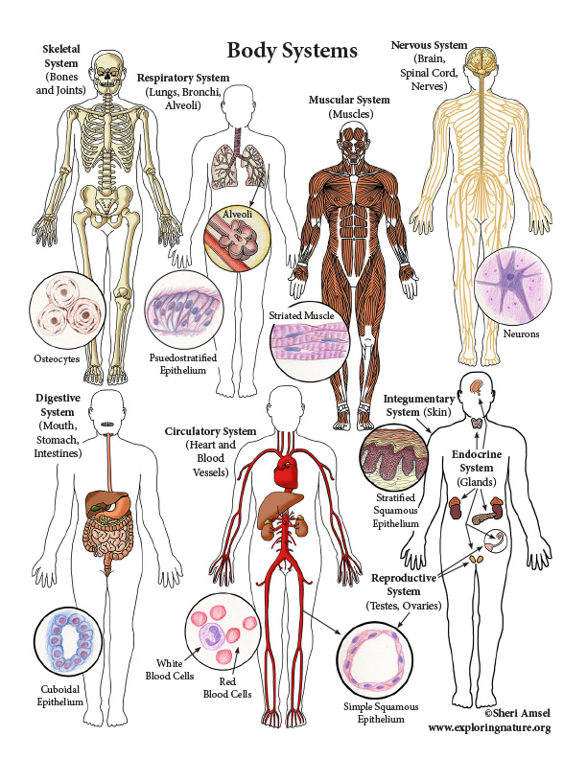

**Figure 2: Systems of the body of human**

(Source: Abduraxmonovna, 2022)

**Respiratory System:**

This system works for carrying oxygen throughout the body and eliminating CO2 from the body. It is composed of the lungs, diaphragm, and airways.

**Digestive System:**

This system is composed of the stomach, mouth, large intestine, and small intestine (Torchio *et al*. 2022). It works for disintegrating food, engrossing nutrients, and removing waste materials.

**Endocrine System:**

This system consists of the endocrine glands, which secrete hormones. It is work for regulating many of the body’s functions, such as growth and metabolism.

**Renal System:**

This system is composed of the kidneys, bladder, and ureters. It works for clarifying waste materials from the blood and it also works for removing them through urine from the body.

**Reproductive System:**

This system consisted of the ovaries, uterus, and other organs (Abduraxmonovna, 2022). It works for producing hormones, creating eggs, and providing a safe environment for a fetus to grow and develop.

# Physiology of the Respiratory System

The lungs are responsible for taking in oxygen and releasing carbon dioxide. The airways, including the trachea, bronchi and bronchioles, carry air to and from the lungs. The diaphragm and intercostal muscles help to control breathing rate, while the nasal passages and sinuses filter, clean and warm the air. The alveoli, the tiny air sacs in the lungs, are responsible for the diffusion of oxygen into the blood stream.

* **Digestion and absorption**

Food is broken down into smaller molecules during digestion, and the body absorbs those smaller molecules during absorption.

* **Enzymes**

NADH dehydrogenase, cytochrome c oxidase, succinate dehydrogenase, ATP synthase.

* **Mechanical respiration**

By using a machine to deliver oxygen to the lungs and expel carbon dioxide from the body, mechanical respiration enables a patient to breathe normally.

* **Blood gases**

Blood gases are utilized to quantify the quantities of O2 and CO2 within the blood and also evaluate the body's acid-base balance. Blood gas tests assess pH, bicarbonate, and oxygen and carbon dioxide partial pressures.

* **Excretion**

During the process of breathing, the respiratory system exhales carbon dioxide, water vapor, and a number of other substances from the lungs, including Sulphur dioxide, ammonia, and nitrogen oxides. The main waste product, carbon dioxide, is discharged during air exhalation. The body's metabolic functions also result in the exhalation of water vapor.

# Homeostatis on co2/oxygen regulation

* **Internal environment**

Internal factors refer to physiological processes and systems that are within the body or cell, such as hormones, enzymes, and metabolic pathways. (Reinke, & Asher, 2019). External factors refer to the environment outside of the body or cell, such as temperature, humidity, light, and other environmental stimuli. The impact of internal and external factors on homeostasis is significant. If the internal and external environments are not balanced, the body or cell will not be able to maintain its homeostasis, leading to a variety of health problems. Similarly, if the body fails to control its hormones or enzymes, it can lead to hormonal imbalances, metabolic disorders, and other health problems. It is a complex process that is essential for the survival of an organism or cell.

* **Negative feedback**

Negative feedback on “CO2/oxygen regulation” can trigger overcompensation, which lowers body oxygen levels and causes hyperventilation. This may result in symptoms like headaches, dizziness, and breathing problems. Furthermore, too much CO2 can raise respiration and oxygen levels, which might result in symptoms like disorientation and anxiety.

* **Homeostatic mechanisms for regulation**

The release of epinephrine and norepinephrine is stimulated when the “sympathetic nervous system” is active, which raises heart rate. A drop-in heart rate, on the other hand, causes the “parasympathetic nervous system” to become active and enhance the production of acetylcholine, which lowers heart rate.

This “sympathetic nervous system” is triggered when the temperature of the body rises, which induces vasoconstriction, more sweating, and higher breathing to lower the body temperature. The “parasympathetic nervous system” is triggered by the hypothalamus when body temperature falls, which promotes vasodilation, increased shivering, and decreased respiration to raise body temperature.

When levels of blood glucose are high, the insulin is coming out from the pancreas, which aids in lowering the levels of blood glucose. On the other hand, when levels of blood glucose are low, the glucagon is releasing from pancreas, which aids in boosting blood glucose levels.

“Blood gas homeostasis” is recognized as the process where the body controls an optimal balance of O2, CO2 and hydrogen ions in the blood. In place of acquiring this balance, the body relies on two main systems: “the respiratory system” and “the cardiovascular system”.

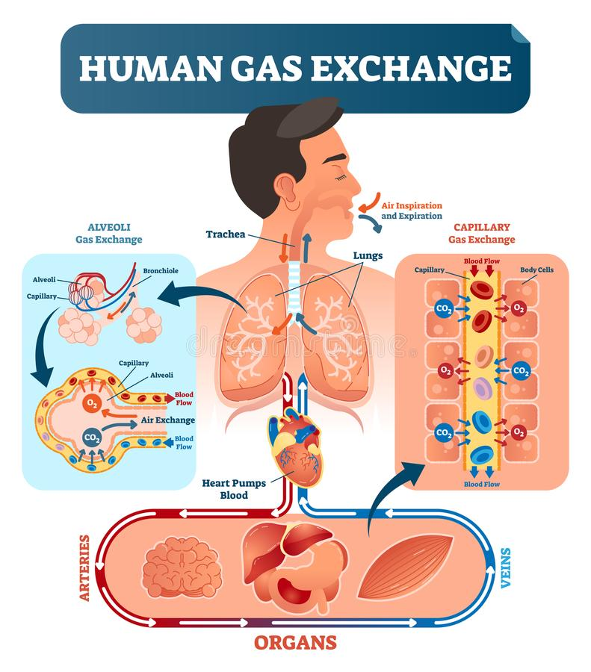

**Figure 3: Gas exchange system**

(Source: Reinke, & Asher, 2019)

Finally, the body uses hormones and enzymes to help regulate blood gas levels. Hormones such as epinephrine and norepinephrine can stimulate the heart and lungs to increase their activity, thus increasing the quantity of O2 and CO2 being interchanged in the body. Enzymes such as carbonic anhydrase help to facilitate the transformation of CO2 and water into bicarbonate ions, and carbonic acid.

Homeostasis is defined as a process by which an organism or a cell maintains its internal environment in a relatively stable and balanced state despite changes in the external environment.

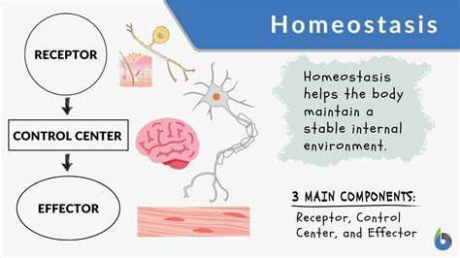

**Figure 4: Homeostasis**

(Source: Ovsenik, *et al*. 2021)

The organs of the human body involved in the regulation of blood gasses are the lungs, heart, and kidneys. All three of these organs are necessary for controlling O2, CO2, and pH levels in the blood. Together, they ensure that the body is supplied with the necessary oxygen and is able to dispose of the carbon dioxide produced by cellular respiration.

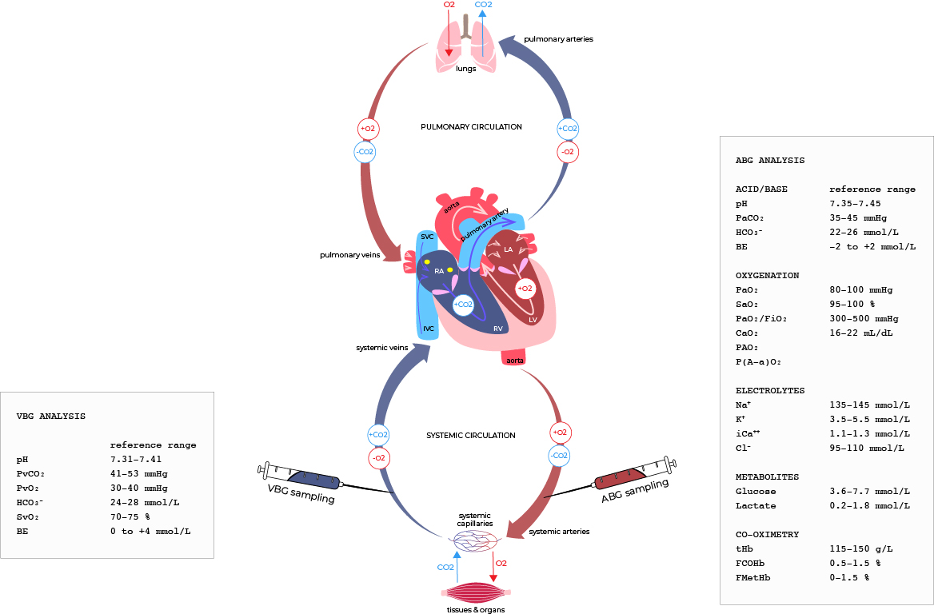

**Figure 5: Blood gasses**

(Source: Di Ciaula, *et al*. 2020)

# Care and treatment

**Medications:**

Medications are often prescribed to patients with COPD to help manage symptoms, reduce flare-ups, and improve quality of life. Bronchodilators are the most common type of medication used to treat COPD. Inhaled corticosteroids are also sometimes prescribed to reduce inflammation in the lungs (George, & Bender, 2019). Other medications, such as antibiotics, may be prescribed to treat infections, while mucolytics can be used to help break down and clear mucus from the airways.

**Surgery:**

Surgery may be recommended for some patients with COPD, relies upon the seriousness of the situation. Lung volume reduction surgery is used to eliminate injured or diseased portions of the lungs, making it easier for the patient to breathe.

**Blood Transfusion:**

In some cases, a patient with COPD may require a blood transfusion. This is usually done to replace lost blood due to severe hemorrhage or anemia. Transfusions can help restore the patient’s red blood cells and hemoglobin levels, which can improve their ability to absorb oxygen.

**Transplant:**

Lung transplantation is sometimes recommended for patients with severe COPD. This is a major surgery that carries significant risks, but it can help enhance the patient’s standard of life and even extend their lifespan. During the procedure, the patient’s lungs are replaced with healthy donor lungs.

**Rehabilitation Programs:**

Rehabilitation programs can help COPD patients improve their breathing, exercise tolerance, and overall quality of life (Wallace *et al*. 2019). These programs typically involve a combination of breathing exercises, physical therapy, and lifestyle changes. The goal is to help the patient achieve the highest possible level of functioning and to reduce the risk of flare-ups.

**Aid for Living:**

Patients with COPD may need assistance with everyday activities. This can include help with shopping, cooking, and other household tasks. Some patients may also need help with personal care tasks, such as bathing and dressing.

**Strategies**

**1. Quit Smoking:**

The habits of “smoking” is the main reason behind the causes of this disease, so it is essential to quit as soon as possible. This can dramatically reduce the symptoms of COPD and even slow down the progression of the disease.

**2. Exercise:**

Regular exercise can help to improve breathing and reduce the symptoms of COPD. Low-impact activities such as walking, cycling and yoga can help to increase lung capacity while strengthening and toning your muscles.

**3. Healthy Diet:**

Habits of healthy eating and “balanced diet” can help to enhance all in all health conditions, reduce inflammation and boost the immune system (Poureslami *et al*. 2020). Include plenty of fruits, vegetables, and lean proteins in your diet.

**Reduce Stress:**

Stress can worsen COPD symptoms, so it is important to find ways to reduce stress and relax. This could include activities such as deep breathing exercises, meditation, or even just taking a few minutes each day to practice mindfulness.

**Get Treatment:**

It is important to seek medical advice and treatment for COPD, as it can help to decline the development of the disease and enhance the standard of life.

## Who will be involved in your care and the appropriate strategies to enable you to live to your full potential

Your “primary care physician”, “a pulmonary specialist”, and “a respiratory therapist” will often make up your care team. Appropriate methods may include giving up smoking, adhering to an exercise programme to improve physical stamina, getting immunized against the flu and pneumonia, learning how to use inhalers and other medications correctly, keeping an eye on oxygen levels, and attending psychotherapy to help manage stress and depression.

## How can I get support to help myself

|  |  |
| --- | --- |
| **What you can do** | **What the respiratory team can do for you** |
| 1. Quit smoking 2. Exercise regularly 3. Take medications 4. Practice good breathing techniques 5. Eat a healthy diet and maintain a healthy weight | People with COPD can receive assistance and care from the respiratory team. This can involve evaluating symptoms, offering treatment recommendations, assisting with lifestyle modifications, monitoring medications, and offering information and support regarding the management of COPD. |

## How might I feel after my diagnosis

## How can I get help about returning to work

With psychological help! Have learn how to quit smoking and life become more sustainable.

**Recommendation based on clinical experiences**

It is suitable for you; if you have contact with the pulmonary specialist for returning to work.

The pulmonary specialist can assist you in evaluating your present health, developing a COPD management strategy, and determining whether you are physically capable of going back to work. They can also offer suggestions for how to manage your symptoms while working and give you advice on how to keep your health in check.

## 

## 

## What information should I receive

## 

**Information**

**Throughout your rehab, your pulmonary specialist teams should do the following.**

* provide breathing exercises
* advice on lifestyle changes, oxygen therapy, medications, pulmonary rehabilitation, vaccinations
* provide education on COPD
* follow up evaluations to monitor your condition
* discuss any dietary changes or supplement recommendations

## Where can I find out more

# 

**COPD Support:** An online community dedicated to providing support and advice to those living with COPD.

# Conclusion

The patient leaflet has provided a comprehensive overview of the whole systems of the body. This leaflet provides valuable information regarding the respiratory and cardiovascular system. This patient leaflet is an important source of information for understanding the functions of kidneys and hormones. It provides an overview of the. It is important to read the leaflet carefully to understand the concepts of internal and external factors which control the metabolic system within the body. This leaflet provides the functions of the organ and this will help to develop a clear view over the control of blood gasses. This leaflet also helps to know about the concepts of inter-relationships of this system.

# Reference list

**Journals**

Abduraxmonovna, A. D. (2022). Study of the Effect of Nutrition-Rich Products on the Human Body. *The Peerian Journal*, *5*, 157-160. Retrieved From:<https://peerianjournal.com/index.php/tpj/article/download/119/95> [Retrieved On: 24.02.2023]

Albert-Bayo, M., Paracuellos, I., González-Castro, A. M., Rodríguez-Urrutia, A., Rodríguez-Lagunas, M. J., Alonso-Cotoner, C., ... & Vicario, M. (2019). Intestinal mucosal mast cells: key modulators of barrier function and homeostasis. *Cells*, *8*(2), 135. Retrieved From: <https://www.mdpi.com/2073-4409/8/2/135/pdf> [Retrieved On: 25.02.2023]

Bennett, J. H., Beeley, J. A., Anderson, P., Belfield, L., Brand, H. S., Didilescu, A. C., ... & Manzanares, M. C. (2020). A core curriculum in the biological and biomedical sciences for dentistry. *European journal of dental education*, *24*(3), 433-441. Retrieved From: <https://discovery.dundee.ac.uk/ws/files/42236564/Bennett_et_al_2020_European_Journal_of_Dental_Education.pdf> [Retrieved On: 26.02.2023]

Das, B., & Nair, G. B. (2019). Homeostasis and dysbiosis of the gut microbiome in health and disease. *Journal of biosciences*, *44*, 1-8. Retrieved From: <https://www.ias.ac.in/public/Volumes/jbsc/044/05/0117.pdf> [Retrieved On: 27.02.2023]

Di Ciaula, A., Baj, J., Garruti, G., Celano, G., De Angelis, M., Wang, H. H., ... & Portincasa, P. (2020). Liver steatosis, gut-liver axis, microbiome and environmental factors. A never-ending bidirectional cross-talk. *Journal of clinical medicine*, *9*(8), 2648. Retrieved From: <https://www.mdpi.com/2077-0383/9/8/2648/pdf> [Retrieved On: 28.02.2023]

George, M., & Bender, B. (2019). New insights to improve treatment adherence in asthma and COPD. *Patient preference and adherence*, 1325-1334. Retrieved From: <https://www.tandfonline.com/doi/pdf/10.2147/PPA.S209532> [Retrieved On: 01.03.2023]

González-Miguel, J., Valero, M. A., Reguera-Gomez, M., Mas-Bargues, C., Bargues, M. D., Simón, F., & Mas-Coma, S. (2019). Numerous Fasciola plasminogen-binding proteins may underlie blood-brain barrier leakage and explain neurological disorder complexity and heterogeneity in the acute and chronic phases of human fascioliasis. *Parasitology*, *146*(3), 284-298. Retrieved From: <https://www.cambridge.org/core/services/aop-cambridge-core/content/view/4EA52A417F3847C31D5EDC7045F5AB3B/S0031182018001464a_hi.pdf/numerous-fasciola-plasminogen-binding-proteins-may-underlie-blood-brain-barrier-leakage-and-explain-neurological-disorder-complexity-and-heterogeneity-in-the-acute-and-chronic-phases-of-human-fascioli.pdf> [Retrieved On: 02.03.2023]

Ovsenik, A., Podbregar, M., & Fabjan, A. (2021). Cerebral blood flow impairment and cognitive decline in heart failure. *Brain and Behavior*, *11*(6), e02176. Retrieved From: <https://onlinelibrary.wiley.com/doi/pdfdirect/10.1002/brb3.2176> [Retrieved On: 03.03.2023]

Poureslami, I., Shum, J., Kopec, J., Sawatzky, R., Gupta, S., Pakhale, S., ... & Canadian Airways Health Literacy Study Group. (2020). Development and pretesting of a new functional-based health literacy measurement tool for chronic obstructive pulmonary disease (COPD) and asthma management. *International Journal of Chronic Obstructive Pulmonary Disease*, 613-625. Retrieved From: https://www.tandfonline.com/doi/pdf/10.2147/COPD.S234418 [Retrieved On: 04.03.2023]

Reinke, H., & Asher, G. (2019). Crosstalk between metabolism and circadian clocks. *Nature Reviews Molecular Cell Biology*, *20*(4), 227-241. Retrieved From: <https://weizmann.esploro.exlibrisgroup.com/esploro/fulltext/journalArticle/Crosstalk-between-metabolism-and-circadian-clocks/993260519803596?repId=1277826770003596&mId=1377826760003596&institution=972WIS_INST> [Retrieved On: 05.03.2023]

Sendak, M., Elish, M. C., Gao, M., Futoma, J., Ratliff, W., Nichols, M., ... & O'Brien, C. (2020, January). " The human body is a black box" supporting clinical decision-making with deep learning. In *Proceedings of the 2020 conference on fairness, accountability, and transparency* (pp. 99-109). Retrieved From: <https://arxiv.org/pdf/1911.08089> [Retrieved On: 06.03.2023]

Torchio, R., Arduino, A., Zilberti, L., & Bottauscio, O. (2022). A fast tool for the parametric analysis of human body exposed to LF electromagnetic fields in biomedical applications. *Computer Methods and Programs in Biomedicine*, *214*, 106543. Retrieved From: <https://iris.inrim.it/bitstream/11696/73094/4/2022_cmpb-preprint.pdf> [Retrieved On: 07.03.2023]

Wallace, A. E., Kaila, S., Bayer, V., Shaikh, A., Shinde, M. U., Willey, V. J., ... & Singer, J. R. (2019). Health care resource utilization and exacerbation rates in patients with COPD stratified by disease severity in a commercially insured population. *Journal of managed care & specialty pharmacy*, *25*(2), 205-217. Retrieved From: https://www.jmcp.org/doi/pdf/10.18553/jmcp.2019.25.2.205?role=tab [Retrieved On: 08.03.2023]

Wells, C. D., & Joo, M. J. (2019). COPD and asthma: diagnostic accuracy requires spirometry. *J Fam Pract*, *68*(2), 76-81. Retrieved From: https://www.hiberniamedical.ie/content/uploads/2019/03/JFP06803076.pdf [Retrieved On: 09.03.2023]

Yang, B., & O'Connell, G. D. (2019). Intervertebral disc swelling maintains strain homeostasis throughout the annulus fibrosus: a finite element analysis of healthy and degenerated discs. *Acta biomaterialia*, *100*, 61-74. Retrieved From: <https://par.nsf.gov/servlets/purl/10161483> [Retrieved On: 10.03.2023]

Zia-Ul-Haq, M., Dewanjee, S., & Riaz, M. (Eds.). (2021). *Carotenoids: Structure and function in the human body* (pp. 1-42). Springer. Retrieved From: <https://www.researchgate.net/profile/Sadia-Javed-2/publication/349435386_Carotenoids_and_Cardiovascular_Diseases/links/6068561a458515614d2eeee8/Carotenoids-and-Cardiovascular-Diseases.pdf> [Retrieved On: 11.03.2023]