# CRITICAL REFLECTIVE DIARY

Table of Contents

CRITICAL REFLECTIVE DIARY 0

Introduction 3

Evidence of Reflection on experience 3

Outlining monthly tasks and responsibilities 3

Description of monthly tasks and responsibilities and monthly diary Extraction 6

Evidence of reviewing the experience in the context 7

Applying relevant theoretical concepts and frameworks 7

Critically analysing the experience in the context of theoretical concepts and frameworks by identifying similarities and differences 10

Evidence of developing ideas 11

Evidence of testing ideas in practice 15

Engagement with colleagues when developing ideas and responding to feedback while developing the ideas 15

Testing the ideas before deployment 16

Conclusion 17

Key responsibilities undertaken during placement 17

Reference List 19

# Introduction

“Reflective diary” refers to the understanding of personal records related to the experiences of in-person learning. The records of ideas and personal opinion regarding a business context can be provided and understood by reviewing a diary. Londis is a supermarket of local convenience stores in the UK which offers a huge choice of daily essentials and big brands at a great value. The responsibilities and tasks for being an “Assistant Manager Trainee” can be evaluated by regulating a dairy on a daily basis. The proposal has evaluated the contexts of monthly tasks and different responsibilities performed by the students while working in the company as an “Assistant Manager Trainee”.

# Evidence of Reflection on experience

## Outlining monthly tasks and responsibilities

| **Monthly tasks** | **Responsibilities** | **Location on InPlace** | **Submission date** |
| --- | --- | --- | --- |
| Plotting the schedule for employees | * Make time to understand the team * Understanding the workload * Tracking the times of clock-outs and clock-in of employees | Month 1 | 03.10.2022 |
| Providing training to employees | * Evaluating employees and identifying the weaknesses * Identifying the training needs and arranging them in an order * Recruiting trainers | Month 2 | 07.11.2022 |
| Hiring new and efficient employees | * Formulating own research * Getting the paperwork done in an efficient order * Outsourcing human resources when it is needed | Month 3 | 05.12.2022 |
| Reviewing the job portal of the company | * Examining the primary duties * Identifying the responsibilities and roles of different team members * Determining the salary ranges | Month 4 | 02.01.2023 |
| Acquiring the developers | * Designing and creating software * Upgrading current applications * Performing distinctive quality checks while managing the responsibility of developers | Month 5 | 06.02.2023 |
| Analysing supervisory experiences | * Scheduling and coordinating meetings * Developing good relationships with customers * Addressing customer and employee concerns | Month 6 | 03.04.2023 |
| Memorising complex policies and regulations | * Coordinating with day to day operations with strict maintenance of policies and regulations * The applicability of policies and regulations can be analysed in a conflict situation | Month 7 | 01.05.2023 |
| Reviewing the pay structure | * Supervising the tasks on a daily basis * Support of team members in conflict situations can be considered for reviewing the pay structure | Month 8 | 05.06.2023 |
| Formulating the use of legal directives and instructions | * Ensuring scheduled business transactions and payments for financial contingencies * Legal procedures of store management can be considered * Enforcing the laws applicable to protect the human rights | Month 9 | 03.07.2023 |
| Regulating the administration support | * Providing the accurate job description to employees in their daily tasks * Maintaining the skills of professional development for administration support | Month 10 | 07.07.2023 |
| Developing the skills of different employees | * Providing required trainings to enhance the skills of managing the workforce * Requirements for the job can be identified for formulating effective structuring of the coursework | Month 11 | 04.09.2023 |
| Managing the training schedules and the resources for the training course | * Ensuring stipulated period of time for each tasks * The completion of training can be regulated while managing the resources * Allocation of resources can be done for maintaining the training schedules | Month 12 |  |

**Table 1: Monthly tasks and Responsibilities of “Assistant Manager Trainee”**

(Source: Created by Author)

## Description of monthly tasks and responsibilities and monthly diary Extraction

Monthly schedules and tasks can be formulated by an individual while performing the dairy extraction. As per the opinion of Rosen *et al.* (2020), plotting schedules for employees and reviewing the tasks can be an effective strategy while performing monthly tasks. The check-out and check-in times of employees can be observed while plotting schedules in an effective way. On the other hand, lack of responsibility to plot the schedules can create hindrances in business performance which can be a threat for maintaining lack of cooperation as a manager (Sivarajah *et al.* 2020). Effective training sessions can be scheduled by a manager in order to integrate the duties with efficient skills and job performance in the supermarket. Monthly diary extraction will be done as an “Assistant Manager Trainee” which is supposed to be signed by the supervisor. This extraction can have a huge role in formulating the research correspondence while reviewing monthly responsibilities and tasks. The formative description of tasks will be helpful for the company in regulating their resources and implementing a better organisational culture.

The formative discussions can guide the activities and efforts in subsequent courses. As per the comments of Tien *et al.* (2021), formative evaluation of responsibilities of tasks can identify the weaknesses and strengths of employees and their needs while working. On the other hand, the authentication of supervisors can integrate the dimensions while improving the businesses and learning procedures through effective training facilities (Alshurideh *et al.* 2022). According to the monthly diary, as an “Assistant Manager Trainee” I will manage the training facilities by recruiting effective training faculties and arranging the needs of training in an effective order. Key weaknesses and strengths of employees will be identified for formulating the effective role of trainers while ensuring effective correspondence. Efficient paperwork regarding planning can be done to formulate the ideas and outsourcing human resources (Kutieshat and Farmanesh, 2022). It will be effective for me to ensure the managerial planning process of effective management in Londis.

The structural contingency in the company has been maintained in order to support the relevance of working at a managerial post. As per the opinion of Chofreh *et al.* (2020), integrating information regarding the business requirements and formulating the structure of a company as per the business requirements have a huge role in business success. Outsourcing of human resources with effective hiring procedures will be done to integrate the managerial contingency in order to maintain a talented working environment. On the other hand, an increase in retention rate will be managed when there is an effective facilitation of business objectives towards the employees (Cartwright *et al.* 2021). Supporting team members during conflict situations can be a strategy for facilitating the training facilities while reviewing the managerial experience. The legal procedures of store management will be done by me as an “Assistant Manager Trainee” in order to enforce the applicability of laws while protecting human rights.

Accurate job description to employees can be provided in order to enhance the managerial skills for reviewing the experience. As per the opinion of MacLeod and van der Veen (2020), identifying requirements of jobs while structuring coursework can be an effective strategy to ensure the managerial view in the coursework. As a manager, it is efficient to integrate the structuring of coursework to maintain the workflow in an effective manner. On the other hand, lack of maintenance of stipulated period of time can be detrimental for managing the training schedules (Ribeiro *et al.* 2019). I will ensure my competencies in completion of training efficiently while focusing on managing the resources. The focus can be given on the allocation of resources while maintaining the training schedules. Regulating optimum balance of training schedules can be effective for deploying the human resources and financial strengths of Londis as an “Assistant Manager Trainee”.

# Evidence of reviewing the experience in the context

## Applying relevant theoretical concepts and frameworks

**“Kolb's reflective model”**

“Kolb's reflective model” can be referred to as the “experiential learning” which can evaluate one's own experience on a situation. As per the opinion of Rashid *et al.* (2019), experiences of an individual can be analysed, reviewed and evaluated in four stages in a systematic way. As per the figure below, the stages include evaluation of "concrete experience", "reflective observation", "abstract conceptualisation" and "active experimentation". Effective and concrete learning facilities will be demonstrated to employees in order to ensure the active participation of the individuals in training facilities. I have faced problems in describing the need for active participation in the training procedures while undertaking their job role in the company with active facilities. "Reflective observation" of an individual can be ensured for integrating active capabilities of employees in conflict management (Astbury *et al.* 2021). As an “Assistant Manager Trainee”, I will ensure the competencies in undertaking the job role of each employee in a scheduled period of time. The employees will be encouraged to support the teamwork of a company and formulate strategic goals for effective observation. The employees can be trained to enhance their working capabilities with the help of significant training faculty.

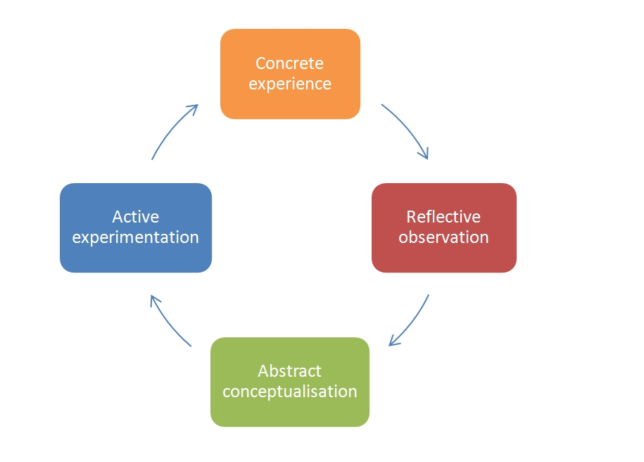

**Figure: “Kolb's reflective model”**

(Source: Astbury *et al.* 2021)

“Kolb's reflective model” has a huge importance in highlighting the components of reflection in the learning cycle. As per the comments of Long *et al.* (2020), accountable experiences of different individuals can be considered to ensure effective facilitation of “Abstract conceptualisation” in the reflective learning process. I will also conceptualise the skills of managing business facilities in order to incorporate the viewpoints regarding the conceptualisation of resources. It can be beneficial if there is an effective facilitation of guidance to accumulate the resources and take business decisions based on the business objectives. Consulting with colleagues while taking the business decisions can be an effective strategy for the businesses while focusing on maintaining competitive advantage (Ge *et al.* 2022). I will manage the business resources efficiently with the colleagues in order to deal with the conflicting business situations. Better understanding and perspectives of business ideas can be effective for formulating the resources as required in the company.

**“Gibbs' Reflective Cycle”**

“Gibbs' Reflective Cycle” integrates the reflection based on the six stages such as “description”, “feelings”, “evaluation”, “analysis”, “conclusion” and “action plan”. As per the opinion of Yurkofsky *et al.* (2019), learnings from experiences can be explored in order to conduct an effective experience that lends to allow an individual to plan and learn things. The rights and wrongs in business placement can be analysed for formulating the effective managerial perspectives while taking business decisions as a manager. On the other hand, descriptions and guidance of different courses can be stringently followed to reflect on the ideas of promoting efficient tools (Kumar *et al.* 2021). The guidance for using the business tools will be effectively maintained to the employees for ensuring a higher productivity rate.

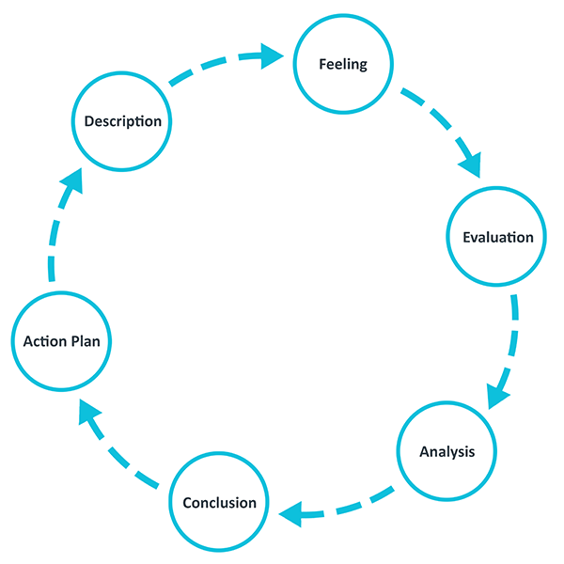

**Figure: “Gibbs' Reflective Cycle”**

(Source: Kumar *et al.* 2021)

As per the above figure, the six steps of the reflective cycle can be followed in order to enhance the productivity of a company. As an “Assistant Manager Trainee”, I have formulated the theoretical perspectives on the employees to reduce the negative impact on managerial concerns. As opined by Auernhammer and Roth (2021), applying relevant theoretical perspectives to outlining the perceptual concepts can be beneficial for identifying the issues and relevant strategies to deal with managerial concerns. I will describe my feelings to the team members by conducting meetings and allowing the employees to express their opinion freely. The evaluation of the feelings of employees can be done on the basis of the critical nature of business situations. The feeling of inability to focus on the critical points during the presentation will hinder the optimistic results of the business procedures.

## Critically analysing the experience in the context of theoretical concepts and frameworks by identifying similarities and differences

Experiences on the basis of business contexts while focusing on managerial issues in Londis can be evaluated while identifying the business opportunities. As per the comments of Tiwari *et al.* (2020), lack of managerial support can degrade the performance level of a company while demonstrating an iterative procedure of improvement. ***“Kolb's reflective model”*** will be used for enhancing the learning experiences and maintaining the conceptualisation based on the business objectives. Observation on reflection can be considered for developing business objectives and dealing with conflict management procedures (Carroll, 2021). I have experienced that there are a lot of opportunities while undertaking the job role and facilitating the active correspondence of business objectives. The optimistic experience on elaborating the business objectives can be considered for completing the work in a scheduled period of time. The competencies in undertaking the job role will be considered for dealing with conflict situations responsibly. ***“Gibbs' Reflective Cycle”*** demonstrates the experience of feeling valued and undertaking the learning of things while formulating the business decisions based on the business objectives.

As per the ***“Gibbs' Reflective Cycle”,*** I will experience the opportunity to meet with the professionally experienced training faculties while working in the company as an “Assistant Manager Trainee”. As per the opinion of Baxter (2022), feelings of being unvalued and depraved can be focused by the managers to regulate the planning of business contingency while deploying the resources. Identifying the wrongs and rights for regulating effectiveness in business planning will be effective for ensuring a high rate of productivity in the business procedures. The action plan will be maintained by me to complete the tasks in a scheduled period of time. As opined by Weissenberger-Eibl *et al.* (2019), an extensive action plan for business formulation can be beneficial for maintaining business competency. Feedback of employees will be taken to consider the managerial assistance to deal with the resources and legitimate the employee orientations.

# Evidence of developing ideas

| **Month** | **Ideas Developed** | **Submission Date** |
| --- | --- | --- |
| Month 1 | * I developed ideas regarding the division of work by plotting the work schedule for Londis employees this month. * Furthermore, I developed ideas regarding the workload and the time or manpower to complete different tasks in retail like inventory management * I learnt about the frequency of improper check-ins and check-outs and the way that they impact retail operations. | 03.10.2022 |
| Month 2 | * I understood the importance of training and development of Londis’ employees. * Furthermore, I understood the challenges in providing training and development opportunities to retail workers. * I also developed an idea to fulfil organisational training and development needs and recruit satisfactory trainers. | 07.11.2022 |
| Month 3 | * I developed an idea on the ways to identify the human resource needs of Londis. * Further, I understood the ways that help understand the suitability of a candidate for a given job role. * I also gained insight into the situations that require outsourcing business operations. | 05.12.2022 |
| Month 4 | * During this month, I developed an understanding of the diversity in job roles and responsibilities in Londis. * I also developed an idea regarding the importance of collaboration among different employees and teams to complete everyday tasks. * Further, I understood the challenges in re-evaluating job roles and responsibilities for better workload division. | 02.01.2023 |
| Month 5 | * I developed an idea regarding the technical challenges that can degrade retail operations such as outdated software. * Further, I understood the ways to check existing digital systems to rectify any weak areas. * I also understood the significance of cyber security threats for Londis. | 06.02.2023 |
| Month 6 | * I developed an understanding of the communication aspects to maintain good relations with customers. * I also developed an idea regarding the importance of solving workplace problems swiftly to avoid operational issues. | 06.03.2023 |
| Month 7 | * I developed an idea of the ways that managers implement organisational policies by coordinating day-to-day operations. * Further, I developed knowledge of the policies that can cause issues in the workplace because of misperceptions or unsuitability. | 03.04.2023 |
| Month 8 | * I understood the operational difficulty in managing everyday tasks by supervising day-to-day work. * I gained an understanding of the ways to maintain and modify the pay structure by engaging with team members in conflict situations. | 01.05.2023 |
| Month 9 | * I understood the importance of automated financial payments to manage transaction timings. * I also studied the important laws and regulations that impact Londis business operations like the Data Protection Act of 2018 which helped me develop an understanding of legislative requirements. | 05.06.2023 |
| Month 10 | * This month, I understood the elements of administrative support including maintaining the professional skills of staff at Londis. | 03.07.2023 |
| Month 11 | * I developed an idea on the ways to provide employee training through methods like demonstration and verbal explanations. * Further, I understood the difficulties in changing the procedures of employees to new strategies because of hesitation to change that can be solved by verbal explanations. | 07.07.2023 |
| Month 12 | * I understood that regular training can impede the organisational operations at Londis due to the diversion of manpower. * Further, I developed an idea of managing training and operations by stacking different training sessions for different groups of employees to continue operations. | 04.09.2023 |

**Table 2: Monthly entry for the development of ideas**

(Source: Created by the author)

In month 1, I participated in activities including creating the work schedule for the employees at Londis. During this time, I have learnt that proper division of work is important to maintain organisational efficiency and avoid operational issues due to human errors resulting from excessive workload. In the second month, I witnessed challenges regarding the provision of proper training and development opportunities to the employees of Londis. I have learnt that Londis can provide sufficient training and development to its employees to improve its workplace practices.

In the third month, I evaluated the human resources needs of Londis which helped me develop an idea regarding the impact of timely fulfilling the human resource needs of retail businesses to avoid operational delays. I have also understood that outsourcing operations by hiring a third party to conduct certain business operations like logistics can help address human resource limitations. Retail operations work through the collaboration of multiple teams and departments to conduct day-to-day operations (Schlepe *et al.* 2021). In this context, I have learnt that it is important to properly divide the workload among employees to avoid human errors resulting from excessive workloads of a few employees.

I have learnt that technical challenges like the usage of outdated digital systems can increase delays in operations and result in errors from my experiences in week five. It is important that retail businesses continuously update their digital systems to avoid operational issues (Kedah, 2023). Further, in week six, I researched and developed various methods of communication including meetings and written memorandums to improve transparency in retail businesses like Londis. It has allowed me to develop an idea regarding the importance of urgently tackling workplace issues by conducting regular meetings.

In week seventh, I also developed an idea regarding the ways to implement organisational policies at Londis by constantly reviewing day-to-day operations and locating any issues in applying the policies at the workplace. The data protection act explains that it is important for businesses to protect sensitive data (Gov.uk, 2023). In this context, I have developed an understanding of laws and legislation like the Data Protection Act of 2018. Further, I have learnt in week 8 that organisational policies can help me supervise everyday activities at the workplace by providing a standard of operational procedures.

I have learnt in the tenth week that maintaining professional skills can help enhance administration support through the development of employees leading to easier management for the administration. Change management is a difficult process and requires businesses to gain the support of employees (Cameron and Green, 2019). Thus, I have researched change management to learn more about the ways to manage employee concerns. In my experience, workplace practices can be improved at Londis by holding meetings to address employee concerns and make changes to increase flexibility in the workplace. I believe that a flexible working environment can improve the quality of operations in the workplace.

# Evidence of testing ideas in practice

## Engagement with colleagues when developing ideas and responding to feedback while developing the ideas

The proper engagement with colleagues can be undertaken to develop the ideas and respond to the feedback of employees on the basis of those feedbacks. As per the opinion of Bacq *et al.* (2020), engagement of colleagues in developing ideas can be considered as an opportunity to ensure the business demands and incorporations on the shared ideas. I will focus on regular receiving and giving feedback which can help in promoting efficacy, change and growth across the teams. The positive changes in the company can be highlighted to ensure the managerial contingency for resolving the conflict situations (Gabriel *et al.* 2020). It is effective for me to interrogate the ideas of employees which can transform the business objectives and deal with the negative consequences. The communication skills to interrogate the ideas will be considered for developing effectiveness and the business demands based on the managerial contingency.

Motivation for enhancing effectiveness to the colleagues can be provided to formulate the business growth and the productivity. As per the comments of Ali and Anwar (2021), encouragement through providing incentives and recognition can enhance the level of performance while increasing the job opportunity. I will provide effective motivation to the team members for enhancing their skill set and reducing conflict in the working arrangements. The feedback of employees can be taken to integrate the survey responses and deal with those while maintaining business objectives (Manuel and Herron, 2020). Job satisfaction of employees can be enhanced when there is an active facilitation of organisational practices based on the employee requirements. The facilitation of ideas to regulate effective working placement will be done by me to promote the business contingency with respect to the business ideas that are fruitful for increasing productivity. Leaders of the company can take their efficient role to promote the training facilitated under the exploratory ideas. I will integrate the leaders for maintaining their guidance for the training facilities which can enhance the effectiveness of training facilities.

## Testing the ideas before deployment

Process of testing different ideas before deployment can be considered for formulating effective results in the managerial procedures. According to the views of Li *et al.* (2021), ensuring the testing phase can be effective to deal with the optimistic results of an organisation which can enhance the business value. The idea related to dividing the work can be scheduled in an effective way and as a manager I will test the result while dividing the tasks. The testing phase is equally important as the formulation of new ideas for the managerial contingencies (Madero Gómez *et al.* 2020). The retail operations of the company can be developed with the ideas of inventory management. I will test the efficiency of “inventory management” to regulate the collaboration of teams in operating the progress in organisational procedures. The ideas before deployment can be ensured for formulating the business correspondence with respect to the business ideas.

Pre-deployment testing has an efficient role in underlying the bugs and regulating the issues based on managerial correspondence. As per the opinion of Adhi Santharm and Ramanathan (2022), managers can ensure their competency by facilitating verified testing facilities in the business functionality. The scheduled outcomes can be formulated by performing the contingencies in end-testing in order to take the measures for manual verification. I will focus on maintaining the manual verifications to regulate strategic contingency in deploying the business objectives. As per the opinion of Ozkeser *et al.* (2019), maintaining the business specific development requirements can be effective for obtaining the human resources for organisational development. I will acquire those development requirements of human resources to integrate the recruitment of stationery trainers.

# Conclusion

Key responsibilities for an individual can be considered for maintaining and managing the business resources and regulating better productivity levels. It can be concluded that better requirements of productivity can be ensured for maintaining strategic business correspondence while integrating the resources. The need for human resources can be mitigated by me by recruiting the professionals who are expert in providing training. The use of placement responsibilities can ensure the contingency over business ideas which can formulate the opportunities based on the managerial opportunities. The managerial support will be provided to employees for acquiring the resource-based activities in a stipulated period of time.

# Key responsibilities were undertaken during placement

| **Responsibilities** | **Outcomes** |
| --- | --- |
| Acquiring the resources to regulate the business objectives | * Higher productivity level * High revenue rate of the company * Effective maintenance of financial resources |
| Formulating managerial support for skill development of employees | * The skill development of employees * Effective accumulation of resources needed for the managerial support |
| Strengthening financial development | * High profitability of business performance * Effective resource-based culture * High efficiency in manual working environment |
| Increasing job frequency | * Low retention rate * High contingency of managers * Increasing tolerance of business resources |
| Integrating new business ideas | * Facilitating innovation in organisational practices * Regulating optimum confidence to develop the managerial contingency * Formulating ideas for development of human resources |
| Dealing with the training facilities | * High growth of businesses in managerial perspectives * Effective training facilities to deal with the business resources |

**Table 3: Key responsibilities of business development**

(Source: Created by Author)

# Reference List

Adhi Santharm, B. and Ramanathan, U., (2022). Supply chain transparency for sustainability–an intervention-based research approach. International Journal of Operations & Production Management, 42(7), pp.995-1021.

Ali, B.J. and Anwar, G., (2021). An empirical study of employees’ motivation and its influence job satisfaction. Ali, BJ, & Anwar, G.((2021)). An Empirical Study of Employees’ Motivation and its Influence Job Satisfaction. International Journal of Engineering, Business and Management, 5(2), pp.21-30.

Alshurideh, M., Kurdi, B., Alzoubi, H., Obeidat, B., Hamadneh, S. and Ahmad, A., (2022). The influence of supply chain partners’ integrations on organizational performance: The moderating role of trust. Uncertain Supply Chain Management, 10(4), pp.1191-1202.

Astbury, J., Ferguson, J., Silverthorne, J., Willis, S. and Schafheutle, E., (2021). High-fidelity simulation-based education in pre-registration healthcare programmes: a systematic review of reviews to inform collaborative and interprofessional best practice. Journal of Interprofessional Care, 35(4), pp.622-632.

Auernhammer, J. and Roth, B., (2021). The origin and evolution of Stanford University’s design thinking: From product design to design thinking in innovation management. Journal of Product Innovation Management, 38(6), pp.623-644.

Bacq, S., Geoghegan, W., Josefy, M., Stevenson, R. and Williams, T.A., (2020). The COVID-19 Virtual Idea Blitz: Marshaling social entrepreneurship to rapidly respond to urgent grand challenges. Business Horizons, 63(6), pp.705-723.

Baxter, R., (2022). Dereliction of Duty: State-Bar Inaction in Response to America's Access-to-Justice Crisis. Yale LJF, 132, p.228.

Cameron, E. and Green, M., (2019). *Making sense of change management: A complete guide to the models, tools and techniques of organizational change*. Kogan Page Publishers.

Carroll, A.B., (2021). Corporate social responsibility: Perspectives on the CSR construct’s development and future. Business & Society, 60(6), pp.1258-1278.

Cartwright, S., Liu, H. and Raddats, C., (2021). Strategic use of social media within business-to-business (B2B) marketing: A systematic literature review. Industrial Marketing Management, 97, pp.35-58.

Chofreh, A.G., Goni, F.A., Klemeš, J.J., Malik, M.N. and Khan, H.H., (2020). Development of guidelines for the implementation of sustainable enterprise resource planning systems. Journal of Cleaner Production, 244, p.118655.

Gabriel, A.G., Alcantara, G.M. and Alvarez, J.D., (2020). How do millennial managers lead older employees? The Philippine workplace experience. Sage Open, 10(1), p.2158244020914651.

Ge, B., De Massis, A. and Kotlar, J., (2022). Mining the past: History scripting strategies and competitive advantage in a family business. Entrepreneurship Theory and Practice, 46(1), pp.223-251.

Gov.uk, (2023). *Data protection*. Available at: https://www.gov.uk/data-protection [Accessed on: 13.4.23]

Kedah, Z., (2023). Use of E-Commerce in The World of Business. *Startupreneur Bisnis Digital (SABDA Journal),* 2(1), pp.51-60.

Kumar, A., Krishnamurthi, R., Bhatia, S., Kaushik, K., Ahuja, N.J., Nayyar, A. and Masud, M., (2021). Blended learning tools and practices: A comprehensive analysis. Ieee Access, 9, pp.85151-85197.

Kutieshat, R. and Farmanesh, P., (2022). The impact of new human resource management practices on innovation performance during the COVID 19 crisis: a new perception on enhancing the educational sector. Sustainability, 14(5), p.2872.

Li, H., Wu, Y., Cao, D. and Wang, Y., (2021). Organizational mindfulness towards digital transformation as a prerequisite of information processing capability to achieve market agility. Journal of Business research, 122, pp.700-712.

Long, T.B., Blok, V., Dorrestijn, S. and Macnaghten, P., (2020). The design and testing of a tool for developing responsible innovation in start-up enterprises. Journal of Responsible Innovation, 7(1), pp.45-75.

MacLeod, M. and van der Veen, J.T., (2020). Scaffolding interdisciplinary project-based learning: a case study. European journal of engineering education, 45(3), pp.363-377.

Madero Gómez, S., Ortiz Mendoza, O.E., Ramírez, J. and Olivas-Luján, M.R., (2020). Stress and myths related to the COVID-19 pandemic’s effects on remote work. Management Research: Journal of the Iberoamerican Academy of Management, 18(4), pp.401-420.

Manuel, T. and Herron, T.L., (2020). An ethical perspective of business CSR and the COVID-19 pandemic. Society and Business Review, 15(3), pp.235-253.

Ozkeser, B., (2019). Impact of training on employee motivation in human resources management. Procedia Computer Science, 158, pp.802-810.

Rashid, Y., Rashid, A., Warraich, M.A., Sabir, S.S. and Waseem, A., (2019). Case study method: A step-by-step guide for business researchers. International journal of qualitative methods, 18, p.1609406919862424.

Ribeiro, I.M., Godina, R., Pimentel, C., Silva, F.J.G. and Matias, J.C.O., (2019). Implementing TPM supported by 5S to improve the availability of an automotive production line. Procedia Manufacturing, 38, pp.1574-1581.

Rosen, C.C., Dimotakis, N., Cole, M.S., Taylor, S.G., Simon, L.S., Smith, T.A. and Reina, C.S., (2020). When challenges hinder: An investigation of when and how challenge stressors impact employee outcomes. Journal of Applied Psychology, 105(10), p.1181.

Schleper, M.C., Gold, S., Trautrims, A. and Baldock, D., (2021). Pandemic-induced knowledge gaps in operations and supply chain management: COVID-19’s impacts on retailing. *International Journal of Operations & Production Management*, 41(3), pp.193-205.

Sivarajah, U., Irani, Z., Gupta, S. and Mahroof, K., (2020). Role of big data and social media analytics for business to business sustainability: A participatory web context. Industrial Marketing Management, 86, pp.163-179.

Tien, N.H., Trang, T.T.T. and Ngoc, P.B., (2021). The role of formative assessment in business education in Vietnam. PalArch's Journal of Archaeology of Egypt/Egyptology, 18(6), pp.85-99.

Tiwari, P., Sadeghi, J.K. and Eseonu, C., (2020). A sustainable lean production framework with a case implementation: Practice-based view theory. Journal of Cleaner Production, 277, p.123078.

Weissenberger-Eibl, M.A., Almeida, A. and Seus, F., (2019). A systems thinking approach to corporate strategy development. Systems, 7(1), p.16.

Yurkofsky, M.M., Blum-Smith, S. and Brennan, K., (2019). Expanding outcomes: Exploring varied conceptions of teacher learning in an online professional development experience. Teaching and Teacher Education, 82, pp.1-13.