**INTERNATIONAL HRM**

**Word count: 3029**

Table of Contents

Introduction 3

Literature Review 3

1. Motives to use International transfers 3

2. Motives for considering alternative forms of international assignments 6

2.1 Benefits and drawbacks of short-term international assignments 9

Conclusion and Recommendations 11

Reference List 12

# Introduction

The report outlines MNCs in terms of understanding the different motives of the company in terms of using international transfers. In this context, the different policies of the company in terms of indulging in international transfers were highlighted in this report.

On the other hand, the report will mainly deal with alternative forms of international assignments considered by the company, which were also highlighted along with understanding the major benefits and drawbacks of short-term international assignments.

Thus, the report strictly adheres to using any kind of organisational approach towards international assignments in terms of guiding a more in-depth understanding as a whole.

# Literature Review

## 1. Motives to use International transfers

International human resource management is a crucial requirement for improved global business strategies. Companies recruit talents that are capable of performing excellently on all platforms to achieve the ultimate organisational goals and objectives. As per the ideas of Dickmann (2021), international human resource management allows companies to manage people working across international boundaries. It helps in spreading the core competencies, values, policies and practices of a company in the global platform while gaining a competitive advantage. In this regard, the necessity of international transfers becomes prominent, as companies reach host countries and learn their norms while mingling with the local culture to create strategic interventions for growth.

The main motive of a company behind international transfers is to transfer managerial knowledge and technical skills to their branch of workers in host countries. Globalisation and other international techniques to connect with companies from other countries increase this requirement. As stated by Fee and Michailova (2020), the transfer of knowledge and expertise from the home branches of a company to its host branches significantly reinforces the profitability of its host branches and increases its overall market viability. In the contemporary scenario, AstraZeneca has continued to consistently shuffle its employee base and indulge in international transfers in order to maintain the efficiency of its operations in its home country as well as the global sphere.

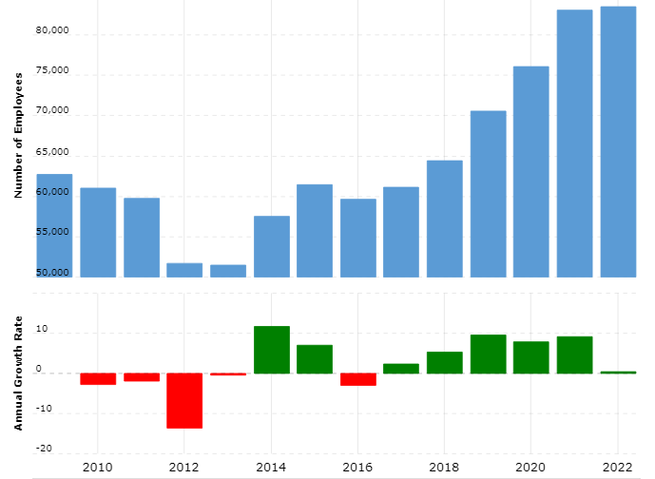

**Figure 1: Number of Employees in AstraZeneca (Global)**

(Source: MacroTrends, 2023)

In terms of the above figure, it can be depicted that AstraZeneca has strived to invest in its global workforce considerably increasing the company’s grip over its host branches. The number of employees in the company amounted to 83,500 in 2022, which is a 0.48% increase from 2021 (MacroTrends, 2023). Therefore, it can be stated that this steady growth in the number of employees for the company provides it with greater comfort in terms of efficiently managing its international transfers and gaining a competitive edge in the global market environment.

A major motive for AstraZeneca to indulge in international transfers is the sharing of expertise while simultaneously increasing its market viability worldwide. According to Duvivier *et al.* (2019), companies efficiently engaging in international transfers can gain better market profits by leveraging emerging trends without compromising on the quality of their products and services. In this prospect, companies engaging in international assignments send their employees to handle business operations at overseas offices or subsidiaries, which is often categorised as business travel.

Hence, in terms of AstraZeneca, the company also fosters the growth of its overseas employees by sending skilled managers to train them in terms of capitalising on emerging market trends. This also enhances the profitability of the company in the global market environment as a whole. Concerning this prospect, another major motive of the company is to form a deeper bond with its clients, which can affect the growth of its profits in a positive manner. Thus, in this manner, the company also sends its employees on international assignments in order to reinforce its business culture without compromising its ethical standards.

Apart from that, companies are able to gain insights into the culture and requirements of the local markets regarding talent pools. Even though the diversity and the favour of reduced labour costs are causing internal assignees to decline, these employees are highly essential for multi-national organisations. According to Andersen (2021), most local employees prefer gaining experience in an international company and leaving after some time to join local firms or start their separate businesses. In this situation, expatriates enable companies to identify the local talents that can stick to the company and ensure steady growth. In addition, expatriates can be highly useful for the internal recruitment process. It is the case because individuals who formerly worked in a foreign setting or are currently working are able to pick employees in the host countries. As searching for accurate talents that can benefit a company for a long time is hard to get in an international setting, recommendations from expatriates become crucial. In other words, companies can get repatriates for the home country, which will be transferred from the foreign subsidiary.

It has been observed that the Gulf countries such as Saudi Arabia have the highest number of expatriate workers. The number stands at 7.8 million workers as noted by Puri-Mirza (2022). The main reason for this increase can be assumed to increase competitive advantage as well. Companies in the international setting are always looking for ways to acquire talents with experience. In this regard, individuals with the experience of an expatriate can create an environment and perform better than individuals with a lack of experience. Moreover, these matters are highly significant for the career development of individuals as well. Bader(2019) explained that certain talents can be found in specific areas across the world. For instance, a technologically advanced country can produce individuals with greater technological knowledge than other countries. Companies can gather this talent through a transfer of employees if the immediate implementation of technology is not possible. Moreover, practical exercise of new knowledge can help in the potential grasp of the situation.

Despite all the benefits that a company can receive through international transfers, increased costs, culture shocks, stereotypes, and barriers to progress alter and affect the overall decisions in it. It can negatively affect companies in the long run as the wrong decisions made during international assignments can cause bigger issues (Bagdadli and Gianecchini, 2019). Therefore, it is evident that the selection of expatriates in a host country is highly significant. Organisations without such planning can be negatively affected, as they can lose their reputation and their working environment can get disturbed in the foreign setting. It can tremendously harm the overall growth in the international competitive market. Thus, even though the main motive of international transfers is to gather knowledge, have insights into new cultures, and detect talent pools for recruitment, factors such as labour costs, culture shocks, and lack of training to mitigate such issues can become hindrances to effective development in the host country and vice versa.

## Motives for considering alternative forms of international assignments

The main motives of international assignments can be listed as position filling, management development, and organisational development. In this regard, companies are adamant about gaining insights into foreign lands and using the information for strategic development in the global market. According to Koleša *et al.* (2022), companies focus on staffing choices for international assignments. It depends on the approaches they select to run in the international market, where diversity is the key benefit. The diverse development in a company allows it to gain cultural information along with diverse talent pools. Thus, geocentric and regiocentric approaches are often used by companies that prefer gaining knowledge from host countries and vice versa. On the other hand, certain areas in the world prefer ethnocentric and polycentric approaches as they consider the lack of host-country nationals' competency and corporate communication needs (Fu and Charoensukmongkol, 2021). Corporate cultures play a huge role in the application of such approaches.

An example of such an organisation can be Sony, which is known to have an ethnocentric approach to hiring staff. As noted earlier, several organisations feel the lack of competence in host-country nationals regarding responsibilities that can be better understood by an individual belonging to the same culture as the company. In this sense, the company has a record-setting decline in its employee recruitment in 2021. Currently, the organisation has a significant decline from over 180 thousand in 2008 to 108 thousand in 2021 (Laricchia, 2022). However, the current growth in sustainability maintenance has caused the ethnocentric approach to decline. In recent years, more companies are gaining momentum in using the geocentric and regiocentric approaches. Staffing becomes highly effective in this regard, as companies gain diverse information and talents. However, according to Lapoint (2023), despite the global approach, the rising costs associated with traditional international assignments are declining.

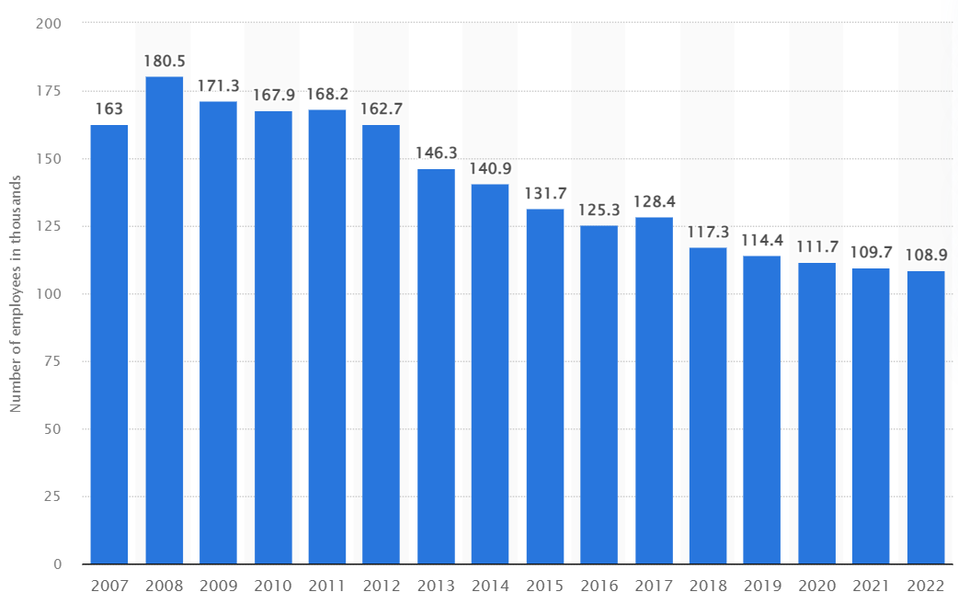

**Figure 2: Staffing of Sony in 2021**

(Source: Laricchia, 2022)

Organisations prefer short-term or alternative assignments that can help them reduce costs and time. In traditional international assignments, expatriates are expected to stay in a foreign country for several years. It is the case because the assignments are long and it can take up to 5 years to complete. However, in the present scenario, alternative international assignments are used by companies. These are either short-term assignments or extended assignments. In these assignments, employees are sent to other countries for a short period. Other than these, non-standard assignments are also been considered by companies in recent times. These are commuter assignments, rational assignments, contractual assignments, and virtual assignments. All these assignments can be considered alternative forms of international assignments. Commuter assignments allow expatriates to return home once every one or two weekends. Schlepphorst *et al.* (2020) mention that such commutes can be done among neighbouring countries. It can save both time and money that are associated with an assignment.

As expatriates are paid more than any regular employee, such a technique can help reduce employee costs. On the other hand, rotational assignments allow employees to commute for a certain period while receiving a break in the home country followed by the completion of the project. In this scenario, employees are expected to stay in the host country and be sent again for a certain period for the next assignment (Jooss *et al.* 2021). However, in both scenarios, the employees sent to host countries are permanent workers of a company. Contrarily, contractual assignments include employees that are specifically hired for six to twelve months on specific assignments. These are contractual employment where the employees might be changed after the project completion. Virtual assignments are associated with technology, as employees manage global responsibilities from their home country. Boccagni (2021) reported that 27% of companies worldwide hired virtual assignees during the Covid-19 pandemic and 42% of firms expected to carry on with the process and introduce the approach in the post-pandemic world.

Considering this development, virtual assignments have become the most popular form of international assignment in the current business world. The main motives of companies using these alternative forms of international assignments are reduction of costs, ease of management of employees, proper control of the actions, and ease of gathering knowledge from the assignments. These techniques not only allow employees to come out of culture shock swiftly but also allow them time to regain momentum as they re-enter their native organisational setting (Liu *et al.* 2021). Despite the benefits these approaches offer, certain issues stick with them. It can be seen that, despite the swiftness of the assignments being done, the employees often suffer as they lack motivation and the lack of work-life balance can further cause exhaustion, affecting agility and performance. Therefore, even though these alternative forms provide ease and benefits, proper selection of staff for these works is essential.

## Benefits and drawbacks of short-term international assignments

Short-term international assignments are on the rise in the current age where every commute is easily available. In the words of Bhattacharyya and Thakre (2021), short-term international assignments are highly preferred by companies across the globe due to their ease of performance, time-saving, and reduced costs. In other words, the main benefits of short-term international assignments are simplicity, cost-effectiveness, and low time consumption. Firms considering this approach are increasing effectiveness as employees receive the opportunity to work outside their native land for a short while, which can be a great inclusion in their professional portfolio. It can help expatriates to attain higher career goals in their lives. On the other hand, in the case of firms, they can recruit employees at lower costs, while the costs associated with the stay of the employee are also decreased (Bücker *et al.* 2020). Further, the information and knowledge gathered from the assignment and the experience remain fruitful for the companies.

Apart from that, in the case of time consumption, short-term assignments take less time and can be fulfilled swiftly. The talent gaps can be maintained thoroughly as the knowledge and skills are shared immediately. A fact to note in this case is that short-term international assignments do not require employees to take their families with them. It is appealing to them because they do not need to uproot their families, as it involves spouses' work and children's schooling (Renshaw *et al.* 2020). The simplicity involves the completion of the project and returning to the home country. It allows them a sense of ease as they are assured that they will return quickly from the foreign land. Managerial control and managerial development is the core purpose of a short-term international assignment. The flexibility that is associated with this assignment is high. The low time consumption helps employees to manage the work better and keep their focus on their assigned projects.

Even though the benefits are prominent for companies considering short-term international assignments, it also has several drawbacks. According to Dang and Rammal (2020), the main issue associated with it is taxation. Assignments are required to take note of the employee wages, healthcare rules and pensions associated with it. Different countries have different rules and regulations regarding this. It causes companies to face challenges such as increased employee salaries, facilities and allowances. It can increase the costs that are related to an employee’s stay in the host country. Foreign assignments in the traditional approach allow employees to connect with the local people and understand their culture from the roots. However, in the case of short-term international assignments, bonding with local colleagues is rarely noticed. Tahir (2021) explained that a lack of bonding with local people can lead to misconceptions and can encourage stereotypes among employees. Thus, it can be considered a major drawback of this type of international assignment.

Culture shock is a common phenomenon among expatriates and vice versa. However, the lack of communication and interaction with the locals can create issues such as false information and unclear knowledge. Such situations can be highly problematic for companies sending employees abroad (Mello *et al.* 2022). As the main purpose of short-term international assignments is skill transfer, such problems can create blunders for companies. It has therefore become highly necessary for companies to select appropriate employees for the projects. In other words, a prominent disadvantage of this alternative assignment is the difficulty of selecting an accurate candidate for international projects. Poor relationships with the locals also affect management control and development. The employees are unable to understand the requirements of the company. The subsidiaries might require a different approach than the main company. It can cause cultural differentiation that can further create problems for the firms.

Other than the company's problems, employees also face issues that are close to their well-being. It has been observed that alcohol abuse has become a concern among expatriates in foreign lands. It has been noted that alcohol consumption caused millions of deaths in 2019 (National Institute of Alcohol Abuse and Alcoholism, 2023). It can not only affect the career of an employee but also affect their family lives. On the other hand, getting a work permit in a new place is also tough for many employees. It takes time to issue such permits which can delay the actual assignments of the organisations.

It shows that, even though short-term international assignments are cost-effective and simple, the barriers associated with them might hinder the way to achieving their purpose. Therefore, while carrying out a short-term international assignment, firms must plan effectively before their commencement. It can not only help to reduce the issues related to it but also make it a success for the company.

# Conclusion and Recommendations

The study concludes the fact that international assignments are a great approach to collecting information and gaining knowledge from international settings. It enables companies in the global platform to gain momentum and competitive advantage. The main motives of international assignments were found to be knowledge gathering and skill sharing. It has been noted that AstraZeneca has continued to consistently shuffle its employee base and indulge in international transfers in order to maintain the efficiency of its operations. It ensures that the company remains in a volatile position in the competitive market. On the other hand, alternative forms of international assignments have been identified in this research as well. Moreover, the type of approach used by companies also affects their overall decisions. Sony, following an ethnocentric approach, has a declining employee population. It is noted that commuter assignments, rotational assignments, and contractual assignments are gaining speed in the business world along with virtual assignments. These assignments enable organisations to carry out their projects at a low cost.

Furthermore, the benefits and drawbacks of short-term international assignments are noted as well. It has several benefits, but the drawbacks often surpass them without proper strategy. Culture shock and other issues related to the lives of the expatriates have been identified in this regard. It has been noted that alcohol abuse is increasing among expatriates, which results in career harm. Moreover, the lack of bonding with locals can cause managerial issues. In this regard, it can be recommended that the companies must carry out effective plans that can help in the development of employees and their performance. It can enable firms to complete projects effectively and engage in actions that can reduce skill gaps. On the contrary, lack of training regarding the management of work in a new culture, employees often face challenges. In this situation, providing proper training regarding the basic culture of the host country to employees can result in more benefits for the companies.

# Reference List

Andersen, N., 2021. Mapping the expatriate literature: A bibliometric review of the field from 1998 to 2017 and identification of current research fronts.*The International Journal of Human Resource Management, 32*(22), pp.4687-4724.

Bader, B., Schuster, T. and Dickmann, M., 2019. Managing people in hostile environments: lessons learned and new grounds in HR research. *The International Journal of Human Resource Management, 30*(20), pp.2809-2830.

Bagdadli, S. and Gianecchini, M., 2019. Organizational career management practices and objective career success: A systematic review and framework.*Human Resource Management Review, 29*(3), pp.353-370.

Bhattacharyya, S.S. and Thakre, S., 2021. Coronavirus pandemic and economic lockdown; study of strategic initiatives and tactical responses of firms. *International Journal of Organizational Analysis, 29*(5), pp.1240-1268.

Boccagni, E., 2021*. Why virtual international assignments are expected to stay post-pandemic.* Available at: https://www.thehrdirector.com/features/hr-in-business/virtual-international-assignments-expected-stay-post-pandemic/ [Accessed: 12 April 2023]

Bücker, J., Poutsma, E., Schouteten, R. and Nies, C., 2020. The development of HR support for alternative international assignments. From liminal position to institutional support for short-term assignments, international business travel and virtual assignments. *Journal of Global Mobility: The Home of Expatriate Management Research, 8*(2), pp.249-270.

Dang, Q.T. and Rammal, H.G., 2020. Japanese expatriates' management in global assignments: A review and research agenda. *Thunderbird International Business Review, 62*(6), pp.689-705.

Dickmann, M., 2021.*International Human Resource Management–Historical Developments, Models, Policies And Practices In Mncs* (p. 225). Sage.

Duvivier, F., Peeters, C. and Harzing, A.W., 2019. Not all international assignments are created equal: HQ-subsidiary knowledge transfer patterns across types of assignments and types of knowledge. *Journal of World Business*, *54*(3), pp.181-190.

Fee, A. and Michailova, S., 2020. How host organizations prepare for and learn from expatriate assignments. *Thunderbird International Business Review*, *62*(4), pp.329-342.

Fu, L. and Charoensukmongkol, P., 2021. Effect of Host Language Proficiency of Chinese Expatriates on Host Country Nationals Support and Work Engagement in Thailand: A Social Identity Perspective. *Asia-Pacific Social Science Review, 21*(3).

Jawad, A.M., 2020. Managing international assignments (expatriates and inpatriates): Effect of cultural diversity. *International Journal of Business and Management, 15*(12), pp.78-92.

Jooss, S., McDonnell, A. and Conroy, K., 2021. Flexible global working arrangements: An integrative review and future research agenda. *Human Resource Management Review, 31*(4), p.100780.

Koleša, I., Burger, A. and Dickmann, M., 2022. The effects of institutions on emerging market firms’ international assignment location decisions.*Economic and Business Review, 24*(1), pp.1-18.

Lapoint, P.A., 2023. Selection of expatriate employees for international assignments: Importance of communication. *Administrative Issues Journal: Connecting Education, Practice, and Research, 13*(2), pp.38-43.

Laricchia, F., 2022. *Number of employees in the Sony Group 2007-2022.* Available at: https://www.statista.com/statistics/638777/sony-group-number-of-employees/ [Accessed: 12 April 2023]

Liu, Y., Vrontis, D., Visser, M., Stokes, P., Smith, S., Moore, N., Thrassou, A. and Ashta, A., 2021. Talent management and the HR function in cross-cultural mergers and acquisitions: The role and impact of bi-cultural identity. *Human Resource Management Review, 31*(3), p.100744.

MacroTrends, 2023. *AstraZeneca: Number of Employees 2010-2022 | AZN* Available at: https://www.macrotrends.net/stocks/charts/AZN/astrazeneca/number-of-employees#:~:text=Interactive%20chart%20of%20AstraZeneca%20 [Accessed: 9 April 2023].

Mello, R., Suutari, V. and Dickmann, M., 2022. Taking stock of expatriates’ career success after international assignments: A review and future research agenda.*Human Resource Management Review*, p.100913.

National Institute of Alcohol Abuse and Alcoholism, 2023. *Global Burden.* Available at: https://www.niaaa.nih.gov/alcohols-effects-health/alcohol-topics/alcohol-facts-and-statistics/global-burden [Accessed: 12 April 2023]

Puri-Mirza, A., 2022. *The number of expat workers GCC Q2 2020, by country.* Available at: https://www.statista.com/statistics/1232925/gcc-number-of-expat-workers-by-country/ [Accessed: 12 April 2023]

Renshaw, P.S.J., Parry, E. and Dickmann, M., 2020. The organizational value of international assignments–the relational underpinning. *The International Journal of Human Resource Management, 32*(1), pp.106-146.

Schlepphorst, S., Koetter, E.C., Werner, A., Soost, C. and Moog, P., 2020. International assignments of employees and entrepreneurial intentions: the mediating role of human capital, social capital and career prospects.*International Journal of Entrepreneurial Behavior & Research, 26*(6), pp.1259-1279.

Tahir, R., 2021. Flexpatriates: issues and challenges for short-term assignments in the United Arab Emirates. International Journal of Management Practice, 14(3), pp.283-305.