**GLOBAL STRATEGY, DEVELOPMENT, AND IMPLEMENTATION**

**Table of Contents**

Introduction 2

Competitive structure analysis 2

Porter’s Five Forces Model 2

Competitive advantage analysis 2

Value chain model 3

VRIO Analysis 4

Implication of the current external environment 4

Challenges for competitive position 4

Recommendation 5

Conclusion 5

References 6

# Introduction

Consideration of innumerable positive impacts of globalisation has involved a number of business firms in the process of expanding businesses across various international markets which further gives rise to strong trade bonding between them. However, the absence of appropriate global strategy makes the process of business globalisation critical to some extent and organisations seem to struggle in increasing sales volume and earning adequate profits. Sainsbury’s is an eminent food retailing brand based in the markets of the United Kingdom which has gradually been successful in setting an example of international business expansion being a multinational supermarket chain. Later, this brand has extended the boundary of its business in the sector of argos and banking. The expected turnover of the company is between £630 million and £690 million in 2023 (Sainsbury’s, 2023). Sainsbury primarily operates in the countries of Ireland and London, United Kingdom. About 172,000 employees currently work with the organisation (Sainsbury’s, 2023).

# Competitive structure analysis

## Porter’s Five Forces Model

***Potential of new entities***

Often, new entrants are observed to pose a severe threat to the competitive edge of many businesses by introducing innovative ideas through products and services and attracting mass customers. However, the process of invading the supermarket chain in the UK seems to create barriers for the new entrants. It is to be noted that new entities often face complications in achieving economies of scale and competing against the existing key players of the UK retail industry like Sainsbury’s. As per the statement of Wirtz *et al.* (2021), economies of scale is perceived to be a cost-effective experience that a company is able to achieve in the effect of increasing the scale of production on average expenses. Moreover, since the commerce sector faces substantial capital needs, it is challenging for startups to successfully establish enterprises as significant expenses are required to be invested in research and development and advanced technology. Nevertheless, newcomers are barely able to rapidly set up their routes of distribution and enter the market since they have simple accessibility to distribution systems. As a result, the potential of new entities in increasing competition against Sainsbury’s stands feebly in the UK.

***Risks of rising alternatives***

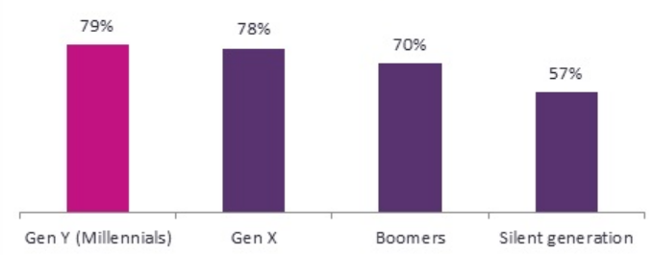

**Figure 1: Percentage of people interested in purchasing differentiated products and services, by generation**

(Source: Globaldata, 2021)

In the UK, most of the people, especially 78% of millennials, are more inclined to experiment with the products and services that stand out from others in terms of culture, countries or any other factors. Taking this contemplation into account, the supermarket chains of the UK are involved in following the product differentiation strategy and achieve a higher degree of competitive advantages in turn. However, a few retailers are found to produce substitutes of the products that mainly Sainsbury’s tend to offer its customers with an intention to facilitate the customers with higher quality of products, yet those are often found expensive while Sainsbury’s is meeting the demands and preferences of the UK consumers even with a great affordability. Therefore, the force of substitutes is moderately able to encounter Sainsbury’s with the risk of losing competitive edge and profit explicitly.

***Power of suppliers***

The overall size of the UK retail industry is vast. In the UK's retail and wholesale industry, there were around 557 thousand businesses in 2020; amongst which roughly 600 were significant organisations with 500 or more employees (Statista, 2021).

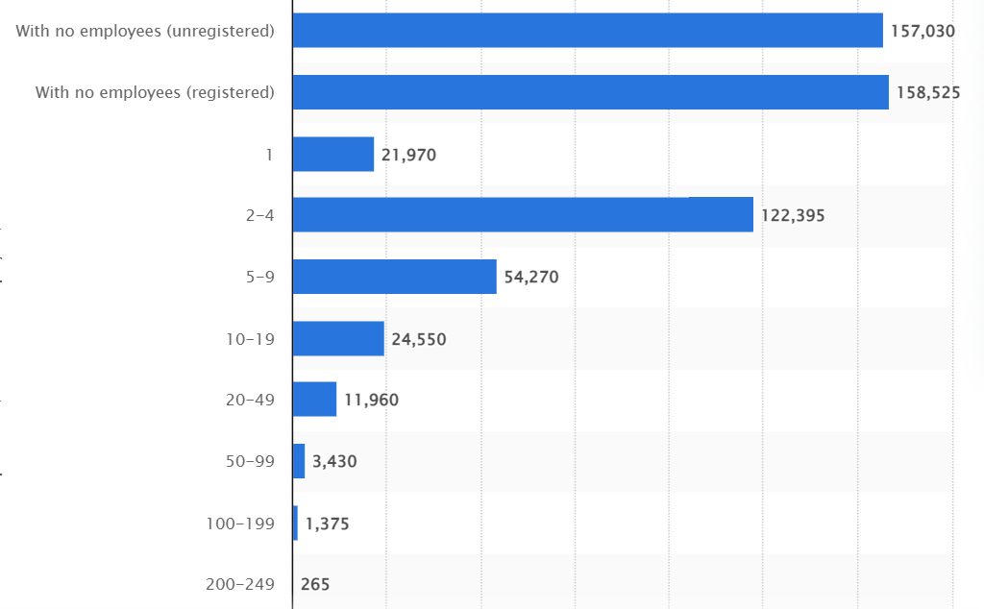

**Figure 2: Numbers of businesses associated with the retailing supermarket chain of the UK**

(Source: Statista, 2021)

Therefore, it is understood that the UK retail sector fosters a huge number of suppliers which is even significantly exceeding the number of retailing organisations. The vendors tend to offer products that are comparatively uniform, not as distinctive, and also offering minimal costs for switching. On the basis of this perspective, it can be determined that the buyers of the raw materials, like Sainsbury’s and other organisations, irrespective of their sizes, are allowed to easily switch to other suppliers in case the existing suppliers fail to collaborate with the retailing brands associated with the UK supermarket chain in the times of their exponential growth. Therefore, suppliers are forced to negotiate with their buyers or the retailers of the UK instead of convincing them to purchase materials at an expensive rate in order to prosper their profit margin.

***Negotiating skills of buyers***

Due to a culturally diversified and huge population, the consumer market of the UK provides Sainsbury’s with around 320,000 customers to serve different products and services and enable this brand to appear as the second largest supermarket chain in the UK (Statista, 2022). However, the data has shown that 56.9% of its customers are female while 43.1% of overall customers are male though gender has been considered to be one of the significant drivers of consumer’s purchasing decisions. It is already mentioned that differentiation of the wide range of products and services reduces the scope of rising substitutes and offers the customers to experiment with the products to expand their demands and preferences beyond stereotype requirements. As a result, the negotiating tendency of consumers falls moderately. However, it is to be noted that there are some external factors affecting consumer buying decisions severely in the UK and the exact quality of the product alongside the pricing and payment methods are the most significant. As per the statement of (Statista, 2022), early in 2022, in the UK, approximately 60% of Gen Z shoppers claimed that a product's cost was a determining component while deciding on their purchases, establishing it as the generation's top buying consideration. Corresponding to that note, it can be said that the negotiating power of customers can still be assessed to be high as they can easily switch to other companies or even grocery stores in case they are offered to buy products at an exceptionally affordable price. Apparently, the consumers are able to switch brands at ease since the expenses for switching are quite low in the UK consumer market.

***Intensity of the competition***

The level of market competition in the retail industry is high in the current marketplace in the United Kingdom. It is to be noted that although there are few gigantic retail brands existing in the core supermarket chain of the UK, yet they are highly powerful to pose threat against Sainsbury’s on the ground of competition. Over a few decades, Tesco is observed to provide significant competition to Sainsbury’s while the performance of William Morrison, ASDA and Marks and Spencer is also responsible for increasing the degree of overall competition to an aggressive level (Globaldata, 2023).

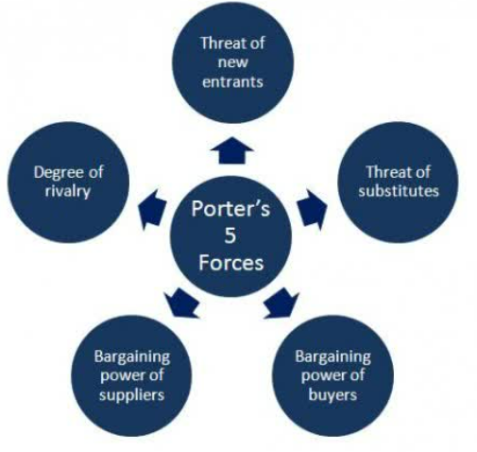

**Figure 3: Porter’s Five Forces framework**

(Source: Self-developed)

**Critical and analytical assessment of the above mentioned competitive environment of the UK**

In the above section, the framework of Porter’s five forces has been used to shed light on the in-depth understanding of the competitive forces that have the potential to give shape to the competitive environment against Sainsbury’s in the UK marketplace. From the above analysis, the potential of new entities is assessed to be low due to huge capital investment in research and development alongside the formation of economies of scale by the existing supermarket chains. The potential of developing economies of scale is proven to be one of the fundamental advantages for Sainsbury’s in terms of increasing sales volume and the growth of profit margin within the supermarket chain of the UK. Sainsbury's recorded a 39.94% growth in gross profit from 2021 to 2022, reaching $3.231 billion (Macrotrends, 2020). On the other hand, the practice of product differentiation strategy is assessed to be the powerful concept for reducing the rising opportunity of substitutes manufacturing and also retaining the potential customers for the long run by making them repetitive buyers. In the consequences, the gain of adequate competitive advantages is determined for Sainsbury’s based on the number of loyal customer acquisition since it is taken into consideration for strengthening the brand value in the cut-throat competitive market. A British grocery company called Sainsbury's had a brand worth of almost 3.75 billion dollars in 2022, an improvement over 2.66 billion in 2018 (Statista, 2018). Apart from that, lower potential of suppliers and moderate power of buyers in negotiating the cost of products are identified to be the driver of sufficient competitive advantage for Sainsbury’s in the UK retail market while higher intensity of competitive rivalry has the potential to deviate Sainsbury’s from accomplishing higher degree of competitive advantages nowadays.

|  |  |
| --- | --- |
| **Competition in the retail industry** | High |
| **Potential of new entrants** | Low |
| **“Power of Suppliers”** | Low |
| **“Power of customers”** | Moderate to high |
| **“Threat of substitute products”** | Moderate |

**Table 1: An evaluation of Porter’s five forces in the context of Sainsbury’s**

(Source: self-developed)

## 

## Evaluation of Porter’s value chain model at Sainsnbury’s

In the ever-increasing competitive standard across the supermarket chain of the UK, the application of the value chain model plays a vital role in consolidating the ground of competitive advantages for Sainsbury’s to a great extent. As per the statement of Khawla and Molnár (2019), a dynamic business model called the value chain is used to analyse all firm operations involved in transforming an item or service from an idea into a marketable good. The integration of the value chain model into the operations of Sainsbury’s determines a set of advantages such as the brand is able to identify the rich sources of competitive advantages along with the inter-relationships between the internal operations and interdependencies between the different business units. Moreover, enhanced flow of information, materials and capital flow empowers the brand to devise effective strategies for further improvisation of organisational performance. Determining the relevance of activities in relation to their function in the process of delivering goods or services is thus the first step in modifying the Porter Value Chain framework. Under this model, the overall operational processes of Sainsbury’s can be categorised into two segments: Primary activities and supportive activities.

**Primary activities of Sainsbury’s**

***Inbound logistics***

Reluctance in analysing the inbound logistics yields challenging circumstances for Sainsbury’s during the span of product development. Building reliable relationships with suppliers is crucial since they provide the assistance needed to acquire, store, and distribute the product. In this context, Sainsbury’s is found to develop a solid collaboration with one of the most effective supply chain experts which is renowned as CHEP and becomes prudent to operate its inbound logistics adeptly by incorporating more than 1000 trucks into the process (Monte, 2021).

***Operations***

Evaluation of operational operations is crucial for boosting profitability, increasing efficiency, and maintaining Sainsbury J Plc competitive performance. While raw materials are delivered and Sainsbury J Plc is prepared to turn the unprocessed goods into the finished product and distribute it, the significance of reviewing operational operations increases. It is evident that this brand has gradually extended its operations into Argos and the banking sector, the primary operations still revolving around the production and distribution of foods, clothes and general merchandise.

***Outbound logistics***

Sainsbury’s tends to assess its outbound activities in order to deliver the finished products to their potential and loyal consumers by going through several intermediaries. Therefore, the outbound logistics is an inclusion of several dynamic activities like the adequate management of materials, warehousing, scheduling, processing orders, transportation and final delivery to the customers. There are 34 distribution centres taken under control of Sainsbury’s for delivering the products to the end destinations and to satisfy customers with on-time delivery (Rodrigue, 2020).

***Marketing and sales***

Sainsbury’s is appreciated for making decent investment in marketing and sales considering it as a primary activity of attracting mass customers by offering lucrative products and deals in comparison with its rivals, alongside the manufacture of high quality and distinctive products in a cost-effective manner. Developing a skilled sales force and selection of suitable marketing channels and pricing strategy, designing promotional activities and establishing relationships with the members are the significant marketing and sales activities practised at Sainsbury’s. However, the “Above the line” and “Below the line” business models are placed at the centre of Sainsbury’s B2B marketing and sales activities (Jones and Comfort, 2020).

***Services***

Sainsbury’s focuses on pre-sales and post-sales services considering them powerful components that give rise to the incremental customer loyalty. Moreover, efficient financial services of Sainsbury’s better carries out the tendency of product differentiation and the enhancement in the existing customer base,

**Supportive activities of Sainsbury’s**

***Firm structure***

Firm infrastructure resonates with a wide range of dynamic activities including overall quality management, legislative and financial affairs management, sufficient capital flow and strategic management. Adhering to the optimised control over infrastructure, the company becomes efficient in providing value to the entirety of the value chain as well as consolidating the brand position in the competitive marketplace. Organisational divisions of Argos, retailing and banking aids Sainsbury’s with a progressive maintenance of infrastructure.

***Human resource management***

By assessing several HR components, such as hiring, identifying, educating, rewarding, performance and other operations, Sainsbury monitors human resource management. Based on the motivation, dedication, and abilities of its personnel, efficient management can help J Plc alleviate the load from the competition. Therefore, the company applies the concept of “Recruitment and Reward” to amplify the management and endeavours in a positive working environment to foster elite employee performance.

***Technology development***

Sainsbury’s takes technology development into consideration to be significant for increasing the value of the value chain since it provides enormous support to all the primary activities integrated into its operations. Modern consumers appreciate Sainsbury’s for offering flexibility with strict security in the payment process by implementing “Amazon’s Just Walk Out” Technology across the facility of Smartshop.

***Procurement***

Approximately 2000 suppliers have been acquired by Sainsbury's, which consumes more than 3 million pounds on purchasing every year. The “Stellar Supply Chain” is deeply integrated into the procurement process of Sainsbury’s.



**Figure 4: Value chain model**

(Source: Created by author)

## VRIO Analysis

|  |  |  |  |  |  |
| --- | --- | --- | --- | --- | --- |
| **Resources** | **Valuable** | **Rare** | **Inimitable** | **Organised** | **Impact on competitive advantage** |
| “Recruitment and Reward” policy in human resources | Yes | No | No | Yes | Temporary competitive advantage |
| Strong “SmartShop” technology | Yes | Yes | Yes | Yes | Sustainable competitive advantage |
| Utilisation of ATL and BTL models | Yes | Yes | Yes | Yes | Sustainable competitive advantage |
| Delivery of adequate products and services | Yes | No | No | Yes | Temporary competitive advantage |

**Table 2: VRIO framework implementation**

(Source: Created by author)

**Critical analysis of VRIO model**

From the above analysis table it has been identified the company is not providing adequate focus on the employee engagement which is the partial aspect of competitive engagement and for this company need to improve this aspect through a rewarding system. smartphone technology has been also identified as the significant aspect in order to develop the technological engagement of the business where the company did not provide adequate focus. Therefore, the company needs to provide additional focus on the use of smartphone technology. Apart from this from the above table it has been also identified that the use of BTL and ATL has been identified as the highly competitive advantage chance of the business and through the implication of this the company can ensure their sustainability in the market effectively. Furthermore, effective supply chain management through adequate delivery processes can also develop their efficiency and competitiveness.

# Implication of the current external environment

## Challenges for competitive position

Sainsbury encounters challenges in labour sufficiency and supply chain in the competitive position. The company’s profit was lowered by 21% due to labour shortage (Newstatesman, 2023). The company’s price range is higher than the competitors who offer similar products in the current external environment. As per the statement of Nuccio and Guerzoni (2019), price is the most significant aspect in the market in order to enhance competitiveness and ensure sustainability in the market. from the recent news it has been identified that the company has faced a price war with the giant companies like Tesco, ASDA, Morrisons in response to the challenge posed by discounters Lidl and Aldi but introduced thousands of “lower, regular prices'' in stores and provided additional focus on its Brand Match scheme in order to compare exclusively on Asda, seen as the big 4 leader on price as well as a relative success with sales growing in recent years. There is other news that has been identified about the issue of this company's connection with the customers. Home delivery demand is high and like so many other retailers, this company has shifted resources to where the company most needed. As consumer needs continue in order to evolve, the ability to respond with agility will become a fundamental part of day-to-day working life (Managementtoday, 2022). Roberts, like all retail leaders, needs to develop the environment for innovation and agility to thrive.

# Recommendations

Sainsbury needs to move into a potential market of a new country to increase its customer base. The global consumer base can be beneficial for earning more profit and increasing sales rates. From the overall analysis there are some recommendations that are identified that are discussed below and critically recommended to the management of the company.

* The company must develop their pricing strategy competitively as the giant organisations are already beating the pricing point of this company and for this advance pricing strategy need to be included.
* The company must need to enhance their consumer engagement as from the above analysis it has been identified that the company has failed to make an interrelation with the consumers in recent years. Artificial intelligence and advanced consumer support can mitigate this issue of the company adequately.
* Apart from above key points the company must focus on the new market entry strategy and need to focus on new market capture to ensure their sustainability and competitiveness in the market.

# Conclusion

In conclusion, it can be said that in-depth analysis of the competitive forces existing in the UK retail market applying Porter’s five forces indicates new entrants, bargaining power of suppliers and the existence of substitutes are the weaker force for Sainsbury’s while the bargaining power of buyers and the intensity of competitive rivalry from Tesco, ASDA and some others are highly prudent to restrict the company from achieving higher competitive advantages. The Value chain analysis provides enormous assistance to the company in assessing the primary activities like inbound and outbound logistics, operations, marketing, sales and services with the support of supportive activities like organisational infrastructure, HRM and more to solidify the base of competitive advantages. However, shortage in labours and appropriate sustainability management are the two major issues that Sainsbury’s have faced in the UK. Yet this brand is recommended to abide by the competitive pricing strategy, usage of AI in customer service during the span of entering new markets.

**Reference list**

Globaldata, (2023). *Home.* Available at: https://www.globaldata.com/company-profile/j-sainsbury-plc/competitors/ [Accessed on: 01/04/2023]

Globaldata, 2021. *Millennials are the most experimental consumers, with seniors least likely to try new products.* Available at: https://www.globaldata.com/media/press-release/millennials-are-the-most-experimental-consumers-with-seniors-least-likely-to-try-new-products/ [Accessed on: 18th April, 2022]

Jones, P. and Comfort, D., 2020. Sustainability bonds and green bonds in the retail sector. International Journal of Sales, Retailing and Marketing, 9(1), pp.37-43.

Khawla, B. and Molnár, B., 2019. A Survey on Dynamic Business Processes and Dynamic Business Processes Modelling. In *The international Conference ICEIS* (pp. 556-563).

Macrotrends, 2020.Available at:<https://www.macrotrends.net/stocks/charts/JSAIY/j-sainsbury/gross-profit#:~:text=J%20Sainsbury%20annual%20gross%20profit,a%209.91%25%20decline%20from%202020>. [Accessed on: 18th April, 2022]

Managementtoday, 2022.Available at:<https://www.managementtoday.co.uk/simon-roberts-big-3-challenges-sainsburys/leadership-lessons/article/1684990> [Accessed on: 18th April, 2022]

Monte, A., 2021. A study of value chain reconfiguration processes under Covid-19 pressures: the case of Tesco PLC in the United Kingdom.

Newstatesman, (2023). *Home.* Available at: https://www.newstatesman.com/business/2022/03/cost-of-living-crisis-supermarket-workers-are-once-more-on-the-front-line [Accessed on: 01/04/2023]

Nuccio, M. and Guerzoni, M., 2019. Big data: Hell or heaven? Digital platforms and market power in the data-driven economy. Competition & Change, 23(3), pp.312-328.

Rodrigue, J.P., 2020. The distribution network of Amazon and the footprint of freight digitalization. Journal of transport geography, 88, p.102825.

Sainsbury’s, (2023a). *Our business model.* Available at: https://www.about.sainsburys.co.uk/~/media/Files/S/Sainsburys/documents/reports-and-presentations/2019/ar-docs/sainsburys-ar2019-businessmodel-strategy.pdf [Accessed on: 01/04/2023]

Sainsbury’s, (2023b). *Ways to shop with us at Sainsbury's*. Available at: https://www.sainsburys.co.uk/ [Accessed on: 01/04/2023]

Sainsbury’s, (2023c). *Sainsbury's Bank*. Available at: https://www.about.sainsburys.co.uk/brands-that-deliver/sainsburys-bank [Accessed on: 01/04/2023]

Statista, 2018.Available at:<https://www.statista.com/statistics/1337783/sainsbury-s-brand-value/#:~:text=In%202022%2C%20Saisbury's%20%2D%20a%20British,from%202.66%20billion%20in%202018>. [Accessed on: 18th April, 2022]

Statista, 2021.*Number of businesses in the wholesale and retail trade sector in the United Kingdom in 2021, by enterprise size* Available at:<https://www.statista.com/statistics/677170/uk-retail-businesses-by-size/> [Accessed on: 18th April, 2022]

Statista, 2022.*Leading considerations influencing Gen Z consumers purchasing decisions in the United Kingdom (UK) in 2022* Available at:<https://www.statista.com/statistics/1288802/factors-considered-by-gen-z-when-making-a-purchase-uk/>[Accessed on: 18th April, 2022]

Wirtz, J., Kunz, W. and Paluch, S., 2021. The service revolution, intelligent automation and service robots. European Business Review, 29(5), p.909.