**FINANCIAL MANAGEMENT**

Table of Contents

Introduction 2

Section: 1 2

Section: 2 4

Section: 3 7

Conclusion 10

Reference 11

# Introduction

Financial management formulates strategic planning along with controlling and undertaking the financial undertakings of an organization within a particular financial year. In a broader sense, it can be stated that financial management formulates the overall financial requirements of an organization within a particular accounting period. With respect to this, the aim of the assessments is to formulate the overall financial management of a particular organization for a particular financial year. For this purpose, first of all, the profile and description of a particular firm will be evaluated here. After that, the present financials of the organization will be evaluated. Further, in the last, the dividend policy of the firm will be discussed by the means of identifying the pattern at which it is paid.

# Section: 1

**Profile of the firm**

Bellway is a well-known house-building company that provides a wide range of building options to people. The company assists clients in terms of planning and designing their houses and building the most preferable buildings that the clients are in need of. The headquarter of the company is located in the UK and at the present time it has been observed that it is employing 2978 employees from all across the globe.

**Description of the business and the shareholders**

The major business of the company is based on the construction of homes. Moreover, the business is also engaged in the selling of homes according to the requirements of the clients. At the present time, the company is incorporating their business into about 22 divisions from Scotland, England, and Wales (*Bellway plc share price,* 2023). Apart from this, the company is also having many subsidiaries that contribute towards the overall productivity of the company. There are basically three sections of the divisions of the shareholders within the company. The first one is the BlacckRock which amounts to $7403671 at the present time. This shareholder is having a 6% of the total shareholding within the company. The second shareholder of the company is Vanguard Group which is having an amount of about $5547033 incurring a total holding percentage of about 4.49. Further, the third shareholder of the company is Abrdn having about $5433420 having a holding percentage of about 4.40% ( *Bellway Corporate,* 2023).

**Financials of the firm**

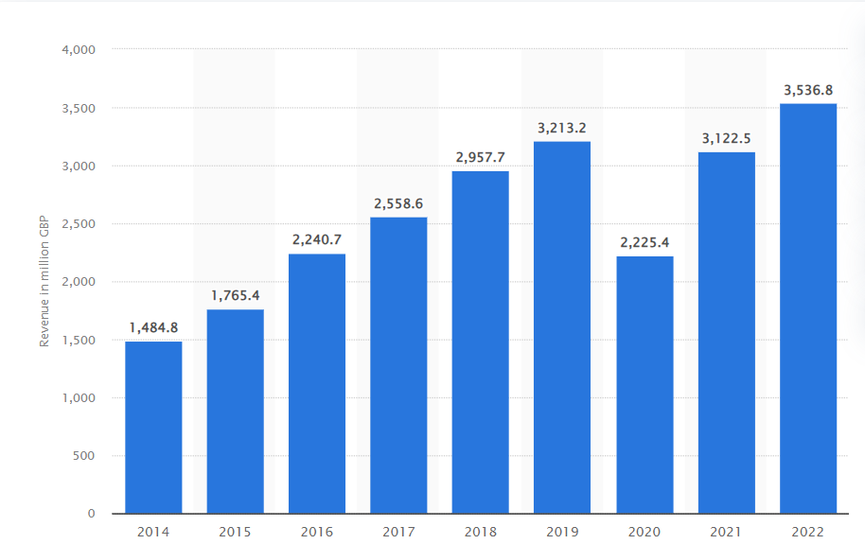

**Figure No 1: Increase in the annual revenue of Bellway Plc**

(Source: *Annual revenue of bellway,* 2023 )

With respect to the figure presented in Figure no 1, it can clearly be ascertained that the company has observed a huge increment in terms of sales volume of the same. The graphical presentation deployed in this figure indicates the data of the company from the year 2014 to 2022. In this context, the lowest sales were observed in the year 2014 at about 1484.8. Whereas the highest revenue generated by the company was in 2022 for about 3536.8. However, the company has observed a huge decline in its annual revenue in the year 2020. The reason behind this aspect was just the outbreak of the global pandemic that has affected the overall business of most of the companies.

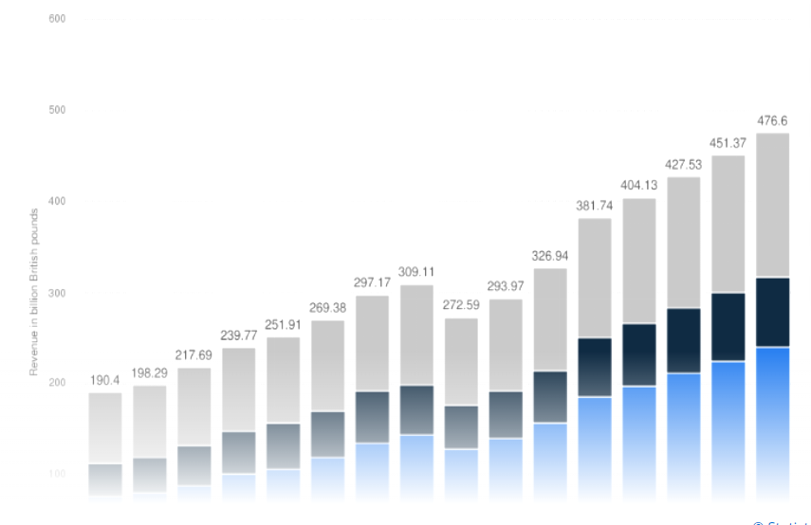

**Figure No 2: Average revenue of the construction business**

(Source: *Statista*, 2023)

With respect to figure No 2 the average turnover of the construction business can be observed from the past few years and the result is expected to be in the future course of action. It can clearly be observed here that the concerned industry is having a huge increment in terms of the aggregate revenue level of the same. Considering this, it can be stated that by the means of comparing the revenue of Bellway Plc with the concerned industry line, the company is having a standardised level of revenue structure. The company is significantly increasing their turnover from the previous financial years at the present time period.

# Section: 2

**Analysis of the current financing of the firm**

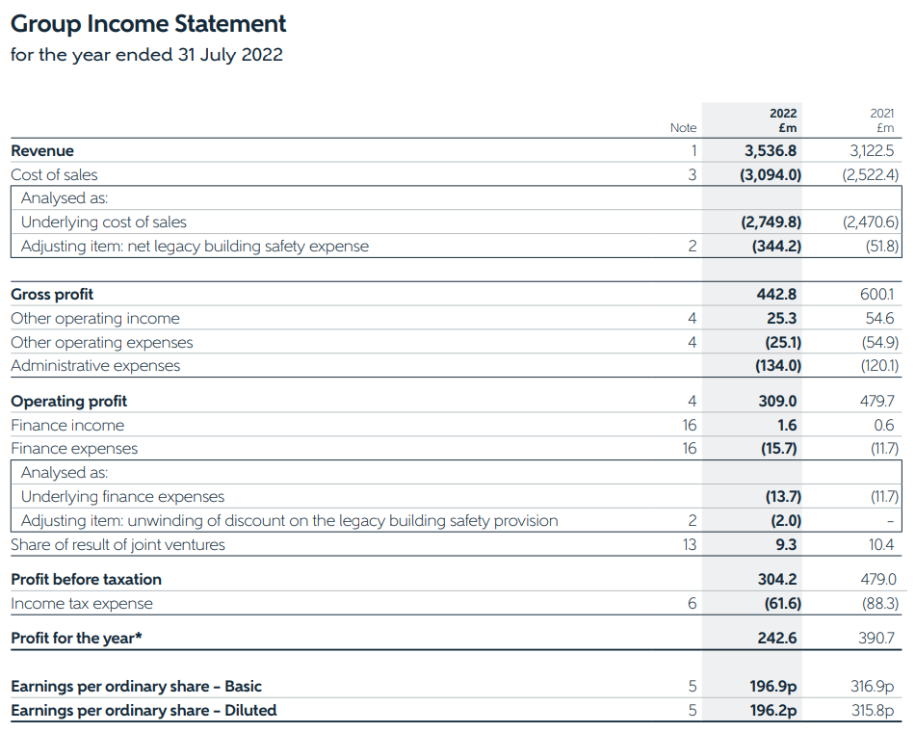

**Figure No 3: Group Income Statement**

(Source: *Bellway P.L.C,* 2023)

As per the findings from Figure no 3, it can be ascertained that the aggregate level of revenue was £3536.8m in 2022 and £3122.5m in the previous financial year. This indicates that the aggregate level of the sales volume of the company has increased from the financial year 2021 to 2022. Moreover, the gross profit of the business was observed to be £600.1m in 2021 and £442.8m in the very next financial year of the same. This implies that the company has also observed an increment in terms of gross profit of the same. However, in terms of the net profit of the company, it can be observed here that it was about £390.7 in 2021 and £242.6 in 2022.

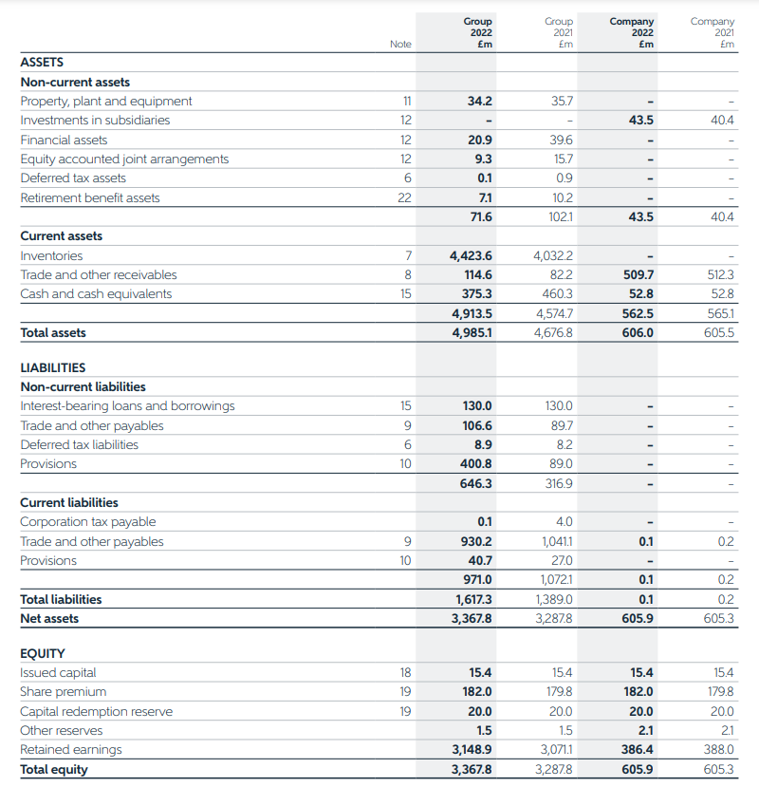

**Figure No 4: Balance Sheet**

(Source: *Bellway P.L.C,* 2023)

In context to the figure presented in Figure no 4, the balance sheet of the concerned organization can be observed for two consecutive financial years that is 2021 and 2022. In this context, the total valuation of the assets of the company was about £4,676.8m in 2021 and £4,985.1m in the next financial year. Moreover, the total liabilities were about £1,389.0m in 2021 and £1,617.3m in 2022. For the total equity, the company was having about £3,287.8m in 2021 and £3,367.8m in the next financial year of the same.

***Capital Structure Theory***

There are basically four theories of capital structure that are being followed by an organization. With respect to this, the theory that has been observed in the case of Bellways Plc at the present time is the Net Income theory. According to this theory, debt is considered to be the most prominent source in terms of funding a particular business during the time of requirement. Apparently, the utilisation of debt in the funding of a business also decreases the risk that is involved with the higher level of expense. Apart from this, the net income theory also helps in decreasing the tax rate that is to be paid. Apparently, the retained earnings generated by the company in 2021 are £3071.1m and £3148.9m for the next year.

***Advantages of using debt as opposed to equity***

The introduction of debt financing is considered to be less risky as compared to the other financing strategy (Huang, 2019). The major reason behind this aspect is just that debt financing helps in decreasing the expenditure level of a company that is involved with the tax payment of the same. In this respect, it can be stated that in case the concerned organization is using debt financing their business will be getting an opportunity for a lower level of expenditure.

***Disadvantages of using debt as opposed to equity***

The major drawback of using debt financing within the business is the repayment of the aggregate level of the debt that they are having (Baines, 2021). In a broader sense, it can be stated that the repayment of the debt that they are having. Considering this, it can be stated that in case a business is having a loss and the company is going to collapse then also the debt is required to be paid by an individual. In this respect, it can be stated that for the concerned organisation also there is an issue in terms of the repayment of the debt level of the same.

# Section: 3

**Dividend Policy of the Firm**

A dividend policy is considered to be the overall structure in which the dividends are paid to the shareholders at the end of a particular financial year (Sami, 2021). It mainly provides an overview of the structure and amount of the dividend that is paid to the shareholders. Different companies are having different patterns in terms of the payment of dividends. There are basically two types of dividends that are being paid by the companies to their shareholders. These dividends are the interim dividend and annual dividend. The annual dividends are paid at the end of the concerned financial year in a business. Whereas, on the other hand, the interim dividend is paid throughout the year. For the concerned organization of Bellways Plc, both the annual and interim dividend is paid to the shareholders in terms of the stock that they are having (*Bellway plc,* 2023). Apart from this, the company is also observed to be giving the dividend both on the basis of the stock as well as the cash to the shareholders. The dividend paid to the shareholders plays a major role in terms of the earnings that have been made by the same. In simple words, it can be stated that the dividend played by Bellways Plc acts as a huge profit for the shareholders apparently making the company productive at the same time.

**Pattern of dividend**

|  |  |  |
| --- | --- | --- |
| **Financial Year** | **Annual Dividend** | **Interim Dividend** |
| 2019 | £0.95 | £0.50 |
| 2020 | £1.0 | - |
| 2021 | £0.05 | £0.35 |
| 2022 | £0.83 | £0.45 |

**Table No 1: Dividend pattern of the Beltways Plc**

(Source: *Beltway Corporate*, 2023)

With respect to the table presented in the table no 1, the dividend pattern of Bellways Plc can clearly be observed in terms of the annual dividend as well as the interim dividend that they are paying to their shareholders. In this respect, it can clearly be observed that in the year 2019, the company provided an annual dividend of about £0.95 and an interim dividend of about £0.50 to their shareholders. Moreover, in the next financial year of 2022, the company has provided an annual dividend of £1.0. However, in that year the company has not provided any interim dividend to the shareholders. For the year 20221, the annual dividend paid by the company was £0.05 and the interim dividend was £0.35. Further, it has been observed that there is a slight increment in the dividend paid to the shareholders over here. During this year the company has provided £0.83 and £0.45 respectively for the annual and the interim dividend making the shareholders more profitable. In any organization, it is necessary to pay an adequate level of dividend to shareholders so as to increase their willingness to get associated with the same. In case a company is not able to deliver a standard level of dividend rate as per the market value, then there is a higher chance that the shareholders of the company will be withdrawing their stock over there. This implies that it is necessary to pay an adequate level of dividend to the shareholders within the concerned financial year. By analysing the dividend trend of Beltways Plc for the past four years, in the year 2020, the overall rate of dividend has increased from the previous ones. This aspect has provided a huge benefit in terms of increasing the productivity of the shareholders as well as the business also at the same time. However, In this respect, I will suggest that the company needs to further increase their dividend rate so that it will be providing more benefit to the business in the future course of action. In other words, it can be stated that the company has to increase the dividend rate that they are paying at the present time for the further development of the business.

**Comparison of the dividend of similar firms**

In order to compare the dividend paid to the shareholders one of the major competitors of Beltways Plc has been considered over here. In this respect, Daniels Homes have been chosen over here. The dividend that the company has paid to the shareholders are as follows:

|  |  |
| --- | --- |
| **Financial Year** | **Dividend Paid** |
| 2019 | £0.35 |
| 2020 | £0.36 |
| 2021 | £0.37 |
| 2022 | £0.40 |

**Table No 2: Dividend Pattern of Daniels Homes**

(Source: *ADM,* 2023)

As per the tabular presentation presented in Table, no 2 the dividend pattern of Daniels Homes can clearly be observed for about four consecutive financial years. In this context, it can be stated that the company has provided a dividend of £0.35 in the year 2019, £0.36 in 2020, £0.37 in 2021 and about £0.40 in 2021.

While comparing the dividend structure of both companies, I observed that Beltways Plc is having a lower level of dividend rate as compared to that of their competitor. However, the company is associated with the payments of the dividend through cash as well as stock also. Whereas, on the other hand, the competitor is observed to be providing a higher rate of divided over here. In this context, according to my opinion, it is necessary for Beltways Plc to increase its dividend rate at the present time. In case the company is not able to do so then it may affect the ultimate productivity of the same.

# Conclusion

The assessment has covered a wide range of information in terms of the financial management of Beltways Plc over some of the financial years. In this respect, the aggregate level of sales of the company has been analysed by comparing the same with the average revenue in the concerned market segment. After this, the income statement as well as the balance sheet of the company has been analysed for the financial years 2021 and 2022 in order to determine the financial performance of the same. Further, last the dividend trend and the policy of Beltways Plc has been evaluated over here by the means of comparing the dividend that is paid by one of its closest competitor at the present time.

# Reference

Baines, J. and Hager, S.B., 2021. The great debt divergence and its implications for the Covid-19 crisis: Mapping corporate leverage as power. New Political Economy, 26(5), pp.885-901.

Bellway P.L.C. annual report and accounts 2022 . Available at: https://www.bellwayplc.co.uk/media/2014/annual-report-2022.pdf (Accessed: April 14, 2023).

Bellway plc (BWY) Fidelity. Available at: https://www.fidelity.co.uk/factsheet-data/factsheet/GB0000904986-bellway/dividends (Accessed: April 14, 2023).

Bellway plc share price (BWY) ordinary 12.5p | Bwy - Hargreaves Lansdown . Available at: https://www.hl.co.uk/shares/shares-search-results/b/bellway-plc-ordinary-12.5p (Accessed: April 14, 2023).

Dividend information ADM. Available at: https://investors.adm.com/financials/dividend-information/default.aspx (Accessed: April 14, 2023).

Huang, K. and Shang, C., 2019. Leverage, debt maturity, and social capital. Journal of Corporate Finance, 54, pp.26-46.

Major shareholders: Bellway P.L.C. Bellway Corporate. Available at: https://www.bellwayplc.co.uk/investor-centre/shareholder-information/major-shareholders (Accessed: April 14, 2023).

Our dividend calculator: Bellway P.L.C. Bellway Corporate. Available at: https://www.bellwayplc.co.uk/investor-centre/share-price-centre/dividend-calculator (Accessed: April 14, 2023).

Published by Statista Research Department and 15, D. Annual revenue of bellway 2022, Statista. Available at: https://www.statista.com/statistics/961776/bellway-annual-revenue/ (Accessed: April 14, 2023).

Published by Statista Research Department and 6, S. UK: Construction market revenue forecast 2027, Statista. Available at: https://www.statista.com/forecasts/1328878/construction-market-revenue-united-kingdom (Accessed: April 14, 2023).

Sami, M. and Abdallah, W., 2021. Assessing the impact of dividend policy on the sustainability of distressed firms. Journal of Modelling in Management, 16(3), pp.987-1001.