**THE NECESSITY FOR PLANNING AND DEVELOPMENT OF SINGAPORE AIRPORT**

Table of Contents

Introduction 2

Analysis 3

Conclusion 6

References 8

**List of figures and tables**

Figure 1: SWOT analysis 5

Table 1: SWOT analysis 6

Table 2: Internal stakeholder analysis 7

Figure 2: PESTLE analysis 8

# Introduction

Aviation is the key component for the maintenance of the economy of Singapore. This contributes approximately 5% to the GDP of Singapore as well as provides almost 20,000 jobs to the job aspirants (Kovačič *et al.* 2021). This helps in terms of transportation of passengers as well as goods from one place to another and facilitates the economic growth of the country. The aviation of Singapore is famous for its several travel awards and flawless service standards. They are earning their reputation by providing comfort and valuable services to their passengers and as a result, they get positive feedback from them. This helps to reflect the reputation and the identity of the Singapore aviation service. The necessity of planning an airport will be able to provide a valuable service to the passengers.

It is crucial for CAAS to plan forward to ensure Singapore's sustainable development as a flourishing worldwide air hub and defend Singapore's civil aviation comfort (Seçilmiş, 2022). For keeping the balance in terms of future air traffic demand participating in the planning of airports in the Singapore is most important one. As per the comment of Yangmin *et al.* (2021), for the development of airports in this country, it is important to develop proper infrastructure for the airport such as a sufficient area for the building of the runaway and new terminal. For making an effective result according to the planning of the infrastructure of the airport the involvement of stakeholders are important. They will invest in the plan according to their will. The major involving stakeholders in the development of aviation are the Federal Aviation Administration, Air carriers, passengers, and Airport organizations. Their effective investment in the development of the airport helps to assist in the growth of the airport. In Singapore aviation is the main pillar for boosting the growth of the economy so, it is necessary to develop an airport here that is also able to provide employment this is a great scenario in terms of the development of a nation.

The lowest price in travelling aviation in Singapore mostly attracts passengers as well as their effective service policies (CHANG, 2019). This aviation industry in Singapore also supports the tourism, and transportation of goods which is also important for the maintenance of the economy in Singapore. The increase of numbers in airports in Singapore facilitates transportation better than before as well as provides a better choice to passengers in terms of travelling.

# Analysis

Singapore is a famous country for its tourism sector which gets its success due to the effective services of the aviation sector. For the facilitation of the growth of the tourism sector in Singapore, it is necessary to develop airports in this country. This will help in the put down of the fare of flights which will be able to grab the attention of the passengers and will facilitate the economic growth of this country. The aviation sector is already has contributed 5% to the gross domestic product of Singapore by providing employment to job seekers (Шкваря *et al.* 2020). The process of creating a short-, intermediate-, and long-term development plan for the airport is known as the creation of an airport master plan. The implementation of the master plan is the key factor for the development of an airport as this will be able to ensure the potential for the available land for the development of runways for airplanes as well as helpful for the creation of the terminals by maximizing the area to establish effective transportation.

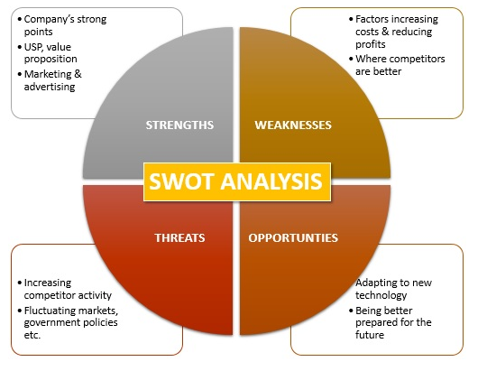

#### Figure 1: SWOT analysis

(Source: https://www.mbaskool.com/business-concepts/marketing-and-strategy-terms/2353-swot-analysis.html)

The SWOT analysis for the development of a master plan to build an airport in Singapore helps to provide an idea about the strength, weaknesses, opportunities, and threats to the aviation industry of Singapore.

|  |  |
| --- | --- |
| **Strengths**   * Will be able to make a powerful economic region. * Facilitates fast services to passengers. * Will be focusing on LCC service (Low-cost carrier) | **Weaknesses**   * Depending on the traditional infrastructure. * Entire dependency on LCC (Yadav and Dhingra, 2022). |
| **Opportunities**   * Will be able to improve the services through big data analysis. * Will be able to grow as multi-functional airports. | **Threats**   * Facilitate competition with neighbouring aviation organizations. * The increasing rate of inadequately documented passengers. |

### Table 1: SWOT analysis

(Source: As per author)

For the effective development of an airport in Singapore, the involvement of stakeholders is important as they are the main key component. The major stakeholders in the aviation industry are The Federal Aviation Administration, air carriers, passengers, and airport organizations.

There are majorly two types of stakeholders’ internal and external stakeholders.

Internal stakeholders

|  |  |  |
| --- | --- | --- |
| **Stakeholders** | **Roles** | **Expectations** |
| **Management** | They provide extensive ranges of customer experience so that they can be able to make loyalty with their passengers which will be beneficial for the rapid growth of the new airport in Singapore. | They expect that the stakeholders from different levels should cooperate with the guidelines of the aviation industry which is important for the provision of effective services to passengers. |
| **Employee** | The pilot and air hostess are the employees of the aviation industry. They are entirely focused on the satisfaction of passengers as their level of satisfaction of them will add value to the aviation service of Singapore. | They expect proper remuneration for the provision of effective services to the passengers. |
| **Shareholders** | Their major role of them is to provide shares for the development of the airport when required as well as provide an opinion when something new is needed to incorporate (Bülbül, 2022). | They try to maximize their shares. |
| **Board of Directors** | Their role is to maintain the finance and accountability for the development of a new airport in Singapore. They are also involved in terms of the making of decisions. | They mainly want to establish their organization in the highest place by reflecting its value. |

### Table 2: Internal stakeholder analysis

(Source: As per author)

By reducing the threats in terms of the development of the airport in Singapore PESTLE analysis will help to guide efficiently in a positive direction through the involvement of stakeholders. This analysis stands for political factors, economic factors, socio-cultural factors, technological factors, legal factors, and environmental factors.

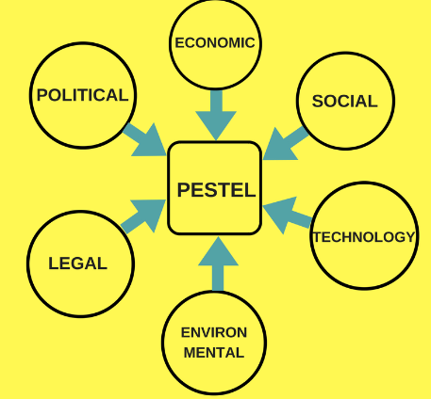

#### Figure 2: PESTLE analysis

(Source: https://www.girlfridayz.com/post/the-importance-of-a-pestel-analysis)

***Political factors:*** The political factors in the aviation industry get major importance which is beneficial for the provision of comfort and favour to the passengers. As per the comment of Sezgin and Demiral (2019), the aviation industry of Singapore regulates the safety measures of the passengers which are important for the sustainability of the aviation industry as well as the development of a new airport. The monopolistic behaviours are the result of tiredness by the political elite of the airlines, and as a result, they have pursued tighter controls of the activities of the airlines.

***Economic factors:*** Economic factor has major importance in the development of an airport in Singapore. For making the infrastructure of the airport it needs a lot of investment. The attraction of stakeholders and the maintenance of the relationship is the most important criteria for the development of this airport. Without proper support from the economy, it is unable to grow an airport as it needs huge labour too.

***Socio-cultural factors:*** In recent years passengers are showing interest in aviation as it is beneficial for quick transportation as well as helpful for emergencies. As per the thought of Landis (2022), the smooth facilitation of the aviation industry in Singapore also helps to improve the tourism sector of this country which is beneficial for the reduction of cross-cultural behaviour. This is important for maintaining awareness of the cultural influences of an individual. The availability and the disruption-free services by the Singapore aviation industry engage the maximum number of passengers which is important for the reflection of the value of this industry. This shows the positive growth in the development of the new airport.

***Technological factors:*** Technological factor is one of the most crucial factors as the entire aviation industry is standing over the technology. Technology is the only factor for the effective development of the airport as this is able to adapt to several external and internal factors and is able to modify as per the requirements of the airport. For the promotion of the new airport and its services, social media will play an important role to reflect the value of this airport as well as grabbing the attention of the majority of passengers (Zhao and Lyu, 2022). The maintenance of air traffic is also regulated by technology.

***Legal factors:*** The number of lawsuits filed by both customers and employees against airlines has increased in recent years. Additionally, the strict regulators make the airlines harsher which is the major reason for more cautious tactics and implemented them as an effective strategy without conflicting with any rules. As per the insight of Bajwoluk (2021), the maintenance of the legal factor in Singapore will be advantageous in terms of the development of an airport without any conflictions.

***Environmental factors:*** In recent days passengers are more aware of the environment so they are measuring their carbon footprints to avoid the exploitation of the environment. Not only is this climatic condition also a crucial factor that needs a proper investigation.

The analysis of internal and external stakeholders is important for the establishment of a valuable master plan for the development of the new airport. The development of the airport needs a large land for the building of the terminal and the runway for airplanes.

# Conclusion

Singapore's economy depends heavily on aviation to remain stable. This generates over 20,000 jobs for job seekers and contributes about 5% to Singapore's GDP. For securing the continuous growth of Singapore as a successful international air hub and safeguard Singapore's civil aviation interests, CAAS needs to make long-term plans. Participating in the design of Singapore's airports is crucial for maintaining the balance in terms of the demand for air travel in the future. The participation of stakeholders is crucial for producing an effective result in accordance with the development of the airport's infrastructure. They will make investments in the strategy in accordance with their wishes. The Federal Aviation Administration, air carriers, passengers, and airport organizations are the main parties involved in the growth of aviation. The process of developing an airport master plan entails coming up with short-, intermediate-, and long-term development plans for the airport. The main factor in the development of an airport is the implementation of the master plan, as this will be able to guarantee the potential for the land that is currently available for the development of airplane runways as well as useful for the creation of the terminals by maximizing the area to establish efficient transportation. The relevance of political issues in the airline business is significant, which is good for giving passengers comfort and favour. The Singaporean aviation sector controls passenger safety regulations, which is crucial for the survival of the sector and the construction of new airports. Due to the airlines' historical propensity for monopolistic activity, the political class has grown weary of them and has advocated stricter regulations over the operations of the airlines. In recent years, both employees and the passengers give allegations against airlines. The regulator is also being stricter with the airlines, which has made them more cautious about their strategies. Given that technology is at the centre of the aviation sector, it is one of the most important components. The ability of technology to adapt to various internal and external elements and to change in accordance with the needs of the airport makes it the sole consideration for the successful growth of the airport. Social media will be crucial for promoting the new airport and its facilities since it will represent the importance of this airport and attract the attention of most travellers. Technology also controls how air traffic is maintained. These are controlled by the external stakeholders whereas the internal stakeholders are mainly focused on disruption-free services as well as the provision of comfort to the passengers so it will be easier for the development of a new airport in Singapore by reflecting its principles toward the passenger services.

# References

Bajwoluk, T., 2021. The functio-spatial structure of airport surroundings: the case of Kraków Airport. *Budownictwo i Architektura*, *20*(4), pp.47-62.

Bülbül, K.G., 2022. A Necessity for Sustainability: Operational Resilience Through Disruption Management in Airlines. In *Corporate Governance, Sustainability, and Information Systems in the Aviation Sector, Volume I* (pp. 11-35). Singapore: Springer Nature Singapore.

CHANG, T., 2019. CHAPTER ELEVEN SUSTAINING SINGAPORE TOURISM. *Sustainable Tourism in Asia: People and Places*, p.188.

Kovačič, B., Doler, D. and Topolšek, D., 2021. Optimization and Development of the Model for Monitoring the Deformations on the Airport Runways. *Processes*, *9*(5), p.833.

Landis, J.D., 2022. Singapores Jewel Changi Airport-always raising the bar. In *Megaprojects for Megacities* (pp. 325-347). Edward Elgar Publishing.

Seçilmiş, N., 2022. Sustainable Aviation Based on Innovation. In *Corporate Governance, Sustainability, and Information Systems in the Aviation Sector, Volume I* (pp. 93-119). Singapore: Springer Nature Singapore.

Sezgin, E. and Demiral, G.N., 2019. Airports as shopfronts of tourism destinations: awarded brand Singapore Changi versus surviving Istanbul Ataturk. In *Eurasian Business Perspectives: Proceedings of the 22nd Eurasia Business and Economics Society Conference* (pp. 355-369). Springer International Publishing.

Yadav, M. and Dhingra, T., 2022. Emerging Scope of Airport Infrastructure: Case of India. In *Infrastructure Planning and Management in India: Opportunities and Challenges* (pp. 35-51). Singapore: Springer Nature Singapore.

Yangmin, B., Shaohong, F. and Yan, L., 2021. Assessing the synergy and sustainability of “Airport-Industry-City"(AIC) system in aerotropolis: Evidence from Zhengzhou Aerotropolis in China. *Environmental Research*, *195*, p.110886.

Zhao, P. and Lyu, D., 2022. Policy Recommendations. In *Lifestyle Change and Transport in China* (pp. 291-314). Singapore: Springer Nature Singapore.

Шкваря, Л.В. and Семенов, А.С., 2020. Smart cities: necessity and development strategies. *Информация и инновации*, *15*(2), pp.52-58.