**UNDERSTANDING THE TOURISM ENVIRONMENT AND ITS STAKEHOLDERS IN THE UK**

**Table of Contents**

Introduction 3

Concept of sustainable tourism and its principles for sustainable tourism development in the UK 3

Role of stakeholders involved in the Decision-making of sustainable tourism development 4

Macro environmental factors contributing to the sustainable tourism development of UK 5

Micro-environment and tourists' motivating factors Influencing the demand for eco-friendly Hotels 8

Conclusion 9

References 11

# Introduction

Sustainable practices in the tourism sector are necessary to ensure the constant flow of local and foreign tourists. The conservation of the local culture and heritage becomes easier with the application of sustainable tourism to a large extent. The socio-economic benefits gained from sustainable tourism in a country strengthen the heritage locations and invite foreign travellers periodically. The current study revolves around the UK travel and tourism sector. The study's aim is to address the principles for sustainable tourism development in the UK and verify the role of stakeholders in decision-making for adequate sustainability in the tourism space. Apart from this, the macro-environmental factors influencing the sustainable tourism business will be evaluated alongside the identification of the micro-environment and tourist motivating factors for accessing sustainable tourism services such as eco-friendly hotels in the UK.

***Thesis statement:*** *The stakeholders play a major role in promoting sustainable tourism actions to strengthen the tourism sector in the UK.*

# Concept of sustainable tourism and its Principles for sustainable tourism development in the UK

The concept of sustainable tourism has emerged to be popular in the UK as there remain manifold benefits of following green practices in the tourism sector. The benefits of sustainable tourism are lower ecological impact, responsible tourist visits, preservation of the cultural heritage, and support and empowerment for the local communities. The three main principles of sustainable tourism are seen as environmental, social, and economic sustainability. These three principles coincide with the triple bottom line of any business environment such as the planet, people, and profit. United Nations (UN) can be seen as a global organisation that helps plan sustainable actions for eco-friendly tourism. As per the views of Hall (2019), the UN 2030 Agenda for Sustainable Development sets a series of sustainable development goals (SDGs). 17 in total to enhance sustainable operations in the field of tourism. The travel and tourism sector is known to be notorious for its poor waste management processes and pollution from the transport of supplies, which goes to deplete the health of the heritage sites and natural resources in the country. United Nations World Tourism Organization (UNWTO) is a unit of the UN that is in charge of promoting responsible, sustainable and universally accessible tourism.

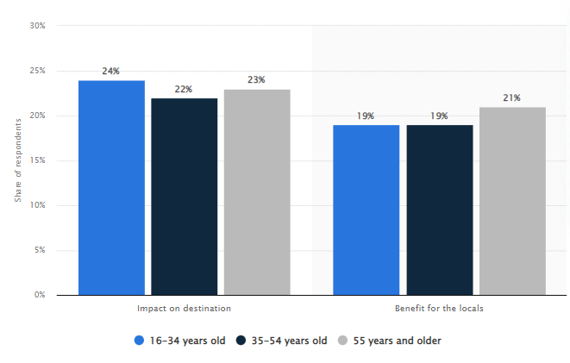

**Figure 1: Tourism sustainability concerns in the UK 2021, by age**

(Source: Statista Research Department, 2023)

According to the current reports, during the year 2021, 24% of 16-34 years old respondents stated that there were greatly concerned about the impact of sustainable tourism on destinations (Statista Research Department, 2023). On the other end, 19% of the respondents suggested that multifaceted benefits are presented with sustainable tourism development. According to the study by Eslami *et al.* (2019), it is proven that the overall quality of life satisfaction aids in the process of supporting sustainable tourism development. In the UK, sustainable tourism expects to be a major socio-economic driver. As per the study by Sobaih *et al.* (2021), the COVID-19 pandemic deeply affected small tourism enterprises in the tourism sector. The severity of the impact has led towards bigger sustainability practices as hygiene and safety concerns are becoming a priority for even the smaller businesses in the tourism sector. As viewed by MacKenzie and Gannon (2019), the role of the private sector in boosting sustainable tourism is immense as the resource accessibility seems to be immense for private sector companies. Therefore, the large-scale private sector hotel chains could pave way for sustainability standards to remain high in the UK, as digitalisation would be key to this process.

# Role of stakeholders involved in the decision-making of sustainable tourism Development

Sustainable tourism indicators (STIs) are required to be applied to the operations of tourism sector businesses in a country to predict the success degree of meeting the UN SDGs. As stated by Rasoolimanesh *et al.* (2020), residents or the community people are the most engaged stakeholders during the time of sustainable tourism development, followed by the tourists, government, and businesses in the tourism sector. UNWTO on the other end is a stakeholder that indirectly influences strong sustainability commitments from the local and the UK government. As mentioned by Roxas *et al.* (2020), stakeholders are collectively responsible for adding merit to sustainable developments in the tourism sector. In relation, an ample degree of awareness shown by the government to help communities lead a better life and gain employment via tourism industry growth would register positive sustainable tourism developmental actions. As discussed by Guo *et al.* (2019), back in 1993 and 1995, the World Tourism Organization (WTO) addressed sustainable tourism development to be the future. While networking building and international compliance are necessary for the stakeholders to keep tourism sustainability adequate in the UK. United Nations Educational, Scientific and Cultural Organization (UNESCO) is seen as a major stakeholder to accelerate the trend of sustainable tourism in destinations around the world. Since it has certified 33 sites in the UK, it has managed to make heritage buildings and locations get recognition from the end of the UK Government as well. This has helped invest financial and technological resources to ensure better longevity of the heritage sites in the UK and follow the principles of sustainable tourism along the way with effectiveness. According to the views of Khalid *et al.* (2019), the decision taken by the national government impacts tourism industry proceedings extensively. Similarly, the UK government would be in charge of collaborating with UNESCO, UNWTO and many more units to build stronger tourism sustainability.

# Macro environmental factors contributing to the sustainable tourism development of the UK

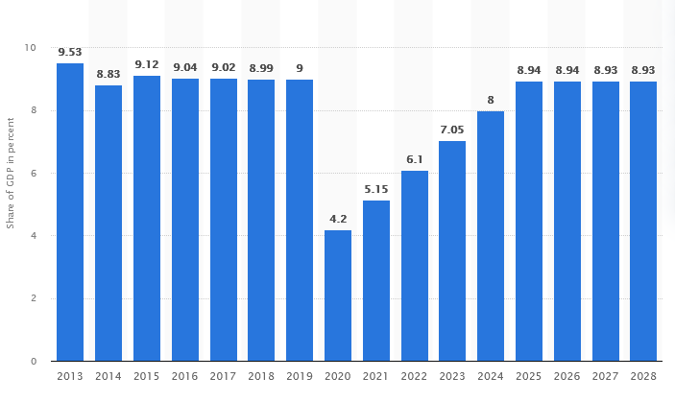

**Figure 2: Share of the GDP of the tourism sector in the UK from 2013 to 2028**

(Source: Degenhard, 2023)

Economic growth is promoted to a large degree as a result of sustainable tourism. The gross domestic product (GDP) value of a country is influenced strongly by the tourism industry, whereas in the UK the tourism contribution to GDP levels is strong as well. According to recent reports, 6.1% of the entire GDP was contributed by the tourism sector in the year 2022 (Degenhard, 2023). This contribution is forecasted to be greater over the next five years in the UK, which helps seek better government assistance during permissions to optimise heritage sites and build renewable energy sources for sustainable tourism. As per the views of Robinson *et al.* (2019), employment and tourism share a correlation, thereby referring to the need for establishing sustainable tourism as that helps community people gain employment opportunities and keep heritage alive. Hence, political and economic variables positively influence sustainable tourism practices in the UK.

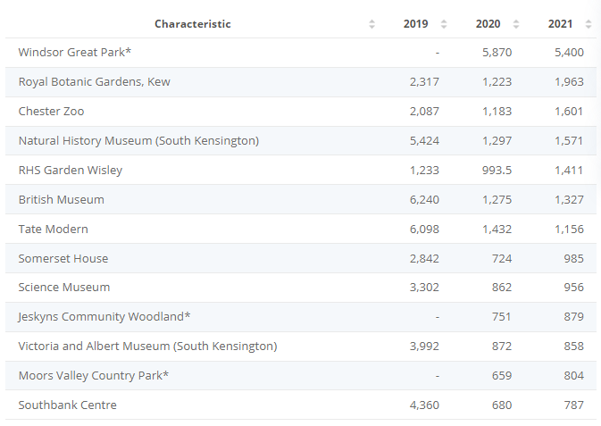

**Figure 3: Most visited tourist attractions in the UK 2019-2021**

(Source: Statista Research Department, 2022)

As per current reports, Windsor Great Park attracted close to 5.4 million visitors during the year 2021, the most that year among any UK tourist site (Statista Research Department, 2022). In relation, several other places followed a higher number of visitors, thereby suggesting the trend of social groups to travel across the UK. This brings sustainability concerns as tourists now always prefer to spend extra for eco-friendly services. However, the technologically efficient structure of the UK hospitality and tourism business instils the need to have a positive visiting experience by staying at green hotels. According to the study by Sharpley (2019), the globalisation trend is resulting in the growth of the hospitality industry but is inviting several sustainability concerns along with it as natural resource management becomes poor due to globalisation. Hence, globalisation, and climate change are macroenvironmental factors that positively influence the tourism sector as it stands as one of the major drivers for practising sustainable tourism.

The concept of circularity is widely associated with the green practices exercised in the tourism and travel sector. Businesses in the industry continuously make efforts to shape the service sustainably and manage environmental damage with diligence from the carried operations. As discussed by Rasoolimanesh *et al.* (2019), the reduction of the generated waste from the hospitality sector is not enough to secure sustainability as the extensive focus should be given towards circularity because it assists in the process of reducing, reusing, and reusing. Pollution levels are minimised to a large extent while following circularity in the tourism and travel business. While the legal codes help cope with suitable environmental practices as the Environmental Act 2021 recently got applied in the UK. Hence, legal factors and circularity aim to assure that sustainable developments are executed systematically in the UK to foster innovation and drive eco-friendly operations in the travel and tourism sector.

# Micro-environment and tourists' motivating factors influencing the demand for eco-friendly hotels

Maslow’s hierarchy of needs suggests that physiological, safety, love and belonging, esteem and self- actualization are the needs that motivate people. The experience of roaming in a new place such as heritage destinations in the UK would possibly meet the self- actualization, highest degree of intrusion need for a traveller. The use of advanced technological solutions and modern infrastructure invites plenty of tourists to avail services from the eco-friendly hotels. These hotels are identified to be highly dependent on sophisticated technology use across all of the operational and service level activities in the business as this makes service availability seamless for the consumers. For example, a wide array of motivating factors remains there for a tourist during service use in a green hotel. These motivation factors are abundant health and safety, a digital booking system, renewable energy, the themed architecture of hotels, and lower exposure to toxins from unhygienic environments. Apart from this, the technology-savvy attitude of the people has kept them indulged in using modern services that are comparatively more sustainable than traditional systems. For instance, digital paperwork during guest visits in hotels helps reduce paper usage in booking and maintain ecological balance. According to the views of Hashish *et al.* (2022), energy efficiency, waste management, greenhouse gas emissions, and social management are key metrics that help define a green hotel in the travel and tourism sector. Similarly, renewable energy usage in operations requires strong infrastructural ground in the hospitality business. Hence, to promote eco-friendly hotels, they must first have adequate financial and technological resources present in an organised way to gain a sustainable competitive advantage. According to the study by Yadegaridehkordi *et al.* (2021), the supplier power and ability to source eco-friendly materials with strong ethical values in a microenvironmental factor shape sustainable tourism. The hotel chains in the UK are backed by ethical supplier sources that help supply materials to the hotel unit operations and reduce pollution constraints. Apart from this, many of the top-tier hotels such as Marriott International are using electric vehicle-based transport to reduce their carbon footprint further.

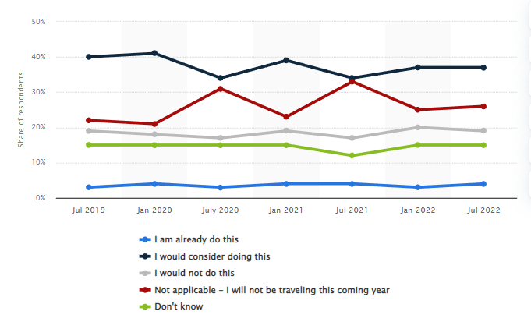

**Figure 4: Travelers choosing green hotels to reduce environmental impact in the UK 2019-2022**

(Source: Statista Research Department, 2022)

The responsiveness among hotel chains to promote sustainable efforts have increased in recent period. This has assured of offering the customers eco-friendly services and hospitality once the customers visit the hotels during their holiday stay. As per current reports, a survey during July 2019 and July 2022 indicated that in the year 2022, the share of travellers considering using eco-friendly hotels grew to 37% over the past two years (Statista Research Department, 2022). Therefore, the trend of an eco-friendly hotel is gaining pace in the UK as environmental concerns are motivating consumers to avail services from these hotel units. As per the views of Weber (2019), UNESCO has referred to the need for preserving heritage sites in respective countries around the world including numerous sites in the UK. Access to heritage sites becomes easier in a destination if there is a presence of sustainable tourism standards. In the UK, there are several heritage sites such as the Tower of London, and Blenheim Palace, whereas close to each of them there remains a handful of eco-friendly hotels. However, some factors curb the purchasing power of the consumers while opting to use the services of a green hotel such as the higher price. Customer willingness to pay a premium for eco-friendly hotels is yet to accelerate in the UK.

# Conclusion

The present developments have helped in inferring that the demand for sustainable tourism is expected to gain momentum in the coming years in the UK. From a macro environmental standpoint, the support of the UK government, economic growth from the tourism sector, sociocultural demands, and legal, and environmental concerns help promote sustainable standards in the travel and tourism sector. On the other end, the Government of the UK, big-scale hotel chains in the UK, suppliers, and UNESCO are collectively found to add value to the sustainable tourism development process in the UK. In an attempt to ensure that sustainable tourism flourishes in the country, the hotel industry is offering eco-friendly services. It can be recommended that the perceived quality for availing eco-friendly hotel services is still growing, therefore awareness has to be increased with promotional campaigns to make sustainability themes stronger in the tourism industry. However, the stakeholders are making necessary actions to ensure better sustainability of the UK tourism sector, thereby indicating the thesis statement to be true.

# References

Degenhard, J., 2023. *Share of the GDP of the tourism sector in the United Kingdom from 2013 to 2028* [online]. Statista. Available: https://www.statista.com/forecasts/1153197/tourism-sector-gdp-share-forecast-in-the-united-kingdom#:~:text=The%20share%20is%20estimated%20to,country%20or%20region%20at%20hand. accessed 2 April, 2023.

Eslami, S., Khalifah, Z., Mardani, A., Streimikiene, D. and Han, H., 2019. Community attachment, tourism impacts, quality of life and residents’ support for sustainable tourism development. *Journal of Travel & Tourism Marketing*, *36*(9), pp.1061-1079.

Guo, Y., Jiang, J. and Li, S., 2019. A sustainable tourism policy research review. *Sustainability*, *11*(11), p.3187.

Hall, C.M., 2019. Constructing sustainable tourism development: The 2030 agenda and the managerial ecology of sustainable tourism. *Journal of Sustainable Tourism*, *27*(7), pp.1044-1060.

Hashish, M.E.S., Abdou, A.H., Mohamed, S.A.K., Elenain, A.S.A. and Salama, W., 2022. The Nexus between Green Perceived Quality, Green Satisfaction, Green Trust, and Customers’ Green Behavioral Intentions in Eco-Friendly Hotels: A Structural Equation Modeling Approach. *International Journal of Environmental Research and Public Health*, *19*(23), p.16195.

Khalid, S., Ahmad, M.S., Ramayah, T., Hwang, J. and Kim, I., 2019. Community empowerment and sustainable tourism development: The mediating role of community support for tourism. *Sustainability*, *11*(22), p.6248.

MacKenzie, N. and Gannon, M.J., 2019. Exploring the antecedents of sustainable tourism development. *International Journal of Contemporary Hospitality Management*, *31*(6), pp.2411-2427.

Rasoolimanesh, S.M., Ramakrishna, S., Hall, C.M., Esfandiar, K. and Seyfi, S., 2020. A systematic scoping review of sustainable tourism indicators in relation to the sustainable development goals. *Journal of Sustainable Tourism*, pp.1-21.

Rasoolimanesh, S.M., Taheri, B., Gannon, M., Vafaei-Zadeh, A. and Hanifah, H., 2019. Does living in the vicinity of heritage tourism sites influence residents’ perceptions and attitudes?. *Journal of Sustainable Tourism*, *27*(9), pp.1295-1317.

Robinson, R.N., Martins, A., Solnet, D. and Baum, T., 2019. Sustaining precarity: Critically examining tourism and employment. *Journal of Sustainable Tourism*, *27*(7), pp.1008-1025.

Roxas, F.M.Y., Rivera, J.P.R. and Gutierrez, E.L.M., 2020. Mapping stakeholders’ roles in governing sustainable tourism destinations. *Journal of Hospitality and Tourism Management*, *45*, pp.387-398.

Sharpley, R., 2020. Tourism, sustainable development and the theoretical divide: 20 years on. *Journal of sustainable tourism*, *28*(11), pp.1932-1946.

Sobaih, A.E.E., Elshaer, I., Hasanein, A.M. and Abdelaziz, A.S., 2021. Responses to COVID-19: The role of performance in the relationship between small hospitality enterprises’ resilience and sustainable tourism development. *International Journal of Hospitality Management*, *94*, p.102824.

Statista Research Department, 2022. *Number of visits to leading tourist attractions in the United Kingdom (UK) from 2019 to 2021* [online]. Statista. Available: https://www.statista.com/statistics/559616/leading-visitor-attractions-in-the-united-kingdom-uk/ accessed 2 April, 2023.

Statista Research Department, 2022. *Share of travelers choosing eco-friendly hotels to reduce their environmental impact in the United Kingdom from July 2019 to July 2022* [online]. Statista. Available: https://www.statista.com/statistics/1340780/travelers-choosing-ecofriendly-hotels-uk/ accessed 2 April, 2023.

Statista Research Department, 2023. *Tourism sustainability concerns in the United Kingdom (UK) in 2021, by age* [online]. Statista. Available: https://www.statista.com/statistics/1135573/tourism-sustainability-concerns-uk-by-age/ accessed 2 April, 2023.

Weber, F., 2019. Demand for sustainable tourism. *Corporate sustainability and responsibility in tourism: A transformative concept*, pp.265-281.

Yadegaridehkordi, E., Nilashi, M., Nasir, M.H.N.B.M., Momtazi, S., Samad, S., Supriyanto, E. and Ghabban, F., 2021. Customers segmentation in eco-friendly hotels using multi-criteria and machine learning techniques. *Technology in Society*, *65*, p.101528.