**TO STUDY THE ISSUES OF SUSTAINABILITY, OPTIMIZATION, AND SCALE IN MANUFACTURING SYSTEMS AND WORK WITH HIGH-PERFORMANCE, NEXT-GENERATION TOOLS AND MATERIALS**

**TABLE OF CONTENTS**

Part One 3

Abstract 3

Introduction 3

Problems to be addressed 3

Potential Benefits 3

Research Aim 4

Research Objectives 4

Scope 4

Research Novel 4

Part Two 4

Literature review 4

Summary of Literature gap 7

Part Three 8

Research techniques 8

Work plan 8

Potential risks 8

Reference list 10

# Part One

## Abstract

In this research sustainability and optimization are two most important concepts that have become increasingly important in the modern world and the idea of sustainability that whatever we do should be done in a way that is environmentally conscious, and that the environment can be protected in the long term. Optimization is the idea of making the most efficient use of resources, in order to maximize the benefits that can be obtained from them. These two concepts are closely related, as they both aim to ensure that resources are used in a way that is beneficial in the long run. In terms of optimization, this means that we should be using resources in the most efficient way possible, in order to maximize the benefits that can be obtained from them. In terms of sustainability, this could involve using renewable energy sources such as solar or wind power, rather than relying on non-renewable sources such as oil and coal.

## Introduction

In this research the system of manufacturing relies on scale to measure and control production and the scale is an important tool for ensuring quality and efficiency in manufacturing. It will be very useful to manufacturers and also for measuring, weighing and counting parts, materials, and products accurately and quickly. Scales are used to measure the weight of materials and parts during the manufacturing process. They will also allow manufacturers for tracking and controlling production. Scales also help manufacturers to measure the weight of finished products, which is important for quality assurance. Scales are used to determine the dimensions of components and parts. They allow manufacturers to check for dimensional accuracy and ensure that parts will be produced to specification and this will be very useful for reducing errors and improving quality control.

## Problems to be addressed

In this research the tools and materials of high performance will provide great advantages to the people who use them. However, they also come with some drawbacks that need to be considered. One problem with high performance tools and materials is their cost and many of these tools and materials are expensive and require significant investments in order to acquire them. This can be a major barrier to entry for many people, as the cost can be prohibitive. The cost of maintenance and replacement parts can also be high. In this research the other issue is that safety and high performance tools and materials often come with more potential hazards than standard tools and materials (Beliatis, *et al.* 2021). This is because they are designed for more intensive use, meaning that there is an increased risk of injury or damage and proper safety protocols must be observed when using these tools and materials. There is the issue of environmental impact. High performance tools and materials are often made from materials that are not sustainable or eco-friendly. This can lead to increased pollution and other environmental issues. These types of tools and materials are often not recyclable, meaning that they must be disposed of properly in order to minimize their environmental impact.

## Potential Benefits

In this research the system of manufacturing has become increasingly complex, and the need for sustainable and optimized systems has grown in recent years. The manufacturing of sustainability systems are those that maximize efficiency and minimize waste and the system of optimization in manufacturing systems is the process of improving the system’s performance and reducing costs. Sustainable and optimized manufacturing systems require comprehensive strategies and technologies (Zhao, and Lei, 2020). These include reducing energy consumption, improving resource utilization, and increasing the use of renewable energy. Adopting advanced manufacturing technologies, such as computer-aided design, 3D printing, and robotics, will be helpful for optimizing the production processes and reducing waste. The principles of incorporating sustainability in the design and implementation of manufacturing systems can help ensure the long-term viability of the system. This includes using recycled materials, using green energy sources, and reducing emissions and waste. Organizational and process changes, such as implementing lean manufacturing and adopting green supply chain management strategies, can help improve efficiency and reduce waste.Scales are very useful for controlling the amount of materials used in manufacturing processes and also for ensuring that the correct amount of materials is used for each production run (Muralidharan, *et al.* 2022). This will be also very useful for reducing waste and improving efficiency and the scales are also used to count the number of components and parts in a production run. This will be also very useful for ensuring that the correct number of components are produced and that the correct number of parts are used in the final product and the scales are very helpful for measuring the production rates and also for monitoring the production levels.

## Research Aim

The main aim for this study is to introduce the issues of sustainability, scale and optimization in the manufacturing system and work with high performance next generation tools and materials.

## Research Objectives

* To discuss the issues of sustainability, scale and optimization in the system of manufacturing.
* To analyze the problems to work with high performance next-generation tools and materials.
* To discuss the process to optimize the production and reduce waste.

## Scope

The scope of this study for recognizing the enterprise of manufacturing which embrace both the revolution of fourth industry and sustainability at the scale. In terms of sustainability, this means that we should be using resources in a way that is mindful of the environment, and that we should be doing our best to reduce our negative impact on the environment (Gao, *et al.* 2021).

## Research Novel

In this novel of this research it is very important to have well-trained personnel in the manufacturing system to ensure that the system is optimized and sustainable. Proper training and education of personnel can help to promote the use of best practices and the adoption of sustainable technologies.

# Part Two

## Literature review

According to the author Wickramasinghe, *et al.* 2021, the machining of high performance is a term used to describe machining processes that produce parts with superior quality, accuracy and speed. The materials and composites used in HPM are typically chosen for their ability to withstand high temperatures, as well as their strength, wear-resistance and low thermal conductivity. Common materials used in HPM include carbide, titanium alloys, stainless steels, and nickel alloys (Wickramasinghe, *et al.* 2021). Composites are often used in HPM because they are lighter and stronger than traditional materials. Composites, such as carbon fiber reinforced plastic, can be used to reduce weight and increase strength. Carbon fiber reinforced plastic also has low thermal conductivity, which helps to reduce thermal distortions during machining, resulting in improved accuracy. The choice of material and composite for HPM should be based on the application and the desired quality and performance. Stainless steels are often used for medical and food processing applications due to their corrosion resistance.

According to the author Wang, *et al.* 2022, the manufacturing system of intelligence refers to technology that allows machines to collaborate and coordinate with each other to produce better outcomes than what any single machine could achieve. The goal of an intelligent manufacturing system is to reduce waste, improve efficiency, and increase quality. To do this, machines must be able to communicate with each other, share information, and use predictive analytics to anticipate potential problems (Wang, *et al.* 2022). This allows the system to optimize production to meet customer demand and minimize operational costs. The benefits of intelligent manufacturing systems are numerous. They can detect, diagnose, and fix problems with minimal human intervention, leading to shorter downtime and fewer defects. They also allow for greater data collection and analysis, which can be used to improve operations and make more informed decisions.

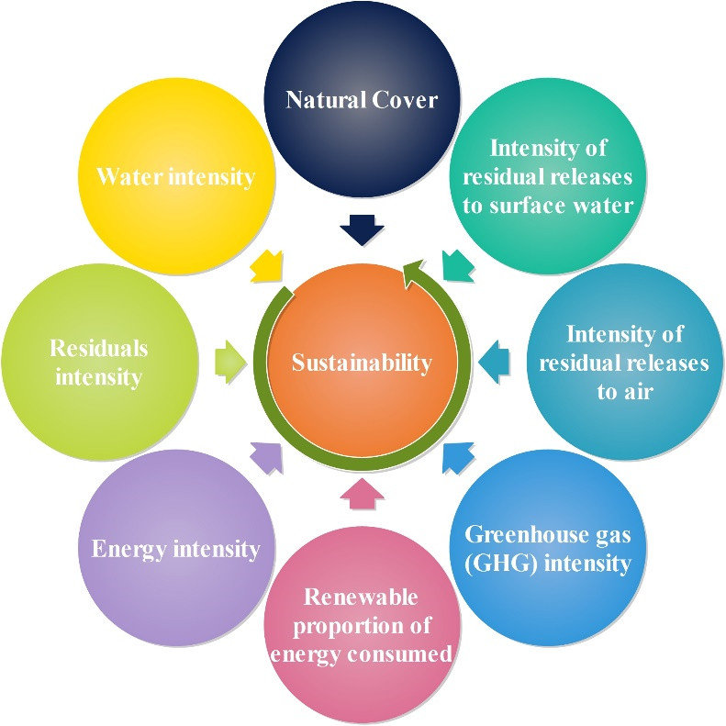

**Figure 1: Factors in manufacturing sustainability**

(Source: https://th.bing.com)

According to the author Cimini, *et al.* 2022, the manufacturing control architecture for the next generation should be focused on increased automation, greater integration of systems, and improved data analysis. Automation can be achieved with the implementation of robotics, artificial intelligence, and machine learning algorithms to reduce labor costs and improve the accuracy of production. Data analysis should also be used to monitor production and identify areas for improvement. By implementing predictive analytics, companies can reduce downtime and improve the effectiveness of their production process ( Cimini, *et al.* 2022).The manufacturing control architecture for the next generation should focus on increasing automation and integrating systems to improve production efficiency, while leveraging data analysis to make informed decisions regarding production.

According to the author Andronie, *et al.* 2021, the most commonly implemented sustainable technologies in manufacturing systems include: Automation technologies such as robotic arms and computer-driven systems can reduce energy consumption and waste, and increase production efficiency. Renewable energy sources such as solar, wind, or geothermal can replace traditional sources of energy in manufacturing systems, resulting in reduced emissions and costs. Cloud computing systems allow for increased efficiency in data processing and communications, enabling manufacturers to reduce energy consumption and emissions (Andronie, *et al.* 2021). By implementing recycling processes, manufacturers can reduce the amount of raw materials needed and the amount of waste produced. 3D printing technologies can reduce the amount of raw materials needed, and the amount of waste produced, while increasing production speed. These technologies can also help organizations meet their sustainability goals, as well as fulfill their obligations to the environment and society.

According to the author Wang, et al. 2021, the optimization of intelligence is an important tool for improving the performance of manufacturing systems. It is a data-driven approach that uses advanced machine learning algorithms to identify patterns and trends in the data and then uses them to optimize the production process. The intelligent optimization process involves several steps. The data is collected from the production process and analyzed to identify patterns and trends (Wang, et al. 2021). Then, the data is used to create a model of the system that can be used to predict its behavior. The model is used to optimize the production process by changing parameters such as production rates, material costs, and inventory levels. Intelligent optimization can be used to improve the efficiency of production processes, reduce costs, and increase production yields. It can also be used to improve the quality of products and reduce the amount of waste generated. By using intelligent optimization, companies can make better decisions about how to allocate resources and optimize their manufacturing system. Intelligent optimization is an important tool for improving the performance of manufacturing systems.

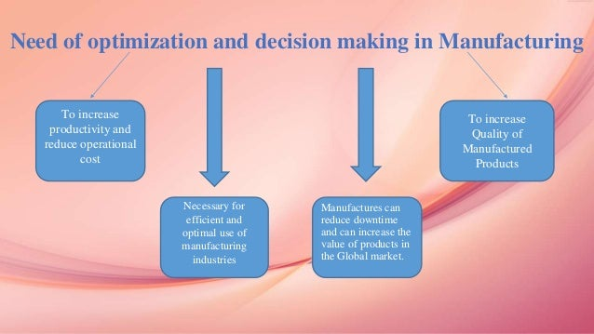

**Figure 2: Sustainable manufacturing**

(Source: https://image.slidesharecdn.com)

According to the author Mourtzis, 2020, it is important for manufacturers to have an efficient manufacturing system in order to reduce cost, increase efficiency, and improve product quality. The operations of a manufacturing system involve the transformation of raw materials into finished products. This includes the selection of materials, cutting and shaping of the materials, assembly of the components, and finally packaging of the finished products. Each of these processes requires proper planning and coordination in order to ensure that the product is manufactured correctly and meets customer requirements (Mourtzis, 2020). The use of automation and robotics is becoming increasingly important in modern manufacturing systems in order to increase efficiency and reduce costs. It is important to have effective communication, planning, and problem-solving capabilities. It is also important to ensure that the system is properly maintained and monitored to ensure that it is running efficiently and safely.

According to the author Johnson, *et al.* 2020, the learning on machines for materials development involves the use of algorithms and data to discover new materials and optimize existing ones. With the help of machine learning, data can be collected from experiments, simulations, and other sources, and then used to create predictive models. These models can help identify promising materials, characterize their properties and behaviors, and determine the best methods for synthesizing them. Machine learning algorithms can be used to analyze large datasets and identify patterns that can lead to the discovery of new materials (Johnson, *et al.* 2020). This can help scientists identify promising materials with better performance than existing ones. This can be useful for designing materials with specific properties and for selecting materials that are suitable for specific applications. Machine learning is a powerful tool for materials development. It can be used for identifying promising materials, optimizing existing materials, and predicting materials properties and behavior.

According to the author Cheng, *et al.* 2021, these materials can be used to create transistors and other electronic components that are much smaller, faster, and more efficient than their traditional counterparts. This advancement is enabling the development of the next generation of electronics, including smartphones, tablets, laptops, and other consumer devices. 2D materials have a range of advantages over conventional 3D materials, including higher electrical conductivity, higher thermal conductivity, and better optical properties (Cheng, *et al.* 2021). These properties make them ideal for use in high-speed, low-power transistors and other components. Their unique properties make them ideal for use in energy-efficient devices that can store and release energy in a controlled manner. This could lead to the development of lighter, more efficient batteries and solar cells, which could revolutionize the way we use energy.

According to the author Manzhos, *et al.* 2021, Solar cells and light emitting technologies are two of the most widely used forms of renewable energy today and solar cells, also known as photovoltaic cells, convert sunlight into electricity. This form of energy is clean, renewable, and abundant. Solar cells are used to power a variety of applications, from residential rooftops to large-scale solar farms. Light emitting technologies, or LEDs, are becoming increasingly popular for energy-efficient lighting. Both solar cells and LEDs have advantages and disadvantages. Solar cells require an initial investment but have no ongoing operating costs, while LEDs typically require more upfront costs but have lower long-term operating costs. Solar cells have a relatively low energy conversion efficiency and require a large amount of space, while LEDs are more efficient and require less space (Manzhos, *et al.* 2021). Both solar cells and LEDs provide clean and renewable energy sources for a variety of applications.

According to the author Hong, *et al.* 2019, they are used in a variety of applications, ranging from aerospace and defense to medical and consumer products. One of the main challenges is the high cost associated with the development and production of high performance materials. These materials require specialized processing and manufacturing techniques which can be expensive to implement. Additionally, these materials often require expensive raw materials, such as rare earth elements, which can further drive up the cost (Hong, *et al.* 2019). These materials often have complex, nonlinear behaviors which are not fully understood. This can lead to unexpected failures and unexpected performance characteristics. It can be difficult to predict the performance of these materials in various applications. There is the challenge of meeting the stringent requirements of many applications.

## Summary of Literature gap

The research gap in the study of manufacturing systems is an area of great interest, particularly in light of the increasing complexity of modern manufacturing processes. In particular, there is a need for further research into how manufacturing systems can be designed, implemented, and managed in order to achieve optimal performance. This research gap includes the need to better understand the operational needs and requirements of different manufacturing systems, as well as the ways in which these systems can be integrated and optimized to maximize their potential. Another important research gap in the study of manufacturing systems is the need to better understand the human element of these systems. In particular, there is a need to understand how humans interact with and are impacted by these systems, including their roles and responsibilities, the ways in which they help to optimize operations, and the ways in which they can be trained and supported.

# Part Three

## Research techniques

The techniques of the research are the processes and the instruments is used when it is starting the study on phenomenon. These types of methods will make it possible for collecting, examining and also exposing the information. In this research a secondary method is used and the qualitative data collection method is used for this research.

## Work plan

A work plan for a project is a very important part for a successful project and the first step for developing the work plan of the project is for identifying the key deliverables. In this research the project starts on 02/03/2023 and completed on 27/6/2023. In this research the results and the outcomes will must be achieved for succeeding the project. The timeline will be very realistic and the plans of contingency for delay problems.

**Gantt chart**

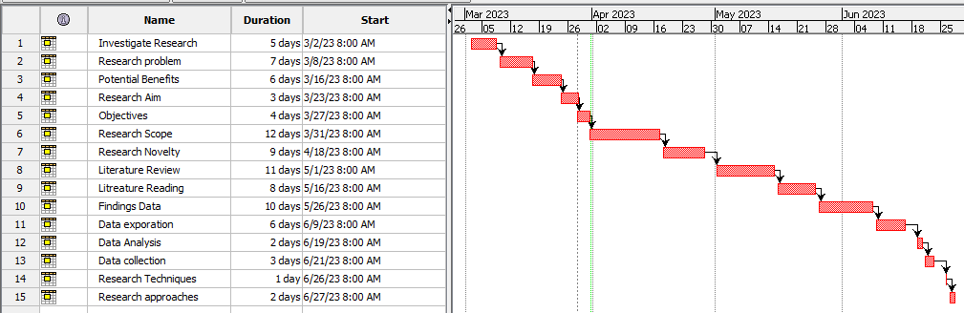

**Figure 3: Gantt chart**

(Source: Self-created in project libre)

## Potential risks

These systems offer tremendous potential for businesses and organizations to achieve greater operational efficiency and improved performance, they also come with a number of potential risks. The most common risks associated with high performance systems are related to their complexity. As the systems are increasingly complex, they are prone to failure and downtime. This can have a serious impact on the overall performance of the system, leading to costly repairs or replacements. This risks of security are a major concern with high performance systems (Koumoulos, *et al.* 2019). These systems can often contain a large amount of sensitive information, making them vulnerable to cyber-attacks and data breaches. In this research the other risk associated with high performance systems is the cost of upkeep and maintenance.

# Reference list

**Journals**

Andronie, M., Lăzăroiu, G., Ștefănescu, R., Uță, C. and Dijmărescu, I., 2021. Sustainable, smart, and sensing technologies for cyber-physical manufacturing systems: A systematic literature review. *Sustainability*, *13*(10), p.5495.

Beliatis, M.J., Jensen, K., Ellegaard, L., Aagaard, A. and Presser, M., 2021. Next generation industrial IoT digitalization for traceability in metal manufacturing industry: A case study of industry 4.0. *Electronics*, *10*(5), p.628.

Cheng, Z., Cao, R., Wei, K., Yao, Y., Liu, X., Kang, J., Dong, J., Shi, Z., Zhang, H. and Zhang, X., 2021. 2D materials enabled next‐generation integrated optoelectronics: from fabrication to applications. *Advanced Science*, *8*(11), p.2003834.

Cimini, C., Pirola, F., Pinto, R. and Cavalieri, S., 2020. A human-in-the-loop manufacturing control architecture for the next generation of production systems. *Journal of manufacturing systems*, *54*, pp.258-271.

Gao, X., Liu, X., He, R., Wang, M., Xie, W., Brandon, N.P., Wu, B., Ling, H. and Yang, S., 2021. Designed high-performance lithium-ion battery electrodes using a novel hybrid model-data driven approach. *Energy Storage Materials*, *36*, pp.435-458.

Hong, K., Lee, T.H., Suh, J.M., Yoon, S.H. and Jang, H.W., 2019. Perspectives and challenges in multilayer ceramic capacitors for next generation electronics. *Journal of Materials Chemistry C*, *7*(32), pp.9782-9802.

Johnson, N.S., Vulimiri, P.S., To, A.C., Zhang, X., Brice, C.A., Kappes, B.B. and Stebner, A.P., 2020. Invited review: Machine learning for materials developments in metals additive manufacturing. *Additive Manufacturing*, *36*, p.101641.

Koumoulos, E.P., Trompeta, A.F., Santos, R.M., Martins, M., Santos, C.M.D., Iglesias, V., Böhm, R., Gong, G., Chiminelli, A., Verpoest, I. and Kiekens, P., 2019. Research and development in carbon fibers and advanced high-performance composites supply chain in Europe: A roadmap for challenges and the industrial uptake. *Journal of Composites Science*, *3*(3), p.86.

Manzhos, S., Chueh, C.C., Giorgi, G., Kubo, T., Saianand, G., Luder, J., Sonar, P. and Ihara, M., 2021. Materials design and optimization for next-generation solar cell and light-emitting technologies. *The Journal of Physical Chemistry Letters*, *12*(19), pp.4638-4657.

Mourtzis, D., 2020. Simulation in the design and operation of manufacturing systems: state of the art and new trends. *International Journal of Production Research*, *58*(7), pp.1927-1949.

Muralidharan, N., Self, E.C., Nanda, J. and Belharouak, I., 2022. Next‐Generation Cobalt‐Free Cathodes–A Prospective Solution to the Battery Industry's Cobalt Problem. *Transition Metal Oxides for Electrochemical Energy Storage*, pp.33-53.

Wang, J., Xu, C., Zhang, J. and Zhong, R., 2022. Big data analytics for intelligent manufacturing systems: A review. *Journal of Manufacturing Systems*, *62*, pp.738-752.

Wang, L., Pan, Z. and Wang, J., 2021. A review of reinforcement learning based intelligent optimization for manufacturing scheduling. *Complex System Modeling and Simulation*, *1*(4), pp.257-270.

Wickramasinghe, K.C., Sasahara, H., Abd Rahim, E. and Perera, G.I.P., 2021. Recent advances on high performance machining of aerospace materials and composites using vegetable oil-based metal working fluids. *Journal of Cleaner Production*, *310*, p.127459.

Zhao, H. and Lei, Y., 2020. 3D nanostructures for the next generation of high‐performance nanodevices for electrochemical energy conversion and storage. *Advanced Energy Materials*, *10*(28), p.2001460.