**7026MHR INNOVATION MANAGEMENT AND**

**ENTREPRENEURSHIP**

Table of Contents

Part A reflective Blog 2

Week 5 2

Week 6 5

Part B Opinion Piece (Importance of innovation for firm's success) 6

Introduction 6

Opinion 7

Discussion 9

Conclusion 12

Part C ppt 13

A brief explanation of the Startup plan 13

Introduction of the offerings 13

Identification of the target customers 13

Overview of market competition and emphasis on competitive advantage 14

Review the factors for sustaining this start-up for long-term success 14

About Me 14

References 15

# Part A reflective Blog

## Week 5

Based on week 5 of the learning session I have learned about the entrepreneurial team that plays a crucial ***role in creating an effective team. A***ttending this class I have got enormous knowledge about team development and team building. The importance of group performance to complete a task in an effective way and the importance of building a team have been learned from attending those lectures in week 5. In addition, the lectures provided different types of video and audio sessions that provide exciting preferences for team performances. Those videos made me amazed and curious about the topic. I feel too eager to know more about the topic after ***observing those videos of team performance.*** As a result, my personal interest has been growing in developing a team and implementing it in a practical way. In the learning session, the teacher asked some of the students about their ideas about the topic and some of them shared their individual opinion about it. In addition, we analyse a range of data about the topic related to team building. Therefore, the entire participants are divided into small groups to explain what we understand about it.



In this context from this learning session, I have observed different types of graphs that help me understand the “***impact of social inequalities on team performance”***, ***the ethnicity of Europe and its effect on team performance”, and “the distributions of startup founders of India in 2015 of different age groups”.*** Thanks to the graphs provided in the learning session in week 5, I analyse that performance plays an important role in completing a task within the scheduled time. In addition, it has been observed that the effectiveness of a balanced team always helps in meeting the success of the project and needs equality for all individuals of the team members.

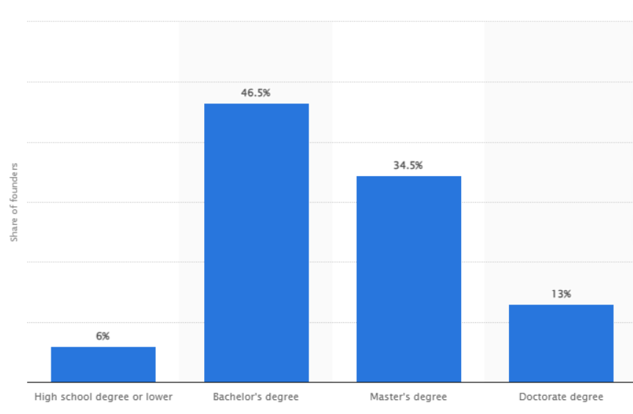

This graph shows that 46.5% of the startup founders wholes bachelor's degrees in South Korea and 34.5% are holding master's degrees and have their own startup business

In this context, the graph related to the educational level of South Korea helps me in understanding the distribution of startup founders in South Korea by educational level. Therefore the devilment of the learners in startup business has been also measuring the data. Therefore from the session, I have learnt the critical role of effective work in enhancing group performance. In addition, I have gathered knowledge about teamwork that helps in performing any difficult job in a simple way. Balanced team performance enables individuals to conduct any difficult job while discussing with team members. The United performance of group members helps in achieving the target and fulfilling the goals. 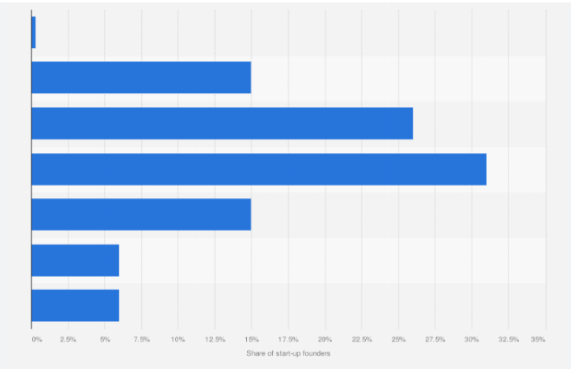

This graph shown in the lecture session in week 5 represents statistics on the distribution of the founders in India in 2015. Hence it has been observed that the share of the founders is aged between 36 to 40 years old. The largest share of startup founders in India belongs to the edge group of 31 to 35 years. Those start-up entrepreneurs become successful through conducting effective performances and developing an effective team. Effective team performances help in meeting all the tasks of the company effectively and achieving success in a rapid way.



Therefore, from the learning session I have learnt that team building helps in increasing the productivity of an organisation and also encourages creativity and innovation. The balanced performance of team members and organisational performances improves communication development. Developing effective communication between the team members has in improving morale and avoided and achieved the targets of the companies effectively. Effective performance and balanced help in creating trust among each other of the team members. It also helps in discovering personal strengths and weaknesses and also develops confidence among each other. Therefore, individual team members become, discussing each other's problems the individual team members become able to share their personal strengths and weaknesses and become supportive of each other. This learning session helps me in understanding the importance of team performance in conducting a task in an effective way. It also has been gaining insight into the process of increasing efficiency or captivity through communicating with the team members. I also understand that effective came performance can help in resolving any type of difficulties or issues through conducting group discussions with the team members. Problem-solving skills also improve through communicating with the team members individually. Group performance for meeting the vision and mission of an organisation in an effective way also requires sharing the roles and responsibilities among each other. It helps in thinking critically about an issue and provides a range of solutions that helps in dealing with uncertainties or issues effectively. Team performance helps in creating bonds and connections between two members and the authorities. It has in creating a long-lasting relationship with the organisation and providers' potential success.

## Week 6



In this week, the teacher presented his lecture about Aula about the major problems that customers mainly learners face on the daily basis. The lecture was very presentable and this has started with defining the concept of technological advancements. This lecturer has presented ideas about the impact of these technological changes on our lives. In this context, by attending the class we have developed our ideas related to important innovative technologies and how this has helped to solve the main problems of the people. The class has basically given ideas about the problems that we have encountered such as the ***lack of technical knowledge, the sudden shifts of the offline class to the online platform*** and ***stable internet connection problems***. Our lecturer has asked the question that the ideas about using the online application because by attending the class through this we can save time and access the resources when this has needed. Moreover, after the pandemic, the sudden shift to online classes has created a huge problem for us because we do not have enough knowledge to utilise this and attend the class in better ways. Therefore, the lecturer has discussed the usage of the online platform "Aula" and its features of this. The problems that have also been created while using the Aula app are that it has often made the screen black or white and the system has hung for a longer period of time. Thus, in between an important class, if this type of problem has arisen for the learners the classes have hampered and the teacher has not presented their lecture in an effective way. In addition to this, the lecturer presented a video presentation and shown step by step information that how to open the app and access the materials from this site. Then we have been asked to tell our ideas about when we taught other students and then how we schedule the lecture through the Aula app. The teacher has mainly tried to improvise our understanding of the utilisation of this application and enhance our knowledge related to technological advancements.

On the other hand, after attending the class I have realized that the smooth running of the Aula app has mainly required a stable internet connection. In this context, as Aula users have faced issues related to the opening time thus the slow connection has degraded its performance in a negative way. After the class, we also analysed that we need to pay more focus to technical skills because there are several options in this application. Therefore, we have decided to watch online learning videos on YouTube so that this can help to enhance our potential and skills. However, the pandemic has suddenly shifted the learning medium from offline to online one, thus this lecture has been seen as beneficial to improving our knowledge about the online learning app. The lecturer has also stated that through Aula we can analyse the learner’s participation in the class and through this, we communicated with the other peer. Thus, before the exam when there is a requirement for any information we easily collect it from the app within the minimum time frame.

The best part of this app is that we have been sharing our work and getting help from educators. Therefore, it can be illustrated that from the lecture we have gathered ideas related to the easily accessible of our course materials and improving our educational qualities as well. Besides this, the lecture about the online learning app Aula has made a positive impact on us because we have gathered ideas about innovation management. Technological ideas have empowered us to solve any problem that we have generally faced in our daily life such as accessing all materials and collecting information about the reading courses. The knowledge has enabled us to join the online class and responded to the queries of other peers in a more efficient way.

The business magnet “Steve Jobs” has once stated that ***“innovation is the only way to win over the market”.*** Innovative ideas and concepts have connected the world in the globalisation age and responded to the changing market trends. Innovation management has been considered as an essential business discipline that aims to ensure growth in the long-term process. Hence, as a sum up of this, it can be illustrated that innovation management is simply the process of coming up with the introduction of new things. There have seen different kinds of innovations in the business such as when the company has introduced new technology or reshaped the infrastructure within the operating process. The main factor is that the organisations that have paid more attention to innovation management have secured the best position in the market.

The other thing that the lecturer has discussed in class about the negative impact of the rising cost of transportation and this has mainly affected the learners to reach their destination. Therefore, the lecturer has illustrated the importance of innovation management from which we can easily contact the driver and travel within minimum cost. The doctor’s unavailability has created problems for people and thus the classes have shown us the importance of booking apps from which we easily connect with a doctor. The lecturer has also given ideas on how to take an appointment without any problems with a doctor when an emergency situation has arisen. Thus, it can be stated that this lecture session has been seen as beneficial because from this we have developed our ideas about the innovative learning app Aula as well as helping people to book a doctor in a challenging situation.

# Part B Opinion Piece (Importance of innovation for firm's success)

## Introduction

A firm can become successful with the ***implementation of modern technolog***y which helps in innovating new things. The growth factor of a firm relies on the ***Adopting strategies of the firm and the manpower***. Adopting technology helps in ***enhancing the efficiency of employees*** along with innovation within a firm. This innovation helps in determining the unique USP of an organisation. Hence, an organisation can become able of gaining a ***competitive advantage*** through its ***unique selling price.*** I have noticed that the success factor of an organisation depends on its employees' performances and creativity. Implementation of innovative strategies such as enhancing the proactiveness of the employees, solving issues immediately, and excellent teamwork can help in enhancing performance and boosting the proactiveness of a firm.



Customer engagement is also important for the success of an organisation. Involving advanced technology helps in communicating with customers directly through using different media platforms, websites, and personal apps. This help in enhancing the performance of the companies by engaging a large volume of customers with this online system. This online platform helps in taking feedback from potential consumers. It also helps in providing the necessary information like different ***offers, and discounts***, to the consumers within a second. This help in enhancing the sales of the products to its potential customers. Therefore, it enables effective communication between consumers and the startup owner which helps in enhancing the business performance in an effective manner. These ***innovative plans*** and strategies can help in gaining the fast success of a firm through ***involving innovation*** within the business process.

## Opinion

***Impact of innovation on business***

The effectiveness of the team's role in developing innovation plays a crucial role in organisational success. Effective performance of team members through providing creative ideas helps in improving the culture of an enterprise and collaboration of the employees in conducting any difficult task in a smarter way. Organisational success relies on the ***team's performance, collaboration and group work*** among the team members to resolve any critical issue through discussion within them. ***Team members share ideas*** with each other and help in solving any urgent problem through ***effective communication*** and ***discussion.*** Effective performance of them also boosts energy and motivates each other to perform a task ***more accurately and efficiently***. The success of the project is also shared among them with joyfully helps in enhancing the team's performance.



An innovative team always focuses on generating new ideas or providing new methods, new approaches, and new interventions, which helps in conducting a task with a new application that drives the market value high of the project. By generating new ideas, the team members make tasks more attractive and unique from the rest. This helps in enhancing the market value of the project and helps in generating more revenues from it. The performance also helps in providing the perfectness of conducting a task. The success factor of a firm depends on the team's performance and innovation in a huge range. I have observed that farms that have creative employees get faster success than other organisations. As a result, those become able of enhancing their cells and profit from the market and also gain positive regulation faster than other incumbent organisations

***Role of innovativeness on organisational success***

Incumbent firms and startups differ in their terms of business process and external cooperation activities which is considered as the source of innovation. Innovation is considered a critical factor for the long-term success of an organisation. Business organisations are focusing on innovative ideas to develop their products or services through developing the remaining products that are in high demand on the market. However, startup organisations focus on generating new creative ideas that can attract customers and solve their consumers' problems with innovative strategies. The start of organisations always focuses on generating innovative products for all types of customers. They design products or services for all types of customers. They mainly focus on designing products that help in attracting customers and enhance profit from the market. I have observed that the status organisations focus on designing products that have lower selling rates, and focus on designing them in a new way to enhance their sales of it.



Therefore, it can be said that the success factor related to innovation of an organisation develops through its creative ideas implemented process vision strategy and inspiration. The growth of business organisations depends on innovative strategies that help in attracting more customers and enhance sales in the market. Comparing start-ups and incumbent organisations, it has been observed that both organisations are innovative however in complaint companies focus on only the products that have high demand. However, startup companies always focus on developing all types of products through innovation and thus they focus on developing their market.

## Discussion

Entrepreneur leaders are mainly focused on developing the other employees surrounding them. Those entrepreneurs focus on creating a sense of urgency within the organisation and its mission by asking about the organisational goals. On the contrary, leaders also motivate employees to perform their tasks effectively and meet organisational goals. I have observed that there are many common features between entrepreneurs and leaders. Both of them focus on the target and for that, they motivate employees or members to enhance their capabilities and build up their confidence. Therefore, there is a high chance of an entrepreneur becoming a good leader to promote the organisation successfully in the competitive market.



An entrepreneurial leader is always on the importance of the organisation and needs and implements strategies to fulfil the requirement. Leaders focus on developing organisational performances by motivating their employees, mitigating conflicts among team members, and providing training to employees to enhance their efficiency. Entrepreneurs also focus on improving organisation and structure by fulfilling the requirement of the employees and allocating budgets to improve the organisational culture.

Therefore there is a high chance of becoming an entrepreneur becoming a leader to improve the organisational infrastructure by motivating employees and enhancing team performance. An entrepreneur coordinating and controlling different factors in production and supervision of the task among the employees makes the organisation ready for dealing with any kind of uncertainty or issue. Leaders also provide guidance to employees for thinking critically to reserve a problem and boost the problem-solving skills among the employees as well. Therefore, the job responsibility of entrepreneurs and leaders can be said to be almost similar. Hence, it can be concluded that entrepreneurs also can become a leader

**Innovation related to Business pitch**

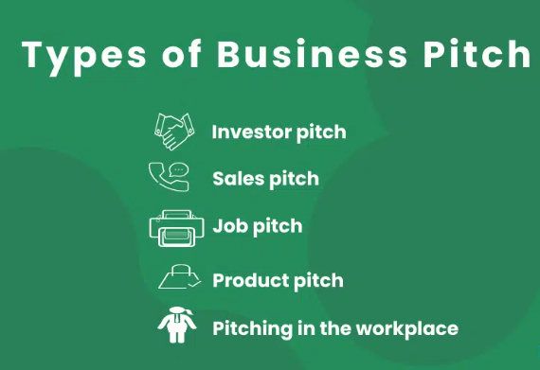

A business pitch is required for providing the people with a clear understanding of the plans or organisational goals. A business pitch helps in setting a strategy for gathering or sharing information that helps in gaining a complete vision of the organisational process. Successful implementation of a business pitch enables an organisation to motivate and persuade the audience and make them able to follow the ideas to execute them in real. Setting a business pitch is important as it helps in creating the first impression of the organisation to make or involve the potential investors with the business process. This helps in sharing an innovative business idea with the investors and the major stakeholders to make them excited about the project of the company. An attractive business pitch enables an organisation to involve investors with the business and run the operation process successfully. Different kinds of business pitches such as investor pitches, sales pitches, job pitches, and product pitches. In this context, using these different kind of tools helps in enhancing the engagement with a business process that helps in enhancing the sales and profit margin of the companies. Thus, the importance of implementing business speeches is important for enhancing the success factor of different projectors of an organisation.

***Effectiveness of big data tool for innovation and entrepreneurship***

The importance of using technology has been observed to be growing among different organisations in an effective manner. In the advent era of digitalisation, the use of data analysis has been observed to be growing within different business industries for inculcating innovation. Big data innovation organisation to make more concrete decisions for developing the organisation. It helps in monitoring the organisational process more effectively and provides the relevant data within a second to help in analysing the key processes and activities efficiently. It has observed by me that different organisations have their revenue through using big data that allows them to enhance their productivity and sales in the market. Using big data, organisations are able to analyse the market in an effective manner and improve organisational performances by making size and accurate decisions for improving infrastructure. These implemented strategies through using big data, allows the organisation to overview the innovation process of business.



Big Data Analytics has enhanced a more personalised customer experience that allows an organisation to collect data about the customer's choice. Organisations become able to develop firm decisions to meet the customer's needs. This exclusive technology helps in involving new innovations within the business process that help in increasing the market share revenue and sales along with customer satisfaction. This help in sustaining the longest position in the business market and gaining a competitive advantage from the similar industry

## Conclusion

Based on the above discussion it has been observed that innovation plays a significant role in developing a business the case of my startup business, I would advocate a budget for involving technology that helps me gather information about the advanced technology and also helps me to contact effective market analysis. I also focus on engaging major stakeholders, creative employees, and efficient suppliers for managing the business process efficiently to involve innovation in business. In this case. I also focus on partnering with major investors for funding for my start-up. I would also do different promotional activities to attract customers with my business products and focus on different strategies to communicate directly with the consumers to attract them to my business. Hence, following the strategy, I can develop my business again with faster success and the market. I hope innovation and technology can help me to enhance sales and attract customers in a rapid manner. I am also planning to invest in my business. I also involve partnerships with other companies to enhance the market value and expand my business in the global market.

# Part C ppt

## A brief explanation of the Startup plan

The startup organisation ***CafePod*** is based in the UK and establishes in the year 2010, based in London (Cafepod.com, 2023). This company has been running successfully from the beginning and running a business with the vision of providing different kinds of coffee.

* The startup company has been established on the year of 2010
* The main vision of the company is to provide high-quality coffee with great taste.
* A variety of coffee from strong coffee to flavoured, decaf, and fusion coffee, everything is available in this start-up company (Cafepod.com, 2023).

## Introduction of the offerings

TheCafePod company offers different varieties of coffee to its potential consumers to make coffee at the home of different flavours. In this context, the organisation generates the new innovative idea ***"from delivery pizza and bear"*** to deliver ***"different varieties of coffee".***

* The company offers ***Strong Coffee*** such as "Brunch Blend", "Daily Grind", "Intense Roast", "Ristretto", "Supercharger Espresso" and "Decaf Coffee".
* Coffee pods are compatible with Nespresso
* It provides the products to the door of its consumers

The startup company provides different types of offerings to the customers to attract them to their innovative businesses. It provides different flavours of coffee pods that are easy to prepare at home.

## Identification of the target customers

The organisation is based in London UK therefore the target customers of the company are mainly the people of London. However, it has been focused o***n targeting demographic segmentation of all ages of people including men and women in London, UK.***

* The customers who like to drink coffee are the main customers of the company.
* The people who lived in London are the main target consumers
* The people who loved to make coffee at home.

## Overview of market competition and emphasis on competitive advantage

The organisation has been growing in a rapid manner in the UK. Therefore, the market competition is also growing in the company. Despite the market competition the organisation has become successful to enhance its sales in the UK market.

* The main competitors of Church's Chicken, JOEY Restaurants, Patton Wings, and Darden Restaurants (Cafepod.com, 2023).
* 11 employees are working at CafePod Ltd (Cafepod.com, 2023).
* The unique idea provides the company with a highly competitive advantage.

## Review the factors for sustaining this start-up for long-term success

The main factor for sustaining this business, in the long run, is its innovativeness. The unique thinking of ***"helping people make great coffee at home"*** and the creativity of the company helped the organisation to increase its market share by involving a large number of customers and enhancing sales.

* The unique idea of ***“helping people make great coffee at home”*** the company are observed as the main factor in gaining faster success
* An affordable pricing strategy helps in engaging more customers.
* The unique vision of the company ***"Experiencing a new level of Coffee"*** enhanced its sales and helped in sustaining the business for the long term in the competitive market.

# About Me

I am a learner and creating this portfolio for skill and learning development. This portfolio helps in gaining information about the importance of innovation and its role in managing business. It also helps in understanding how entrepreneurs can involve innovation for achieving organisational success and perform all the tasks in a systematic way. In this context, the Implementation of effective strategies through involving new ideas and visions can enable me to gain knowledge about how tio achieve long-run success. Therefore, this study helps me enhance my knowledge about the importance of innovation for a successful run of business involving entrepreneurs.

# References

Cafepod.com, (2023). *HELPING PEOPLE MAKE GREAT COFFEE AT HOME.* Retrieved on: 30.03.2023 from:https://www.cafepod.com/pages/our-story#:~:text=Helping%20people%20make%20great%20coffee,over%20pizza%20%26%20beers%20in%20London.