**IMPACT OF SUPPLY CHAIN MANAGEMENT THEORIES ON SAINSBURY’S SUSTAINABILITY AND DEVELOPMENT**

Table of Contents

Introduction 3

Part1: Impact of Supply Chain Management Theory on Organizational Sustainability 3

Analysing External and Internal Environment for Sainsbury 3

Analysis of Strategic Design 6

Innovative ideas of the company 7

Making Decisions on the above ideas 8

Effective Communication 8

Impact of Supply Chain Management Theory on Organisational Sustainability 10

Collaboration and Partnership 10

Quality assessment 10

CSR approaches of Sainsbury 10

Part 2: Implication of United Nations Sustainable Development Goals for the company after Covid-19 11

Recommendations of UN SDGs goals 11

Strategy to cope with Covid 19 Impact 12

Conclusion 13

References 14

Appendix: Sustainable goals of UN 18

# Introduction

Supply chain management or SCM refers to the process of flow of goods, data and finances of the product from raw materials to the delivery of the product's destination. SCM provides products to retail businesses with the correct quantity and quality and also provides delivery of the products on time as per the requirements of the retailers. Therefore it increases the productivity of the products and helps the retailers in their businesses. Sainsbury is a multi-channel retailer that provides groceries and food to customers. The strategy of Sainsbury is to provide innovative products with the best value and low cost. The report aims to examine the impact of SCM theories and practices on Sainsbury's sustainability and development.

# Part1: Impact of Supply Chain Management Theory on Organizational Sustainability

## Analysing External and Internal Environment for Sainsbury

**External Factors affecting Sainsbury**

|  |  |  |
| --- | --- | --- |
| **Factors** | **Description** | **Impact** |
| Political | * The decision of the UK to leave through Brexit makes the Retail industry weaker(Bisciari, 2019). [Threat] * Raising sales tax increases product prices which can affect the Retail Industry.[Threat] | * Trading with European countries is prohibited which can affect the Profit Margin of Sainsbury. * Increased sales tax can cause increased prices and that can drop the total sales which cause less profit for Sainsbury. |
| Economical | * Total value of UK retail sales in 2022 is £441 bn(Retail Economics, 2023).[Opportunity] * In 2023 the rate of inflation in the UK is 10.1%(ONS, 2023). [Threat] | * It can be assumed that by the end of 2023, the total sale of the retail industry would reach approximately 30 trillion US dollars, which helps Sainsbury to grow. * The high inflation rate will affect the growth of Sainsbury in the UK. |
| Social | * The population rate of the UK in 2023 is 68,861,318 which is equivalent to 0.87% of the total world population (Worldometer, 2023). [Opportunity] * In the UK retail Industry, there are 2.986 million jobs as of 2022 (BRC, 2022).[Opportunity] | * A high population can help Sainsbury to acquire a good number of consumers. * The large amount of employment in the retail industry helps Sainsbury to be more productive. |
| Technological | * The UK retail industry has jumped to many online shopping apps that increase retail revenue. [Opportunity] | * Sainsbury can increase their sales by including their products in Online shopping apps. |
| Environmental | * The UK retail industry produces Solid wastes which are generated from shopping bag use, disposal of shipping packaging, and expired product disposal. These solid wastes can impact the environment (EI, 2019). [Threat] | * Large amounts of disposal of solid waste can reduce Sainsbury's sustainability aspects. |
| Legal | * The retail industry of the UK maintains the Fair Trading Act (Legislation.gov.uk, 2023.). [Opportunity] | * The Fair Trading Act for the retail industry can help Sainsbury to do their business with truthfulness. |

**Table 1: PESTLE analysis for the UK Retail industry**

(Source: Created by Author)

**Internal Factors affecting Sainsbury**

Market Presence- Sainsbury is the 2nd largest chain of supermarkets in the UK with 1400 shops among them around 800 convenience stores and 600 supermarkets. Details of the shops are mentioned in the figure below.

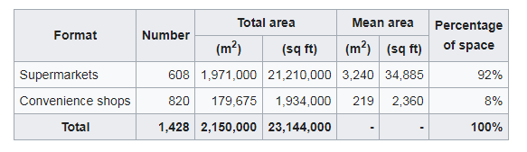

**Figure 1: Details of Sainsbury shop**

(Source: Sainsbury's, 2023a)

Sainsbury's has mainly served in the UK and its headquarters are in London, England and the United Kingdom. J Sainsbury plc, the mother company, is divided into three divisions which are known as Sainsbury's Supermarkets Ltd., Sainsbury's Bank, and Argos (Sainsbury's, 2023b).

Products- All shops of Sainsbury's have allowed a large display of products. The main products of Sainsbury are groceries, clothing products and general merchandise.

Marketing- Sainsbury has done their marketing strategy both online and offline. The online shopping service is known as 'Sainsbury Online' (Sainsbury's, 2023c). Both online and offline offer a large range of products and services. Customers can grant their services by visiting the shops or by ordering online or by phone.

Employee Base- The number of employees working in Sainsbury is 171,000 till 2022 (Macrotrends, 2023). For the benefit of employees, a meeting has been organized once a month to discuss employee issues. In the meeting, a budget is also made for investing in employee facilities.

R&D- Sainsbury offers their own brand products which match the quality of the national brand products but at a low price. Sainsbury offers a high range of healthy products that contain low fat. It also has more than 15,000 own-brand products which contain fresh & bakery, frozen food, drinks, electronics, clothing, health & beauty products, baby products, meat, cleaning products, entertainment and many more.

**Vertical Network Collaboration for Sainsbury**

Sainsbury uses Vertical Integration in their Network Collaboration. According to Li and Chen (2020), Vertical integration is a corporate strategy where the business controls the supply chain in the production process on its own without third-party involvement. The below figure shows the different types of Vertical Integration.

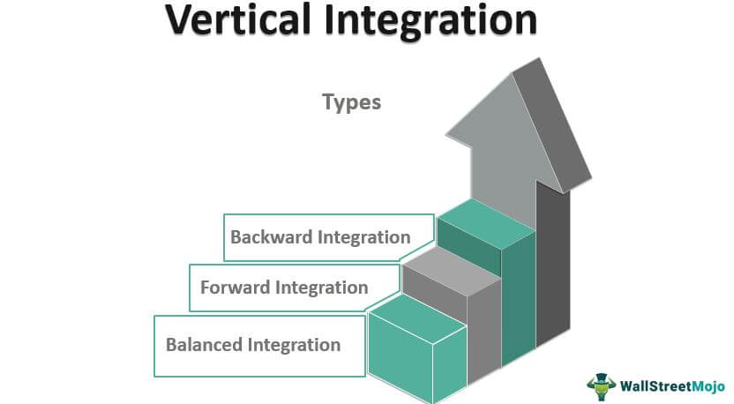

**Figure 2: Types of Vertical Integration**

(Source:Saghafian, 2023)

Sainsbury has the second largest beef market share, but the beef value declined gradually in Sainsbury's supermarkets. Therefore to control the decline of the beef supply chain, Sainsbury focused on the Vertical Integration growth strategy. This strategy helps Sainsbury to make the beef supply chain cost-effective, produce high-quality beef products, control beef production volume, increase sales, and improve profits. The backward Integration helps to reduce the leverage that vendors have over the business.

## Analysis of Strategic Design

The analysis of the strategic design in the Sainsbury food company in the UK is the implementation of traditional concepts and design principles structure problems. This strategy aims to improve the planning management of Sainsbury. As per Haralayya (2021), customers are attracted by the plans of the companies. The strategic design helps Sainsbury to accelerate various cost-saving ideas so that it can invest in upgrading the product qualities, increasing alternatives and innovations and improving the moral values and loyalty towards their customers.

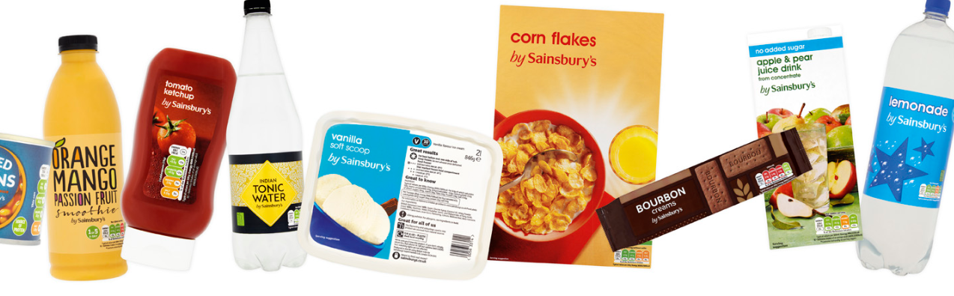

**Figure 3**: **Product design of Sainsbury**

(Source: Sainsbury, 2023)

Sainsbury's portfolio brands such as Argos, Tu and Sainsbury's bank support their core product management and deliver to customers and shareholders. As per Wibowo*et al*. (2020), strategic designs help to get a positive response from consumers. Therefore Sainsbury should continue to analyse the strategic design to achieve a positive response from the customers. It also pursues partnerships with other parties and benefits the third parties that can respond to a positive impact of Sainsbury.

## Innovative ideas of the company

Sainsbury is accelerating the rate of ideas and innovations to induce price cuts as a wedge of its dedication to improving the value for customers a food company needs to update innovative ideas and information as this will sustain business and maintain customers. Innovation ideas are important as the food industry is competitive. The food company can produce health-conscious nourishment. As per Chamoso*et al*. (2019), some companies can use technologies to carry out their operations and reach a wide range of customers and focus on healthy eating practices. Sainsbury follows various innovative ideas to develop their business.

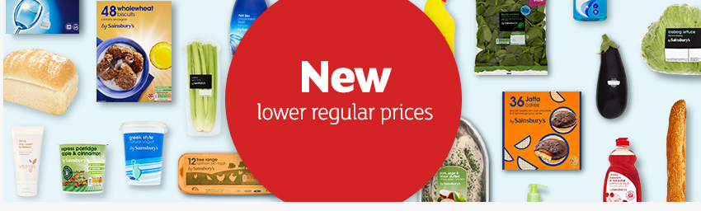

**Figure 4: New innovative products of Sainsbury**

(Source: Sainsbury, 2023)

As the modern lifestyle, growing concerns and shifting demographics about health and nutrition are putting threats in consumption. The Sainsbury food company began a new trial bay named Taste of the future in more than 69 stores (The grocer, 2019). It allows the experience of the most innovative ideas in the place faster. This innovation enables the Sainsbury food company to find new trends, brands and missions and achieve valuable consumer insights. As Sainsbury formed future brand projects to deliver differentiation and distinction for their products. Therefore it will give their customers more valid reasons to collaborate with them as it focuses on transformation and a lot of investment in the food and beverage industry. Hence future brand projects aim to partner with the best benefits and assist them in productivity.

## Making Decisions on the above ideas

The making of decisions about the innovative ideas of the Sainsbury food company in the UK concerns the methodological and theoretical framework of suggested practices. As per Tao *et al*. (2020), the decision-making of scientific approaches to the administration of the food industry was carried out to help the management deal with the demands of food production. It is achieved by preparing specified key performance factors in the industry as the system performance is handed over to a cost analysis tool. It requires a series of steps taken by the company to identify the best alternatives to meet their demands. However, there are different decision-making models used by the Sainsbury food company in the UK which include rational models, intuitive models, recognition primed models and creative models. Thus these alternative actions determine which will be the best alternatives as it also focuses on pattern recognition and the importance of innovative ideas.

## Effective Communication

Sainsbury believes in communicating face-to-face, over telephones and through digital platforms and online conversations. As per Fitriasari*et al*. (2020), communication is needed in every business to achieve the aims and goals of the business and for the success of the business.

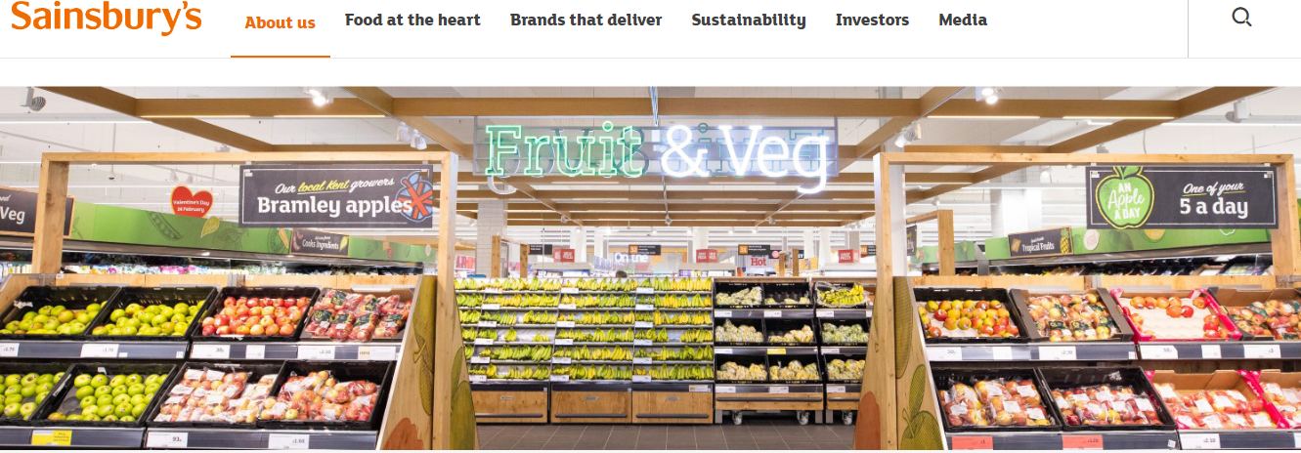

**Figure 5: product featuring communication with consumers**

(Source: Sainsbury, 2023)

Salisbury further uses Prosearch which is a tracing tool to communicate with the shareholders of Sainsbury or the shareholders by the dividend of the company as they also use AGM to communicate with the shareholders. Sainsbury uses their online websites to communicate with the customers directly and also give information and help to resolve the problems of the customer with their communication skills. Hence the communication skills of Sainsbury are very effective for the customers.

## Impact of Supply Chain Management Theory on Organisational Sustainability

## Collaboration and Partnership

Collaboration and partnership are approaches which are deliberately interlinked as partnership brings the opportunity to collaborate. Supply chain management is considered to be a collaborative activity between internal departments and external partners that can contribute to the attainment of optimised flow in business operations (Zekhnini*et al.* 2020). Collaborative supply chain management thus can satisfy the demand of customers and ensure delivery of the product within time. Partnership with fashion brand Sosandar can promote supply chain transparency and attain better leverage over the supply of the products (Industry fashion, 2023). Partnership and collaboration increased the responsiveness towards the requirement of the customers and improvised operational efficiencies. However, a collaborative approach with the partners of supply chain operation has established high ethical standards in Sainsbury and has developed a commitment towards environmental and trade standards (Karki*et al.* 2021). Hence, it can be analysed that successful collaboration can reduce the critical processing of inventory and eliminate errors with lesser environmental impact.

## Quality assessment

According to Liaw*et al.* (2021), the assessment of quality is the collection of data and the procedure of analysing them through the degree of conformity by predetermined standards. The effectiveness of the supply chain can be measured with the quality assessment that can help organisations to assess the problems associated with the conduction of the supply chain by dragging shortage and lost revenue. The sustainability standard of Sainsbury has contributed to assessing the capability and standard of performance that can proactively manage the quality of the product line and tackle the overall processing of the supply chain. It can support revising the strategic plans and increase the focus on the evaluation of the suppliers (Pattinson*et al.* 2021). It can, therefore, increase the agile approach in the business process and guide the leaders to improve the design and execution of quality strategy for management. It further can reduce the bias risks in the implementation of the supply chain process for the attainment of organisational sustainability.

## CSR approaches of Sainsbury

Corporate Social Responsibility states a managerial concept where companies combine environmental and social concerns in their administration and interaction with shareholders. It is understood in a way by which they fulfil their social, economic and environmental imperatives as well as meeting the expectations of the customer to have socially responsible practices in the food production chain of the Sainsbury food company creates a need for agreed processes and systems. The guidance offers Sainsbury some ideas on how to work to achieve sustainable outcomes as it focuses on organization governance, human rights, labour practices and preservation of the environment. It includes fair operating schemes, solving consumer issues and community development and involvement. Consumers pay attention to ecological protection, health issues and food safety. The Sainsbury food company has to take care of these topics to obtain more customer satisfaction and loyalty towards the company.

# Part 2: Implication of United Nations Sustainable Development Goals for the company after Covid-19

## Recommendations of UN SDGs goals

Goal 9 of UN SDGs can be recommended to Sainsbury to improvise the supply chain operation as the pandemic has increased the operational cost of the organisation leading to a decrease in sales. Goal 9 has developed the aspect that there is a requirement for building resilient infrastructure with the promotion of inclusive and sustainable operations and fostering innovation (UN.org, 2023). Implementation of such a goal can support Sainsbury to revise the operational processing and encourage innovation with the enhancement of technological capability. Supply chain innovation can be impactful to look into innovative ways to utilise the resources that increase the capability of the brand to satisfy the requirement of the customers. The effectiveness of the supply chain can contribute to the reduction of errors and controlling of the unnecessary returns. Reduction of food wastage and elimination of the use of plastic has been the sustainable goal of Sainsbury (Jones *et al.* 2020). To add more reliability to it, the 9th goal of UN SDGs can support financial up gradation and technological accommodation to modify the infrastructure to build resilience. Innovation can diversify the suppliers and the manufacturing partners and can reduce logistic and operational complexity.

Goal 3 of UN SDGs can be recommended to Sainsbury as it can support the revision of the workforce with diversification among males and females. Women are found to be less prioritised in the workplace and their representation in leadership and management teams is low (Global data, 2022). Implementation of good health and well-being can reduce the biases towards male representatives in the executive team within Sainsbury. It can increase the motivation of women to work in an environment where they don't have to face any discrimination for promotions and representatives. The gender gap can be revised with the implementation of goal 3 and the company can revise the organisational structure keeping in mind the promotion of healthy practice and well-being for each employee accepting diversification. The company has faced the challenge of labour market disruption due to the impact of the pandemic which can be revised by adopting good health and well-being practices. The company has to revise its commitment to the physical, mental and financial well-being of its employees and thus goal 3 of UN SDGs is impactful for Sainsbury (UN.org, 2023). Satisfaction among employees can increase their capability towards production and provides control of workforce management solutions. Thus analysing the circumstances of Sainsbury after Covid-19, goal 9 and 3 has been suggested to revise supply chain operations and employee wellbeing ***[Refer to appendix].***

## Strategy to cope with Covid 19 Impact

During Covid 19 pandemic, Sainsbury’s has fallen to a £261m annual loss despite booming sales of groceries (The Guardian, 2021). Hence, Sainsbury has adopted the below-mentioned strategies to cope with covid 19 pandemic.

**Providing Digital Security:** After Covid 19, all organizations have shifted their operation virtually along with workers, customers, partners and vendors (Nayal et al., 2022). This causes a high risk of digital security breaches as cyber criminals is trying to gain access to the data of the organization. Hence to overcome this situation Sainsbury should practice extra vigilance and awareness before clicking on any suspicious link and downloading any doubtful file (Rizzoni et al. 2022). With these safety measures, Sainsbury can prevent data theft and network breaches and can protect their enterprise and employees.

**Upgrading the business process:** After Covid 19, Sainsbury has upgraded their business process and strategy by embracing e-commerce and contactless shopping which can help them to increase their efficiency and productivity. According to Eceiza et al. (2020), upgrading the business process can also help to mitigate the intrinsic disruptions to the organization caused by Covid 19 which helps to improve the capability of the organization.

**Showing appreciation to employees:** Appreciation for employees' work, effort, dedication and contribution towards the organization lead to an act of benefit for the organization. Acknowledging the efforts of employees makes them motivated and a productive outcome can be achieved (Ali and Anwar, 2021). Adopting this type of positive behaviour from the management team of Sainsbury can help employees to mitigate their fear of job security and help to move forward in their careers as well.

**Finding growth opportunities:** As per Reardon et al. (2021), an organization can grow their business by selling its products and delivering services to the consumers and also by developing a strategic partnership with resellers, distributors and suppliers. Therefore after Covid 19, Sainsbury should maintain a good relationship with their partners so that it can make a positive impact on their business.

**Organizational Readiness Assessment:** An organizational readiness assessment is a measurement of the organization's preparedness when the organization is undergoing major change because of Covid 19 (Alolabi et al. 2021). In order to identify any gap in Sainsbury, the pandemic-specific templates as well as the industry and role readiness templates are used. Hence, with the help of readiness assessment, Sainsbury can track their progress and development.

**Creating Risk Management Plan:** After Covid 19 pandemic, Sainsbury should create a risk management plan to identify and prioritize any risks for their business. According to Shad et al. (2019), with the help of a risk management plan organizations can resolve any new risk and can grow their business.

**Business Impact Analysis:** With the help of this process Sainsbury can identify the most problematic part of operating their business and can resolve the issue by prioritizing that critical part which helps to develop the business of Sainsbury (Corallo et al. 2020).

**Policy Management:** After the Covid pandemic, Sainsbury should revisit and update their policy for managing their business properly in the new normal (Kronblad and Pregmark, 2021).

# Conclusion

From this above study, it can be concluded that Sainsbury's sustainability is dependent on supply chain management which is collaboration and partnership between internal departments and external partners, quality assessment of products and corporate social responsibilities. This supply chain operation of Sainsbury fulfils Goal 9 of UN SDG. Goal 3 of UN SDGs can justify Sainsbury's diversification of the workforce. In order to cope with Covid 19 pandemic, Sainsbury should maintain some business strategies that help them to expand their business globally by providing digital security to the data of consumers and employees, upgrading the business process, appreciating the employees of Sainsbury, finding growth opportunities, by Readiness Assessment, by creating risk management plan and with the help of Business impact analysis and policy management.

# References

Ali, B.J. and Anwar, G., 2021. An empirical study of employees’ motivation and its influence job satisfaction. Ali, BJ, & Anwar, G.(2021). An Empirical Study of Employees’ Motivation and its Influence Job Satisfaction. *International Journal of Engineering, Business and Management,* 5(2), pp.21-30.

Alolabi, Y.A., Ayupp, K. and Dwaikat, M.A., 2021. Issues and implications of readiness to change. *Administrative Sciences,* 11(4), p.140.

Bisciari, P., 2019. A survey of the long-term impact of Brexit on the UK and the EU27 economies.

BRC, 2022. Retail Jobs Report. Available at: <https://brc.org.uk/media/680620/rjrq32022.pdf>[Accessed on 30th March 2023].

Chamoso, P., González-Briones, A., Rivas, A., De La Prieta, F. and Corchado, J.M., 2019. Social computing in currency exchange. *Knowledge and Information Systems, 61*, pp.733-753.

Corallo, A., Lazoi, M. and Lezzi, M., 2020. Cybersecurity in the context of industry 4.0: A structured classification of critical assets and business impacts. *Computers in industry,* 114, p.103165.

Dwivedi, Y.K., Hughes, D.L., Coombs, C., Constantiou, I., Duan, Y., Edwards, J.S., Gupta, B., Lal, B., Misra, S., Prashant, P. and Raman, R., 2020. Impact of COVID-19 pandemic on information management research and practice: Transforming education, work and life. *International journal of information management,* 55, p.102211.

Eceiza, J., Kristensen, I., Krivin, D., Samandari, H. and White, O., 2020. *The future of operational-risk management in financial services. Preuzeto,* 17, p.2022.

EI, 2019. Environmental Issues and Sustainability in the Retail Industry. Available at: <https://ei1.com/2019/04/04/environmental-issues-and-sustainability-in-the-retail-industry/#:~:text=The%20two%20main%20issues%20are,significant%20impact%20on%20the%20environment>.[Accessed on 30th March 2023].

Fitriasari, F., 2020. How do Small and Medium Enterprise (SME) survive the COVID-19 outbreak?.*JurnalInovasiEkonomi, 5*(02).

Global data, 2022.Sainsbury diversity in the workforce. Available at: <https://www.globaldata.com/data-insights/retail-amp-wholesale/sainsburys-diversity-in-the-workforce-2096662/> [Accessed on 30th March 2023].

Haralayya, B., 2021. Effect of Branding on Consumer Buying Behaviour at Vijay Bharat Motors Pvt Ltd, Bidar. *Iconic Research And Engineering Journals, 4*(12), pp.207-222.

Industry fashion, 2023.*Sainsbury partnership with Sosandar*. Available at: <https://www.theindustry.fashion/sainsburys-partnership-with-sosandar-hopes-to-increase-brand-awareness/> [Accessed on 30th March 2023].

Jones, P., Wynn, M. and Comfort, D., 2020. SDG 12, Sustainable consumption and the UK’s leading retailers. *RESPONSIBLE CONSUMPTION AND PRODUCTION*, p.7.

Karki, S.T., Bennett, A.C. and Mishra, J.L., 2021. Reducing food waste and food insecurity in the UK: The architecture of surplus food distribution supply chain in addressing the sustainable development goals (Goal 2 and Goal 12.3) at a city level.*Industrial Marketing Management*, *93*, pp.563-577.

Kronblad, C. and Pregmark, J.E., 2021. Responding to the COVID-19 crisis: the rapid turn toward digital business models. *Journal of Science and Technology Policy Management,* (ahead-of-print)

Legislation.gov.uk, 2023. UK Acts. Available at: <https://www.legislation.gov.uk/ukpga/1973/41>[Accessed on 30th March 2023].

Li, W. and Chen, J., 2020. Manufacturer’s vertical integration strategies in a three-tier supply chain. *Transportation Research Part E: Logistics and Transportation Review,* 135, p.101884.

Liaw, S.T., Guo, J.G.N., Ansari, S., Jonnagaddala, J., Godinho, M.A., Borelli Jr, A.J., de Lusignan, S., Capurro, D., Liyanage, H., Bhattal, N. and Bennett, V., 2021. Quality assessment of real-world data repositories across the data life cycle: a literature review. *Journal of the American Medical Informatics Association*, *28*(7), pp.1591-1599.

Macrotrends, 2023. *J Sainsbury: Number of Employees 2010-2022 | JSAIY.* Available at:https://www.macrotrends.net/stocks/charts/JSAIY/j-sainsbury/number-of-employees#:~:text=J%20Sainsbury%20total%20number%20of,a%204.56%25%20increase%20from%202020.[Accessed on 30th March 2023]

Nayal, P., Pandey, N. and Paul, J., 2022. Covid‐19 pandemic and consumer‐employee‐organization wellbeing: A dynamic capability theory approach. *Journal of Consumer Affairs*, 56(1), pp.359-390.

ONS, 2023. *Consumer price inflation, UK: February.* 2023. Available at: <https://www.ons.gov.uk/economy/inflationandpriceindices/bulletins/consumerpriceinflation/february2023#:~:text=The%20Consumer%20Prices%20Index%20>(CPI,of%200.8%25%20in%20February%202022. [Accessed on 30th March 2023].

Pattinson, A.L., Seimon, R.V., Harper, C., Nassar, N., Grech, A., Santoso, E.A., Franklin, J., Inan-Eroglu, E., Gibson, A.A. and Sainsbury, A., 2021.Diet Quality following Total Meal Replacement Compared with Food-Based Weight-Loss Diets in Postmenopausal Women with Obesity: A Secondary Analysis of the TEMPO Diet Trial.*The Journal of nutrition*, *151*(11), pp.3299-3312.

Reardon, T., Heiman, A., Lu, L., Nuthalapati, C.S., Vos, R. and Zilberman, D., 2021. “Pivoting” by food industry firms to cope with COVID‐19 in developing regions: E‐commerce and “copivoting” delivery intermediaries. *Agricultural Economics,* 52(3), pp.459-475.

Retail Economics, 2023. UK Retail Stats and Facts. Available at: <https://www.retaileconomics.co.uk/library-retail-stats-and-facts>[Accessed on 30th March 2023].

Rizzoni, F., Magalini, S., Casaroli, A., Mari, P., Dixon, M. and Coventry, L., 2022. Phishing simulation exercise in a large hospital: A case study. *Digital Health*, 8, p.20552076221081716.

Saghafian, S., Song, L.D., Newhouse, J.P., Landrum, M.B. and Hsu, J., 2023. *The impact of vertical integration on physician behavior and healthcare delivery: Evidence from gastroenterology practices* (No. w30928). National Bureau of Economic Research.

Sainsbury, 2023. *Our new regular prices.* Available at: <https://www.sainsburys.co.uk/shop/gb/groceries/get-ideas/values/features/our-new-regular-prices> [Accessed on: 30 March 2023].

Sainsbury, 2023. *About us*. Available at: <https://www.about.sainsburys.co.uk/about-us> [Accessed on: 30 March 2023].

Sainsbury, 2023. *Sustainability.* Available at: <https://www.about.sainsburys.co.uk/sustainability/plan-for-better/our-stories/2018/reformulating-our-products-sugar-update> [Accessed on: 30 March 2023].

Sainsbury's, 2023a. Available at: <https://www.sainsburys.co.uk/>[Accessed on 30th March 2023].

Sainsbury's, 2023b. Available at: <https://www.about.sainsburys.co.uk/about-us>[Accessed on 30th March 2023].

Sainsbury's, 2023c. Available at: <https://www.sainsburys.co.uk/shop/gb/groceries/discoverhome/shopping-online>[Accessed on 30th March 2023].

Shad, M.K., Lai, F.W., Fatt, C.L., Klemeš, J.J. and Bokhari, A., 2019. Integrating sustainability reporting into enterprise risk management and its relationship with business performance: A conceptual framework. *Journal of Cleaner production,* 208, pp.415-425.

Tao, D., Yang, P. and Feng, H., 2020. Utilization of text mining as a big data analysis tool for food science and nutrition. *Comprehensive reviews in food science and food safety, 19*(2), pp.875-894.

The grocer, 2019. *Sainsbury’s calls brands to pitch for Taste of the Future bay space*. Available at: <https://www.thegrocer.co.uk/ranging-and-merchandising/sainsburys-calls-brands-to-pitch-for-taste-of-the-future-bay-space/596254.article> [Acceessed on: 30 March].

The Guardian, 2021. Sainsbury’s slumps to £261m loss on back of Covid costs. Available at: <https://www.theguardian.com/business/2021/apr/28/sainsburys-slumps-to-261m-loss-on-back-of-covid-costs> [Accessed on: 06-04-2023]

UN.org, 2023. *Envision goals for 2030.* Available at: <https://www.un.org/development/desa/disabilities/envision2030.html> [Accessed on 30th March 2023].

Wibowo, A., Chen, S.C., Wiangin, U., Ma, Y. and Ruangkanjanases, A., 2020. Customer behavior as an outcome of social media marketing: The role of social media marketing activity and customer experience. *Sustainability, 13*(1), p.189.

Worldometer, 2023. *U.K. Population*. Available at: <https://www.worldometers.info/world-population/uk-population/>[Accessed on 30th March 2023].

Zekhnini, K., Cherrafi, A., Bouhaddou, I., Benghabrit, Y. and Garza-Reyes, J.A., 2020. Supply chain management 4.0: a literature review and research framework. Benchmarking: *An International Journa*l, 28(2), pp.465-501.

# Appendix: Sustainable goals of UN

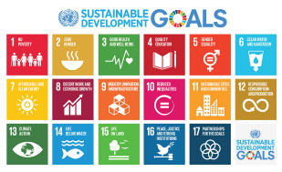

(Source: UN.org, 2023)