**PROJECT EVALUATION, PLANNING, AND CONTROL**

Table of Contents

1.0 Introduction 3

2.0 Project Scope 3

3.0 Planning Tools & Techniques 5

4.0 Resource Allocation 8

5.0 Project monitoring and control 11

7.0 Earned Value Report 19

9.0 Referencing 22

# 1.0 Introduction

The report of the project will include the research and analysis of technological options available in the market, identification of future requirements of the emergency services, project implementation, and successful transition to the new system.

**Rationale**

The proposed project is to research, evaluate and implement a new 4G-critical communications system to replace the existing Airwave service used by the emergency services in Great Britain (England, Wales, and Scotland). The project will aim to meet the future requirements of emergency services for mobile communications, ensuring the continued delivery of its Emergency Services Mobile Communications in the future (Gallagher and DeVine, 2019).

# 2.0 Project Scope

**Objectives:**

The objectives of the proposed project are:

* To research, evaluate, and select the most suitable 4G-critical communications system for emergency services in Great Britain.
* To ensure innovative technology for emergency services in mobile communications.
* To implement the new system in a cost-effective and timely manner, with minimal disruption to the current emergency services.
* To provide training and support to emergency service personnel to ensure a smooth transition to the new system**.**

**Deliverable Statement:**

The deliverables of the proposed project are:

* A detailed report of the technological options available in the market for 4G-critical communications systems.
* A comprehensive analysis of the future requirements of emergency services for mobile communications.
* An implementation plan for the new system, including timelines, costs, and resource requirements.
* Training and support documentation for emergency service personnel.

**Assumptions:**

The emergency services' existing infrastructure will be able to support the new 4G-critical communications system (Adeel *et al.* 2019). Resource allocation will involve a ***Gantt chart structure*** for the estimation of the £350m budget from the government for training and support during the transition period of the project.

**Constraints:**

The project must be completed within 12 months from the commencement date of 16th January 2023 (Gallagher and DeVine, 2019). The project must be completed within the awarded budget of £350m. The project must be implemented without causing any disruption to the current emergency services.

**Success Factors:**

* Successful research, evaluation, and selection of the most suitable 4G-critical communications system for emergency services (Nayyar *et al.* 2020). Smooth transition to the new system with minimal disruption to the emergency services.
* Improved mobile communications for emergency services to meet future requirements. Training and support has been provided to emergency service personnel.

**Success Criteria:**

Project may develop success over implementation of the new 4G-critical communications system (Savunen *et al.* 2023). It may deal with minimal disruption to the current emergency services during the transition period.

Positive feedback from emergency service personnel on the new system's usability and functionality will give a positive way of the emergency services for mobile communications.

**Exclusion:**

The proposed project does not include any changes to the emergency services' existing infrastructure, except for the integration of the new 4G-critical communications system.

# 3.0 Planning Tools & Techniques

**Gantt chart**

| **Task Name** | **Duration (days)** | **Predecessors** | **Start Date** | **End Date** |
| --- | --- | --- | --- | --- |
| Initiation of the project | 1 |  | 16.01.23 | 16.01.23 |
| Research technological options | 25 | 1 | 16.01.23 | 17.02.23 |
| Collate and elaborate future requirements | 31 | 2 | 17.02.23 | 31.03.23 |
| Analyse and select a 4G-critical communication system | 30 | 3 | 31.03.23 | 11.05.23 |
| Develop implementation plan | 28 | 4 | 12.05.23 | 20.06.23 |
| Procure equipment and services | 27 | 5 | 21.06.23 | 27.07.23 |
| Test and deploy 4G-critical communication system | 39 | 6 | 28.07.23 | 20.09.23 |
| Train emergency services personnel | 35 | 7 | 21.09.23 | 08.11.23 |
| Implement system | 38 | 8 | 09.11.23 | 01.01.24 |
| Final review and testing | 10 | 9 | 02.01.24 | 15.01.24 |

**Table 1: Gantt chart**

(Source: Project-libre)

The initial planning and setup of the project, is expected to take one day and will commence on 16th January 2023. Then the next task involves researching the available technological options in the market for a 4G-critical communications system, which is expected to take 25 days, starting on 16th January 2023, and ending on 17th February 2023 (Savunen *et al.* 2023). This next task contains collecting and elaborating on the future requirements of the emergency services for mobile communications, which is expected to take 31 days and will begin on 17th February 2023 and end on 31st March 2023.

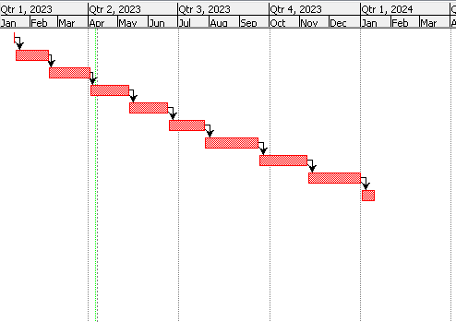

**Figure 1: Time frame of the project**

(Source: Project-libre)

The analysis and selection of the most appropriate system will involve 30 days, beginning on March 31, 2023, and ending on May 11, 2023. The development of an implementation strategy takes 28 days, beginning on May 12, 2023, and ending on June 20, 2023.

The next step is to acquire the necessary equipment and services is scheduled to take 27 days and will begin on June 21, 2023, and finish on June 27, 2023 (Elbanna *et al.* 2019). The testing and deployment is projected to take 39 days, beginning on July 28th, 2023, and ending on September 20th, 2023.

It is seen that it will get 35 days, beginning on September 21, 2023, and ending on November 8, 2023, to train emergency services personnel. The implementation system entails the installation structure, which is expected to take 38 days and will begin on November 9, 2023, and finish on January 1, 2024.

Completing a final review and testing will take 10 days and will begin on January 2nd, 2024, and finish on January 15th, 2024. Tasks 4 and 7 appear to be on the critical path, which is the sequence of tasks that must be done on time for the project to be completed on time.

# 4.0 Resource Allocation

The project has several resources to implement this project on its way, so it will include,

| Project Manager | In this project, the manager will see overall project management, planning, coordination, and execution. He will also ensure that the project is completed within the allocated budget and timeframe. |
| --- | --- |
| Technical Lead | He is responsible for overseeing the technical aspects of the project, including identifying and selecting the appropriate technological options available in the market, elaborating on future requirements for mobile communications, and ensuring the successful implementation of the project. |
| Implementation Team | Leading activity will involve communications systems, including installation, configuration, and testing of the new system (Elbanna et al. 2019). The implementation team will work closely with the technical lead to ensure that the new system meets the future requirements of emergency services. |
| Quality Assurance (QA) Team | It will involve all the requirements or not. It may meet the required quality standards or will not be managed by the QA team (Shahzadi *et al.* 2021). The QA team will conduct thorough testing of the new system and provide recommendations for any necessary improvements. |
| Training Team, | The training team will work closely with the implementation team to ensure that emergency service personnel are trained on the new system before it is fully implemented |

**Table 2: Resource allocation**

(Source: Self-created)

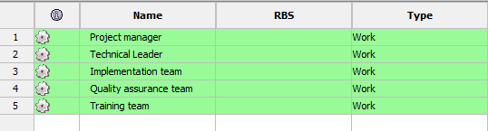

**Figure 2: Allocation of resources in software**

(Source: Project-libre)

Here according to the figure, this is the allocation of resources. It will involve activity tasks to generate their role in depth. Gantt chart resource allocation through ***project libre software*** has helped to generate detailed descriptions of task involvement with duration.

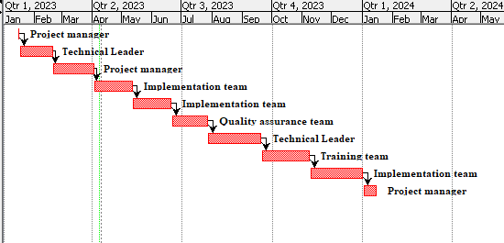

**Figure 3: Resource description**

(Source: Project-libre)

The first step towards project management is to establish clear communication channels and protocols; project manager has a depth role (Storck *et al.* 2020). These should include the frequency and method of quality assurance through the QA team, as well as the individual implementation team responsible for each team management role.

# 5.0 Project monitoring and control

| **Task Name** | **Detailed tasks** | **Estimation of date** |
| --- | --- | --- |
| Initiation of the project  (Activity 1-8) | Conduct a feasibility study to assess the technical, economic, and operational viability of the project.  Identify and analyze the stakeholders and their expectations.  Define the project scope, objectives, and requirements. | 1 |
| Research technological options  (Activity 9 - 20) | Identify and evaluate the available technological options in the market.  Consult with the emergency services to determine their mobile communication requirements and preferences (Viswanathan *et al.* 2020).  Conduct a gap analysis to identify the gaps between the current and future mobile communication systems.  Develop the technical specifications for the new 4G-critical communications system.  Develop a detailed design for the new mobile communication system, including the hardware, software, and network infrastructure. | 25 |
| Collate and elaborate future requirements  (Activity 21 - 31) | Identify and analyze the risks associated with the project and develop risk mitigation strategies.  Develop a procurement plan and solicit bids from potential suppliers.  Evaluate the bids and select the most suitable supplier based on their technical and commercial merits.  Negotiate and finalize the contract with the selected supplier. | 31 |
| Analyse and select a 4G-critical communication system  (Activity 32 - 40) | Develop the project charter and obtain approval from the project sponsor and stakeholders.  Develop a detailed project plan, including the schedule, budget, risk management plan, quality plan, and communication plan. | 30 |
| Develop an implementation plan  (Activity 40 - 51) | Develop and test prototypes and models of the new system to verify its functionality, reliability, and compatibility (Adeel *et al.* 2019).  Conduct user acceptance testing with the emergency services to ensure the new system meets their requirements and expectations. | 28 |
| Procure equipment and service  (Activity 51 - 57) | Implement the new system nationwide and monitor its performance and usage. | 27 |
| Test and deploy 4G-critical communication system  (Activity 57 - 60) | Networks designed for public safety and disaster relief  Mission-critical networks with stringent criteria for accessibility, reach, ability, safety, and service quality (QoS).  As a starting point, mission-critical customers require capabilities comparable to those provided by current portable radio networks (Shahzadi *et al.* 2021). Mission-critical traffic must be allowed to communicate across various networks.  Investing in mission-critical systems that offer communication capabilities in harsh conditions will benefit only a tiny but essential amount of users. | 39 |
| Train emergency services personnel  (Activity 61 - 69) | Develop training materials and conduct training sessions for the emergency services personnel to use the new system effectively (Adeel *et al.* 2019).  Develop a migration plan to transition from the current Airwave system to the new system seamlessly. | 35 |
| Implement system  (Activity 70 - 75) | Develop a detailed implementation plan  Assign roles and responsibilities to Identify team members  Ensure that the necessary resources such as funding, equipment, and personnel  Communicate the implementation plan  Execute the plan | 38 |
| Final review and testing  (Activity 75- 78) | Conduct pilot tests of the new system in selected areas and evaluate its performance.  Conduct post-implementation review and evaluation to identify areas for improvement and lessons learned (Adeel *et al.* 2019).  Close out the project and transfer the system's ownership and support to the emergency services | 10 |

**Table 3: Activity list**

(Source: self-created)

For project monitoring the very initial stage is Schedule Management. In the beginning, it is confirmed whether the project starts on 16th January 2023 or not. Then it has been ensured that work stops every Saturday at 5 pm (UK time) and that Sundays are non-working days (Elbanna *et al.* 2019). Then it has been checked during holidays whether it has scheduled any work or not. In this case, it is taken into account the Easter holiday on the 14th & 15th of April 2023, the May holiday on the 25th of May 2023, the local trade holiday on the 31st of August 2023, the Christmas holiday on the 25th & 26th of December 2023, and New year holiday on 1st January 2024. Then it adjusted the project schedule accordingly and communicated changes to stakeholders.

After that, it is ensured the project deliverables meet the required quality standards. Monitoring and controlling the quality of work being produced is very important. Project quality checks and inspections have been done on a regular basis (Storck *et al.* 2020). In this way, it has improved the quality management plan. Another factor is Risk Management where continuous identification and evaluation of project risks is required. Then it developed mitigation strategies to minimize the impact of identified risks. After monitoring risks it is adjusted strategies as needed.

**6.0 Project Progress Report**

| **Project task** | **Status** |
| --- | --- |
| Initiation of the project  (Activity 1-8) | Completed as per instruction |
| Research technological options  (Activity 9 - 20) | Done as scheduled |
| Collate and elaborate future requirements  (Activity 21 - 31) | 21 to 23 completed.  24 tasks started 3 days later.  25 was late for 2 days.  26- 31 have been done as scheduled |
| Analyse and selecting a 4G-critical communication system  (Activity 32 - 41) | 32-35 have been done as per the date of ***10th April***. |
| Develop an implementation plan  (Activity 42 - 51) | Incomplete. |
| Procure equipment and service  (Activity 51 - 57) | Incomplete. |
| Test and deploy 4G-critical communication system  (Activity 57 - 60) | Incomplete. |
| Train emergency services personnel  (Activity 61 - 69) | Incomplete. |
| Implement system  (Activity 70 - 75) | Incomplete. |
| Final review and testing  (Activity 75- 78) | Incomplete. |

**Table 4: Progress report**

(Source: self-created)

The progress report has clearly mentioned that from activity 1 to 35 has been done on the date of 10th April till now. It can also help to mitigate risks and resolve issues that may arise during the project's lifecycle. By maintaining open and transparent communication with stakeholders, project managers can identify potential problems early on and develop appropriate mitigation strategies (Viswanathan *et al.* 2020). In summary, successful project management requires effective communication management that involves maintaining open communication channels, providing regular updates, and addressing concerns and issues rose by stakeholders promptly.

Another activity 36 to 78 has a status of incomplete as it will look after in the upcoming days. So project management will involve the establishment of a process for controlling changes to the project scope, schedule, or budget (Sutherland, 2021). This process enables project managers to evaluate change requests and assess their impact on the project, including the potential risks and benefits of implementing them. Effective communication with stakeholders is essential in obtaining their approval before making any changes to the project. This approach ensures that everyone involved in the project is aware of the changes, understands why they are necessary, and has an opportunity to provide feedback and input before any action is taken.

Performance management has been another significant part of project management, which involves monitoring the performance of the project team and individual team members (Roosevelt, 2022). This process enables project managers to identify areas where team members need improvement and provide feedback and coaching to help them improve their performance. Recognizing and rewarding outstanding performance is also essential in motivating team members and encouraging them to continue to perform at a high level (Shah *et al.* 2019). By implementing an effective performance management process, project managers can ensure that their teams are working at their best and that the project is progressing toward its goals.

# 7.0 Earned Value Report

| **Resource** | **Cost (£)** | **Plan Value (£)** | **Earn Value (£)** | **Percentage of Budget** |
| --- | --- | --- | --- | --- |
| Project Manager | 70 | 73 | 69 | 20% |
| Technical Lead | 105 | 110 | 105 | 30% |
| Implementation Team | 105 | 112 | 105 | 30% |
| Quality Assurance | 35 | 40 | 34 | 10% |
| Training Team | 35 | 41 | 32 | 10% |
| Total | 350 | 400 | 350 | 100% |

**Table 5: Budget and values**

(Source: Self-created)

Above table has measured Cost Management (Adeel *et al.* 2019). It monitored the project budget and expenses regularly and gave a total budget of ***350(£).*** It has taken necessary actions to control costs and avoid overspending which can take up to ***400(£).*** Whenever there arise any concerns regarding the budget then it is consulted with the stakeholders.

Allocation of ***planned value*** has been addressing any concerns or issues raised by stakeholders promptly (Viswanathan, and Mogensen, 2020). Therefore, project managers should create an environment where stakeholders feel comfortable expressing their concerns or ideas about the project. This approach helps to foster a collaborative and productive relationship between the project team and stakeholders.

**8.0 Consolidated Plan**

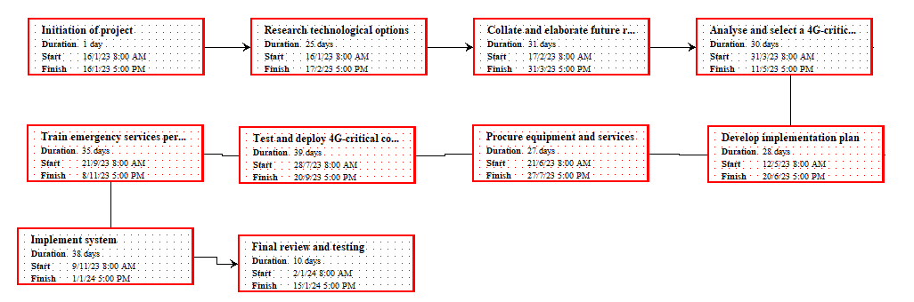

**Figure 4: Network diagram**

(Source: self-created in project libre)

***Establish Communication Channels*** ***and Protocols*** to establish clear communication channels and protocols. These should include the frequency and method of communication, as well as the individuals responsible for each communication. ***Identify all the stakeholders*** involved in the project, including the project team, sponsors, customers, vendors, and any other interested parties.  ***Provide regular updates*** on the project's status, schedule, and budget to all stakeholders involved in the project (Viswanathan, and Mogensen, 2020). This could include weekly or monthly status reports, and progress meetings, so the project can figure out whether it will be done as per instruction on time or not.

***Planning has a role to address Issues and Concerns*** that arise during the project's lifecycle. This requires prompt and transparent communication, as well as a willingness to listen to feedback and make necessary adjustments.

***Leverage technology*** could include using project management software, collaboration tools, and other communication technologies that enable stakeholders to share information collaborate in real-time, and stay informed about the project's progress (Abascal, and Civit Balcells, 2023). By following this planning, project managers can establish effective communication channels and protocols that ensure stakeholders are kept informed and engaged throughout the project's lifecycle.

# 9.0 Referencing

Abascal, J. and Civit Balcells, A., 2023, March. Mobile communication for older people: new opportunities for autonomous life. In Workshop on Universal Accessibility of Ubiquitous Computing: Providing for the Elderly (2000)..

Adeel, A., Gogate, M., Farooq, S., Ieracitano, C., Dashtipour, K., Larijani, H. and Hussain, A., 2019. A survey on the role of wireless sensor networks and IoT in disaster management. Geological disaster monitoring based on sensor networks, pp.57-66.

Adeel, A., Gogate, M., Farooq, S., Ieracitano, C., Dashtipour, K., Larijani, H. and Hussain, A., 2019. A survey on the role of wireless sensor networks and IoT in disaster management. Geological disaster monitoring based on sensor networks, pp.57-66.

Elbanna, A., Bunker, D., Levine, L. and Sleigh, A., 2019. Emergency management in the changing world of social media: Framing the research agenda with the stakeholders through engaged scholarship. International Journal of Information Management, 47, pp.112-120.

Gallagher, J.C. and DeVine, M.E., 2019. Fifth-generation (5G) telecommunications technologies: issues for congress. Congressional Research Service, 1(30), pp.1-39.

Nayyar, A., Nguyen, B.L. and Nguyen, N.G., 2020. The internet of drone things (IoDT): future envision of smart drones. In First International Conference on Sustainable Technologies for Computational Intelligence: Proceedings of ICICI 2019 (pp. 563-580). Springer Singapore.

Roosevelt, F.D., 2022. In the field of communications, however, there is today no single Government agency charged with broad authority. The Congress has vested certain authority over certain forms of communications in the Interstate Commerce Commission and there is in addition the agency known as the Federal Radio Commission. Free Speech and Censorship: A Documentary and Reference Guide, p.66.

Savunen, T., Hämmäinen, H., Kilkki, K. and Kekolahti, P., 2023. The role of mobile network operators in next-generation public safety services. Telecommunications Policy, 47(3), p.102489.

Scott, B.K., Miller, G.T., Fonda, S.J., Yeaw, R.E., Gaudaen, J.C., Pavliscsak, H.H., Quinn, M.T. and Pamplin, J.C., 2020. Advanced digital health technologies for COVID-19 and future emergencies. Telemedicine and e-Health, 26(10), pp.1226-1233.

Shah, S.A., Seker, D.Z., Hameed, S. and Draheim, D., 2019. The rising role of big data analytics and IoT in disaster management: recent advances, taxonomy and prospects. IEEE Access, 7, pp.54595-54614.

Shahzadi, R., Ali, M., Khan, H.Z. and Naeem, M., 2021. UAV assisted 5G and beyond wireless networks: A survey. Journal of Network and Computer Applications, 189, p.103114.

Storck, C.R. and Duarte-Figueiredo, F., 2020. A survey of 5G technology evolution, standards, and infrastructure associated with vehicle-to-everything communications by internet of vehicles. IEEE access, 8, pp.117593-117614.

Sutherland, E., 2021. A short note on 5G enterprise networks. Available at SSRN.

Toh, C.K., Sanguesa, J.A., Cano, J.C. and Martinez, F.J., 2020. Advances in smart roads for future smart cities. Proceedings of the Royal Society A, 476(2233), p.20190439.

Viswanathan, H. and Mogensen, P.E., 2020. Communications in the 6G era. IEEE Access, 8, pp.57063-57074.