**COMMUNICATION AND INTERPROFESSIONAL COLLABORATION**

**Table of Contents**

Introduction 2

Video/Case study analysis 2

Explain briefly what your chosen video is about 2

Explain the terms: communication, multi-professional, multi-disciplinary team working, and collaboration 2

Identification and explanation of the different styles of communication, models, and theories of communication in the chosen film you chose 3

What was the impact of the communication style, was it negative or positive? 4

Discussion of the impact of the communication style on the professional work environment when working with a multidisciplinary team. 4

Conflict management and the theories of conflict management 5

Managing conflicts in professional settings 5

Difference between cross-cultural communication and intercultural communication 6

Conclusion 8

Reference List 9

# Introduction

The report will focus on making an analysis of a case study video which considers tattooing as a matter of social prejudice. The report will emphasise making a brief analysis of various factors which are communication, multi-professionalism, team working in multi-disciplinary ways and collaboration. This report focuses on providing insight into various styles of communication, their models and theories in accordance with the above case study. The report helps in identifying the impact of communication styles along with their impact whether it is positive or negative. This process helps in highlighting conflict management and discusses managing conflicts in accordance with their professional settings.

# Video/Case study analysis

## Explain briefly what your chosen video is about

The video focuses on the impacts of tattooing on an individual and on society. The report considers tattooing as a sign of mental illness. Tattooing oneself in the visible areas of the body restricts an individual to get employed in any good or reputed organisation. The video emphasised that an individual was restricted to join Starbucks which is one of the leading brands in the UK. The video also describes the behaviour of other non-tattooed people towards tattooed people in society. The people are not willing to help tattooed people and treat them differently in society. On the other hand, people are empathetic towards non-tattooed people in society.

## Explain the terms: communication, multi-professional, multi-disciplinary team working, and collaboration

Communication is one important factor which is considered in the managerial process. It is a means of transferring and directing an individual to perform specific tasks or actions. In other words, Communication is referred to as a process of sharing meaning and understanding the facts with the opposite party (Björnson *et al*, 2019).

Multi-professional refers to an individual who is well-equipped for different tasks and activities. This also signifies an individual who is involved in various professions (Van Mieghem *et al.*, 2020).

Multidisciplinary team working indicates various teams which comprise individuals who are working towards one common objective of attainment of goals and objectives of the organisation (Soukup *et al.*, 2018).

Collaboration refers to an act of working together with an individual or an organisation for attaining a common objective (Ajoudani *et al.*, 2018).

## Identification and explanation of the different styles of communication, models, and theories of communication in the chosen film you chose

*Different styles of communication*

The different styles of communication which have been used in this video are interactive communication style, rhetorical style communication and scripted storytelling style. The adoption of an interactive style of communication helps in describing the experience of individuals and participants in their alternate positions. An interacting communication style is used in this film which is emphasised on the basis of communication among different individuals in the film.

Rhetoric style of communication is one of the common methods which is adopted for processing this particular documentary video. Rhetoric communication style is used in this video which aims at persuading its audience and hence the fulfilment of all three Cs of rhetoric style - credibility, compelling and convincing, are observed to be achieved.

Scripted storytelling style aims at giving a brief description of the incidents or events through the help of stories. The video has adopted a scripted storytelling style to give a description of society with respect to various tattooing incidents (Nai, 2021).

*Models of communication*

The various models of communication which are used in videos are poetic, expository, reflexive, participatory and performative. This documentary video has adopted performative, participatory and reflective models of communication to describe the impacts of using tattoos in society. The participatory form of communication is an important model which is used in various documentary videos. This video has adopted this style to give a clear view to its audience regarding the prevailing social malaise which is pertaining in society. The performative model of communication has helped in describing the social barrier which is created in society while using tattoos. This also describes how tattooed people are not allowed to be recruited by premium and prestigious organisations through the adoption of this model of communication (Waisbord, 2020). The reflective models aim at getting the reflection from the audience.

*Theories of communication*

The three theories of communication which have been adopted in this video are the magic bullet theory, multi-step flow theory and cultivation theory.

Magic bullet theory of communication has been used in this video which emphasises that originators' or video performers' action has a direct impact on the minds of the individuals in society. This theory is based on various assumptions made by the video creator which emphasises the fact the video or documentary film is able to inject a message into the minds of its targeted audience.

Multi-step flow theory of communication is adopted while presenting this video. This theory aims at creating an intervention between the opinions of leaders and the remarks of the audience. This theory of communication aims at mitigating social malaise by delivering opinions from video creators. This video has described the opinions of various tattoo users in society. This video helps in spreading the messages related to tattooing.

The cultivation theory of communication has been used in this video to spread various messages through digital platforms in society. Cultivation communication aims at creating long-lasting impacts on the minds of viewers by portraying various real-life problems. The video portrayed various tattoo-related events in society, and how these tattooed people were rejected by various prestigious organisations. This helps the viewer to take positive steps and decisions in their lives.

## What was the impact of the communication style, was it negative or positive?

After reviewing the video or the documentary film, it was observed that the communication style was positive. The video helped in describing various real-life events and circumstances, real-life events and humiliations faced by the tattooed people. The video also indicated the reactions and ill-treatment towards tattooed people in society. The impact of communication styles being adopted in this video was positive because this video aimed at educating, persuading or motivating its target audience against the social malaise persisting in society. This video focused on creating social awareness among the people of the society by citing live examples which would create a positive impact.

## Discussion of the impact of the communication style on the professional work environment when working with a multidisciplinary team.

The impact of communication style on the professional work environment is considered to be an important factor while working with a multidisciplinary team. When different individuals are engaged in different multidisciplinary teams, this reveals that these people have various complementary skills which need to be assimilated to attain common goals or organisational objectives. Every individual working in various teams might not prefer a common way of communication. Communication style is an essential element which is to be considered while developing plans and strategies. A manager in a tattoo parlour must clearly explain the requirement of its customer's tattoo which will help in delivering the best tattoo to the customers. The superiors in this industry can adopt innovative communication styles to deliver the best job performance.

***Role of Ethics in interprofessional practice***

Ethics is considered to be one of the most important and contributing factors in interprofessional practice. Ethics refers to adopting fair and absolute principles while carrying on any task or profession. Ethics in inter-professional practices focuses on developing mutual respect among different members of the team. Based on the common objective of delivering quality products and services helps in enhancing and upgrading the work atmosphere in the organisation. Adoption of ethics in interprofessional practice helps in delivering the best quality service to its customer. This helps in enhancing the brand value and goodwill of the company. The tattoo parlour management can coordinate with its team members to provide quality service to its customers. This will help in attaining the goals of the parlour.

## Conflict management and the theories of conflict management

Conflict management refers to the ways and means which are adopted to resolve misunderstandings and conflicts efficiently and effectively. This management process aims at minimising the negative impacts arising on account of various disagreements within an organisation. The process of conflict management deals with various incompatibilities in an organisation arising due to the divergence of opinions, needs and objectives. This management process focuses on resolving disputes in order to maximise positive achievements in the organisation. Dealing with and resolving conflicts is a key managerial ability which shall be possessed by a manager. This helps in increasing the growth rate and productivity of an organisation. It emphasises arriving at a solid possible conclusion by minimising the misunderstandings between two parties. This is a mechanism of handling disputes among various parties involved.

## Managing conflicts in professional settings

Conflict management in relation to professional settings focuses on improving the work culture and environment in the organisation. It aims at providing the clarity of goals in the minds of subordinates. The various steps which are involved in order to handle the conflicts in workplace are:

Talking to the opposite party over a particular issue. Identify the ways which could help in minimising the misunderstanding and arriving at an absolute solution.

Listening carefully to both parties involved in the conflict helps in identifying their cause of disagreement and arriving at a possible solution. Identifying various reasons for agreement and disagreement among the related parties involved in the conflict. Prioritising the area of disagreement and trying to resolve the issues amicably. Developing a plan which will work on a conflict. Following up on the plans that they are being executed properly or not.

The various theories related to conflict management are :

Traditional theories refer to theories adopted for conflicted management which are based on assumptions that the conflict harms the growth and prosperity of an organisation.. It is formulated by troublemakers and they should be subdued effectively. This theory emphasises that conflicts between human beings are unavoidable. The traditional theory of conflict management focuses on the negative aspects of conflicts. This management theory focuses on the fact that conflicts result in trouble and disparities so emphasises the ways how it can be overcome. It can be overcome by avoidance, ignoring, resolving issues and others.

Contemporary theory is also one of the important conflict management theories which emphasises that conflicts are unavoidable. If they are managed properly then they may yield positive results. This theory of conflict management emphasises positive steps to be taken by management to resolve the issues pertaining, to the organisation. The management prepares guidelines and plans for resolving certain issues pertaining to the organisation.

Interactionist theory emphasises the fact that human beings are social animals. Interacting over various issues persisting among individuals may result in mutual interaction. Adoption Of this theory helps in reducing conflicts and helps to perform tasks in teamwork which will help in achieving organisational objectives.

## Difference between cross-cultural communication and intercultural communication

Cross-cultural communication

Cross-cultural communication helps in performing a study on how individuals coming from various backgrounds communicate and coordinate in similar and different ways with each other. Communication is an important factor which is considered in the public relation process. Communication barriers are a major cause of hindrance in the operation of an organisation. Cross-cultural communication also known as intercultural communication is a study which is undertaken to know how verbal and nonverbal communication takes place between individuals coming from diverse backgrounds and cultures. Organisations with a multicultural environment mainly focus on cross-culture organisations. Strong intercultural communication among the employees in an organisation can fuel the growth objectives of the organisation.

Intercultural communication

It, on the other hand, refers to the communication process held between individuals belonging to two diverse cultures. This process of communication is also referred to as transactional, contextual, symbolical, and interpretive forms of communication. The intercultural communication process helps in integrating individuals belonging to different and diverse cultures. Intercultural communication is also referred to as a study which is undertaken to identify the practices of communication in various cultural contexts. This implies various factors which are domestic, ethnic and national cultures. Intercultural communication helps in developing a sense of respect for other cultures. Good intercultural communication helps in eliminating conflicts in an organisation.

***Five-dimensional Model in intercultural communication***

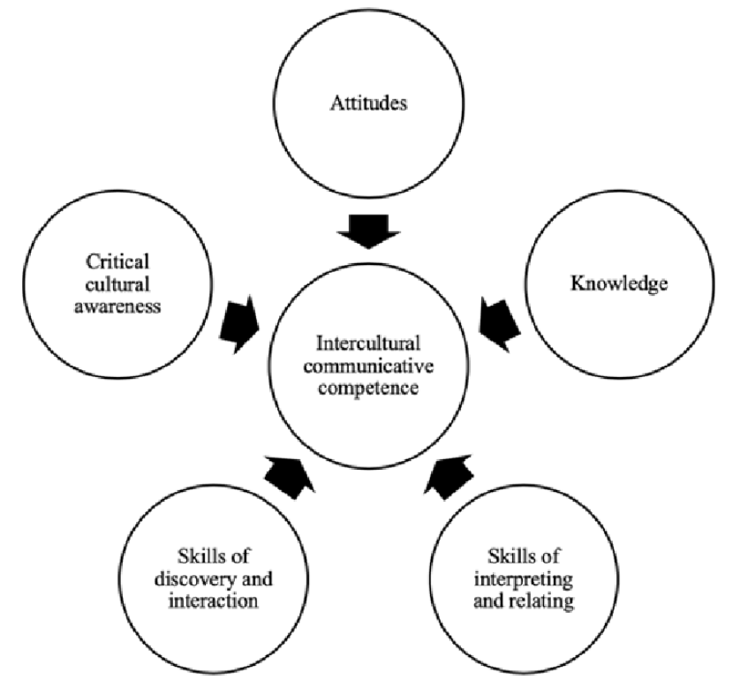

**Figure 1: Five-dimension model**

(Source: Uzum *et al*., 2020)

The five-dimension model is considered to be an important factor which is considered in the five-dimensional model of intercultural communication are:

*Power distance*

The power distance helps in coping with cultural differences in the organisation. The application of power distance helps in streamlining the operations of the company. The power distance function emphasises eliminating the similarities between individuals

*Indulgence vs collectivism*

This dimension is related to the way in which individuals are encouraged in order to belong to a specified group of cultures. This dimension opposes individualistic thinking and assumptions.

*Masculinity vs Femininity*

This model of communication emphasises not reinforcing masculine work to the female employees. This model emphasises providing equal parity to both males and females.

*Long term orientation*

This is a degree associated with the achievement of long-term goals. It focuses on firms' orientation to the achievement of their long-term objectives.

*Individualism versus collectivism*

This dimension of intercultural communication aims at working collectively towards the achievement of goals and objectives. It helps in bringing a sense of teamwork among employees.

# Conclusion

The report describes a video which considers tattooing as a matter of social prejudice. This report concludes with various matters which are communication***,*** multi-professional, multi-disciplinary team working, and collaboration. The report aims at emphasising the identification and implications of various styles of communication in the context of this video. The report also focuses on the impact of the communication style on the professional work environment when working with a multidisciplinary team. The report also emphasises conflict management and discusses various conflict management theories. Lastly, the report discusses the difference between cross-cultural and intercultural communication.

# 

# Reference List

Ajoudani, A., Zanchettin, A.M., Ivaldi, S., Albu-Schäffer, A., Kosuge, K. and Khatib, O., 2018. Progress and prospects of human–robot collaboration. *Autonomous Robots*, *42*, pp.957-975.

Björnson, E., Sanguinetti, L., Wymeersch, H., Hoydis, J. and Marzetta, T.L., 2019. Massive MIMO is a reality—What is next?: Five promising research directions for antenna arrays. *Digital Signal Processing*, *94*, pp.3-20.

Nai, A., 2021. Fear and loathing in populist campaigns? Comparing the communication style of populists and non-populists in elections worldwide. *Journal of Political Marketing*, *20*(2), pp.219-250.

Soukup, T., Lamb, B.W., Arora, S., Darzi, A., Sevdalis, N. and Green, J.S., 2018. Successful strategies in implementing a multidisciplinary team working in the care of patients with cancer: an overview and synthesis of the available literature. *Journal of multidisciplinary healthcare*, pp.49-61.

Uzum, B. & Akayoglu, S. and Yazan, B. 2020. Using telecollaboration to promote intercultural competence in teacher training classrooms in Turkey and the USA. ReCALL. 32. 1-16. 10.1017/S0958344019000235.

Van Mieghem, A., Verschueren, K., Petry, K. and Struyf, E., 2020. An analysis of research on inclusive education: a systematic search and meta review. *International Journal of Inclusive Education*, *24*(6), pp.675-689.

Waisbord, S., 2020. Family tree of theories, methodologies, and strategies in development communication. *Handbook of communication for development and social change*, pp.93-132.