**DATA PROCESSING FOR IOT**

**TABLE OF CONTENTS**

Introduction 3

Discussion 3

Advantages for Using IoT in a factory assembling car from components 3

Disadvantages for Using IoT in a factory assembling car from components 6

Applying machine learning and parallel data processing for attack detection in IoT 6

Applications of IoT 7

Operation procedure for applying the framework IoT in a factory assembling car from components 10

Problems statement 11

Solution 12

Conclusion 12

Reference list 14

Appendices 17

# Introduction

In this research the internet of things will become most popular to manage and process the data of multimedia in the different types of application and also for ensuring the efficient and the multimedia for the management will be very effective and the framework of hybrid had been developed the variant types of techniques such as computing of mobile, cloud computing and edge computing. To leverage the strengths of these technologies, the hybrid framework is able to provide a comprehensive solution that can manage and process multimedia data effectively. The hybrid framework enables multimedia data to be stored, managed, and processed in a distributed manner and it will also allow for a more efficient use of resources as the data can be distributed across multiple devices.

# Discussion

In this research the IoT will transform the way businesses and consumers interact with each other and the network of IoT is physical objects embedded with sensors, networks, and other technologies to monitor, collect, and exchange data. In this study the IoT will continue for gaining popularity, so there will be a need for a robust consent management platform for personal data processing in IoT (Rathee, *et al.* 2020). The platform of consent management for personal data processing in IoT must be capable of managing user consent, processing personal data, and providing transparent communication between the user and the service provider. This type of platform will be designed for ensuring that user data is processed in accordance with the user's wishes, and that the user is aware of how their data is being used. The platform will provide the user with the ability for modifying or revoking their consent at any time and this type of platform will be designed to be secure and reliable, with encryption and authentication protocols to ensure the safety of the user's data. It should also have a comprehensive policy for data retention, ensuring that all collected data is securely stored and properly handled and this platform will ensure that the users are provided with clear and accessible information about how their data is being used and give them the ability to control the use of their data.

## Advantages for Using IoT in a factory assembling car from components

In this research the way of revolution for IoT will interact with the world and the way industries operate and in the industry of manufacturing IoT is providing many advantages to factories that assemble cars from components. IoT will allow for monitoring remotely for the factory operation and the sensors can be placed throughout the factory to allow the managers of the factory to monitor the performance of the machines, the rate of production for the components and the performance of workers (Wan, *et al.* 2019). This will be very useful for identifying the areas of weakness, such as slow production rates, and can provide early warnings about potential problems. This will improve monitoring and can be helpful for ensuring that the production process runs smoothly and efficiently. In this research the IoT can also be helpful for improving the quality of the products produced in the factory and the sensors will be used for detecting the potential defects in components, allowing them to be fixed or replaced before they are used in the assembly process (Wu, 2020). This will be also very useful for reducing the number of faulty products that are produced, while also improving the reputation of the factory. IoT can also be helpful for improving the safety in the factory and in this research the sensors will be very helpful for monitoring the environment of the factory, such as temperature and humidity levels, as well as the presence for the materials of hazardous.

**1. Improved productivity because of better monitoring**

In this research it was found that in recent years the Internet of Things (IoT) is an emerging technology that has been gaining a lot of attention and also it is the network of physical objects embedded with sensors, software, and network connectivity that enable them to collect and exchange data (Babiuch, *et al.* 2019) . IoT has the potential to revolutionize the way we work and live. The main way IoT is being used for improving productivity is through better monitoring. IoT devices can be used to track and monitor a wide range of parameters, from temperature to humidity to motion. This data can then be used to make more informed decisions and optimize processes. In manufacturing, sensors can be used to monitor the production process and detect anomalies, leading to more efficient production and fewer delays. In the healthcare industry, IoT can be used to monitor patient health and alert healthcare professionals when there is a change in a patient’s condition and the IoT will also be very useful for automating the processes, leading to increased efficiency (Durga, *et al.* 2019). In manufacturing the robots can be used to automate the production process, resulting in faster and more efficient production and the IoT will also be used to automate the delivery of goods, which can save time and money.

**2. Improved efficiency as devices**

In this research the main advantages of IoT is the type of physical objects network such as electronic devices, vehicles and machines which are connected to the internet. The revolution of IoT has the way for foing things and makes the improvements incredible for the efficient devices. In this research the main advantages of IoT is its ability to automate processes and the devices of IoT are connected to the Internet and also allowing them to communicate with each other and with external systems (Mukherjee, *et al.* 2020).

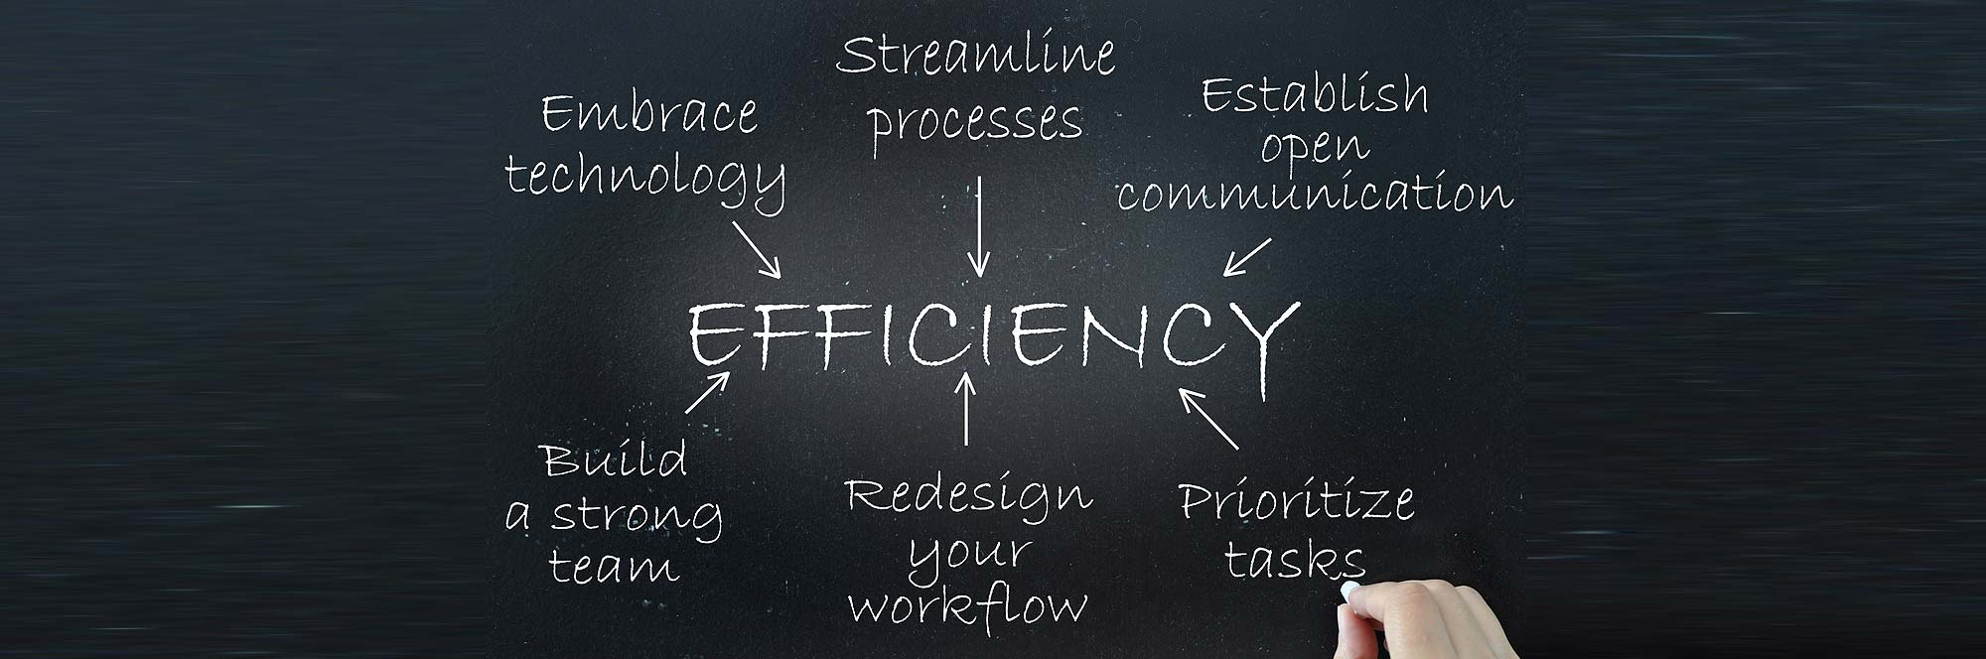

**Figure 1: Improving Efficiency**

(Source: https://pmc.az)

This means that processes can be automated, allowing for faster, more efficient operations. In industrial settings the devices of IoT will be very useful for monitoring and controlling processes, allowing for faster, more efficient production and the other advantage of IoT is its ability to collect data. IoT devices can collect data from the environment and transmit it to a central system. In this study the data collected from sensors can be used to adjust the temperature of a building, resulting in improved energy efficiency and also the device of IoT will allow for the remote monitoring and control.

**3. Lower costs of operations with an increase in safety**

In this study the network of IoT is connected with the devices which are able to exchange data and interact with each other and the device of IoT is being used in many Variant types of industries, such as manufacturing, healthcare, transportation, and home automation. One of the main advantages of IoT is the potential to reduce costs of operations and increase safety. In this research the device of IoT will be very helpful for reducing the operational costs by providing real-time data that can be used to optimize processes (Liu, *et al.* 2021). In a manufacturing setting, sensors could be used to track the amount of energy being used in the production process and the data will be very helpful for more efficiently managing energy usage, which can lead to cost savings. IoT can be used to monitor the performance of machines and the data also can be used to more quickly and accurately identify any problems with the machines, leading to lower maintenance costs. IoT can also improve safety by providing more accurate and timely data. In a healthcare setting, sensors can be used to monitor vital signs and detect any abnormalities (Jan, *et al.* 2019). This data can then be used to alert medical staff if there is a problem and allow for timely intervention and the device of IoT can be used to detect hazardous situations in industrial settings and alert workers before an accident occurs.

## Disadvantages for Using IoT in a factory assembling car from components

In this research the use of internet of things for the factory in assembling the car from the components have some types of disadvantages in the industry. The implementing and maintaining cost for the system of IoT for the factory will be quite high. This is because the hardware and software required to make the system work need to be purchased and installed and the system of IoT will need to be regularly updated to ensure that it is running efficiently and securely (Debauche, *et al.* 2022). In this study it was also found that the training cost for the staff for using the system may also be an issue and the security of the system will be a very important concern for the industry. The collected data by the IoT system must be protected from unauthorized access and manipulation. This will require that the system be properly configured and regularly updated to prevent hackers from gaining access to the data and this will be a costly and time-consuming process and the accuracy of the collected data by the system may also be a concern.

## Applying machine learning and parallel data processing for attack detection in IoT

The increasing use of IoT devices will present the challenge to growth for the detection of attack and the machine learning and processing of parallel data has been identified as promising avenues for detecting malicious activity in IoT networks (Babar, and Arif, 2019). The algorithms of machine learning will be very useful for identifying the patterns in the data of IoT and also for allowing the detection of anomalies that may indicate an attack. The algorithm of supervised learning will be very useful for detecting the changes in network traffic patterns that may indicate an attack. Unsupervised learning techniques, such as clustering and anomaly detection, may also be used to detect deviations from normal behavior. This can be particularly useful for analyzing large volumes of data from IoT devices, which may generate large amounts of data in a short period of time. In this research machine learning and processing of parallel data will be very powerful tools for detecting malicious activity in the networks of IoT.

## Applications of IoT

In this research there are many different types of applications for the network of IoT and those are:

1. **Fleet and driver management:** In this research the fleet and driver management of IoT is the most important application of the Internet of Things (IoT) that is revolutionizing the way businesses manage their fleets and drivers (Yassine, *et al.* 2019). The application of IoT fleet and driver management provides businesses with real-time visibility and control over their fleets and drivers, enabling them to make decisions quickly and efficiently. The main benefits of IoT fleet and driver management is the ability for monitoring and tracking the driver performance and with this type of the application of IoT, businesses can track driver performance in real-time, allowing them to adjust schedules and routes to maximize efficiency and reduce costs. Businesses can also track the condition of their vehicles and drivers to ensure safety and compliance with regulations. Another benefit of IoT fleet and driver management is the ability to reduce fuel costs (Shah, *et al.* 2019). By monitoring and tracking vehicle performance, businesses can identify areas of improvement in their fleet and driving habits, making it easier to reduce fuel costs. Businesses can set up alerts to notify them of potential issues with their vehicles, allowing them to take corrective action quickly.
2. **Real-time vehicle telematics:** In this research the application of IoT real-time vehicle telematics is becoming increasingly popular, as it offers a range of benefits to both businesses and individuals. In these businesses, real-time telematics can offer increased efficiency and safety for their fleet. To track the vehicles in real-time, businesses can monitor traffic conditions and plan routes to reduce fuel consumption and cut costs. They can also provide drivers with real-time feedback to improve their driving behavior and help them to avoid accidents (Poongodi, *et al.* 2020). Telematics can be used to monitor vehicle maintenance and alert businesses when maintenance is needed, helping to reduce downtime and keep vehicles running smoothly. In this research real-time vehicle telematics can provide peace of mind and convenience. By tracking their vehicles in real-time, they can be informed of their exact location at any time, reducing the risk of theft or tampering. It can also provide valuable data on fuel consumption, helping them to identify when they may be using more fuel than necessary and also it can provide information on things like speed, acceleration and braking, enabling them to assess their driving and improve their safety on the roads and the application of IoT real-time vehicle telematics offers numerous benefits to both businesses and individuals. ***[Referred to Appendix 3]***

**Figure 2: Application of IoT**

(Source: Self-created in MS-Word)

1. **Cellular vehicle to everything:** In this research the application of Internet of Things (IoT) on cellular vehicles to everything (C-V2X) is a rapidly growing technology that has promising implications for the future of transportation. In this study the C-V2X is a communication technology that enables vehicles to communicate with each other and their environment, providing a variety of data ranging from traffic and road conditions to vehicle health and safety information (Azar, *et al.* 2019). This type of technology can potentially revolutionize the way we travel and has the potential to drastically reduce the number of accidents on the road. C-V2X technology is being used in a variety of ways to improve safety and efficiency in the transportation sector. One of the most promising applications of C-V2X is in automated vehicle systems. The technology of the C-V2X, vehicles can communicate with each other to coordinate traffic and adjust speed for avoiding the collisions and this type of autonomous driving has the potential to significantly reduce the number of car accidents, which can save lives and reduce economic losses due to car accidents (Li, *et al.* 2020). C-V2X can also be used for improving the traffic flow and reducing congestion by enabling vehicles to coordinate their movements in order for reducing the delays and optimizing road usage and also the technology of C-V2X has the potential applications in the logistics industry.
2. **IoT based predictive maintenance:** In this research the component of IoT has a way of revolution and also has to think about the maintenance of predictive and the technology of IoT will be enabled for the data collection from the devices and sensors which are connected and it can be used for monitoring the machines and systems operational health. This type of data will be very useful for detecting the potential problems on the system and it is also very helpful for allowing preventive action to be taken (Ghosh, *et al.* 2019). The use of the technology of IoT in the maintenance of predictive will be very helpful for minimizing the downtime and also reducing the need for costly repairs. In this technology it is also very important for monitoring the machines and systems performance and addressing the problems before they become more serious and also very helpful for saving both money and time. In this technology the maintenance of predictive will be very helpful for reducing the catastrophic risk for the failure of the system and this have serious implications for the continuity of the business. The key advantages for using the IoT-based maintenance of predictive was the ability for identifying so quickly for any type of potential issues with the system. To use the sensors for collecting the real-time data, the operators will be detected any type of problems in the system and also take action before the issues become more serious (Firouzi, *et al.* 2020). This will be very helpful for reducing downtime and increasing efficiency, resulting in cost savings for the business and the other benefit of using IoT-based predictive maintenance is that it can help to reduce the risk of catastrophic system failure. ***[Referred to Appendix 2]***
3. **In- vehicle infotainment:** In this research the application of the Internet of Things (IoT) is rapidly becoming a very important component for the industry of automotive. In this study the system of Vehicle infotainment is one of the most visible and popular applications of IoT in vehicles, as they provide drivers and passengers with access to a wide range of content, services, and features (Betty Jane, and Ganesh, 2020). With the aid of IoT, VI systems can be connected to multiple external devices, such as smartphones, tablets, and other connected devices and it will allow for a variety of services, such as streaming media, navigation and location services, remote diagnostics, and access to vehicle data. The system of VI can also be connected to the cloud and also for allowing access to cloud-based services such as music streaming, online search, and more. IoT also allows for the integration of other sensors and devices into the vehicle, such as cameras, radar, and other sensors. This enables the vehicle to be better aware of its surroundings and to assist the driver in making better driving decisions. In this application the integration of these sensors also allows for the development of advanced driver assistance systems (ADAS), which can be helpful for improving the safety and reducing the risk of accidents.

## Operation procedure for applying the framework IoT in a factory assembling car from components

In this study to make the system of IoT is a very complex endeavor and also it will require combining both of hardware and software with successfully across the different types of domains. In this process the capabilities of sensing and actuation have to be brought into the environments and by using the devices and networks of IoT (Islam, *et al.* 2020). In order to apply the framework of IoT in a factory that assembles cars from components, the following steps should be taken: ***[Referred to Appendix 1]***

**1. Identify the components that need to be monitored:** Before implementing the framework of IoT, it is also very important for identifying the components that need to be monitored. This includes the parts of the car that are to be assembled, as well as the components that are used in the process of assembly.

**2. Develop the IoT infrastructure:** Once the components have been identified, the next step is to develop the IoT infrastructure. This will involve to create the necessary hardware and software components, such as sensors, controllers, and communication networks.

**Figure 3: IoT framework process**

(Source: Self-created in MS-Word)

**3. Develop the data-collection process:** In order to obtain useful data from the components, it is necessary to develop a data-collection process. This will involve determining the data points that need to be monitored, as well as developing the necessary algorithms for collecting and analyzing the data.

**4. Develop the analytics process:** Once the data has been collected, it is necessary to develop the analytics process. This will involve developing algorithms for analyzing the data and extracting meaningful insights from it.

## Problems statement

The application framework of the IoT in a factory assembling cars from components can be a great asset for the manufacturing business and the network of IoT is connected with the devices that can communicate with each other, making it an ideal platform for a factory with a large number of interconnected components. The system of IoT will be very helpful for automating the process, reducing costs, and increasing efficiency (Vij, *et al.* 2020). The implementation of IoT in a factory assembling cars from components has its own challenges. The factory must have the necessary infrastructure to support IoT, such as sensors, gateways, and networks. The factory must also have the technical expertise to manage the devices and platform. The factory must have the necessary data and analytics to properly evaluate the performance of the components and the whole system. This data must be collected and stored securely, as well as shared with the relevant personnel in a timely manner. The factory must also ensure that the components and their data are secure from external threats. This means that the factory must have the necessary security measures in place to prevent unauthorized access to the devices and their data. The factory must also have the necessary policies and procedures in place to ensure that the devices and their data are used in a safe and responsible manner.

## Solution

The application of the framework of IoT in a factory assembling cars from components is a great way for improving the overall efficiency and the system of IoT can be used for monitoring the entire production process, from start to finish, allowing for real-time data analysis and tracking of the entire assembly process (Cui, *et al.* 2022). This would provide insight into the current state of the production line and allow for faster identification and correction of any issues that may arise. The sensors of IoT will be very useful for monitoring the quality of the components being used in the production process, ensuring that only the best components are being used to assemble the cars. This will be very helpful for reducing the downtime due to environmental conditions, as well as reduce the risk of potential health issues for employees and the framework of IoT can be used for connecting the system of the factory to the outside world and also allowing for easy access to real-time data. This will allow the factory for better understanding the current state of the production process, allowing for faster and more efficient decision-making.

# Conclusion

The framework is designed to be scalable, so that data can be easily moved between different devices and applications and it will be very useful for ensuring that the data can be processed and stored in the most efficient manner. This type of framework also enables multimedia data to be securely managed and processed. In this research it was achieved by using encryption technology and secure protocols to protect the data from unauthorized access. This type of framework will provide the support for streaming multimedia data, which allows for real-time processing and analysis of the data and the framework of hybrid was designed to be flexible, so that it can be easily adapted to different applications and environments.

# Reference list

**Journals**

Azar, J., Makhoul, A., Barhamgi, M. and Couturier, R., 2019. An energy efficient IoT data compression approach for edge machine learning. *Future Generation Computer Systems*, *96*, pp.168-175.

Babar, M. and Arif, F., 2019. Real-time data processing scheme using big data analytics in internet of things based smart transportation environment. *Journal of Ambient Intelligence and Humanized Computing*, *10*, pp.4167-4177.

Babiuch, M., Foltýnek, P. and Smutný, P., 2019, May. Using the ESP32 microcontroller for data processing. In *2019 20th International Carpathian Control Conference (ICCC)* (pp. 1-6). IEEE.

Betty Jane, J. and Ganesh, E.N., 2020. Big data and internet of things for smart data analytics using machine learning techniques. In *Proceeding of the International Conference on Computer Networks, Big Data and IoT (ICCBI-2019)* (pp. 213-223). Springer International Publishing.

Cui, L., Gao, M., Dai, J. and Mou, J., 2022. Improving supply chain collaboration through operational excellence approaches: an IoT perspective. *Industrial Management & Data Systems*, *122*(3), pp.565-591.

Debauche, O., Mahmoudi, S. and Guttadauria, A., 2022. A new edge computing architecture for IoT and multimedia data management. *Information*, *13*(2), p.89.

Durga, S., Nag, R. and Daniel, E., 2019, March. Survey on machine learning and deep learning algorithms used in internet of things (IoT) healthcare. In *2019 3rd international conference on computing methodologies and communication (ICCMC)* (pp. 1018-1022). IEEE.

Firouzi, F., Farahani, B., Weinberger, M., DePace, G. and Aliee, F.S., 2020. Iot fundamentals: Definitions, architectures, challenges, and promises. *Intelligent Internet of Things: From Device to Fog and Cloud*, pp.3-50.

Ghosh, S., Ghosh, K., Karamakar, S., Prasad, S., Debabhuti, N., Sharma, P., Tudu, B., Bhattacharyya, N. and Bandyopadhyay, R., 2019, December. Development of an IOT based robust architecture for environmental monitoring using UAV. In *2019 IEEE 16th India Council International Conference (INDICON)* (pp. 1-4). IEEE.

Islam, M.M., Rahaman, A. and Islam, M.R., 2020. Development of smart healthcare monitoring system in IoT environment. *SN computer science*, *1*, pp.1-11.

Jan, B., Farman, H., Khan, M., Talha, M. and Din, I.U., 2019. Designing a smart transportation system: an internet of things and big data approach. *IEEE Wireless Communications*, *26*(4), pp.73-79.

Li, M., Yu, F.R., Si, P., Wu, W. and Zhang, Y., 2020. Resource optimization for delay-tolerant data in blockchain-enabled IoT with edge computing: A deep reinforcement learning approach. *IEEE Internet of Things Journal*, *7*(10), pp.9399-9412.

Liu, Q., Xia, T., Cheng, L., Van Eijk, M., Ozcelebi, T. and Mao, Y., 2021. Deep reinforcement learning for load-balancing aware network control in IoT edge systems. *IEEE Transactions on Parallel and Distributed Systems*, *33*(6), pp.1491-1502.

Mukherjee, A., Misra, S., Sukrutha, A. and Raghuwanshi, N.S., 2020. Distributed aerial processing for IoT-based edge UAV swarms in smart farming. *Computer Networks*, *167*, p.107038.

Poongodi, T., Krishnamurthi, R., Indrakumari, R., Suresh, P. and Balusamy, B., 2020. Wearable devices and IoT. *A handbook of Internet of Things in biomedical and cyber physical system*, pp.245-273.

Rathee, G., Sharma, A., Saini, H., Kumar, R. and Iqbal, R., 2020. A hybrid framework for multimedia data processing in IoT-healthcare using blockchain technology. *Multimedia Tools and Applications*, *79*(15-16), pp.9711-9733.

Shah, S.A., Seker, D.Z., Hameed, S. and Draheim, D., 2019. The rising role of big data analytics and IoT in disaster management: recent advances, taxonomy and prospects. *IEEE Access*, *7*, pp.54595-54614.

Vij, A., Vijendra, S., Jain, A., Bajaj, S., Bassi, A. and Sharma, A., 2020. IoT and machine learning approaches for automation of farm irrigation system. *Procedia Computer Science*, *167*, pp.1250-1257.

Wan, S., Lu, J., Fan, P. and Letaief, K.B., 2019. Toward big data processing in IoT: Path planning and resource management of UAV base stations in mobile-edge computing system. *IEEE Internet of Things Journal*, *7*(7), pp.5995-6009.

Wu, Y., 2020. Cloud-edge orchestration for the Internet of Things: Architecture and AI-powered data processing. *IEEE Internet of Things Journal*, *8*(16), pp.12792-12805.

Yassine, A., Singh, S., Hossain, M.S. and Muhammad, G., 2019. IoT big data analytics for smart homes with fog and cloud computing. *Future Generation Computer Systems*, *91*, pp.563-573.

# Appendices

**Appendix 1: Process of IoT**

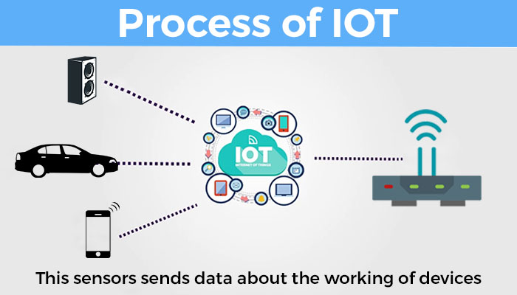

(Source: https://s3-eu-central-1.amazonaws.com)

**Appendix 2: Diagram of predictive maintenance**

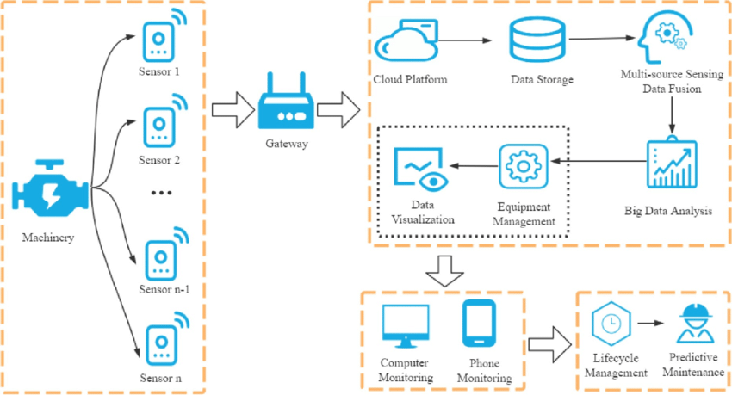

(Source: https://www.researchgate.net)

**Appendix 3: Telematics systems**

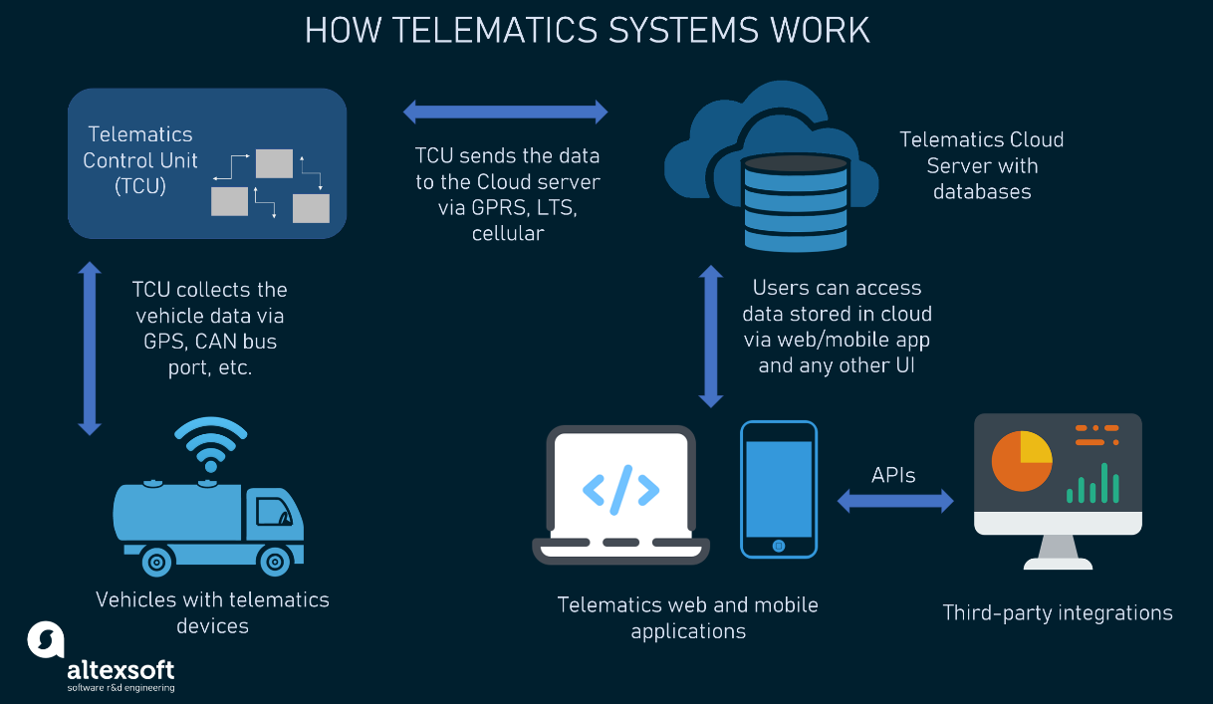

(Source: https://content.altexsoft.com)