**INTERNATIONAL MARKETING**

Table of Contents

Introduction 2

Critical analysis of new geo-market location 2

Kotler’s product levels analysis 2

Brand theory 3

Ansoff theory 3

New Market and Critical Market Analysis Focus 4

Macro market analysis 4

Customer Persona 8

Customer Journey Map 9

STP analysis 10

Conclusion 11

References 12

# Introduction

International Marketing refers to the procedure of expanding business and selling products and services outside of the domestic audience. Organisations expand their business in foreign territories using international marketing to improve brand awareness, earn elevated profit percentages and create a global customer base for the brand. International marketing is advantageous for an organisation to improve the quality of the products or services so that the anticipation of the target customers can be met. Correspondingly, the method helps a company to establish a positive image of the brand in the existing marketplace.

This report covers a critical analysis of the new geo-market location of the company, Bellway PLC. The company is originally from the United Kingdom and about to expand its business in India. The services and products of the company are scrutinised through Kotler’s product levels analysis. Similarly, Brand theory and Ansoff GM theory are applied to evaluate the choice of the brand. The report accordingly illustrates the new market and develops a critical market analysis. The macro market analysis is accomplished through PESTEL analysis and STP analysis is followed to evaluate the positioning of the brand and analysis of the micro market. This report is developed by a secondary research process.

# Critical analysis of new geo-market location

## Kotler’s product levels analysis

|  |  |
| --- | --- |
| **Core benefit** | * The services of Bellway Plc will meet the expectations of customers for high-quality and well-designed homes (Bellwayplc, 2023). * The services accordingly enhance and develops housing to meet the local demand. |
| **Formal product** | * The company is considered a 5-star homebuilder that builds high-quality new houses in alluring locations. * Bellway Plc serves to combat the increasing national housing shortage in the nation (Bellwayplc, 2023). |
| **Augmented product** | * The brand is unique in the construction industry as it provides the best quality housings at a reasonable price range. * The company accordingly value the most to the choices of the customers as it is a customer-centric company. * Bellway Plc has a strong reputation as an adequate employer by taking interest in the career development of the employees (Bellwayplc, 2023). |

**Table 1: CFA analysis through Kotler’s product levels analysis**

(Source: Created by author)

## Brand theory

Brand theory refers to the utilisation of branding not as a separate method strategically. The brand theory is beneficial for company growth and creates brand awareness among the target market (Santos *et al*. 2022). Bellway Plc can use the brand theory to create recognition in the new business market, such as India. The company needs to study the market well to understand the current market trends as well as the conditions of the marketplace. Bellway Plc can therefore create new business strategies to meet the market requirements. Correspondingly, the company can comprehend the choices, preferences, demands and needs of the target audiences in the market with the help of brand theory and market analysis.

Determining the target customer segment is an essential part of the brand theory as it helps to understand the behaviour of the target consumers (Kumar *et al*. 2021). Thus, Bellway Plc ought to recognise the target audiences to create brand awareness. Defining the personality of a brand is likewise essential for executing a brand theory (Iglesias and Ind, 2020). Bellway Plc needs to clarify the missions and visions to the employees and target customers so that they can understand the company's goals and objectives. Thus, the company can be able to create brand loyalty in the target market. Bellway Plc needs to maintain its good reputation in the marketplace by providing the best quality services at an affordable price range. The brand can enhance the relationship between the company and its consumers by constructing an adequate communication infrastructure.

## Ansoff theory

The Ansoff matrix is a framework that helps to evaluate the growth initiatives of a company. The matrix allows stakeholders to conceptualise the grade of threat linked with additional growth strategies (Clarissia, 2020). The growth strategies of the framework are “Market Penetration”, “Market Development”, “Product Development” and “Diversification”. “Market Penetration” is the image of growing sales of existing yields in an existing marketplace. On the other hand, “Market Development” concentrates on marketing existing products or services into a new marketplace. “Product Development” furnishes the idea of presenting new products or services to an existing marketplace. Correspondingly, “Diversification” is the idea of penetrating a new marketplace with completely new products or services (Yaqoob and Omer, 2021). The Matrix is operated to assess the comparative magnificence of “growth strategies” that leverage both “existing products” and marketplaces compared to new ones, as well as the grade of threat linked with each.

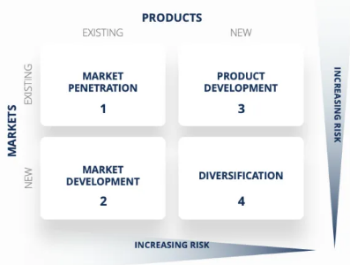

**Figure 1: Ansoff matrix**

(Source: Yaqoob and Omer, 2021)

The growth strategy of “Market Development” is appropriate for Bellway Plc as the company is entering a new nation, India with its existing services of building and construction. The strategy is the next least treacherous because it does not demand consequential investment in the product growth process (Kukartsev *et al*. 2019). It will allow the team of management to leverage existing services and carry them to a foreign market. The strategy will be beneficial for the company to serve a foreign consumer segment or “target demographic”. It will accordingly help Bellway Plc in regional expansion as well as international expansion.

# New Market and Critical Market Analysis Focus

## Macro market analysis

|  |  |  |
| --- | --- | --- |
| **Factors** | **Facts of the United Kingdom** | **Facts of India** |
| **Political** | * The anticipated Corruption Index rate of the United Kingdom is 79.00 points at the end of the year 2023. * The Political Stability Index indicates that the United Kingdom has indexed 0.54 points in the year 2023 (Theglobaleconomy, 2023). | * The rank of India in the “corruption perception index” is 85 (BBC, 2023). * India ranks 23rd in the "Political Stability Index" showing 14.3 points in political stability out of a hundred (LowyInstitute, 2023). |
| **Economic** | * The inflation rate of the UK is predicted to be 6.1% in the year 2023 (Statista, 2023). * The anticipated GDP expansion rate of the United Kingdom is nearly about 0.3% in 2023 (Gov.uk, 2023). | * The budget percentage of capital expenditure is improved to Rs. 10 trillion in 2023 (Indiatimes, 2023). * India witnessed a 3.3% growth in the GDP rate in the year 2023 (Indiatimes, 2023). * The inflation rate of India in 2023 is nearly about 6.44% (Statista, 2023). |
| **Social** | * The employment rate of the country is around 75.7% between 2022 and 2023 (Gov.uk, 2023). * The rate of literacy in the year 2023 in the United Kingdom is approximately 99% (Worldpopulationreview, 2023). | * The unemployment rate of India is nearly 7.45% in the current year (BBC, 2023). * The rate of literacy in India is close to about 84.11% in the year 2023 (Indiatoday, 2023). |
| **Technological** | * There are about 66 million internet users in the United Kingdom in 2023 (Statista, 2023). * In the United Kingdom, “Generative AI”, “Cloud-native platform” and “Metaverse” are operated in the current year (UK Tech News, 2023). | * In India’s industrial sectors, technologies like “AI”, “Virtual reality” and “augmented reality” are utilised (meity.gov, 2023). * “Machine learning”, “robotics” and “language processing” are used by business sectors in India (India.gov, 2023). |
| **Environmental** | * The country follows the “Environment Act 2021” for protecting the environment from harm (Legislation.gov, 2023). * The “Environmental Protection Act 1974” is observed in the UK to control pollution rate (Legislation.gov, 2023). | * In India, “The National Environment Appellate Authority Act, 1997” is pursued to maintain CSR successfully (Legislative.gov, 2022). * “The National Environmental Tribunal Act, 1995” is commemorated in the nation of India for protecting the environment (Indiankanoon, 2023). |
| **Legal** | * The “Companies Act UK 1948” is maintained and followed in the UK for preventing fraud and bankruptcy (Legislation.gov, 2023). * The United Kingdom observes the “Companies Act 2006” to focus on company requirements and distribution (Legislation.gov, 2023). | * “Foreign Trade (Development and Regulation) Act, 1992” is observed by the corporate industries of India for managing foreign business and exchange (Mca.gov, 2023). * The “Partnership Act, 1932” is maintained and followed by the corporate sectors in India to support lawful partnership business (mca.gov, 2023). |

**Table 2: PESTEL Analysis**

(Source: Created by author)

**Political factors:** The political stability of the UK is higher than India's as the former holds points of 0.54 points. Thus, Bellway needs to focus on the current political status of the nation before entering the market. On the contrary, the corruption rate of India is higher than the UK as the rate point in India is 85 whereas the UK has 79 points (BBC, 2023). Therefore, the company needs to follow strict rules and regulations for avoiding the negative effects of corruption in India.

**Economic factors:** The inflation rate of India in 2023 is nearly about 6.44% whereas the rate of inflation in the UK is 6.1% (Gov.uk, 2023; Statista, 2023). It can be noticed that the inflation rate in India is higher and that is why Bellway needs to reduce its production cost to maintain its company budget.

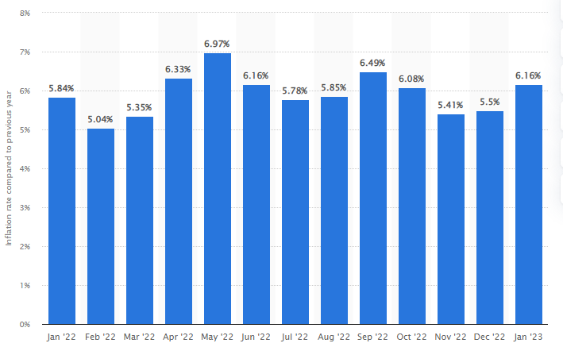

**Figure 2: Inflation rate of India from January 2022 to January 2023**

(Source: Statista, 2023)

The growth of the GDP rate is currently higher in India as it is in a growing phase. Thus, the company can take advantage of the situation in India and contribute its portion to develop good business associations.

**Social factors:** The literacy rate in India is lower than in the UK and as a result, Bellway can face a few difficulties in hiring skilled employees. On the other hand, the unemployment rate in India is higher which is nearly 7.45% in the current year (BBC, 2023). Therefore, Bellway can get available employees to hire. On the contrary, due to the higher unemployment rate, the company can struggle to get experienced staff for the organisation.

**Technological factors:** The usage of advanced technologies is almost the same in both countries. In India, business bodies are using “AI”, “Virtual reality” and “augmented reality” vastly (meity.gov, 2023). Correspondingly, the nation is planning to bring more advanced technological support such as “Generative AI”, “Cloud-native platforms” and “Metaverse” similar to the UK. Thus, Bellway can use new and innovative technologies in its business and accomplish tasks with more accuracy and quality. The company can also get the opportunity to develop technically and achieve digital transformation in the business process with high accuracy of technical support.

**Environmental factors:** The United Kingdom follows the "Environment Act 2021" for protecting the environment from harm and the "Environmental Protection Act 1974" is observed in the UK to control the pollution rate (Legislation.gov, 2023). On the other hand, in India, "The National Environmental Tribunal Act, 1995" is commemorating the nation of India for protecting the environment and "The National Environment Appellate Authority Act, 1997" is pursued to maintain CSR strategies (Legislative.gov, 2022; Indiankanoon, 2023). Thus, this factor can help Bellway to become a good corporate citizen in India.

**Legal factors:** The United Kingdom follows the “Companies Act UK 1948” to prevent fraud and bankruptcy and the “Companies Act 2006” focuses on company requirements and distribution (Legislation.gov, 2023). On the other hand, the “Foreign Trade (Development and Regulation) Act, 1992” is observed by the corporate industries of India for managing foreign business and exchange and the “Partnership Act, 1932” is maintained to support lawful partnership business (Mca.gov, 2023). Thus, Bellway can follow the acts to carry on business by avoiding illegal issues.

## Customer Persona

|  |  |
| --- | --- |
| **Name:** | Alok Sinha |
| **Gender:** | Male |
| **Age:** | 40 |
| **Location:** | New Delhi, India |
| **Occupation:** | Senior Accountant |
| **Income:** | 15 lakhs INR annually |
| **Hobbies and interests:** | ● Spending time with friends and family  ● Travelling |
| **Goals:** | ● Become CEO of the company presently working in.  ● Spend time with friends and family on weekends.  ● Purchase a 3BHK residence for own and family |
| **Engaged in media platforms:** | ● Facebook  ● WhatsApp |
| **Expectations:** | ● Wants to buy a residential apartment for the family which is well-built  ● Wants an apartment near the metro station and market  ● Wants an apartment in which a playground is available for children. |

**Table 3: Customer Persona**

(Source: Created by author)

## Customer Journey Map

A customer journey map refers to a presentation of the widespread understanding and phases of the journey of a consumer. A nicely-designed customer journey can be advantageous for Bellway Plc to grow its consumer happiness and buyer engagement with the brand. It is accommodating for assessing the experiences of the consumers and adjusting the business process accordingly (Alvarez *et al*. 2020). The company ought to observe and support the phases of the customer journey such as “awareness”, “consideration”, “purchase”, “retention” and “advocacy”.

|  |  |  |  |
| --- | --- | --- | --- |
|  | **Prepurchase stage** | **Purchase stage** | **Post Purchase stage** |
| **Purchase touch points** | * Creating transparent goals and objectives * Advertising by catchy commercials * Developing brand awareness | * Fulfilling consumer demands * Providing the best construction services * Providing finished and furnished housings. | * Receiving reviews from customers * Register complaints * Interact regularly with customers |

**Table 4: Customer Experience & Journey**

(Source: Created by author)

The customer journey map includes three main phases which are the “Prepurchase phase”, “Purchase phase” and “Post Purchase phase”. In the foremost phase, the organisation needs to develop appealing commercials to draw the attention of the target consumers (Alvarez *et al*. 2020). The corporation can use social media platforms and official websites to disseminate attractive advertisements.

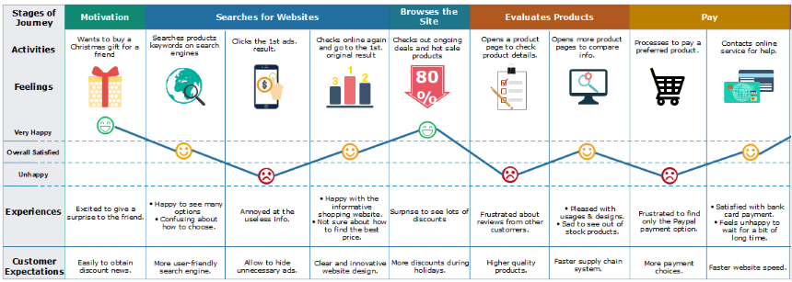

**Figure 3:** **Customer Journey Map**

(Source: Alvarez *et al*. 2020)

The organisation correspondingly requires to assemble brand awareness in the existing marketplace by managing campaigns. The organisational goals and objectives ought to be explained to the target consumers to dodge any kind of misunderstanding and miscommunication. In the second phase, the organisation needs to fulfil the expectations of the clients by furnishing high-quality housing services at an affordable price.

## STP analysis

**Segmentation:** The property developer company focuses on the consumer segment that desires to build new residential apartments and commercial buildings. The brand can consolidate on "Demographic segmentation" for comprehending the choices, demands and preferences of the consumers based on their gender, age, occupation and education level (Sathiyamoorthi *et al*. 2021).

**Targeting:** Bellway Plc mainly can target the age group of 30 to 50 years who wish to build new apartments. The company can also target promoters and housing brochures for offering their services.

**Positioning:**

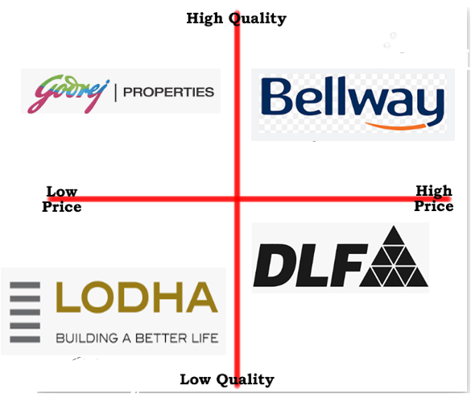

**Figure 4: Brand Positioning Map for Bellway Plc**

(Source: Created by author)

Bellway Plc momentarily possesses the positioning of “high quality and high price” in the existing marketplace as the price range of the service is high. The housebuilder company requires to reduce the price range for improving the accessibility of the services to all segments of the target customers (Sathiyamoorthi *et al*. 2021). Consequently, the brand can maintain the positioning of “high quality and low price” for drawing the engagement of the client and growing the sales rate.

# Conclusion

It can be concluded that Bellway Plc can use the brand theory to create recognition in the new business market of India. The services of Bellway Plc will meet the expectations of customers for high-quality and well-designed homes. The growth strategy of “Market Development” is appropriate for Bellway Plc as the company is entering a new nation, India with its existing services of building and construction. The brand can consolidate on “Demographic segmentation” in the new business market. Moreover, the construction of brand reputation is accordingly significant for observing brand theory. The company also needs to build a strong and stable relationship with its target audience.

# References

Alvarez, J., Léger, P.M., Fredette, M., Chen, S.L., Maunier, B. and Senecal, S., (2020). An enriched customer journey map: how to construct and visualize a global portrait of both lived and perceived users’ experiences?. *Designs*, *4*(3), p.29.

BBC, (2023). *Home.* Available at: https://www.bbc.com/news/world-asia-india-59870297 [Accessed on: 25/03/2023]

BBC, (2023). *Home.* Available at: https://www.bbc.com/news/world-asia-india-59870297 [Accessed on: 25/03/2023]

Bellwayplc, (2023). *About Bellway*. Available at: https://www.bellwayplc.co.uk/about-bellway#:~:text=We%20build%20high%20quality%20homes,demand%20and%20enhance%20the%20community. [Accessed on: 25/03/2023]

Clarissia, S.M.S., (2020). A study on Ansoff Matrix Technique: As a growth strategy and an adaptive learning technique adopted in the leading brand of products. *BIMS Journal of Management*, p.18.

Economictimes.indiatimes, (2023). *Home.* Available at: https://economictimes.indiatimes.com/news/economy/indicators/moodys-ups-indias-growth-projection-for-2023-to-5-5-on-higher-capex-budget/articleshow/98326098.cms [Accessed on: 25/03/2023]

Gov.uk, (2023). *Gross Domestic Product (GDP)*. Available at: <https://www.ons.gov.uk/economy/grossdomesticproductgdp#:~:text=GDP%20monthly%20estimate%2C%20UK%3A%20January%202023&text=Monthly%20real%20gross%20domestic%20product,by%200.5%25%20in%20December%202022>. [Accessed on: 25/03/2023]

Gov.uk, (2023). *Unemployment*. Available at: <https://www.ons.gov.uk/employmentandlabourmarket/peoplenotinwork/unemployment#:~:text=The%20UK%20employment%20rate%20was,employees%20and%20self%2Demployed%20workers>. [Accessed on: 25/03/2023]

Iglesias, O. and Ind, N., (2020). Towards a theory of conscientious corporate brand co-creation: The next key challenge in brand management. *Journal of Brand Management*, *27*, pp.710-720.

India.gov, (2023). *Science & Technology*. Available at: https://www.india.gov.in/topics/science-technolog [Accessed on: 25/03/2023]

Indiankanoon.org. (2023) *Home*. Available at: https://indiankanoon.org/doc/885022/ [Accessed on: 25/03/2023]

Indiankanoon.org. (2023) *Home*. Available at: https://indiankanoon.org/doc/885022/ [Accessed on: 25/03/2023]

Indiatoday, (2023). *Home.* Available at: https://www.indiatoday.in/education-today/news/story/literacy-rate-in-india-bihar-lowest-at-618-kerala-highest-at-94-2346672-2023-03-14 [Accessed on: 25/03/2023]

Kukartsev, V.V., Fedorova, N.V., Tynchenko, V.S., Danilchenko, Y.V., Eremeev, D.V. and Boyko, A.A., (2019), August. The analysis of methods for developing the marketing strategies in agribusiness. In *IOP Conference Series: Earth and Environmental Science* (Vol. 315, No. 2, p. 022107). IOP Publishing.

Kumar, A., Paul, J. and Starčević, S., (2021). Do brands make consumers happy?-A masstige theory perspective. *Journal of Retailing and Consumer Services*, *58*, p.102318.

Legislation.gov, (2023). *Companies Act 1948*. Available at: <https://www.legislation.gov.uk/ukpga/1948/38/enacted#:~:text=1948%20CHAPTER%2038,amending%20the%20first%2Dmentioned%20Act>. [Accessed on: 25/03/2023]

Legislation.gov, (2023). *Companies Act 2006*. Available at: <https://www.legislation.gov.uk/ukpga/2006/46/contents> [Accessed on: 25/03/2023]

Legislation.gov, (2023). *Control of Pollution Act.* *1974*. Available at:<https://www.legislation.gov.uk/ukpga/1974/40#:~:text=1974%20CHAPTER%2040,connected%20with%20the%20matters%20aforesaid>. [Accessed on: 25/03/2023]

Legislation.gov, (2023). *Environment Act 2021*. Available at: <https://www.legislation.gov.uk/ukpga/2021/30/contents/enacted> [Accessed on: 25/03/2023]

Legislative.gov, (2022). *Home.* Available at: https://legislative.gov.in/sites/default/files/A1997-22.pdf [Accessed on: 25/03/2023]

Mca.gov, (2023). *Home.* Available at: https://www.mca.gov.in/Ministry/actsbills/pdf/Partnership_Act_1932.pdf [Accessed on: 25/03/2023]

Mca.gov, (2023). *THE COMPANIES ACT, 2013.* Available at: https://www.mca.gov.in/Ministry/pdf/CompaniesAct2013.pdf [Accessed on: 25/03/2023]

Meity.gov, (2023). *Home.* Available at: https://www.meity.gov.in/emerging-technologies-division#:~:text=India%20is%20now%20prepping%20for,%2C%20natural%20language%20processing%2C%20etc. [Accessed on: 25/03/2023]

Power.lowyinstitute, (2023). *Home.* Available at: https://power.lowyinstitute.org/data/resilience/institutional-stability/political-stability/ [Accessed on: 25/03/2023]

Santos, Z.R., Cheung, C.M., Coelho, P.S. and Rita, P., (2022). Consumer engagement in social media brand communities: A literature review. *International Journal of Information Management*, *63*, p.102457.

Sathiyamoorthi, R., Sankaranarayanan, G., Munuswamy, D.B. and Devarajan, Y., (2021). Experimental study of spray analysis for Palmarosa biodiesel‐diesel blends in a constant volume chamber. *Environmental Progress & Sustainable Energy*, *40*(6), p.e13696.

Statista, (2023). *CPI annual inflation rate UK 2000-2027*. Available at: <https://www.statista.com/statistics/306720/cpi-rate-forecast-uk/#:~:text=In%202023%2C%20the%20annual%20inflation,when%20it%20reached%204.5%20percent>. [Accessed on: 25/03/2023]

Statista, (2023). *Home.* Available at: https://www.statista.com/statistics/1360962/india-cost-inflation-index/#:~:text=During%20the%20financial%20year%202023,previous%20year's%20figure%20of%20317. [Accessed on: 10/03/2023]

Statista, (2023). *India: Inflation rate from January 2022 to January 2023*. Available at: https://www.statista.com/statistics/276322/monthly-inflation-rate-in-india/ [Accessed on: 25/03/2023]

Statista, (2023). *Number of internet and social media users in United Kingdom (UK) as of January 2023*. Available at: <https://www.statista.com/statistics/507392/uk-number-and-penetration-rate-of-internet-and-mobile-internet-users/#:~:text=UK%3A%20digital%20population%20January%202023&text=As%20of%20January%202023%2C%20the,percent%20of%20the%20total%20population>. [Accessed on: 25/03/2023]

Statista, (2023). *Pizza Express Group turnover worldwide*. Available at: https://www.statista.com/statistics/758382/pizza-express-group-revenue/ [Accessed on: 25/03/2023]

Theglobaleconomy, (2023). *United Kingdom: Political stability*. Available at:  https://www.theglobaleconomy.com/United- Kingdom/wb_political_stability/#:~:text=The%20latest%20value%20from%202021,to%20compare%20trends%20over%20time. [Accessed on: 25/03/2023]

Uktechnews, (2022). *Top 5 technology trends for 2023*. Available at: <https://uktechnews.co.uk/2022/10/10/top-5-technology-trends-for-2023/#:~:text=A%20survey%20of%20over%201%2C200,trust%20at%20scale%20(5)>. [Accessed on: 25/03/2023]

Worldpopulationreview, (2023). *Literacy Rate by Country 2023*. Available at: <https://worldpopulationreview.com/country-rankings/literacy-rate-by-country> [Accessed on: 25/03/2023]

Yaqoob, M.K. and Omer, H.A., (2021). The Role of Digital Marketing in Promoting Ansoff Matrix Strategies: A survey study in Al-Alamiah store in Mosul City. *Muthanna Journal of Administrative and Economic Sciences*, *11*(3).