**INTRODUCTION INTO LINGUISTICS**

**Table of Contents**

Introduction 3

Discussion 3

Definition of the term human language. 3

The relationship between language and thinking. 3

Natural language, programming languages and animal languages. 4

Conclusion 5

Reference 6

# 

**Introduction**

The scientific study of language is known as linguistics, in this topic the discussion will be on what is the human language, the relationship between language and thoughts and what is the distinguishing factor between natural language, programming language, and animal language.

# Discussion

## Definition of the term human language.

The language that evolved as the primary source of communication among humans is known as human language. The human language has evolved naturally or has been intentionally constructed but the main characteristic of this language is to establish communication between the human being (Gibson, *et al.*, 2019). Every human is known to acquire more than one language as a child which is known to be the native language. Though every language differs from the others still every language is valuable for sharing thoughts through communication. Human language has various forms, they may be written or spoken as well as they have other ways to encode the language that as through manual signs.

## The relationship between language and thinking.

Thinking is correlated with language. Language gives foundation to the thoughts of the individual and also to society's values and beliefs. The spoken language of an individual has an immense influence on their thoughts and how they perceive the world. Language is the basis of communication among humans through conventional or structured methods and properly follows the grammatical rules, and is also used through various signals that convey meaningful messages.

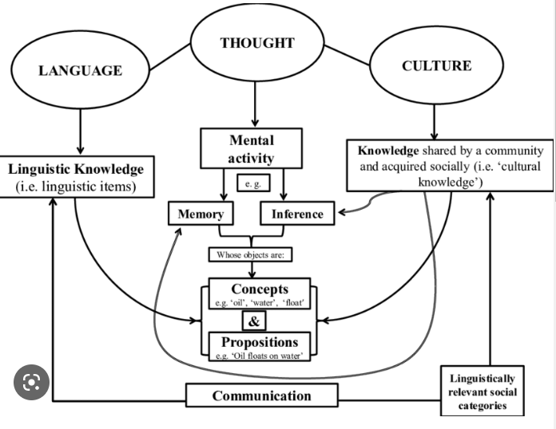

**Figure 1: Relation between language and thinking**

(Source: Researchgate, 2023)

Language is not an inborn characteristic of humans it is learned over the years, it is one of the first thing that humans learn. Though it is not possible for an individual to create words just after birth, the human minds start acquiring the language in their minds they hear from their surroundings (Mamadalieva, 2021). Language is basically the Skeleton that allows the mind to create thoughts of consciousness Humans have self-reflective characteristics and language helps to process information in a proper way. It has been found that individuals who learn more languages their mind work faster and that may be the reason that smart people have great vocabulary characteristics. Learning helps the mind to respond differently in different situations Children who are bi-linguistic can easily learn various forms of information in their life.

## Natural language, programming languages and animal languages.

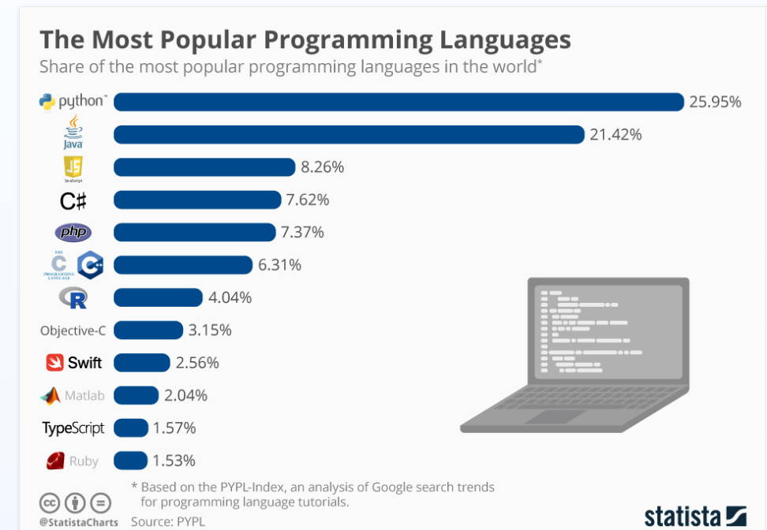

**Figure 2: Mostly used programming language**

(Source: Feldman and Richter, 2019)

It is important to evaluate the differentiation between the natural languages that are used by humans for the purpose of communication and the *programming languages* as it is important for various fields for the formulation of various tools necessary for the practical task. Recognition of the speech, extracting information from the text, and checking the grammar at the various practical task that correlates the natural language and the machine language. For example, Alexa converts a simple natural language to machine language through a message which is processed by the computer. Machine language is used for developing new software, it is unlike other languages as it uses binary codes to perform its operations (Guzman and Lewis, 2020). While natural language is based on the rules of grammar for communication purposes, on the other hand, the programming language is based on semantic rules that are the use of certain symbols. There are a few basic differences between the natural language, for example, English, and the programming language, for example, Java.

*Natural language* is used for communication purposes while programming language helps the individual to interact with the machine (Qiu, et al., 2020). Programming language needs to be precise and should be interpreted by a high level of expertise as the machine cannot think of itself while using natural language few errors may occur but that can be interpreted by the other individual while making the communication. The crucial difference between programming and natural language is that the former may be used in an informal way while the latter uses a specific symbol for communication.

Animals also have their own languages and they used them for communication among themselves. Although animal language is not as complicated and expressive as natural language (Fitch, 2020). Animals generally communicate through body language like gestures and actions. Animals are known to be born with the capability of communication and those are not influenced by their surroundings, however, the human language is generally determined by the culture and society to which the individual belongs. The basic difference that exists between human and animal language is that humans have analytical skills that enable them to create new phrases, words and expressions On the other hand animals have only limited signals for communication as they cannot expand them.

# Conclusion

From the above-given points it can be concluded that human languages evolved through learning, while the programming languages fully based on the binary data input by the human and the animal language are the inborn characteristics that they get from the biological transmission.

# 

# Reference

Feldman, S. and Richter, F. (2019) Infographic: The Most Popular Programming Languages, Statista Infographics. Available at: https://www.statista.com/chart/16567/popular-programming-languages/ (Accessed: April 14, 2023).

Fitch, W.T., 2020. Animal cognition and the evolution of human language: why we cannot focus solely on communication. Philosophical Transactions of the Royal Society B, 375(1789), p.20190046.

Gibson, E., Futrell, R., Piantadosi, S.P., Dautriche, I., Mahowald, K., Bergen, L. and Levy, R., 2019. How efficiency shapes human language. Trends in cognitive sciences, 23(5), pp.389-407.

Guzman, A.L. and Lewis, S.C., 2020. Artificial intelligence and communication: A Human–Machine Communication research agenda. New Media & Society, 22(1), pp.70-86.

Mamadalieva, F.A., 2021. LINGUOCULTUROLOGICAL ASPECT OF THE RELATIONSHIP BETWEEN LANGUAGE AND THINKING. Scientific progress, 2(1), pp.1012-1017.

Qiu, X., Sun, T., Xu, Y., Shao, Y., Dai, N. and Huang, X., 2020. Pre-trained models for natural language processing: A survey. Science China Technological Sciences, 63(10), pp.1872-1897.

Researchgate,2023.The relationship between language, thought, and culture (no date). Available at: https://www.researchgate.net/figure/The-relationship-between-language-thought-and-culture_fig2_317372213 (Accessed: April 14, 2023).