**STRATEGIES FOR THE DIGITAL ECONOMY**

**Executive Summary**

Digital economy does refer to the global network of financial activities, commercial transactions as well as professional interactions that can be enabled by ICT. The study determines the aspects of the digital economy and identifies appropriate digital strategic innovation for Next Plc to overcome its issues and gain strategic advantage. Investing in R&D can help the company to enhance their productivity and revenue. This study, further, has developed a detailed implementation plan along with key performance measures and technological development.

Table of Contents

Introduction 3

a. Evaluating a strategy for the organisation to succeed in the digital economy 3

i. Identify the key issues facing the company 3

ii. Select and define a relevant digital strategy 4

iii. Discuss the innovation that is critical to the success of this strategy 6

b. Creating an implementation plan that leverages relevant digital technologies 7

i. Create an appropriate project plan to implement the strategy 7

ii. Identify the key performance measures to monitor the success 8

iii. Identify the key processes to be fulfilled to ensure success of the implementation plan 9

iv. Discuss the importance of the appropriate relevant digital technologies needed for the success of the strategy 10

Conclusion 11

References 12

# Introduction

The digital economy strategy tends to increase the ability of building foundations to expand the digital economy and capability in adapting emerging advanced technologies to support digital growth. The UK government has taken a strategic approach to increase the foundation of the digital economy by harnessing the power of data and conferred by Brexit to support growth and encourage both innovation and investment (Gov.uk, 2022). The purpose of the study is to demonstrate a digital economy strategy for the organisation *Next Plc* to get success through innovation. This paper focuses on the digital economy strategy of investing majorly on Research and Development to stimulate private investment. The study also analyses an implementation plan of leveraging relevant digital technologies for the organisation to gain strategic advantage through change.

# a. Evaluating a strategy for the organisation to succeed in the digital economy

## i. Identify the key issues facing the company

The global environment is rapidly increasing and developing through the constant emergence of advanced technologies. It determines that organisations need to evolve with the emerging technologies in order to support growth and success. In this case due to the lack of proper incorporation with advanced technologies, organisations in the UK are experiencing a significant decrease in sales due to losing customers (Martínez-Caro *et al.* 2020). Next Plc is also experiencing certain challenges due to its incapability of proper adaptation of technologies and supporting digital economic success. The identified key issues of Next Plc through analysing their current situation are described further;

* Next Plc does not use chatbots as a transaction processing system instead they still use manual workflow to provide information to their consumers. Their inability of assisting their consumers 24/7 and resolving their queries instantly is majorly affecting consumer retention rate of the company. A recent report shows that the company gets its 50% orders from online and 80% returns to the store due to their incapability of understanding the consumer needs and providing proper guidance and fulfilling their demands (Proactiveinvestors.co.uk, 2019). Hence, it is majorly affecting their sales growth.
* Another issue of decline in sales that has emerged is due to the effects of the Russia-Ukraine war. It has been identified that the closing of Russia and Ukraine websites of Next Plc cost £85m loss in sales (Business-live.co.uk, 2022). Therefore, the company is majorly facing a significant decrease in demand and sales which is impacting majorly in their revenues and losing investors.
* The company does not contain stock information and previous sales information which further influences issues with their consumers and determines complexities in resolving consumer order issues.
* Next Plc also does not invest in research and development which is limiting their services to fulfil the demands of the market and the consumers. Therefore, it has also impacted majorly in their sales and decreased the satisfaction level of their consumers. The lack of digital support affected 56% drop which majorly affected their revenues in 2020 (Ft.com, 2020).



**Figure 1: Sales drop of Next Plc UK**

(Source: Ft.com, 2020)

## ii. Select and define a relevant digital strategy

Digital strategies demonstrate the proper implementation of the digital technologies and expanding businesses in the digital platform to overcome issues of the current environment and to lead through digital disruption. It has been identified that Next Plc is majorly experiencing issues due to their incapability of adopting digital technologies and lack of investment in R&D is increasing their issues while establishing their business in the UK market. Hence, the company might consider undertaking the strategy to *invest majorly on Research and development (R&D) to harness the power of data* and incorporate the information to get beneficial outputs.

Research and development helps organisations to stand against competition and helps in gaining strategic advantage to sustain growth. This strategy not only can help Next plc to enhance R&D tax incentives to stimulate private investment but also can help in understanding the needs and demands of the consumers (Gov.uk, 2022). As per the “2018 Amendment (No. 7)” enterprises can enjoy additional tax deductions with expenditure sustained on domestic R&D. It has been figured that Next Plc has approximately 8 million consumers and amongst them 6 million are from the UK (Nextplc.co.uk, 2022). Thus, the company can significantly focus on investing in domestic R&D to get additional tax deductions and get major information to create further strategic approaches to increase the satisfaction level of their consumers. For instance, the amendment determines that the first $2 million spent on a qualifying R&D can allow 300% deduction in tax and further expenditure can allow further 200% deduction (Gov.uk, 2019). For example, Burberry has invested around £80 million in R&D which has helped the company to sustain in the complex environment (Fashionnetwork.com, 2019). Thus, it can determine a major optimization of expenses of Next plc and the company can use extra funding to implement advanced technologies to increase their efficiency to support the digital economy.

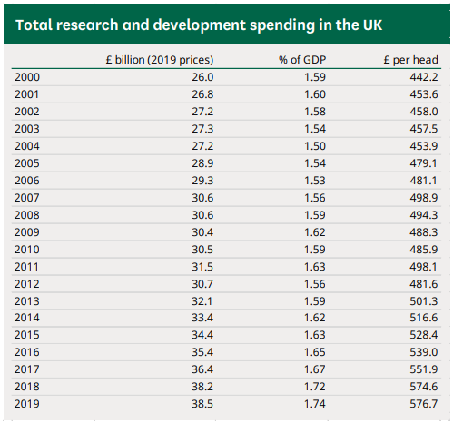

**Figure 2: UK government spending for R&D section**

(Source: Researchbriefings.files.parliament.uk, 2022)

The company needs to sustain their investors and to get more support to diversify their organisation services to support the demand of their consumers. However, Next Plc is losing investors due to their decline in sales and losing the demand of the UK consumers. It has been identified that the company investors are sitting on a 26% loss (Nextplc.co.uk, 2022). Furthermore, with the implementation of the strategy of investing majorly on research and development can help the company to enhance R&D tax incentives which can stimulate private investors. The digital strategy of investing more on R&D can help demonstrate better resources and creative ideas to gain competitive advantage for Next Plc to conduct their business in the rapidly changing environment. Additionally, the UK government investment in research and development has increased from £15 billion to £20 billion between the years 2020 and 2021. Currently the allocated R&D budget of the UK government is £39.8 billion for 2022-2025 (Gov.uk, 2022). It determines that the UK companies such as Next plc need to majorly focus on investing in R & D to retrieve their sales.

## iii. Discuss the innovation that is critical to the success of this strategy

Next Plc needs to critically access data and information regarding consumers and the market demands in order to understand the demand and the market trends. Based on the study of Gong and Ribiere (2021), the global environment is rapidly developing through bringing revolutionary changes and innovation. Therefore, in order to successfully implement the strategy the company needs to access massive data regarding the fashion industry and conduct research developmental procedures through bringing innovation. Hence, it can help the company to sustain in the complex and competitive market. The major competitors of Next plc in the UK market are Zara, H&M, Marks and Spencer, Primark and other retailers. It can be determined that these companies have undertaken special digital strategies to satisfy their consumer demand. For example, Zara has taken fast fashion strategy to support the rapid change in demand and fashion trends in the fashion industry (Hbr.org, 2022). Therefore in order to compete with these retailers the company might consider adapting advanced technologies such as chatbots, cloud computing, AI and big data analytics to support innovation through investing in R&D. Moreover, it can be determined that analysing the major concepts of research and development it can be analysed that the company might consider enhancing their employment resources as well to get efficient performance to support these technological advancements.

Investment in R&D can help Next Plc to contribute to the economy through taking participation in the market more appropriately and getting cost benefits and investors support can majorly help the company to overcome the identified challenges and issues. Based on the study of Loureiro *et al.* (2020), stakeholder’s involvement and proper engagement is crucial for companies to bring revolutionary change and innovations. Therefore, with more investment in R&D the company can get the benefit of stimulating private investment aspects.

# b. Creating an implementation plan that leverages relevant digital technologies

## i. Create an appropriate project plan to implement the strategy

The company implementing the digital economy strategy of investing more on R&D can be followed by a project plan described below;

| **Objectives** | **Involved stakeholders** | **Strategies** | **Duration** |
| --- | --- | --- | --- |
| To identify investors to sponsor the R&D program | CEO, operation manager, PR executive | Creating channels and building effective networking systems to gather investors for R&D programs. Using proper PR techniques to enhance communication level and convincing power. | 2 weeks |
| To implement advanced technologies | IT executive, senior manager | Adapting AI, big data analytics and cloud computing to support the R&D requirements. | 2 weeks |
| To provide adequate training to the employees | Associates, Operational manager | Organising training programs that can increase the efficiency level of the employees. | 2 weeks |
| To deploy market researcher | HR manager | Providing adequate resources to the market researcher to evaluate information gathered by conducting R&D. | 2 weeks |
| To brainstorm creative ideas to implement development | Employees, team leaders, managers | Gathering knowledge and increasing networking systems to brainstorm ideas that can help accelerate their sales based on the R&D reports. | 2 weeks |

**Table 1: Project plan for implementing R&D program at Next Plc**

(Created by Author)

The above table depicts the implementation plan of the R&D program to ensure proper success. It can be determined that analysing the implementation plan demonstrates that proper engagement of the stakeholders of the Next Plc is majorly important for the company to successfully invest in R&D to get benefits. Next Plc operates with approximately 43,040 employees that help the company to conduct business efficiently (Nextplc.co.uk, 2022). Therefore, the company needs to organise training to enhance the efficiency of their employees to obtain the required skill set to operate digital technologies. Thus, it can help the company to ensure proper utilisation of R&D and the implemented advanced technologies.

## ii. Identify the key performance measures to monitor the success

Certain measures can be taken in order to ensure proper utilisation of the R&D program and to monitor the success. The measures that can be taken are;

* Next Plc might consider effectively analysing their *return on digital investments*. It can help the company to ensure proper returns and evaluate profits due to investment in R&D and related technologies. Based on the study of Chen and Srinivasan (2023), return on digital investments can help depict profit that is gained by the investment on the additional digital technologies for research and development. Therefore, analysing the return on digital investments is crucial to analyse the beneficial output.
* Analysing *employee productivity i*s the key measuring point that can majorly help the company to understand the performance level of the employees to determine proper implementation of the plan to invest and incorporate with the R&D program.
* *Adoption & Performance Metrics* such as; customer reviews, personal reviews, feedbacks, ratings and consumer satisfaction level these measures can be taken cautiously to evaluate the benefits of implementing R&D.
* *Cost benefit analysis* can also help in determining the success rate of the digital economy strategy. As opined by Mishan and Quah (2020), cost benefit analysis helps organisations to gather data on the intervention benefits through comparing costs in monetary units. It can help the company to determine the specific benefits gained by investing in R&D.
* *Revenue from Digital Technology* is considered as another major performance indicator which can help organisations to determine the specific amount that has been gained by implementing the advanced technologies. Next plc might consider evaluating and analysing their profits and comparing their profits to gather data on the major benefits gained by implementing digital technologies.

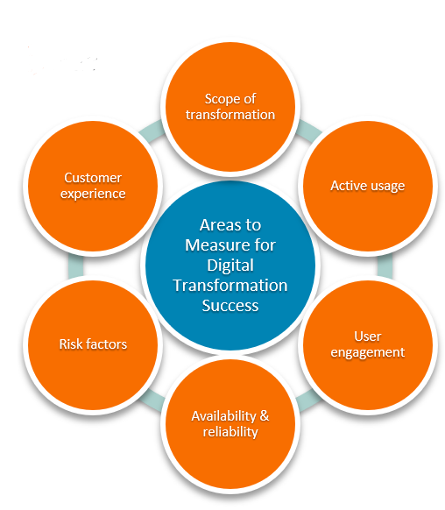

**Figure 3: Measuring areas for digital transformation**

(Source: Mishan and Quah, 2020)

## iii. Identify the key processes to be fulfilled to ensure success of the implementation plan

The key processes to ensure the success of the implementation are;

* Next Plc might ensure an effective leadership to ensure success of the implemented plan to determine proper investment on R&D and utilising the implemented digital technologies. Transformational leadership can help organisations to adapt changes more efficiently that can majorly help accelerate the process of bringing innovation (Bakker *et al.* 2022). Therefore, it can be determined that the company in order to ensure the success might consider implementing transformational leadership that can help gilding the employees towards change more effectively and smoothly.
* Next Plc has a diversified and inclusive workforce which enables the company to get different skilful employees. Thus, the company might consider undertaking feedback regularly to get major insights on the efficiency of the implementation plan.
* Proper communication plan is needed for the company to ensure success with zero conflicts. Based on the study of Carnevale and Hatak (2020), employees tend to get used to traditional processes and find it hard to comply with sudden change. Therefore, in order to incorporate digital technological usages, proper communication between employees and their leaders needs to be amended to resolve queries more effectively.
* The company might also conduct a survey process to ensure proper utilisation of their strategy and ensure innovation. The company can further go through the process of determining effective strategic operations of the plan to ensure success.

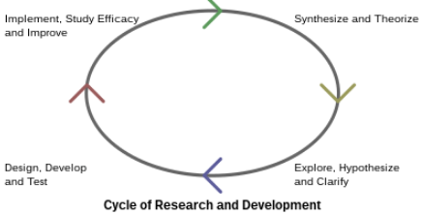

**Figure 4: R&D process**

(Source: Bakker *et al.* 2022)

## iv. Discuss the importance of the appropriate relevant digital technologies needed for the success of the strategy

Research and development requires proper alignment with advanced technology usage which can have intensity benefits. It has been identified that Next Plc is experiencing a significant decline in their sales which is affecting their business. Due to the decreasing demand of consumers the company majorly needs to invest in R&D to accelerate success. Based On the study of Siddiqui *et al.* (2019), cloud computing is an effective technology which helps in incorporating R&D processes. Therefore, the company Next Plc can leverage cloud computing to get beneficial attributes and enhance their productivity to gain strategic advantage. It has been identified that approximately 75% of the companies in the UK have incorporated digital technologies to sustain in the current complex market and to gain competitive advantage. Therefore, with proper investment in R&D the company can get major benefits through increasing their online consumer satisfaction and mitigating their issues related to decreasing consumer demand for their services and products. Hence, it can be determined that investing in R&D is majorly important for Next plc to determine success and to understand the demand of the consumer and increasing consumer retention rate.

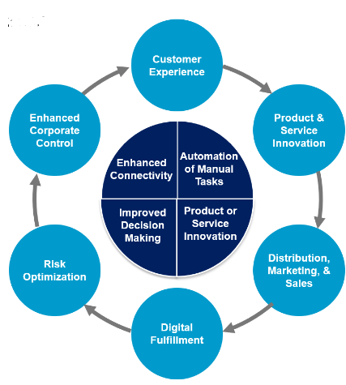

**Figure 5: Key processes and fundamentals of R&D**

(Source: Siddiqui *et al.* 2019)

# Conclusion

The study concludes that the digital economy plays a major role in success and proper establishment. It has been identified that R&D majorly helps in bringing innovation revolutionary change which is necessary for sustaining future growth. Hence, Next Plc can majorly get help from investing in R&D and gain strategic advantages. This paper helps to demonstrate the need to adapt innovation strategies to support the digital economy.

# References

Bakker, A.B., Hetland, J., Olsen, O.K. and Espevik, R., (2022). Daily transformational leadership: A source of inspiration for follower performance?. European Management Journal.

Business-live.co.uk (2022), *Closing Ukraine and Russia websites to cost Next Plc £85m in lost sales;* Available at: https://www.business-live.co.uk/retail-consumer/closing-ukraine-russia-websites-cost-23484674 [Accessed on: 5th April, 2023]

Carnevale, J.B. and Hatak, I., (2020). Employee adjustment and well-being in the era of COVID-19: Implications for human resource management. Journal of business research, 116, pp.183-187.

Chen, W. and Srinivasan, S., (2023). Going digital: Implications for firm value and performance. Review of Accounting Studies, pp.1-47.

Fashionnetwork.com (2019), *Burberry, Asos join 'first-of-its kind' R&D programme for UK fashion industry;* Available at: https://ww.fashionnetwork.com/news/Burberry-asos-join-first-of-its-kind-r-d-programme-for-uk-fashion-industry,1034936.html [Accessed on: 5th April, 2023]

Ft.com (2020), *Outlook brightens at Next as decline in sales eases sharply;* Available at: https://www.ft.com/content/4e7c12c7-f693-459e-8a40-ef380f3808f8 [Accessed on: 5th April, 2023]

Gong, C. and Ribiere, V., (2021). Developing a unified definition of digital transformation. Technovation, 102, p.102217.

Gov.uk (2019), *DEDUCTION FOR RESEARCH AND DEVELOPMENT EXPENDITURE;* Available at: https://www.ird.gov.uk/eng/pdf/dipn55.pdf [Accessed on: 5th April, 2023]

Gov.uk (2022), *Government announces plans for largest ever R&D budget;* Available at: https://www.gov.uk/government/news/government-announces-plans-for-largest-ever-rd-budget [Accessed on: 5th April, 2023]

Gov.uk (2022), *UK Digital Strategy;* Available at: https://www.gov.uk/government/publications/uks-digital-strategy/uk-digital-strategy#:~:text=We%20are%20rolling%20out%20world,encouraging%20both%20investment%20and%20innovation. [Accessed on: 5th April, 2023]

Hbr.org (2022), *Rapid-Fire Fulfillment;* Available at: https://hbr.org/2004/11/rapid-fire-fulfillment [Accessed on: 5th April, 2023]

Loureiro, S.M.C., Romero, J. and Bilro, R.G., (2020). Stakeholder engagement in co-creation processes for innovation: A systematic literature review and case study. Journal of Business Research, 119, pp.388-409.

Martínez-Caro, E., Cegarra-Navarro, J.G. and Alfonso-Ruiz, F.J., (2020). Digital technologies and firm performance: The role of digital organisational culture. Technological Forecasting and Social Change, 154, p.119962.

Mishan, E.J. and Quah, E., (2020). Cost-benefit analysis. Routledge.https://books.google.com/books?hl=en&lr=&id=IGoPEAAAQBAJ&oi=fnd&pg=PP1&dq=Cost+benefit+analysis+&ots=QumZ_PxkvY&sig=nwhfTqOIjFYaBajwVZdZB_MaOEM

Nextplc.co.uk (2022), *BUSINESS MODEL;* Available at: https://www.nextplc.co.uk/~/media/Files/N/Next-PLC-V2/documents/2019/business-model.pdf [Accessed on: 5th April, 2023]

Nextplc.co.uk (2022), *OUR PEOPLE;* Available at: https://www.nextplc.co.uk/~/media/Files/N/Next-PLC-V2/documents/corporate-responsibility/cr-2021-our-people.pdf [Accessed on: 5th April, 2023]

Nextplc.co.uk (2022), *Results for the Half Year Ending July 2022;* Available at: https://www.nextplc.co.uk/~/media/Files/N/Next-PLC-V2/documents/2022/half-year-results-july2022.pdf [Accessed on: 5th April, 2023]

Proactiveinvestors.co.uk (2019), *Next still facing UK retail challenges amid weak consumer demand, analysts caution;* Available at: https://www.proactiveinvestors.co.uk/companies/news/183994/next-still-facing-uk-retail-challenges-amid-weak-consumer-demand-analysts-caution-183994.html [Accessed on: 5th April, 2023]

Researchbriefings.files.parliament.uk (2022), Research & Development Spending; Available at: https://researchbriefings.files.parliament.uk/documents/SN04223/SN04223.pdf [Accessed on: 5th April, 2023]

Siddiqui, S.T., Alam, S., Khan, Z.A. and Gupta, A., (2019). Cloud-based e-learning: using cloud computing platform for an effective e-learning. In Smart Innovations in Communication and Computational Sciences: Proceedings of ICSICCS-2018 (pp. 335-346). Springer Singapore.