**ASSIGNMENT 2- INDIVIDUAL BUSINESS DISSERTATION**

**A STUDY INTO HOW COMPANIES INFLUENCE TECHNOLOGY AND INNOVATION WITHIN SUPPLIERS: CASE OF APPLE AND SAMSUNG**

**Abstract**

The research is aimed at highlighting the importance of technological innovation in managing the supply chain of Apple and Samsung in a better way. The research also highlights the rising challenges in Apple and Samsung due to their adaptation of technological innovation. The measures which are needed to be followed to mitigate those challenges are also mentioned. The research is carried out by following interpretivism philosophy, inductive approach and descriptive design. The implementation of technological innovations has helped Apple and Samsung to maintain their SCM. It helps the brands to keep a record of their huge number of suppliers. It also demonstrates the effect of using modern technologies to influence their sales figures. However, there is a certain lack of data regarding extensive strategies which are followed by brands to mitigate the challenges of implementation of technological innovation. The research also focuses on providing recommendations like investing more in the production facilities which produce electronic chips on their own, providing suppliers with financial assistance in their moments of distress.

**Table of Contents**

Introduction 4

Background of the research 4

Rationale of the research 4

Research Aims and Objectives 5

Research Question 5

Brief overview of Methodology 5

Significance of the study 6

Summarisation of the findings 6

Reflection 12

Conclusion 15

References 16

Appendices: 17

Appendix 1: Staged submission 1 17

Appendix 2: Staged submission 2 34

Appendix 3: Staged submission 3 41

# Introduction

## Background of the research

Technological innovation is a function through which new technologies are introduced in the market and are adopted by marketers and suppliers for fast and efficient work. As per Dash *et al*. (2019), technological innovation plays a huge role in modern days as it helps marketers as well as to maintain the quality of the products and deliver the products at the right time which increases the brand value and sales of the businesses. Hence the suppliers should adopt technological innovation as it helps them to deliver the products at the right time to their consumers which helps to increase the relationship between the suppliers and consumers and hence will increase the profitability of the suppliers. As per Almeida *et al*. (2021), Apple and Samsung are the two most popular companies in the technology industry. Apple is an American technology company. Its headquarters is in Cupertino, California. One of Apple's largest suppliers is Foxconn. Apple A16 bionic is the chip used in Apple supplier technology. As per Liébana-Cabanillas *et al*. (2020), the main aim of Apple is to bring the best experience received by the user through its innovations in their hardware and software.

Samsung is a South Korean technology company. Its headquarters are in Seoul, South Korea. Samsung Exynos Processor is the chip used by Samsung supplier technology. The main purpose of Samsung is to spend its technology and talents to make the best products and create the best global economy.

## Rationale of the research

The foremost issue faced by Apple and Samsung is high market competition and a shortage of chips. As per the perspective of Hermundsdottir and Aspelund (2021), market competition adversely affects business strategies where businesses tend to lead their concerned industrial marketplace. In terms of Apple, high product price allows its competitors to sell their respective products at a low price which helps them in engaging the customers easily. However, being one of the reputed OEMs, Apple focuses on quality which tends to influence product innovation which also helps them to remain competitive in the marketplace (NYtimes, 2022**).** In terms of Samsung, the concerned OEM faced a delay in the manufacturing of multiple electronic goods like CPUs and many more. It was observed that a delay in the supply of raw materials led the concerned business to delay its manufacturing process which in turn restricted fulfilling the demands of the customers within their expected time (Channelnews, 2021). The stated issues of Apple and Samsung can be addressed by improvising the supplier-brand relationship management where brands can influence suppliers to use or adopt technological innovation. Hence, this research tends to shed light upon the primary factors which influence the suppliers of Apple and Samsung to adopt technological innovation for improving their supply management.

## Research Aims and Objectives

**Aims**

This research aims to influence the technology and innovation within the suppliers of the brand Apple and Samsung.

**Objectives**

* To analyze the significance of the suppliers of Apple and Samsung fostering the technological innovation
* To critically identify the primary challenges faced by Apple and Samsung to encourage their supplier relationship
* To suggest potential recommendations to Apple and Samsung to improve their supplier relationship by adopting technological innovation

## Research Question

What is the key significance of influencing suppliers of Apple and Samsung to foster technological innovation?

What are the primary challenges faced by Apple and Samsung to encourage the supplier relationship?

What are the suggestions to Apple and Samsung to encourage the supplier relationship?

## Brief overview of Methodology

Methodology in this research context helped in acquiring relevant information and also in concluding the research work with effective findings. As per Momaya (2019), one of the primitive methodological frameworks which are widely used is named Saunders's research onion. This onion was followed while conducting this research as the layers of the onion helped in the breakdown of the research phases or milestones. In this context, the interpretivism philosophy was adopted while collecting secondary data in this research. As per the concern of Cerar *et al.* (2021), as compared to the primary data collection process, the secondary data collection procedure is an easier process to follow. Primary data sources were avoided as a collection of primary data could consume high time and would be required to attain appropriate consent from human participants. In this research prospect, secondary data sources were extracted from various data sources like Google Scholar, Proquest, organisational websites of Samsung and Apple. Sources included online journals, news articles and business reports presented on the official business website of Samsung and Apple. Hence, using a keyword search process, initially, 50 secondary data sources were collected, however, applying purposive sampling 15-20 data sources were selected finally. A descriptive research design and inductive research approach were applied while analysing the collected secondary data through a thematic analysis approach. Descriptive design helped in answering the above-mentioned research questions with key evidence. These methods helped in elaborating 7 themes with evidence. Discussion of themes in a narrative approach also helped the research to address every of the above-mentioned research questions.

## Significance of the study

Samsung and Apple focus on technology and innovation to increase sales, production, and profit and to maintain profitability and also influence their suppliers to use such technological innovation. Technology and innovation in modern days are necessary and thus it will help the suppliers of Apple and Samsung to increase the availability and production of the components and chips used in smartphones. This research also focuses on the impacts of technological innovation and the challenges faced by the suppliers while adopting technological innovation therefore this research is quite significant in influencing the technology and innovation within the suppliers of Apple and Samsung.

# Summarisation of the findings

***Finding 1: Technical innovation adopted by suppliers of Apple and Samsung helps them to improve their SCM***

The finding has been derived after considering Theme 1 of the secondary data analysis. It has been observed by cultivating the graphical data given under theme 1 that the number of suppliers of Apple has increased significantly in recent years in countries like China, Brazil and France. The increased presence of the suppliers in these countries has offered them access to a larger number of resources including raw materials and human labourers. Accessibility of these has enabled them to maintain their supply chain in a productive way. It has been observed that the adaptation of innovative technologies has multiplied the outcomes in the management of the supply chain. The introduction of automation and robotics technology has helped them to perform complex processes in easier ways. They have also helped them to mitigate human errors in their operations and keep a proper record of the stocks which helps them to avoid the risks of supply chain-related concerns.

Theme 7 of the secondary data analysis elaborates on the importance of properly trained employees among the suppliers. It highlights some of the advantages that the suppliers are supposed to enjoy by having a trained workforce. Application of technology in training purposes enables them to improve reliability, monitor service levels, simplify their operational processes, reduce costs and many more. The suppliers are able to monitor the progress of the services by using technology like surveillance software. Implementation of automation and robotics software helps them to simplify their processes which reduce the workload on them and the potential risks of errors committed by human resources.

Therefore, it can be interpreted by considering the mentioned themes of the secondary data analysis that the application of technological innovations in their operational procedures helps the suppliers to manage their processes in a better way. Thus, this finding helps us to analyse the significance of adapting technological innovation in the suppliers of Apple and Samsung.

***Finding 2: Brands like Apple and Samsung are getting inclined to use technological innovations among their suppliers as they are plenty in numbers***

Analysing Theme 2 of the secondary data analysis, it is observed that the number of suppliers of Apple and Samsung is plenty. Considering the data presented in the context it can be stated that the presence of the plethora of suppliers helps those mentioned brands to operate in a better way by removing their dependency on a smaller number of suppliers. It can be stated that brands like Apple and Samsung rely on different suppliers to procure the same raw material. Therefore, when some suppliers face issues in delivering the raw materials the brands can procure them from other alternative sources and keep the linearity of the production process intact. Besides, the presence of a large number of suppliers helps brands like Apple and Samsung to procure raw materials at a lower price by comparing the prices offered by different suppliers. However, there is a specific challenge in monitoring them through manual processes as they are huge in number. This is where looking at the technological solutions comes in handy.

Technological innovation helps them to establish a particular network between the brands and their suppliers and keep a record of the processes. This helps them to monitor the performance of their suppliers and direct their businesses accordingly to reward the performing suppliers in a better way. Therefore this finding also emphasises the importance of having technological innovation in the SCM of the respective companies.

***Finding 3: The performance of Apple and Samsung in terms of sales and generation of revenue helps them to influence their suppliers to improve their performance***

The thematic analysis of the third theme represented in the secondary data analysis provides information regarding the overall sales figures and profit margins of brands like Apple and Samsung. The performance of these brands leaves a positive impact on them as they feel pride in being a part of such successful companies. This feeling often motivates them to extend the degree of their performances. The suppliers look to go beyond the benchmark set by the companies to prove them beneficial for them since companies like Samsung and Apple treat their suppliers in a prioritised manner and look after their well-being.

It is also observed that these brands work with the same set of suppliers for a significant period of time which fosters a sense of attachment of the suppliers to the brands. Improved communication between them helps the suppliers to perform in a better way since they have proper clues regarding the operational processes of the brands. The role of using technological innovations by the suppliers to uplift their performance to contribute to the success of the brands is significant as it enables them to use various advantageous business procedures like automation, robotics, analytics and data management. Thus, this finding represents the significance of using technological innovations in suppliers to increase the profitability of the companies.

***Finding 4: Suppliers of Samsung and Apple face tough challenges from their competitors in adopting technological innovation in their operation***

Theme 4 and theme 5 of the secondary data analysis represent the challenges faced by the suppliers of brands like Apple and Samsung while performing several business operations. Theme 4 states that the presence of several other market players likes Oppo, Vivo, Xiaomi and many others works as a major challenge for the brands as well as their suppliers. The increased high competition between the suppliers of the brands is causing their businesses to witness several challenges. It is observed that most of the raw materials which are required in the primary production facilities of brands are mostly the same and their availability is also limited. It has also been showcased that several suppliers of Apple and Samsung are common ones.

Thus, an increased number of suppliers have access to limited resources, which makes it difficult for them to procure a significant amount of raw materials. This affects the overall profitability of the suppliers. Thus they are not able to spend significantly on new technologies due to the lack of financial resources which affects the sustainability of their business.

This is how this particular finding is aligned with the challenges faced by the suppliers of Apple and Samsung.

***Finding 5: High market competition and shortage of chips work as a challenge for the brands like Apple and Samsung***

High market competition is not only affecting the suppliers but the brands as well. Integrated circuits and chips are the main components of a Smartphone. The lack of availability of these and the increased competition between various brands are denting the overall business figures of companies like Apple and Samsung. Theme 4 elaborates on the presence of a high amount of competition among the brands that produce electronic gadgets and theme 5 depicts shortages in the availability of chips these two are working in a collaborative way in denting the overall business perspective of brands like Apple and Samsung.

The availability of raw materials is limited in electronic industries due to global issues like chip shortages in the electronic industry. Brands like Apple and Samsung have set up their own production facilities which manufacture chips. However, despite having their own production facilities these brands are not able to meet the demand for the chips which are required. Therefore the gap in the requirement and the availability of chips are stretching which is dampening the production processes and the overall revenue generation of these brands. The presence of various brands in the electronic industry which provides gadgets at a significantly lower cost as compared to Apple and Samsung is also damaging the overall business perspective of the mentioned brands. Since people are getting attracted to the alternatives which are presented in a cost-effective way.

***Finding 6: The net sales of the brands are getting affected by the shortage in availability of chips***

The production facilities are said to be suffering due to the issues in the availability of raw materials like semiconductor chips as discussed in theme 5 of the secondary data analysis. Owing to the scarcity of their availability electronic gadgets manufacturing committees are getting adversely impacted as they are not able to produce the same number of products which they desired to produce. Thus, it is creating a gap between the demand and supply of the products. It has also been observed that companies like Samsung and Apple have invested in their own production facilities. The facilities are developed to produce electronic chips that satisfy their demand. However, despite having their own production facilities they are not able to draw parity between the demand and supply. Thus the brands are finding it difficult to satisfy the needs of the customers. Besides, due to the issues in the availability of raw materials, the prices of the gadgets are getting increased. This is also forcing the customers to explore the alternate products of other brands which offer their products in a more cost-effective way. Thus the overall sales figures and the revenue of brands like Apple and Samsung are getting affected.

Therefore, it can be stated that this particular finding of the research deals with the challenge associated with brands like Apple and Samsung.

***Finding 7: Suppliers are getting inclined to adopt technological innovations which help them to counter delays in delivery issues***

One of the major issues that are faced by suppliers of electronic gadget manufacturing companies is regarding delays in delivery issues. The activities of the suppliers go through a range of processes which include the procurement of the raw materials from their producers and then supply to the production facilities of the companies. However, it is observed that there are some instances in which the deliveries are getting delayed and the companies are forced to pay for the delays by compromising their revenues. Theme 6 of the secondary data analysis comprehensively states that due to the issues in the supply chain how the deliveries of products like the Apple iPhone 13 got delayed. It also showcases how the lack of availability of chips has resulted in the reduced production of electronic gadgets by Samsung. Therefore, in order to mitigate the impacts of these mentioned issues several suggestions are made in terms of applying technological innovations.

The introduction of innovative technologies ensures that the companies are able to track the supply process in a useful way that enables them to register new orders after considering several aspects of the SCM in real-time. This consideration will enable them to mitigate the issues regarding the delay in delivery.

Hence it can be said that this finding is aligned to provide suitable measures which can be used by brands like Apple and Samsung to reduce the challenges faced by their suppliers.

***Finding 8: Proper training of the suppliers helps in improving the relationships between the suppliers and businesses***

It has been observed from the above research that proper training of the suppliers works as a major tool in managing the relationship with the suppliers. Theme 7 highlighted in the secondary data analysis comprehensively elaborates on the role of proper training of the suppliers in improving the relationship between the suppliers and the brands. Theme 7 showcases that proper training of the suppliers enables the brands like Apple and Samsung to improve the reliability of the suppliers, monitor the aspects of the contract they form with their suppliers, reduce costs, improve customer service and many more. It can be stated that several training programmes will direct the suppliers to work in a specific way to accomplish the target set by the company. SRM also enables the brands to direct their suppliers to operate in a cost-effective way by using tools like price control and driving innovations.

SRM also helps the brand to motivate its suppliers so that they work tirelessly to improve the reputation of the respective brands. Motivated suppliers who are trained effectively perform their tasks efficiently which increases the quality of the products and the services of brands like Apple and Samsung. This in turn looks after the generation of revenue by fostering satisfaction among its customers. The brands, therefore, look to carry on the partnership with the suppliers who are able to bring profitability to the businesses. This helps them to operate their businesses in a more successful way since the suppliers who are associated with the business for a long period of time are supposed to have a more profound idea regarding the business practices of the brands. Hence, it can be interpreted that training the suppliers works as a measure to mitigate the challenges faced by the respective brands and their suppliers.

***Findings 9: Brand-supplier relationship management is also affected by increasing competition in the case of both Apple and Samsung***

From the discussion of theme 4, it was clearly identified that both OEMs face high competition in their respective operating marketplaces. It was discussed that high market competition hinders brand-supplier relations as suppliers face tremendous issues while focusing on supply management. However, it was also identified in theme 2 that a huge set of suppliers for both the OEMs enabled them in procuring the raw materials at a cost-effective price. Hence, the brand-supplier relationship is well maintained in both cases where brands focus on procuring the best quality materials at affordable prices. The use of technological innovation for suppliers also improvised the supply practices in both cases where it was observed that brands influence suppliers to use such technologies to foster their practices and sustain their SCM activities. However, multiple literary sources also discussed that the adoption of technological innovation is a challenging factor, hence, in the last theme providence of training facilities to the suppliers can also be effective in building high brand supplier relationship management. However, it was also identified that the manufacturing process of both businesses degraded since the pandemic, hence, the adoption of high brand supplier relations in Apple and Samsung can also help such businesses to sustain their competitiveness in the upcoming future prospects.

# Reflection

The overall process of conducting the whole research is explained through the lens of the Gibbs reflective cycle. This reflective cycle is aimed at providing structures to the learning derived from experience by examining them and allowing the researchers to learn and plan from several incidents of the research. Gibbs's reflective cycle primarily covers around six different stages of a study. They are illustrated in the following figure.

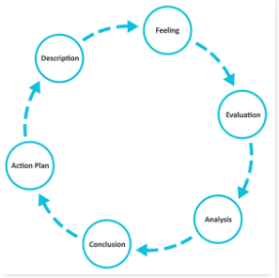

**Figure 1: Stages of Gibbs reflective cycle**

(Source: Adeani *et al.* 2020)

***Description***

While pursuing the "MAR042-6 Business Dissertation" unit, I was instructed to complete two assessments, where the first assessment involved the completion of a proposal and a dissertation in the second assessment. I was asked to prepare an individual business dissertation by conducting research on how companies like Apple and Samsung introduce and implement technological innovations in their process of managing the supply chain which benefits the profitability of the suppliers as well as the brands. In week 5, I completed the literature review in 2000 words. In week 7, I submitted a detailed analysis of the method in 1500 words. In week 9, I completed the analysis of the research findings in 2000 words. I was given this opportunity by my professor at the University of Bedfordshire Business School last month. During the event of getting the responsibility to conduct the research on the mentioned topic, my professor, my friends at the university, my classmates and the honourable project moderator were there. All of my classmates and I was anxiously waiting to find out our respective research topic. Our professor handled the situation with thorough expertise which he gained through the experience of many years and demonstrated each of the topics to us in a simple yet engaging way. I was there to receive my research topic which was part of the university curriculum and I was expecting to receive an easy yet interesting research topic that would help me to develop my research and analysing capability.

***Feeling***

I was really nervous before starting the research procedures by considering the potential outcomes of the research but the difficulties regarding the procedures seemed to evaporate after I started to conduct this research in a planned manner. At first, I figured out the importance of the research in the rationale part and sighted the aims and objectives of the research which were to find out the significance of implementing technological innovation in SCM of Apple and Samsung, the challenges which the companies were facing in implementation and provide the suitable strategies to mitigate those challenges. Thereafter, I highlighted the variables of the research like the implementation of technical innovation and SCM based on the critical analysis of the available literature provided by previous scholars. After that, I considered interpretivism research philosophy, inductive approach and descriptive research design for the research. Following these procedures and conducting the research in a planned manner made things easier for me while conducting this research. I, like everyone else in my class, was also curious and at times a bit nervous like me during the conduction of the research. However, following the proper framework has enabled my classmates to conduct their research in a meaningful and easy way and overcome their initial anxiety.

***Evaluation***

Despite having the proper structure of the research I was a bit lethargic in the first half of the research which put an additional burden on me to complete the entire process within the stipulated time. The availability of the data is fundamental to the research; in this case, all of our classmates have worked in a collaborative way. Anyone, when he was finding any data which held relevance to the research work of others, was sharing that with everyone. Therefore, the collection of data became relatively easy.

***Analysis***

I observed that the implementation of technological innovation has enabled Apple and Samsung to maintain their SCM in a better way, a large number of suppliers is forcing brands to use digital approaches in keeping records of them, huge competition in the market and lack of availability in chips are suppressing the growth of the companies. I was able to conclude that measures like training the suppliers according to the demand of the market may help the companies to mitigate the challenges. I would like to stress the fact that the availability of data regarding the companies enabled me to conduct the research in a prolific way.

***Conclusion***

I was able to conclude that the introduction and implementation of technological innovation in the SCM play a pivotal role for the companies like Apple and Samsung. Technology helps them to maintain the supply chain in an easy way by implementing automation, robotics and analytics. However, I felt there was room for improvement in finding more suitable measures which could help the brands to mitigate challenges like high competition and availability of chips.

***Action plan***

If I was given the task of performing the same task again I would have followed the same procedures but worked in a more dedicated way from the very beginning. That would have taken care of the increased load that I took during the end of the deadline. I would have set myself a daily target which I would be competing in the given timeline so that I could complete the task much before the deadline without burdening myself with a lot of tasks.

**Recommendation**

As discussed in the research itself, Apple and Samsung have started their own facilities to produce electronic chips. However, they are not able to meet the current demand. Therefore, I would suggest the companies speed up their processes in the production facilities so that they are able to produce a large number of chips which can satisfy the need. The companies should hold regular training of their suppliers so that they are able to operate in a more productive way. At times, the brands should provide their trusted suppliers with financial assistance like loans to improve technological infrastructure in their facilities.

# Conclusion

The research aimed at providing the significance of using technological innovations in the suppliers of brands like Apple and Samsung. It can be concluded from the research that technological innovations help suppliers to manage the supply chain in a better way by adapting to facilities like automation, robotics and analytics of data. The suppliers are facing major challenges due to the increased competition in the market and the lack of availability of raw materials like electronic chips. It can be concluded from the research that companies should look to rely on alternate channels to procure chips that help in maintaining the linearity of the production line. The research also states the importance of training the suppliers to operate them in a more useful way.

# References

Adeani, I.S., Febriani, R.B. and Syafryadin, S., 2020. USING GIBBS’REFLECTIVE CYCLE IN MAKING REFLECTIONS OF LITERARY ANALYSIS. *Indonesian EFL Journal*, 6(2), pp.139-148.

Almeida, M., Sousa, E., Rodrigues, C., Candeias, M.B. and Au-Yong-Oliveira, M., 2021. Samsung vs. Apple: How Different Communication Strategies Affect Consumers in Portugal. *Administrative Sciences, 11*(1), p.19.

Cerar, J., Nell, P.C. and Reiche, B.S., 2021. The declining share of primary data and the neglect of the individual level in international business research. *Journal of International Business Studies*, *52*(7), pp.1365-1374.

Channelnews, 2021*. Samsung Electronics Facing Major Problems*. Available at: <https://www.channelnews.com.au/samsung-electronics-facing-major-problems/>[Accessed on: 12th April 2023].

Dash, R., McMurtrey, M., Rebman, C. and Kar, U.K., 2019. Application of artificial intelligence in automation of supply chain management. *Journal of Strategic Innovation and Sustainability, 14*(3), pp.43-53.

Hermundsdottir, F. and Aspelund, A., 2021. Sustainability innovations and firm competitiveness: A review. *Journal of Cleaner Production*, *280*, p.124715.

Liébana-Cabanillas, F., García-Maroto, I., Muñoz-Leiva, F. and Ramos-de-Luna, I., 2020. Mobile payment adoption in the age of digital transformation: The case of Apple Pay. *Sustainability, 12*(13), p.5443.

Momaya, K.S., 2019. The past and the future of competitiveness research: A review in an emerging context of innovation and EMNEs. *International Journal of Global Business and Competitiveness*, *14*(1), pp.1-10.

NYtimes, 2022*. Apple Built Its Empire With China. Now Its Foundation Is Showing Cracks*. Available at: <https://www.nytimes.com/2022/11/07/business/apple-china-ymtc.html>[Accessed on: 12th April 2023].

# Appendices:

## Appendix 1: Staged submission 1

**Chapter 2: Literature Review**

**2.1 Role of suppliers in electronic businesses**

A supplier is a person or an entity that delivers products and services at a reasonable cost to another entity for sale (Durmić, 2019). Suppliers in the electronics business must abide by all applicable laws and regulations, including those about child labour and the protection of human rights (Alghababsheh *et al.* 2021). Suppliers should provide equal opportunities to all retailers and treat them fairly and equally, regardless of their backgrounds. The below figure shows the role of suppliers in Supply Chain Management.

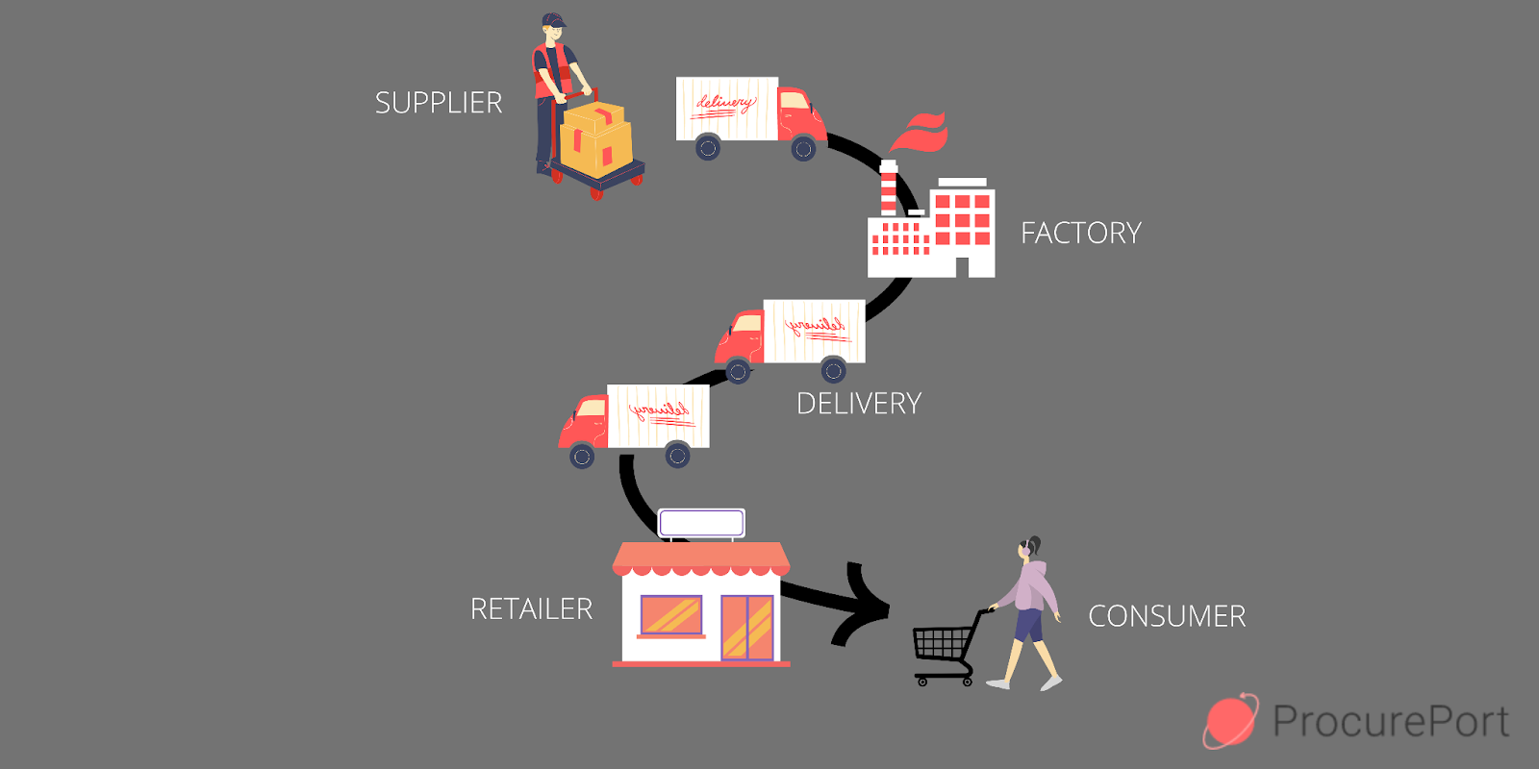

**Figure 2.1: The role of suppliers in Supply Chain Management.**

(Source: Ellram *et al.* 2019*)*

In order to keep merchants' trust, suppliers must guarantee them the product's quality and price and also present goods and services of high quality at reasonable prices which helps to enhance the future business of electronic goods. Suppliers use different modes of transportation to deliver goods within time at distribution centres, factories and warehouses. The practice of stock management enables suppliers to keep track of the product. This essential tracking system makes sure that the supply chain is not hampered by a shortage of products or raw materials for electronic goods. As per Ingaldi and Ulewicz (2019), one of the main responsibilities of suppliers in the electronics business is to fulfil the requirements of organizations by accepting, packing, and shipping orders for particular products and services.

**2.2 Issues faced by suppliers and their impact on electronics businesses**

The issues faced by the suppliers of electronic businesses include competition, order fulfilment, issue of quality and more. As per Alzoubi *et al*. (2022), the competition in electronics technology is developing day by day as electronics businesses play a vital role in the development of other businesses. Therefore the competition in the electronic business in the market is high and the suppliers face issues as the competition in the electronic business increases. Hence the competition creates a big impact on the sales of electronic products. The second issue faced by the suppliers' of electronic businesses is order fulfilment as the demand for electronic technologies is very high. Therefore it creates problems for the suppliers of electronic businesses to fulfil the orders required by the consumers and retailers. As per Fabeil *et al*. (2020), lack of order fulfilment creates a big impact on electronic businesses as it cannot satisfy the customers which can affect the business. Finding the right market is also a big issue faced by the suppliers of electronic businesses. The supplier also faced the issue of quality of electronic products as the customers purchase the electronics products from the suppliers. However, as per Wang *et al*. (2020), the quality issues of the electronics products can affect the supplier. Hence the quality issues of the electronic products have a big impact on the electronic businesses of suppliers as it decreases the brand value and the sales of the electronic goods which creates losses for the electronic businesses of the suppliers.

**2.3 Influencing factors of using technologies for suppliers**

Here some factors have been discussed that influence suppliers by using technologies.

**Quality of products**

It is observed that technological innovation practices can affect product quality. Using technology in the products and services can help consumers to get the desired quality of the product. Product quality can enhance the product market position which helps to increase the market share of the electronic industry as well. The below figure shows the effectiveness of technology in service quality.

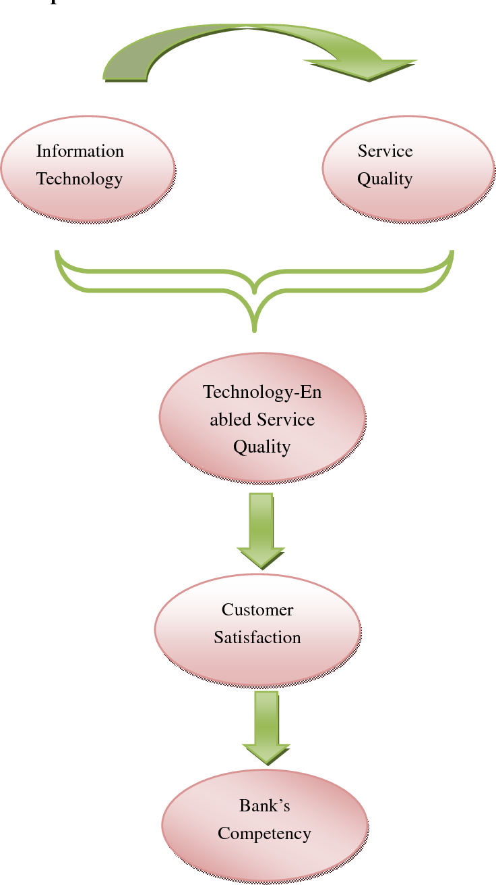

**Figure 2.3.1: The effectiveness of technology in service quality.**

(Source: Olimovich *et al.* 2020)

**Delivery**

With the help of technology, the delivery of any product is fulfilled within less amount of time which helps to meet the satisfaction level of clients. Therefore it can be said that an increased level of technology, will increase the efficiency of the product and service delivery as well.

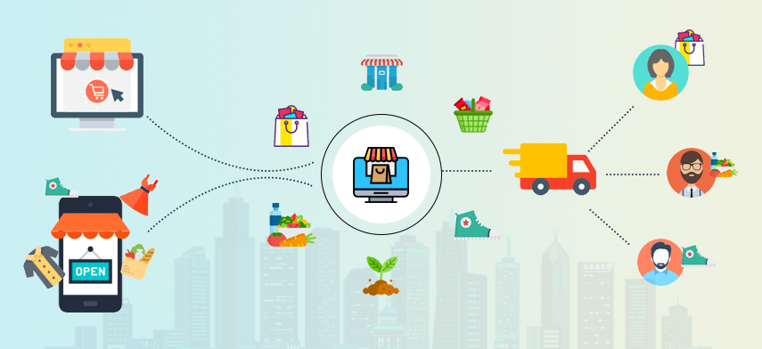

**Figure 2.3.2: The delivery model on consumer demand**

(Source: Yang *et al.* 2020)

The above figure shows the delivery model on consumer demand. Demand planning and forecasting technology and software help suppliers to improve their forecasts, assure the supply and demand of authentic products, and on-time delivery of products and services is also done which provides a positive impact on the client's experience.

**Cost**

Prices of any products or services are dependable on product quality, market and competitive factors. Technology helps to filter and sort the prices of all products and services which helps the consumers to get an overview of the product prices. The consumer will demand more products if the price of that product is low compared to others. On the other hand, providing offers on different products and services can also increase demand. The below figure shows the impact of information technology on reducing the cost.

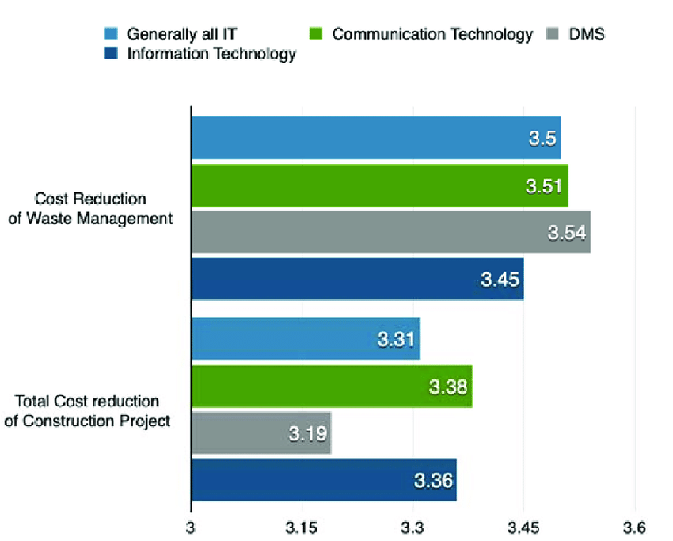

**Figure 2.3.3: The impact of information technology on reducing the cost**

(Source: Tallon *et al.* 2019)

**Competitive Market**

Technology helps to gather information about the target market. The below figure shows some importance of Technology in Marketing.

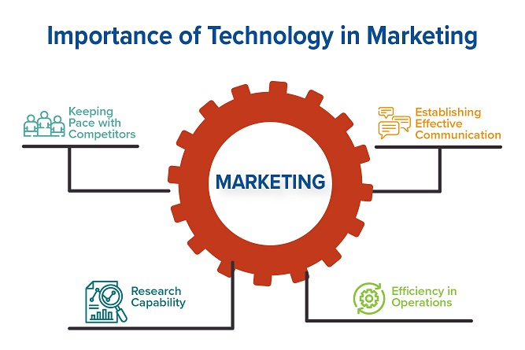

**Figure 2.3.4: Importance of Technology in Marketing**

(Source: Vlačić *et al.*  2021)

After knowing about the competitors, it is required to change the marketing strategy so that the demand for the product and services is increased compared to others which will lead to gaining a competitive advantage.

**2.4 Benefits of fostering technologies and innovation among suppliers**

The benefits of fostering technologies and innovation among suppliers are improved productivity, reduce costs, help to increase brand value and more. As per Aghion *et al*. (2021), fostering technologies and innovation helps and benefits the suppliers as it improves productivity. Therefore by adopting the technologies and innovation, the suppliers produce huge productivity of electronic goods which helps them to increase sales and also help to increase profitability. However, as per Suchek *et al*. (2021), the adoption or fostering of technology and innovation among suppliers also reduces the costs as the cost of adopting technologies and innovation is quite expensive.

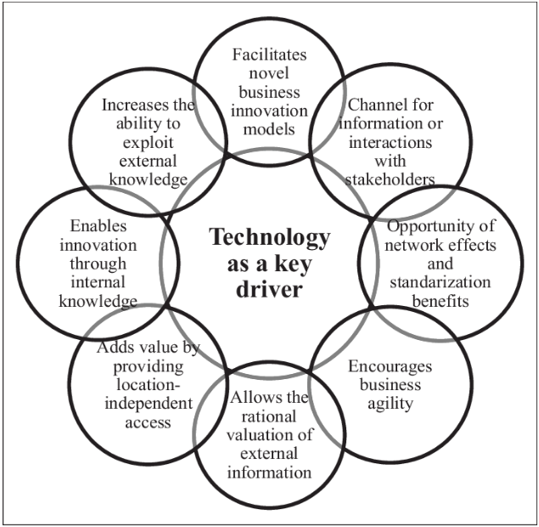

**Figure 2.4.1: Benefits of technology and innovation**

(Source: Hensen and Dong, 2020)

However, by adopting technologies and innovation the suppliers decrease human labour costs as the technologies provide more productivity than the workers which saves them money of the supplier than giving wages every month to the employees. As per Demartini *et al*. (2019), the adoption of technologies and innovation helped and benefited the suppliers to increase profitability with fewer expenses. The adoption or fostering of technology and innovation among suppliers also improves the brand value of the supplier businesses as with the help of modern technology and innovation, the suppliers provide quality and efficient products at the right time. However, as per He *et al*. (2020), providing customers high quality and efficient products at the right time helps to satisfy the need and demands of the customers which increases the brand value of the businesses of suppliers. Hence the adoption or fostering of technology and innovation benefited the suppliers as it increased the brand value of the supplier businesses by providing the customers with quality goods and services and fulfilling the requirements of the customers at the right time.

**2.5 Challenges faced by suppliers to adapt technology and innovation**

The challenges faced by suppliers to adopt technology and innovation include high cost, lack of technically skilled employees and demand for new technologies to compete with competitors. As per Ullah *et al.* (2021), the high cost of technology and innovation is a big challenge faced by the suppliers while adopting the technology and innovation as the modern technologies and innovation cost is high, therefore it is hard for moderate suppliers to adopt the technology and innovation with such big investment.

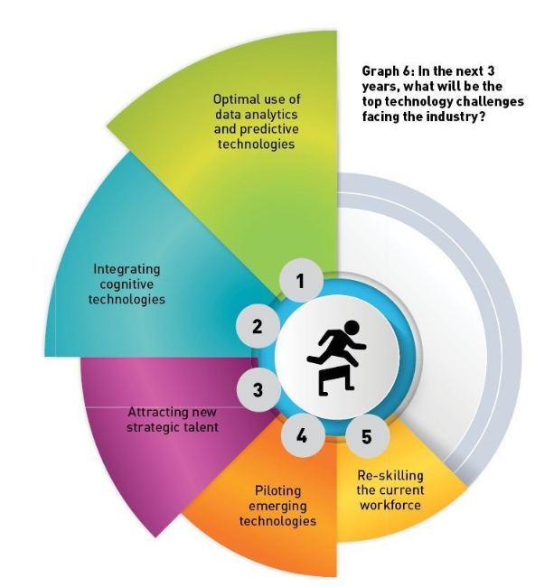

**Figure 2.5.1: Challenges of adopting technology**

(Source: Makhdoom *et al. 2*019)

Hence the high cost of technology and innovations is a crucial challenge for the suppliers while adopting it. Technologies and innovation need technically skilled employees for using and adopting them appropriately. However as per Kazancoglu *et al*. (2022), the lack of technically skilled employees creates problems for the suppliers as without technically skilled labours, the suppliers cannot perform their technology and innovation well. Hence the lack of technically skilled employees is a big challenge for suppliers while adopting technology and innovation. Technologies and innovation modify every day with new and updated versions as the updated version of the technology have many more facilities and advantages than the older versions. Therefore the updated version of technology and innovation by the competitors of the supplier's business increases the speed of the competitors as they have better technology and innovation. Hence the demand for new technology and innovation is also a big factor faced by the suppliers while adopting it.

**2.6 Strategies to mitigate the identified challenges**

The strategies to mitigate the identified challenges such as high cost while adopting technology and innovation by the supplies. As per Sahoo *et al*. (2023), suppliers can use strategic alliances with other supplier businesses to increase their investment power and purchase technology and innovation.

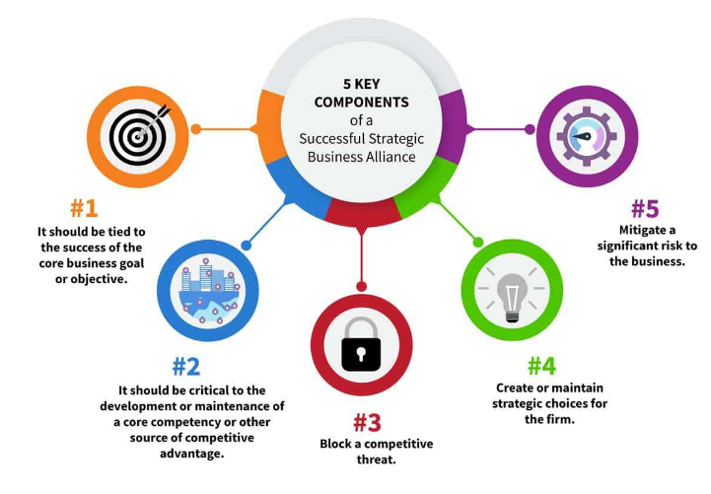

**Figure 2.6.1: Key components of strategic alliance**

(Source: Elia *et al,* 2019)

Hence merging with other suppliers can mitigate the high-cost challenges faced by the suppliers while adopting technology and innovation. The second strategy to mitigate the second challenge faced by suppliers is to find technically skilled labourers to perform the technology and innovation the suppliers need to provide well-skilled technical employees. However, as per Killip *et al.* (2020), the supplier needs to find employees who have knowledge and experience regarding the technology as it helps to improve and increase the sales and profit of the suppliers. Hence finding technically skilled labours will help the suppliers to perform well and it will also mitigate the lack of skilled employees’ challenges faced by the suppliers. The third strategy to mitigate the third challenge faced by the suppliers is to continuously update the technology and innovation. As per Khanfar *et al*. (2021), the update of technology by other competitors creates problems in the competition for the suppliers as the rival competitors have better-advanced technology which helps in more efficient and quality work. The better quality and efficient work by the rival competitors with the help of updated technology affects the suppliers who use old technology. However, as per Brandenburger and Nalebuff (2021), the supplier should always update their technology to compete with the rival competitors. Hence updating the technology and innovation will help the suppliers to compete with the rival competitors and help to maintain sales and profitability.

**2.7 Theoretical Discussion**

***Stakeholder Management Theory***

According to Flak and Rose (2005), Stakeholder Management theory is a theory of business ethics and capitalism that interconnects a relationship between a business and its consumers, suppliers, investors, local communities, employees and others who have a stake in that organization shown in the below figure.

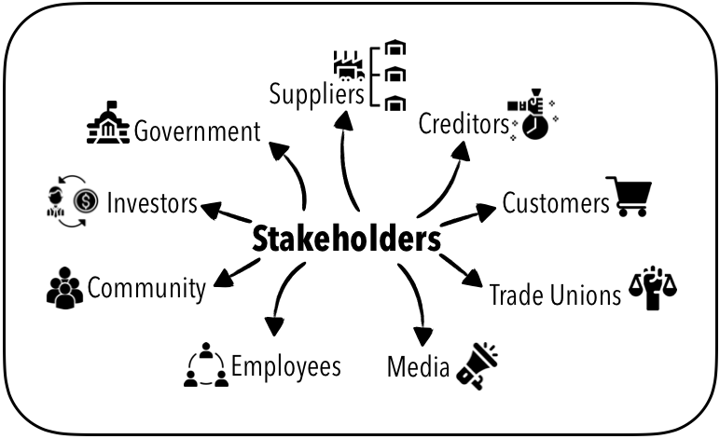

**Figure 2.7.1: Overview of Stakeholders**

(Source: Pedrini and Ferri, 2019)

The electronic industry can increase its market growth with the help of the Stakeholder Management Theory. This theory helps electronics companies to expand their business by increasing productivity, lowering turnover rates and improving employee satisfaction. The below figure shows six principles in stakeholder theory.

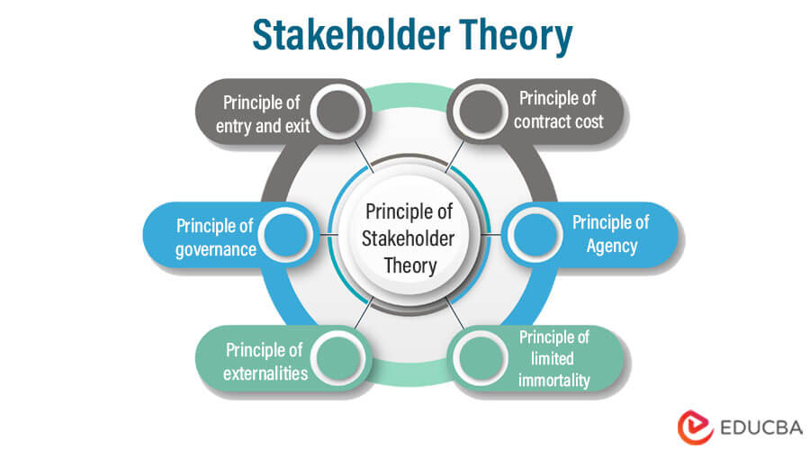

**Figure 2.7.2: Principal of Stakeholder Theory**

(Source: Srinivasan and Dhivya, 2020)

Considering employees of electronics companies to their stakeholders, employees feel valued and motivated. Hence, it helps to get a more productive outcome from them that is beneficial for the electronics industry. As per Hanaysha and Alzoubi (2022), an increased productivity rate helps electronics companies to provide better products and services to consumers in less time. With the improved outcome, electronics companies get customer loyalty and consumers become one of the stakeholders of the company. Whenever electronics companies meet the customer satisfaction level, the value of their companies also increases. Hence, investors who are the most important stakeholder of a company, invest money in the product that helps electronics companies to grow in the market and gain a competitive edge (Kölbel *et al.* 2020). Besides productivity and profit, stakeholder theory provides ethical benefits as well. Improvement of mental health of the workforce is noticed because of increased job satisfaction of the employees. This theory also helps to promote the social-economic status of electronics companies in the local community which helps to create healthy competition among other companies.

***Diffusion of Innovation Theory***

Diffusion of Innovation is a theory that states the speed and pattern at which innovation and technology spread. According to Rogers, there are five established adopter categories which are Innovators, Early Adopters, Early Majority, Late Majority, and Laggards.

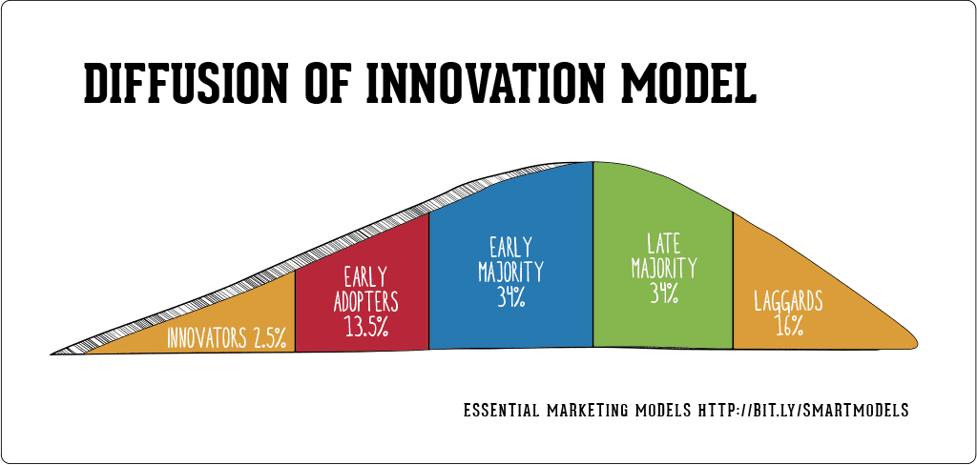

**Figure 2.7.3: Model of Diffusion of Innovation**

(Source: Choi *et al.* 2023)

The above figure shows the model of Diffusion of Innovation. The diffusion of innovation is influenced by 4 elements which are Innovation, time, communication channels and social system (Ilias *et al.* 2021). These 4 elements help the electronics industry to expand its business in the market. As per Van de Kaa *et al.* (2019), innovation in the electronic industry includes compatibility, adaptability, and complexity which helps companies to anticipate market changes more quickly and get ahead of opportunities. Adoption of innovation always takes time. Hence time is an important factor in this theory. In order to gather knowledge about new technology and concepts in the electronics industry, communication plays a major role. The social system includes groups, people or organizations which are important in the theory of diffusion of innovation because it helps to facilitate the innovation and technologies that are beneficial for the growth of the electronics industry.

**2.8: Literature Gap**

Previously multiple scholars discussed the issues faced by the suppliers of the electronics industry and their impacts on the business. The studies also provide ideas about the factors of using technology that influence the suppliers of the electronics industry. The benefits of fostering technologies and innovation among the suppliers of the electronics industry have also been discussed by scholars. Moreover, the studies also provide information about the challenges faced by the suppliers to adopt the innovation and also strategies to mitigate those challenges. However, the previous scholars have not discussed in detail the primary challenges that are faced by suppliers of the electronics industry while adapting new technologies and innovation. Hence, some primary challenges are discussed in this chapter for the benefit of the suppliers of the electronics industry.

**Sources included in stage submission 1**

Aghion, P., Cherif, R. and Hasanov, F., 2021. Competition, innovation, and inclusive growth. IMF Working Papers, 80, pp.1-7.

Alghababsheh, M. and Gallear, D., 2021. Socially sustainable supply chain management and suppliers’ social performance: The role of social capital. *Journal of Business Ethics,* 173, pp.855-875.

Alzoubi, H., Alshurideh, M., Kurdi, B., Alhyasat, K. and Ghazal, T., 2022. The effect of e-payment and online shopping on sales growth: Evidence from banking industry. *International Journal of Data and Network Science, 6*(4), pp.1369-1380.

Brandenburger, A. and Nalebuff, B., 2021. The rules of co-opetition. *Harvard Business Review, 99*(1), pp.48-57.

Choi, J.O., Jin, K. and Yu, U., 2023. Induced diffusion percolation model: Examining the role of superactive nodes in the diffusion of innovations. *Communications in Nonlinear Science and Numerical Simulation*, 120, p.107154.

Demartini, M., Evans, S. and Tonelli, F., 2019. Digitalization technologies for industrial sustainability. *Procedia manufacturing, 33*, pp.264-271.

Durmić, E., 2019. Evaluation of criteria for sustainable supplier selection using FUCOM method. *Operational Research in Engineering Sciences: Theory and Applications,* 2(1), pp.91-107.

Elia, S., Petruzzelli, A.M. and Piscitello, L., 2019. The impact of cultural diversity on innovation performance of MNC subsidiaries in strategic alliances. *Journal of Business Research, 98*, pp.204-213.

Ellram, L.M. and Murfield, M.L.U., 2019. Supply chain management in industrial marketing–Relationships matter. *Industrial Marketing Management*, 79, pp.36-45.

Fabeil, N.F., Pazim, K.H. and Langgat, J., 2020. The impact of Covid-19 pandemic crisis on micro-enterprises: Entrepreneurs’ perspective on business continuity and recovery strategy. *Journal of Economics and Business, 3*(2).

Flak, L.S. and Rose, J., 2005. Stakeholder governance: Adapting stakeholder theory to e-government. *Communications of the Association for Information Systems,* 16(1), p.31.

Hanaysha, J.R. and Alzoubi, H.M., 2022. The effect of digital supply chain on organizational performance: An empirical study in Malaysia manufacturing industry. *Uncertain Supply Chain Management,* 10(2), pp.495-510.

He, J., Evans, N.M., Liu, H. and Shao, S., 2020. A review of research on plant‐based meat alternatives: Driving forces, history, manufacturing, and consumer attitudes. *Comprehensive Reviews in Food Science and Food Safety, 19*(5), pp.2639-2656.

Hensen, A.H. and Dong, J.Q., 2020. Hierarchical business value of information technology: Toward a digital innovation value chain. *Information & Management, 57*(4), p.103209.

ILIAS, A., GHANI, E.K. and AZHAR, Z., 2021. XBRL Adoption Process in Malaysia Using Diffusion of Innovation Theory. *The Journal of Asian Finance, Economics and Business,* 8(2), pp.263-271.

Ingaldi, M. and Ulewicz, R., 2019. How to make e-commerce more successful by use of Kano’s model to assess customer satisfaction in terms of sustainable development. *Sustainability,* 11(18), p.4830.

Kazancoglu, I., Kazancoglu, Y., Kahraman, A., Yarimoglu, E. and Soni, G., 2022. Investigating barriers to circular supply chain in the textile industry from Stakeholders’ perspective. *International Journal of Logistics Research and Applications, 25*(4-5), pp.521-548.

Khanfar, A.A., Iranmanesh, M., Ghobakhloo, M., Senali, M.G. and Fathi, M., 2021. Applications of blockchain technology in sustainable manufacturing and supply chain management: A systematic review. *Sustainability, 13*(14), p.7870.

Killip, G., Owen, A. and Topouzi, M., 2020. Exploring the practices and roles of UK construction manufacturers and merchants in relation to housing energy retrofit. *Journal of Cleaner Production, 251*, p.119205.

Kölbel, J.F., Heeb, F., Paetzold, F. and Busch, T., 2020. Can sustainable investing save the world? Reviewing the mechanisms of investor impact. *Organization & Environment,* 33(4), pp.554-574.

Makhdoom, I., Abolhasan, M., Abbas, H. and Ni, W., 2019. Blockchain's adoption in IoT: The challenges, and a way forward. *Journal of Network and Computer Applications, 125*, pp.251-279.

Olimovich, D.I. and Khudoynazarovich, S.A., 2020. The cost-effectiveness of improving the quality of hotel services. *Academy,* (4 (55)), pp.40-42.

Pedrini, M. and Ferri, L.M., 2019. Stakeholder management: a systematic literature review. *Corporate Governance: The International Journal of Business in Society,* 19(1), pp.44-59.

Sahoo, S., Kumar, A. and Upadhyay, A., 2023. How do green knowledge management and green technology innovation impact corporate environmental performance? Understanding the role of green knowledge acquisition. *Business Strategy and the Environment, 32*(1), pp.551-569.

Srinivasan, N.P. and Dhivya, S., 2020. An empirical study on stakeholder management in construction projects. *Materials Today: Proceedings,* 21, pp.60-62.

Suchek, N., Fernandes, C.I., Kraus, S., Filser, M. and Sjögrén, H., 2021. Innovation and the circular economy: A systematic literature review. Business Strategy and the Environment, 30(8), pp.3686-3702.

Tallon, P.P., Queiroz, M., Coltman, T. and Sharma, R., 2019. Information technology and the search for organizational agility: A systematic review with future research possibilities. *The Journal of Strategic Information Systems,* 28(2), pp.218-237.

Ullah, F., Sepasgozar, S.M., Thaheem, M.J. and Al-Turjman, F., 2021. Barriers to the digitalisation and innovation of Australian Smart Real Estate: A managerial perspective on the technology non-adoption. *Environmental Technology & Innovation, 22*, p.101527.

Van de Kaa, G., Fens, T., Rezaei, J., Kaynak, D., Hatun, Z. and Tsilimeni-Archangelidi, A., 2019. Realizing smart meter connectivity: Analyzing the competing technologies Power line communication, mobile telephony, and radio frequency using the best worst method. Renewable and Sustainable Energy Reviews, 103, pp.320-327.

Vlačić, B., Corbo, L., e Silva, S.C. and Dabić, M., 2021. The evolving role of artificial intelligence in marketing: A review and research agenda. *Journal of Business Research,* 128, pp.187-203.

Wang, L., Wang, X. and Yang, W., 2020. Optimal design of electric vehicle battery recycling network–From the perspective of electric vehicle manufacturers. *Applied Energy, 275*, p.115328.

Yang, Y., Liu, H. and Chen, X., 2020. COVID-19 and restaurant demand: early effects of the pandemic and stay-at-home orders. *International Journal of Contemporary Hospitality Management*

## Appendix 2: Staged submission 2

**Chapter 3: Research Methodology**

**3.1 Research paradigm**

The concerned research was conducted by following the Saunders research methodology framework which helped to devise the strategies and steps of the research precisely. This framework also helped the researcher to address every layer as shown in the below figure.

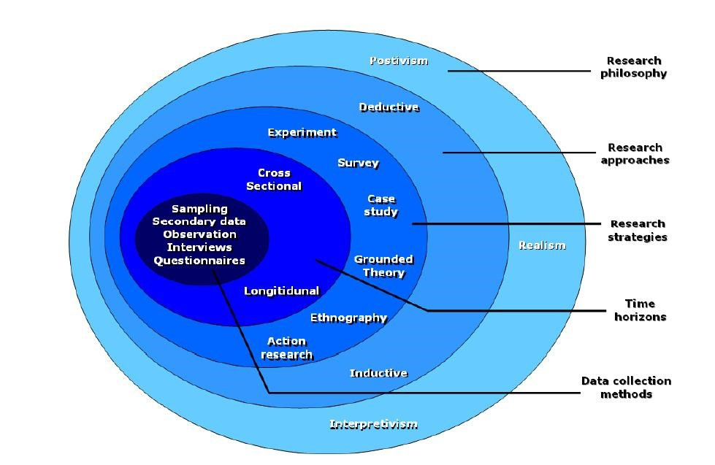

**Figure 3.1: Saunders research methodology**

(Source: Chong and Plonsky, 2023)

Concerning this research framework, the paradigm includes philosophy, approach and design. All three methods were used in this research. As per Rothstein (2021), philosophy refers to the method or the belief through which the researchers collect information in their respective research studies. The philosophy method was helpful as this helped in avoiding non-relevant secondary data sources. However, three forms of research philosophies were known which are realism, interpretivism and positivism. As the research aimed to relate the factors with the influencing levels of suppliers while adopting technological innovation, hence, the researcher focused on using interpretivism research philosophy as this method helped in relating the key factors with social and professional behaviours of the suppliers associated with Samsung and Apple. Moreover, positivism was avoided in this case for excluding biased information as this method could not provide strategic solutions for the primary challenges faced by the suppliers while adopting technological innovation.

In terms of approach method, this helped the researcher to break down the overall research processes into different milestones. As per Peloquin*et al.* (2020), inductive, abductive and deductive are the three forms of the research approach. An inductive research approach was applied in this case as this method helped to critically analyse the factors which influence the suppliers of Samsung and Apple to adopt technological innovation. Other approaches were avoided in this research as they could include biased findings in the research.

In terms of research design, Nguyen *et al.* (2021), stated that the use of this research method helps in formulating the research processes for analysing the data collection. Descriptive design was primarily followed in this research where this method helped to showcase the findings with evidence in a descriptive manner. Hence, it is expected that the use of descriptive design helped the researcher to address every research area like supplier relationship management, technological innovation adaptation in Samsung and Apple and many more. In addition, descriptive information was also helpful to answer the above research questions with key evidence too.

**3.2 Research Strategy**

As per the concern of Hernández Valdés *et al.* (2020), research strategy refers to the overall research process including execution, planning and monitoring. This method was applied or followed in this research as it helped to guide the researcher to complete the study within the expected timeline as well as helped in processing the research data for answering the key question concerning the key factors which influence the suppliers of Samsung and Apple to use technological innovation for the betterment of their supply strategy. However, Rothwell *et al.* (2019), two forms of research strategy were known which are namely, quantitative and qualitative. Qualitative research strategy deals with the processes of research which focus on non-numeric information related to the research context while quantitative research strategy refers to the amalgamation of numeric data and their use for meeting the research objectives. However, in this research prospect, a qualitative research strategy was primarily followed as this helped to underpin several research questions to identify the pattern and the strategy used by Apple and Samsung to sustain their long-term relationship with their key suppliers.

**3.3 Data collection method**

Data collection in a research study is required for analysing the key facet related to the key research contexts. As per Spector-Bagdady (2021), data in research can be accumulated in two various forms which are namely, primary and secondary research data. Secondary data sets refer to the information which is pre-published or already available to the researcher while in terms of primary research data, it deals with the accumulation of real-time information from human participants.

As the research focused on analysing various factors which influence suppliers of Samsung and Apple to use or adopt technological innovations, hence, use of primary research data collection, in this case, was avoided as this process could result in accumulating biased information. However, as per Pitoglou *et al.* (2022), the secondary data collection process involves extracting key information from pre-published data sources where the researcher has the authority to validate the main findings presented in those data sources. Hence, in this research, a secondary data collection process was followed where 50 secondary sources were selected initially which consisted of online journals, news articles and organisational reports of Samsung and Apple. Keyword searching technique was primarily deployed for accessing such data sources where keywords like "suppliers ', "technological innovation" and many more were used or searched on authentic websites and in Google scholar.

**3.4 Sampling Size and Method**

As per the concern of Soini (2020), sampling refers to the method which describes a process followed by a researcher to select data sources from a vast population. In this case, the sampling method was applied for avoiding biased data related to the factors which influence the key suppliers of Apple and Samsung to adopt technological innovation. In this prospect, a purposive sampling method was applied as this method helped the researcher to select the secondary data sources as per their relevance and validity. An exclusion and inclusion criteria were also applied in this case where data sources which were published before 2018 were excluded and data sources having citations and no copyright issues were included in this research. This criterion helped the researcher to analyse the most updated and relevant issues that are faced by the suppliers of Apple and Samsung.

**3.5 Validity and Reliability of the Research**

A validity and reliability check was performed while conducting this particular research as this check helped the research to include the most relevant and adequate data sources in the study. In addition, cited articles were chosen for providing an insight analysis of the key benefits gained by the suppliers of Apple and Samsung while using technological innovation in their supply management. The inclusion of data sources which were published after 2018 ensured that the key information used in this research was updated and hence, none of the outdated information regarding the business-supplier relationship between Apple and Samsung was covered or used in this research. In addition, the use of multiple authentic secondary data sources in research also implies that the key findings of this research can also be used by other organisations for influencing their suppliers to use technological innovation for sustaining their supply management.

**3.6 Data Analysis**

Data analysis is considered one of the key research methods which refer to the processing and analysing of the collected data for answering the key research questions. In regards, Popa (2020), identified multiple techniques which were used for analysing data in a research context statistical data analysis, narrative data analysis, regression analysis and many more. As the research did not involve primary data collection, hence, statistical data analysis process was not followed, rather a thematic analysis approach was adopted where several themes were identified and discussed based on the collected secondary data sources. As per McGrane *et al.* (2022), the thematic analysis approach helps identify the patterns of the research areas or contexts. In regards, discussion of themes in a narrative approach helped the researcher to address the key research objectives and also helped to answer the research questions too. Hence, the use of thematic analysis in this context was justified and useful for identifying the factors which indulge the suppliers of Samsung and Apple to use technological innovation in their operations.

**3.7 Ethical consideration**

Several ethical considerations were followed while conducting this research as this helped to avoid misinterpretation of the key findings of this research. As per Richter *et al.* (2021), ethical considerations in research also help researchers to influence and engage the audience or readers in resting the findings with the research objectives. In regards, while selecting the secondary sources, cited articles were chosen and in the thesis, an adequate citation method was used for appraising the contribution of previous scholars.

**3.8 Research limitations**

As the research was fully conducted based on secondary data, it can be expected that the collection of primary data through surveys and interviews could influence the findings more as this could help in analysing real-time factors which influence suppliers of Apple and Samsung to use technological innovation. As per the concern of Nordfalk and Ekstrøm (2019), primary data collection consumes a huge time and also requires consent from human participants. As research was conducted by following a strict timeline, hence, primary data collection was not used in this case as this could delay the research work. However, it can be expected that the collection of real-time information could help in identifying the primary challenges faced by the suppliers while adopting technological innovation.

**Sources used in stage submission 2**

Chong, S.W. and Plonsky, L., 2023. A typology of secondary research in Applied Linguistics. *Applied Linguistics Review*, (0).

Hernández Valdés, J., JuárezNájera, M., Bustos Aguayo, J.M., BermúdezRuíz, G., Quintero Soto, M.L., Rosas Ferrusca, F.J., Rincón Ornelas, R.M. and GarcíaLirios, C., 2020. Proposing categories for retrospective secondary research on treatment adherence. *Revista Med*, *28*(2), pp.11-24.

McGrane, N., Dunbar, P. and Keyes, L.M., 2022. To summarise the approach to and findings of the PPIE undertaken as part of a programme of secondary research with a vulnerable, hard to reach population during the COVID-19 pandemic.

Nguyen, N.Y., Kha, D.D. and Ichikawa, Y., 2021. Developing a multivariable lookup table function for estimating flood damages of rice crop in Vietnam using a secondary research approach. *International Journal of Disaster Risk Reduction*, *58*, p.102208.

Nordfalk, F. and Ekstrøm, C.T., 2019. Newborn dried blood spot samples in Denmark: the hidden figures of secondary use and research participation. *European Journal of Human Genetics*, *27*(2), pp.203-210.

Peloquin, D., DiMaio, M., Bierer, B. and Barnes, M., 2020. Disruptive and avoidable: GDPR challenges to secondary research uses of data. *European Journal of Human Genetics*, *28*(6), pp.697-705.

Pitoglou, S., Filntisi, A., Anastasiou, A., Matsopoulos, G.K. and Koutsouris, D., 2022. Measuring the impact of anonymization on real-world consolidated health datasets engineered for secondary research use: Experiments in the context of MODELHealth project. *Frontiers in Digital Health*, *4*, p.177.

Popa, A., 2020. Supporting secondary research in early drug discovery process through a Natural Language Processing based system. In *Proceedings of the International Conference on Applied Statistics* (Vol. 2, No. 1, pp. 254-267).

Richter, G., Borzikowsky, C., Hoyer, B.F., Laudes, M. and Krawczak, M., 2021. Secondary research use of personal medical data: patient attitudes towards data donation. *BMC medical ethics*, *22*(1), pp.1-10.

Rothstein, M.A., 2021. Informed consent for secondary research under the new NIH data sharing policy. *Journal of Law, Medicine & Ethics*, *49*(3), pp.489-494.

Rothwell, E., Johnson, E., Riches, N. and Botkin, J.R., 2019. Secondary research uses of residual newborn screening dried bloodspots: a scoping review. *Genetics in Medicine*, *21*(7), pp.1469-1475.

Soini, S., 2020. The GDPR, secondary research purposes and global data sharing—one-wheel too many. *European Journal of Human Genetics*, *28*(6), pp.694-694.

Spector-Bagdady, K., 2021. Governing secondary research use of health data and specimens: the inequitable distribution of regulatory burden between federally funded and industry research. *Journal of Law and the Biosciences*, *8*(1), p.lsab008.

## Appendix 3: Staged submission 3

**Chapter 4: Analysis and Findings**

**Theme 1: The adoption of technological innovation among suppliers of Apple and Samsung helped the brands to evolve their respective SCM**

According to Carter *et al.* (2020), the evolution of supply chain management is defined by the increasing integration of different tasks. Apple and Samsung both have their inventory management that helps to innovate new products with the help of technology to meet the customer requirement and demand. Apple manufactures its own chips and produces processors for using it in its own laptop and desktop. In order to manage the global supply chain network Samsung uses block chain technology that helps to keep track of all shipments and reduce costs as well. The suppliers of Apple and Samsung comprehend the demand of the company and ensure to delivery of the product without any delay. That helps to evolve the supply chain management of Apple and Samsung.

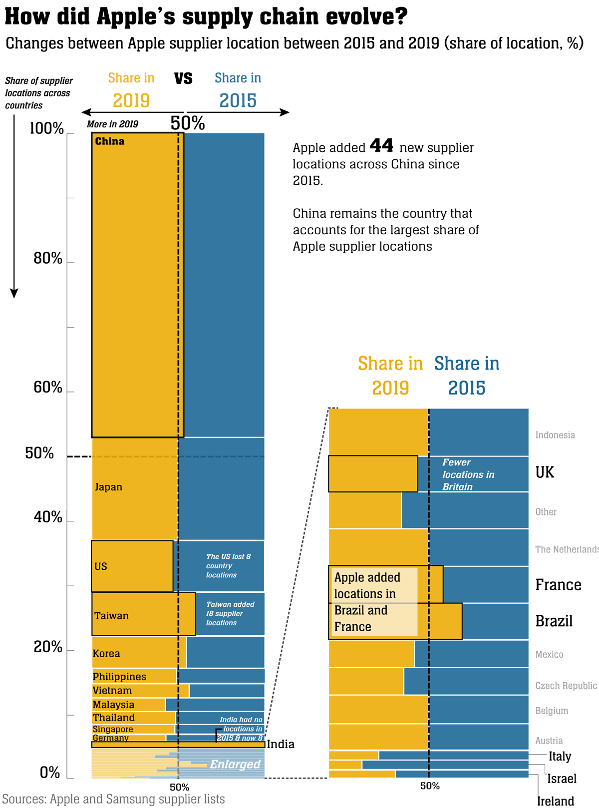

**Figure 4.1: Location of Apple suppliers**

(Source: E&T, 2023)

The above figure shows the changes in the location of Apple suppliers from 2015 to 2019. The Apple suppliers have considerably been changing their locations till 2019 and around 50 new locations have been added. The presence of Apple suppliers in China surged to 47% in 2019 which is 3% more than in the last 4 years. Till 2019, Apple has added 44 new supplier locations across China and some new Apple suppliers are also added in Brazil and France as well. The largest share of Apple suppliers is found in China. Hence it can be said that Apple suppliers are spread throughout the world which helps Apple to expand their business worldwide. Better supply chain management helps Apple and Samsung to develop their innovation by using technology that helps to get a productive output and fulfil the requirements of customers. Fulfilling customers' requirements can help to increase the market value of Apple and Samsung. Therefore, investors invest money in the business that helps to increase the profit margin of Apple and Samsung. Hence it can be said that technological innovation can help to evolve the supply Chain of Samsung and Apple and influence suppliers of Apple and Samsung to increase market growth.

**Theme 2:A high number of suppliers of Samsung and Apple influenced the brand to promote the use of technological innovation among the suppliers**

An increased number of suppliers of Samsung and Apple can help to grow their business. Customers feel confident because of the higher number of suppliers as customers feel assured about the product which is sold by many suppliers. Larger suppliers can help to gain a competitive advantage because of better opportunities and more sales. As per Rezaei and FallahLajimi (2019), a high number of suppliers leads to sustained profitable growth by introducing new products to the customers in a short time, increasing the margins of products and many more. A large number of suppliers of Apple and Samsung can provide different kinds of rebates and deals that lead to more sales and high profitability. An increased number of suppliers in Samsung and Apple can help to maintain a good customer relationship that maximizes the competitive advantage. In order to fulfil all these above requirements, suppliers of Samsung and Apple should adopt technological innovation.

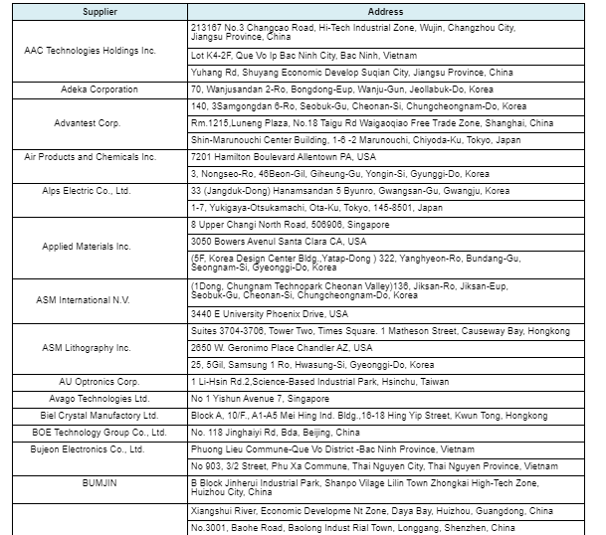

**Figure 4.2: Supplier List of Samsung**

(Source: Samsung, 2023)

The above figure shows the list of Samsung suppliers. With the help of the right supply chain strategy and network, Samsung establishes a high supplier base that helps to supply raw materials for manufacturing its products of Samsung. This strategy also helps Samsung to form a better relationship with suppliers that helps to manage the performance and efficiency of the suppliers. With a high number of suppliers, Samsung can enhance production and sale with the help of technological innovation that helps Samsung to expand its market globally.

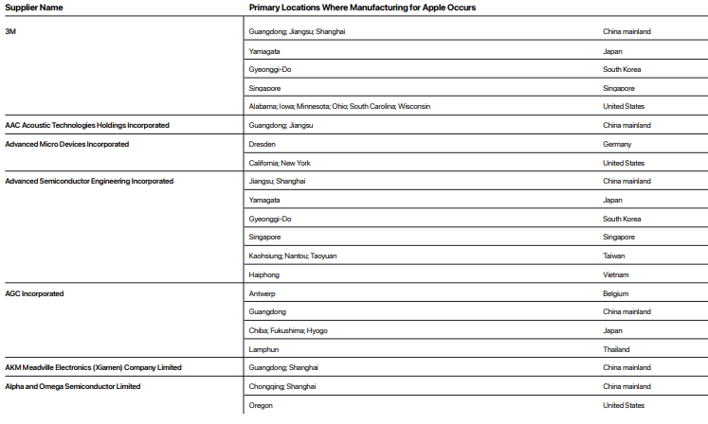

**Figure 4.3: Supplier List of Apple**

(Source: Apple, 2022)

The above figure shows the list of Apple suppliers. According to the supplier list released by Apple in 2021, Apple has around 180 suppliers (WSJ, 2022). A high number of suppliers help Apple to be knowledgeable about their customer demand which helps Apple to produce more innovative products. This helps Apple to meet customer satisfaction and gain a profitable margin. Customers can get the products that are innovated by Apple, at a lower cost in less time because of the high number of customers. With the help of a Supplier management strategy, Apple can manage their huge number of suppliers to gain a competitive edge. Hence, It is observed that with the help of technological innovation, the suppliers of Samsung and Apple can increase their market value and stretch their business across the world.

**Theme 3: High net sales and revenue of Samsung and Apple help the brands to influence suppliers to improve their supply through technological innovation**

Jihadi *et al.* (2021) stated a strong business always generates more revenue and high net sales. High net sales and revenue of Samsung and Apple help their business to turn into higher profit margins. This kind of situation occurs whenever companies lower their expenses and generate the same revenue or increase the expenses more slowly than equivalent sales increases. Apple and Samsung can lower their expenses by adapting innovation and technology that helps Apple and Samsung to generate more revenue. Apple innovates their chips, processors and many more that help to minimize expenses. Samsung gets the raw materials efficiently from their suppliers which helps to reduce expenses. Hence it can be said that technological innovation helps Samsung and Apple to get high net sales and revenue.

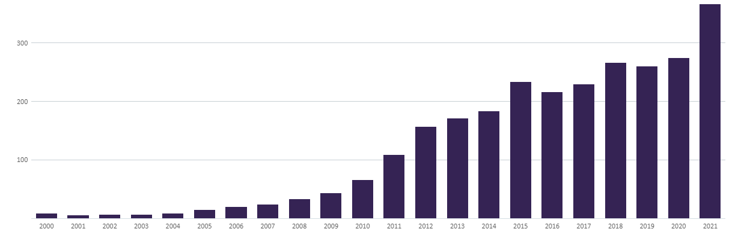

**Figure 4.4: Annual Net Sales of Apple (2000 - 2021, $ billion)**

(Source: GlobalData, 2023)

In 2018, Apple's market capitalization was $1 trillion, in 2020 it increased to $2 trillion and in 2022 it became $3 trillion. The net sale of Apple in 2020 was $274 billion and $365 billion in 2021 which is 33% more than the previous year (GlobalData, 2023). Products and services of Apple are iPhone, Mac, iPad, Services, Home, Wearables, and Accessories. IPhones accounted for Apple's more than half of Apple's net sales and sales of Mac and iPad accounted for 10% and 9% of Apple's net sales. Hence it can be said technology is responsible for Apple's high net sales and revenue.

In 2022, Samsung reported consolidated sales of KRW 70.46 trillion and an operating profit of KRW 4.31 trillion. It reported a record-breaking 302.23 trillion in yearly sales for the entire year, along with an operating profit of KRW 43.38 trillion (SamsungNewsroom, 2023). Hence, it is observed that with technological innovation Samsung and Apple gain high net sales that influence the supplier to foster technological innovation.

**Theme 4: High market competition is a primary challenge for the suppliers of Samsung and Apple to adopt technological innovation**

A Highly competitive market is an important challenge faced by the suppliers of Apple and Samsung to implement technological innovation. As per Banka *et al*. (2022), technology is growing day by day so the suppliers also have to invest a lot more in the research and development of their products. The Samsung and Apple companies are producing products of the same efficiency in the market therefore the suppliers face high competition among the suppliers of Samsung and Apple. Customer needs and preferences are evolving in price and brands of the products change consumers' needs and preferences.

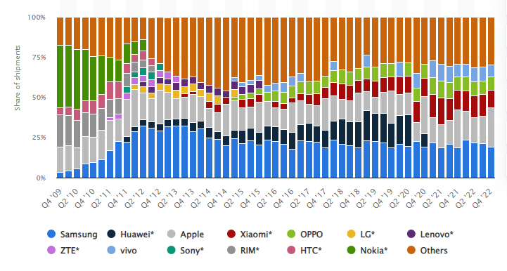

**Figure 4.5: Global 4th quarter share of smartphones from 2009 to 2022.**

(Source: Statista, 2023)

According to the graph above, the main line of Samsung is the Galaxy series which was released in the month of April 2009. The brand Samsung also suffered from a drop-down in shipments during the time of the pandemic. As in the second quarter of 2019, Samsung shipped 75.5 million units which fell to 54.2 million units in the second quarter of 2020. Samsung later reduced smartphone shipments from 2020 to 2022 to recover the losses. However, according to the graph above, Apple is the major manufacturer in the world as they have shipped more than 225 million iPhones all over the world. They launch and sell their products in the fourth quarter as their first quarter shipped around 84 million units.

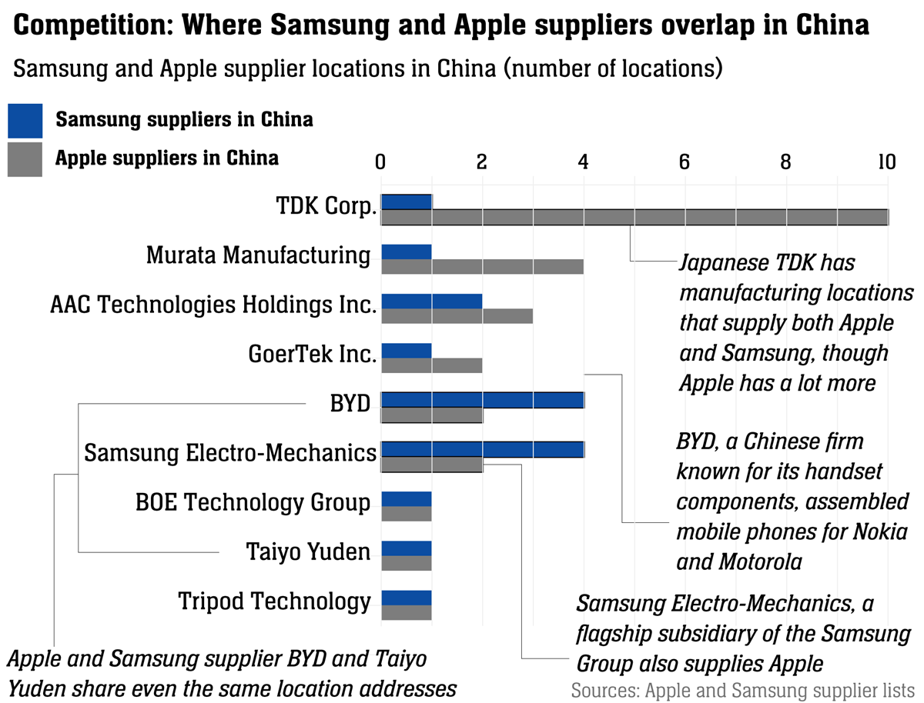

**Figure 4.6: Supply Chain evolve of Apple**

(Source: Engineering and Technology, 2020)

**Theme 5: The chip shortage issue decrease the net sales of smartphone brands like Samsung and Apple**

The smartphone is created with several types of chips which helps them to perform efficiently without any obstacle. As per Komkaite *et al*. (2019), chips in smartphones are the heart of the phones without the chips the smartphones are worthless as they will not work. Thus the chips of smartphones are necessary as all the parts in the smartphones have chips. Therefore the chip shortage issues create problems and decrease the net sales of smartphone brands like Samsung and Apple.

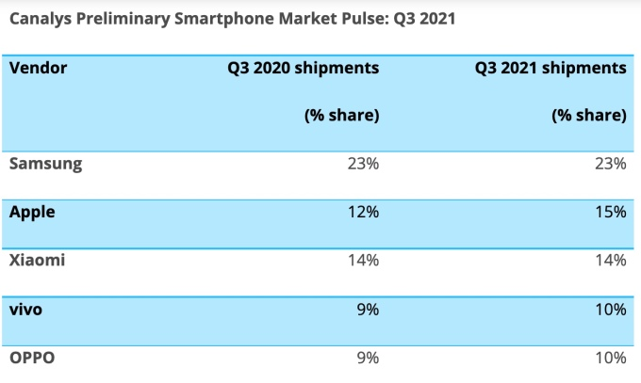

**Figure 4.7: Shipment table of smartphones**

(Source: Joint TechCrunch, 2021)

According to the table shown above, the global sales of smartphones are 6% in the quarter due to the lack of chip shortage. As per the table the market of smartphones in past quarters as Samsung steadily held 23% from year to year however apple sales increased to 3 per cent which is 155 in the quarter. Moreover, Xiaomi also continues steadily and has its position in third place with a sales of 14% year-to-year constant. Therefore, due to cheap shortages the brands like Samsung and Apple face problems regarding their sales as they make their chips still face the shortage of chips. The brands like Samsung and Apple have their manufacturer as well as suppliers, thus they still face issues regarding the chip shortage. Hence Samsung and Apple need to sustain the relationship with their suppliers to increase the number of chips as it helps them to recover their losses and increase the profitability of the brands like Samsung and Apple. Therefore it is observed that the shortage of chips decreases the net sales of Samsung and Apple and it's a primary challenge faced by the brands.

**Theme 6:Delivery delays also influence suppliers to adopt technological innovation in Apple and Samsung**

Time is a crucial factor in any business as the delivery of products at the right time increases the brand value, attracts customers, and increases the sales of brands like Samsung and Apple. As per Chen and Yao (2022), the delays in the delivery of chips and other phone products delay the whole system from manufacturing to selling the products. Therefore to avoid or ignore the delays the supplier should adopt technological innovation as it helps in fast and efficient work which benefited the brands such as Samsung and Apple to increase sales and make more profits.

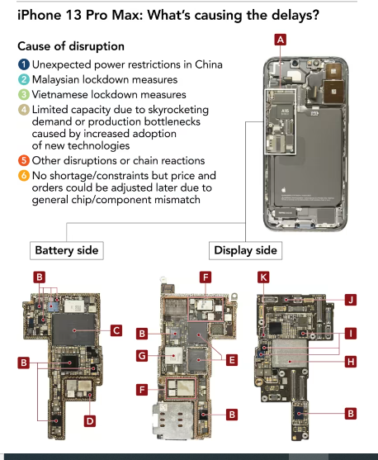

**Figure 4.8: Delays and disruption of iPhone 13 Pro max**

(Source: Nikkei asia, 2021)

According to the table above, China shut down their factories at the time of the golden week. Thus the important suppliers of Apple were not present at that time which created a huge problem for the brand Apple as they worked 24 hours to fulfil and capture the holiday demand of the customers. Due to China and the shortage of chips, the assembly was halted for many days for the delays in the delivery of chips and other components. One of the causes of the delay of the iPhone 13 is the A15 core processor provided by the supplier TSMC as they faced the issue of price and orders. Therefore it is observed that the delay in delivery influences the suppliers to adopt technological innovation.

**Samsung:**

Samsung is suspending orders for several days due to the lack of components and chips. As Samsung had reduced its production of smartphones. The orders of Samsung were halfway in 2022 as they produce 230 million units of smartphones as their year target was 310 units. Samsung also ignores the orders of Ac, Tvs and more. Thus the suppliers planned a shipment which was scaling down 50%. Hence it is observed that the delay in delivery influences suppliers of Samsung to adopt technological innovation.

**Theme 7: Providing training to the suppliers can help in improving supplier-business relationships in Apple and Samsung**

Training can be provided to the suppliers to improve the supplier's business relationship with Apple and Samsung. As per Fearne *et al*. (2021), the companies must train the suppliers to make timely payments which is a very crucial role. Timely payments impact the good services of Apple and Samsung. They must be trained to prioritize the values of the product over the prices. The suppliers must provide efficient service to their customers. The price must not be the main factor as the suppliers of Apple and Samsung must be trained to use advanced technology to increase the sales of the Apple and Samsung brands.

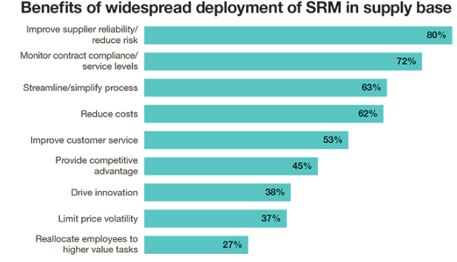

**Figure 4.9: Benefits of SRM in the supply base**

(Source: Supply chain management review, 2019)

The above figure shows the benefits of SRM in Apple and Samsung which includes improvement of suppliers' ability by 80%, monitoring contract by 72%, streamlining processes by 63%, reduce cost by 62%, improvement of service by 53%, competitive advantage by 45%, drive innovation by 38%, limit price by 37% and reallocate employees by 27%. The benefits of using SRm in supporting supplier business relationships of Apple and Samsung as it improves customer reliability and introduces certain measures to motivate the performance of suppliers of Apple and Samsung. The brands' Apple and Samsung also consider the capability to monitor a supplier's compliance with the contract. It also considers its capacity to streamline monitoring processes which benefits Apple and Samsung with the help of SRM.

The SRM helps in reducing the cost of Apple and Samsung by implementing various price-controlling measures such as pricing control and innovation. It also improves the service of the suppliers in the Apple and Samsung companies as it provides a competitive advantage, drive innovation, pricing control and the potential to relocate employees and suppliers to advanced tasks of Apple and Samsung brands. Hence it is observed that providing training to the suppliers can help in improving supplier-business relationships between Apple and Samsung.

**Sources for Stage submission 3**

Apple, 2022. *2022 Apple Supplier List*. Available at: <https://www.apple.com/supplier-responsibility/pdf/Apple-FY21-Supplier-List.pdf>[Accessed on 11 April 2023]

Banka, M., Tien, N.H., Dao, M.T.H. and Minh, D.T., 2022. Analysis of business strategy of real estate developers in Vietnam: the application of QSPM matrix. *International journal of multidisciplinary research and growth evaluation, 3*(1), pp.188-196.

Carter, C.R., Hatton, M.R., Wu, C. and Chen, X., 2020. Sustainable supply chain management: continuing evolution and future directions. *International Journal of Physical Distribution & Logistics Management,* 50(1), pp.122-146.

Chen, X. and Yao, L., 2022, March. Analysis of Game Cooperation in the Manufacturing Industry Under the Impact of Covid-19 on Global Supply Chain Based on Dynamic Game. *In 2022 7th International Conference on Financial Innovation and Economic Development (ICFIED 2022*) (pp. 2825-2831). Atlantis Press.

E&T, 2023. *How did Apple’s supply chain evolve?* Available at: <https://eandt.theiet.org/content/articles/2020/07/a-visual-analysis-of-how-apple-s-supply-chain-evolved-and-what-this-means-for-competition-with-samsung/>[Accessed on 11 April 2023]

Engineering and technology, 2020. *How did Apple’s supply chain evolve?* Available at: <https://eandt.theiet.org/content/articles/2020/07/a-visual-analysis-of-how-apple-s-supply-chain-evolved-and-what-this-means-for-competition-with-samsung/> [Accessed on 11 April 2023]

Fearne, A., Wagner, B., McDougall, N. and Loseby, D., 2021. The power of purpose–lessons in agility from the Ventilator Challenge. *Supply Chain Management: An International Journal, 26*(6), pp.753-766.

GlobalData, 2023. *Apple’s Annual Net Sales (2000 – 2021, $ Billion).* Available at:<https://www.globaldata.com/data-insights/technology--media-and-telecom/apples-annual-net-sales/>[Accessed on 11 April 2023]

Jihadi, M., Vilantika, E., Hashemi, S.M., Arifin, Z., Bachtiar, Y. and Sholichah, F., 2021. The effect of liquidity, leverage, and profitability on firm value: Empirical evidence from Indonesia. *The Journal of Asian Finance, Economics and Business*, 8(3), pp.423-431.

Joint techcrunch, 2021. *Smartphone sales down 6% as chip shortages begin to impact market.* Available at: <https://techcrunch.com/2021/10/15/smartphone-sales-down-6-as-chip-shortages-begin-to-impact-market/?guccounter=1&guce_referrer=aHR0cHM6Ly93d3cuZ29vZ2xlLmNvbS8&guce_referrer_sig=AQAAAAUg075pdadDmnT6ReIpzckJgxQfIjCH9vXTosM4Xn76teGYMMxBajVzXWkGENbP7Y-a4n1En-dtsJdU9xvQIKYScXWcKe2kCCX9O736PB6RvfQD4u094-KOJ7vG1fTbcCdqyxcqnT3WtCXPUFQA_XDqVDhp5BRGcYqO3Vgx-OWM> [Accessed on 11 April 2023]

Komkaite, A., Lavrinovica, L., Vraka, M. and Skov, M.B., 2019, May. Underneath the skin: An analysis of youtube videos to understand insertable device interaction. *In Proceedings of the 2019 CHI conference on human factors in computing systems* (pp. 1-12).

Nikkei asia, 2021. *Apple's nightmare before Christmas: Supply chain crisis delays gift deliveries.* Available at: <https://asia.nikkei.com/Spotlight/The-Big-Story/Apple-s-nightmare-before-Christmas-Supply-chain-crisis-delays-gift-deliveries> [Accessed on 11 April 2023]

Rezaei, J. and FallahLajimi, H., 2019. Segmenting supplies and suppliers: bringing together the purchasing portfolio matrix and the supplier potential matrix. *International Journal of Logistics Research and Applications,* 22(4), pp.419-436.

Samsung, 2023. *Listed in order of name of suppliers in 80% of Samsung Electronics’ transaction volume who agreed to be disclosed.* Available at: <https://www.samsung.com/us/aboutsamsung/sustainability/supply-chain/supplier-list/>[Accessed on 11 April 2023]

SamsungNewsroom, 2023. *Samsung Electronics Announces Fourth Quarter and FY 2022 Results.* Available at: <https://news.samsung.com/global/samsung-electronics-announces-fourth-quarter-and-fy-2022-results#:~:text=The%20Company%20posted%20KRW%2070.46,43.38%20trillion%20in%20operating%20profit>. [Accessed on 11 April 2023]

Statista, 2023. *Global smartphone market share from 4th quarter 2009 to 4th quarter 2022*. Available at: <https://www.statista.com/statistics/271496/global-market-share-held-by-smartphone-vendors-since-4th-quarter-2009/> [Accessed on 11 April 2023]

Supply chain management review, 2019. *Enhance the value of your supplier relationships*. Available at: <https://www.scmr.com/article/enhance_the_value_of_your_supplier_relationships> [Accessed on 11 April 2023]

WSJ, 2022. *Apple Suppliers Add Manufacturing Sites in U.S., With Focus on California.* Available at: <https://www.wsj.com/articles/apple-suppliers-add-manufacturing-sites-in-u-s-with-focus-on-california-11664884045>[Accessed on 11 April 2023]