**FOOD AND BEVERAGE OPERATION MANAGEMENT**

Table of Contents

1.0 Introduction 3

2.0 Marriot menu evaluation report 3

3.0 Menu planning considerations and constraints for the new Italian restaurant 10

4.0 Sustainability considerations for the new Italian restaurant 11

5.0 Conclusion 12

Reference list 14

# 1.0 Introduction

The purpose of this piece of paper is to offer consulting guidance for the effective menu planning of an upcoming Italian restaurant being launched in London. The research will review the current menu of Marriott hotels in London, determine sustainable menu planning factors, and evaluate menu planning considerations and constraints. The report's suggestions will assist the food and beverage team of the forthcoming Italian restaurant in creating a successful menu that complies with consumer tastes, industry trends, and sustainability ideals.

# 2.0 Marriot menu evaluation report

**Address of the hotel:** Carluccio’s Marriott Regents Park 128 King Henry’s Road, London NW3 3ST, United Kingdom

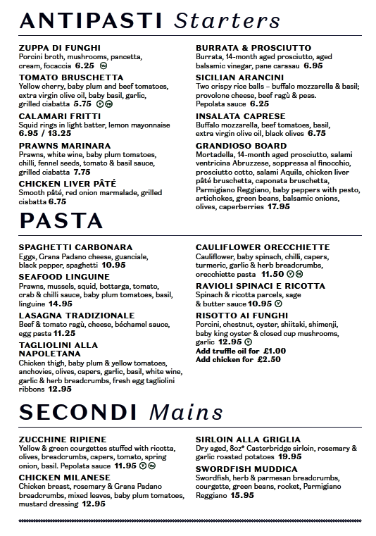

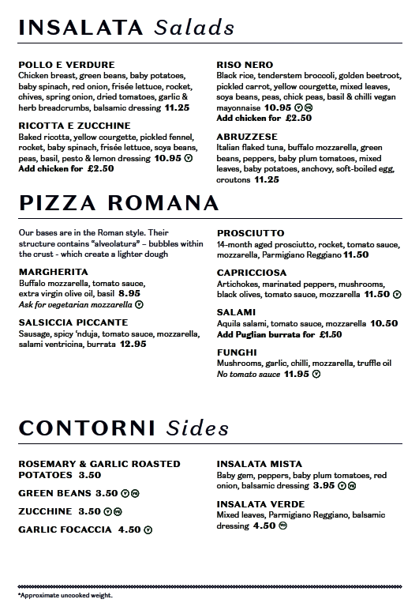

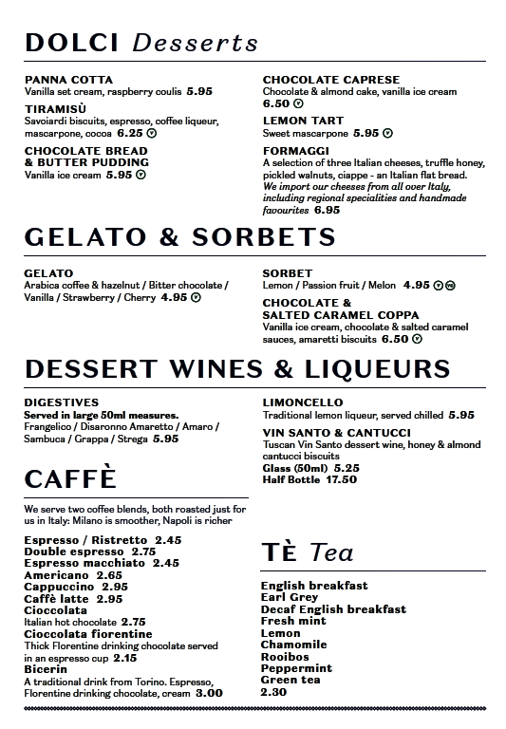

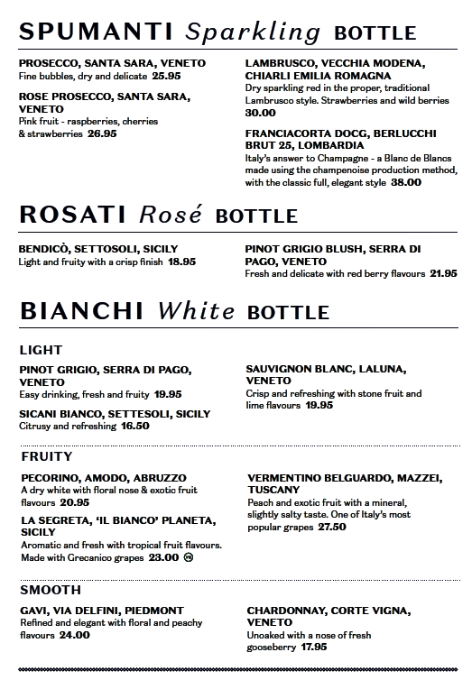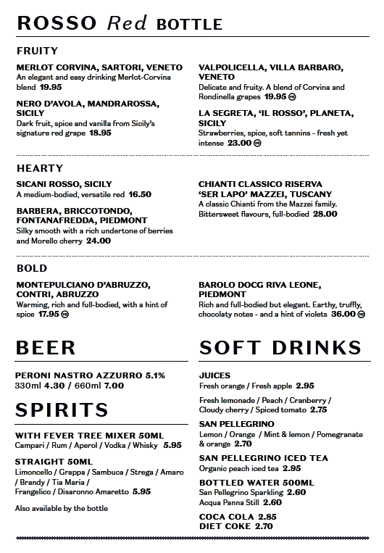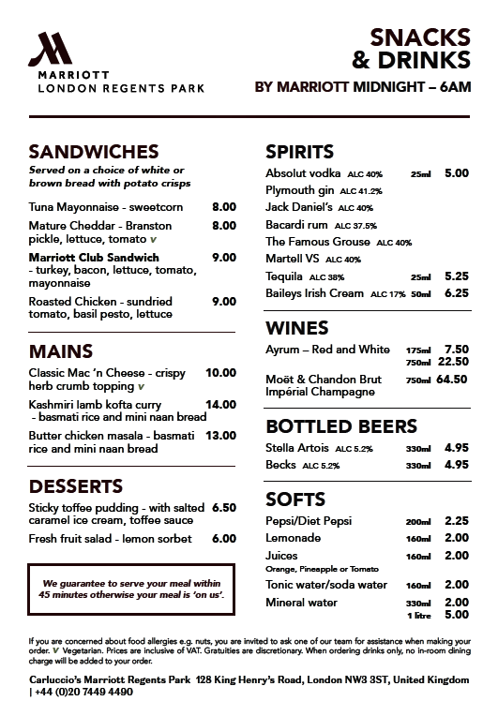

**Evaluation of the menu:** This menu, which is broken up into three sections for starters (ANTIPASTI), entrées (SECONDI), and desserts (DOLCI), comes from one of the Marriott restaurants. Zuppa Di Funghi, Spaghetti Carbonara eggs, Calamari Fritti, swordfish mixed herb and parmesan breadcrumbs), and Panna Cotta are just a few of the dishes mentioned (Styler, 2006). Additionally, starters (ANTIPASTI), entrées (SECONDI), and desserts (DOLCI), comes from one of the Marriott restaurants. The menu allows for various additions and modifications, such as putting chicken into the risotto or adding truffle oil to the mushroom dish (Mariani and Mariani, 2000). It also includes some vegetarian alternatives. The restaurant also provides a selection of liqueurs and other digestive beverages, such as limoncello. Panna cotta containing raspberry coulis, tiramisu, plus lemon tart are available as dessert alternatives. For those who want a lighter dessert, the restaurant also provides a range of Italian cheeses, gelato, and sorbets. A variety of dessert beverages and liqueurs, such as limoncello and Frangelico, are also available for customers to select from.

A variety of foods, including vegetarian and gluten-free alternatives, are offered on the available menu to accommodate different dietary needs and palate preferences (Cousins *et al. 2014*). Most of the items appear to be priced reasonably, from $8 to $20, which is typical for a dining establishment in this category. particular consumers may be turned off by the somewhat higher cost of particular meals, such as the seafood plate and the ribeye steak. A good selection of drinks, including spirits, beers, and cocktails, is also available on the menu, with prices starting at $6 to $16.

The menu is organised and simple to understand in terms of design. The addition of images for some items enhances the menu's aesthetic appeal and can aid consumers in choosing what they want to order (Beldona *et al*.2014). However, to make it simpler for customers to read, the font size may be increased significantly. Even if each dish's description is succinct and to the point, it would still be helpful to know more about the dish's history or any unusual ingredients that were utilized.

# 3.0 Menu planning considerations and constraints for the new Italian restaurant

A freshly opened Italian restaurant that is attempting to develop its own unique identity in an extremely competitive marketplace will find that menu planning is an even more vital procedure. Planning the menu for an upcoming Italian restaurant requires taking into account a number of factors and restrictions.

1. The target market for the restaurant's menu must be taken into account. The restaurant will be able to better construct a menu that meets the demands of its target market by having an understanding of its tastes and expectations (Gustafsson *et al*. 2006). For instance, if the restaurant wants to attract a younger crowd, they would wish to offer more contemporary Italian cuisine on the menu.
2. The restaurant must take ingredient availability into account. Italian food relies largely on fresh ingredients; thus, the restaurant needs to make sure that its suppliers can regularly deliver high-quality supplies (Hjalager and Corigliano, 2000). This might entail working with vendors to acquire food locally or changing the menu according to the season.
3. The restaurant must take the neighbourhood competition into account. The restaurant will be able to detect market gaps and develop a distinctive menu that differentiates itself from the competition by doing market research and examining the menus of rivals (Ozdemir and Caliskan, 2014).
4. The restaurant needs to think about profitability and costs. To maintain profitability without pricing oneself out of the market, the menu must be priced appropriately. This can entail paying close attention to component pricing, portion proportions, and overhead expenses (Nagle and Muller, 2018).

A detailed awareness of the target market, ingredient availability, competitors, and cost concerns are necessary for menu design for a new Italian restaurant (Murphy and Smith, 2009). The restaurant may design a menu that satisfies client demands while being profitable and staying competitive in the marketplace by carefully taking these elements into account.

# 4.0 Sustainability considerations for the new Italian restaurant

Menu for an upcoming Italian restaurant with sustainable considerations ideas:

| **Menu Item** | **Price (in euros)** | **Sustainable Consideration** |
| --- | --- | --- |
| Antipesti | € 6.75 | Locally-sourced ingridents |
| Insalata Caprese | € 10.50 | Seasonal produce |
| Risotto alla Carbonara | € 14.50 | Use of organic rice |
| Spaghetti alla Carbonara | € 12.50 | Use of free-range eggs |
| Pizza Margherita | € 9.50 | Use of organic flour |
| Pollo alla Griglia | € 18.50 | Use of free-range chicken |
| Branzino alla Griglia | € 22.50 | Sustainable seafood |
| Tiramisu | € 7.50 | Use of fair-trade cocoa |

It's crucial to take into account a number of elements when creating a sustainable menu, including decreasing food waste, sourcing foods locally, encouraging animal welfare, and lowering the restaurant's carbon footprint. Using locally sourced products in the antipasti & seasonally available vegetables in the Insalata Caprese are just two examples of the sustainable menu planning strategies that are used in the aforementioned menu (Parasecoli, 2004).

A dedication to encouraging sustainable agriculture may be seen in the use of organic flour and rice in the Pizza Margherita and Risotto alla Carbonara, respectively. Animal welfare is promoted by using natural eggs in the Spaghetti alla Carbonara and free-range chicken in the Pollo alla Griglia. Dedication to ethical sourcing may be seen in the Branzino alla Griglia's usage of sustainable fish. Finally, the restaurant's dedication to sustainable and ethical procurement is demonstrated by the incorporation of fair-trade chocolate in the Tiramisu (Barrows and Powers, 2008).

# 5.0 Conclusion

In conclusion, menu planning that is sustainable is an important component for every restaurant, particularly the new Italian eatery. It not only aids in decreasing the waste of food but also encourages moral and environmentally responsible behaviour. The menu ought to be created to give a selection of foods made using organic, regional, and locally produced components. In order to draw clients and yet pay the cost of manufacturing, costs should be fair. In the end, a sustainable menu may help the restaurant succeed while also helping the planet and society.

# Reference list

Barrows, C.W. and Powers, T., 2008. Introduction to management in the hospitality industry, study guide. John Wiley & Sons.

Beldona, S., Buchanan, N. and L. Miller, B., 2014. Exploring the promise of e-tablet restaurant menus. International Journal of Contemporary Hospitality Management, 26(3), pp.367-382.

Cousins, J., Lillicrap, D. and Weekes, S., 2014. Food and beverage service. Hachette UK.

Gustafsson, I.B., Öström, Å., Johansson, J. and Mossberg, L., 2006. The Five Aspects Meal Model: a tool for developing meal services in restaurants. Journal of foodservice, 17(2), pp.84-93.

Hjalager, A.M. and Corigliano, M.A., 2000. Food for tourists—determinants of an image. International journal of tourism research, 2(4), pp.281-293.

Mariani, J. and Mariani, G., 2000. The Italian American Cookbook: A Feast of Food from a Great American Cooking Tradition. Harvard Common Press.

McVety, P.J., Ware, B.J. and Ware, C.L., 2008. Fundamentals of menu planning. John Wiley & Sons.

Murphy, J. and Smith, S., 2009. Chefs and suppliers: An exploratory look at supply chain issues in an upscale restaurant alliance. International Journal of Hospitality Management, 28(2), pp.212-220.

Nagle, T.T. and Muller, G., 2018. The strategy and tactics of pricing. Routledge.

Ozdemir, B. and Caliskan, O., 2014. A review of literature on restaurant menus: Specifying the managerial issues. International Journal of gastronomy and food science, 2(1), pp.3-13.

Parasecoli, F., 2004. Food culture in Italy. Greenwood Publishing Group.

Styler, C., 2006. Working the plate: The art of food presentation. John Wiley & Sons.